Project Name: E-Verify Tutorial Quizzes, Questions, and Answers

Description: As a result of Legacy Retirement efforts, the redesigned E-Verify user interface has a modern design. The E-Verify lesson quiz questions have been modified to suit the new design. The E-Verify Guidance will revise and connect the tutorial quiz questions and answers with the Legacy Retirement modernization efforts.
Currently | Change
Employer and Employer Agent Users (EEA) (Program Admininstrators (PA) and General Users (GU) | Questions and Answers
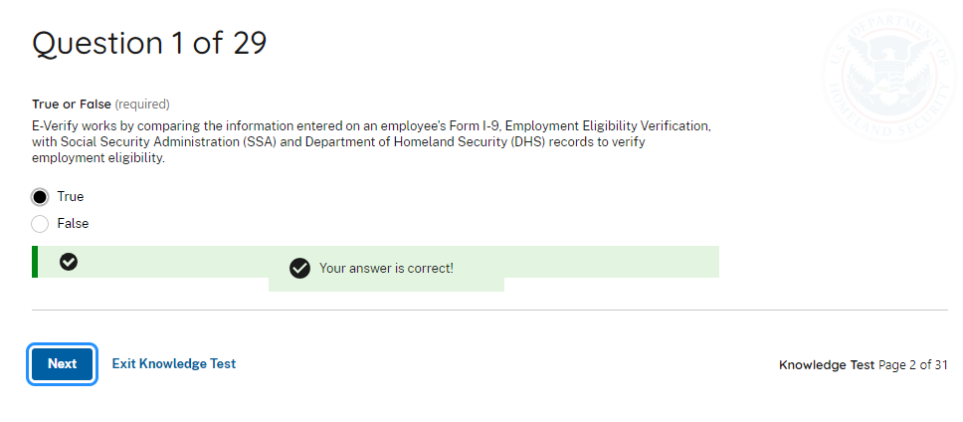 | E-Verify compares the information entered on an employee’s Form I-9, Employment Eligibility Verification, with official government records available to the Department of Homeland Security (DHS) and the Social Security Administration (SSA) to confirm employment eligibility.  - True  - False
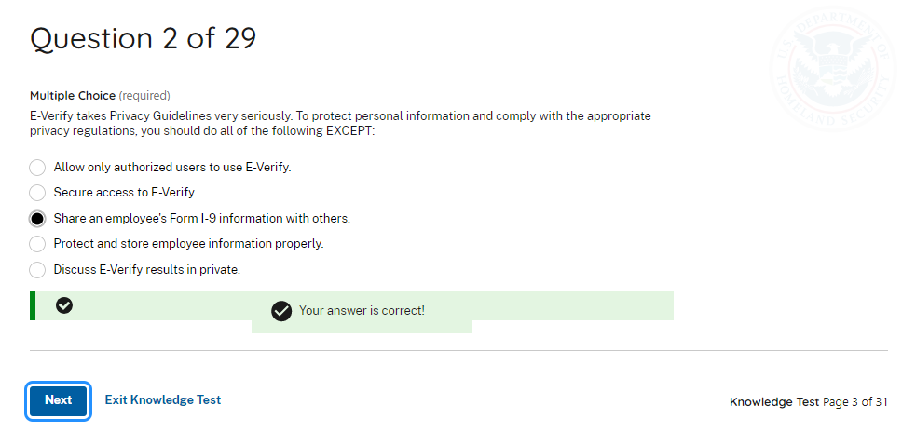 | E-Verify adheres to privacy guidelines and protection of personal information. To protect personal information and comply with the appropriate privacy regulations, you should do all of the following EXCEPT:  - Allow only authorized users to use E-Verify.  - Secure access to E-Verify.  - Share an employee’s Form I-9 information with others.  - Protect and store employee information properly.  - Discuss E-Verify results in private.
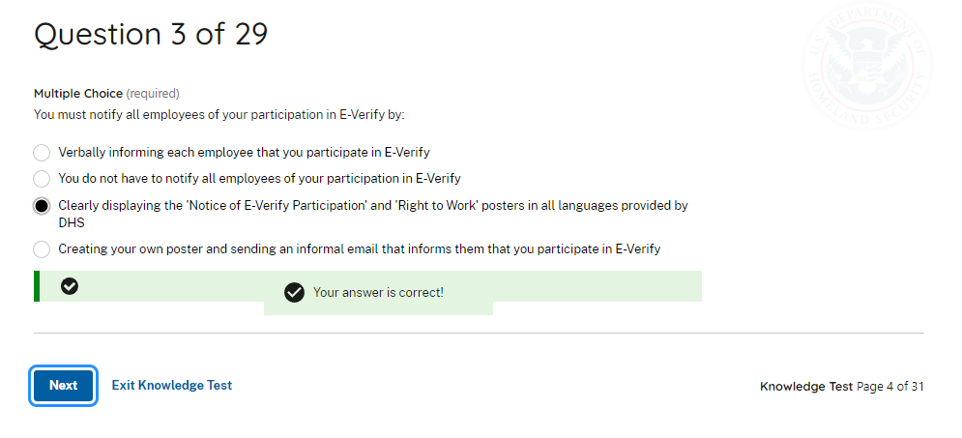 | You must notify all employees of your participation in E-Verify by:  - Verbally informing each employee that you participate in E-Verify.  - You do not have to notify all employees of your participation in E-Verify.  - Clearly displaying the Notice of E-Verify Participation and Right to Work posters provided by DHS in English and Spanish.  - Creating your own poster and sending an informal email that informs your employees that you participate in E-Verify.
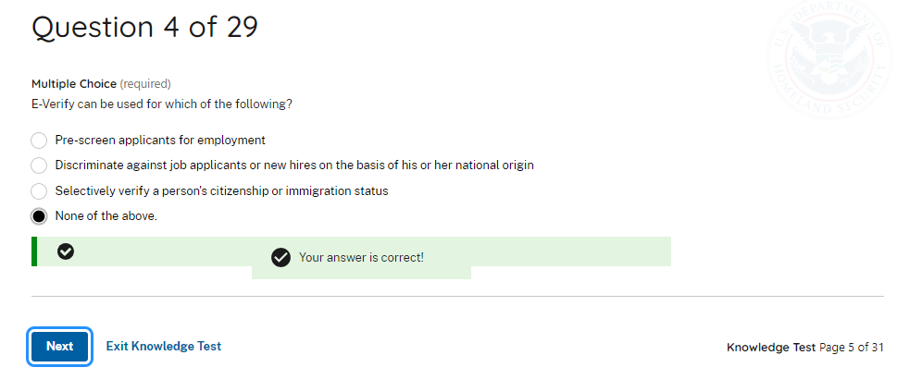 | E-Verify can be used for which of the following?  - Pre-screen applicants for employment.  - Discriminate against job applicants or new hires on the basis of his or her national origin.  - Selectively verify a person’s citizenship or immigration status.  - None of the above.
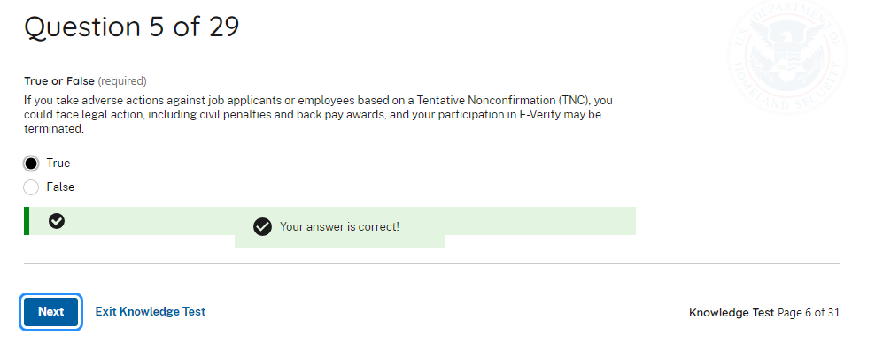 | If you take adverse action against employees based on an initial mismatch, you could face legal action, including civil penalties and back pay awards, and your participation in E-Verify may be terminated.  - True  - False
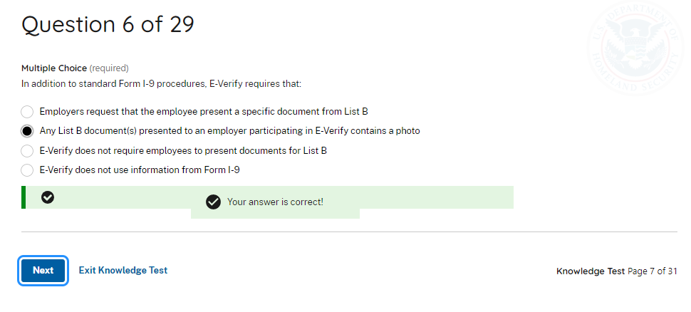 | In addition to standard Form I-9 procedures, E-Verify requires that:  - Employers request that the employee present a specific List B document.  - Any List B document(s) presented to an employer participating in E-Verify must contain a photo.  - Employees only present a List A document.  - Employees only present a List B document and List C document.
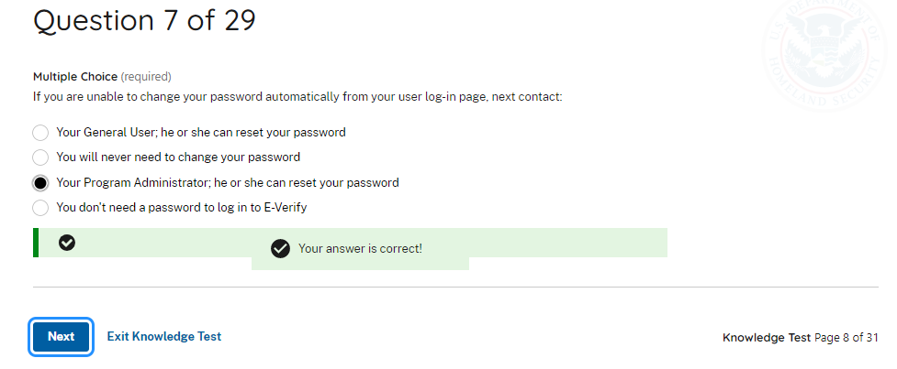 | If you are unable to change your password automatically from your user log-in page, you should contact:  - Your General User, who can reset your password.  - You will never need to change your password.  - Your Program Administrator, who can reset your password.  - You don’t need a password to log into E-Verify.
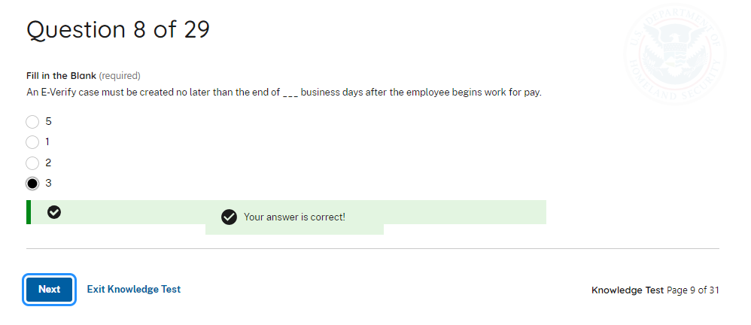 | An E-Verify case must be created no later than the end of _ _ _ business day(s) after the employee begins work for pay.  - 5  - 1  - 2  - 3
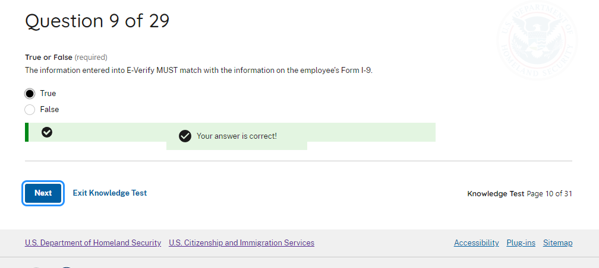 | The information entered into E-Verify MUST match the information on the employee’s Form I-9.  - True  - False
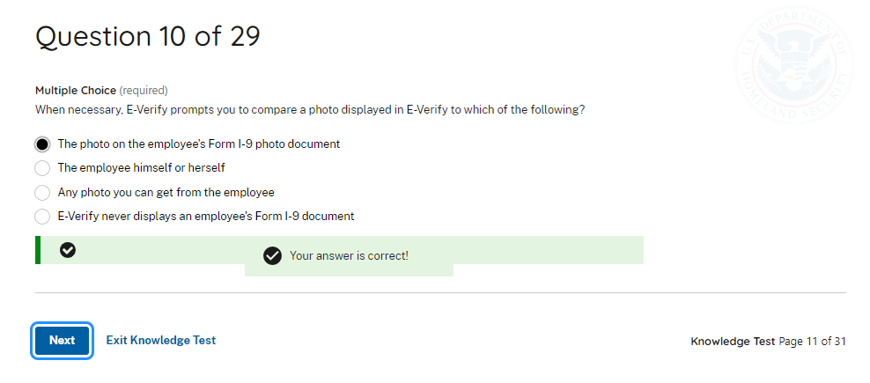 | When necessary, E-Verify prompts you to compare a photo displayed in E-Verify to which of the following?  - The photo on document the employee presented for the Form I-9.  - The employee themselves.  - Any photo you can get from the employee.  - E-Verify never displays a photo from the employee’s Form I-9 document.
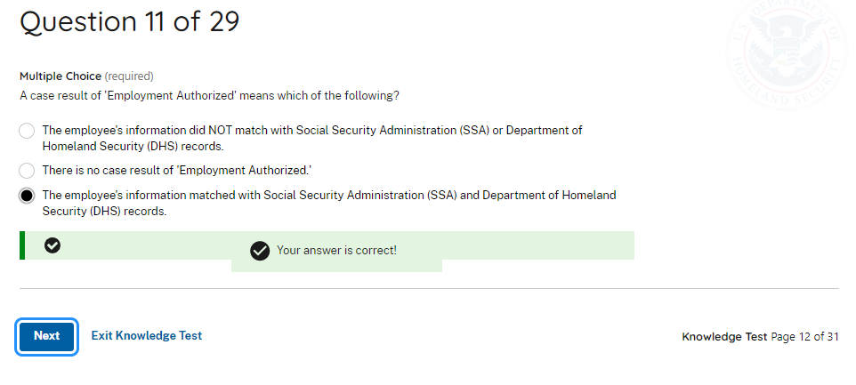 | The case result of Employment Authorized means which of the following?  - The employee’s information did NOT match official government records that E-Verify can access.  - There is no case result of Employment Authorized.  - The employee’s information matched official government records that E-Verify can access.
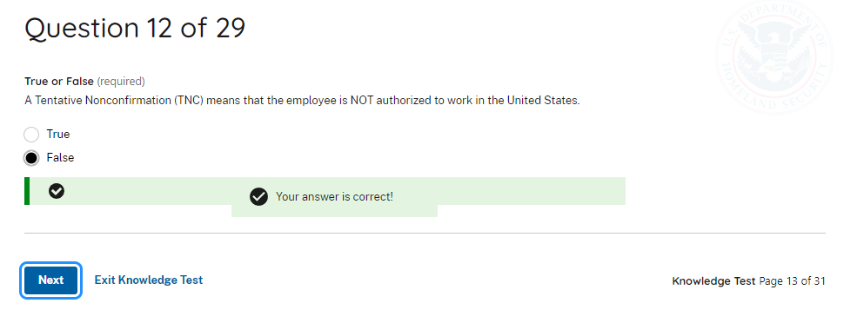 | A mismatch means that the employee is NOT authorized to work in the United States.  - True  - False
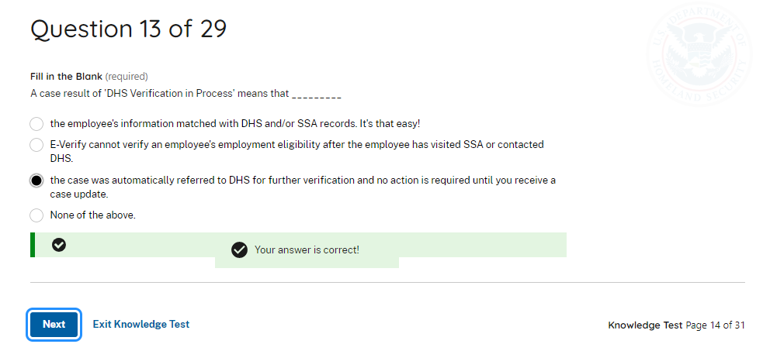 | A case result of E-Verify Needs More Time means that _ _ _ _  - The employee’s information matched with official government records that E-Verify can access.  - E-Verify cannot verify an employee’s employment eligibility after the employee has contacted DHS or visited SSA.  - The case was automatically referred to DHS for further verification and no action is required until you receive a case update.  - None of the above.
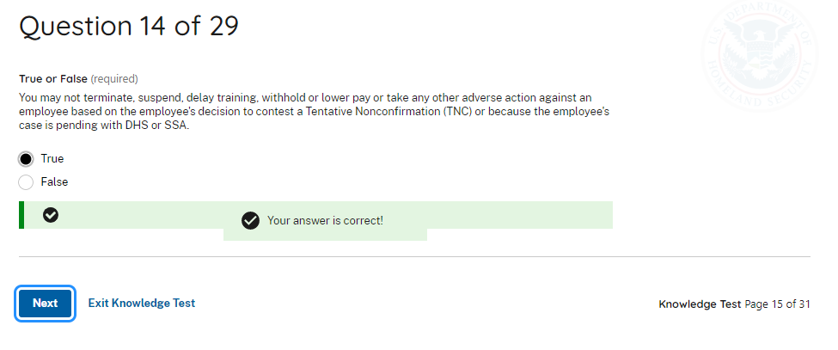 | Employers may not terminate, suspend, delay training, withhold or lower pay, or take any other adverse action against an employee because of the mismatch, until the mismatch becomes a Final Nonconfirmation.  - True  - False
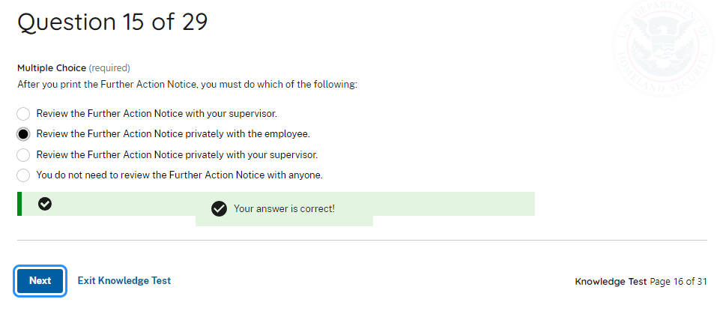 | After your print the Further Action Notice, you must do which of the following:  - Contact DHS and/or SSA to begin resolving the issue on behalf of the employee.  - Review the Further Action Notice privately with the employee.  - Review the further Action Notice privately with your supervisor.  - You do not need to review the Further Action Notice with anyone.
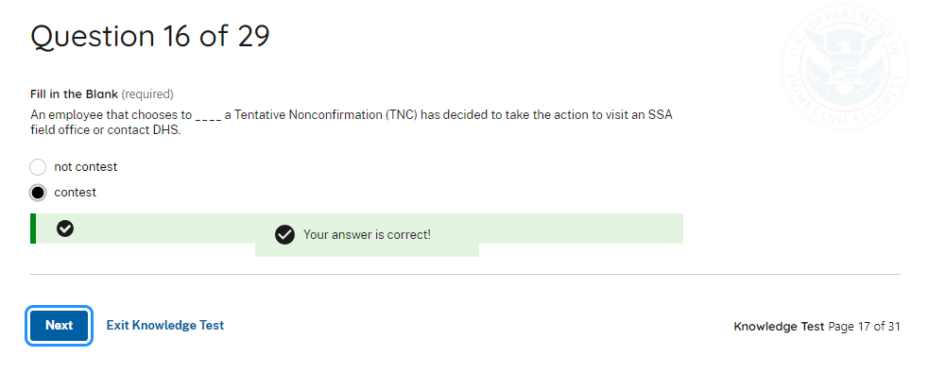 | E-Verify requires an employee who gets a mismatch to choose whether to take action to resolve the case within 10 federal government working days after E-Verify issues the mismatch result.  - True  - False
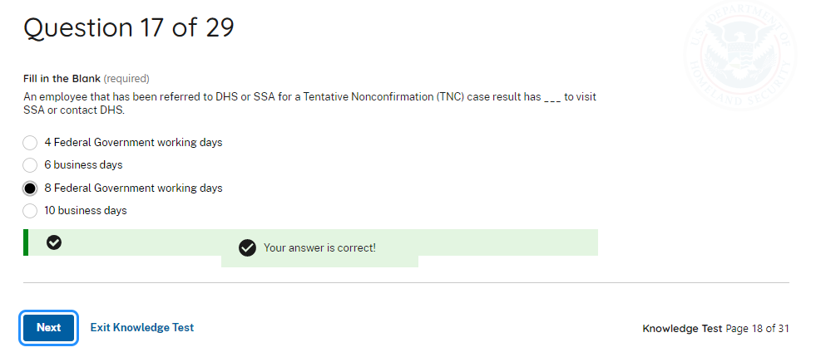 | An employee who was referred to DHS and/or SSA for a mismatch case result has ___ to contact DHS or visit SSA.  - 4 federal government working days  - 6 business days  - 8 federal government working days  - 10 business days
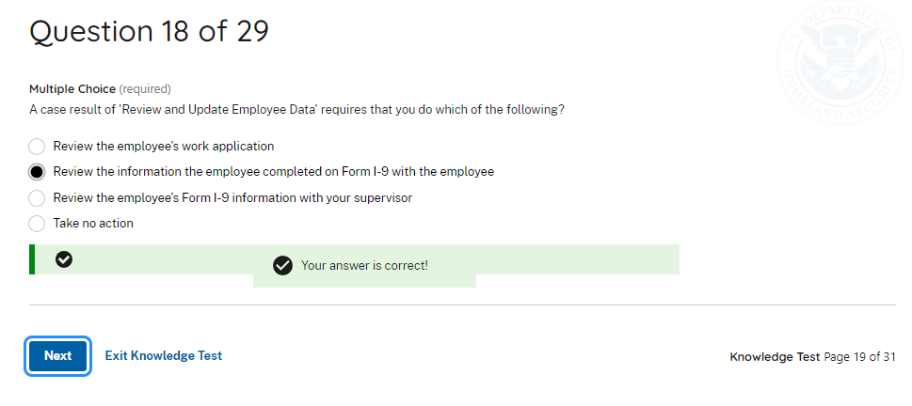 | Delete - OBE
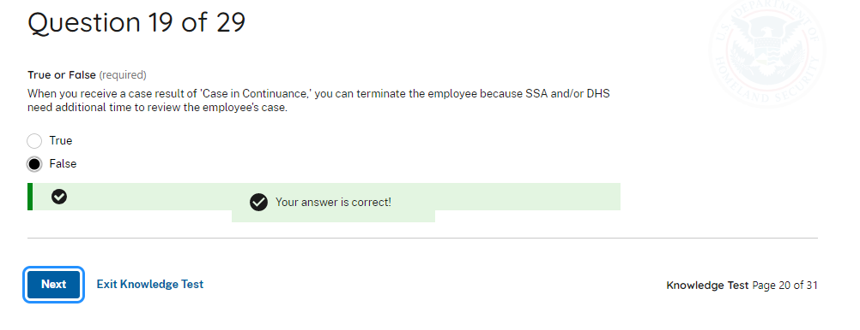 | When you receive a case result of Case in Continuance, you can terminate the employee because DHS and/or SSA needs additional time to review the employee’s case.  - True  - False
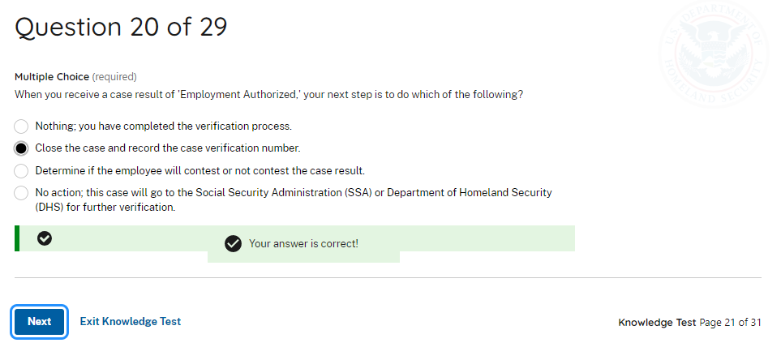 | When you receive a case result of Employment Authorized, your next step is to do which of the following?  - Nothing, you have completed the verification process.  - Record the E-Verify case number on the employee’s Form I-9 or attach a copy of the case details page to the Form I-9. E-Verify automatically closes Employment Authorized cases.  - Determine if the employee will contest or not contest the case result.  - No action, this case will go to DHS or SSA for further verification.
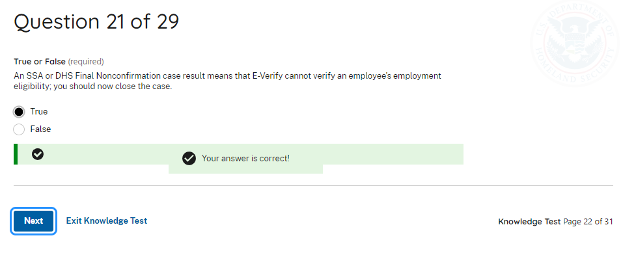 | A DHS or SSA Final Nonconfirmation case result means that E-Verify cannot confirm an employee’s employment eligibility based on the accessed government records; you must close the case.  - True  - False
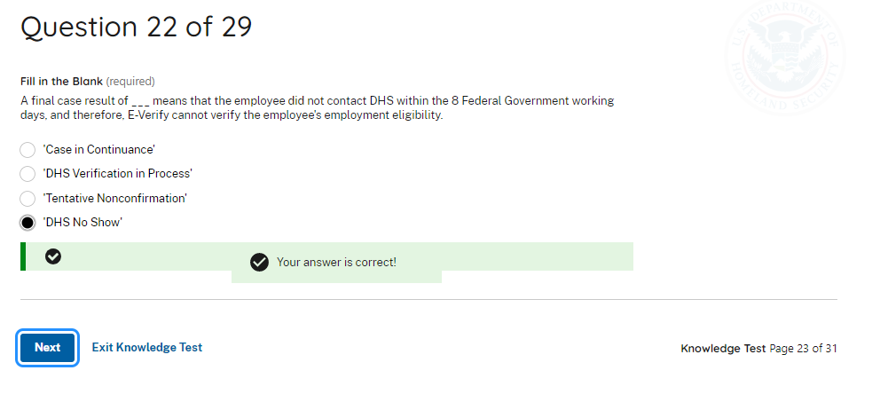 | A case result of ___ means that the employee did not contact DHS or SSA within 8 federal government working days and E-Verify cannot verify the employee’s employment eligibility.  - Case in Continuance  - E-Verify Needs More Time  - Tentative Nonconfirmation (Mismatch)  - DHS or SSA No Show
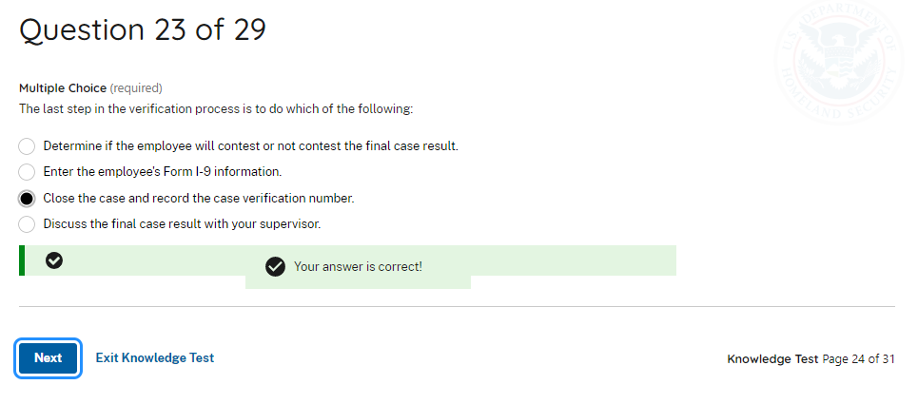 | The last step in the confirmation process is to do which of the following:  - Determine if the employee will contest or not contest the final case result.  - Enter the employee’s Form I-9 information.  - Record the E-Verify case number on the employee’s Form I-9 or attach a copy of the case details page to the Form I-9 and close the case if there is a Final Nonconfirmation. E-Verify automatically closes Employment Authorized cases.  - Discuss the final case result with your supervisor.
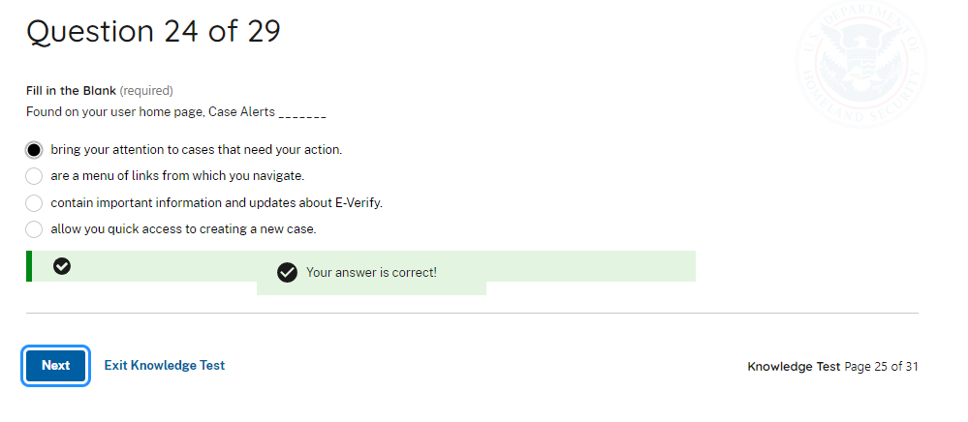 | Found on your user home page, Case Alerts _ _ _  - Bring cases that need action to your attention.  - Are a menu of links from which you navigate.  - Contain important information and updates about E-Verify.  - Allow you quick access to create a new case.
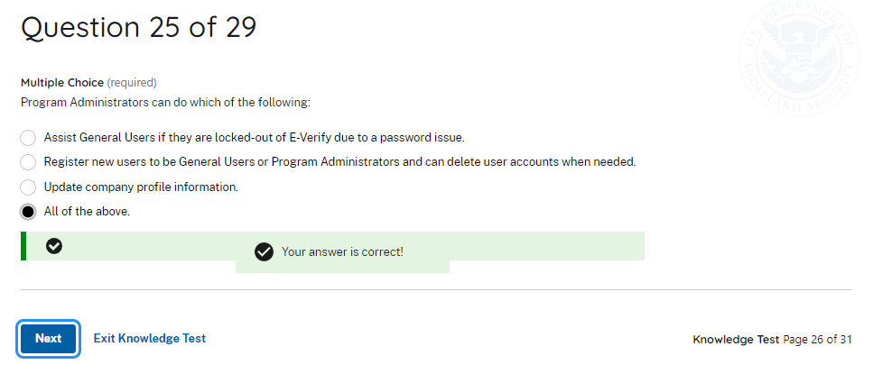 | Program Administrators can do which of the following:  - Assist General Users if they are locked-out of E-Verify due to password issues.  - Register new users to be General Users or Program Administrators and ability to delete user accounts when needed.  - Update company or entity profile information.  - All the above.
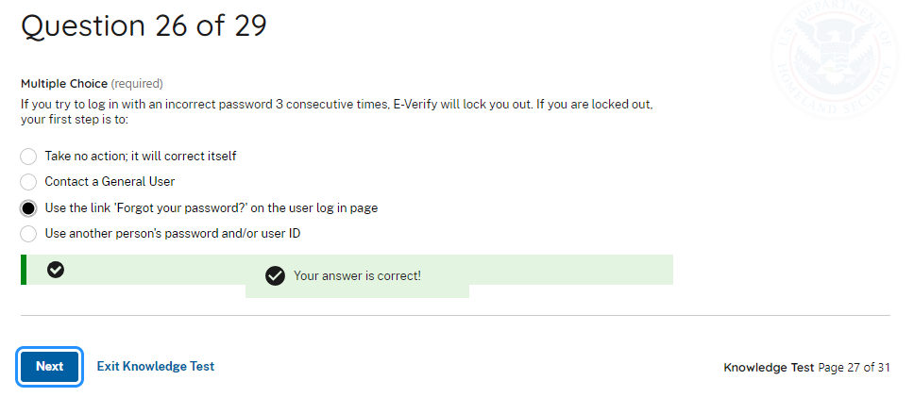 | If you try to log in with an incorrect password three consecutive times, E-Verify will lock you out. If you are locked out, your first step is to:  - Take no action; it will correct itself.  - Contact a General User.  - Use the link Forgot your Password? On the user log in page.  - Use another person’s password and/or user ID.
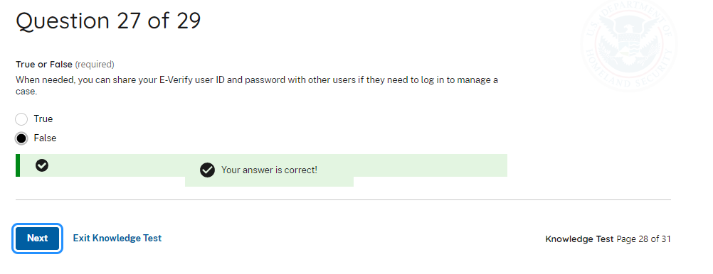 | When needed, you can share your E-Verify user ID and password with other users if they need to log in to manage a case.  - True  - False
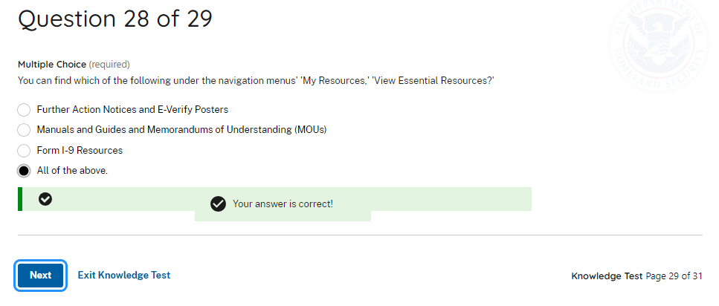 | Delete
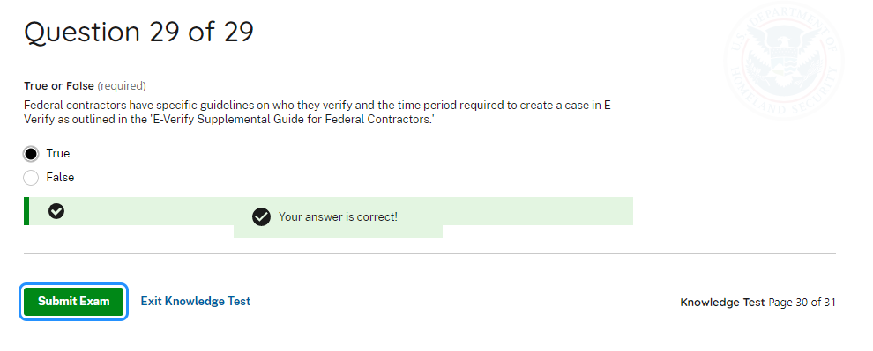 | Federal contractors have specific guidelines on who they create cases for and the time required to create a case. This is outlined in the E-Verify Supplemental Guide for Federal Contractors.  - True  - False
The Knowledge check with 29 questions includes a final question (#29) about federal contractor responsibilities if they have the FAR clause – this should load for PA and GU users on both Employer and Employer Agent accounts, but ONLY if those accounts have a category showing Federal Contractor with FAR Clause.
The Knowledge Check with 28 questions should load for PA and GU users on both Employer and Employer Agent accounts for all category types EXCEPT Federal Contractor with FAR Clause.
Corporate Admininistrator | Questions and Answers
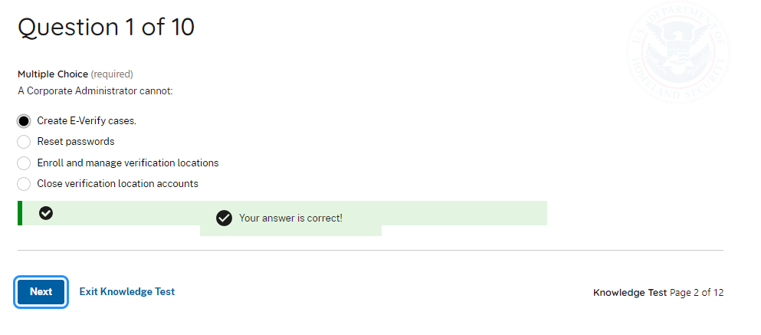 | A Corporate Administrator cannot:  - Create E-Verify cases.  - Reset passwords.  - Enroll and manage verification locations.  - Close verification location accounts.
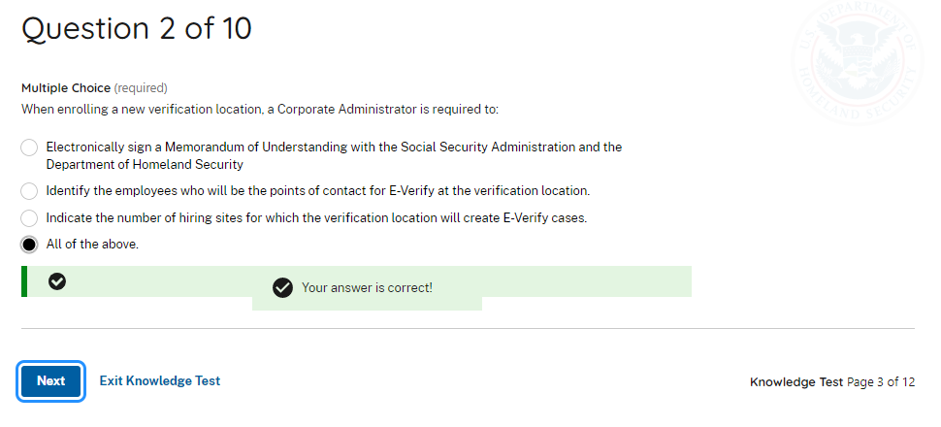 | When enrolling a new verification location, a Corporate Administrator is required to:  - Electronically sign a Memorandum of Understanding with the Department of Homeland Security and Social Security Administration.  - Identify the employees who will be the points of contact for E-Verify at the verification locations.  - Indicate the number of hiring sites for which the verification location will create E-Verify cases.  - All the above.
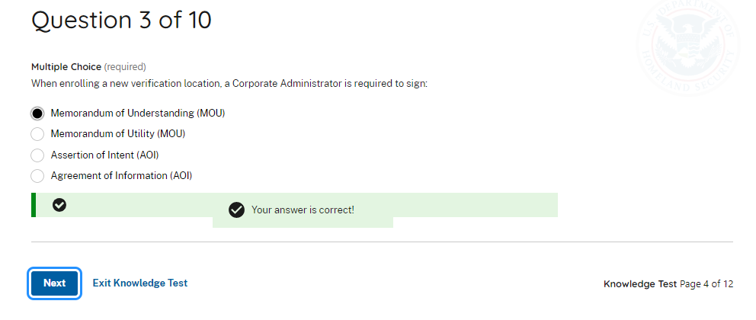 | When enrolling a new verification location, a Corporate Administrator is required to sign an E-Verify:  - Memorandum of Understanding (MOU)  - Memorandum of Utility (MOU)  - Assertion of Intent (AOI)  - Agreement of Information (AOI)
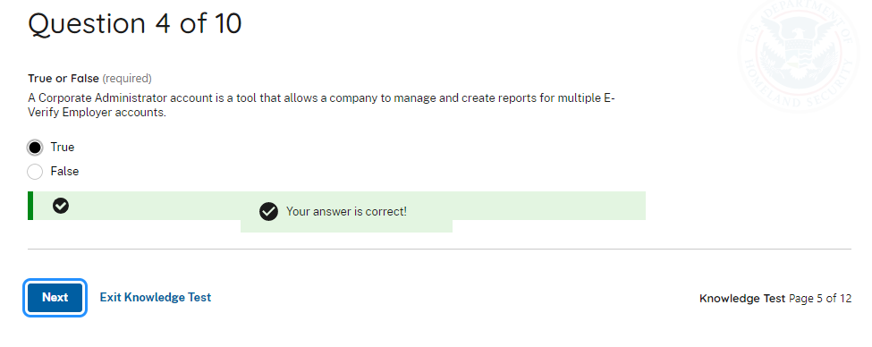 | A Corporate Administrator account is a tool that allows a company to manage and create reports for multiple E-Verify employer accounts.  - True  - False
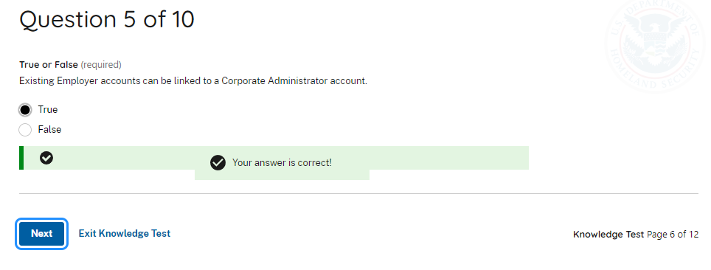 | Delete OBE
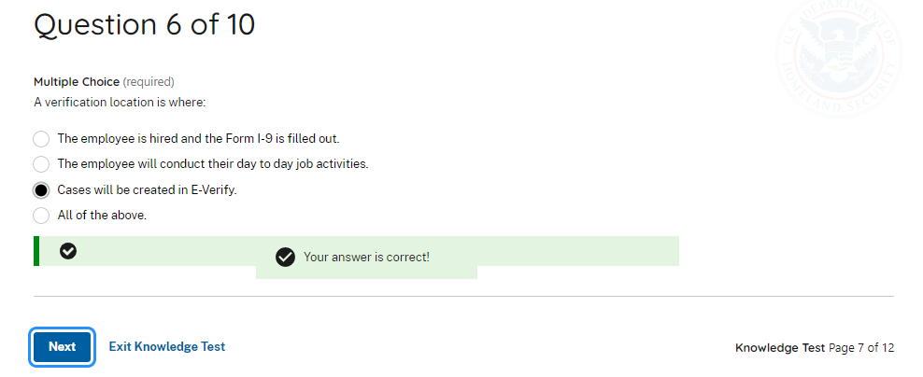 | A verification location is where:  - The employee is hired and the Form I-9 is completed.  - The employee will conduct their day-to-day job activities.  - Cases will be created in E-Verify.  - All the above.
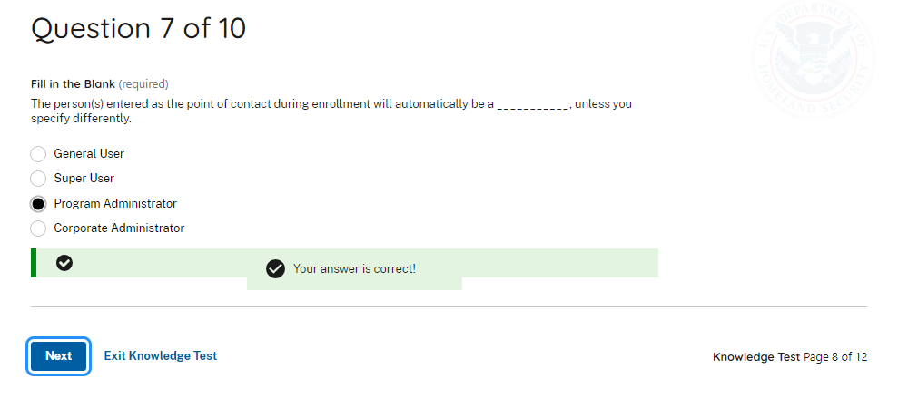 | The person(s) entered as a point of contact during enrollment will automatically be a _ _ _  unless you specify differently.  - General User  - Super User  - Program Administrator  - Corporate Administrator
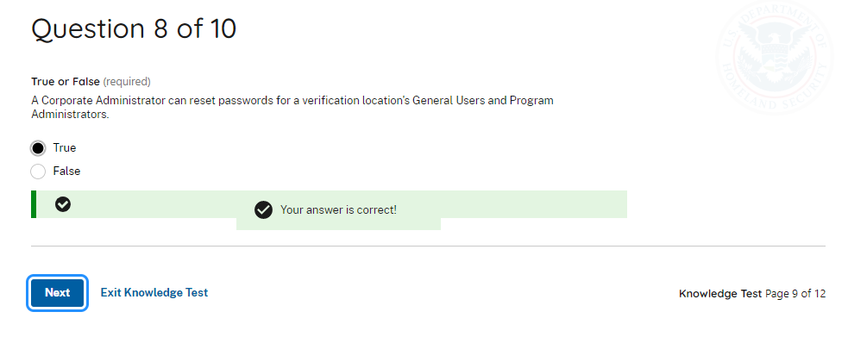 | A Corporate Administrator can reset passwords for a verification location’s General User and Program Administrators.  - True  - False
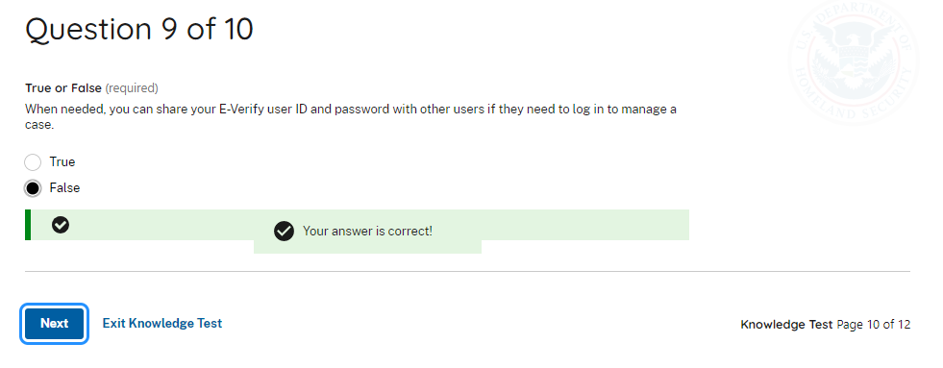 | When needed, you can share your E-Verify user ID and password with other users if they need to log in.  - True  - False
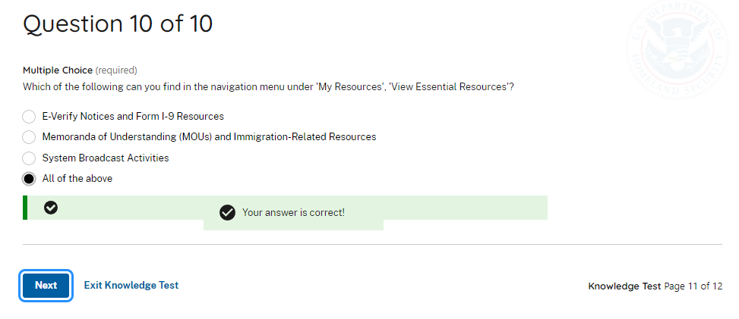 | Delete

