National Center for education statistics
(nces)

Statewide Longitudinal Data System (SLDS) Survey 2023 –2025

OMB# 1850-0933 v.11

Appendices A – D – Contact Materials

May 2023

Appendices included

- Introductory Email Script and Instructions
- 2023 Webinar PowerPoint and Webinar Announcement
- Non-Response Follow-Up Email Script & Submission Confirmation
- Non-Response Call Script

APPENDIX A – Introductory Email Script and Instructions

[Introductory Email Script – Attachment]

[date 1]

Dear Project Director and/or Primary SLDS Contact,

The National Center for Education Statistics (NCES) has initiated a data collection effort to help inform ongoing evaluation and targeted technical assistance efforts to enrich the quality of the Statewide Longitudinal Data System (SLDS) Program’s support to States regarding system development, enhancement, and use.

This project is a formalized expansion of the SLDS Program’s Interim Progress Report (IPR), which was intended to provide NCES with insight on State and U.S. territory SLDS capacity for automated linking of K-12, teacher, postsecondary, workforce, career and technical education (CTE), adult education, and early childhood data.

To ensure the success of the SLDS Survey, we need your help. Included in this email is a link to the SLDS Survey and completion instructions. We encourage all respondents to complete the online version to ease both completion and analysis time. Should you have issues accessing or completing the online version of the Survey, please do not hesitate to contact us. We will accept completed surveys via email until the deadline of [date 2].
.

By providing NCES with information regarding the capacity of your State’s SLDS, NCES will be able to provide a publicly accessible set of metrics and use cases showing data-linking and use capacity by State in the form of an IES-approved Statistics in Brief, which will enable interested users to quickly ascertain which States have capacity to link data across sectors. For example, which States can link K12, postsecondary, and workforce data, and how they are using these data to inform policy and practice. We also will use the data collected from the Survey to respond to questions from internal and external stakeholders regarding SLDS capacity in the States, and to inform future grant rounds and technical assistance planning.

The cooperation of your State is important to the success of this national survey of SLDS capacity. NCES will not sell these data and will notify you when the public metrics and use cases become available, in the form of an IES Statistics in Brief. The Survey data will be collected on an annual basis. SLDS system capacity changes frequently (ex. Infrastructure enhancements, evolving P20W agency collaborations, State legislation impacts, etc.), so collecting data less often would make the information too obsolete to be useful for targeted technical assistance planning.

If you have questions about the SLDS Survey, please contact Kristen King at Kristen.king@ed.gov.

Sincerely,

Ross Santy
Associate Commissioner, Administrative Data Division
National Center for Education Statistics
Institute of Education Sciences

[Instructions – Body of Email]

Dear [Name],

We are requesting your participation in completing the official OMB-approved (OMB#1850-0933 v.11 ) 2023 Statewide Longitudinal Data System (SLDS) Survey under the direction of Ross Santy, Associate Commissioner of the Administrative Data Division at the National Center for Education Statistics. In the email attachment, we have provided his introductory letter that includes additional information about the survey and its importance. The information following contains important details and recommendations to help you complete the survey by the due date of [date 3].

To access [State’s] 2023 Statewide Longitudinal Data System (SLDS) Survey, please click on the customized link here:

Note: If applicable, your state or territories customized link has also been sent to the following key personnel: [Name]

- If you (or someone from your state or territory) completed the survey last year, we have provided your state’s/territory’s 2022 survey responses. We hope the reference supports the review of your prior responses so that you can make the appropriate 2023 selections for each specified element or capability in your SLDS.
- If no survey was completed and submitted by a representative from your state/territory last year, no reference will be included. If your state/territory submitted an SLDS survey in a prior year and you would like a copy of those responses for reference, please reach out to the State Support Team and we will be happy to provide those to you.

Additionally, we would like to make a few recommendations so that you are able to complete it with the greatest ease.

- The survey tool will automatically save your responses on each completed page. If you navigate away from the survey, simply use the provided link to return to your saved responses. Incomplete pages will not be saved. You must complete each item on a survey page and move to the next page in order for your responses to be saved.
- Please read each question and the provided 2022 response (if available) completely.
- Please make a selection even if your response has not changed from last year to indicate the option that best reflects your SLDS at the time you complete this survey.
- All “Other” options and text fields have been left blank to ensure accuracy for this year.
- To navigate to a specific section of the survey, use the “Return to Menu” button at the bottom of each page, or the Table of Contents menu at the upper left-hand corner of each page. The navigation arrows will automatically return you to sections of the survey you have not yet filled out, if any.
- The final section of the survey includes space for additional comments. If you have multiple individuals filling out the survey, please coordinate to ensure that any additional comments are included in this field.
- Once you submit your survey, you cannot make further changes to your submission. If you submit the survey prior to completion, you will be unable to make further changes and you will need to fill out the entire survey again. Please ensure that you have completed all survey items accurately before submitting.
Thank you in advance for completing and submitting the 2023 SLDS Survey. Please reach out to me with any questions you may have. The contribution by your state/territory is important in informing the national landscape of SLDS capacity. Please submit your survey by [date 4].

Thank you,

Kristen King
Federal Program Officer, Statewide Longitudinal Data System Program
National Center for Education Statistics
Institute of Education Sciences

APPENDIX B – 2023 Webinar PowerPoint and Webinar Announcement

[Webinar]
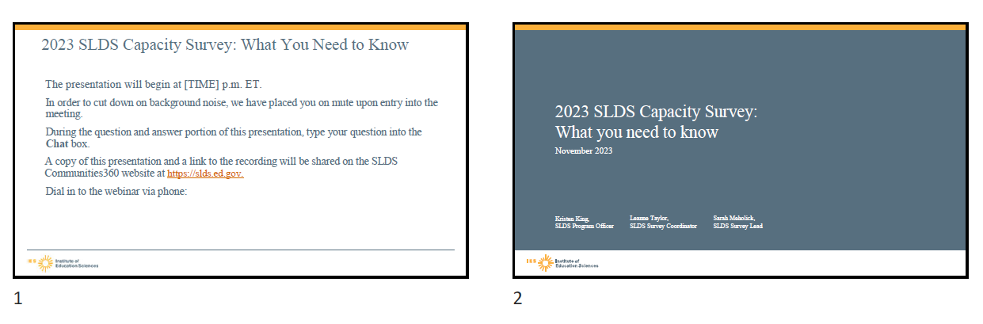

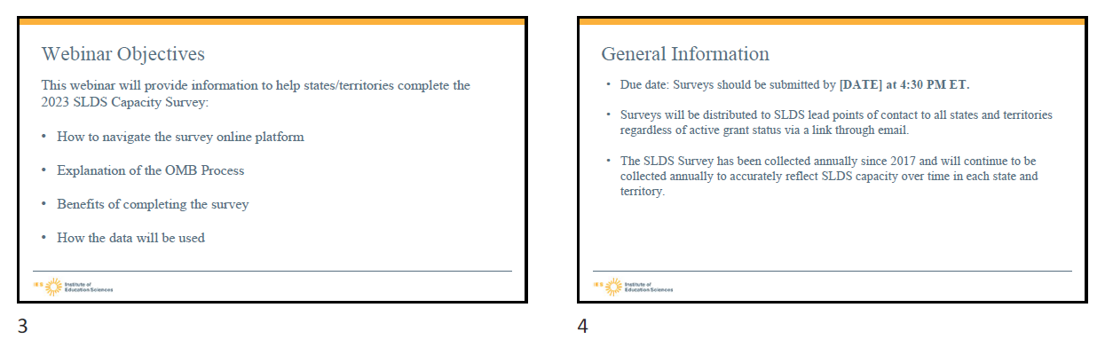

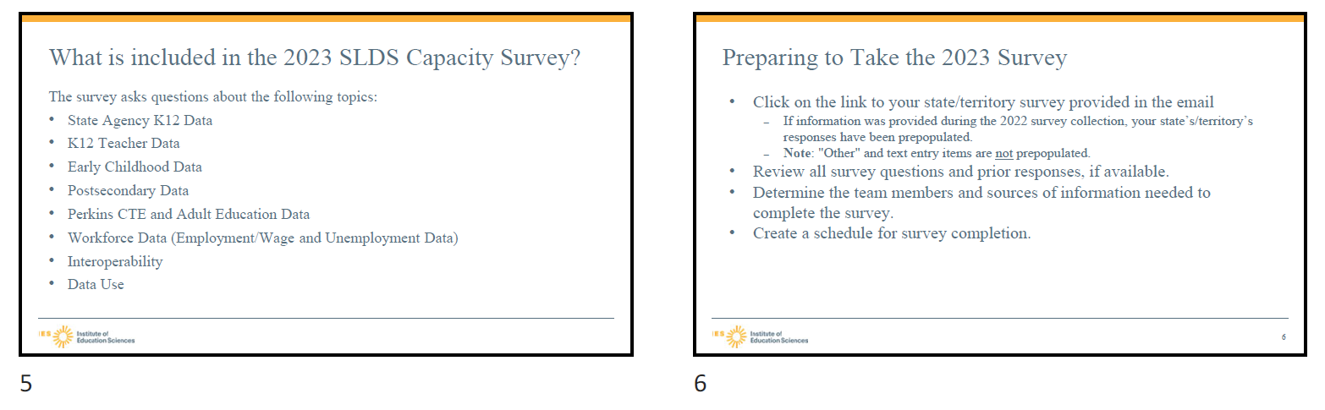
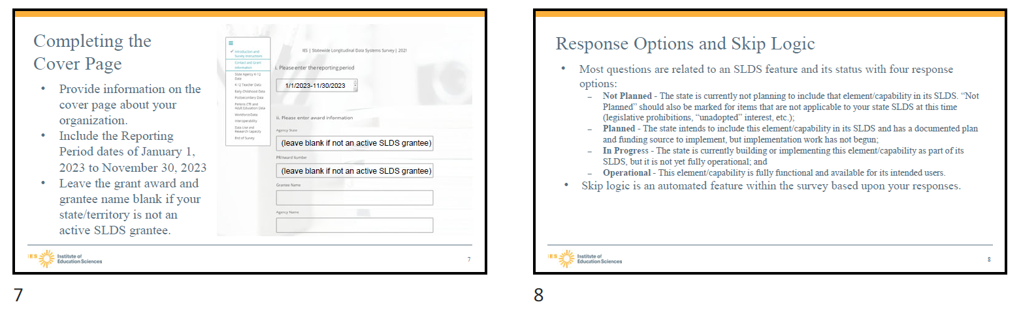

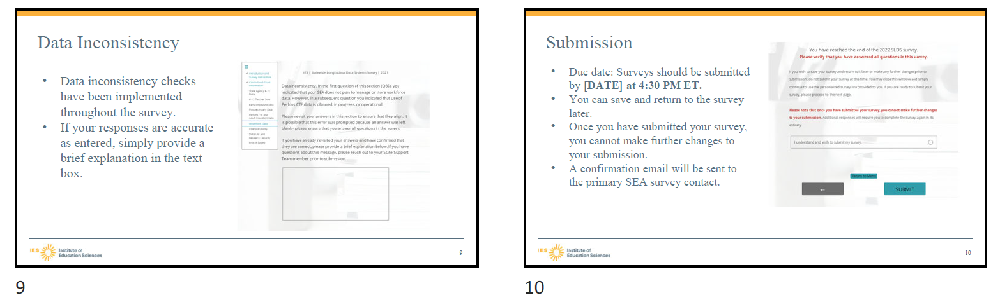

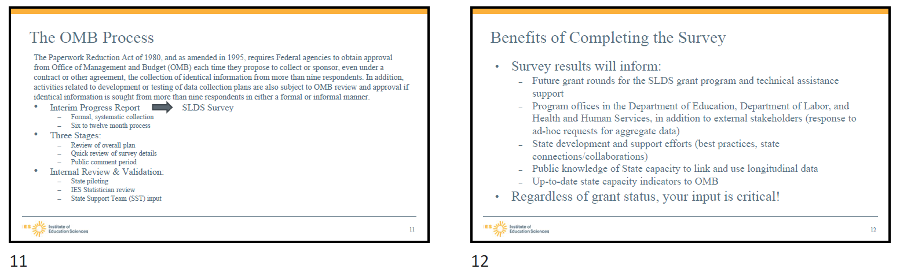
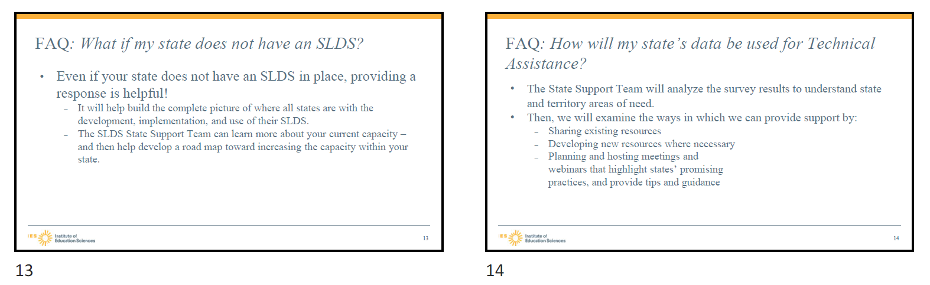

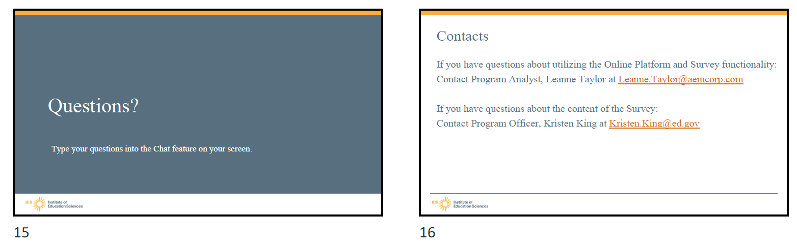

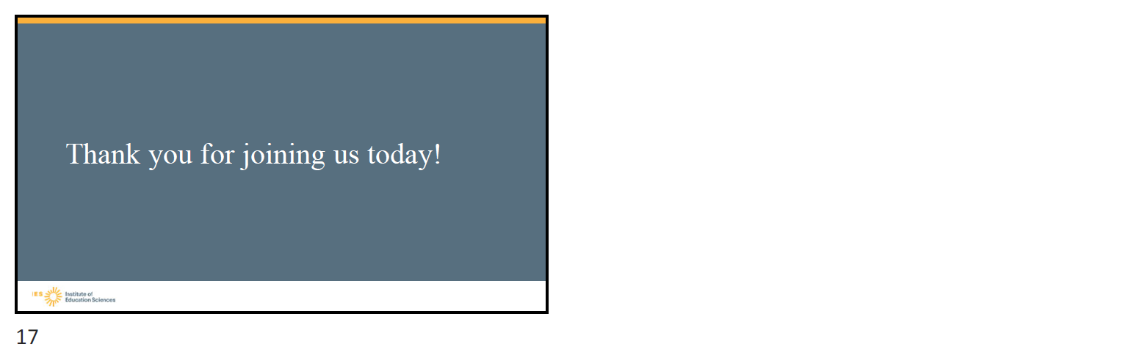

APPENDIX B – Webinar PowerPoint and Webinar Announcement

[Webinar Announcement]

Please join the Statewide Longitudinal Data System (SLDS) program on [date 5], at 2:00 PM ET for the webinar: What to Expect: The 2023 SLDS Capacity Survey. During the session, SLDS Program Officer, Kristen King, Data Analyst, Sarah Meholick, and Program Analyst, Leanne Taylor, will discuss the upcoming 2023 SLDS Capacity Survey. The team will present on the process and expectations for survey completion.

We strongly encourage you to attend the session as there will be an opportunity for you to ask questions during the Q&A session at the end of the webinar although a recording of the webinar will be available.

Please forward this invitation to others who may be interested the information.

To join the webinar, please follow the link below:

APPENDIX C – Non-Response Follow-Up Email Script and Submission Confirmation

[Gentle Reminder]

[date6]

Dear Project Director and/or Primary SLDS Contact:

I am reaching out with a friendly reminder for you to complete [state/territory]’s 2023 SLDS Capacity Survey, the official OMB-approved survey (OMB# 1850-0933 V.11) from the National Center for Education Statistics. We initially reached out in November 2023 asking for participation in the Survey because your response is vital to providing an overall picture of the SLDS capacity for the field.

Please use the link below to complete the Survey by [date 6], so the information you provide can be included in the final 2023 survey results. As a reminder, 2023 Survey responses will be made available to the public in the form of a Statistics in Brief report (see an example here) and the associated data file. Do not hesitate to reach out if you have questions.

Survey link: [link here]

If you have questions about the SLDS Survey, please contact Kristen King at Kristen.king@ed.gov.

Sincerely,

Ross Santy
Associate Commissioner, Administrative Data Division
National Center for Education Statistics
Institute of Education Sciences

[Final Request Email]

[date 7]

Dear Project Director and/or Primary SLDS Contact:

I am reaching out to make a final request for you to complete (state/territory)’s 2023 SLDS Capacity Survey, the official OMB-approved survey (OMB# 1850-0933 v.11) from the National Center for Education Statistics. We initially reached out in November 2023 asking for participation in the survey because your response is vital to providing an overall picture of the SLDS capacity for the field. However, we have not received a survey submission from your SEA.

Please use the link below to complete the Survey by [date 8] so the information you provide can be included in the final 2023 survey results. As a reminder, 2023 survey responses will be made available to the public in the form of a Statistics in Brief report (see an example here) and the associated data file. Do not hesitate to reach out if you have questions. This is our final request for (state/territory)’s response.

Survey link: [link here]

If you have questions about the SLDS Survey, please contact Kristen King at Kristen.king@ed.gov.

Sincerely,

Ross Santy
Associate Commissioner, Administrative Data Division
National Center for Education Statistics
Institute of Education Sciences

[Submission Confirmation]

Thank you for submitting the 2023 Statewide Longitudinal Data System (SLDS) Survey. Your submission has been received. The contribution by your state/territory is important in informing the national landscape of SLDS capacity. We will reach out if there are any questions during the validation process. Again, thank you for your submission.

APPENDIX D – Non-Response Call Script

This information below describes the non-response telephone procedures that will be used for the Statewide Longitudinal Data System (SLDS) Survey. The purpose of the telephone calls is to encourage non-responsive States to complete to the survey.

MATERIALS AND FILES PROVIDED

- The National Center for Education Statistics (NCES) has a Microsoft Excel spreadsheet containing the contact information for each non-respondent State.
- Columns will be added for comments, to document each non-response follow-up attempt/conversation and outcome of the call.

The Call

- Call the State contact listed.
- If you aren’t able to speak to the contact, ask to leave a voicemail.

Good morning (afternoon, etc.). My name is_____. I am calling for the Statewide Longitudinal Data System (SLDS) Survey, sponsored by the National Center for Education Statistics, NCES, within the U.S. Department of Education. We are calling because we are collecting data on your State’s SLDS system capacity, and the survey deadline is [date2]. I am calling to offer any assistance in completing the Survey, if needed. Please call me at __________ at your earliest convenience. Thank you.

- If you are able to speak with the respondent, follow the script below for the calls. (Items in blue are not part of the script.)

Good morning (afternoon, etc.). My name is_____. I am calling for the Statewide Longitudinal Data System (SLDS) Survey, sponsored by the National Center for Education Statistics, NCES, within the U.S. Department of Education. We are calling because we are collecting data on your State’s SLDS system capacity, and the survey deadline is [date2]. I am calling to offer any assistance in completing the Survey, if needed.

Your participation is very important to the success of the survey.

I would like to email this information to you. May I confirm that your email address is ________?
(If yes, send non-response email to contact. If no, update email address on spreadsheet, GRADS360, and listserv. Next, send non-response email to new contact email.)

Thank you for your time. Have a good ____ (morning, etc.).

Record on the spreadsheet any other information the respondent gave you in reference to the Survey.
- For each State Contact, try to speak to a person who can give you the information. If you have no success, record that on the call sheet.

