Memorandum United States Department of Education
Institute of Education Sciences
National Center for Education Statistics
DATE: May 19, 2023
TO: Robert Sivinski, OMB
THROUGH: Carrie Clarady, NCES
FROM: Michelle McNamara, NCES
SUBJECT: National Household Education Survey 2023 (NHES:2023) Full-scale Data Collection Recruitment Change Request (OMB# 1850-0768 v.20)

The National Household Education Survey (NHES) is a data collection program of the National Center for Education Statistics (NCES) designed to provide descriptive data on the education activities of the U.S. population, with an emphasis on topics that are appropriate for household surveys rather than institutional surveys. Such topics have covered a wide range of issues, including early childhood care and education, children’s readiness for school, parents’ perceptions of school safety and discipline, before- and after-school activities of school-age children, participation in adult and career education, parents’ involvement in their children’s education, school choice, homeschooling, and civic involvement. The US is administering the NHES in 2023 for the thirteenth time since the collection began in 1991. Data collection will run from January 2023 through August 2023.
In conjunction with NHES:2023, NCES is also conducting a debriefing study with respondents to the NHES who reported their child was enrolled in virtual classes. This debriefing study is designed to provide insight about virtual school experiences that can help plan future survey administrations.
OMB approved recruitment and collection for the NHES:2023 and the NHES:2023 debriefing study (included as Appendix 4) in August 2022 (OMB# 1850-0768 v.19).
This change request is for approval to make two sets of changes, one to the recruitment approaches for the NHES:2023 topical mailings, and another for the NHES:2023 debriefing study for virtual education.
- First, we have decided to add a fifth topical package mailing for some respondents. Similar to many other survey studies, the NHES has experienced a slightly lower than expected response rate during its current data collection period, and we would like to add an additional mailing using a different delivery type and branding for respondents sampled for our topical surveys who have not yet completed a topical survey. These respondents have already indicated a willingness to participate in our study by responding to the screener and we hope that an additional, different kind of mailing may encourage questionnaire completion. We plan to add a fifth topical mailed package for all households that received their first mailing before June 1, 2023, but have not yet responded to any of the previous four mailings. By targeting all potential respondents who have received their first mailing by June 1, 2023 we are able to contact the largest number of respondents (estimated to be about 2,000) without having to make any changes to our data collection window. This final fifth mailed package will be delivered via UPS (except for P.O. box only recipients who will receive the mailing via USPS Priority Mail). The package will include a letter on U.S. Department of Education, Institute of Education Sciences, NCES letter head from NCES Associate Commissioner Christopher Chapman encouraging participation, the topical survey for which the respondent has been sampled, and a return envelope. Please see the full text of the letter written for this package below.
- In addition, we have decided to refine our recruitment efforts for the NHES:2023 debriefing study for virtual education. We intend to revise the language of email and voicemail correspondence to better highlight benefits of participation based on feedback we’ve heard from interviewees thus far. Given that many participants have repeatedly stated the strong conviction that participation allows them to voice their unique perspectives, we have revised language in the email to present this study as a means for sharing opinion on their child’s schooling. Additionally, we are more prominently mentioning the convenience of the online format of the interview, the fact that interviews will not take more than 60 minutes, and the $40 incentive. Similarly, we are more prominently mentioning the $40 incentive in voicemail messages. Because we have experienced some no-show interviews, we also would like to spend some time in the scheduling phone call to verify that potential participants have received our scheduling email, and we also would like to ask for permission to send reminder text messages to potential participants. Reminder text messages would only be sent to participants who have scheduled an interview with us, provided a text-capable phone number and assented to let an interviewer text them. Text messages would be sent 6 to 12 hours before the interview using Ring Central to remind participants of the time and date for their scheduled interview. Please see a detailed log of those changes below
Part A required only brief revision to correct a small error in the original document. Part B has been updated to reflect the addition of the fifth topical mailing package for the NHES:2023. Appendix 1 has been updated to include the full text of the new letter for the fifth topical mailing package. Appendix 4 has been updated to include the revised text for the recruitment emails, voicemail and scheduling phone scripts, and the full text of the text reminder. More detailed descriptions of the changes in this package are included on the following pages; specific changes are marked in red font.
This request makes no change to the total estimated respondent burden and does not change the cost to the federal government.

Changes to Part A

A.16 Publication Plans and Project Schedule

Exhibit 2. NHES:2019 schedule of major activities
Task | Date of Scheduled Conduct/Completion
Survey Letters and Instruments Formatting and Printing | July-December, 2022
Data Collection Begins (advance letter mailing) | January 5, 2023
Data Collection Ends | August 18, 2023
First Look Reports Released | August 18, 2024
Public and Restricted-use Data Files Released | December 31, 2024

Changes to Part B

B.2 Statistical Procedures for Collection of Information
Topical Procedures
All nonresponse follow-up mailings will contain a cover letter, replacement questionnaire, and business reply envelope. The third and fifth mailings will be sent rush delivery.
Reminders and nonresponse follow-up. Topical reminders and nonresponse follow-up activities will only be conducted for paper screener respondents. Web screener respondents will be routed directly to the topical survey and will not receive reminders if they do not start or complete the topical survey. Paper screener households that do not respond to the initial topical mailing will be mailed a second topical questionnaire approximately two weeks after the reminder postcard. If households that have been mailed a second topical questionnaire do not respond, a third package will be mailed by rush delivery (FedEx or USPS Priority Mail) approximately three weeks after the second mailing. Most households will be sent packages via FedEx delivery; only those households with a P.O. Box-only address will be sent USPS Priority Mail. If the household does not respond to the third mailing, a fourth mailing will be sent via USPS First Class mail. All households that received their first mailing before June 1, 2023 (topical mailing groups 1-7) and have received a fourth mailing but have not yet responded will receive a final fifth mailed package via UPS delivery with P.O. Box-only addresses receiving packages via USPS Priority Mail.

Figure 3: Topical Mail Out Data Collection Plan–Continued
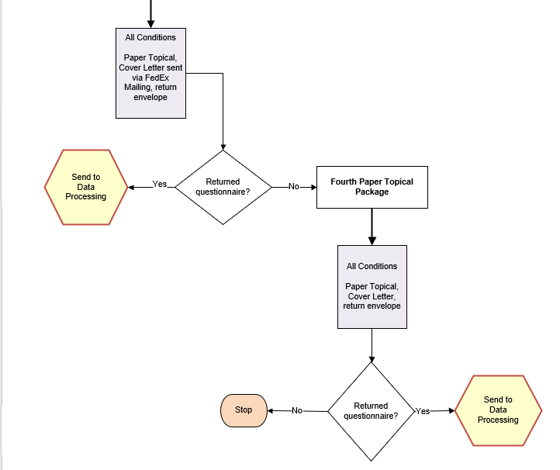

Figure 3: Topical Mail Out Data Collection Plan–Continued
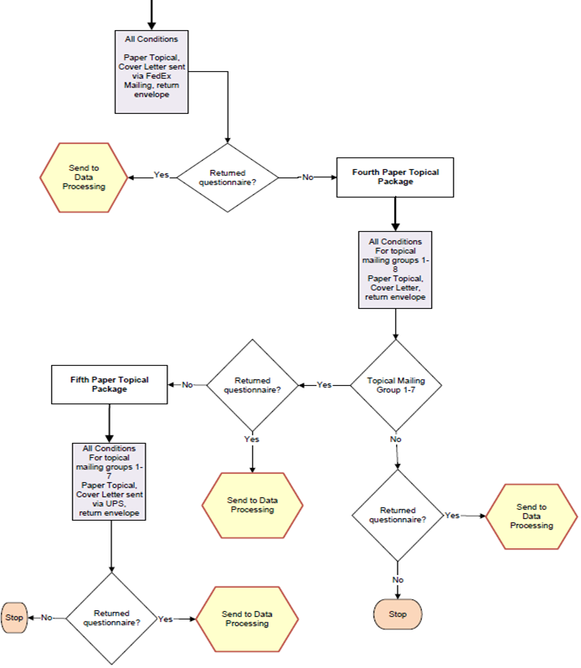

B.3 Methods for Maximizing Response Rates
Engaging Respondent Interest and Cooperation. The content of respondent letters and FAQs is focused on communicating the legitimacy and importance of the study. Experience has shown that the NHES child survey topics are salient to most parents. In NHES:2012, Census Bureau “branding” was experimentally tested against Department of Education branding. Response rates to Census Bureau branded questionnaires were higher compared to Department of Education branded questionnaires and was used in the NHES:2016 and NHES:2019 collections. NHES:2023 will continue to use Census Bureau-branded materials in the data collection for all except the final, fifth topical mailing which will also have Department of Education branding.

B.5 Individuals Responsible for Study Design and Performance
The following government staff participated in the study design and are responsible for the collection and analysis of the NHES:2023 data: Sarah Grady¹⁵, Lisa Hudson, Michelle McNamara and Andrew Zukerberg of the National Center for Education Statistics (NCES, U.S. Department of Education), and Shawna Cox and Christina Cox of the Census Bureau (U. S. Department of Commerce).

Changes to Appendix 1 (pp. 103-106)

Fifth ECPP and PFI topical package letters
A fifth (and final) mailing will be sent to both ECPP-eligible and PFI-eligible households that received their first mailing before June 1, 2023, This fifth package will be sent via UPS delivery.

Mail-based screener respondents with an ECPP-eligible or PFI-eligible child who received their first mailing by June 1, 2023 and had not responded to the first, second, third or fourth topical mailings will receive a fifth topical mailing. For the fifth ECPP/PFI mailing, mail screener respondents who used the English form will receive NHES-25L, and screener respondents who used the Spanish form will receive NHES-25LS.

Fifth topical mail package reminder letter (ECPP/PFI) NHES-25L
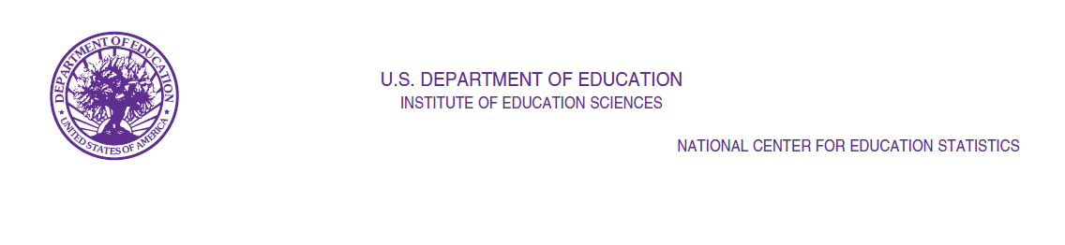
NHES-25L
(05-2023)

Dear Parent/Guardian of [CHILD]:

Thank you for your response to the National Household Education Survey earlier this year.

Understanding the experiences of our nation’s children benefits families by helping to answer vital questions about children’s early learning experiences and schooling. This information helps to inform policies at national, state, and local levels. Please take this chance to make your voice heard about your child’s experiences.

That is why I am reaching out to you today to complete this important survey. You may have received letters from the Census Bureau about responding to this final stage of the study. Now I am reaching out to ask you to please complete the enclosed survey immediately and return it in the postage-paid envelope provided to you.

When completing the survey, please answer about:

[CHILD]

Thank you in advance for your continued participation. It should only take you about 20 minutes to complete this survey.

Sincerely,

Chris Chapman
Associate Commissioner

National Center for Education Statistics
U.S. Department of Education
Enclosure

Authorization and Confidentiality of Information

The National Center for Education Statistics (NCES), within the U.S. Department of Education, is authorized to conduct the National Household Education Survey (NHES) by the Education Sciences Reform Act of 2002 (ESRA 2002, 20 U.S.C. §9543). The U.S. Census Bureau is administering this voluntary survey on behalf of NCES. There are no penalties should you choose not to participate in this study. All of the information you provide may be used only for statistical purposes and may not be disclosed, or used, in identifiable form for any other purpose except as required by law (20 U.S.C. §9573 and 6 U.S.C. §151).
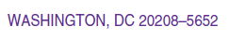

Spanish Fifth topical mail package reminder letter (ECPP/PFI) NHES-25LS

NHES-25LS
(05-2023)

Estimado(a) Padre/Madre/Tutor(a) Legal de [CHILD]:

Gracias por las respuestas que nos proporcionó en la Encuesta Nacional en Hogares sobre Educación hace unos meses.

Entender las experiencias de los niños en nuestra nación beneficia a las familias, al ayudarles a entender cuestiones vitales sobre las experiencias de aprendizaje temprano y enseñanza de los niños. Esta información ayuda a informar políticas a nivel local, estatal y nacional. Por favor aproveche esta oportunidad para que se escuche su voz acerca de las experiencias de su niño(a).

Es por esto que le escribo hoy para completar esta importante encuesta. Puede que haya recibido otras cartas de la Oficina del Censo acerca de responder a este paso final del estudio. Ahora me pongo en contacto con usted para pedirle que por favor complete la encuesta adjunta de inmediato, y la devuelva en el sobre con franque pagado que se le ha proporcionado.

Cuando complete esta encuesta, por favor responda sobre:

[CHILD]

Le agradecemos de antemano por su continua participación. Completar la encuesta debería tomar solo unos 20 minutos.

Atentamente

Chris Chapman
Comisionada Asociada

Centro Nacional de Estadísticas de Educación
Departamento de Educación de los E.E. U.U. Documento Adjunto

Aviso sobre la autorización y la confidencialidad de la información

El Centro Nacional de Estadísticas de Educación (NCES, por sus siglas en inglés), del Departamento de Educación, está autorizado a realizar este estudio por la Ley de Reforma de las Ciencias Educativas del 2002 (ESRA 2002; Título 20 del Código de los EE. UU., Sección 9543). La Oficina del Censo de los EE. UU. administra esta encuesta voluntaria en nombre del NCES. No hay sanciones si usted decide no participar en este estudio. Toda la información que brinde puede ser utilizada solo con fines estadísticos y no puede divulgarse ni usarse en forma identificable para ningún otro fin, excepto cuando lo exija la ley (Título 20 del Código de los EE. UU., Sección 9543 y Título 6 del Código de los EE. UU., Sección 151).

Changes to Appendix 4

Design, Recruitment, and Data Collection

Recruitment
Participants scheduled for a debriefing interview will be emailed the Informed Consent document (Attachment 4-A). Schedule participants who were contacted by phone first will be asked to confirm that they received their informed consent document during the scheduling conversation. All scheduled participants will be asked if they consent to receive reminders about their scheduled interview via text, and, if so, to provide a text-capable phone number. Copies of the phone, email, and text recruitment materials, along with the Informed Consent document, are included in Attachment 4-A of this appendix. In addition to these materials, Attachment 4-A includes a frequently asked questions (FAQ) document that was developed for both the recruiters and interviewers, to assist them in answering any questions the participant may have during scheduling or the interview.

Recruitment Contact Materials
The following are the recruitment contact materials that will be used to schedule participants who indicated that they were interested in the debriefing study via the recruitment items in the NHES:2023 PFI web instrument.

Recruitment Email – First Contact

English
Subject: Make your voice heard - Study for the U.S. Department of Education
Dear <Title First Name> <Last Name>:
Recently, you completed the National Household Education Survey, an online survey conducted by the Census Bureau for the U.S. Department of Education.
In that survey, you indicated that you may be interested in contributing to a follow up study in which you will have the opportunity to share more about your child’s unique virtual educational experiences and how those may have affected your survey responses. We hope to have a member of our team interview you about your experiences and survey responses.
At a time convenient to you, we would like to conduct a Zoom interview lasting 60 minutes or less in which you will have the opportunity to elaborate on your responses and share additional details that may not have been captured in the original survey.
We are offering you a Our goal with this interview is to better understand your child’s educational experiences, and how those experiences may have affected your responses on the survey. The interview will be conducted on Zoom at a time convenient for you and will last no more than 60 minutes. In appreciation of your participation, we offer a $40 cash incentive that will be mailed to you at the conclusion of your interview as a thank you for your participation.
Your input is essential to improving our understanding of the choices that students and parents make regarding education in the U.S.
If you are still interested in contributing to this effort or have any further questions participating in this interview or have any questions, please contact me at <<recruiter email>> or <<phone number>>.
Thank you for your time and support.

Sincerely,

<Recruiter Name>
American Institutes for Research
The U.S. Office of Management and Budget has approved this data collection under OMB #1850-0768. Your participation in this study is entirely voluntary. The data provided may be used only for statistical purposes and may not be disclosed, or used, in identifiable form for any other purpose except as required by law (20 U.S. Code, Section 9573). Reports of the findings from the study will not identify you individually. Individual responses will be combined with those from other participants to produce summary statistics and reports.

Spanish
Subject: Alce su voz - Estudio para el Departamento de Educación de EE. UU.
Estimado(a) <TitleFirst Name> <Last Name>:
Recientemente, usted completó una encuestaNHES la Encuesta Nacional en Hogares sobre Educación online realizada por la Oficina del Censo de los EE. UU. para el Departamento de Educación.
En esta encuesta, usted indicó que estaría interesado(a) en participar con nosotros en una entrevista acerca de la encuesta. un estudio de seguimiento en donde tendrá la oportunidad de compartir más acerca de las experiencias únicas de su hijo(a) en su educación virtual y como las mismas pudieron afectar sus respuestas en la encuesta. Esperamos que un miembro de nuestro equipo le entreviste acerca de sus experiencias y respuestas a la encuesta.
Cuando le venga bien a usted, nos gustaría realizar una Nuestro objetivo con esta entrevista es entender mejor las experiencias de educación de su niño(a), y en qué manera esas experiencias pueden haber afectado sus respuestas a la encuesta. Esta entrevista se realizará a través de Zoom cuando le venga bien a usted que no y no durará más de 60 minutos en la que tendrá la oportunidad de elaborar más acerca de sus respuestas y compartir detalles adicionales los cuales que no fueron capturados en la encuesta original.
Estamos ofreciéndole Como muestra de agradecimiento. Le ofrecemos recibirá un $40 en efectivo como muestra de nuestro agradecimiento como incentivo que le enviaremos por correo postal después de finalizar su entrevista. como muestra de nuestro agradecimiento.
Su contribución es esencial para mejorar nuestro entendimiento acerca de las decisiones que toman los estudiantes y padres de familia acera de la educación en los EE.UU.
Si sigue interesado(a) en contribuir a este esfuerzo o tiene alguna pregunta, por favor póngase en contacto conmigo al <<recruiter email>> o en el <<phone number>>.
Si todavía está interesado(a) en participar en esta entrevista o tiene alguna pregunta, por favor póngase en contacto conmigo al <<recruiter email>> o en el <<phone number>>.
Muchas gracias por su tiempo y apoyo.
Sinceramente,
<Recruiter Name>
American Institutes for Research
La Oficina de Administración y Presupuesto de los EE. UU. ha aprobado esta recolección de datos bajo el número de OMB #1850-0768. Su participación en este estudio es completamente voluntaria. Toda la información que proporcione puede ser utilizada solo con fines estadísticos y no puede divulgarse ni usarse de forma identificable para ningún otro fin, excepto cuando lo exija la ley (Título 20 del Código de los EE. UU., Sección 9573). Informes con los resultados del estudio no le identificarán de manera individual. Las respuestas individuales se combinarán con las de otros participantes para generar estadísticas resumidas e informes.

Recruitment Email – 2nd attempt and 3rd attempt

English
Subject: Reminder – Tell us more about your child’s educational experiences Follow-up for a study for the U.S. Department of Education
Dear <TitleFirst Name> <Last Name>:
Recently, we sent you an email following up on your interest in participating in a regarding your participation in a web-based research interview for the National Center for Education Statistics (NCES), within the U.S. Department of Education. You had initially indicated to us that you would be interested in sharing more when you completed the National Household Education Survey online.
You indicated your interest in the interview when you completed the online education survey for NCES. The interview would be conducted on Zoom at a time convenient for you and would last no more than 60 minutes or less. In this time, you will have the opportunity to share more details about your child’s educational experiences and how those experiences are reflected in your survey responses. Our goal with this follow-up study is to better understand your child’s educational experiences, and how those experiences are reflected in the survey.
To thank you for your participation, we offer a $40 cash incentive that will be mailed to you at the conclusion of your interview.
If you are still interested in participating in this interview or have would still like to contribute to this effort of have any questions, please contact me at <<recruiter email>> or <<phone number>>.

Thank you for your time and support.

Sincerely,

<Recruiter Name>
American Institutes for Research
Full address, work phone, email, logo
The U.S. Office of Management and Budget has approved this data collection under OMB #1850-0768. Your participation in this study is entirely voluntary. The data provided may be used only for statistical purposes and may not be disclosed, or used, in identifiable form for any other purpose except as required by law (20 U.S. Code, Section 9573). Reports of the findings from the study will not identify you individually. Individual responses will be combined with those from other participants to produce summary statistics and reports.

Spanish
Subject: Seguimiento de un estudio para el Departamento de Educación de los EE. UU. Recordatorio: Cuéntenos más acerca de la educación de su hijo
Estimado(a) <Title First Name> <Last Name>:
Recientemente le enviamos un correo electrónico en referencia a su interés en participar en una entrevista online para el Centro Nacional de Estadísticas de Educación (NCES, por sus siglas en inglés), dentro del Departamento de Educación de los EE. UU. Usted indicó interés en una entrevista para compartir más información cuando completó la encuesta Nacional en Hogares sobre Educación.
Esta entrevista se realizará a través de Zoom cuando le venga bien a usted y no durará más de 60 minutos o menos. Durante este tiempo, tendrá la oportunidad de compartir más detalles acerca de las experiencias educativas de su hijo(a) y como se reflejan en sus respuestas a la encuesta. Nuestro objetivo con esta entrevista es entender mejor las experiencias de educación de su niño(a), y en qué manera esas experiencias se reflejan en la encuesta.
Como muestra de agradecimiento, recibirá un$40 en efectivo como incentivo que le enviaremos por correo después de finalizar su entrevista.
Si todavía está interesado(a)quisiera contribuir a este esfuerzo en participar en esta entrevista o tiene alguna pregunta, por favor póngase en contacto conmigo al <<recruiter email>> o en el <<phone number>>.
Muchas gracias por su tiempo y apoyo.
Sinceramente,

<Recruiter Name>
American Institutes for Research
Full address, work phone, email, logo
La Oficina de Administración y Presupuesto ha aprobado esta colección de datos bajo OMB#1850-0768. Su participación en este estudio es completamente voluntaria. Los datos proveidos serán utilizados solamente para propósitos estadísticos y no podrán ser compartidos o utilizados de una forma identificable o para otros propósitos como requerido por la ley (20 U.S. Code, Section 9573). Los reportes de los resultados del estudio no identificaran a los participantes. Las respuestas individuales serán combinados con los de los demás participantes para elaborar los reportes y resúmenes estadísticos.

Recruitment Phone Script (all call attempts)

English
Hello, my name is <Interviewer name>. I am a researcher with ([American Institutes for Research]/[Activate Research]). May I please speak to <<Respondent’s First and Last Name>>?
[If not respondent, say] Is <<Respondent’s First and Last Name>> available? [If not available, say that you are following up on a survey for the National Center for Education Statistics. Leave your name and number and ask that they return your call at their earliest convenience.]
[If respondent, say] Recently, you participated in an online survey conducted by the Census Bureau for the U.S. Department of Education. I am part of a team that is conducting follow-up research to better understand children’s educational experiences and how well the survey captures those experiences. You indicated that you may be interested in our follow-up study. You would receive $40 as a token of our appreciation. Would you be willing to participate in an online interview? It would be conducted on Zoom at a time convenient for you and would last no more than 60 minutes. You would receive $40 as a token of our appreciation.
[If no, say] I understand. Thank you very much for your time. [Terminate call.]
[If yes, say] Thank you very much. I appreciate it. What days and times would be most convenient for you? [Use the confidential online tracker to record the time and date of the interview.] Great. I have you scheduled for <<date and time>>. <<<AIR/Activate staff name>> will be your interviewer. We will send a calendar invitation with the Zoom link to you now. I will also send a few documents that will give you more information about the interview. May I have an email address? [Use the confidential online tracker to record the email.]
[For respondents that we have only contacted via phone] I’m sending the calendar invite, and it may take me a bit of time to organize that. Please be patient. I’ve sent the calendar invite. Do you see it in your email inbox?
I would also like to set up a time to do a quick tech check to troubleshoot any issues with Zoom. This check should take no more than 10 minutes. When would be a convenient time for you? [Use the confidential online tracker to record time and date]
To help you remember the times when we’ve agreed to meet, we would like to be able to text you to remind you about your interview. We would text you a couple of times as a reminder before your appointment. Text charges from your phone carrier may apply. May I have a phone number where you can accept text messages? [Use the confidential online tracker to record the phone number.]
Thank you so much. I will send the calendar invitation out shortly. We look forward to speaking with you on <<date and time of tech check>>.

Spanish
Hola, mi nombre es <Interviewer name>. Trabajo para ([American Institutes for Research]/[Activate Research]). ¿Podría hablar con <<Respondent’s First and Last Name>>?
[If not respondent, say] ¿Está <<Respondent’s First and Last Name>> disponible? [If not available, say that you are following up on a survey for the National Center for Education Statistics. Leave your name and number and ask that they return your call at their earliest convenience.]
[If respondent, say] Recientemente, usted participó en una encuesta online realizada por la Oficina del Censo de los EE. UU. para el Departamento de Educación. Soy parte del equipo que está realizando el seguimiento para entender mejor las experiencias de educación de los niños y qué tan bien las captura la encuesta. Recibiría $40 como muestra de nuestro agradecimiento.
¿Estaría dispuesto(a) a participar en una entrevista online? Se realizaría a través de Zoom cuando le venga bien a usted y no duraría más de 60 minutos. Recibiría $40 como muestra de nuestro agrademiento.
[If no, say] Lo entiendo. Muchas gracias por su tiempo. [Terminate call.]
[If sí, say] Muchísimas gracias. ¿Qué días y horas serían más convenientes para usted? [Use the confidential online tracker to record the time and date of the interview.] Estupendo. Le he apuntado para <<date and time>>. <<<AIR/Activate staff name>> será su entrevistador(a). Le enviaremos una invitación electrónica con el link de Zoom ahora [ahorita]. También le enviaré unos documentos con más información sobre la entrevista. ¿Podría darme una dirección de correo electrónico? [Use the confidential online tracker to record the email.]
[For respondents that we have only contacted via phone] Voy a enviarle la invitación ahorita, por favor tenga paciencia conmigo mientras la organizo. Le envié la invitación a su correo. ¿Lo puede ver en su bandeja de entrada?
También quisiera programar una llamada para hacer un chequeo rápido de su conexión y comprobar que puede conectarse a Zoom. Esta llamada no llevará más de 10 minutos. ¿Cuándo le vendría bien? [Use the confidential online tracker to record time and date]
Para ayudarle recordar las horas que hemos acordado, me gustaría poder enviarle un mensaje de texto como recordatorio de su entrevista. Nos gustaría textearle un par de veces para recordarle de su cita, y cargos de mensajes de su compañía telefónica pueden aplicar. ¿Podría darme un número de teléfono donde puede aceptar mensajes? [Use the confidential online tracker to record the pone number.]

Muchas gracias. Le enviaré la invitación enseguida. Esperamos hablar con usted el <<date and time of tech check>>.

Recruitment Voicemail (all call attempts)

English
Hello, my name is <Interviewer name>. I am a researcher with ([American Institutes for Research]/[Activate Research]). I am trying to reach <<Respondent’s First and Last Name>> to follow-up on an online survey conducted by the Census Bureau for the U.S. Department of Education. In that survey, <<Respondent’s First Name>> indicated interest in participating in a follow-up study. Please return my call at << Recruiter’s Phone Number>> at your earliest convenience. You would receive $40 as a token of our appreciation.

Spanish
Hola, mi nombre es <Interviewer name> y trabajo para ([American Institutes for Research]/[Activate Research]). Estoy intentando contactarme con <<Respondent’s First and Last Name>> como seguimiento a una encuesta online realizada por la Oficina del Censo de los EE. UU. para el Departamento de Educación. En esa encuesta, <<Respondent’s First and Last Name>> indicó interés en participar en un estudio de seguimiento. Llámeme por favor al << Recruiter’s Phone Number>> tan pronto le sea posible. Como agradecimiento, usted recibiría $40 por su participación.

Reminder Text Messages (all text attempts)
Text messages will be sent to consenting participants using RingCentral, a cloud-based communications service that lets businesses send and receive texts messages using a regular business phone number, 6 to 12 hours before their tech check and their interview appointments.

English
Hello, this is <Interviewer name>. I am a texting you to remind you that are scheduled to meet <day of the week, date and time>. I’m looking forward to speaking with you soon!

Spanish
Hola, mi nombre es <Interviewer name>. Este mensaje es para server de recordatorio que hemos programado su entrevista para el <day of the week, date and time>. Espero conversar con Ud. hoy/manana!

As of September 2021, Sarah Grady is at the U.S. Energy Information Administration. As of December 31, 2022 Lisa Hudson has retired.

