National Household Education Survey 2023 (NHES:2023)
Full-scale Data Collection

OMB# 1850-0768 v.20

Appendix 1 – Respondent Contact Materials

February 2022
revised June 2022
revised May 2023

Contents
NHES:2023 Design and mailing contact strategy 4
Authorization and Confidentiality of Information 9
Advance letters 10
Advance letter (Baseline) NHES-10L(B) 11
Bilingual Advance letter (Baseline) NHES-10LB(B) 12
Advance letter (Choice-Plus) NHES-10L(CP) 14
Bilingual Advance letter (Choice-Plus) NHES-10LB(CP) 15
Advance letter (Early Bird) NHES-10L(EB) 17
Bilingual Advance letter (Early Bird) NHES-10LB(EB) 18
Advance letter (Alternate) NHES-10L(AC) 20
Bilingual Advance letter (Alternate) NHES-10LB(AC) 21
Initial screener package letters 23
Initial screener invitation letter (Baseline) NHES-11L(B) 24
Bilingual Initial screener invitation letter (Baseline) NHES-11LB(B) 25
Initial screener invitation letter (Choice-Plus) NHES-11L(CP) 27
Bilingual Initial screener invitation letter (Choice-Plus) NHES-11LB(CP) 28
Initial screener invitation letter (Early Bird) NHES-11L(EB) 30
Bilingual Initial screener invitation letter (Early Bird) NHES-11LB(EB) 31
Initial screener invitation letter (Alternate) NHES-11L(AC) 33
Bilingual Initial screener invitation letter (Alternate) NHES-11LB(AC) 34
Screener pressure-sealed envelope 36
Screener pressure-sealed mailer (Baseline) 0939-12P(B) 37
Bilingual Screener pressure-sealed mailer (Baseline) 0939-12PB(B) 38
Screener pressure-sealed mailer (Choice-Plus) 0939-12P(CP) 39
Bilingual Screener pressure-sealed mailer (Choice-Plus) 0939-12PB(CP) 40
Screener pressure-sealed mailer (Early Bird) 0939-12P(EB) 41
Bilingual Screener pressure-sealed mailer (Early Bird) 0939-12PB(EB) 42
Screener pressure-sealed mailer (Alternate) 0939-12P(AC) 43
Bilingual Screener pressure-sealed mailer (Alternate) 0939-12PB(AC) 44
First screener reminder calls 45
Pre-FedEx mailing reminder call all except alternate contact (baseline) 45
Pre-FedEx mailing reminder call alternate contact 45
Second screener package letters 46
Second screener mail package reminder letter (Baseline) NHES-12L(B) 47
Bilingual Second screener mail package reminder letter (Baseline) NHES-12LB(B) 48
Second screener mail package reminder letter (Choice-Plus) NHES-12L(CP) 50
Bilingual Second screener mail package reminder letter (Choice-Plus) NHES-12LB(CP) 51
Second screener mail package reminder letter (Early Bird) NHES-12L(EB) 53
Bilingual Second screener mail package reminder letter (Early Bird) NHES-12LB(EB) 54
Second screener mail package reminder letter (Alternate) NHES-12L(AC) 56
Bilingual Second screener mail package reminder letter (Alternate) NHES-12LB(AC) 57
Third screener package letters 59
Third screener mail package reminder letter (Baseline) NHES-13L(B) 60
Bilingual Third screener mail package reminder letter (Baseline) NHES-13LB(B) 61
Third screener mail package reminder letter (Choice-Plus) NHES-13L(CP) 63
Bilingual Third screener mail package reminder letter (Choice-Plus) NHES-13LB(CP) 64
Third screener mail package reminder letter (Alternate) NHES-13L(AC) 66
Bilingual Third screener mail package reminder letter (Alternate) NHES-13LB(AC) 67
Fourth screener package letters 69
Fourth screener mail package reminder letter (Baseline) NHES-14L(B) 70
Bilingual Fourth screener mail package reminder letter (Baseline) NHES-14LB(B) 71
Fourth screener mail package reminder letter (Choice-Plus) NHES-14L(CP) 73
Bilingual Fourth screener mail package reminder letter (Choice-Plus) NHES-14LB(CP) 74
Fourth screener mail package reminder letter (Alternate) NHES-14L(AC) 76
Bilingual Fourth screener mail package reminder letter (Alternate) NHES-14LB(AC) 77
Second screener reminder calls 79
Pre-Fifth mailing reminder call all except alternate contact (baseline) 79
Pre-Fifth mailing reminder call alternate contact 79
Fifth screener mailing postcards 80
Bilingual Fifth screener mail package reminder letter (Baseline/Choice-Plus/Early Bird) NHES-15PB(B) 81
Bilingual Fifth screener mail package reminder letter (Alternate) NHES-15PB(AC) 83
Promised incentive letter 85
Bilingual Promised Incentive Letter NHES-90LB 86
Initial ECPP topical package letters 88
First ECPP mail package letter NHES-21L 89
Spanish First ECPP mail package letter NHES-21LS 90
Topical ECPP and PFI reminder postcards 91
Topical reminder card (ECPP/PFI) 0939-22P 92
Spanish Topical reminder card (ECPP/PFI) 0939-22PS 93
Second ECPP topical package letters 94
Second ECPP mail package reminder letter NHES-22L 95
Spanish Second ECPP mail package reminder letter NHES-22LS 96
ECPP reminder call and third topical package letters 97
Reminder topical call (ECPP) 97
Third ECPP mail package reminder letter NHES-23L 98
Spanish Third ECPP mail package reminder letter NHES-23LS 99
Fourth ECPP and PFI topical package letters 100
Fourth topical mail package reminder letter (ECPP/PFI) NHES-24L 101
Spanish Fourth topical mail package reminder letter (ECPP/PFI) NHES-24LS 102
Initial PFI topical package letters 103
First PFI mail package letter NHES-31L 104
Spanish First PFI mail package letter NHES-31LS 105
Second PFI topical package letters 106
Second PFI mail package reminder letter NHES-32L 107
Spanish Second PFI mail package reminder letter NHES-32LS 108
PFI reminder call and third PFI topical package letters 109
Reminder topical call (PFI) 109
Third PFI mail package reminder letter NHES-33L 110
Spanish Third PFI mail package reminder letter NHES-33LS 111
Frequently asked questions 112
Bilingual Screener Commonly Asked Questions – Paper Questionnaire Mailings 113
Bilingual Screener Commonly Asked Questions – Web Mode Paper Insert 115
Cash Insert 117
Bilingual Cash Insert 118
Telephone Questionnaire Assistance Phone script 119
Website content 120
NHES:2023 Web Survey Instrument Text 126
Item: Log In Page (login) 127
Item: PIN Page - returning (pin returning) 130
Item: PIN Page - verification (pin verification) 131
Item: PIN Reset and Recovery (recovery) 133
Item: New PIN Page (newpin) 135
Item: Welcome back (welcome_back) 136
Item: Accessibility Screen (accessibility) 137
Item: Security Screen (security) 138
Instructions 139
FAQs Tab 140
Screener Roster questions: 143
Multiple question items on 1 page example: 145
Grid example: 146
Select all that apply example: 147
Completed survey screen: 148
Timeout Warning: 149
Save and Continue later screen: 150

NHES:2023 Design and mailing contact strategy
The exhibits in this section briefly describe the NHES:2023 data collection design and the respondent contact strategy through mailings and phone calls. Exhibit 1 describes the strategy for the screener data collection and exhibit 2 describes the topical strategy.

Exhibit 1. Overview of NHES:2023 screener design, by experimental condition – continued
 | Baseline Condition | Targeted Choice-Plus Condition | Early Bird Incentive Condition | Alternate Materials Condition | Targeted Renter Mailings Condition¹
Summary | Makes further updates to NHES:2019 “updated sequential mixed-mode” (MM) design based on lessons learned in 2019; will also be used as a control condition | Tests use of choice-plus protocol for lower-RP cases | Tests promised incentive offer for response to the first two screener packages¹ | Tests materials that are more explicit about how the survey request differs for households with and without children | Tests alternate addressee line and salutation among renter households
Sampling | 53,000 cases  Random assignment to condition | 89,500 cases  - 51,250 lower-RP  - 38,250 higher-RP  Random assignment to condition | 53,000 cases  Random assignment to condition | 9,500 cases  Random assignment to condition | For analysis: 26,500 cases in baseline condition  - 5,800 renters  - 20,700 non-renters  Random assignment to condition  [For operations: 102,500 cases, fully crossed with other experiments]
Mailing protocol | Web-push | Different protocol for lower- and higher-RP cohorts:  - Lower-RP: choice-plus  - Higher-RP: web-push (same as baseline condition) | Web-push (same as baseline condition, with addition of promised incentive mailing) | Web-push (same as baseline condition) | Web-push (same as baseline condition)
Wording of contact materials | All mailings use “Baseline” materials  Same contact material wording for all cases in this condition | Different wording for lower- and higher-RP cohorts:  - Lower-RP: Nearly all contacts use “Choice” materials² (reminder calls and fifth mailing use baseline materials)  - Higher-RP: Baseline materials | Early mailings use “Early bird” materials³  Reminder calls and late mailings use Baseline materials  Same contact material wording for all cases in this condition | All mailings use “Alternate” materials⁴  Same contact material wording for all cases in this condition | Different addressee line and salutation for renters and non-renters:  - Renters: Baseline materials (except for addressee line/ salutation)  - Non-renters: Baseline materials
See notes at end of exhibit.
Exhibit 1. Overview of NHES:2023 screener design, by experimental condition – continued
 | Baseline Condition | Targeted Choice-Plus Condition | Early Bird Incentive Condition | Alternate Materials Condition | Targeted Renter Mailings Condition
Advance mailing | Baseline advance letter in letter-size envelope (NHES-10L(B); NHES-10LB(B)) | Lower-RP cohort: Choice advance letter in letter-size envelope (NHES-10L(CP), NHES-10LB(CP)) | Early-bird advance letter in letter-size envelope (NHES-10L(EB), NHES-10LB(EB)) | Alternate advance letter in letter-size envelope (NHES-10L(AC), NHES-10LB(AC)) | Renters: Baseline advance letter with tailoring in letter-size envelope (NHES-10L(B); NHES-10LB(B))
Advance mailing |  | Higher-RP cohort: Baseline advance letter in letter-size envelope(NHES-10L(B); NHES-10LB(B)) |  |  | Non-renters: Baseline advance letter in letter-size envelope (NHES-10L(B); NHES-10LB(B))
Initial screener package | Baseline web letter with $5 loose in letter-size envelope (NHES-11L(B), NHES-11LB(B)) | Lower-RP cohort: Choice letter, paper screener, and return envelope, with $5 adhered to card stock in full-size envelope (NHES-11L(CP), NHES-11LB(CP)) | Early-bird web letter with $5 loose in letter-size envelope (NHES-11L(EB), NHES-11LB(EB)) | Alternate web letter with $5 loose in letter-size envelope (NHES-11L(AC), NHES-11LB(AC)) | Renters: Baseline web letter with tailoring and $5 loose in letter-size envelope (NHES-11L(B), NHES-11LB(B))
Initial screener package |  | Higher-RP cohort:  Baseline web letter with $5 loose in letter-size envelope (NHES-11L(B), NHES-11LB(B)) |  |  | Non-renters: Baseline web letter with $5 loose in letter-size envelope (NHES-11L(B), NHES-11LB(B))
Pressure-sealed envelope | Baseline pressure-sealed envelope (0939-12P(B), 0939-12PB(B)) | Lower-RP cohort: Choice pressure-sealed envelope (0939-12P(CP), 0939-12PB(CP)) | Early-bird pressure-sealed envelope (0939-12P(EB), 0939-12PB(EB)) | Alternate pressure-sealed envelope (0939-12P(AC), 0939-12PB(AC)) | Renters: Baseline pressure-sealed envelope with tailoring (0939-12P(B), 0939-12PB(B))
Pressure-sealed envelope |  | Higher-RP cohort: Baseline pressure-sealed envelope (0939-12P(B), 0939-12PB(B)) |  |  | Non-renters: Baseline pressure-sealed envelope (0939-12P(B), 0939-12PB(B))
Second screener package | Baseline web letter in FedEx envelope (NHES12-L(B), NHES12-LB(B)) | Lower-RP cohort: Choice letter, paper screener, and return envelope in full-size envelope⁶ (NHES12-L(CP), NHES12-LB(CP)) | Early-bird web letter in FedEx envelope (NHES12-L(EB), NHES12-LB(EB)) | Alternate web letter in FedEx envelope (NHES12-L(AC), NHES12-LB(AC)) | Renters: Baseline web letter with tailoring in FedEx envelope (NHES12-L(B), NHES12-LB(B))
Second screener package |  | Higher-RP cohort: Baseline web letter in FedEx envelope (NHES12-L(B), NHES12-LB(B)) |  |  | Non-renters: Baseline web letter in FedEx envelope (NHES12-L(B), NHES12-LB(B))
First screener reminder call⁵ | Baseline autocall | Lower-RP cohort: Baseline autocall (at third screener package) | Baseline autocall | Alternate autocall | Baseline autocall
First screener reminder call⁵ | Baseline autocall | Higher-RP cohort: Baseline autocall (at second screener package) | Baseline autocall | Alternate autocall | Baseline autocall
See notes at end of exhibit.
Exhibit 1. Overview of NHES:2023 screener design, by experimental condition – continued
 | Baseline Condition | Targeted Choice-Plus Condition | Early Bird Incentive Condition | Alternate Materials Condition | Targeted Renter Mailings Condition
Third screener package | Baseline letter, paper screener, and return envelope in full-size envelope (NHES-13L(B), NHES-13LB(B)) | Lower-RP cohort: Choice letter, paper screener, and return envelope in FedEx envelope⁶ (NHES-13L(CP), NHES-13LB(CP)) | Baseline letter, paper screener, and return envelope in full-size envelope (NHES-13L(B), NHES-13LB(B)) | Alternate letter, alternate paper screener, and return envelope in full-size envelope (NHES-13L(AC), NHES-13LB(AC)) | Renters: Baseline letter with tailoring, paper screener, and return envelope in full-size envelope (NHES-13L(B), NHES-13LB(B))
Third screener package |  | Higher-RP cohort: Baseline letter, paper screener, and return envelope in full-size envelope (NHES-13L(B), NHES-13LB(B)) |  |  | Non-renters: Baseline letter, paper screener, and return envelope in full-size envelope (NHES-13L(B), NHES-13LB(B))
Fourth screener package | Baseline letter, paper screener, and return envelope in full-size envelope (NHES-14L(B), NHES-14LB(B)) | Lower-RP cohort: Choice letter, paper screener, and return envelope in full-size envelope (NHES14-L(CP), NHES14-LB(CP)) | Baseline letter, paper screener, and return envelope in full-size envelope (NHES-14L(B), NHES-14LB(B)) | Alternate letter, alternate paper screener, and return envelope in full-size envelope (NHES-14L(AC), NHES-14LB(AC)) | Renters: Baseline letter with tailoring, paper screener, and return envelope in full-size envelope (NHES-14L(B), NHES-14LB(B))
Fourth screener package |  | Higher-RP cohort: Baseline letter, paper screener, and return envelope in full-size envelope (NHES-14L(B), NHES-14LB(B)) |  |  | Non-renters: Baseline letter, paper screener, and return envelope in full-size envelope (NHES-14L(B), NHES-14LB(B))
Fifth screener mailing | Baseline reminder large (8.5” x 5.5”) postcard with web login credentials and QR code in large postcard-size envelope; designed to allow sample members to prop postcard in keyboard while typing in the URL and web login information. (NHES-15PB(B)) | Baseline reminder large postcard in large postcard-size envelope with web login credentials. (NHES-15PB(B)) | Baseline reminder large postcard with web login credentials in large postcard-size envelope. (NHES-15PB(B)) | Alternate reminder large postcard with return envelope in large postcard-size envelope. (NHES-15PB(A)) | Renters: Baseline reminder large postcard with tailoring and web login credentials in large postcard-size envelope. (NHES-15PB(B))
 |  |  |  |  | Non-renters: Baseline reminder large postcard with web login credentials in large postcard-size envelope. (NHES-15PB(B))
Second screener reminder call⁷ | Baseline autocall | Baseline autocall | Baseline autocall | Alternate autocall | Baseline autocall
Promised incentive mailing⁸ | N/A | Lower-RP cohort: Promised incentive cover letter and $20 in letter-size envelope (NHES-90LB(CP)) | Promised incentive cover letter and $20 in letter-size envelope (NHES-90LB(CP)) | N/A | N/A
Promised incentive mailing⁸ | N/A | Higher-RP cohort: N/A |  | N/A | N/A
Note: if a mailing method is not specified (ex: FedEx), it can be assumed that the mailing will be a regular First Class mailing.
¹ The targeted renter materials experiment will be fully crossed with all other NHES:2023 experiments—that is, half of all sample members in each condition will be assigned to the targeted renters materials condition. For the purposes of this table, we focus on the implementation of this experiment within the baseline condition, since that is the primary condition of interest for assessing the success of the experiment. However, for the purposes of data collection, the same logic would apply for all other conditions—that is, renters would receive materials “with tailoring” and non-renters would receive the standard materials for that condition. The “tailoring” will consist of docuprinting an alternate addressee line and salutation onto the materials. Other than this, the mailings will be identical to those sent to non-renters in that condition.
² The “choice” materials will offer web, paper, and inbound phone response options, as well as noting that the sample member will receive $20 for completing the survey by web or inbound telephone.
³ The “early bird” materials will note that the sample member will receive $20 for completing the survey by a specified date. The early mailings are the advance letter, initial screener package, pressure-sealed envelope, and second screener package. The late mailings are the third, fourth, and fifth screener packages.
⁴ The “alternate” materials will be more explicit about how the purpose of the survey differs for households with children and households without children. The fifth mailing will consist of a postcard that includes the screener gate item that sample members will be asked to mail back with their response (it will not include web login credentials)
⁵ In most cases, the first reminder call should occur concurrently with the mailing date for the second screener package. However, for choice-plus cases within the targeted choice-plus condition, it should occur concurrently with the mailing date for the third screener package.
⁶ The choice-plus protocol within the targeted choice-plus condition will use FedEx at the third screener package, as in the NHES:2019 choice-plus protocol. Using FedEx at the second screener package would further increase the cost of the choice-plus mailings. The rationale for earlier FedEx mailings within a web-push protocol (pushing more respondents to the web) does not apply to choice-plus.
⁷ The second reminder call should occur concurrently with the mailing date for the fifth screener mailing.

Exhibit 2. Overview of NHES:2023 topical design, by experimental condition
 | Baseline Condition | Early Bird Incentive Condition | Targeted Choice-Plus Condition | Alternate Materials Condition | Targeted Renter Mailings Condition¹
Types of cases getting topical mailings² | Paper screener respondents: Screener completes by paper where a child was sampled for one of the topical surveys
Initial topical package | Cover letter and paper topical with $5 adhered to cardstock (early screener Rs)/$15 (late screener Rs) in full-size envelope (ECPP: NHES-21L, NHES-21LS; PFI: NHES-31L, NHES-31LS)
Reminder postcard | Reminder postcard (ECPP & PFI: 0939-22P, 0939-22PS)
Second topical package | Cover letter and paper topical in full-size envelope (ECPP: NHES-22L, NHES-22LS; PFI: NHES-32L, NHES-32LS)
Third topical package | FedEx mailing with cover letter and paper topical (ECPP: NHES-23L, NHES-23LS; PFI: NHES-33L, NHES-33LS)
Reminder call | Autocall concurrent with mailing date for third topical package
Fourth topical package | Cover letter and paper topical in full-size envelope (ECPP & PFI: NHES-24L, NHES-24LS)
Fifth topical package | UPS mailing with cover letter and paper topical (ECPP & PFI: NHES-25L, NHES-25LS)
¹ The tailoring used in the screener phase will continue in the topical phase.
² There will not be any variation in the topical materials by experimental condition, other than continuing the screener-phase renter tailoring.

Authorization and Confidentiality of Information

The following text box will appear on the back of each single language (English or Spanish) letter with the corresponding language. Bilingual letters will include this text box on the bottom of the letter with the corresponding language. For example, an English letter will have an English authorization and confidentiality text box. On all reminder postcards and pressure-sealed envelopes the authorization and confidentiality language will be on the bottom of the mailer on the side that includes the text provided in this document. Note that depending on location of the text box on each letter the font size could vary but will be readable.

English:
The National Center for Education Statistics (NCES), within the U.S. Department of Education, is authorized to conduct the National Household Education Survey (NHES) by the Education Sciences Reform Act of 2002 (ESRA 2002, 20 U.S.C. §9543). The U.S. Census Bureau is administering this voluntary survey on behalf of NCES. There are no penalties should you choose not to participate in this study. All of the information you provide may be used only for statistical purposes and may not be disclosed, or used, in identifiable form for any other purpose except as required by law (20 U.S.C. §9573 and 6 U.S.C. §151).

Spanish:
El Centro Nacional para Estadísticas de la Educación (NCES por sus siglas en inglés), dentro del Departamento de Educación, está autorizado a realizar este estudio por medio de la Reforma a la Ley de las Ciencias de la Educación del 2002 (ESRA 2002; titulo 20; sección 9543). La Oficina del Censo de Estados Unidos administra esta encuesta voluntaria en nombre de NCES. No hay sanciones si decide no participar en este estudio. Toda la información que brinde puede ser utilizada solo con fines estadísticos y no puede divulgarse ni usarse en forma identificable para ningún otro fin, excepto cuando lo exija la ley (20 U.S.C. §9573 y 6 U.S.C. §151).

Advance letters
All sampled households will receive an advance letter. Households will be sent either an English letter (NHES-10L(B), NHES-10L(CP), NHES-10L(EB), or NHES-10L(AC)) or bilingual letter (NHES-10LB(B), NHES-10LB(CP), NHES-10LB(EB), or NHES-10LB(AC)) depending on whether the household is predicted to have a Spanish speaker.

Advance letter (Baseline) NHES-10L(B)
 | 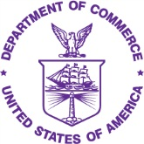 | UNITED STATES DEPARTMENT OF COMMERCE  Economics and Statistics Administration  U.S. Census Bureau  Washington, DC 20233-0001  OFFICE OF THE DIRECTOR
NHES-10L(B)
(04-2021)

Dear <Addressee Line>:
I am pleased to inform you that your household has been selected to participate in an important national survey on the education of people in the United States, the 2023 National Household Education Survey. The U.S. Census Bureau conducts this survey of households on behalf of the U.S. Department of Education every few years. We conduct it to gather information about learning activities that happen outside of schools.
What to expect next:
- In a few days you will receive an invitation in the mail from us to complete the survey.
- The survey can be completed at home by an adult in the household.
- Depending on your answers, it takes about 3 to 30 minutes to complete.
- We included $5 as a token of our appreciation for your participation. Please look for it in your next mailing from us!
If you would like more information, please visit nces.ed.gov/nhes or contact us toll-free at 1-888-840-8353.
Thank you in advance for your help with this important survey.

Sincerely,
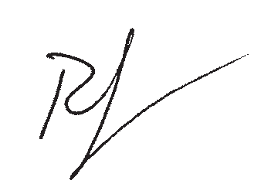

Ron S. Jarmin
Acting Director, U.S. Census Bureau

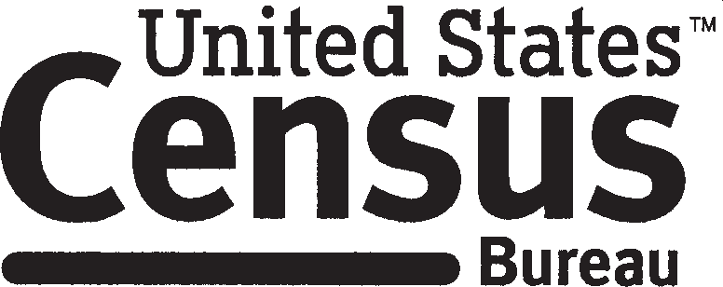 census.gov

Bilingual Advance letter (Baseline) NHES-10LB(B)
UNITED STATES DEPARTMENT OF COMMERCE
Economics and Statistics Administration
U.S. Census Bureau
Washington, DC 20233-0001
OFFICE OF THE DIRECTOR
NHES-10LB(B)
(04-2021)
<Reverse side of this letter will be in Spanish>

Dear <Addressee Line>:
I am pleased to inform you that your household has been selected to participate in an important national survey on the education of people in the United States, the 2023 National Household Education Survey. The U.S. Census Bureau conducts this survey of households on behalf of the U.S. Department of Education every few years. We conduct it to gather information about learning activities that happen outside of schools.
What to expect next:
- In a few days you will receive an invitation in the mail from us to complete the survey.
- The survey can be completed at home by an adult in the household.
- Depending on your answers, it takes about 3 to 30 minutes to complete.
- We included $5 as a token of our appreciation for your participation. Please look for it in your next mailing from us!
If you would like more information, please visit nces.ed.gov/nhes or contact us toll-free at 1-888-840-8353.
Thank you in advance for your help with this important survey.

Sincerely,

Ron S. Jarmin
Acting Director, U.S. Census Bureau
Si usted prefiere la versión en español, vea al dorso de la carta.

census.gov
Bilingual Advance letter (Baseline) NHES-10LB(B)
UNITED STATES DEPARTMENT OF COMMERCE
Economics and Statistics Administration
U.S. Census Bureau
Washington, DC 20233-0001
OFFICE OF THE DIRECTOR
NHES-10LB(B)
(03-2021)
<Reverse side of this letter will be in English>

Estimado(a) <Addressee Line>:
Me complace informarle de que su hogar ha sido seleccionado para participar en una importante encuesta nacional sobre la educación de las personas en los Estados Unidos, la Encuesta Nacional en Hogares sobre Educación del 2023. La Oficina del Censo de los EE. UU. realiza esta encuesta en nombre del Departamento de Educación de los EE. UU. cada ciertos años para recopilar información sobre las actividades de aprendizaje que se llevan a cabo fuera de las escuelas.
Qué debe esperar próximamente:
- Dentro de unos días recibirá de nuestra parte una invitación por correo postal para completar la encuesta.
- La encuesta puede ser respondida en casa por un adulto del hogar.
- Dependiendo de sus respuestas, le llevará entre 3 y 30 minutos completarla.
- Como muestra de nuestro agradecimiento, incluiremos $5 por su participación. ¡Los recibirá en nuestro próximo envío por correo!
Si desea más información, visite nces.ed.gov/nhes/ (en inglés) o comuníquese con nosotros llamando al número gratuito 1-888-840-8353.
Le agradecemos de antemano por su ayuda con esta importante encuesta.

Atentamente,

Ron S. Jarmin
Director interino, Oficina del Censo de los EE. UU.
If you prefer English, please see the letter on the other side.

census.gov

Advance letter (Choice-Plus) NHES-10L(CP)
UNITED STATES DEPARTMENT OF COMMERCE
Economics and Statistics Administration
U.S. Census Bureau
Washington, DC 20233-0001
OFFICE OF THE DIRECTOR
NHES-10L(CP)
(05-2021)

Dear <Addressee Line>:
I am pleased to inform you that your household has been selected to participate in an important national survey on the education of people in the United States, the 2023 National Household Education Survey. The U.S. Census Bureau conducts this survey of households on behalf of the U.S. Department of Education every few years. We conduct it to gather information about learning activities that happen outside of schools.
What to expect next:
- In a few days you will receive an invitation in the mail from us to complete the survey.
- The survey can be completed at home by an adult in the household.
- Depending on your answers, it takes about 3 to 30 minutes to complete.
- We included $5 as a token of our appreciation for your participation. Please look for it in your next mailing from us! Also, if you complete the survey online or by phone, we will mail you an additional $20.
If you would like more information, please visit nces.ed.gov/nhes or contact us toll-free at 1-888-840-8353.
Thank you in advance for your help with this important survey.

Sincerely,

Ron S. Jarmin
Acting Director, U.S. Census Bureau

census.gov

Bilingual Advance letter (Choice-Plus) NHES-10LB(CP)
UNITED STATES DEPARTMENT OF COMMERCE
Economics and Statistics Administration
U.S. Census Bureau
Washington, DC 20233-0001
OFFICE OF THE DIRECTOR
NHES-10LB(CP)
(05-2021)
<Reverse side of this letter will be in Spanish>

Dear <Addressee Line>:
I am pleased to inform you that your household has been selected to participate in an important national survey on the education of people in the United States, the 2023 National Household Education Survey. The U.S. Census Bureau conducts this survey of households on behalf of the U.S. Department of Education every few years. We conduct it to gather information about learning activities that happen outside of schools.
What to expect next:
- In a few days you will receive an invitation in the mail from us to complete the survey.
- The survey can be completed at home by an adult in the household.
- Depending on your answers, it takes about 3 to 30 minutes to complete.
- We included $5 as a token of our appreciation for your participation. Please look for it in your next mailing from us! Also, if you complete the survey online or by phone, we will mail you an additional $20.
If you would like more information, please visit nces.ed.gov/nhes or contact us toll-free at 1-888-840-8353.
Thank you in advance for your help with this important survey.

Sincerely,

Ron S. Jarmin
Acting Director, U.S. Census Bureau

Si usted prefiere la versión en español, vea al dorso de la carta.

census.gov

Bilingual Advance letter (Choice-Plus) NHES-10LB(CP)
UNITED STATES DEPARTMENT OF COMMERCE
Economics and Statistics Administration
U.S. Census Bureau
Washington, DC 20233-0001
OFFICE OF THE DIRECTOR
NHES-10LB(CP)
(05-2021)
<Reverse side of this letter will be in English>

Estimado(a) <Addressee Line>:
Me complace informarle que su hogar fue seleccionado para participar en una importante encuesta nacional sobre la educación de las personas en los Estados Unidos, la Encuesta Nacional en Hogares sobre Educación del 2023. La Oficina del Censo de los EE. UU., en nombre del Departamento de Educación de los EE. UU., realiza esta encuesta en los hogares cada ciertos años para recopilar información sobre las actividades de aprendizaje que se llevan a cabo fuera de las escuelas.
Qué debe esperar próximamente:
- Dentro de unos días, recibirá de nuestra parte una invitación por correo postal para completar la encuesta.
- La encuesta puede ser respondida en casa por un adulto del hogar.
- Dependiendo de cuáles sean sus respuestas, tardará entre 3 y 30 minutos en completarla.
- Como muestra de nuestro agradecimiento, incluiremos $5 por su participación. ¡Los recibirá en nuestro próximo envío por correo! Además, si completa la encuesta por internet o por teléfono, le enviaremos $20 adicionales.
Si desea recibir más información, visite nces.ed.gov/nhes/ (en inglés) o comuníquese con nosotros llamando al número gratuito 1-888-840-8353.
Le agradecemos de antemano por su ayuda con esta importante encuesta.

Atentamente,

Ron S. Jarmin
Director interino, Oficina del Censo de los EE. UU.

If you prefer English, please see the letter on the other side.

census.gov

Advance letter (Early Bird) NHES-10L(EB)
UNITED STATES DEPARTMENT OF COMMERCE
Economics and Statistics Administration
U.S. Census Bureau
Washington, DC 20233-0001
OFFICE OF THE DIRECTOR
NHES-10L(EB)
(06-2021)

Dear <Addressee Line>:
I am pleased to inform you that your household has been selected to participate in an important national survey on the education of people in the United States, the 2023 National Household Education Survey. The U.S. Census Bureau conducts this survey of households on behalf of the U.S. Department of Education every few years. We conduct it to gather information about learning activities that happen outside of schools.
What to expect next:
- In a few days you will receive an invitation in the mail from us to complete the survey.
- The survey can be completed at home by an adult in the household.
- Depending on your answers, it takes about 3 to 30 minutes to complete.
- We included $5 as a token of our appreciation for your participation. Please look for it in your next mailing from us! Also, if you complete the survey by March 13th, we will mail you an additional $20.
If you would like more information, please visit nces.ed.gov/nhes or contact us toll-free at 1-888-840-8353.
Thank you in advance for your help with this important survey.

Sincerely,

Ron S. Jarmin
Acting Director, U.S. Census Bureau
Enclosures
census.gov

Bilingual Advance letter (Early Bird) NHES-10LB(EB)
UNITED STATES DEPARTMENT OF COMMERCE
Economics and Statistics Administration
U.S. Census Bureau
Washington, DC 20233-0001
OFFICE OF THE DIRECTOR
NHES-10LB(EB)
(06-2021)
<Reverse side of this letter will be in Spanish>

Dear <Addressee Line>:
I am pleased to inform you that your household has been selected to participate in an important national survey on the education of people in the United States, the 2023 National Household Education Survey. The U.S. Census Bureau conducts this survey of households on behalf of the U.S. Department of Education every few years. We conduct it to gather information about learning activities that happen outside of schools.
What to expect next:
- In a few days you will receive an invitation in the mail from us to complete the survey.
- The survey can be completed at home by an adult in the household.
- Depending on your answers, it takes about 3 to 30 minutes to complete.
- We included $5 as a token of our appreciation for your participation. Please look for it in your next mailing from us! Also, if you complete the survey by March 13th, we will mail you an additional $20.
If you would like more information, please visit nces.ed.gov/nhes or contact us toll-free at 1-888-840-8353.
Thank you in advance for your help with this important survey.

Sincerely,

Ron S. Jarmin
Acting Director, U.S. Census Bureau
Enclosures
Si usted prefiere la versión en español, vea al dorso de la carta.
census.gov
Bilingual Advance letter (Early Bird) NHES-10LB(EB)
UNITED STATES DEPARTMENT OF COMMERCE
Economics and Statistics Administration
U.S. Census Bureau
Washington, DC 20233-0001
OFFICE OF THE DIRECTOR
NHES-10LB(EB)
(07-2021)
<Reverse side of this letter will be in English>

Estimado(a) <Addressee Line>:
Me complace informarle que su hogar fue seleccionado para participar en la Encuesta Nacional en Hogares sobre Educación del 2023, una importante encuesta nacional sobre la educación de las personas en los Estados Unidos. La Oficina del Censo de los EE. UU., en nombre del Departamento de Educación de los EE. UU., realiza esta encuesta en los hogares cada ciertos años para recopilar información sobre las actividades de aprendizaje que se llevan a cabo fuera de las escuelas.
Qué debe esperar próximamente:
- Dentro de unos días, recibirá de nuestra parte una invitación por correo postal para completar la encuesta.
- La encuesta puede ser respondida en casa por un adulto del hogar.
- Dependiendo de cuáles sean sus respuestas, tardará entre 3 y 30 minutos en completarla.
- Como muestra de nuestro agradecimiento, incluiremos $5 por su participación. ¡Los recibirá en nuestro próximo envío por correo! Además, si completa la encuesta a más tardar el 13 de marzo, le enviaremos por correo $20 adicionales.
Si desea recibir más información, visite nces.ed.gov/nhes/ (en inglés) o comuníquese con nosotros llamando al número gratuito 1-888-840-8353.
Le agradecemos de antemano por su ayuda con esta importante encuesta.

Atentamente,

Ron S. Jarmin
Director interino, Oficina del Censo de los EE. UU.
Documentos Adjuntos
If you prefer English, please see the letter on the other side.

census.gov

Advance letter (Alternate) NHES-10L(AC)
UNITED STATES DEPARTMENT OF COMMERCE
Economics and Statistics Administration
U.S. Census Bureau
Washington, DC 20233-0001
OFFICE OF THE DIRECTOR
NHES-10L(AC)
(05-2021)

Dear <Addressee Line>:
I am pleased to inform you that your household has been selected to participate in an important national survey on the education of children in the United States, the 2023 National Household Education Survey. The U.S. Census Bureau conducts this survey of households on behalf of the U.S. Department of Education every few years. We conduct it to gather information about learning activities that happen outside of schools.
What to expect next:
- In a few days you will receive an invitation in the mail from us to complete the survey.
- The survey can be completed at home by an adult in the household.
- If there are no children or youth age 20 or younger in your household, it takes about 3 minutes to complete. If there are children in your household, it will take about 30 minutes to complete because we will ask questions about one of the children in the household.
- We included $5 as a token of our appreciation for your participation. Please look for it in your next mailing from us!
If you would like more information, please visit nces.ed.gov/nhes or contact us toll-free at 1-888-840-8353.
Thank you in advance for your help with this important survey.

Sincerely,

Ron S. Jarmin
Acting Director, U.S. Census Bureau

census.gov

Bilingual Advance letter (Alternate) NHES-10LB(AC)
UNITED STATES DEPARTMENT OF COMMERCE
Economics and Statistics Administration
U.S. Census Bureau
Washington, DC 20233-0001
OFFICE OF THE DIRECTOR
NHES-10LB(AC)
(05-2021)
<Reverse side of this letter will be in Spanish>

Dear <Addressee Line>:
I am pleased to inform you that your household has been selected to participate in an important national survey on the education of children in the United States, the 2023 National Household Education Survey. The U.S. Census Bureau conducts this survey of households on behalf of the U.S. Department of Education every few years. We conduct it to gather information about learning activities that happen outside of schools.
What to expect next:
- In a few days you will receive an invitation in the mail from us to complete the survey.
- The survey can be completed at home by an adult in the household.
- If there are no children or youth age 20 or younger in your household, it takes about 3 minutes to complete. If there are children in your household, it will take about 30 minutes to complete because we will ask questions about one of the children in the household.
- We included $5 as a token of our appreciation for your participation. Please look for it in your next mailing from us!
If you would like more information, please visit nces.ed.gov/nhes or contact us toll-free at 1-888-840-8353.
Thank you in advance for your help with this important survey.

Sincerely,

Ron S. Jarmin
Acting Director, U.S. Census Bureau
Si usted prefiere la versión en español, vea al dorso de la carta.

census.gov
Bilingual Advance letter (Alternate) NHES-10LB(AC)
UNITED STATES DEPARTMENT OF COMMERCE
Economics and Statistics Administration
U.S. Census Bureau
Washington, DC 20233-0001
OFFICE OF THE DIRECTOR
NHES-10LB(AC)
(07-2021)
<Reverse side of this letter will be in English>

Estimado(a) <Addressee Line>:
Me complace informarle que su hogar fue seleccionado para participar en una importante encuesta nacional sobre la educación de los niños en los Estados Unidos, la Encuesta Nacional en Hogares sobre Educación del 2023. La Oficina del Censo de los EE. UU., en nombre del Departamento de Educación de los EE. UU., realiza esta encuesta en los hogares cada ciertos años para recopilar información sobre las actividades de aprendizaje que se llevan a cabo fuera de las escuelas.
Qué debe esperar próximamente:
- Dentro de unos días, recibirá de nuestra parte una invitación por correo postal para completar la encuesta.
- La encuesta puede ser respondida en casa por un adulto del hogar.
- Si no hay niños o jóvenes de 20 años o menos en su hogar, le llevará unos 3 minutos completarla. Si hay niños en su hogar, le llevará unos 30 minutos completarla porque le haremos preguntas acerca de uno de los niños en el hogar.
- Como muestra de nuestro agradecimiento, incluiremos $5 por su participación. ¡Los recibirá en nuestro próximo envío por correo!
Si desea recibir más información, visite nces.ed.gov/nhes/ (en inglés) o comuníquese con nosotros llamando al número gratuito 1-888-840-8353.
Le agradecemos de antemano por su ayuda con esta importante encuesta.

Atentamente,

Ron S. Jarmin
Director interino, Oficina del Censo de los EE. UU.

If you prefer English, please see the letter on the other side.

census.gov

Initial screener package letters
The letters accompanying the initial screener packages represent the first formal invitation sampled households receive to complete the survey.
All households in NHES:2023 will be asked to complete the web survey with the first screener package mailing. Among those households, most will receive NHES-11L(B). Households in areas with a high concentration of Spanish-speaking residents will receive the bilingual NHES-11LB(B).
The NHES:2023 design includes a “targeted choice-plus” experiment, in which lower propensity cases will receive a treatment whereby they have the choice of responding by web, paper, or phone; however, because web and phone responses are preferred, those response modes will be incentivized by an additional promised incentive. The first screener package mailing for lower response propensity households will be the English-version NHES-11L(CP), or the bilingual NHES-11LB(CP) for addresses flagged for bilingual mailing. Those sampled for the “targeted choice-plus” experiment group but not predicted to be lower propensity cases will receive the English NHES-11L(B) or the bilingual NHES-11LB(B) noted above.
Another experiment, the “early bird incentive” experiment, will test the utility of a promised $20 incentive contingent on response by a specified deadline, within a web-push protocol. Households sampled for this experiment will receive either the English NHES-11L(EB) or the bilingual NHES-11LB(EB).
Finally, the “alternate contact” experiment will attempt to increase response rates (for both households with and without children) by being more explicit in the screener materials about how the purpose and nature of the data collection differs depending on whether there are children in the household. In addition to receiving different communication letters, the test cases in this experiment will also receive an “opt-out” paper screener that has the gate question asking whether the household has children on the cover of the screener. The letter these cases will receive in the first screener mailing are the English-language NHES-11L(AC) or the bilingual NHES-11LB(AC).

Initial screener invitation letter (Baseline) NHES-11L(B)

UNITED STATES DEPARTMENT OF COMMERCE
Economics and Statistics Administration
U.S. Census Bureau
Washington, DC 20233-0001
OFFICE OF THE DIRECTOR
NHES-11L(B)
(04-2021)

Dear <Addressee Line>:
Last week, the U.S. Census Bureau sent a letter to your household about the 2023 National Household Education Survey. Please complete this survey online as soon as possible using the instructions below.
Follow these three easy steps.
Even if there are no children or youth age 20 or younger in your household, please log in to let us know.
- Go to: https://respond.census.gov/nhes
- Enter your User ID:
- Click "Begin survey" to participate in the survey.
This survey will take only about 3 minutes if there are no children or youth age 20 or younger in this household. If there are children or youth age 20 or younger, it will take about 30 minutes. We know that you are busy, and we have enclosed $5 as a token of our appreciation for your time.
We understand that some households do not have Internet access. If you prefer to complete the survey by phone, have questions, or need assistance, please contact the U.S. Census Bureau toll-free at 1–888–840–8353. Answers to frequently asked questions about the survey are included in this mailing. You can also find more information online at nces.ed.gov/nhes.
Thank you for your participation in this valuable national survey. We look forward to your response.

Sincerely,

Ron S. Jarmin
Acting Director, U.S. Census Bureau
Enclosures
census.gov

Bilingual Initial screener invitation letter (Baseline) NHES-11LB(B)

UNITED STATES DEPARTMENT OF COMMERCE
Economics and Statistics Administration
U.S. Census Bureau
Washington, DC 20233-0001
OFFICE OF THE DIRECTOR
NHES-11LB(B)
(04-2021)
<Reverse side of this letter will be in Spanish>

Dear <Addressee Line>:
Last week, the U.S. Census Bureau sent a letter to your household about the 2023 National Household Education Survey. Please complete this survey online as soon as possible using the instructions below.
Follow these three easy steps.
Even if there are no children or youth age 20 or younger in your household, please log in to let us know.
- Go to: https://respond.census.gov/nhes
- Enter your User ID:
- Click "Begin survey" to participate in the survey.
This survey will take only about 3 minutes if there are no children or youth age 20 or younger in this household. If there are children or youth age 20 or younger, it will take about 30 minutes. We know that you are busy, and we have enclosed $5 as a token of our appreciation for your time.
We understand that some households do not have Internet access. If you prefer to complete the survey by phone, have questions, or need assistance, please contact the U.S. Census Bureau toll-free at 1–888–840–8353. Answers to frequently asked questions about the survey are included in this mailing. You can also find more information online at nces.ed.gov/nhes.
Thank you for your participation in this valuable national survey. We look forward to your response.

Sincerely,

Ron S. Jarmin
Acting Director, U.S. Census Bureau
Enclosures
Si usted prefiere la versión en español, vea al dorso de la carta.
census.gov

Bilingual Initial screener invitation letter (Baseline) NHES-11LB(B)

UNITED STATES DEPARTMENT OF COMMERCE
Economics and Statistics Administration
U.S. Census Bureau
Washington, DC 20233-0001
OFFICE OF THE DIRECTOR
NHES-11LB(B)
(07-2021)
<Reverse side of this letter will be in English>

Estimado(a) <Addressee Line>:
La semana pasada, la Oficina del Censo de los EE. UU. envió una carta a su hogar sobre la Encuesta Nacional en Hogares sobre Educación del 2023. Por favor, complete esta encuesta en línea tan pronto como sea posible siguiendo las instrucciones a continuación.
Siga estos tres sencillos pasos:
- Visite: https://respond.census.gov/nhes
- Escriba su identificación de usuario:
- Haga clic en “Empezar encuesta” para participar en la encuesta.
Aun si no hay niños o jóvenes de 20 años o menos en su hogar, por favor ingrese en la encuesta por internet y déjenoslo saber.
Esta encuesta solo le llevará unos 3 minutos si no hay niños o jóvenes de 20 años o menos en su hogar. Si hay niños o jóvenes de 20 años o menos, le llevará unos 30 minutos. Sabemos que usted es una persona ocupada, y como muestra de nuestro agradecimiento incluimos $5 por su tiempo.
Entendemos que no todos los hogares tienen acceso a internet. Si prefiere completar la encuesta por teléfono, tiene alguna pregunta, o necesita ayuda, comuníquese con la Oficina del Censo de los EE. UU. llamando al número gratuito 1-888-840-8353. En este correo se incluyen respuestas a preguntas frecuentes.
Puede encontrar más información disponible en internet en: nces.ed.gov/nhes/ (en inglés).
Le agradecemos su participación en esta importante encuesta nacional. Esperamos su respuesta.

Atentamente,

Ron S. Jarmin
Director interino, Oficina del Censo de los EE. UU.
Documentos Adjuntos
If you prefer English, please see the letter on the other side.
census.gov

Initial screener invitation letter (Choice-Plus) NHES-11L(CP)

UNITED STATES DEPARTMENT OF COMMERCE
Economics and Statistics Administration
U.S. Census Bureau
Washington, DC 20233-0001
OFFICE OF THE DIRECTOR
NHES-11L(CP)
(05-2021)

Dear <Addressee Line>:
Last week, the U.S. Census Bureau sent a letter to your household about the 2023 National Household Education Survey. Please complete this survey as soon as possible.
There are three different ways you can complete the survey:
- By going online and following the three easy steps below
- Over the phone by calling the U.S. Census Bureau toll-free at 1-888-840-8353
- Returning the enclosed survey in the postage-paid envelope that is provided
Follow these three easy steps to compete the survey online:
- Go to: https://respond.census.gov/nhes
- Enter your User ID:
- Click "Begin survey" to participate in the survey.
Even if there are no children or youth age 20 or younger in your household, please log in to let us know
We know that you are busy, and we have enclosed a $5 token of our appreciation for your time. Want an extra $20? Complete the survey online or over the phone and we will send you $20 as an additional thank you for your participation!
If you have questions, or need assistance, please contact the U.S. Census Bureau toll-free at 1-888-840-8353. Answers to frequently asked questions about the survey are included in this mailing. You can also find more information online at nces.ed.gov/nhes.
Thank you for your participation in this valuable national survey. We look forward to your response.

Sincerely,

Ron S. Jarmin
Acting Director, U.S. Census Bureau
Enclosures
census.gov

Bilingual Initial screener invitation letter (Choice-Plus) NHES-11LB(CP)

UNITED STATES DEPARTMENT OF COMMERCE
Economics and Statistics Administration
U.S. Census Bureau
Washington, DC 20233-0001
OFFICE OF THE DIRECTOR
NHES-11LB(CP)
(05-2021)
<Reverse side of this letter will be in Spanish>

Dear <Addressee Line>:
Last week, the U.S. Census Bureau sent a letter to your household about the 2023 National Household Education Survey. Please complete this survey as soon as possible.
There are three different ways you can complete the survey:
- By going online and following the three easy steps below
- Over the phone by calling the U.S. Census Bureau toll-free at 1-888-840-8353
- Returning the enclosed survey in the postage-paid envelope that is provided
Follow these three easy steps to compete the survey online:
- Go to: https://respond.census.gov/nhes
- Enter your User ID:
- Click "Begin survey" to participate in the survey.
Even if there are no children or youth age 20 or younger in your household, please log in to let us know
We know that you are busy, and we have enclosed a $5 token of our appreciation for your time. Want an extra $20? Complete the survey online or over the phone and we will send you $20 as an additional thank you for your participation!
If you have questions, or need assistance, please contact the U.S. Census Bureau toll-free at 1-888-840-8353. Answers to frequently asked questions about the survey are included in this mailing. You can also find more information online at nces.ed.gov/nhes.
Thank you for your participation in this valuable national survey. We look forward to your response.

Sincerely,

Ron S. Jarmin
Acting Director, U.S. Census Bureau
Enclosures
Si usted prefiere la versión en español, vea al dorso de la carta.
census.gov
Bilingual Initial screener invitation letter (Choice-Plus) NHES-11LB(CP)

UNITED STATES DEPARTMENT OF COMMERCE
Economics and Statistics Administration
U.S. Census Bureau
Washington, DC 20233-0001
OFFICE OF THE DIRECTOR
NHES-11LB(CP)
(05-2021)
<Reverse side of this letter will be in English>

Estimado(a) <Addressee Line>:
La semana pasada, la Oficina del Censo de los EE. UU. envió una carta a su hogar sobre la Encuesta Nacional en Hogares sobre Educación del 2023. Complete esta encuesta tan pronto como sea posible.
Hay tres maneras diferentes en las que puede completar la encuesta:
- Conéctese a internet y siga los tres sencillos pasos que se muestran a continuación.
- Comuníquese por teléfono llamando al número gratuito de la Oficina del Censo de los EE. UU. 1-888-840-8353.
- Devuelva la encuesta adjunta en el sobre con franqueo pagado que se le proporciona.
Siga estos tres sencillos pasos para completar la encuesta por internet:
- Visite: https://respond.census.gov/nhes
- Escriba su identificación de usuario:
- Haga clic en “Empezar encuesta” para participar en la encuesta.

Aun si no hay niños o jóvenes de 20 años o menos en su hogar, por favor, ingrese a la encuesta por internet y déjenoslo saber.
Sabemos que usted es una persona ocupada y como muestra de nuestro agradecimiento incluimos $5 por su tiempo. ¿Le gustaría recibir $20 adicionales? ¡Complete la encuesta por internet o por teléfono y le enviaremos $20 como una forma adicional de agradecerle por su participación!
Si tiene alguna pregunta o si necesita ayuda, comuníquese con la Oficina del Censo de los EE. UU. llamando al número gratuito 1-888-840-8353. En este correo se incluyen respuestas a las preguntas más frecuentes sobre la encuesta. También puede encontrar más información disponible en internet en: https://nces.ed.gov/nhes/ (en inglés).
Le agradecemos su participación en esta importante encuesta nacional. Esperamos su respuesta.

Atentamente,

Ron S. Jarmin
Director interino, Oficina del Censo de los EE. UU.
Documentos Adjuntos
If you prefer English, please see the letter on the other side.
census.gov

Initial screener invitation letter (Early Bird) NHES-11L(EB)

UNITED STATES DEPARTMENT OF COMMERCE
Economics and Statistics Administration
U.S. Census Bureau
Washington, DC 20233-0001
OFFICE OF THE DIRECTOR
NHES-11L(EB)
(06-2021)

Dear <Addressee Line>:
Last week, the U.S. Census Bureau sent a letter to your household about the 2023 National Household Education Survey. Please complete this survey online as soon as possible using the instructions below.
Follow these three easy steps.
- Go to: https://respond.census.gov/nhes
- Enter your User ID:
- Click "Begin survey" to participate in the survey.
Even if there are no children or youth age 20 or younger in your household, please log in to let us know.
This survey will take only about 3 minutes if there are no children or youth age 20 or younger in your household. If there are children, it will take about 30 minutes. We know that you are busy, and we have enclosed $5 as a token of our appreciation for your time.
If you complete the survey by March 13, we will mail you an additional $20 as a thank you for your prompt response.
We understand that some households do not have Internet access. If you prefer to complete the survey by phone, have questions, or need assistance, please contact the U.S. Census Bureau toll-free at 1–888–840–8353. Answers to commonly asked questions about the survey are included in this mailing. You can also find more information online at nces.ed.gov/nhes.
Thank you for your participation in this valuable national survey. We look forward to your response.

Sincerely,

Ron S. Jarmin
Acting Director, U.S. Census Bureau
Enclosures
census.gov

Bilingual Initial screener invitation letter (Early Bird) NHES-11LB(EB)

UNITED STATES DEPARTMENT OF COMMERCE
Economics and Statistics Administration
U.S. Census Bureau
Washington, DC 20233-0001
OFFICE OF THE DIRECTOR
NHES-11LB(EB)
(06-2021)
<Reverse side of this letter will be in Spanish>

Dear <Addressee Line>:
Last week, the U.S. Census Bureau sent a letter to your household about the 2023 National Household Education Survey. Please complete this survey online as soon as possible using the instructions below.
Follow these three easy steps.
- Go to: https://respond.census.gov/nhes
- Enter your User ID:
- Click "Begin survey" to participate in the survey.
Even if there are no children or youth age 20 or younger in your household, please log in to let us know.
This survey will take only about 3 minutes if there are no children or youth age 20 or younger in your household. If there are children, it will take about 30 minutes. We know that you are busy, and we have enclosed $5 as a token of our appreciation for your time.
If you complete the survey by March 13, we will mail you an additional $20 as a thank you for your prompt response.
We understand that some households do not have Internet access. If you prefer to complete the survey by phone, have questions, or need assistance, please contact the U.S. Census Bureau toll-free at 1–888–840–8353. Answers to commonly asked questions about the survey are included in this mailing. You can also find more information online at nces.ed.gov/nhes.
Thank you for your participation in this valuable national survey. We look forward to your response.

Sincerely,

Ron S. Jarmin
Acting Director, U.S. Census Bureau
Enclosures
Si usted prefiere la versión en español, vea al dorso de la carta.
census.gov
Bilingual Initial screener invitation letter (Early Bird) NHES-11LB(EB)

UNITED STATES DEPARTMENT OF COMMERCE
Economics and Statistics Administration
U.S. Census Bureau
Washington, DC 20233-0001
OFFICE OF THE DIRECTOR
NHES-11LB(EB)
(07-2021)
<Reverse side of this letter will be in English>

Estimado(a) <Addressee Line>:
La semana pasada, la Oficina del Censo de los EE. UU. envió una carta a su hogar sobre la Encuesta Nacional en Hogares sobre Educación del 2023. Por favor, complete esta encuesta por internet tan pronto como sea posible, siguiendo las instrucciones a continuación.
Siga estos tres sencillos pasos:
- Visite: https://respond.census.gov/nhes
- Escriba su identificación de usuario:
- Haga clic en “Empezar encuesta” para participar en la encuesta.
Aun si no hay niños o jóvenes de 20 años o menos en su hogar, por favor, ingrese a la encuesta por internet y déjenoslo saber.
Esta encuesta solo le llevará unos 3 minutos si no hay niños o jóvenes de 20 años o menos en su hogar. Si hay niños o jóvenes de 20 años o menos, le llevará unos 30 minutos. Sabemos que usted es una persona ocupada y como muestra de nuestro agradecimiento incluimos $5 por su tiempo.
Si usted completa la encuesta a más tardar el 13 de marzo, le enviaremos $20 adicionales como agradecimiento por su pronta respuesta.
Entendemos que no todos los hogares tienen acceso a internet. Si prefiere completar la encuesta por teléfono, tiene alguna pregunta o necesita ayuda, comuníquese con la Oficina del Censo de los EE. UU. llamando al número gratuito 1-888-840-8353. En este correo se incluyen respuestas a preguntas frecuentes. Puede encontrar más información disponible en internet en: nces.ed.gov/nhes/ (en inglés).
Le agradecemos su participación en esta importante encuesta nacional. Esperamos su respuesta.

Atentamente,

Ron S. Jarmin
Director interino, Oficina del Censo de los EE. UU.
Documentos Adjuntos
If you prefer English, please see the letter on the other side.
census.gov

Initial screener invitation letter (Alternate) NHES-11L(AC)

UNITED STATES DEPARTMENT OF COMMERCE
Economics and Statistics Administration
U.S. Census Bureau
Washington, DC 20233-0001
OFFICE OF THE DIRECTOR
NHES-11L(AC)
(05-2021)

Dear <Addressee Line>:
Last week, the U.S. Census Bureau sent a letter to your household about the 2023 National Household Education Survey. The focus of this survey is the care and educational activities of children. First, we need to determine if your household has children.
- If there are no children or youth age 20 or younger in your household, let us know and you are done! The survey will take only about 3 minutes to complete.
- If there are children or youth age 20 or younger in your household, we will ask questions about the care and education of one of the children. The survey will take about 30 minutes to complete.
Please complete this survey online as soon as possible using the instructions below. Follow these three easy steps.
- Go to: https://respond.census.gov/nhes
- Enter your User ID:
- Click "Begin survey" to participate in the survey.
Even if there are no children in your household, please log in to let us know.
We know that you are busy, and we have enclosed $5 as a token of our appreciation for your time.
We understand that some households do not have Internet access. If you prefer to complete the survey by phone, have questions, or need assistance, please contact the U.S. Census Bureau toll-free at 1–888–840–8353. Answers to commonly asked questions about the survey are included in this mailing. You can also find more information online at nces.ed.gov/nhes.
Thank you for your participation in this valuable national survey. We look forward to your response.

Sincerely,

Ron S. Jarmin
Acting Director, U.S. Census Bureau
Enclosures
census.gov

Bilingual Initial screener invitation letter (Alternate) NHES-11LB(AC)

UNITED STATES DEPARTMENT OF COMMERCE
Economics and Statistics Administration
U.S. Census Bureau
Washington, DC 20233-0001
OFFICE OF THE DIRECTOR
NHES-11LB(AC)
(05-2021)
<Reverse side of this letter will be in Spanish>

Dear <Addressee Line>:
Last week, the U.S. Census Bureau sent a letter to your household about the 2023 National Household Education Survey. The focus of this survey is the care and educational activities of children. First, we need to determine if your household has children.
- If there are no children or youth age 20 or younger in your household, let us know and you are done! The survey will take only about 3 minutes to complete.
- If there are children or youth age 20 or younger in your household, we will ask questions about the care and education of one of the children. The survey will take about 30 minutes to complete.
Please complete this survey online as soon as possible using the instructions below. Follow these three easy steps.
- Go to: https://respond.census.gov/nhes
- Enter your User ID:
- Click "Begin survey" to participate in the survey.
Even if there are no children in your household, please log in to let us know.
We know that you are busy, and we have enclosed $5 as a token of our appreciation for your time.
We understand that some households do not have Internet access. If you prefer to complete the survey by phone, have questions, or need assistance, please contact the U.S. Census Bureau toll-free at 1–888–840–8353. Answers to commonly asked questions about the survey are included in this mailing. You can also find more information online at nces.ed.gov/nhes.
Thank you for your participation in this valuable national survey. We look forward to your response.

Sincerely,

Ron S. Jarmin
Acting Director, U.S. Census Bureau
Enclosures
Si usted prefiere la versión en español, vea al dorso de la carta.
census.gov
Bilingual Initial screener invitation letter (Alternate) NHES-11LB(AC)

UNITED STATES DEPARTMENT OF COMMERCE
Economics and Statistics Administration
U.S. Census Bureau
Washington, DC 20233-0001
OFFICE OF THE DIRECTOR
NHES-11LB(AC)
(07-2021)
<Reverse side of this letter will be in English>

Estimado(a) <Addressee Line>:
La semana pasada, la Oficina del Censo de los EE. UU. envió una carta a su hogar sobre la Encuesta Nacional en Hogares sobre Educación del 2023. El enfoque de esta encuesta es el cuidado y las actividades educativas de los niños. Primero, necesitamos determinar si hay niños en su hogar.
- Si no hay niños o jóvenes de 20 años o menos en su hogar, déjenoslo saber, y ¡eso es todo! Completar la encuesta le llevará solo unos 3 minutos.
- Si hay niños o jóvenes de 20 años o menos en su hogar, le haremos preguntas sobre el cuidado y la educación de uno de los niños. Completar la encuesta le llevará unos 30 minutos.
Complete esta encuesta por internet tan pronto como sea posible, siguiendo las instrucciones a continuación. Siga estos tres sencillos pasos:
- Visite: https://respond.census.gov/nhes
- Escriba su identificación de usuario:
- Haga clic en “Empezar encuesta” para participar en la encuesta.

Aun si no hay niños o jóvenes de 20 años o menos en su hogar, por favor, ingrese a la encuesta por internet y déjenoslo saber.
Sabemos que usted es una persona ocupada, y como muestra de nuestro agradecimiento incluimos $5 por su tiempo.
Entendemos que no todos los hogares tienen acceso a internet. Si desea completar la encuesta por teléfono, tiene alguna pregunta o necesita ayuda, comuníquese con la Oficina del Censo de los EE. UU. llamando al número gratuito 1-888-840-8353. Puede encontrar más información disponible en internet en: nces.ed.gov/nhes/ (en inglés).
Le agradecemos su participación en esta importante encuesta nacional. Esperamos su respuesta.

Atentamente,

Ron S. Jarmin
Director interino, Oficina del Censo de los EE. UU.
Documentos Adjuntos
If you prefer English, please see the letter on the other side.
census.gov

Screener pressure-sealed envelope
NHES has long utilized reminder/thank you postcards. These postcards are sent to all sample members and are intended to boost the impact of the initial screener packages. When NHES was exclusively paper mode in 2012 and 2016, paper postcards were sent. Starting with the NHES:2017 web test and the NHES:2019, pressure-sealed envelopes, which are folded postcards with tear-off tabs, have been used so that the postcards can include respondents’ unique and confidential web survey log-in credentials.
Cases in the baseline condition will receive either the English or bilingual pressure-sealed envelope (0939-12P(B) or 0939-12PB(B), respectively). In addition, those sampled for the “targeted choice-plus” experiment but not predicted to be lower-propensity cases will also receive these materials.
Different pressure-sealed envelopes will be used for the experimental groups:
- the “targeted choice-plus” experiment and predicted to be low propensity cases will receive either the English or bilingual pressure-sealed envelopes (0939-12P(CP) or 0939-12PB(CP)) that highlight the promised $20 incentive for web or phone completion,
- the “early bird incentive” experiment group will receive either the English or bilingual pressure-sealed envelope (0939-12P(EB) or 0939-12PB(EB)) that remind them of the promised incentive for completion by the deadline and,
- the “alternate contact” experiment cases will receive either the English or bilingual pressure-sealed envelopes (0939-12P(AC) or 0939-12PB(AC)) that communicates expectation for households with or without children.

Screener pressure-sealed mailer (Baseline) 0939-12P(B)
UNITED STATES DEPARTMENT OF COMMERCE
Economics and Statistics Administration
U.S. Census Bureau
Washington, DC 20233-0001
OFFICE OF THE DIRECTOR
0939-12P(B)
(04-2021)

Recently we mailed you a letter asking you to participate in the 2023 National Household Education Survey. If you or someone in your household has already completed the survey, we thank you very much for your help! If you have not completed your survey, please do so right away.

Follow these steps to finish the survey online:

1. Go to: https://respond.census.gov/nhes

- Enter your User ID:
- Click "Begin survey" to participate in the survey.
Even if there are no children or youth age 20 or younger in your household, please log in to let us know.
If you have questions, feel free to contact us toll-free at 1–888–840–8353.

Sincerely,

Ron S. Jarmin
Acting Director, U.S. Census Bureau

census.gov

Bilingual Screener pressure-sealed mailer (Baseline) 0939-12PB(B)
UNITED STATES DEPARTMENT OF COMMERCE
Economics and Statistics Administration
U.S. Census Bureau
Washington, DC 20233-0001
OFFICE OF THE DIRECTOR
0939-12PB(B)
(04-2021)

Recently we mailed you a letter asking you to participate in the 2023 National Household Education Survey. If you or someone in your household has already completed the survey, we thank you very much for your help! If you have not completed your survey, please do so right away.

Follow these steps to finish the survey online:

- Go to: https://respond.census.gov/nhes
- Enter your User ID:
- Click “Begin survey” to participate in the survey.

Even if there are no children or youth age 20 or younger in your household, please log in to let us know.
If you have questions, feel free to contact us toll-free at 1–888–840–8353.

Recientemente le enviamos por correo postal una carta para invitarlo(a) a participar en la Encuesta Nacional en Hogares sobre Educación del 2023. Si usted o alguien en su hogar ya ha completado la encuesta, ¡le damos las gracias por su ayuda! Si no ha completado la encuesta, por favor, hágalo cuanto antes.

Siga estos pasos para finalizar la encuesta por internet:

- Visite: https://respond.census.gov/nhes
- Escriba su identificación de usuario:
- Haga clic en "Empezar encuesta” para participar en la encuesta.

Aun si no hay niños o jóvenes de 20 años o menos en su hogar, por favor, ingrese a la encuesta por internet y háganoslo saber.
Si tiene alguna pregunta, comuníquese con nosotros llamando al número gratuito 1–888–840–8353.

Sincerely,
Ron S. Jarmin
Acting Director, U.S. Census Bureau

census.gov

Screener pressure-sealed mailer (Choice-Plus) 0939-12P(CP)
UNITED STATES DEPARTMENT OF COMMERCE
Economics and Statistics Administration
U.S. Census Bureau
Washington, DC 20233-0001
OFFICE OF THE DIRECTOR
0939-12P(CP)
(05-2021)

Recently we mailed you a letter asking you to participate in the 2023 National Household Education Survey. If you or someone in your household has already completed the survey, we thank you very much for your help! If you have not completed your survey, please do so right away.

Follow these steps to finish the survey online:

1. Go to: https://respond.census.gov/nhes
- Enter your User ID:
- Click "Begin survey" to participate in the survey.
Even if there are no children or youth age 20 or younger in your household, please log in to let us know.
Don’t forget—if you complete the survey online or over the phone we will send you an additional $20.
If you have questions, feel free to contact us toll-free at 1–888–840–8353.

Sincerely,
Ron S. Jarmin
Acting Director, U.S. Census Bureau

census.gov

Bilingual Screener pressure-sealed mailer (Choice-Plus) 0939-12PB(CP)
UNITED STATES DEPARTMENT OF COMMERCE
Economics and Statistics Administration
U.S. Census Bureau
Washington, DC 20233-0001
OFFICE OF THE DIRECTOR
0939-12PB(CP)
(05-2021)

Recently we mailed you a letter asking you to participate in the 2023 National Household Education Survey. If you or someone in your household has already completed the survey, we thank you very much for your help! If you have not completed your survey, please do so right away.

Follow these steps to finish the survey online:

- Go to: https://respond.census.gov/nhes
- Enter your User ID:
- Click “Begin survey” to participate in the survey.

Even if there are no children or youth age 20 or younger in your household, please log in to let us know.
Don’t forget—if you complete the survey online or over the phone we will send you an additional $20.

If you have questions, feel free to contact us toll-free at 1–888–840–8353.

Recientemente le enviamos por correo postal una carta para invitarlo(a) a participar en la Encuesta Nacional en Hogares sobre Educación del 2023. Si usted o alguien en su hogar ya ha completado la encuesta, ¡le damos las gracias por su ayuda! Si no ha completado la encuesta, por favor, hágalo cuanto antes.

Siga estos pasos para finalizar la encuesta por internet:

- Visite: https://respond.census.gov/nhes
- Escriba su identificación de usuario:
- Haga clic en "Empezar encuesta” para participar en la encuesta.

Aun si no hay niños o jóvenes de 20 años o menos en su hogar, por favor, ingrese a la encuesta por internet y háganoslo saber.
Recuerde que si completa la encuesta por internet o por teléfono, le enviaremos $20 adicionales.

Si tiene alguna pregunta o prefiere completar la encuesta por teléfono comuníquese con nosotros llamando al número gratuito 1–888–840–8353.

Sincerely,
Ron S. Jarmin
Acting Director, U.S. Census Bureau

census.gov

Screener pressure-sealed mailer (Early Bird) 0939-12P(EB)
UNITED STATES DEPARTMENT OF COMMERCE
Economics and Statistics Administration
U.S. Census Bureau
Washington, DC 20233-0001
OFFICE OF THE DIRECTOR
0939-12P(EB)
(06-2021)

Recently we mailed you a letter asking you to participate in the 2023 National Household Education Survey. If you or someone in your household has already completed the survey, we thank you very much for your help! If you have not completed your survey, please do so right away. Remember, if we get your response by March 13, we will send you an additional $20.

Follow these steps to finish the survey online:

1. Go to: https://respond.census.gov/nhes
- Enter your User ID:
- Click "Begin survey" to participate in the survey.
Even if there are no children or youth age 20 or younger in your household, please log in to let us know.
If you have questions, feel free to contact us toll-free at 1–888–840–8353.

Sincerely,
Ron S. Jarmin
Acting Director, U.S. Census Bureau

census.gov

Bilingual Screener pressure-sealed mailer (Early Bird) 0939-12PB(EB)
UNITED STATES DEPARTMENT OF COMMERCE
Economics and Statistics Administration
U.S. Census Bureau
Washington, DC 20233-0001
OFFICE OF THE DIRECTOR
0939-12PB(EB)
(06-2021)

Recently we mailed you a letter asking you to participate in the 2023 National Household Education Survey. If you or someone in your household has already completed the survey, we thank you very much for your help! If you have not completed your survey, please do so right away. Remember, if we get your response by March 13, we will send you an additional $20.

Follow these steps to finish the survey online:

- Go to: https://respond.census.gov/nhes
- Enter your User ID:
- Click “Begin survey” to participate in the survey.

Even if there are no children or youth age 20 or younger in your household, please log in to let us know.
If you have questions, feel free to contact us toll-free at 1–888–840–8353.

Recientemente le enviamos por correo postal una carta para invitarlo(a) a participar en la Encuesta Nacional en Hogares sobre Educación del 2023. Si usted o alguien en su hogar ya ha completado la encuesta, ¡le damos las gracias por su ayuda! Si no ha completado la encuesta, por favor, hágalo cuanto antes. Recuerde que si recibimos su respuesta a más tardar el 13 de marzo, le enviaremos $20 adicionales.
Siga estos pasos para finalizar la encuesta por internet:

- Visite: https://respond.census.gov/nhes
- Escriba su identificación de usuario:
- Haga clic en "Empezar encuesta” para participar en la encuesta.

Aun si no hay niños o jóvenes de 20 años o menos en su hogar, por favor, ingrese a la encuesta por internet y háganoslo saber.
Si tiene alguna pregunta, comuníquese con nosotros llamando al número gratuito 1–888–840–8353.

Sincerely,
Ron S. Jarmin
Acting Director, U.S. Census Bureau

census.gov

Screener pressure-sealed mailer (Alternate) 0939-12P(AC)
UNITED STATES DEPARTMENT OF COMMERCE
Economics and Statistics Administration
U.S. Census Bureau
Washington, DC 20233-0001
OFFICE OF THE DIRECTOR
0939-12P(AC)
(05-2021)

Recently we mailed you a letter asking you to participate in the 2023 National Household Education Survey. If you or someone in your household has already completed the survey, we thank you very much for your help! If you have not completed your survey, please do so right away. Households without children or youth age 20 or younger just need to login and let us know there are no children in the household. Households with children will be asked questions about the care and education of ONE of their children.

Follow these steps to finish the survey online:

1. Go to: https://respond.census.gov/nhes
- Enter your User ID:
- Click "Begin survey" to participate in the survey.
Even if there are no children or youth age 20 or younger in your household, please log in to let us know.

If you have questions, feel free to contact us toll-free at 1–888–840–8353.

Sincerely,
Ron S. Jarmin
Acting Director, U.S. Census Bureau

census.gov

Bilingual Screener pressure-sealed mailer (Alternate) 0939-12PB(AC)
UNITED STATES DEPARTMENT OF COMMERCE
Economics and Statistics Administration
U.S. Census Bureau
Washington, DC 20233-0001
OFFICE OF THE DIRECTOR
0939-12PB(AC)
(05-2021)

Recently we mailed you a letter asking you to participate in the 2023 National Household Education Survey. If you or someone in your household has already completed the survey, we thank you very much for your help! If you have not completed your survey, please do so right away. Households without children or youth age 20 or younger just need to login and let us know there are no children in the household. Households with children will be asked questions about the care and education of ONE of their children.

Follow these steps to finish the survey online:

- Go to: https://respond.census.gov/nhes
- Enter your User ID:
- Click “Begin survey” to participate in the survey.

Even if there are no children or youth age 20 or younger in your household, please log in to let us know.
If you have questions, feel free to contact us toll-free at 1–888–840–8353.

Recientemente le enviamos por correo postal una carta para invitarlo(a) a participar en la Encuesta Nacional en Hogares sobre Educación del 2023. Si usted o alguien en su hogar ya ha completado la encuesta, ¡le damos las gracias por su ayuda! Si no ha completado la encuesta, por favor, hágalo cuanto antes. Los hogares en donde no hay niños o jóvenes de 20 años o menos, solo necesitan ingresar a la encuesta por internet y dejarnos saber que no hay niños en su hogar. A los hogares con niños se les preguntará sobre el cuidado y la educación de UNO de sus niños.

Siga estos pasos para finalizar la encuesta por internet:

- Visite: https://respond.census.gov/nhes
- Escriba su identificación de usuario:
- Haga clic en "Empezar encuesta” para participar en la encuesta.

Aun si no hay niños o jóvenes de 20 años o menos en su hogar, por favor, ingrese a la encuesta por internet y háganoslo saber.
Si tiene alguna pregunta, comuníquese con nosotros llamando al número gratuito 1–888–840–8353.

Atentamente,
Ron S. Jarmin
Director Interino, Oficina del Censo de los EE. UU.

census.gov

First screener reminder calls
Address information can be matched to phone numbers for more than half of the addresses in the NHES sample. Automated calls to these phone numbers are theorized to boost the impact of the FedEx package, which will be utilized for most second screener mailings (except for the cases receiving the choice-plus treatment that will receive the third screener mailing via FedEx). Below, the text of those robocall messages is provided for households about to receive a FedEx package. All households except those assigned to the “alternate contact” experiment will receive the same message; the message in the “alternate contact” experiment includes additional language that explains how both households with and without children should respond.

Pre-FedEx mailing reminder call all except alternate contact (baseline)
Hello, this is the U.S. Census Bureau, calling on behalf of the National Household Education Survey. Thank you for receiving our earlier mailings. We know you are busy, but your response is vital to the success of our study about children’s care and education. Keep a lookout for our next mailing. It will be sent by FedEx. We thank you in advance for your help with this important national study.

Pre-FedEx mailing reminder call alternate contact
Hello, this is the U.S. Census Bureau, calling on behalf of the National Household Education Survey. Thank you for receiving our earlier mailings. We know you are busy, but your response is vital to the success of our study about children’s care and education. Keep a lookout for our next mailing. It will be sent by FedEx. The mailing will have directions about how to let us know whether or not there are children in your household. We still want to hear from you even if there are no children. We thank you in advance for your help with this important national study.

Second screener package letters
Except for the lower-propensity cases in the “targeted choice-plus” experiment group, NHES:2023 sample members will receive the second screener packages via FedEx. Hence, both the English and bilingual letters in this mailing emphasize the rush delivery method.
Cases in the baseline condition will receive either the English or bilingual letter (NHES12-L(B) or NHES12-LB(B), respectively). In addition, those sampled for the “targeted choice-plus” experiment but not predicted to be lower-propensity cases will also receive these materials. Lower-propensity cases in the choice-plus treatment will be mailed English or bilingual letters (NHES12-L(CP) or NHES12-LB(CP), respectively) that will again emphasize the promised incentive for respondents who choose to complete the survey by web or phone.
Households that are part of the “early bird incentive” experiment group will also receive either the English or bilingual letter (NHES12-L(EB) or NHES12-LB(EB), respectively) that highlight the promised incentive for respondents who choose to respond by the cut-off date; this is the last letter these cases receive before the cut-off date, and thus the last letter that mentions the promised incentive.
Finally, households in the alternate contact condition will receive the English or bilingual letter (NHES12-L(AC) or NHES12-LB(AC), respectively) that explicitly communicates the difference in the nature of the data collection depending on whether there are children in the household.

Second screener mail package reminder letter (Baseline) NHES-12L(B)
UNITED STATES DEPARTMENT OF COMMERCE
Economics and Statistics Administration
U.S. Census Bureau
Washington, DC 20233-0001
OFFICE OF THE DIRECTOR
NHES-12L(B)
(04-2021)

Dear <Addressee Line>:
We have mailed this survey using rush delivery because of the importance of YOUR response to the success of the survey. We cannot replace you with another household. We have not yet received your completed survey for the 2023 National Household Education Survey.
Please respond to this survey. Follow these steps to complete the survey:
- Go to: https://respond.census.gov/nhes
- Enter your User ID:
- Click "Begin survey" to participate in the survey.

Even if there are no children or youth age 20 or younger in your household, please log in to let us know.
If you have questions, need assistance, or prefer to complete the survey by phone, please contact us toll-free at 1–888–840–8353. Answers to frequently asked questions about the survey are included in this mailing. You can also find more information online at nces.ed.gov/nhes.
Thank you for taking part in this important survey.
Sincerely,

Ron S. Jarmin
Acting Director, U.S. Census Bureau

Enclosures

census.gov

Bilingual Second screener mail package reminder letter (Baseline) NHES-12LB(B)
UNITED STATES DEPARTMENT OF COMMERCE
Economics and Statistics Administration
U.S. Census Bureau
Washington, DC 20233-0001
OFFICE OF THE DIRECTOR
NHES-12LB(B)
(04-2021)
<Reverse side of this letter will be in Spanish>

Dear <Addressee Line>:
We have mailed this survey using rush delivery because of the importance of YOUR response to the success of the survey. We cannot replace you with another household. We have not yet received your completed survey for the 2023 National Household Education Survey.
Please respond to this survey. Follow these steps to complete the survey:
- Go to: https://respond.census.gov/nhes
- Enter your User ID:
- Click "Begin survey" to participate in the survey.

Even if there are no children or youth age 20 or younger in your household, please log in to let us know.
If you have questions, need assistance, or prefer to complete the survey by phone, please contact us toll-free at 1–888–840–8353. Answers to frequently asked questions about the survey are included in this mailing. You can also find more information online at nces.ed.gov/nhes.
Thank you for taking part in this important survey.
Sincerely,

Ron S. Jarmin
Acting Director, U.S. Census Bureau

Enclosures

Si usted prefiere la versión en español, vea al dorso de la carta.

census.gov
Bilingual Second screener mail package reminder letter (Baseline) NHES-12LB(B)
UNITED STATES DEPARTMENT OF COMMERCE
Economics and Statistics Administration
U.S. Census Bureau
Washington, DC 20233-0001
OFFICE OF THE DIRECTOR
NHES-12LB(B)
(04-2021)
<Reverse side of this letter will be in English>

Estimado(a) <Addressee Line>:
Le hemos enviado esta encuesta mediante el servicio de entrega urgente debido a la importancia que tiene SU respuesta para el éxito de la Encuesta Nacional en Hogares sobre Educación del 2023. No podemos reemplazarle con otro hogar. Nuestros registros indican que todavía no hemos recibido su encuesta completada de la Encuesta Nacional en Hogares sobre Educación del 2023.
Por favor, responda a esta encuesta. Siga estos pasos para completar la encuesta:
- Visite: https://respond.census.gov/nhes
- Escriba su identificación de usuario:
- Haga clic en "Empezar encuesta” para participar en la encuesta.

Aun si no hay niños o jóvenes de 20 años o menos en su hogar, por favor ingrese a la cuenta por internet, déjenoslo saber.
Si tiene alguna pregunta, necesita ayuda, o prefiere completar la encuesta por teléfono, comuníquese con nosotros llamando al número gratuito 1-888-840-8353. En este correo se incluyen las respuestas a las preguntas más frecuentes sobre la encuesta. También puede encontrar más información disponible en internet en: nces.ed.gov/nhes/ (en inglés).
Le agradecemos su participación en esta importante encuesta.

Atentamente,

Ron S. Jarmin
Director interino, Oficina del Censo de los EE. UU.
Documentos Adjuntos
If you prefer English, please see the letter on the other side.

census.gov

Second screener mail package reminder letter (Choice-Plus) NHES-12L(CP)
UNITED STATES DEPARTMENT OF COMMERCE
Economics and Statistics Administration
U.S. Census Bureau
Washington, DC 20233-0001
OFFICE OF THE DIRECTOR
NHES-12L(CP)
(05-2021)

Dear <Addressee Line>:
Recently, we asked for your help with the 2023 National Household Education Survey. We are following up to ask for your help. This survey is the only way we can gather important information about education. Remember—if you complete the survey online or over the phone, we will send you $20. Follow these steps to complete the survey:
- Go to: https://respond.census.gov/nhes
- Enter your User ID:
- Click "Begin survey" to participate in the survey.

Even if there are no children or youth age 20 or younger in your household, please log in to let us know.
If you have questions, need assistance, or prefer to complete the survey by phone, please contact us toll-free at 1-888-840-8353. Answers to frequently asked questions about the survey are included in this mailing. You can also find more information online at nces.ed.gov/nhes.
Thank you for taking part in this important survey.

Sincerely,

Ron S. Jarmin
Acting Director, U.S. Census Bureau
Enclosures

census.gov

Bilingual Second screener mail package reminder letter (Choice-Plus) NHES-12LB(CP)
UNITED STATES DEPARTMENT OF COMMERCE
Economics and Statistics Administration
U.S. Census Bureau
Washington, DC 20233-0001
OFFICE OF THE DIRECTOR
NHES-12LB(CP)
(05-2021)
<Reverse side of this letter will be in Spanish>

Dear <Addressee Line>:
Recently, we asked for your help with the 2023 National Household Education Survey. We are following up to ask for your help. This survey is the only way we can gather important information about education. Remember—if you complete the survey online or over the phone, we will send you $20. Follow these steps to complete the survey:
- Go to: https://respond.census.gov/nhes
- Enter your User ID:
- Click "Begin survey" to participate in the survey.

Even if there are no children or youth age 20 or younger in your household, please log in to let us know.
If you have questions, need assistance, or prefer to complete the survey by phone, please contact us toll-free at 1-888-840-8353. Answers to frequently asked questions about the survey are included in this mailing. You can also find more information online at nces.ed.gov/nhes.
Thank you for taking part in this important survey.

Sincerely,

Ron S. Jarmin
Acting Director, U.S. Census Bureau
Enclosures
Si usted prefiere la versión en español, vea al dorso de la carta.

census.gov
Bilingual Second screener mail package reminder letter (Choice-Plus) NHES-12LB(CP)
UNITED STATES DEPARTMENT OF COMMERCE
Economics and Statistics Administration
U.S. Census Bureau
Washington, DC 20233-0001
OFFICE OF THE DIRECTOR
NHES-12LB(CP)
(05-2021)
<Reverse side of this letter will be in English>

Estimado(a) <Addressee Line>:
Recientemente, le hemos pedido su colaboración con la Encuesta Nacional en Hogares sobre Educación del 2023. Estamos comunicándonos nuevamente con usted para pedirle su ayuda. Esta encuesta es la única forma en la que podemos recopilar información importante sobre educación. Recuerde que si completa la encuesta por internet o por teléfono, le enviaremos $20. Siga estos pasos para completar la encuesta:
- Visite: https://respond.census.gov/nhes
- Escriba su identificación de usuario:
- Haga clic en “Empezar encuesta” para participar en la encuesta.

Aun si no hay niños o jóvenes de 20 años o menos en su hogar, por favor, ingrese a la encuesta por internet y déjenoslo saber.
Si tiene alguna pregunta, necesita ayuda o prefiere completar la encuesta por teléfono, comuníquese con nosotros llamando al número gratuito 1-888-840-8353. En este correo se incluyen respuestas a las preguntas más frecuentes sobre la encuesta. También puede encontrar más información disponible en internet en: https://nces.ed.gov/nhes/ (en inglés).
Gracias por participar en esta importante encuesta.

Atentamente,

Ron S. Jarmin
Director interino, Oficina del Censo de los EE. UU.

Documentos Adjuntos

If you prefer English, please see the letter on the other side.

census.gov

Second screener mail package reminder letter (Early Bird) NHES-12L(EB)
UNITED STATES DEPARTMENT OF COMMERCE
Economics and Statistics Administration
U.S. Census Bureau
Washington, DC 20233-0001
OFFICE OF THE DIRECTOR
NHES-12L(EB)
(06-2021)

Dear <Addressee Line>:
We have mailed this survey using rush delivery because of the importance of YOUR response to the success of the survey. We cannot replace you with another household. We have not yet received your completed survey for the 2023 National Household Education Survey.
Complete your survey by March 13 and we will mail you $20 as a token of our appreciation for your prompt response.
Please respond to this survey. Follow these steps to complete the survey:
- Go to: https://respond.census.gov/nhes
- Enter your User ID:
- Click "Begin survey" to participate in the survey.

Even if there are no children or youth age 20 or younger in your household, please log in to let us know.
If you have questions, need assistance, or prefer to complete the survey by phone, please contact us toll-free at 1–888–840–8353. Answers to commonly asked questions about the survey are included in this mailing. You can also find more information online at nces.ed.gov/nhes.
Thank you for taking part in this important survey.
Sincerely,

Ron S. Jarmin
Acting Director, U.S. Census Bureau
Enclosures
census.gov

Bilingual Second screener mail package reminder letter (Early Bird) NHES-12LB(EB)
UNITED STATES DEPARTMENT OF COMMERCE
Economics and Statistics Administration
U.S. Census Bureau
Washington, DC 20233-0001
OFFICE OF THE DIRECTOR
NHES-12LB(EB)
(06-2021)
<Reverse side of this letter will be in Spanish>

Dear <Addressee Line>:
We have mailed this survey using rush delivery because of the importance of YOUR response to the success of the survey. We cannot replace you with another household. We have not yet received your completed survey for the 2023 National Household Education Survey.
Complete your survey by March 13 and we will mail you $20 as a token of our appreciation for your prompt response.
Please respond to this survey. Follow these steps to complete the survey:
- Go to: https://respond.census.gov/nhes
- Enter your User ID:
- Click "Begin survey" to participate in the survey.

Even if there are no children or youth age 20 or younger in your household, please log in to let us know.
If you have questions, need assistance, or prefer to complete the survey by phone, please contact us toll-free at 1–888–840–8353. Answers to commonly asked questions about the survey are included in this mailing. You can also find more information online at nces.ed.gov/nhes.
Thank you for taking part in this important survey.
Sincerely,

Ron S. Jarmin
Acting Director, U.S. Census Bureau
Enclosures
Si usted prefiere la versión en español, vea al dorso de la carta.

census.gov
Bilingual Second screener mail package reminder letter (Early Bird) NHES-12LB(EB)
UNITED STATES DEPARTMENT OF COMMERCE
Economics and Statistics Administration
U.S. Census Bureau
Washington, DC 20233-0001
OFFICE OF THE DIRECTOR
NHES-12LB(EB)
(07-2021)
<Reverse side of this letter will be in English>

Estimado(a) <Addressee Line>:
Debido a la importancia que tiene SU respuesta para el éxito de la encuesta, le hemos enviado esta encuesta mediante el servicio de entrega urgente. No podemos reemplazarle con otro hogar. Todavía no hemos recibido su encuesta completada de la Encuesta Nacional en Hogares sobre Educación del 2023.
Complete su encuesta a más tardar el 13 de marzo y le enviaremos $20 como agradecimiento por su pronta respuesta.
Por favor responda a esta encuesta. Siga estos pasos para completar la encuesta:
- Visite: https://respond.census.gov/nhes
- Escriba su identificación de usuario:
- Haga clic en “Empezar encuesta” para participar en la encuesta.

Aun si no hay niños o jóvenes de 20 años o menos en su hogar, por favor ingrese a la encuesta por internet y déjenoslo saber.
Si tiene alguna pregunta, necesita ayuda o prefiere completar la encuesta por teléfono, comuníquese con nosotros llamando al número gratuito 1-888-840-8353. Se incluyen respuestas a las preguntas más frecuentes en este correo. Puede encontrar más información disponible en internet en: https://nces.ed.gov/nhes/ (en inglés).
Gracias por participar en esta importante encuesta.

Atentamente,

Ron S. Jarmin
Director interino, Oficina del Censo de los EE. UU.

Documentos Adjuntos

If you prefer English, please see the letter on the other side.

census.gov

Second screener mail package reminder letter (Alternate) NHES-12L(AC)
UNITED STATES DEPARTMENT OF COMMERCE
Economics and Statistics Administration
U.S. Census Bureau
Washington, DC 20233-0001
OFFICE OF THE DIRECTOR
NHES-12L(AC)
(05-2021)

Dear <Addressee Line>:
We have mailed this survey using rush delivery because of the importance of YOUR response to the success of the 2023 National Household Education Survey. The purpose of the survey is to gather information about children’s care and educational activities. We cannot replace you with another household. Our records indicate that your 2023 National Household Education Survey response has not yet been submitted.
The first question of the survey asks whether there are children or youth age 20 or younger in your household. Once you fill out the first question of the survey:
- If there are NO children: You are done!
- If there are children: You will be asked additional questions about the care and education of ONE child.
Please respond to this survey. Follow these steps to complete the survey:
- Go to: https://respond.census.gov/nhes
- Enter your User ID:
- Click "Begin survey" to participate in the survey.

Even if there are no children in your household, please log in to let us know.
If you have questions, need assistance, or prefer to complete the survey by phone, please contact us toll-free at 1–888–840–8353. Answers to commonly asked questions about the survey are included in this mailing. You can also find more information online at nces.ed.gov/nhes.
Thank you for taking part in this important survey.
Sincerely,

Ron S. Jarmin
Acting Director, U.S. Census Bureau
Enclosures

census.gov

Bilingual Second screener mail package reminder letter (Alternate) NHES-12LB(AC)
UNITED STATES DEPARTMENT OF COMMERCE
Economics and Statistics Administration
U.S. Census Bureau
Washington, DC 20233-0001
OFFICE OF THE DIRECTOR
NHES-12LB(AC)
(05-2021)
<Reverse side of this letter will be in Spanish>

Dear <Addressee Line>:
We have mailed this survey using rush delivery because of the importance of YOUR response to the success of the 2023 National Household Education Survey. The purpose of the survey is to gather information about children’s care and educational activities. We cannot replace you with another household. Our records indicate that your 2023 National Household Education Survey response has not yet been submitted.
The first question of the survey asks whether there are children or youth age 20 or younger in your household. Once you fill out the first question of the survey:
- If there are NO children: You are done!
- If there are children: You will be asked additional questions about the care and education of ONE child.
Please respond to this survey. Follow these steps to complete the survey:
- Go to: https://respond.census.gov/nhes
- Enter your User ID:
- Click "Begin survey" to participate in the survey.

Even if there are no children in your household, please log in to let us know.
If you have questions, need assistance, or prefer to complete the survey by phone, please contact us toll-free at 1–888–840–8353. Answers to commonly asked questions about the survey are included in this mailing. You can also find more information online at nces.ed.gov/nhes.
Thank you for taking part in this important survey.
Sincerely,

Ron S. Jarmin
Acting Director, U.S. Census Bureau
Enclosures
Si usted prefiere la versión en español, vea al dorso de la carta.

census.gov
Bilingual Second screener mail package reminder letter (Alternate) NHES-12LB(AC)
UNITED STATES DEPARTMENT OF COMMERCE
Economics and Statistics Administration
U.S. Census Bureau
Washington, DC 20233-0001
OFFICE OF THE DIRECTOR
NHES-12LB(AC)
(07-2021)
<Reverse side of this letter will be in English>

Estimado(a) <Addressee Line>:
Le hemos enviado esta encuesta mediante el servicio de entrega urgente debido a la importancia que tiene SU respuesta para el éxito de la Encuesta Nacional en Hogares sobre Educación del 2023. El propósito de la encuesta es recopilar información acerca del cuidado de niños y las actividades de educación. No podemos reemplazarle con otro hogar. Nuestros registros indican que todavía no nos ha sido enviada su encuesta completada de la Encuesta Nacional en Hogares sobre Educación del 2023.
La primera pregunta que la encuesta hace es si hay niños o jóvenes de 20 años o menos en su hogar. Una vez que usted complete la primera pregunta de la encuesta:
- Si NO hay niños: ¡Usted ya terminó!
- Si hay niños: Se le harán preguntas adicionales acerca del cuidado y la educación de UNO de los niños.
Por favor responda a esta encuesta. Siga estos pasos para completar la encuesta:
- Visite: https://respond.census.gov/nhes
- Escriba su identificación de usuario:
- Haga clic en “Empezar encuesta” para participar en la encuesta.

Aun si no hay niños en su hogar, por favor ingrese a la encuesta por internet y déjenoslo saber.
Si tiene alguna pregunta, necesita ayuda o prefiere completar la encuesta por teléfono, comuníquese con nosotros llamando al número gratuito 1-888-840-8353. En este correo se incluyen respuestas a preguntas frecuentes. Puede encontrar más información disponible en internet en: https://nces.ed.gov/nhes/ (en inglés) .
Gracias por participar en esta importante encuesta.

Atentamente,

Ron S. Jarmin
Director interino, Oficina del Censo de los EE. UU.
Documentos Adjuntos
If you prefer English, please see the letter on the other side.
census.gov

Third screener package letters
If a sample member has not yet responded to the NHES survey after the second screener mailing, a third screener package will be sent. All households that have not responded will receive a paper survey at this stage of NHES:2023. For cases in the baseline condition, the third package will include the English NHES-13L(B) or the bilingual NHES-13LB(B). In addition, those sampled for the “targeted choice-plus” experiment but not predicted to be lower-propensity cases and those sampled for the “early bird incentive” experiment will also receive these materials.
Lower-propensity cases receiving the choice-plus treatment will be mailed English or bilingual letters (NHES-13L(CP) or NHES-13LB(CP), respectively) that will continue to emphasize the promised incentive for respondents who choose to complete the survey by web or phone. However, unlike the third screener package for all other cases, these packages will be sent via FedEx emphasizing the rush delivery.
Finally, addresses in the “alternate contact” experiment group will receive the “opt-out” screener in this package; the accompanying letters (NHES-13L(AC) and NHES-13LB(AC)) will tell the respondent how to complete the survey if there are no children in the household.

Third screener mail package reminder letter (Baseline) NHES-13L(B)
UNITED STATES DEPARTMENT OF COMMERCE
Economics and Statistics Administration
U.S. Census Bureau
Washington, DC 20233-0001
OFFICE OF THE DIRECTOR
NHES-13L(B)
(03-2021)

Dear <Addressee Line>:
Recently, we asked for your help with the 2023 National Household Education Survey. We are following up to ask for your help. This survey is the only way we can gather important information about education. For most people, this survey takes 3 minutes or less.
Please fill out the enclosed survey and return it within two weeks.
Here is how to respond:
- If there are no children or youth age 20 or younger in this household: Answer the first question on the survey and return it in the postage-paid envelope that is provided. You’re done!
- If there are children or youth age 20 or younger in this household: Please complete the very brief survey and return it in the postage-paid envelope that is provided.

Answers to frequently asked questions about the survey are included in this mailing.
You can also call us toll-free at 1–888–840–8353 with any questions or to complete the survey with an interviewer.
Thank you for taking part in this important study.

Sincerely,

Ron S. Jarmin
Acting Director, U.S. Census Bureau
Enclosures
census.gov

Bilingual Third screener mail package reminder letter (Baseline) NHES-13LB(B)
UNITED STATES DEPARTMENT OF COMMERCE
Economics and Statistics Administration
U.S. Census Bureau
Washington, DC 20233-0001
OFFICE OF THE DIRECTOR
NHES-13LB(B)
(03-2021)
<Reverse side of this letter will be in Spanish>

Dear <Addressee Line>:
Recently, we asked for your help with the 2023 National Household Education Survey. We are following up to ask for your help. This survey is the only way we can gather important information about education. For most people, this survey takes 3 minutes or less.
Please fill out the enclosed survey and return it within two weeks.
Here is how to respond:
- If there are no children or youth age 20 or younger in this household: Answer the first question on the survey and return it in the postage-paid envelope that is provided. You’re done!
- If there are children or youth age 20 or younger in this household: Please complete the very brief survey and return it in the postage-paid envelope that is provided.

Answers to frequently asked questions about the survey are included in this mailing.
You can also call us toll-free at 1–888–840–8353 with any questions or to complete the survey with an interviewer.
Thank you for taking part in this important study.

Sincerely,

Ron S. Jarmin
Acting Director, U.S. Census Bureau
Enclosures
Si usted prefiere la versión en español, vea al dorso de la carta.
census.gov
Bilingual Third screener mail package reminder letter (Baseline) NHES-13LB(B)
UNITED STATES DEPARTMENT OF COMMERCE
Economics and Statistics Administration
U.S. Census Bureau
Washington, DC 20233-0001
OFFICE OF THE DIRECTOR
NHES-13LB(B)
(03-2021)
<Reverse side of this letter will be in English>

Estimado(a) <Addressee Line>:
Recientemente, le hemos pedido su colaboración con la Encuesta Nacional en Hogares sobre Educación del 2023. Estamos comunicándonos nuevamente con usted para pedirle su ayuda. Esta encuesta es la única forma en la que podemos recopilar información importante sobre educación. A la mayoría de la gente, esta encuesta le toma 3 minutos o menos.
Por favor, complete la encuesta adjunta y devuélvala en dos semanas o menos.
Así es cómo debe responder:
- Si no hay niños o jóvenes de 20 años o menos en este hogar: Responda a la primera pregunta de la encuesta y devuélvala en el sobre con franqueo pagado que se le ha proporcionado. ¡Y ya terminó!
- Si hay niños o jóvenes de 20 años o menos en este hogar: Por favor, complete esta breve encuesta y devuélvala en el sobre con franqueo pagado que se le ha proporcionado.
En este correo se incluyen respuestas a las preguntas más frecuentes sobre la encuesta.
También nos puede llamar al número gratis 1-888-840-8353 para cualquier pregunta o para completar la encuesta con un encuestador.
Gracias por participar en esta importante encuesta.

Atentamente,

Ron S. Jarmin
Director interino, Oficina del Censo de los EE. UU.

Documentos Adjuntos

If you prefer English, please see the letter on the other side.

census.gov

Third screener mail package reminder letter (Choice-Plus) NHES-13L(CP)
UNITED STATES DEPARTMENT OF COMMERCE
Economics and Statistics Administration
U.S. Census Bureau
Washington, DC 20233-0001
OFFICE OF THE DIRECTOR
NHES-13L(CP)
(05-2021)

Dear <Addressee Line>:
We have mailed this survey using rush delivery because of the importance of YOUR response to the success of the survey. We cannot replace you with another household. We have not yet received your completed survey for the 2023 National Household Education Survey.
Don’t forget—if you complete the survey online or over the phone, we will send you $20. If you prefer to complete the enclosed paper survey, please return it in the postage-paid envelope as soon as possible.
Follow these steps to complete the survey online:
- Go to: https://respond.census.gov/nhes
- Enter your User ID:
- Click "Begin survey" to participate in the survey.

Even if there are no children or youth age 20 or younger in your household, please log in to let us know.
Call us toll-free at 1-888-840-8353 with any questions or to complete the survey by phone. If there are no children in your household, this call will take 5 minutes or less. Answers to frequently asked questions about the survey are also included in this mailing.
Thank you for taking part in this important study.

Sincerely,

Ron S. Jarmin
Acting Director, U.S. Census Bureau
Enclosures
census.gov

Bilingual Third screener mail package reminder letter (Choice-Plus) NHES-13LB(CP)
UNITED STATES DEPARTMENT OF COMMERCE
Economics and Statistics Administration
U.S. Census Bureau
Washington, DC 20233-0001
OFFICE OF THE DIRECTOR
NHES-13LB(CP)
(05-2021)
<Reverse side of this letter will be in Spanish>

Dear <Addressee Line>:
We have mailed this survey using rush delivery because of the importance of YOUR response to the success of the survey. We cannot replace you with another household. We have not yet received your completed survey for the 2023 National Household Education Survey.
Don’t forget—if you complete the survey online or over the phone, we will send you $20. If you prefer to complete the enclosed paper survey, please return it in the postage-paid envelope as soon as possible.
Follow these steps to complete the survey online:
- Go to: https://respond.census.gov/nhes
- Enter your User ID:
- Click "Begin survey" to participate in the survey.

Even if there are no children or youth age 20 or younger in your household, please log in to let us know.
Call us toll-free at 1-888-840-8353 with any questions or to complete the survey by phone. If there are no children in your household, this call will take 5 minutes or less. Answers to frequently asked questions about the survey are also included in this mailing.
Thank you for taking part in this important study.

Sincerely,

Ron S. Jarmin
Acting Director, U.S. Census Bureau
Enclosures
Si usted prefiere la versión en español, vea al dorso de la carta.
census.gov
Bilingual Third screener mail package reminder letter (Choice-Plus) NHES-13LB(CP)
UNITED STATES DEPARTMENT OF COMMERCE
Economics and Statistics Administration
U.S. Census Bureau
Washington, DC 20233-0001
OFFICE OF THE DIRECTOR
NHES-13LB(CP)
(05-2021)
<Reverse side of this letter will be in English>

Estimado(a) <Addressee Line>:
Debido a la importancia que tiene SU respuesta, le hemos enviado esta encuesta mediante el servicio de entrega urgente. No podemos reemplazarle con otro hogar. Todavía no hemos recibido su encuesta completada para la Encuesta Nacional en Hogares sobre Educación del 2023.
Recuerde que si completa la encuesta por internet o por teléfono, le enviaremos $20. Si prefiere completar la encuesta impresa adjunta, envíela en el sobre con franqueo pagado tan pronto como sea posible.
Siga estos pasos para completar la encuesta por internet:
- Visite: https://respond.census.gov/nhes
- Escriba su identificación de usuario:
- Haga clic en “Empezar encuesta” para participar en la encuesta.

Aun si no hay niños o jóvenes de 20 años o menos en su hogar, por favor, ingrese a la encuesta por internet y déjenoslo saber.
Si tiene alguna pregunta o si desea completar la encuesta por teléfono, llámenos al número gratuito 1-888-840-8353. Si no hay niños en su hogar, esta llamada tomará 5 minutos o menos. En este correo se incluyen respuestas a las preguntas más frecuentes sobre la encuesta.
Gracias por participar en esta importante encuesta.

Atentamente,

Ron S. Jarmin
Director interino, Oficina del Censo de los EE. UU.

Documentos Adjuntos

If you prefer English, please see the letter on the other side.
census.gov

Third screener mail package reminder letter (Alternate) NHES-13L(AC)
UNITED STATES DEPARTMENT OF COMMERCE
Economics and Statistics Administration
U.S. Census Bureau
Washington, DC 20233-0001
OFFICE OF THE DIRECTOR
NHES-13L(AC)
(05-2021)

Dear <Addressee Line>:
Recently, we asked for your help with the 2023 National Household Education Survey. We are contacting you again to ask for your response. This survey is the only way we can gather important information about children’s care and educational activities. For most people, this survey takes 3 minutes or less.
Please fill out the enclosed survey and return it as soon as possible. The purpose of this survey is to identify households with and without children.
- If there are no children or youth age 20 or younger in this household: Answer the first question on the survey and return it in the postage-paid envelope that is provided. You’re done!
- If there are children or youth age 20 or younger in this household: Please complete the brief survey and return it in the postage-paid envelope that is provided. We may send you another survey to learn more about the care and education of ONE child in your household.
Answers to commonly asked questions about the survey are included in this mailing.
You can also call us toll-free at 1–888–840–8353 with any questions or to complete the survey with an interviewer. If there are no children in your household, this call will take 5 minutes or less.
Thank you for taking part in this important study.

Sincerely,

Ron S. Jarmin
Acting Director, U.S. Census Bureau
Enclosures
census.gov

Bilingual Third screener mail package reminder letter (Alternate) NHES-13LB(AC)
UNITED STATES DEPARTMENT OF COMMERCE
Economics and Statistics Administration
U.S. Census Bureau
Washington, DC 20233-0001
OFFICE OF THE DIRECTOR
NHES-13LB(AC)
(05-2021)
<Reverse side of this letter will be in Spanish>

Dear <Addressee Line>:
Recently, we asked for your help with the 2023 National Household Education Survey. We are contacting you again to ask for your response. This survey is the only way we can gather important information about children’s care and educational activities. For most people, this survey takes 3 minutes or less.
Please fill out the enclosed survey and return it as soon as possible. The purpose of this survey is to identify households with and without children.
- If there are no children or youth age 20 or younger in this household: Answer the first question on the survey and return it in the postage-paid envelope that is provided. You’re done!
- If there are children or youth age 20 or younger in this household: Please complete the brief survey and return it in the postage-paid envelope that is provided. We may send you another survey to learn more about the care and education of ONE child in your household.
Answers to commonly asked questions about the survey are included in this mailing.
You can also call us toll-free at 1–888–840–8353 with any questions or to complete the survey with an interviewer. If there are no children in your household, this call will take 5 minutes or less.
Thank you for taking part in this important study.

Sincerely,

Ron S. Jarmin
Acting Director, U.S. Census Bureau
Enclosures
Si usted prefiere la versión en español, vea al dorso de la carta.

census.gov
Bilingual Third screener mail package reminder letter (Alternate) NHES-13LB(AC)
UNITED STATES DEPARTMENT OF COMMERCE
Economics and Statistics Administration
U.S. Census Bureau
Washington, DC 20233-0001
OFFICE OF THE DIRECTOR
NHES-13LB(AC)
(07-2021)
<Reverse side of this letter will be in English>

Estimado(a) <Addressee Line>:
Recientemente, le hemos pedido su colaboración con la Encuesta Nacional en Hogares sobre Educación del 2023. Estamos comunicándonos nuevamente con usted para pedirle su respuesta. Esta encuesta es la única forma en la que podemos recopilar información importante sobre el cuidado y las actividades educativas de los niños.
A la mayoría de la gente, esta encuesta le toma 3 minutos o menos.
Por favor, complete la encuesta adjunta y devuélvala lo más pronto posible. El propósito de esta encuesta es identificar hogares con o sin niños.
- Si no hay niños o jóvenes de 20 años o menos en este hogar: Responda a la primera pregunta de la encuesta y devuélvala en el sobre con franqueo pagado que se le ha proporcionado. ¡Y ya terminó!
- Si hay niños o jóvenes de 20 años o menos en este hogar: Por favor, complete esta breve encuesta y devuélvala en el sobre con franqueo pagado que se le ha proporcionado. Puede que le enviemos otra encuesta para saber más acerca del cuidado y la educación de UNO de los niños de su hogar.
En este correo se incluyen respuestas a las preguntas más frecuentes sobre la encuesta.
También nos puede llamar al número gratuito si tiene alguna pregunta o desea completar la encuesta con un entrevistador. Si no hay niños en su hogar, esta llamada le tomará 5 minutos o menos.
Gracias por tomar parte en esta importante encuesta

Atentamente,

Ron S. Jarmin
Director interino, Oficina del Censo de los EE. UU.
Documentos Adjuntos

If you prefer English, please see the letter on the other side.

census.gov

Fourth screener package letters
If a sample member has not responded to the NHES survey after the third screener mailing, a fourth screener package will be sent. All households that have not responded will receive a paper survey at this stage of NHES:2023. For cases in the baseline condition, the fourth package will include the English NHES-14L(B) or the bilingual NHES-14LB(B). In addition, those sampled for the “targeted choice-plus” experiment but not predicted to be lower-propensity cases and those sampled for the “early bird incentive” experiment will also receive these materials.
Lower-propensity cases receiving the choice-plus treatment will be mailed English or bilingual letters (NHES14-L(CP) or NHES14-LB(CP), respectively) that will continue to emphasize the promised incentive for respondents who choose to complete the survey by web or phone.
Finally, addresses in the “alternate contact” experiment group will receive the “opt-out” screener in this package; the accompanying letters (NHES-14L(AC) and NHES-14LB(AC)) will tell the respondent how to complete the survey if there are no children in the household.

Fourth screener mail package reminder letter (Baseline) NHES-14L(B)
UNITED STATES DEPARTMENT OF COMMERCE
Economics and Statistics Administration
U.S. Census Bureau
Washington, DC 20233-0001
OFFICE OF THE DIRECTOR
NHES-14L(B)
(04-2021)

Dear <Addressee Line>:
I am personally writing to request only a few minutes of your time to help with the National Household Education Survey. Whether your household is large or small, has children or not, your response is needed to provide the best possible data about education in America. For most people, it takes 3 minutes or less to complete the survey.
If you have any questions or would like to complete the survey with an interviewer, please give us a call toll-free at 1–888–840–8353. Answers to frequently asked questions about the survey are included in this mailing. Please respond to the enclosed survey and return it within two weeks.
You can find more information online at nces.ed.gov/nhes.
Thank you for taking part in this important survey.
Sincerely,

Ron S. Jarmin
Acting Director, U.S. Census Bureau
Enclosures

census.gov

Bilingual Fourth screener mail package reminder letter (Baseline) NHES-14LB(B)
UNITED STATES DEPARTMENT OF COMMERCE
Economics and Statistics Administration
U.S. Census Bureau
Washington, DC 20233-0001
OFFICE OF THE DIRECTOR
NHES-14LB(B)
(04-2021)
<Reverse side of this letter will be in Spanish>

Dear <Addressee Line>:
I am personally writing to request only a few minutes of your time to help with the National Household Education Survey. Whether your household is large or small, has children or not, your response is needed to provide the best possible data about education in America. For most people, it takes 3 minutes or less to complete the survey.
If you have any questions or would like to complete the survey with an interviewer, please give us a call toll-free at 1–888–840–8353. Answers to frequently asked questions about the survey are included in this mailing. Please respond to the enclosed survey and return it within two weeks.
You can find more information online at nces.ed.gov/nhes.
Thank you for taking part in this important survey.
Sincerely,

Ron S. Jarmin
Acting Director, U.S. Census Bureau
Enclosures
Si usted prefiere la versión en español, vea al dorso de la carta.

census.gov
Bilingual Fourth screener mail package reminder letter (Baseline) NHES-14LB(B)
UNITED STATES DEPARTMENT OF COMMERCE
Economics and Statistics Administration
U.S. Census Bureau
Washington, DC 20233-0001
OFFICE OF THE DIRECTOR
NHES-14LB(B)
(04-2021)
<Reverse side of this letter will be in English>

Estimado(a) <Addressee Line>:
Le estoy escribiendo personalmente para pedirle solo unos minutos de su tiempo para colaborar con la Encuesta Nacional en Hogares sobre Educación. Independientemente de que su hogar sea grande o pequeño, tenga niños o no, sus respuestas son importantes para proporcionarnos los mejores datos posibles sobre la educación en los Estados Unidos. A la mayoría de la gente le toma 3 minutos o menos completar la encuesta.
Si tiene alguna pregunta o desea completar la encuesta con un entrevistador, llámenos al número gratuito 1-888-840-8353. En este correo se incluyen respuestas a las preguntas más frecuentes sobre la encuesta. Por favor, responda a la encuesta adjunta y devuélvala en un plazo de dos semanas.
Puede encontrar más información disponible en internet en: nces.ed.gov/nhes/ (en inglés).
Gracias por participar en esta importante encuesta.

Atentamente,

Ron S. Jarmin
Director interino, Oficina del Censo de los EE. UU.

Documentos Adjuntos

If you prefer English, please see the letter on the other side.

census.gov

Fourth screener mail package reminder letter (Choice-Plus) NHES-14L(CP)
UNITED STATES DEPARTMENT OF COMMERCE
Economics and Statistics Administration
U.S. Census Bureau
Washington, DC 20233-0001
OFFICE OF THE DIRECTOR
NHES-14L(CP)
(05-2021)

Dear <Addressee Line>:
I am personally writing to request only a few minutes of your time to help with the National Household Education Survey. Whether your household is large or small, has children or not, your response is needed to provide the best possible data about education in America. For most people, it takes 3 minutes or less to complete the survey.
Remember—if you respond within the next TWO WEEKS online or over the phone, we will send you $20 as a thank you.
Follow these steps to complete the survey online:
- Go to: https://respond.census.gov/nhes
- Enter your User ID:
- Click "Begin survey" to participate in the survey.
Even if there are no children or youth age 20 or younger in your household, please log in to let us know.
If you have any questions or would like to complete the survey by phone, please give us a call toll-free at 1-888-840-8353.
Answers to frequently asked questions about the survey are included in this mailing. You can also find more information about this study online at nces.ed.gov/nhes.
Thank you for taking part in this important survey.
Sincerely,

Ron S. Jarmin
Acting Director, U.S. Census Bureau
Enclosures
census.gov

Bilingual Fourth screener mail package reminder letter (Choice-Plus) NHES-14LB(CP)
UNITED STATES DEPARTMENT OF COMMERCE
Economics and Statistics Administration
U.S. Census Bureau
Washington, DC 20233-0001
OFFICE OF THE DIRECTOR
NHES-14LB(CP)
(05-2021)
<Reverse side of this letter will be in Spanish>

Dear <Addressee Line>:
I am personally writing to request only a few minutes of your time to help with the National Household Education Survey. Whether your household is large or small, has children or not, your response is needed to provide the best possible data about education in America. For most people, it takes 3 minutes or less to complete the survey.
Remember—if you respond within the next TWO WEEKS online or over the phone, we will send you $20 as a thank you.
Follow these steps to complete the survey online:
- Go to: https://respond.census.gov/nhes
- Enter your User ID:
- Click "Begin survey" to participate in the survey.
Even if there are no children or youth age 20 or younger in your household, please log in to let us know.
If you have any questions or would like to complete the survey by phone, please give us a call toll-free at 1-888-840-8353.
Answers to frequently asked questions about the survey are included in this mailing. You can also find more information about this study online at nces.ed.gov/nhes.
Thank you for taking part in this important survey.
Sincerely,

Ron S. Jarmin
Acting Director, U.S. Census Bureau
Enclosures
Si usted prefiere la versión en español, vea al dorso de la carta.

census.gov
Bilingual Fourth screener mail package reminder letter (Choice-Plus) NHES-14LB(CP)
UNITED STATES DEPARTMENT OF COMMERCE
Economics and Statistics Administration
U.S. Census Bureau
Washington, DC 20233-0001
OFFICE OF THE DIRECTOR
NHES-14LB(CP)
(05-2021)
<Reverse side of this letter will be in English>

Estimado(a) <Addressee Line>:
Le estoy escribiendo personalmente para pedirle solo unos minutos de su tiempo para colaborar con la Encuesta Nacional en Hogares sobre Educación. Independientemente de que su hogar sea grande o pequeño, tenga niños o no, sus respuestas son importantes para proporcionarnos los mejores datos posibles sobre la educación en los Estados Unidos. A la mayoría de la gente le toma 3 minutos o menos completar la encuesta.
Recuerde que si contesta la encuesta en el transcurso de las siguientes DOS SEMANAS, por internet o por teléfono, le enviaremos $20 como muestra de agradecimiento.
Siga estos pasos para completar la encuesta por internet:
- Visite: https://respond.census.gov/nhes
- Escriba su identificación de usuario:
- Haga clic en “Empezar encuesta” para participar en la encuesta.

Aun si no hay niños o jóvenes de 20 años o menos en su hogar, por favor, ingrese a la encuesta por internet y déjenoslo saber.
Si tiene alguna pregunta o desea completar la encuesta por teléfono, llámenos al número gratuito 1-888-840-8353.
En este correo se incluyen respuestas a las preguntas más frecuentes sobre la encuesta. También puede encontrar más información disponible en internet en: nces.ed.gov/nhes/ (en inglés).
Gracias por participar en esta importante encuesta.
Atentamente,

Ron S. Jarmin
Director interino, Oficina del Censo de los EE. UU.
Documentos Adjuntos
If you prefer English, please see the letter on the other side.
census.gov

Fourth screener mail package reminder letter (Alternate) NHES-14L(AC)
UNITED STATES DEPARTMENT OF COMMERCE
Economics and Statistics Administration
U.S. Census Bureau
Washington, DC 20233-0001
OFFICE OF THE DIRECTOR
NHES-14L(AC)
(05-2021)

Dear <Addressee Line>:
I am personally writing to request only a few minutes of your time to help with the National Household Education Survey. Whether your household is large or small, has children or not, your response is needed to provide the best possible data about education in America. If there are no children or youth age 20 or younger in your household, you just need to answer ONE question. If there are children in your household, you will answer a few additional questions. For most people, it takes 3 minutes or less to complete the survey.
If you have any questions or would like to complete the survey with an interviewer, please give us a call toll-free at 1–888–840–8353. Answers to commonly asked questions about the survey are included in this mailing. Please respond as soon as possible.
You can find more information online at nces.ed.gov/nhes.
Thank you for taking part in this important survey.
Sincerely,

Ron S. Jarmin
Acting Director, U.S. Census Bureau
Enclosures

census.gov

Bilingual Fourth screener mail package reminder letter (Alternate) NHES-14LB(AC)
UNITED STATES DEPARTMENT OF COMMERCE
Economics and Statistics Administration
U.S. Census Bureau
Washington, DC 20233-0001
OFFICE OF THE DIRECTOR
NHES-14LB(AC)
(05-2021)
<Reverse side of this letter will be in Spanish>

Dear <Addressee Line>:
I am personally writing to request only a few minutes of your time to help with the National Household Education Survey. Whether your household is large or small, has children or not, your response is needed to provide the best possible data about education in America. If there are no children or youth age 20 or younger in your household, you just need to answer ONE question. If there are children in your household, you will answer a few additional questions. For most people, it takes 3 minutes or less to complete the survey.
If you have any questions or would like to complete the survey with an interviewer, please give us a call toll-free at 1–888–840–8353. Answers to commonly asked questions about the survey are included in this mailing. Please respond as soon as possible.
You can find more information online at nces.ed.gov/nhes.
Thank you for taking part in this important survey.
Sincerely,

Ron S. Jarmin
Acting Director, U.S. Census Bureau
Enclosures

Si usted prefiere la versión en español, vea al dorso de la carta.

census.gov

Bilingual Fourth screener mail package reminder letter (Alternate) NHES-14LB(AC)
UNITED STATES DEPARTMENT OF COMMERCE
Economics and Statistics Administration
U.S. Census Bureau
Washington, DC 20233-0001
OFFICE OF THE DIRECTOR
NHES-14LB(AC)
(07-2021)
<Reverse side of this letter will be in English>

Estimado(a) <Addressee Line>:
Le estoy escribiendo personalmente para pedirle solo unos minutos de su tiempo para colaborar con la Encuesta Nacional en Hogares sobre Educación. Independientemente de que su hogar sea grande o pequeño, tenga niños o no, sus respuestas son importantes para proporcionarnos los mejores datos posibles sobre la educación en los Estados Unidos. Si no hay niños o jóvenes de 20 años o menos en su hogar, usted solo necesita responder UNA pregunta. Si hay niños en su hogar, usted responderá algunas preguntas adicionales. A la mayoría de la gente esta encuesta le toma 3 minutos o menos.
Si tiene alguna pregunta o desea completar la encuesta con un entrevistador, llámenos al número gratuito 1-888-840-8353. En este correo se incluyen respuestas a las preguntas más frecuentes sobre la encuesta. Por favor, responda tan pronto como le sea posible.
Puede encontrar más información disponible en internet en: nces.ed.gov/nhes/ (en inglés).
Gracias por participar en esta importante encuesta.

Atentamente,

Ron S. Jarmin
Director interino, Oficina del Censo de los EE. UU.

Documentos Adjuntos

If you prefer English, please see the letter on the other side.
census.gov

Second screener reminder calls
In addition to the first screener reminder calls, NHES:2023 will also use a second screener reminder call. This call will be made concurrently with the mailing date for the fifth mailing. The text for these robocall messages is provided below. All households except those assigned to the “alternate contact” experiment will receive the same message; the message for cases in the “alternate contact” experiment include additional language that explains how both households with and without children should respond.

Pre-Fifth mailing reminder call all except alternate contact (baseline)
Hello, this is the U.S. Census Bureau, calling on behalf of the National Household Education Survey. Thank you for receiving our earlier mailings. We still have not heard from you. We know you are busy, but your response is vital to the success of our study about children’s care and education. We are about to send you a mailing with your last chance to respond. We thank you in advance for your help with this important national study.

Pre-Fifth mailing reminder call alternate contact
Hello, this is the U.S. Census Bureau, calling on behalf of the National Household Education Survey. Thank you for receiving our earlier mailings. We still have not heard from you. We know you are busy, but your response is vital to the success of our study about children’s care and education. We are about to send you a mailing with your last chance to respond. The mailing will have directions about how to let us know whether or not there are children in your household. We still want to hear from you even if there are no children. We thank you in advance for your help with this important national study.

Fifth screener mailing postcards
Unlike previous administrations, NHES:2023 will include a fifth “last ditch attempt” thank you/reminder. Among households that have not responded at this point, most households will receive a bilingual postcard that includes web login information and a QR code so that sample members can respond online (NHES-15PB(B)). The bilingual postcard for households assigned to the “alternate contact” experiment will include the screener gate item that asks whether children or youth age 20 or younger live in the household (NHES-15PB(A)). These “alternate contact” respondents will be asked to mark their responses and mail back the postcard using a prepaid envelope.

Bilingual Fifth screener mail package reminder letter (Baseline/Choice-Plus/Early Bird) NHES-15PB(B)
NHES-15PB(B)
(05-2021)
<Reverse side of this letter will be in Spanish>

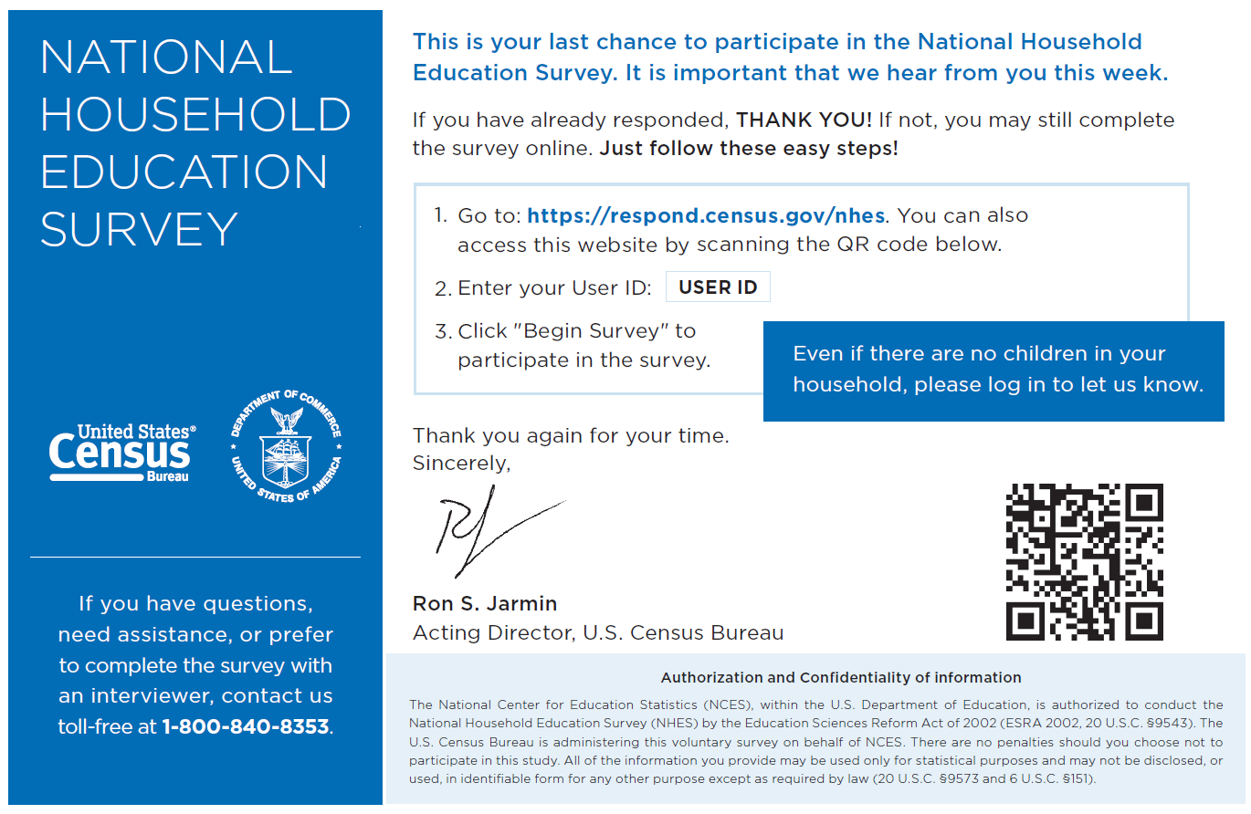

Bilingual Fifth screener mail package reminder letter (Baseline/Choice-Plus/Early Bird) NHES-15PB(B)
NHES-15PB(B)
(05-2021)
<Reverse side of this letter will be in English>

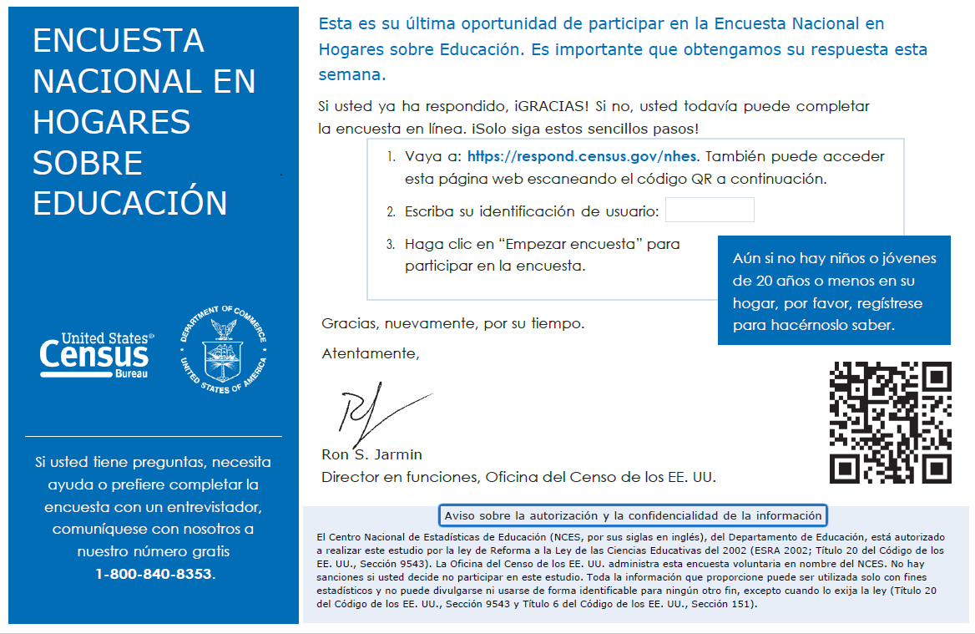

Bilingual Fifth screener mail package reminder letter (Alternate) NHES-15PB(AC)
NHES-15PB(AC)
(05-2021)
<Reverse side of this letter will be in Spanish>
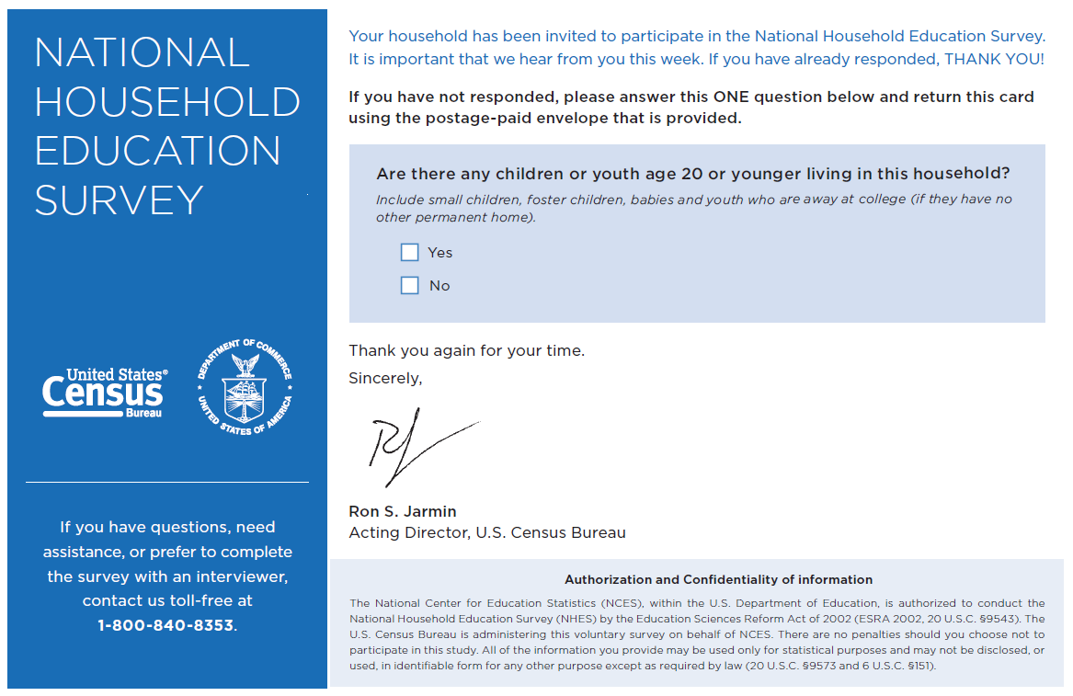

Bilingual Fifth screener mail package reminder letter (Alternate) NHES-15PB(AC)
NHES-15PB(AC)
(05-2021)
<Reverse side of this letter will be in English>
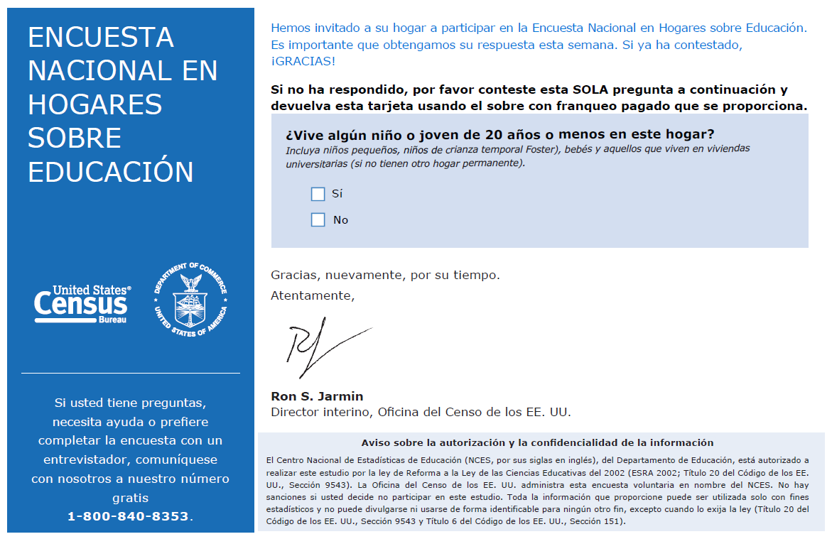

Promised incentive letter
Two groups of households will receive this bilingual letter with a $20 incentive (NHES-90LB): (1) households in the “choice-plus” experiment that respond to the screener and topical (if the household has a PFI or ECPP-eligible child) by web or phone, and (2)households in the “early bird incentive” condition that respond to the screener and topical (if the household has a PFI or ECPP-eligible child) by web or phone before the due date (March 14, 2023).

Bilingual Promised Incentive Letter NHES-90LB
UNITED STATES DEPARTMENT OF COMMERCE
Economics and Statistics Administration
U.S. Census Bureau
Washington, DC 20233-0001
OFFICE OF THE DIRECTOR
NHES-90LB
(05-2021)
<Reverse side of this letter will be in Spanish>

Dear <Addressee Line>:

A few weeks ago, your household completed a survey from the U.S. Department of Education conducted by the U.S. Census Bureau. Thank you for your response to this important study. Enclosed is a token of our appreciation for your participation.

If you have any questions, please call us toll-free at 1-888-840-8353.

Sincerely,

Ron S. Jarmin
Acting Director, U.S. Census Bureau
Enclosures
Si usted prefiere la versión en español, vea al dorso de la carta.

census.gov
Bilingual Promised Incentive Letter NHES-90LB
UNITED STATES DEPARTMENT OF COMMERCE
Economics and Statistics Administration
U.S. Census Bureau
Washington, DC 20233-0001
OFFICE OF THE DIRECTOR
NHES-90LB
(05-2021)
<Reverse side of this letter will be in English>

Estimado(a) <Addressee Line>:

Hace algunas semanas, su hogar completó una encuesta del Departamento de Educación de los EE. UU., realizada por la Oficina del Censo de los EE. UU. Gracias por sus respuestas a esta importante encuesta. Adjuntamos una muestra de nuestro agradecimiento por su participación.

Si tiene alguna pregunta, llámenos al número gratuito 1-888-840-8353.

Atentamente,

Ron S. Jarmin
Director interino, Oficina del Censo de los EE. UU.
Documentos Adjuntos
If you prefer English, please see the letter on the other side.

census.gov

Initial ECPP topical package letters
If at any point during the screener period a respondent completes the NHES screener by web, a sample member (child) is chosen “on the fly” and the respondent is asked to answer additional questions about the sampled child. In other words, web screener respondents immediately become topical web respondents and no further follow-up is needed. In addition, screener respondents who were sampled to receive the ECPP topical but who did not respond to any ECPP topical items will not receive any follow-up. This section provides the cover letters that will be placed on top of the ECPP topical surveys for households in which a screener was returned by mail and an eligible ECPP child (birth to 6 years old but not yet in kindergarten) could be sampled.
For all experiment groups, if a paper screener was returned in English, the respondent will receive NHES-21L. If a paper screener was returned in Spanish, the respondent will receive NHES-21LS.

First ECPP mail package letter NHES-21L
UNITED STATES DEPARTMENT OF COMMERCE
Economics and Statistics Administration
U.S. Census Bureau
Washington, DC 20233-0001
OFFICE OF THE DIRECTOR
NHES-21L
(05-2021)

Dear <Addressee Line>:
A few weeks ago, your household completed a survey from the U.S. Department of Education administered by the U.S. Census Bureau. Thank you for your response. We are now asking you to help us by completing the final part of this important study about early childhood care and education.
The survey you completed stated that the child listed below lives in this household.
When completing this survey, please answer about:

We know that you are busy; we have enclosed a cash token of appreciation for your time on the final part of this study. The survey should only take about 20 minutes to complete. Please return the completed survey in the enclosed postage-paid envelope.
If you have any questions about the study, please call us toll-free at 1-888-840-8353.
Thank you in advance for your continued participation.
Sincerely,

Ron S. Jarmin
Acting Director, U.S. Census Bureau
Enclosures census.gov

Spanish First ECPP mail package letter NHES-21LS
UNITED STATES DEPARTMENT OF COMMERCE
Economics and Statistics Administration
U.S. Census Bureau
Washington, DC 20233-0001
OFFICE OF THE DIRECTOR
NHES-21LS
(05-2021)

Estimado(a) <Addressee Line>:
Hace algunas semanas, su hogar completó una encuesta del Departamento de Educación de los EE. UU., realizada por la Oficina del Censo de los EE. UU. Gracias por las respuestas que nos proporcionó. Ahora le pedimos su ayuda para completar la parte final de este importante estudio sobre la educación y el cuidado en la primera infancia.
En la encuesta que usted completó, dijo que el niño/la niña que se menciona a continuación vive en su hogar. Cuando complete esta encuesta, por favor responda sobre:

Sabemos que usted es una persona ocupada y como muestra de nuestro agradecimiento incluimos dinero en efectivo por su tiempo en la parte final de este estudio. Completar la encuesta debería tomar solo unos 20 minutos. Por favor, devuelva la encuesta completada en el sobre adjunto con franqueo pagado.
Si tiene alguna pregunta relacionada con el estudio, llámenos al número gratuito 1-888-840-8353.
Le agradecemos de antemano por su continua participación.
Atentamente,

Ron S. Jarmin
Director interino, Oficina del Censo de los EE. UU.
Documentos Adjuntos

census.gov

Topical ECPP and PFI reminder postcards
Recipients of the initial ECPP or PFI package will receive a thank you/reminder postcard about a week after receiving their topical package in order to boost the impact of the first topical mailing.
Screener respondents who used the English form will receive the 0939-22P postcard, and screener respondents who used the Spanish form will receive the 0939-22PS postcard.

Topical reminder card (ECPP/PFI) 0939-22P
UNITED STATES DEPARTMENT OF COMMERCE
Economics and Statistics Administration
U.S. Census Bureau
Washington, DC 20233-0001
OFFICE OF THE DIRECTOR
0939-22P
(04-2018)

Recently we mailed a survey asking you to participate in the 2023 National Household Education Survey. That survey is the final step in this important study about education in our country. If you or someone else in your household has already returned the survey, we thank you very much for your help! If you have not completed and returned your survey, please do so right away.

If you have questions, feel free to contact us toll-free at 1-888-840-8353.

Sincerely,

Ron S. Jarmin
Acting Director
U.S. Census Bureau

Spanish Topical reminder card (ECPP/PFI) 0939-22PS
UNITED STATES DEPARTMENT OF COMMERCE
Economics and Statistics Administration
U.S. Census Bureau
Washington, DC 20233-0001
OFFICE OF THE DIRECTOR
0939-22PS
(04-2018)

Recientemente le enviamos por correo postal una encuesta para invitarlo(a) a participar en la Encuesta
Nacional en Hogares sobre Educación del 2023. Esa encuesta es el último paso de este importante
estudio sobre la educación en nuestro país. Si usted u otra persona en su hogar ya devolvió la
encuesta, ¡le damos gracias por su ayuda! Si no ha completado y devuelto la encuesta, por favor, hágalo
en el plazo de dos semanas.

Si tiene alguna pregunta, comuníquese con nosotros llamando al número gratuito 1–888–840–8353.

Atentamente,

Ron S. Jarmin
Director interion
Oficina del Censo de los EE. UU.

Second ECPP topical package letters
Mail-based screener respondents with an ECPP-eligible child who did not respond to the first topical mailing will receive a second topical mailing.
Screener respondents who used the English form will receive NHES-22L, and screener respondents who used the Spanish form will receive NHES-22LS.

Second ECPP mail package reminder letter NHES-22L
UNITED STATES DEPARTMENT OF COMMERCE
Economics and Statistics Administration
U.S. Census Bureau
Washington, DC 20233-0001
OFFICE OF THE DIRECTOR
NHES-22L
(05-2021)

Dear <Addressee Line>:
Did you know that in 2019, about 59 percent of young children were regularly cared for by someone other than their parents?
This is just one of the statistics that we learn from the National Household Education Survey.
Now, we need you to help update important information about children’s early learning. Please find the survey and postage-paid envelope enclosed again for your convenience.
Please answer this survey about the child listed below:

If you have questions or need assistance, please contact us toll-free at 1-888-840-8353. You can find more information online at nces/ed/gov/nhes.

Sincerely,

Ron S. Jarmin
Acting Director, U.S. Census Bureau
Enclosures census.gov

Spanish Second ECPP mail package reminder letter NHES-22LS
UNITED STATES DEPARTMENT OF COMMERCE
Economics and Statistics Administration
U.S. Census Bureau
Washington, DC 20233-0001
OFFICE OF THE DIRECTOR
NHES-22LS
(05-2021)

Estimado(a) <Addressee Line>:
¿Sabía que, en el 2019, a cerca del 59 por ciento de los niños pequeños los cuidaron habitualmente personas que no eran sus padres?
Este es solamente uno de los datos estadísticos que hemos obtenido a partir de la Encuesta Nacional en Hogares sobre Educación.
Ahora necesitamos que usted nos ayude a actualizar información importante sobre el aprendizaje temprano de los niños. Le enviamos nuevamente la encuesta adjunta y el sobre con franqueo pagado para su comodidad.
Responda esta encuesta sobre:

Si tiene alguna pregunta o si necesita ayuda, comuníquese con nosotros llamando al número gratuito 1-888-840-8353. Puede encontrar más información disponible en internet en: https://nces.ed.gov/nhes/ (en inglés).
Atentamente,

Ron S. Jarmin
Director interino, Oficina del Censo de los EE. UU.
Documentos Adjuntos
census.gov

ECPP reminder call and third topical package letters
Mail-based screener respondents with an ECPP-eligible child who did not respond to the first or second topical mailings will receive a robocall and a third mailing. The robocall will alert respondents that a FedEx package is coming.
For the third ECPP mailings, mail screener respondents who used the English form will receive NHES-23L, and screener respondents who used the Spanish form will receive NHES-23LS.

Reminder topical call (ECPP)
Hello! This is the U.S. Census Bureau on behalf of the National Household Education Survey. Thank you for receiving our earlier mailings. We know you are busy. Keep a lookout for our next mailing. It will be sent by FedEx! We thank you in advance for your help with this important national study about early childhood care and education!

Third ECPP mail package reminder letter NHES-23L
UNITED STATES DEPARTMENT OF COMMERCE
Economics and Statistics Administration
U.S. Census Bureau
Washington, DC 20233-0001
OFFICE OF THE DIRECTOR
NHES-23L
(05-2021)

Dear <Addressee Line>:
We have mailed this letter using rush delivery because of the importance of your response. We have not yet received your completed survey for the 2023 National Household Education Survey. Your responses to this survey will help provide a complete picture of early childhood care and education in the United States.
Please fill out the enclosed survey about the child listed below and return it in the postage-paid envelope as soon as possible.

Call us toll-free at 1-888-840-8353 with any questions or to complete the survey with an interviewer. This call will take 20 minutes or less.
Thank you for taking part in this important study.
Sincerely,

Ron S. Jarmin
Acting Director, U.S. Census Bureau
Enclosures
census.gov

Spanish Third ECPP mail package reminder letter NHES-23LS
UNITED STATES DEPARTMENT OF COMMERCE
Economics and Statistics Administration
U.S. Census Bureau
Washington, DC 20233-0001
OFFICE OF THE DIRECTOR
NHES-23LS
(05-2021)

Estimado(a) <Addressee Line>:
Debido a la importancia que tiene su respuesta, le hemos enviado esta carta mediante el servicio de entrega urgente. Todavía no hemos recibido su encuesta completada para la Encuesta Nacional en Hogares sobre Educación del 2023. Sus respuestas a este cuestionario ayudarán a proporcionar una idea clara sobre el cuidado y la educación que se proporciona a la primera infancia en los Estados Unidos.
Por favor, complete la encuesta adjunta sobre el niño/la niña que se menciona a continuación y devuélvala en el sobre con franqueo pagado tan pronto como sea posible.

Si tiene alguna pregunta o si desea completar la encuesta con un entrevistador, llámenos al número gratuito 1-888-840-8353. Esta llamada durará 20 minutos o menos.
Gracias por participar en este importante estudio.
Atentamente,

Ron S. Jarmin
Director interino, Oficina del Censo de los EE. UU.
Documentos Adjuntos

census.gov

Fourth ECPP and PFI topical package letters
The fourth (and final) mailing will be sent to both ECPP-eligible and PFI-eligible households.
Mail-based screener respondents with an ECPP-eligible or PFI-eligible child who did not respond to the first, second, or third topical mailings will receive a fourth topical mailing. For the fourth ECPP/PFI mailing, mail screener respondents who used the English form will receive NHES-24L, and screener respondents who used the Spanish form will receive NHES-24LS.

Fourth topical mail package reminder letter (ECPP/PFI) NHES-24L
UNITED STATES DEPARTMENT OF COMMERCE
Economics and Statistics Administration
U.S. Census Bureau
Washington, DC 20233-0001
OFFICE OF THE DIRECTOR
NHES-24L
(05-2021)

Dear <Addressee Line>:
I sent the last survey invitation to you by rush delivery because of the importance of YOUR response to the 2023 National Household Education Survey.
The final step of the survey should only take about 20 minutes to complete.
Please fill out the enclosed survey about:

Please respond within the next TWO WEEKS. If you have any questions or would like to complete the survey with an interviewer, please call us toll-free at 1-888-840-8353.
You can find more information about this study online at nces.ed.gov/nhes.
Thank you for taking part in this important study.
Sincerely,

Ron S. Jarmin
Acting Director, U.S. Census Bureau
Enclosures
census.gov

Spanish Fourth topical mail package reminder letter (ECPP/PFI) NHES-24LS
UNITED STATES DEPARTMENT OF COMMERCE
Economics and Statistics Administration
U.S. Census Bureau
Washington, DC 20233-0001
OFFICE OF THE DIRECTOR
NHES-24LS
(05-2021)

Estimado(a) <Addressee Line>:
Debido a la importancia que tiene SU respuesta para la Encuesta Nacional en Hogares sobre Educación del 2023, le envié la última invitación para participar en la encuesta mediante el servicio de entrega urgente.
Completar la parte final de la encuesta debería tomar solo unos 20 minutos.
Complete la encuesta adjunta sobre:

Por favor, responda en el transcurso de las siguientes DOS SEMANAS. Si tiene alguna pregunta o desea completar la encuesta con un entrevistador, llámenos al número gratuito 1-888-840-8353.
Puede encontrar más información disponible en internet en: nces.ed.gov/nhes/ (en inglés).
Gracias por participar en esta importante encuesta.

Atentamente,

Ron S. Jarmin
Director interino, Oficina del Censo de los EE. UU.
Documentos Adjuntos
census.gov

Fifth ECPP and PFI topical package letters
A fifth (and final) mailing will be sent to both ECPP-eligible and PFI-eligible households that received their first mailing before June 1, 2023, This fifth package will be sent via UPS delivery.

Mail-based screener respondents with an ECPP-eligible or PFI-eligible child who received their first mailing by June 1, 2023 and had not responded to the first, second, third or fourth topical mailings will receive a fifth topical mailing. For the fifth ECPP/PFI mailing, mail screener respondents who used the English form will receive NHES-25L, and screener respondents who used the Spanish form will receive NHES-25LS.

Fifth topical mail package reminder letter (ECPP/PFI) NHES-25L
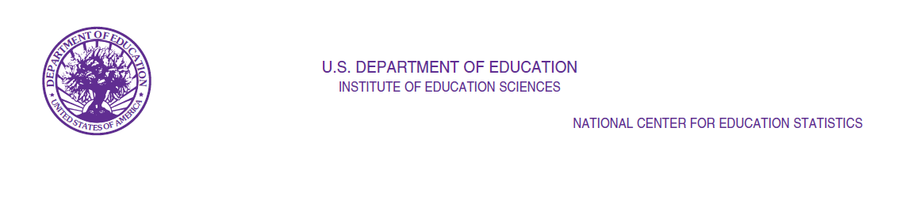
NHES-25L
(05-2023)

Dear Parent/Guardian of [CHILD]:

Thank you for your response to the National Household Education Survey earlier this year.

Understanding the experiences of our nation’s children benefits families by helping to answer vital questions about children’s early learning experiences and schooling. This information helps to inform policies at national, state, and local levels. Please take this chance to make your voice heard about your child’s experiences.

That is why I am reaching out to you today to complete this important survey. You may have received letters from the Census Bureau about responding to this final stage of the study. Now I am reaching out to ask you to please complete the enclosed survey immediately and return it in the postage-paid envelope provided to you.

When completing the survey, please answer about:

[CHILD]

Thank you in advance for your continued participation. It should only take you about 20 minutes to complete this survey.

Sincerely,

Chris Chapman
Associate Commissioner

National Center for Education Statistics
U.S. Department of Education
Enclosure

Authorization and Confidentiality of Information

The National Center for Education Statistics (NCES), within the U.S. Department of Education, is authorized to conduct the National Household Education Survey (NHES) by the Education Sciences Reform Act of 2002 (ESRA 2002, 20 U.S.C. §9543). The U.S. Census Bureau is administering this voluntary survey on behalf of NCES. There are no penalties should you choose not to participate in this study. All of the information you provide may be used only for statistical purposes and may not be disclosed, or used, in identifiable form for any other purpose except as required by law (20 U.S.C. §9573 and 6 U.S.C. §151).
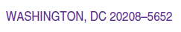

Spanish Fifth topical mail package reminder letter (ECPP/PFI) NHES-25LS

NHES-25LS
(05-2023)

Estimado(a) Padre/Madre/Tutor(a) Legal de [CHILD]:

Gracias por las respuestas que nos proporcionó en la Encuesta Nacional en Hogares sobre Educación hace unos meses.

Entender las experiencias de los niños en nuestra nación beneficia a las familias, al ayudarles a entender cuestiones vitales sobre las experiencias de aprendizaje temprano y enseñanza de los niños. Esta información ayuda a informar políticas a nivel local, estatal y nacional. Por favor aproveche esta oportunidad para que se escuche su voz acerca de las experiencias de su niño(a).

Es por esto que le escribo hoy para completar esta importante encuesta. Puede que haya recibido otras cartas de la Oficina del Censo acerca de responder a este paso final del estudio. Ahora me pongo en contacto con usted para pedirle que por favor complete la encuesta adjunta de inmediato, y la devuelva en el sobre con franque pagado que se le ha proporcionado.

Cuando complete esta encuesta, por favor responda sobre:

[CHILD]

Le agradecemos de antemano por su continua participación. Completar la encuesta debería tomar solo unos 20 minutos.

Atentamente

Chris Chapman
Comisionada Asociada

Centro Nacional de Estadísticas de Educación
Departamento de Educación de los E.E. U.U. Documento Adjunto

Aviso sobre la autorización y la confidencialidad de la información

El Centro Nacional de Estadísticas de Educación (NCES, por sus siglas en inglés), del Departamento de Educación, está autorizado a realizar este estudio por la Ley de Reforma de las Ciencias Educativas del 2002 (ESRA 2002; Título 20 del Código de los EE. UU., Sección 9543). La Oficina del Censo de los EE. UU. administra esta encuesta voluntaria en nombre del NCES. No hay sanciones si usted decide no participar en este estudio. Toda la información que brinde puede ser utilizada solo con fines estadísticos y no puede divulgarse ni usarse en forma identificable para ningún otro fin, excepto cuando lo exija la ley (Título 20 del Código de los EE. UU., Sección 9543 y Título 6 del Código de los EE. UU., Sección 151).

Initial PFI topical package letters
If at any point during the screener period a respondent completes the NHES screener by web, a sample member (child) is chosen “on the fly” and the respondent is asked to answer additional questions about the sampled child. In other words, web screener respondents immediately become topical web respondents and no further follow-up is needed. In addition, screener respondents who were sampled to receive the PFI topical but who did not respond to any PFI topical items will not receive any follow-up. This section provides the cover letters that will be placed on top of PFI topical surveys for households in which a screener was returned by mail and an eligible PFI child (age 20 years or younger and in grades kindergarten through 12) could be sampled.
If a paper screener was returned in English, the respondent will receive NHES-31L. If a paper screener was returned in Spanish, the respondent will receive NHES-31LS.

First PFI mail package letter NHES-31L
UNITED STATES DEPARTMENT OF COMMERCE
Economics and Statistics Administration
U.S. Census Bureau
Washington, DC 20233-0001
OFFICE OF THE DIRECTOR
NHES-31L
(05-2021)

Dear <Addressee Line>:
A few weeks ago, your household completed a survey from the U.S. Department of Education administered by the U.S. Census Bureau. Thank you for your response. We are now asking you to help us by completing the final part of this important study about children’s education.
The survey you completed states that the child listed below lives in this household. When completing the survey, please answer about:

We know that you are busy, and have enclosed a cash token of appreciation for your time on the final part of this study. The survey should only take about 20 minutes to complete. Please return the completed survey in the enclosed postage-paid envelope.
If you have any questions about the study, please call us toll-free at 1-888-840-8353.
Thank you in advance for your continued participation.
Sincerely,

Ron S. Jarmin
Acting Director, U.S. Census Bureau
Enclosures

census.gov

Spanish First PFI mail package letter NHES-31LS
UNITED STATES DEPARTMENT OF COMMERCE
Economics and Statistics Administration
U.S. Census Bureau
Washington, DC 20233-0001
OFFICE OF THE DIRECTOR
NHES-31LS
(05-2021)

Estimado(a) <Addressee Line>:
Hace algunas semanas, su hogar completó una encuesta del Departamento de Educación de los EE. UU., realizada por la Oficina del Censo de los EE. UU. Gracias por las respuestas que nos proporcionó. Ahora le pedimos su ayuda para completar la parte final de esta importante encuesta sobre la educación de los niños.
En la encuesta que usted completó, dijo que el niño/la niña que se menciona a continuación vive en su hogar. Cuando complete esta encuesta, por favor responda sobre:

Sabemos que usted es una persona ocupada y como muestra de nuestro agradecimiento incluimos dinero en efectivo por dedicar tiempo a la parte final de este estudio. Completar la encuesta debería tomar solo unos 20 minutos. Por favor, devuelva la encuesta completada en el sobre adjunto con franqueo pagado.
Si tiene alguna pregunta relacionada con el estudio, llámenos al número gratuito 1-888-840-8353.
Le agradecemos de antemano por su continua participación.
Atentamente,

Ron S. Jarmin
Director interino, Oficina del Censo de los EE. UU.
Documentos Adjuntos

census.gov

Second PFI topical package letters
Mail-based screener respondents with a PFI-eligible child who did not respond to the topical survey request after the first mailing will receive a second mailing.
Screener respondents who used the English form will receive NHES-32L, and screener respondents who used the Spanish form will receive NHES-32LS.

Second PFI mail package reminder letter NHES-32L
UNITED STATES DEPARTMENT OF COMMERCE
Economics and Statistics Administration
U.S. Census Bureau
Washington, DC 20233-0001
OFFICE OF THE DIRECTOR
NHES-32L
(05-2021)

Dear <Addressee Line>:
Did you know that in 2019, 77 percent of students had an amount of homework that their parents described as “about right”?
This is just one of the statistics that we learn from the National Household Education Survey.
Now, we need you to help update important information about children’s education. Please find the survey and postage-paid envelope enclosed again for your convenience.
Please answer this survey about the child listed below:

If you have questions or need assistance, please contact us toll-free at 1-888-840-8353. You can find more information online at nces.ed.gov/nhes.
Sincerely,

Ron S. Jarmin
Acting Director, U.S. Census Bureau
Enclosures
census.gov

Spanish Second PFI mail package reminder letter NHES-32LS
UNITED STATES DEPARTMENT OF COMMERCE
Economics and Statistics Administration
U.S. Census Bureau
Washington, DC 20233-0001
OFFICE OF THE DIRECTOR
NHES-32LS
(05-2021)

Estimado(a) <Addressee Line>:
¿Sabía que, en el 2019, el 77 por ciento de estudiantes tuvo una cantidad de tarea que sus padres describieron como “adecuada”?
Este es solamente uno de los datos estadísticos que hemos obtenido a partir de la Encuesta Nacional en Hogares sobre Educación.
Ahora necesitamos que usted nos ayude a actualizar información importante sobre la educación de los niños. Le enviamos nuevamente la encuesta adjunta y el sobre con franqueo pagado para su comodidad.
Responda a esta encuesta sobre:

Si tiene alguna pregunta o si necesita ayuda, comuníquese con nosotros llamando al número gratuito 1-888-840-8353. Puede encontrar más información disponible en internet en: https://nces.ed.gov/nhes/ (en inglés).

Atentamente,

Ron S. Jarmin
Director interino, Oficina del Censo de los EE. UU.
Documentos Adjuntos
census.gov

PFI reminder call and third PFI topical package letters
Mail-based screener respondents with a PFI-eligible child who did not respond to the first or second topical mailings will receive a robocall and a third mailing. The robocall will alert respondents that a FedEx package is coming.
For the third PFI mailings, mail screener respondents who used the English form will receive NHES-33L, and screener respondents who used the Spanish form will receive NHES-33LS.

Reminder topical call (PFI)
Hello! This is the U.S. Census Bureau on behalf of the National Household Education Survey. Thank you for receiving our earlier mailings. We know you are busy. Keep a lookout for our next mailing. It will be sent by FedEx! We thank you in advance for your help with this important national study about children’s education!

Third PFI mail package reminder letter NHES-33L
UNITED STATES DEPARTMENT OF COMMERCE
Economics and Statistics Administration
U.S. Census Bureau
Washington, DC 20233-0001
OFFICE OF THE DIRECTOR
NHES-33L
(05-2021)

Dear <Addressee Line>:
We have mailed this survey using rush delivery because of the importance of your response. We have not yet received your completed survey for this 2023 National Household Education Survey. Your responses to this survey will help provide a complete picture of families’ involvement in their children’s education in the United States.
Please fill out the enclosed survey about the child listed below and return it in the postage-paid envelope as soon as possible.

Call us toll-free at 1-888-840-8353 with any questions or to complete the survey with an interviewer. This call will take 20 minutes or less.
Thank you for taking part in this important study.
Sincerely,

Ron S. Jarmin
Acting Director, U.S. Census Bureau
Enclosures

census.gov

Spanish Third PFI mail package reminder letter NHES-33LS
UNITED STATES DEPARTMENT OF COMMERCE
Economics and Statistics Administration
U.S. Census Bureau
Washington, DC 20233-0001
OFFICE OF THE DIRECTOR
NHES-33LS
(05-2021)

Estimado(a) <Addressee Line>:
Debido a la importancia que tiene SU respuesta, le hemos enviado esta carta mediante el servicio de entrega urgente. Todavía no hemos recibido su encuesta completada para la Encuesta Nacional en Hogares sobre Educación del 2023. Sus respuestas a esta encuesta ayudarán a proporcionar una idea clara sobre la participación de la familia en la educación de sus niños en los Estados Unidos.
Por favor, complete la encuesta adjunta sobre el niño(a) que se menciona a continuación y devuélvala en el sobre con franqueo pagado tan pronto como sea posible.

Si tiene alguna pregunta o si desea completar la encuesta con un entrevistador, llámenos al número gratuito 1-888-840-8353. Esta llamada durará 20 minutos o menos.
Gracias por participar en esta importante encuesta.
Atentamente,

Ron S. Jarmin
Director interino, Oficina del Censo de los EE. UU.
Documentos Adjuntos

census.gov

Frequently asked questions
For NHES:2023, the frequently asked questions (FAQs) will be included as a separate document that is included in all the mailings. Each FAQ document will be bilingual with English on one side and Spanish on the other.
The following pages include:
- FAQ insert for screener mailing packages that include a paper survey
- A different FAQ insert for the screener packages sent to web-sampled households

Bilingual Screener Commonly Asked Questions – Paper Questionnaire Mailings
Frequently Asked Questions about the  National Household Education Survey | 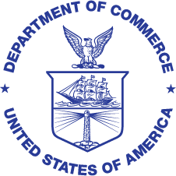
Why was I chosen for this survey?
Your address was randomly selected to be part of this survey from a list of all the addresses in the United States. We do not know who lives at each address. However, every address had a chance to be selected. Now that your address was chosen, your response is vital to the success of the study!
No children live here. Should I give this survey to a neighbor or family member who has children?
No. Now that your address has been chosen, information about your household’s experiences will represent hundreds of households like yours. Together with other survey participants, your experiences will represent those of everyone in the United States. We cannot replace you. You should not give the survey to another household even if you do not have children.
Who is doing the survey?
This survey is conducted by the Federal Government. The U.S. Census Bureau is doing the data collection for this study by the National Center for Education Statistics, within the U.S. Department of Education. This survey has been approved by the Office of Management and Budget, the office that reviews all federally sponsored surveys.
Why should I take part in the survey?
The survey results will be used by policymakers and researchers to improve programs for children. This survey is the best way to learn about children’s care, early learning activities, and schooling from your perspective. While the Census Bureau collects similar information, this survey is unique and asks for up-to-date information not available from any other sources, including other government agencies.
How will the responses I provide be used? Will my privacy be protected?
Your responses will be combined with those of others to produce statistical summaries and reports. Your address and household members’ names will not be included on anything the study releases or shares. Your responses may be used only for statistical purposes and may not be disclosed, or used, in identifiable form for any other purpose except as required by law.
How much time will it take to respond to this survey?
On average, it should take 3 minutes for you to respond.
If there are no children or anyone currently in school in my household, should I respond?
Yes, you should respond to this survey. We need responses from households without children to get survey results that represent everyone in the U.S. population. If there are no children in your household, you will only need to answer one question!
Who should I contact if I have questions or comments about this survey?
If you have any questions about this survey or the status of your individual survey submission, contact the Census Bureau toll-free at 1-888-840-8353.

Si usted prefiere la versión en español, vea al dorso de la carta.

Preguntas Más Frecuentes sobre la Encuesta Nacional en Hogares sobre la Educación
¿Por qué fui seleccionado para esta encuesta?
Su dirección fue seleccionada al azar de una lista de direcciones en los Estados Unidos para tomar parte de esta encuesta. No sabemos quiénes viven en cada dirección. Sin embargo, cualquiera de estas direcciones podría haber sido seleccionada. Ahora que su dirección fue escogida, ¡su respuesta es vital para el éxito de este estudio!
No viven niños aquí. ¿Puedo darle la encuesta a un vecino o pariente que tenga niños?
No. Ahora que su dirección ha sido seleccionada, la información sobre las experiencias de su hogar representará a cientos de hogares como el suyo. Junto con otras encuestas participantes, sus experiencias representarán a las de todos en los Estados Unidos. No podemos reemplazarlo. No deberá usted dar la encuesta a otro hogar, aun si usted no tiene niños.
¿Quién está haciendo la encuesta?
Está encuesta es realizada por el Gobierno Federal. La Oficina del Censo de los EE. UU. está realizando la recolección de datos para este estudio del Centro Nacional para Estadísticas de la Educación, del Departamento de Educación de los EE. UU. Esta encuesta ha sido aprobada por la Oficina de Administración y Presupuesto, la oficina que revisa todas las encuestas auspiciadas a nivel federal.
¿Por qué debería tomar parte de esta encuesta?
Los resultados de esta encuesta serán usados por legisladores e investigadores para mejorar los programas para niños. Esta encuesta es la mejor forma de saber sobre el cuidado de niños, actividades tempranas de aprendizaje, y enseñanza desde su perspectiva. Aunque le Oficina del Censo recoge información similar, esta encuesta es única, y le pregunta por información actualizada que no podemos obtener de ninguna otra fuente, incluyendo otras agencias gubernamentales.
¿Cómo serán usadas sus respuestas? ¿Estará protegida mi privacidad?
Sus respuestas serán mezcladas con la de otros para preparar resúmenes e informes estadísticos. Su dirección y nombres de los miembros de su hogar no serán incluidos en nada que este estudio publique o comparta. Sus respuestas pueden ser usadas solo para fines estadísticos y no pueden ser divulgadas o usadas en ninguna forma identificable con ningún otro propósito excepto cuando así lo requiera la ley.
¿Cuánto tiempo llevará el responder a esta encuesta?
En promedio, le llevará 3 minutos para responder.
¿Si en mi hogar no hay niños o alguien que esté actualmente en la escuela, debería responder?
Si. Usted debería responder a esta encuesta. Necesitamos respuestas de hogares que no tienen niños para obtener resultados de la encuesta que representen a cada uno en la población de los EE. UU. ¡Si no hay niños en su hogar, usted necesitará responder solo a una pregunta!
¿Con quién debería comunicarme si tengo preguntas sobre esta encuesta?
Si tiene preguntas sobre esta encuesta, o estatus de la entrega individual de su encuesta, comuníquese con la Oficina del Censo al número gratis 1-888-840-8353.
If you prefer the English version, see the other side of the letter

Bilingual Screener Commonly Asked Questions – Web Mode Paper Insert
Frequently Asked Questions about the
National Household Education Survey
Why was I chosen for this survey?
Your address was randomly selected to be part of this survey from a list of all the addresses in the United States. We do not know who lives at each address. However, every address had a chance to be selected. Now that your address was chosen, your response is vital to the success of the study!
No children live here. Should I give this survey to a neighbor or family member who has children?
No. Now that your address has been chosen, information about your household’s experiences will represent hundreds of households like yours. Together with other survey participants, your experiences will represent those of everyone in the United States. We cannot replace you. You should not give the survey to another household even if you do not have children.
Who is doing the survey?
This survey is conducted by the Federal Government. The U.S. Census Bureau is doing the data collection for this study by the National Center for Education Statistics, within the U.S. Department of Education. This survey has been approved by the Office of Management and Budget, the office that reviews all federally sponsored surveys.
Why should I take part in the survey?
The survey results will be used by policymakers and researchers to improve programs for children. This survey is the best way to learn about children’s care, early learning activities, and schooling from your perspective. While the Census Bureau collects similar information, this survey is unique and asks for up-to-date information not available from any other sources, including other government agencies.
How will the responses I provide be used? Will my privacy be protected?
Your responses will be combined with those of others to produce statistical summaries and reports. Your address and household members’ names will not be included on anything the study releases or shares. Your responses may be used only for statistical purposes and may not be disclosed, or used, in identifiable form for any other purpose except as required by law.
How much time will it take to respond to this survey?
If you have no children, the survey will take about 3 minutes. If you do have children, the survey will take about 30 minutes or less.
If there are no children or anyone currently in school in my household, should I respond?
Yes, you should respond to this survey. We need responses from households without children to get survey results that represent everyone in the U.S. population. If there are no children in your household, you will only need to answer one question!
Who should I contact if I have questions or comments about this survey?
If you have any questions about this survey or the status of your individual survey submission, contact the Census Bureau toll-free at 1-888-840-8353.

Si usted prefiere la versión en español, vea al dorso de la carta.

Preguntas Más Frecuentes sobre la Encuesta Nacional en Hogares sobre la Educación
¿Por qué fui seleccionado para esta encuesta?
Su dirección fue seleccionada al azar de una lista de direcciones en los Estados Unidos para tomar parte de esta encuesta. No sabemos quiénes viven en cada dirección. Sin embargo, cualquiera de estas direcciones podría haber sido seleccionada. Ahora que su dirección fue escogida, ¡su respuesta es vital para el éxito de este estudio!
No viven niños aquí. ¿Puedo darle la encuesta a un vecino o pariente que tenga niños?
No. Ahora que su dirección ha sido seleccionada, la información sobre las experiencias de su hogar representará a cientos de hogares como el suyo. Junto con otras encuestas participantes, sus experiencias representarán a las de todos en los Estados Unidos. No podemos reemplazarlo. No deberá usted dar la encuesta a otro hogar, aun si usted no tiene niños.
¿Quién está haciendo la encuesta?
Está encuesta es realizada por el Gobierno Federal. La Oficina del Censo de los EE. UU. está realizando la recolección de datos para este estudio del Centro Nacional para Estadísticas de la Educación, del Departamento de Educación de los EE. UU. Esta encuesta ha sido aprobada por la Oficina de Administración y Presupuesto, la oficina que revisa todas las encuestas auspiciadas a nivel federal.
¿Por qué debería tomar parte de esta encuesta?
Los resultados de esta encuesta serán usados por legisladores e investigadores para mejorar los programas para niños. Esta encuesta es la mejor forma de saber sobre el cuidado de niños, actividades tempranas de aprendizaje, y enseñanza desde su perspectiva. Aunque le Oficina del Censo recoge información similar, esta encuesta es única, y le pregunta por información actualizada que no podemos obtener de ninguna otra fuente, incluyendo otras agencias gubernamentales.
¿Cómo serán usadas sus respuestas? ¿Estará protegida mi privacidad?
Sus respuestas serán mezcladas con la de otros para preparar resúmenes e informes estadísticos. Su dirección y nombres de los miembros de su hogar no serán incluidos en nada que este estudio publique o comparta. Sus respuestas pueden ser usadas solo para fines estadísticos y no pueden ser divulgadas o usadas en ninguna forma identificable con ningún otro propósito excepto cuando así lo requiera la ley.
¿Cuánto tiempo llevará el responder a esta encuesta?
Si no tiene niños, la encuesta le llevará 3 minutos; y más o menos 30 minutos, si tiene niños.
¿Si en mi hogar no hay niños o alguien que esté actualmente en la escuela, debería responder?
Si. Usted debería responder a esta encuesta. Necesitamos respuestas de hogares que no tienen niños para obtener resultados de la encuesta que representen a cada uno en la población de los EE. UU. ¡Si no hay niños en su hogar, usted necesitará responder solo a una pregunta!
¿Con quién debería comunicarme si tengo preguntas sobre esta encuesta?
Si tiene preguntas sobre esta encuesta, o estatus de la entrega individual de su encuesta, comuníquese con la Oficina del Censo al número gratis 1-888-840-8353.
If you prefer the English version, see the other side of the letter

Cash Insert
For NHES:2023, this piece of yellow card-stock will have $5 incentives adhered to it and it will be included as a separate document for initial screener mailings to lower response propensity cohort of the Targeted Choice Plus condition and for all initial topical mailings to early responders. Each cash insert document will be bilingual with English on the top and Spanish on the bottom.
The following page includes an example of the type of language this cash insert is likely to include, and the final version will have a Census logo.

Bilingual Cash Insert

THANK YOU!
We greatly appreciate your help with this important national survey.
We know that you are busy, and have enclosed a cash token of appreciation for your time on the final part of this study. The survey results will be used by policymakers and researchers to improve programs for children.

¡GRACIAS!
Le agradecemos mucho su ayuda con esta importante encuesta nacional.
Sabemos que usted es una persona ocupada y como muestra de nuestro agradecimiento incluimos dinero en efectivo por dedicar tiempo a la parte final de este estudio. Los resultados de esta encuesta serán usados por legisladores e investigadores para mejorar los programas para niños

Telephone Questionnaire Assistance Phone script
The Census Bureau’s toll-free telephone line will be staffed with English-speaking and bilingual operators from 8:00 am to 8:00 pm EST every day during the NHES:2023 data collection period. These operators will be able to answer questions about NHES, check on the status of a submission, and also complete the interview with the respondent. In order to complete the interview, the operator will use the same web survey instrument that the respondent would use if the respondent completed it online him- or herself. Question wording that the operators will use is provided in the web specifications in Appendix 3 of this submission. Additionally, telephone operators will use the following script to initiate completion of the screener with respondents who call in to the Telephone Questionnaire Assistance (TQA) line:

English:

“Thank you for calling. To start this voluntary survey, can I please have your USER ID which is located on the letter to help me locate your record? {If they don’t provide their User ID ask for their address }

Thank you

Are there any children or youth age 20 or younger living in this household?
Include small children, foster children, babies and youth who are away at college (if they have no other permanent home).

[If no:] “Thank you for calling and completing the survey.”

[If yes, the operator will complete the survey for the respondent screen by screen. Beforehand, the operator will say:]

“Okay, thank you. The survey will take about 30 minutes or less to complete. Let’s start with the first question about your household and see how far we can get…”

Spanish:
“Gracias por llamar. Para comenzar esta encuesta voluntaria, ¿puede decirme tener su ID de usuario que se encuentra en la carta para ayudarme a localizar su registro? {Si no proporcionan su ID de usuario, solicite la dirección}

Gracias

¿Hay algún niño o joven de 20 años o menos viviendo en este hogar?
Incluya niños pequeños, niños de crianza temporal (Foster), bebés y jóvenes que están en la universidad (si no tienen otro hogar permanente).

[if no:] “Gracias por llamar y completar la encuesta.”

[If sí, the operator will complete the survey for the respondent screen by screen. Beforehand, the operator will say:]
"Gracias. La encuesta demorará alrededor de 30 minutos o menos en completarse. Comencemos con la primera pregunta sobre su hogar y veamos qué tan lejos podemos llegar ... "

Website content
During the collection period for NHES:2023, the NHES website at nces.ed.gov/nhes will include a special link. The webpages in the link will provide information to NHES sample members about the study. The primary goals of these web pages will be:
- Provide a quick link for survey respondents to get to the web survey instrument to complete the survey. Qualitative research indicates that sample members often use search engines to get to the web survey instrument rather than typing the url into the browser. The NHES website should have a quick link to the web survey instrument; and,
- Provide enough information about the study to establish its legitimacy for skeptical sample members.

Link from home page of nces.ed.gov/nhes:

Did you receive a letter asking you to participate in the 2023 National Household Education Survey?
Click here for more information!

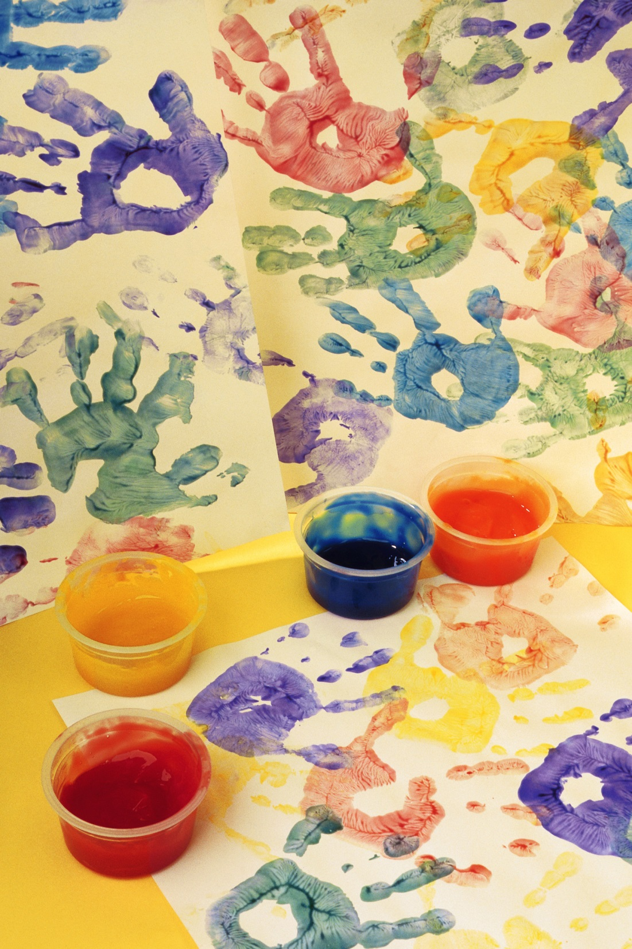


The 2023 National Household Education Survey

(1) General information about the National Household Education Survey (NHES)
(2) Participating in NHES
(3) Survey sponsor and data collector
(4) Data privacy, confidentiality, and security

Did you receive a letter like this one about the National Household Education Survey (NHES)? Click here to complete the survey.

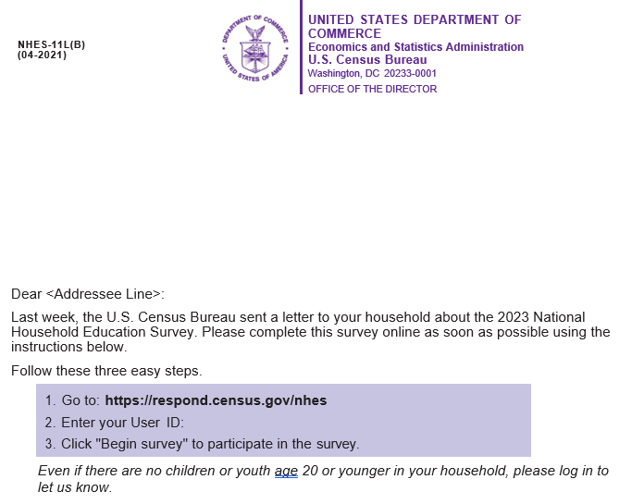

General Information about the National Household Education Survey (NHES)

What is NHES?
The National Household Education Survey (NHES) provides descriptive data on the educational activities of the U.S. population and offers researchers, educators, and policymakers a variety of statistics on the condition of education in the United States. NHES collects data about learning at home and about education decisions made at home. These are topics that are not easily collected through schools.

What types of questions will be asked?
First, all households are asked to answer some initial questions in order to help us understand their household characteristics. Depending on the characteristics of the household, some will receive additional questions asking about young children’s care and education, or students’ and families’ experiences with schools or homeschooling.

What is the purpose of NHES? How will my responses be used?
The Department of Education wants to understand the condition of education in the United States.
This study is the only way that we can learn about children’s care, early learning activities, and schooling from your perspective. Data from this study may be used by policymakers and researchers to improve programs for children.

Your responses will be combined with those from other households to inform educators, policymakers, schools and universities about changes in the condition of education in the United States. Reports from past studies can be found at http://nces.ed.gov/pubsearch/getpubcats.asp?sid=004.

Why was I chosen for this survey?
Your address was randomly selected to be part of this survey from a list of all the addresses in the United States. We do not know who lives at each address. However, every address had a chance to be selected. Now that your address was chosen, your response is vital to the success of the study!

Participating in NHES

Why should I take part in this study?
The survey results will be used by policymakers and researchers to improve programs for children. This survey is the best way to learn about children’s care, early learning activities, and schooling from your perspective. While the Census Bureau collects similar information, this survey is unique and asks for up-to-date information not available from any other sources, including other government agencies.

How much time will it take?
If you have no children, the survey will take about 3 minutes, including the time for reviewing instructions. If you do have children, the survey will take about 30 minutes or less.

Survey Sponsor and Data Collector

Who is sponsoring this study? Is this study conducted by the Federal Government?
The U.S. Census Bureau is administering this voluntary survey on behalf of the National Center for Education Statistics (NCES). NCES, within the U.S. Department of Education, is authorized to conduct this survey by the Education Sciences Reform Act of 2002 (ESRA 2002, 20 U.S.C. §9543). This study has been approved by the Office of Management and Budget (OMB), the office that reviews all federally sponsored surveys.
If you have any comments concerning the accuracy of the time estimate or suggestions for improving the survey, please email: NHES@census.gov or write directly to: Michelle McNamara, National Household Education Survey (NHES), National Center for Education Statistics, Potomac Center Plaza, 550 12th Street SW, Room 4010, Washington, DC 20202.
If you have any questions about this survey or the status of your individual submission of this survey, contact the Census Bureau toll-free at 1-888-840-8353. You may also complete the survey by calling this phone number from 8 am to 8 pm EST, any day of the week.

Data Privacy, Confidentiality, and Security

How will the responses I provide be used? Will my privacy be protected?

Your responses will be combined with those of others to produce statistical summaries and reports. Your address and household members’ names will not be included on anything the study releases or shares. Your responses may be used only for statistical purposes and may not be disclosed, or used, in identifiable form for any other purpose except as required by law.

NHES:2023 Web Survey Instrument Text
Because the text for the NHES:2023 web instrument is not yet programmed into the Census Bureau’s web administration software system, the following section contains the text for the NHES:2023 web survey instrument along with screenshots from the NHES:2019 web survey instrument as examples, for all screens that are not survey questions (e.g. log in page, pin reset and recovery page, welcome back screen, FAQ screen, and instructions screen). This section also includes examples of the different survey question layouts (e.g. select-all-that-apply item and grid items). Survey questions can be found in the screener and topical web specifications in Appendix 3 of this submission. All text that is or will be featured on the screen is provided below each screenshot. The screenshots are provided as a layout reference only. If text varies between the screenshot and the text below it, the NHES:2023 screen will feature the text listed below each screenshot in this document.

Item: Log In Page (login)
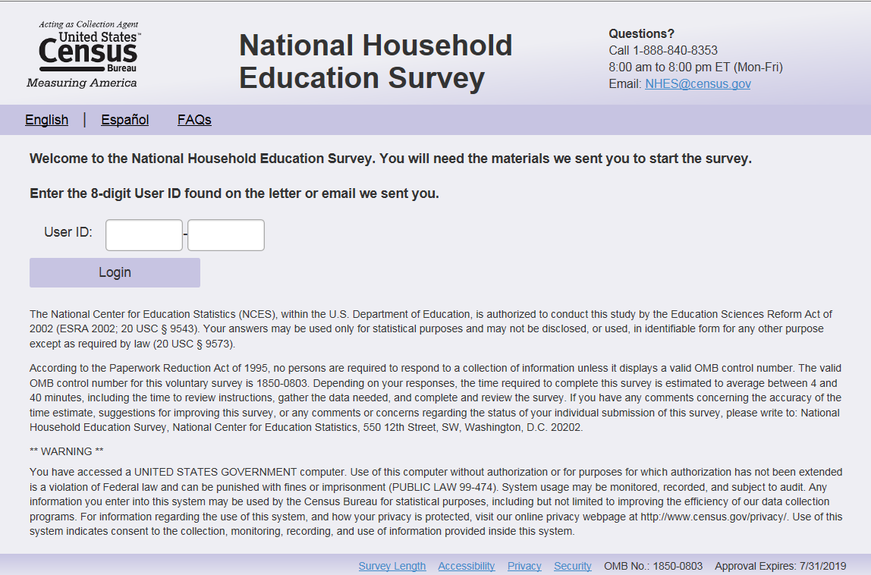
English Text Reads:
Welcome to the National Household Education Survey. You will need the materials we sent you to start the survey.

Enter the 8-digit User ID provided on the letter that we sent you.

User ID:

[Background function (not on the screen): I’m not a robot (reCAPTCHA verification)]
Login (button)
In the upper right corner:

Questions?
Call 1-888-840-8353
8:00 am to 8:00 pm ET (Daily)
Email: NHES@census.gov (make this a dark blue color so that it’s 508 compliant, similar to Accessibility and Security Items).

NCES authority to collect and confidentiality/cybersecurity pledge:

The National Center for Education Statistics (NCES), within the U.S. Department of Education, is authorized to conduct this survey by the Education Sciences Reform Act of 2002 (ESRA 2002, 20 U.S.C. §9543). All of the information you provide may be used only for statistical purposes and may not be disclosed, or used, in identifiable form for any other purpose except as required by law (20 U.S.C. §9573 and 6 U.S.C. §151).

OMB Paperwork Reduction Act (PRA) statement:
According to the Paperwork Reduction Act of 1995, no persons are required to respond to a collection of information unless it displays a valid OMB control number. The valid OMB control number for this voluntary information collection is XXXX-XXXX. The time required to complete this information collection is estimated to average between 3 and 30 minutes per response, including the time to review instructions, search existing data resources, gather the data needed, and complete and review the information collection. If you have any comments concerning the accuracy of the time estimate, suggestions for improving this survey, or any comments or concerns regarding the status of your individual submission of this survey, please e-mail: nhes@census.gov or write directly to: Michelle McNamara, National Center for Education Statistics (NCES), PCP, 550 12th St., SW, 4th floor, Washington, DC 20202

Warning message:

U.S. Census Bureau Notice and Consent Warning
You are accessing a United States Government computer network. Any information you enter into this system is confidential. It may be used by the Census Bureau for statistical purposes and to improve the website.
Use of this system indicates your consent to collection, monitoring, recording, and use of the information that you provide for any lawful government purpose. So that our website remains safe and available for its intended use, network traffic is monitored to identify unauthorized attempts to access, upload, change information, or otherwise cause damage to the web service. Use of the government computer network for unauthorized purposes is a violation of Federal law and can be punished with fines or imprisonment (PUBLIC LAW 99-474).

Spanish text reads:
Bienvenidos a la Encuesta Nacional en Hogares sobre Educación. Usted necesitará los materiales que le enviamos para comenzar la encuesta.
Escriba los 8-dígitos de identificación del usuario que están en la carta que le enviamos.

User ID:

[Background function (not on the screen): No soy un robot (reCAPTCHA verification)]
Iniciar sesión (button)

In the upper right corner:
¿Preguntas?
Llame al 1-888-840-8353
8:00 am a 8:00 pm ET (Diariamente
Correo electrónico: NHES@census.gov(make this a dark blue color so that it’s 508 compliant, similar to Accessibility and Security Items).

NCES authority to collect and confidentiality/cybersecurity pledge:
El Centro Nacional para Estadísticas de la Educación (NCES por sus siglas en inglés), dentro del Departamento de Educación de los Estados Unidos está autorizado a realizar esta Encuesta Nacional en Hogares sobre Educación (NHES por sus siglas en inglés) por medio de la Reforma a la Ley de las Ciencias de la Educación del 2002 (ESRA 2002, título 20: sección 9543). La Oficina del Censo de Estados Unidos administra esta encuesta voluntaria en nombre de NCES. No hay sanciones si decide no participar en este estudio. Toda la información que brinde puede ser utilizada solo con fines estadísticos y no puede divulgarse ni usarse en forma identificable para ningún otro fin, excepto cuando lo exija la leyley (20 U.S.C. §9573 y 6 U.S.C. §151).
OMB Paperwork Reduction Act (PRA) statement:
De acuerdo a la Ley de Reducción de Papeleo de 1995, no se requiere que ninguna persona responda a una recopilación de información a menos que muestre un número de control OMB válido. El número de control OMB válido para encuesta voluntaria es XXXX-XXXX. El tiempo requerido para completar esta encuesta se estima en un promedio de 3 a 30 minutos por respuesta, incluido el tiempo necesario para revisar las instrucciones, reunir los datos necesarios y completar y revisar la encuesta. Si tiene algún comentario sobre la precisión del tiempo estimado, las sugerencias para mejorar esta encuesta, o cualquier comentario o inquietud con respecto al estado de su presentación individual de esta encuesta, por favor envíe un correo electrónico a: NHES@census.gov o escriba a: Michelle McNamara, National Center for Education Statistics (NCES), PCP, 550 12th Street, SW, 4th floor, Washington, D.C. 20202.

U.S. Census Bureau Notice and Consent Warning:
Aviso de la Oficina del Censo de los EE. UU. y Advertencia sobre el consentimiento
Usted está accediendo a una red de computación del gobierno de los Estados Unidos. Toda la información que escriba en este sistema es confidencial. La Oficina del Censo puede usar dicha información para propósitos estadísticos y para mejorar el sitio web.
El uso de este sistema indica su consentimiento a que recopilemos, monitoreemos, registremos y usemos la información que usted proporcione para cualquier propósito legal del gobierno. Con el fin de que nuestro sitio web siga siendo seguro y que siga disponible para el uso al que está destinado, monitoreamos el tráfico en la red para identificar los intentos no autorizados de acceder, subir o cambiar información, o de dañar de alguna otra manera el servicio del sitio web. El uso de la red de computación del gobierno para fines no autorizados se trata de una violación de las leyes federales y puede ser penalizado con multas o encarcelamiento (LEY PÚBLICA 99-474).

Skips:
If this is the first time logging in, go to the PIN page-verification (first_pin). If this is not the first time logging in, go to PIN Page-returning (return_pin). If “Forgot PIN?” link (Spanish: ¿Olvidó su código PIN?) is clicked, go to PIN Reset (recovery) page.

Programming specifications:
- User ID Field: User IDs will be 8 digits, but the User ID field will be nine digits in length to accommodate a masked hyphen; once a respondent enters the first four digits, the hyphen will appear and separate these digits from the remaining four.
- reCAPTCHA: This happens in the background without the user clicking a box. If the system suspects that the user is suspicious and the system is at risk, the user may be required to complete a visual verification exercise (e.g., to select all squares that include a crosswalk). The reCAPTCHA verification process must be successfully completed before the user is able to progress to the next screen by clicking “Login”.
- Do not display the headings “NCES authority to collect and confidentiality/cybersecurity pledge:” and “Warning messages:” on login page.
- Log-in PIN entry does not work well with the accessibility reader. It needs to be reprogrammed to put focus on the PIN field.
- If the User ID is not recognized, display the following error message:
- English: “The User ID entered is invalid. Please check your User ID and try again. For assistance, call 1-888-840-8353.”
- Spanish: “Usted ha ingresado una identificación que no es válida. Por favor verifique su identificación e intente de nuevo. Para recibir ayuda, por favor comúniquese con la Oficina del Censo al 1-888-840-8353”

Item: PIN Page - returning (pin returning)

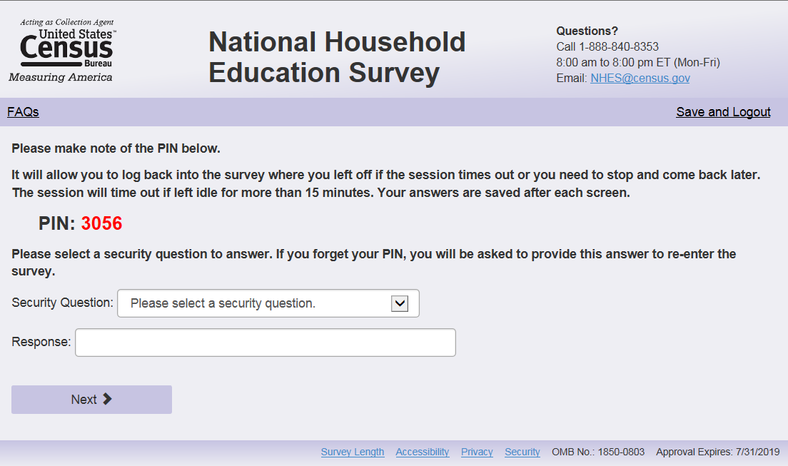

English Text Reads:
Enter the 4-digit PIN we gave you when you first logged in.
PIN: (response box)
“Login” (button)

Spanish Text reads:

Escriba el código PIN de 4 dígitos que le dimos cuando inició la sesión la primera vez.
“Iniciar sesión” (button)
Skips:
If PIN is authenticated, go to Welcome back (welcome_back) page.

Logic checks/programming specifications:
Display on the same page as Log In Page (login). Display below User ID box. Display text on the right of PIN response box:
(Returning users only)
A ‘Forgot PIN?’ link will also be available under the PIN box. (Spanish: ¿Olvidó su código PIN?)
If the user cannot be authenticated after entering the PIN, display the following error message under the PIN box:
- English: “The User ID or PIN entered is invalid. Please check your User ID and PIN and try again. For assistance, call 1-888-840-8353.”
- Spanish: “Usted ha ingresado una identificación o PIN que no es válida. Por favor verifique su identificación y PIN e intente de nuevo. Para recibir ayuda, por favor comúniquese con la Oficina del Censo al 1-888-840-8353'”
If the user clicks ‘Forgot PIN?’, then go to PIN Reset (recovery) page.

Item: PIN Page - verification (pin verification)

English Text Reads:
Please make note of the PIN below.
The PIN will allow you to log back into the NHES survey if the session times out or you need to stop and come back later. Your answers are saved after each screen.
The session will time out if left idle for more than 15 minutes.
PIN: XXXX
Please select a security question to answer. If you forget your PIN, you will be asked to provide this answer to re-enter the survey.
Security Question: Drop down menu with default questions
* Please select a security question. (default)
* What is the name of your first pet?
* In what city were you born?
* What is your paternal grandfather’s first name?
* What was the last name of your third grade teacher?
* Who was your childhood hero?
* What is the name of your favorite pet?
* When you were young what did you want to be when you grew up?

Response: [50 character response box]

“Next” (button)

Spanish Text reads:

Anote el código PIN a continuación.
El PIN le permitirá reconectarse a la encuesta en el punto donde se quedó si la sesión termina o si necesita regresar más tarde.
La sesión caducará si permanece inactiva durante más de 15 minutos.
PIN: XXXX
Seleccione una pregunta de seguridad para contestarla. Si olvida su código PIN, le pedirán que responda a esta respuesta para regresar a la encuesta.
Pregunta de seguridad: Drop down menu with default questions
*Seleccione una pregunta de seguridad. (default)
*¿Cuál era el nombre de su primera mascot?
*¿En qué ciudad nació usted?
*¿Cuál era el nombre de su abuelo paterno?
*¿Cuál era el apellido de su maestro de tercer grado?
*¿Quién era su héroe durante la infancia?
*¿Cuál era el nombre de su mascota preferida?
*De joven, ¿qué quería ser cuando fuera grande?

Respuesta: [50 character response box]
“Siguiente” (button)

Logic checks/programming specifications:
- The instrument should generate a 4-digit pin that will allow the user to log back into the instrument.
- The response box should NOT be case-sensitive.

Item: PIN Reset and Recovery (recovery)
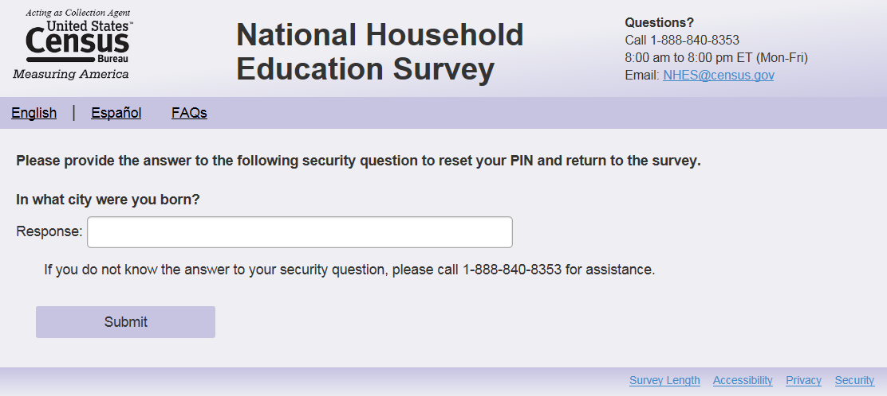

English Text Reads:
Please provide the answer to the following security question to reset your PIN and return to the survey.
Security Question: (display verification question selected on PIN screen in bold)
Answer: [Response box]
Please call 1-888-840-8353 if you do not know the answer to your security question.
Return to login (button) Submit (button)

Spanish Text reads:
Responda a la siguiente pregunta de seguridad para regresar a la encuesta.
Security Question: (display verification question selected on PIN screen in bold)
Respuesta: [Response box]
Por favor llame al número 1-888-840-8353 si no sabe la respuesta a su pregunta de seguridad
Return to login(button) Siguiente (button)
Skips:
If correct response is entered, go to New PIN Page (newpin).
If Return to login button is clicked, go to login page.
Logic checks/programming specifications:
The response box should NOT be case-sensitive.

On blank or incorrect entry, display error message: “You have entered an incorrect response. Please provide your answer to the following security question to reset your PIN and return to the survey.” Spanish: “Usted ha ingresado una respuesta incorrecta. Por favor responda la siguiente pregunta de seguridad para renovar su código PIN y volver a la encuesta.”

When the total number of attempts between entering a PIN and answering a verification question has reached three, display the following error message: “You have entered an incorrect response for the third time, and your survey is now locked. Please call the Census Bureau for assistance at 1-888-840-8353.” Spanish: Ha introducido una respuesta incorrecta por tercera vez y su encuesta ahora está bloqueada. Para recibir ayuda, por favor comúniquese con la Oficina del Censo al 1-888-840-8353.”

Pin Reset Instructions for Census:
If a respondent forgets their PIN and security question, below are the only 2 scenarios for which someone can have their PIN reset:
- The screener is not complete; we reset the case and wipe out the Screener data.
- The screener is complete and no one was sampled; we reset the case and wipe out screener data.

For other scenarios, including those listed below, we can NOT reset the PIN:

- Someone finished the Screener, someone was sampled, and they did NOT start the topical. (This would mean we would need to reset the Screener, which COULD result in someone else in the household being sampled. Once sampling occurs, resetting the Screener cannot happen, it messes up operational mailout activities and sampling activities on the backend for ASD); OR,
- Someone finished the Screener, someone was sampled, and they’ve started the topical; OR,
- Someone completed the topical.

Item: New PIN Page (newpin)

If a respondent is unable to provide their PIN, they must provide the answer to the verification question they selected during their first login. If the correct answer is submitted, the respondent will receive a new PIN and be asked to log in again.

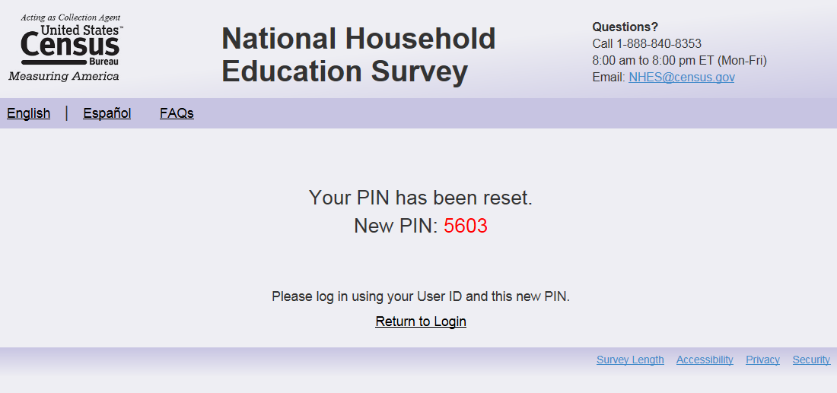

English Text Reads (centered on screen):
Your PIN has been reset:
New PIN: XXXX
Please log in using your User ID and this new PIN.
Return to Login (button)
Spanish text reads (centered on screen):
Su PIN se ha cambiado.
Nuevo PIN: XXXX
Para inciar su seción escriba su identificación de usuario y su nuevo PIN.
Regresar a Entrar a su cuenta
Skips:
If the respondent clicks the Return to Login button, go to login page. If the respondent clicks the Return to Login button, go to login page.

Item: Welcome back (welcome_back)

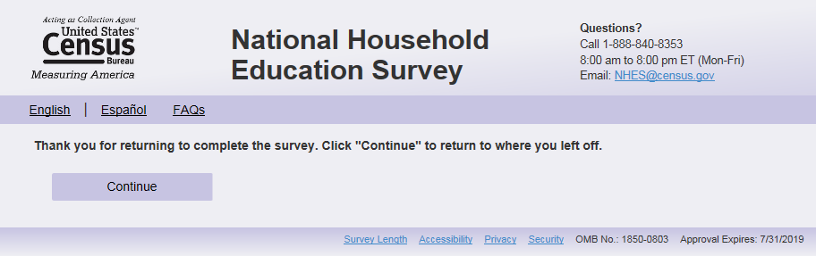

English Text reads:
Welcome back! Click “Continue” to return to where you left off.
[As a reminder, answer these questions thinking about [this child].]

Spanish text reads:
¡Bienvenido(a)! Presione "Continuar" para regresar donde se había quedado. [Recuerde que tiene que contestar a estas preguntas pensando sobre [este niño (esta niña)] ]Skips:
Go to last page saved.

Logic checks/programming specifications
The text should be top left corner, not indented and in bold font.
Display “Continue” button. (Spanish: “Continuar”)
English: Only display “As a reminder, answer these questions thinking about [this child].” after sampling of the child has occurred. Leave blank if child sampling has not occurred.
Spanish: Only display “Recuerde que tiene que contestar a estas preguntas pensando sobre [este niño (esta niña)]” after sampling of the child has occurred. Leave blank if child sampling has not occurred.
Fills for [this child] should follow the column referring to the fills “on the first screen page, where respondents enter the survey” in “Fills throughout survey” section. For example, if full information was provided on screener, the text should read:
As a reminder, answer these questions thinking about "[NAME], the [male/female] child or youth born in [DOB month], [DOB year], in [GRADE]". (Spanish: Le recordamos que tiene que contestar a estas preguntas pensando en [NAME], [el niño/la niña] o joven nacido(a) el [DOB month] del [DOB year], que está en [GRADE].)
If no name was provided, the text should read:
As a reminder, answer these questions thinking about "The [male/female] child or youth born in [DOB month], [DOB year], in [GRADE]" (Spanish: Le recordamos que tiene que contestar a estas preguntas pensando en [el niño/la niña] o joven nacido(a) el [DOB month] del [DOB year], que está en [GRADE].)

Item: Accessibility Screen (accessibility)
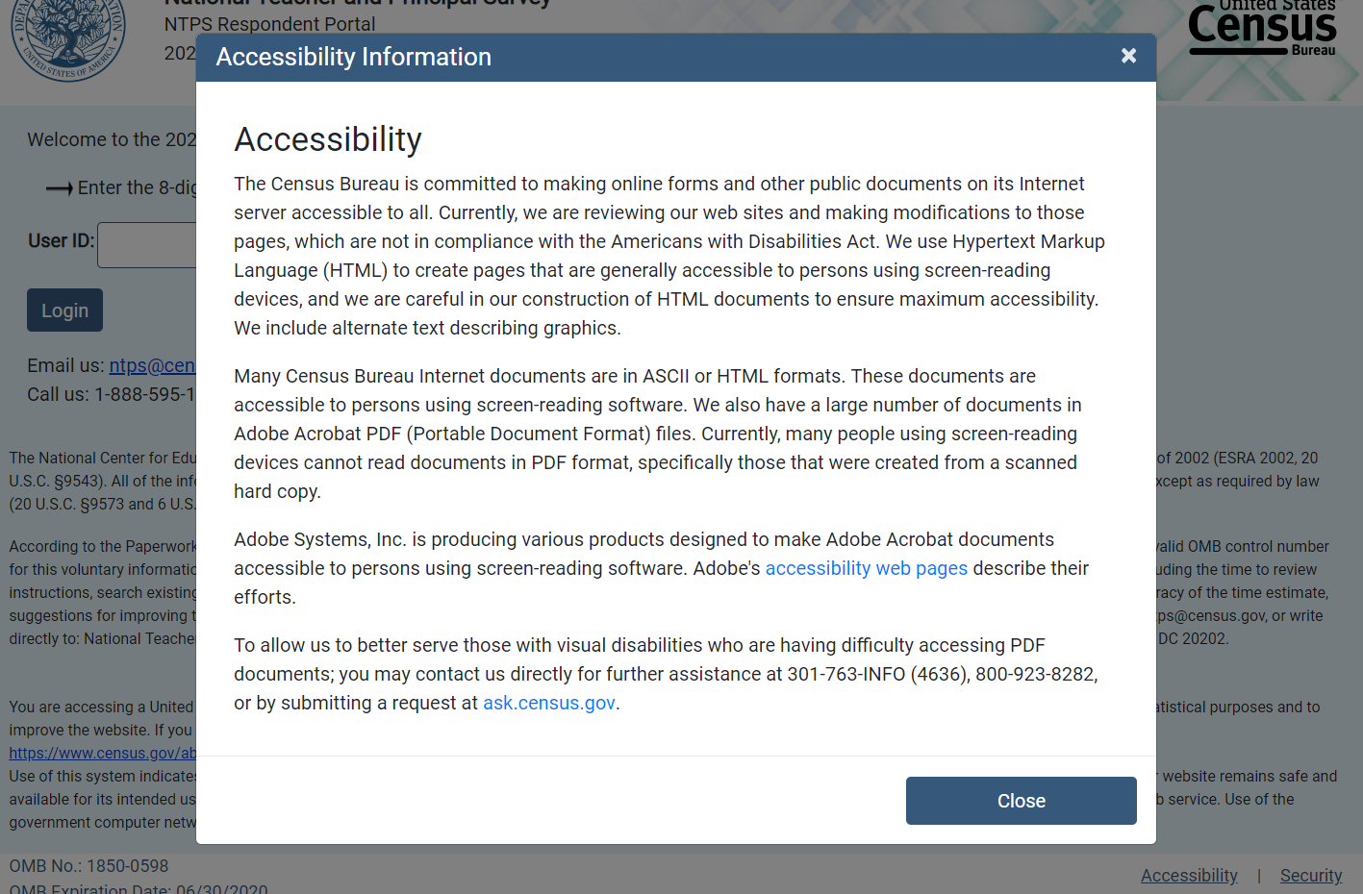

Accessibility
The Census Bureau is committed to making online forms and other public documents on its Internet server accessible to all. Currently, we are reviewing our web sites and making modifications to those pages, which are not in compliance with the Americans with Disabilities Act. We use Hypertext Markup Language (HTML) to create pages that are generally accessible to persons using screen-reading devices, and we are careful in our construction of HTML documents to ensure maximum accessibility. We include alternate text describing graphics.
Many Census Bureau Internet documents are in ASCII or HTML formats. These documents are accessible to persons using screen-reading software. We also have a large number of documents in Adobe Acrobat PDF (Portable Document Format) files. Currently, many people using screen-reading devices cannot read documents in PDF format, specifically those that were created from a scanned hard copy.
Adobe Systems, Inc. is producing various products designed to make Adobe Acrobat documents accessible to persons using screen-reading software. Adobe's accessibility web pages describe their efforts.
To allow us to better serve those with visual disabilities who are having difficulty accessing PDF documents; you may contact us directly for further assistance at 301-763-INFO (4636), 800-923-8282, or by submitting a request at ask.census.gov.

Close
Logic checks/programming specifications
When user clicks on the “Accessibility” link on the bottom right hand corner of all NHES web pages, the user should be taken to a pop up window. The above text should be displayed to users.
Information about Accessibility is available to respondents via the link in the bottom right hand corner of all survey instrument screens. The information about Accessibility appears as a modal pop-up. A “Close” button will also be located on this page to close the pop-up.

Item: Security Screen (security)
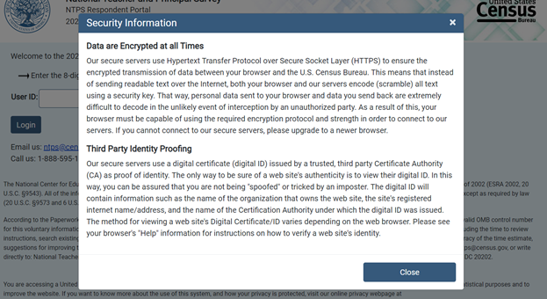
Data are Encrypted at all Times

Our secure servers use Hypertext Transfer Protocol over Secure Socket Layer (HTTPS) to ensure the encrypted transmission of data between your browser and the U.S. Census Bureau. This means that instead of sending readable text over the Internet, both your browser and our servers encode (scramble) all text using a security key. That way, personal data sent to your browser and data you send back are extremely difficult to decode in the unlikely event of interception by an unauthorized party. As a result of this, your browser must be capable of using the required encryption protocol and strength in order to connect to our servers. If you cannot connect to our secure servers, please upgrade to a newer browser.

Third Party Identity Proofing
Our secure servers use a digital certificate (digital ID) issued by a trusted, third party Certificate Authority (CA) as proof of identity. The only way to be sure of a web site's authenticity is to view their digital ID. In this way, you can be assured that you are not being "spoofed" or tricked by an imposter. The digital ID will contain information such as the name of the organization that owns the web site, the site's registered internet name/address, and the name of the Certification Authority under which the digital ID was issued. The method for viewing a web site's Digital Certificate/ID varies depending on the web browser. Please see your browser's "Help" information for instructions on how to verify a web site's identity.
Close

Logic checks/programming specifications
The formatting of this page should mirror that on the “FAQs” page.

When user clicks on the “Security” link on the bottom right hand corner of all NHES web pages, the user should be taken to a pop up window. The above text should be displayed to users.
Information about Security is available to respondents via the link in the bottom right hand corner of all survey instrument screens. The information about Security appears as a modal pop-up. A “Close” button will also be located on this page to close the pop-up.

Instructions
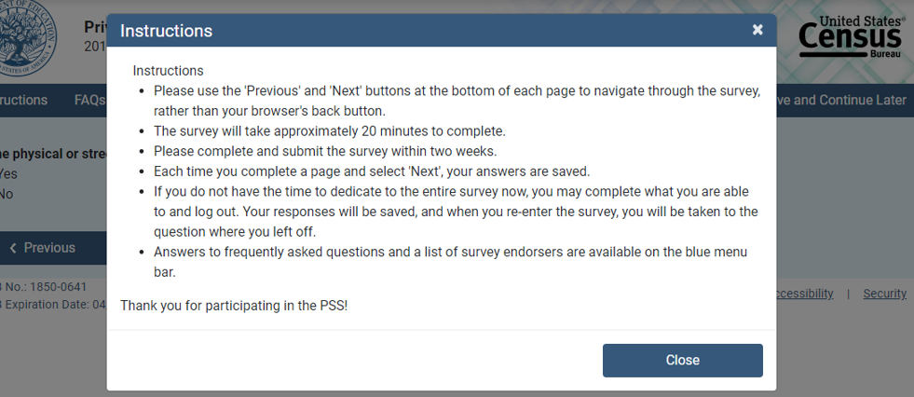
- English text reads:
- Please use the ‘Previous’ and ‘Next’ buttons at the bottom of each page to navigate through the survey, rather than your browser’s back button.
- Each time you complete a page and select ‘Next’, your answers are saved.
- The survey will take approximately 3 to 30 minutes to complete.
- Please complete and submit the survey as soon as possible.
- If you do not have the time to dedicate to the entire survey now, you may complete what you are able to and log out. Your responses will be saved. When you re-enter the survey, you will provide your user ID and PIN, and will be taken to the question where you left off.
- Answers to frequently asked questions are available on the blue menu bar.
- If you would like to complete the survey in Spanish, please click “Español” on the top left corner of the web page.

Thank you for participating in the NHES!

Spanish text reads:
- Utilice los botones "Anterior" y "Siguiente" en la parte inferior de cada página para navegar a través de la encuesta, en lugar del botón Atrás de su navegador.
- Cada vez que completa una página y selecciona 'Siguiente', sus respuestas se guardan.
- La encuesta tardará aproximadamente de 3 a 30 minutos en completarse.
- Por favor, complete y envíe la encuesta lo antes posible.
- Si no tiene el tiempo para dedicar a toda la encuesta ahora, puede completar lo que pueda y cerrar sesión. Sus respuestas se guardarán. Cuando vuelva a ingresar a la encuesta, proporcionará su identificación del usuario de sesión y PIN, y se le llevará a la pregunta donde la dejó.
- Las respuestas a las preguntas más frecuentes están disponibles en la barra de menú azul.
- Si desea completar la encuesta en English, haga clic en "English" en la esquina superior izquierda de la página web.
¡Gracias por participar en el NHES!
Logic checks/programming specifications
Instructions are available to respondents via the menu bar. Instructions appear as a modal pop-up when users clicked on ‘Instructions’ on menu bar. A “Close” button will also be located on this page to close the pop-up.

FAQs Tab
Frequently Asked Questions (FAQs) are available to respondents via the menu bar. The FAQs appear as a modal pop-up. In the modal pop-up window, each question will be listed as a link and, once selected, will take the respondent to the applicable text. A “Close” button will also be located on this page to close the pop-up modal window.

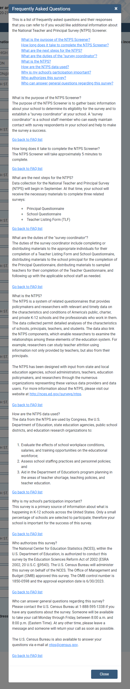

English text reads:
Frequently Asked Questions about the National Household Education Survey

Q: Why was I chosen for this survey?
A: Your address was randomly selected to be part of this survey from a list of all the addresses in the United States. We do not know who lives at each address. However, every address had a chance to be selected. Now that your address was chosen, your response is vital to the success of the study!

Q: No children live here. Should I give this survey to a neighbor or family member who has children?
A: No. Now that your address has been chosen, information about your household’s experiences will represent hundreds of households like yours. Together with other survey participants, your experiences will represent those of everyone in the United States. We cannot replace you. You should not give the survey to another household even if you do not have children.

Q: Who is doing the survey?
A: This survey is conducted by the Federal Government. The U.S. Census Bureau is doing the data collection for this study by the National Center for Education Statistics, within the U.S. Department of Education. This survey has been approved by the Office of Management and Budget, the office that reviews all federally sponsored surveys.
Q: Why should I take part in this study?
A: The survey results will be used by policymakers and researchers to improve programs for children. This survey is the best way to learn about children’s care, early learning activities, and schooling from your perspective. While the Census Bureau collects similar information, this survey is unique and asks for up-to-date information not available from any other sources, including other government agencies.
Q: How will the responses I provide be used? Will my privacy be protected?
A: Your responses will be combined with those of others to produce statistical summaries and reports. Your address and household members’ names will not be included on anything the study releases or shares. Your responses may be used only for statistical purposes and may not be disclosed, or used, in identifiable form for any other purpose except as required by law.
Q: How much time will it take to respond to this survey?
A: If you have no children, the survey will take about 3 minutes, including the time for reviewing instructions. If you do have children, the survey will take about 30 minutes or less.
Q: If there are no children or anyone currently in school in my household, should I respond?
A: Yes, you should respond to this survey. We need responses from households without children to get survey results that represent everyone in the U.S. population. If there are no children in your household, you will only need to answer one question!

Q: Who should I contact if I have questions or comments about this survey?
A: If you have any questions about this survey or the status of your individual survey submission, contact the Census Bureau toll-free at 1-888-840-8353.

Close Button

Spanish text reads:
Preguntas Más Frecuentes sobre la Encuesta Nacional en Hogares sobre la Educación
P: ¿Por qué fui seleccionado para esta encuesta?
R: Su dirección fue seleccionada al azar de una lista de direcciones en los Estados Unidos para tomar parte de esta encuesta. No sabemos quiénes viven en cada dirección. Sin embargo, cualquiera de estas direcciones podría haber sido seleccionada. Ahora que su dirección fue escogida, ¡su respuesta es vital para el éxito de este estudio!
P: No viven niños aquí. ¿Puedo darle la encuesta a un vecino o pariente que tenga niños?
R: No. Ahora que su dirección ha sido seleccionada, la información sobre las experiencias de su hogar representará a cientos de hogares como el suyo. Junto con otras encuestas participantes, sus experiencias representarán a las de todos en los Estados Unidos. No podemos reemplazarlo. No deberá usted dar la encuesta a otro hogar, aun si usted no tiene niños.
P: ¿Quién está haciendo la encuesta?
R: Está encuesta es realizada por el Gobierno Federal. La Oficina del Censo de los EE. UU. está realizando la recolección de datos para este estudio del Centro Nacional para Estadísticas de la Educación, del Departamento de Educación de los EE. UU. Esta encuesta ha sido aprobada por la Oficina de Administración y Presupuesto, la oficina que revisa todas las encuestas auspiciadas a nivel federal.
P: ¿Por qué debería tomar parte de esta encuesta?
R: Los resultados de esta encuesta serán usados por legisladores e investigadores para mejorar los programas para niños. Esta encuesta es la mejor forma de saber sobre el cuidado de niños, actividades tempranas de aprendizaje, y enseñanza desde su perspectiva. Aunque le Oficina del Censo recoge información similar, esta encuesta es única, y le pregunta por información actualizada que no podemos obtener de ninguna otra fuente, incluyendo otras agencias gubernamentales.
P: ¿Cómo serán usadas sus respuestas? ¿Estará protegida mi privacidad?
R: Sus respuestas serán mezcladas con la de otros para preparar resúmenes e informes estadísticos. Su dirección y nombres de los miembros de su hogar no serán incluidos en nada que este estudio publique o comparta. Sus respuestas pueden ser usadas solo para fines estadísticos y no pueden ser divulgadas o usadas en ninguna forma identificable con ningún otro propósito excepto cuando así lo requiera la ley.
P: ¿Cuánto tiempo llevará el responder a esta encuesta?
R: Si no tiene hijos, la encuesta tomará aproximadamente 3 minutos, incluido el tiempo para leer las instrucciones. Si tiene hijos, completar la encuesta tomará cerca de 30 minutos o menos.
P: ¿Si en mi hogar no hay niños o alguien que esté actualmente en la escuela, debería responder?
R: Si. Usted debería responder a esta encuesta. Necesitamos respuestas de hogares que no tienen niños para obtener resultados de la encuesta que representen a cada uno en la población de los EE. UU. ¡Si no hay niños en su hogar, usted necesitará responder solo a una pregunta!
P: ¿Con quién debería comunicarme si tengo preguntas sobre esta encuesta?
R: Si tiene preguntas sobre esta encuesta, o estatus de la entrega individual de su encuesta, comuníquese con la Oficina del Censo al número gratis 1-888-840-8353.

.
Cerrar Button

Screener Roster questions:

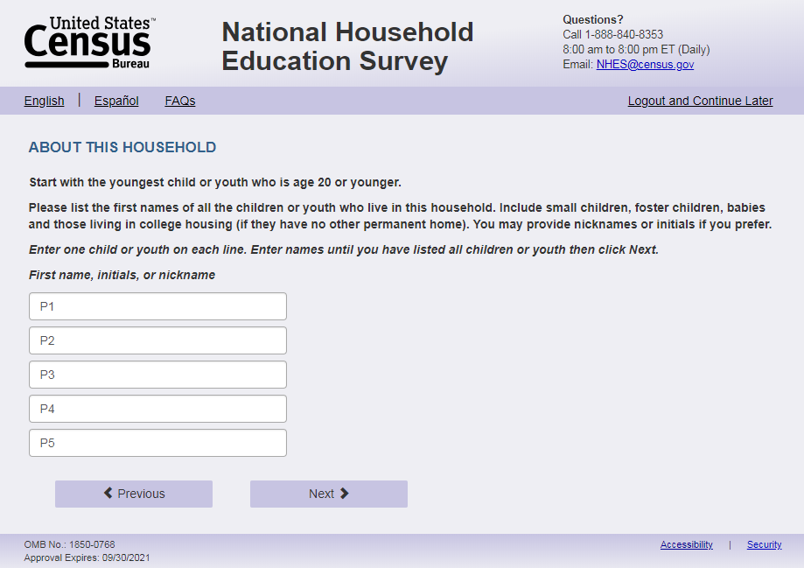
English Respondent Text Reads:
Please list the first name of each household child age 20 or younger. If you prefer, you may use initials or nicknames instead of names.
[Start with the youngest child.]
______________ (s1_p1name)
______________ (s1_p2name)
______________ (s1_p3name)
______________ (s1_p4name)
______________ (s1_p5name)
______________ (s1_p6name)
______________ (s1_p7name)
______________ (s1_p8name)
______________ (s1_p9name)
______________ (s1_p10name)

Spanish Respondent Text Reads:
Por favor, enumere los nombres de todos los niños o jóvenes que viven en este hogar de 20 años o menos. Si lo prefiere, puede usar iniciales o apodos en vez de nombres.
[Empiece con el más pequeño.]
______________ (s1_p1name)
______________ (s1_p2name)
______________ (s1_p3name)
______________ (s1_p4name)
______________ (s1_p5name)
______________ (s1_p6name)
______________ (s1_p7name)
______________ (s1_p8name)
______________ (s1_p9name)
______________ (s1_p10name)

Logic Checks/Programming specifications
Display the number of boxes based on s1_childmany. If s1_childmany is blank display all 10 boxes.
If s1_childmany > 1, display the text in brackets “Start with the youngest child.” Spanish: “Empiece con el más pequeño”
Number of children in the household as referenced in the rest of the web specs is as follows:
- If s1_childmany and the number of names in s1_rosteraname are equal then number of children =s1_childmany
- If s1_childmany and the number of names in s1_rosteraname are not equal (s1_childmany>s1_rosteraname is the only possible scenario since s1_rosteraname only shows the number of boxes reported in s1_childmany) then number of children = number of names in s1_rosteraname
- If s1_childmany is missing, and number of names in s1_rosteraname >0, number of children = number of names in s1_rosteraname.
- If s1_childmany is missing, and number of names in s1_rosteraname are all blank or 0, number of children = 0.
If the number of children entered on s1_rosteraname is less than the number of children entered on s1_childmany, then ask the follow-up screener questions (s1_pXdobmm through s1_pXgrade_web, where X is the number of children reported in s1_rosteraname). If s1_childmany equals the number entered in s1_rosteraname (and s1_childmany and s1_rosteraname is not 0 or blank), then ask about that number in the follow-up screener questions (s1_pXdobmm through s1_pXgrade_web, where X is the number of children reported in s1_childmany and s1_rosteraname), unless that number is 0 or blank, in which follow: If s1_childmany and s1_rosteraname are all blank or 0 then assume no children in household and end survey (follow skip pattern programming for the end survey screen).
If the respondent reports 6 children in s1_childmany but only puts 2 children in s1_p1name and s1_p2name and then reports a child in s1_p6name make sure that the corresponding data for that person in the sex, age, enrollment, and grade questions (s1_pXdobmm through s1_pXgrade_web) aligns with the p3name variable. In 2017 the data output had the name in p1_s6name but the remaining data for that person in s1_p3<variable name>. For sampling purposes the NHES:2023 will only sample from first five children reported (s1_p1-s1_p5).

Multiple question items on 1 page example:
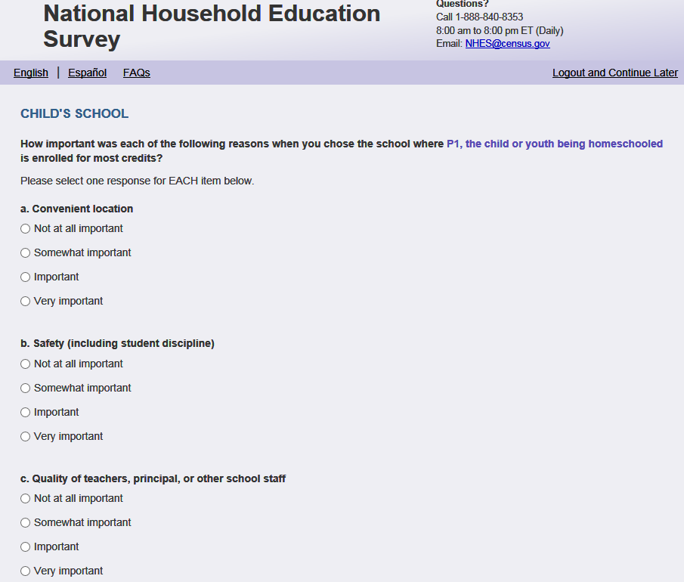

Grid example:
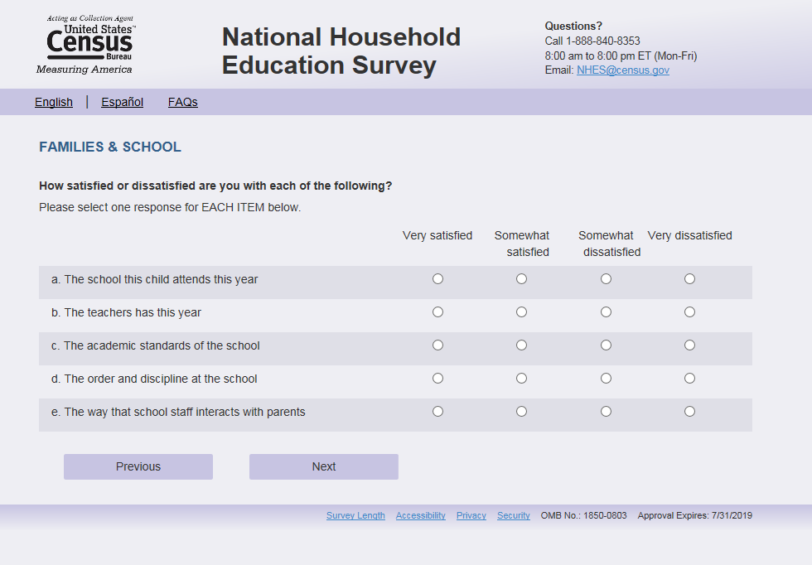

Select all that apply example:
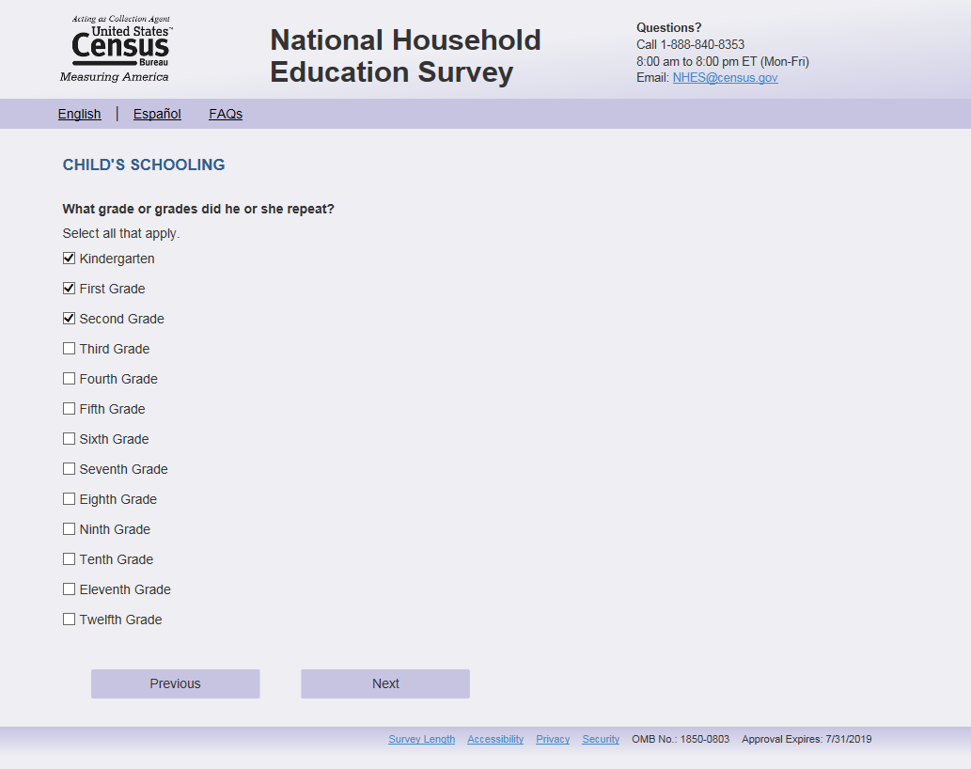

Completed survey screen:
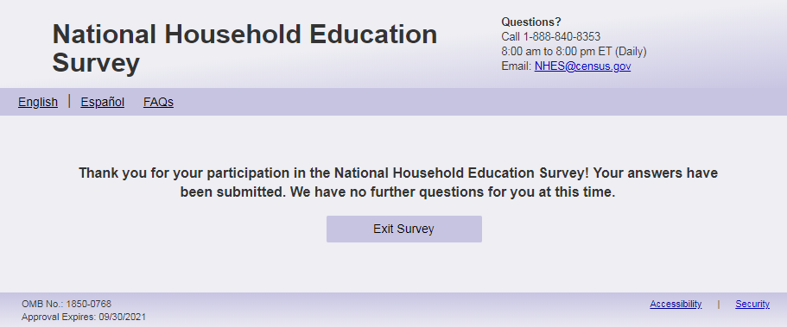
English Text reads (with and without children – no additional incentive):
Thank you for your participation in the National Household Education Survey! Your answers have been submitted. [The remainder of this survey focuses on children age 20 or younger. Because no children age 20 or younger live in your household, we have no further questions for you.] (We have no further questions for you at this time.)

Spanish text reads (with and without children – no additional incentive) :
Gracias por su participación en la Encuesta Nacional en Hogares sobre Educación. Sus respuestas han sido enviadas. [El resto de esta encuesta se centra en niños de 20 años o menos. Debido a que ningún niño de 20 años o menos vive en su hogar, no tenemos más preguntas para usted.] (No tenemos más preguntas.)

English Text Reads (with and without children –additional incentive):
Thank you for your participation in the National Household Education Survey! Your answers have been submitted. [This survey is about children’s care and educational experiences. Since you mentioned you do not have any children age 20 or younger living at this household, you are not eligible for the remainder of this survey. However, your response is still important as it helps us understand your household.] We will mail you $20 to show our appreciation for completing the survey. Please confirm your contact information below to ensure you receive the cash incentive.
To whom should we address the envelope?

Thank you! You should receive your cash incentive soon. If you do not receive it after 3-5 weeks, please call us toll free at 1-888-840-8353.

Spanish Text Reads (with and without children –additional incentive):
Gracias por su participación en la Encuesta Nacional en Hogares sobre Educación. Sus respuestas han sido enviadas. [Esta encuesta es sobre las experiencias de cuidado y educación de los niños. Debido a que usted mencionó que no tiene hijos(as) de 20 años o menos viviendo en este hogar, usted no es elegible para el resto de la encuesta. Sin embargo, su respuesta es importante ya que nos ayuda a entender su hogar.] Le enviaremos por correo $20 para mostrarle nuestro agradecimiento por completar la encuesta. Por favor, confirme su información de contacto a continuación para asegurarse de recibir el incentivo en efectivo.
¿A quién deberíamos dirigirnos el sobre?

¡Gracias! Debería recibir su incentivo en efectivo pronto. Si no lo recibe después de 3-5 semanas, llámenos grátis al 1-888-840-8353.

Timeout Warning:
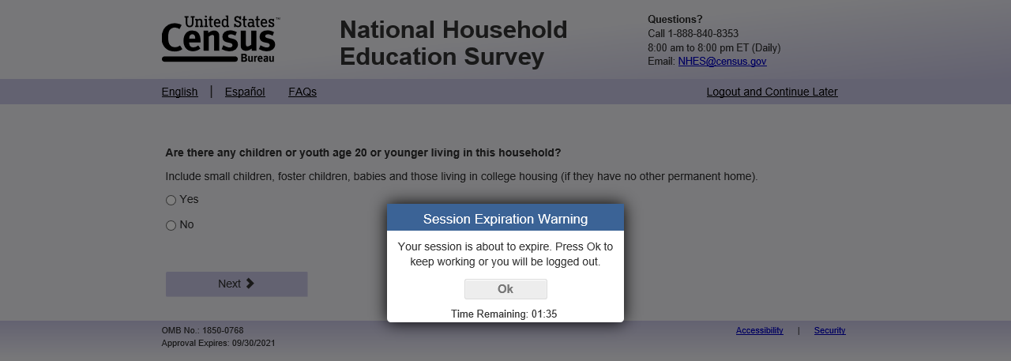
English text reads:
Your session is about to expire. Press Ok to keep working or you will be logged out.
Ok (button)
Time Remaining: (clock countdown)

Spanish text reads:
Su sesión está a punto de caducar. Presione Ok para continuar o se cerrará la sesión.
Ok (button)
Tiempo restante: (clock countdown)

Logic checks/programming specifications
Display this pop-up warning if users are inactive for 10 minutes on item screens, including screener pages and topical pages. The clock countdown starts from 5 minutes, shown on the right of “Time remaining:” (English) “Tiempo restante:” (Spanish).
If users press ‘Ok’, the warning will be removed and users can continue the survey where they got timed-out.

Save and Continue later screen:

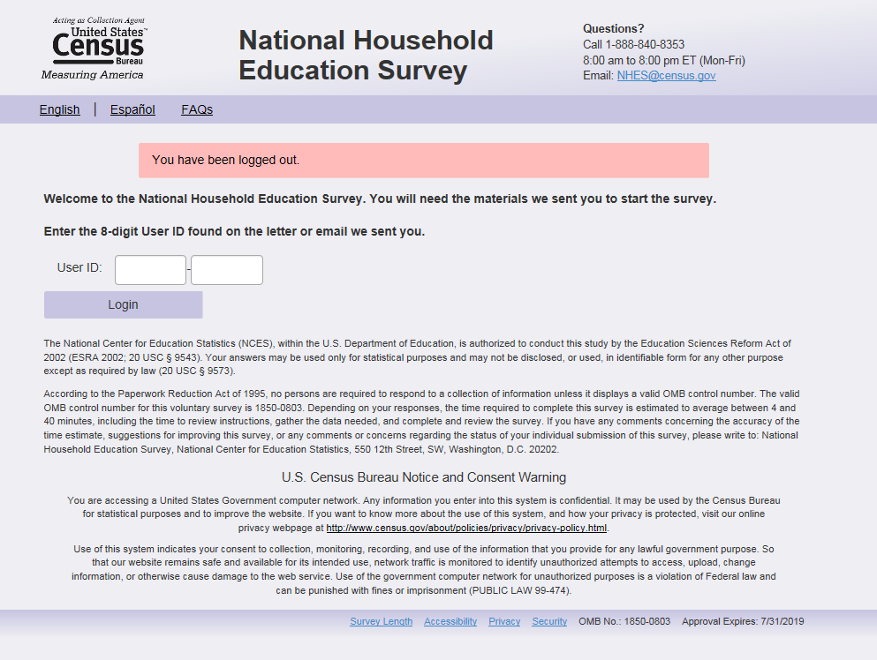

Text on this screen will read:
English text reads:

Your session has been inactive for 15 minutes. Please log in to complete the survey.
User ID: ____ - ____

Spanish text reads:
Su sesión ha estado inactiva durante 15 minutos. Inicie sessión para completar la encuesta.
User ID: ____ - ____

The National Center for Education Statistics (NCES), within the U.S. Department of Education, is authorized to conduct the National Household Education Survey (NHES) by the Education Sciences Reform Act of 2002 (ESRA 2002, 20 U.S.C. §9543). The U.S. Census Bureau is administering this voluntary survey on behalf of NCES. There are no penalties should you choose not to participate in this study. All of the information you provide may be used only for statistical purposes and may not be disclosed, or used, in identifiable form for any other purpose except as required by law (20 U.S.C. §9573 and 6 U.S.C. §151).

According to the Paperwork Reduction Act of 1995, no persons are required to respond to a collection of information unless it displays a valid OMB control number. The valid OMB control number for this voluntary survey is 1850-0768. The time required to complete this survey is estimated to average between 3 and 23 minutes per response, including the time to review instructions, gather the data needed, and complete and review the survey. If you have any comments concerning the accuracy of the time estimate, suggestions for improving this survey, or any comments or concerns regarding the status of your individual submission of this survey, please e-mail: NHES@census.gov or write directly to: Michelle McNamara, National Center for Education Statistics (NCES), PCP, 550 12th Street, SW, 4th floor, Washington, D.C. 20202.

** WARNING **

You have accessed a UNITED STATES GOVERNMENT computer. Use of this computer without authorization or for purposes for which authorization has not been extended is a violation of Federal law and can be punished with fines or imprisonment (PUBLIC LAW 99-474). System usage may be monitored, recorded, and subject to audit. Any information you enter into this system may be used by the Census Bureau for statistical purposes, including but not limited to improving the efficiency of our data collection programs. Use of this system indicates consent to the collection, monitoring, recording, and use of information provided inside this system.

