Software Catalog Login

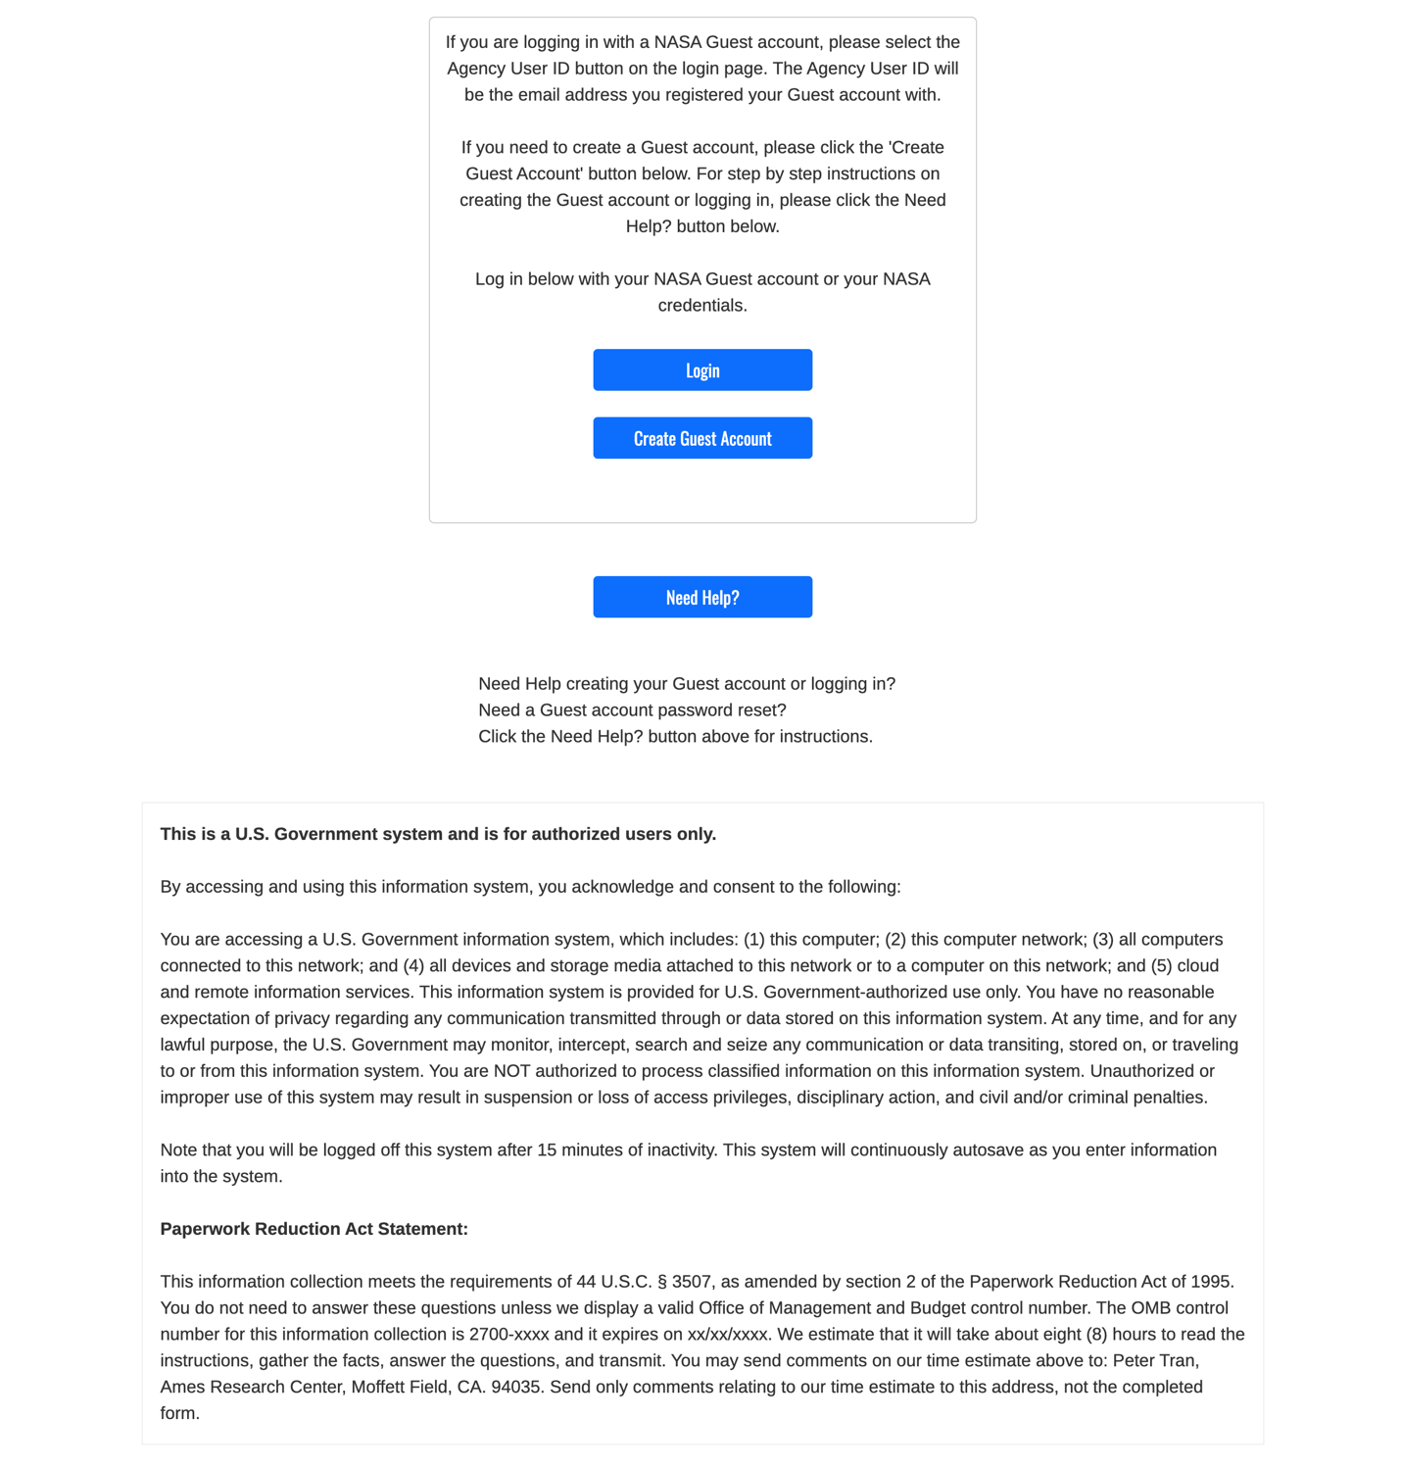

Personal Questionnaire
If the value “Personal” is selected for the field “Intended Use”, the system loads the Personal Questionnaire form.

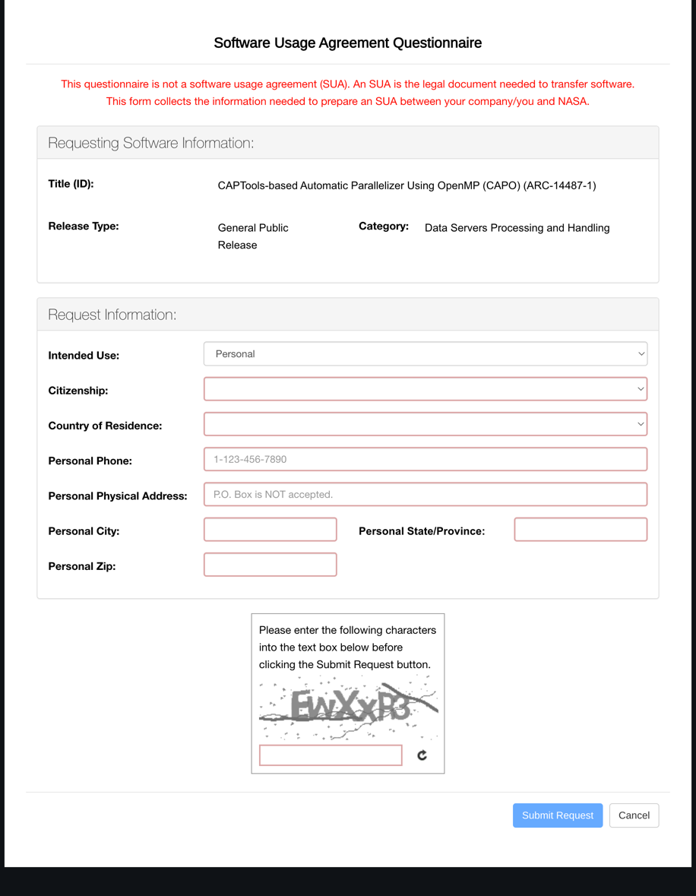

Business/Government Questionnaire (U.S. Federal Government Civil Servant / Active Duty Military)
If the value “Business/Government” is selected for the field “Intended Use” and either value “U.S. Federal Government Civil Servant” or “Active Duty Military” is selected for the “You are requesting as a/an:” field, the system loads the Business/Government Questionnaire (U.S. Federal Government Civil Servant / Active Duty Military) form.
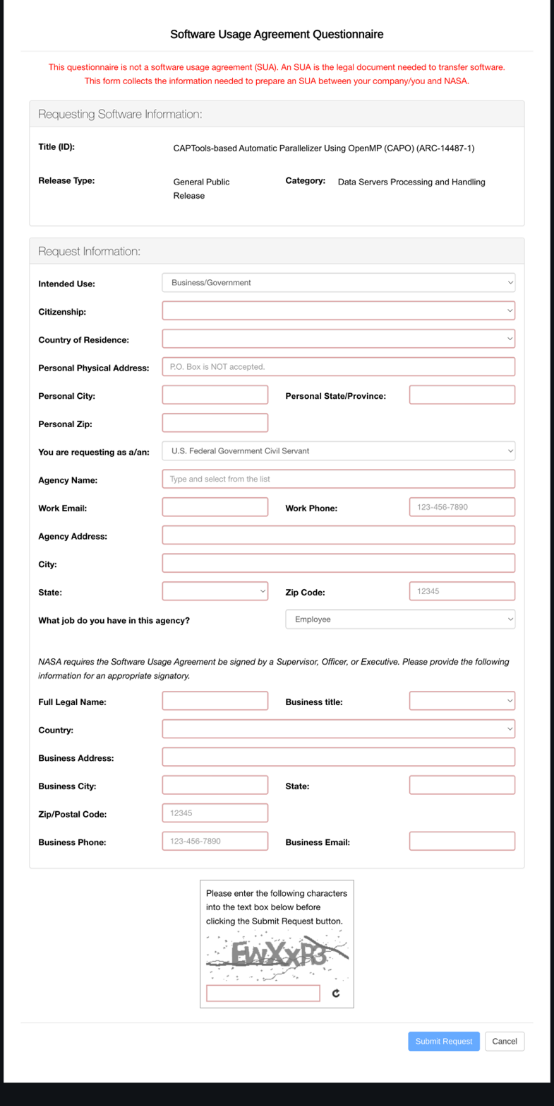

Business/Government Questionnaire (JPL Employee)
If the value “Business/Government” is selected for the field “Intended Use” and the value “JPL Employee” is selected for the “You are requesting as a/an:” field, the system loads the Business/Government Questionnaire (JPL Employee) form.

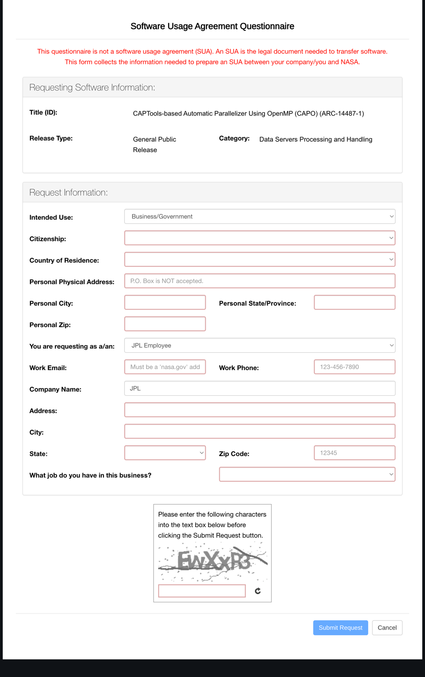

Business/Government Questionnaire (NASA Intern)
If the value “Business/Government” is selected for the field “Intended Use” and the value “NASA Intern” is selected for the “You are requesting as a/an:” field, the system loads the Business/Government Questionnaire (NASA Intern) form.

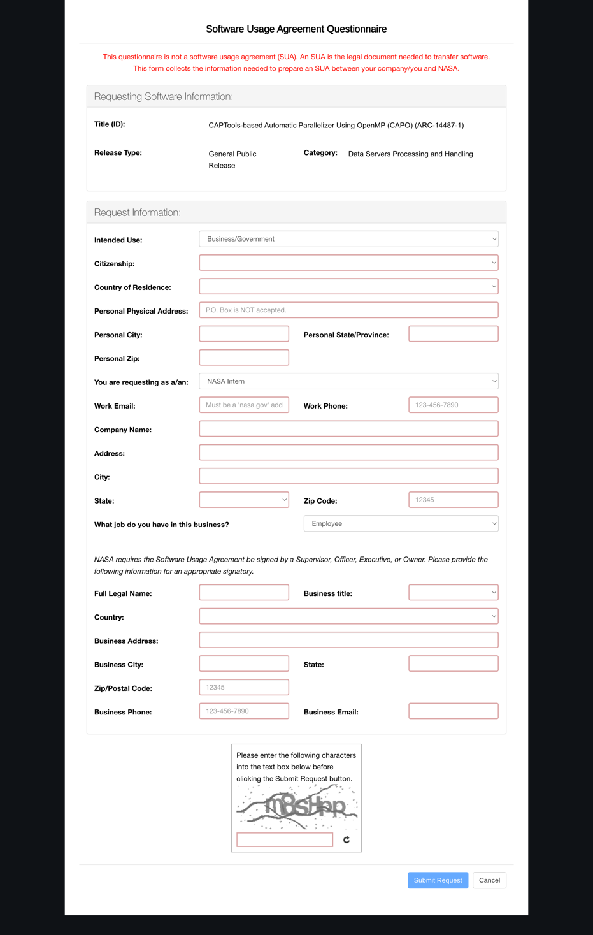

Business/Government Questionnaire (Business or Non-Profit)
If the value “Business/Government” is selected for the field “Intended Use” and the value “Business or Non-Profit” is selected for the “You are requesting as a/an:” field, the system loads the Business/Government Questionnaire (Business) form.

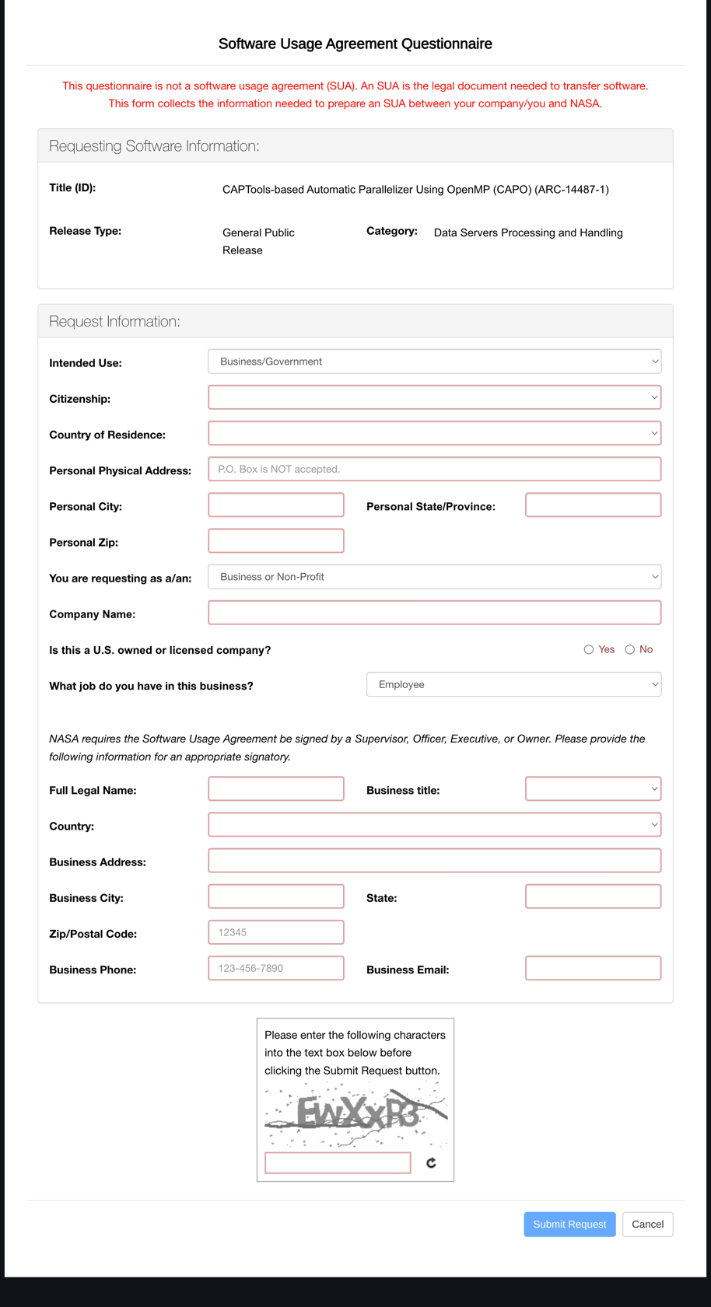

Academic Questionnaire
If the value “Academic” is selected for the field “Intended Use”, the system loads the Academic Questionnaire form.

