Non-substantive Change Request
0535-0001 – Cold Storage
Refrigerated Storage Capacity - October 2023
This non-substantive change request affects the screening questions for the October 2023 Refrigerated Storage Capacity Survey. The changes will provide a clearer flow for the various types of respondents.
These changes will not impact the current sampling methodology, sample size or respondent burden.
The revised Refrigerated Storage Capacity questionnaire is loaded to ROCIS.
The specific changes are listed below in item 2 and 2e:
Screening, Item 2 from
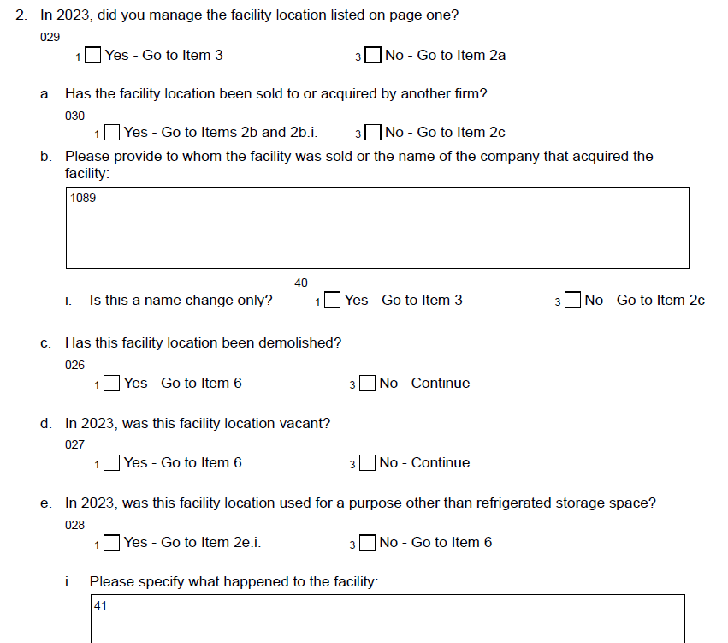
To
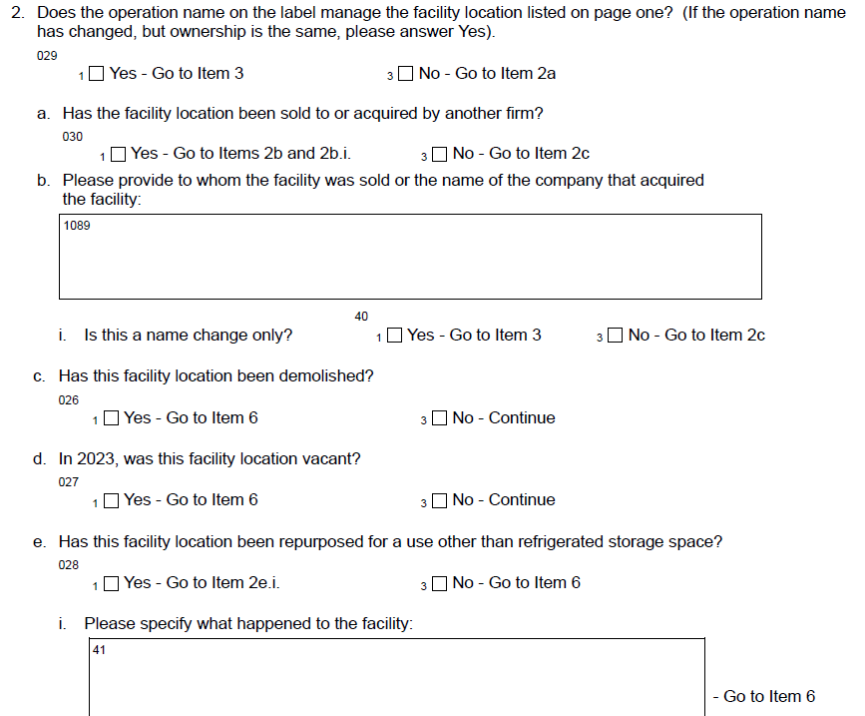

This previous phrasing “did you manage the facility location listed on page one” led to incorrect screenouts.
The survey population for the Refrigerated Storage Capacity Survey is all warehouses that store one of the 110 commodities in the Monthly Cold Storage and are artificially cooled to a temperature of 50 degrees Fahrenheit or lower where food products are placed and held for 30 days or more. These are typically businesses that have accountants, assistants, or secretaries that can provide the requested information when the facility manager is unable to respond.
To account for these potential employees that can provide the requested information, the phrasing “Does the operation name on the label manage the facility location listed on page one.” will be used.

