**Non-substantive Change Request**

**0535-0039 – Fruit, Nut, and Specialty Crops Surveys**

**Fruit And Nut Production and Disposition Inquiry - February 2023**

**Pecan Production and Disposition Inquiry (Version 2 – TX & OK) - February 2023**

**Michigan Fruit Inventory - 2022**

**California Fresh Grape Inquiry - 2022 Crop**

This non-substantive change requests affects four surveys (three currently approved) and the addition of one survey. Each survey’s changes will be addressed separately in this request:

Fruit And Nut Production and Disposition Inquiry - February 2023

The changes for the Fruit and Nut Production and Disposition Inquiry are:

* *SECTION – APPLES –*

Due to the extended period apples can be sold from advances in on-farm storage, the following changes are requested:

* + The “not sold” for the current crop year (2022) has two additional items:
    - Not sold and stored for fresh market,
    - Not sold and stored for processing
  + production and sales are asked for both the current and previous crop year. For example, the February 2023 survey will ask for the 2022 and 2021 crop years.
* *SECTION – AVOCADOS –*

The marketing season for avocadoes is different in Florida (April – March). As a result, the avocado section in the Florida version includes language to reference the April – March period in Florida. Other avocado States will keep the reference period (November – October).

* *SECTION – PEARS –*

Due to the extended period pears can be sold from advances in on-farm storage, the following changes are requested:

* + The “not sold” for the current crop year (2022) has two additional items:
    - Not sold and stored for fresh market,
    - Not sold and stored for processing
  + production and sales are asked for both the current and previous crop year. For example, the February 2023 survey will ask for the 2022 and 2021 crop years.

These changes will not impact the current sample size or respondent burden.

Pecan Production and Disposition Inquiry (Version 2 – TX & OK) - February 2023

The changes for this version of the Pecan Production and Disposition Inquiry are:

* Bearing acreage is collected by variety (improved / native). This change is needed to allow NASS to calculate yield per variety. NASS publishes production by variety.
* The respondent is given the option to report acreage or number of trees for the native varieties. NASS’ experience is that many growers of native trees could not report the number of acres since the tree grow wild across their farms. For the improved type this not an issue the trees are not wild and are usually planted in rows.

From

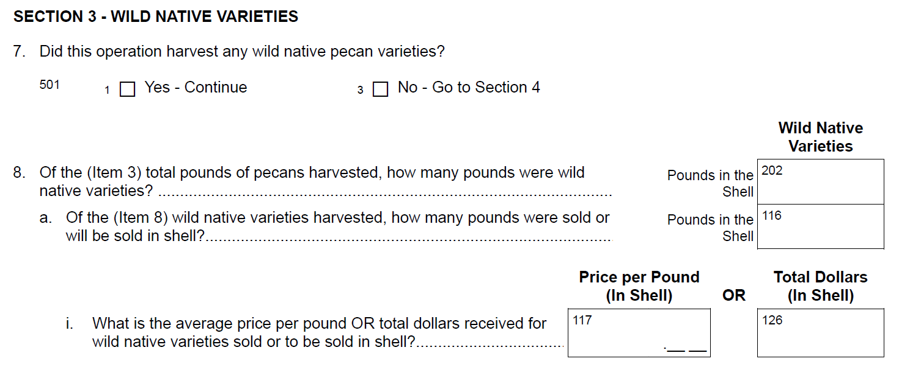

To

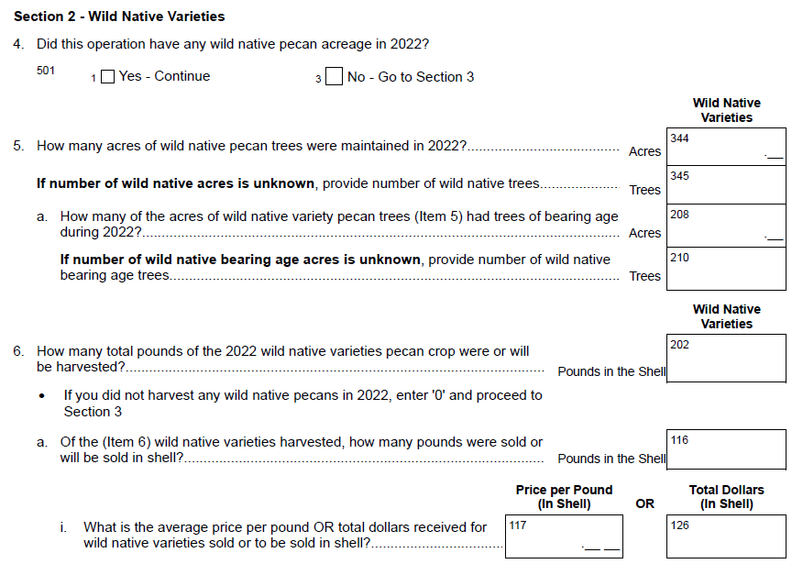

These changes will not impact the current sample size or respondent burden.

Michigan Fruit Inventory - 2022

The Michigan Fruit Inventory for 2022 is funded by the between the Cherry Marketing Institute and Michigan Apple Committee. The cooperators requested the following changes to the currently approved Michigan Fruit Inventory survey:

* The 2022 will focus on only Apples, Tart Cherries, Sweet Cherries, Peaches, and Plums,
* An organic code column to report the organic status for each block (Conventional, Transitioning, or Certified). The organic status is to determine the extent that growers are producing or plan to produce organically grown apples, cherries, and plums at the variety-level, which is different from published organic statistics.
* A new section of questions about neglected/abandoned orchards. Abandoned/neglected orchards near active orchards increases pest management costs for the active orchards. This information will assist data users the extent of this potential problem.

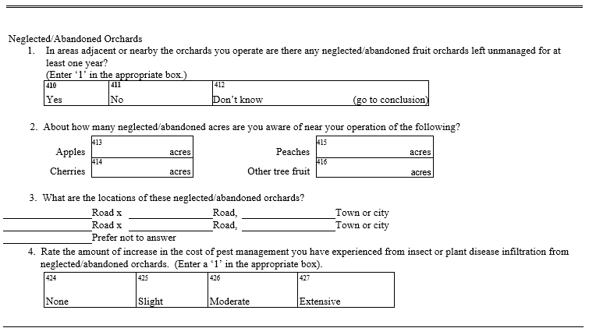

These changes will not impact the current sample size or respondent burden.

California Fresh Grape Inquiry - 2022 Crop - **NEW**

NASS publishes acreage, yield, production, price, and value for table grapes produced in California. The California Fresh Grape Inquiry will be used to obtain this information for the table grapes. This survey supports the NASS grape estimating program by collecting information from the approximately forty buyers that purchase table grapes from California producers.

Assuming an 80 percent response rate, with one mailing and phone followup, this will add an additional

* forty respondents for a new total of 64,895,
* forty responses of burden for a new total of 74,450, and
* seven hours of total burden for a new total of 31,610.

Revised questionnaires for all affected surveys are loaded to ROCIS.