**SUPPLEMENTAL SUPPORTING STATEMENT Part A**

**FRUIT, NUTS, AND SPECIALTY CROPS**

**Substantive Change**

**OMB No. 0535-0039**

This substantive change is being submitted as a supplemental supporting statement to the Fruit, Nuts, and Specialty Crops docket. This document identifies changes made to the Maple Syrup Survey that will be conducted starting in May 2023.

The proposed changes were presented and discussed at length at the International Maple Syrup Conference in October 2022. There were industry members from all states in the National Agricultural Statistics Service estimating program present at the conference. The International Maple Syrup Institute created a working group from their membership that was instrumental in bringing the industry’s concerns to NASS’ attention with suggestions to improve the Maple dataseries and resulting questionnaire. Specific individuals involved are noted in Item 8.

The changes from the already approved questionnaire include:

Removal of the French Version

The version in French was no longer used as it contained different questions than the English version and resulted in a non-standardized data being collected. The data collection plan will be developed to obtain response from producers previously requiring the French version.

Questions Removed

Question 1 – The “No” followup question.

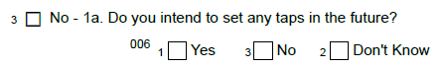

Questions 5 and 6:

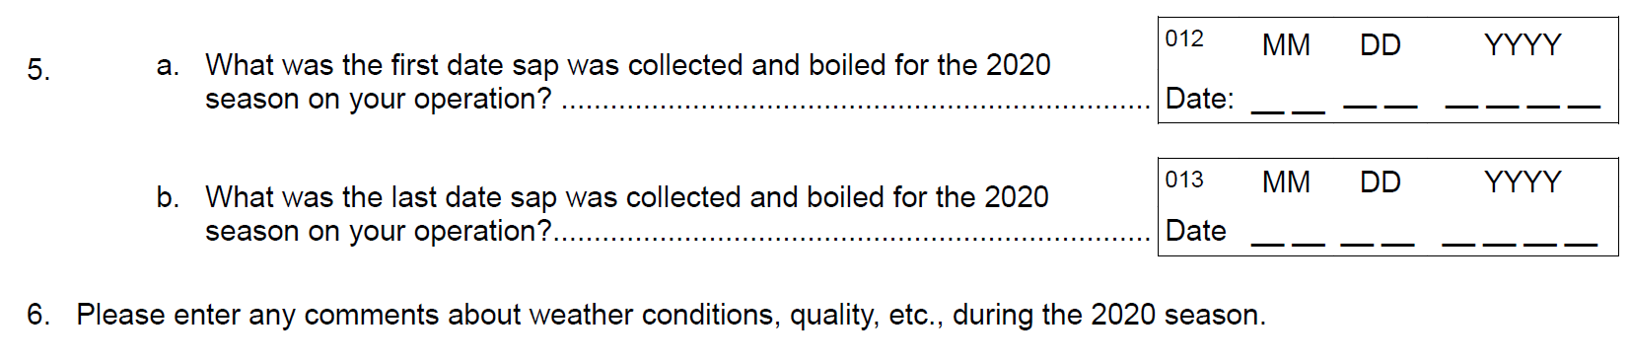

Question 7:

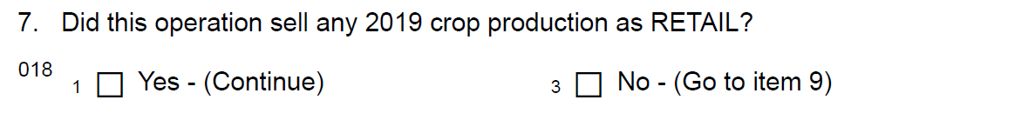

7b: 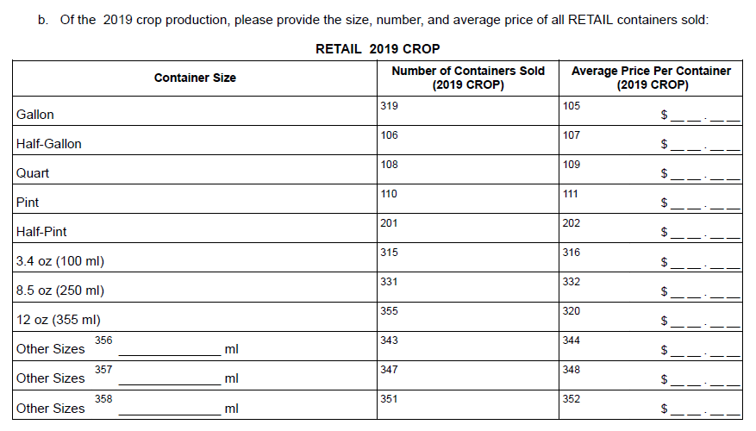

Question 8:

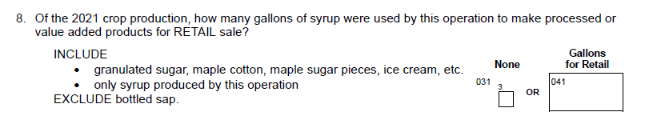

Question 9:

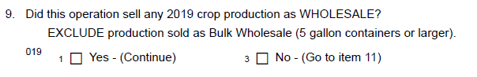

9b: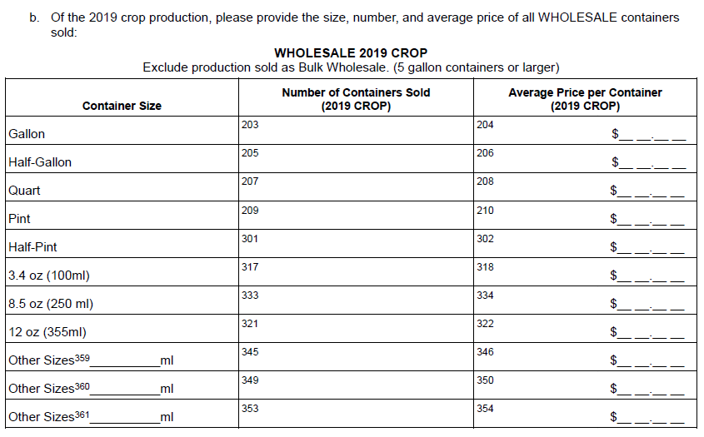

Question 10:

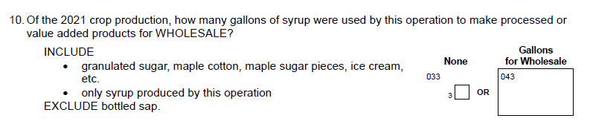

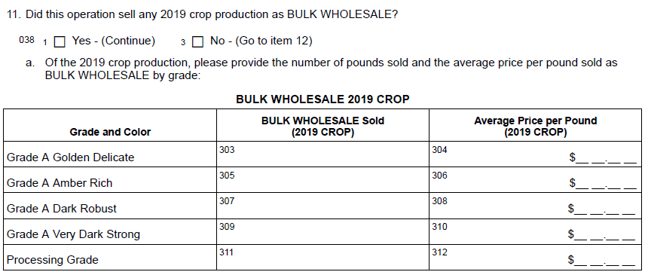

Questions Modified

Question 1: Revision of the “include” statement from “taps set on trees owned by you, leased from others, or tapped rent-free” to “taps set on trees on your operation, regardless of whether you owned the land”. Answering yes directs to continue the survey, no directs to survey conclusion.

Maple Production Questions are revised from:

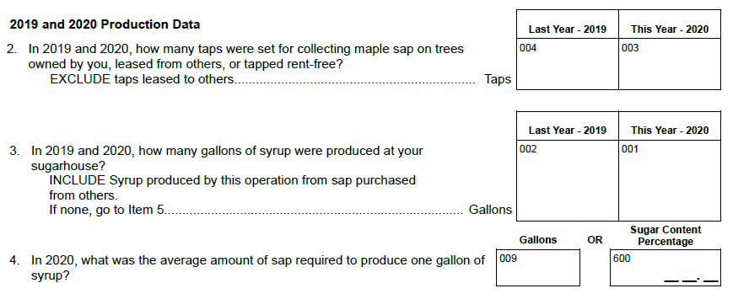

To

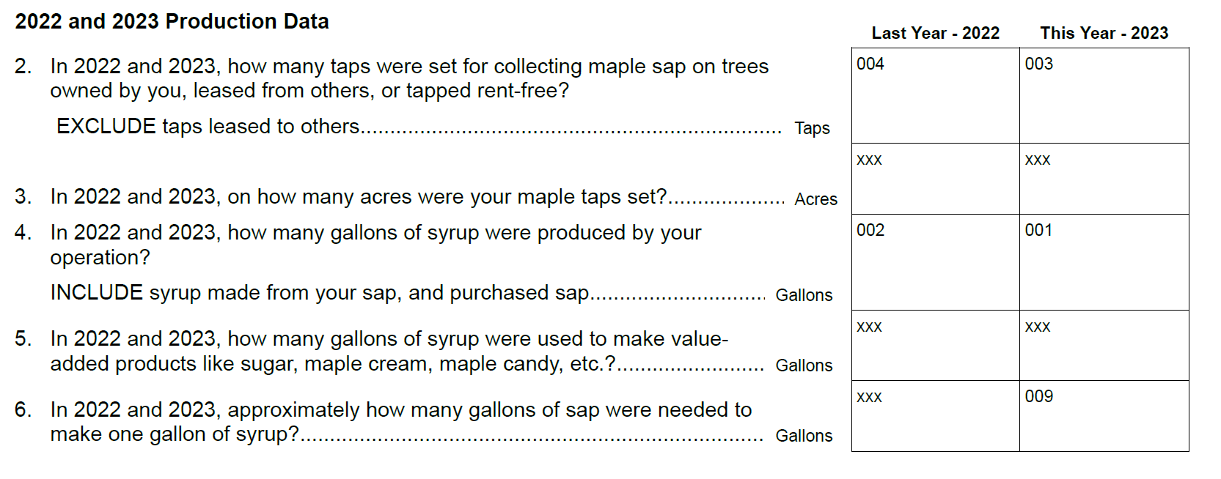

Maple Sales Questions will now be:

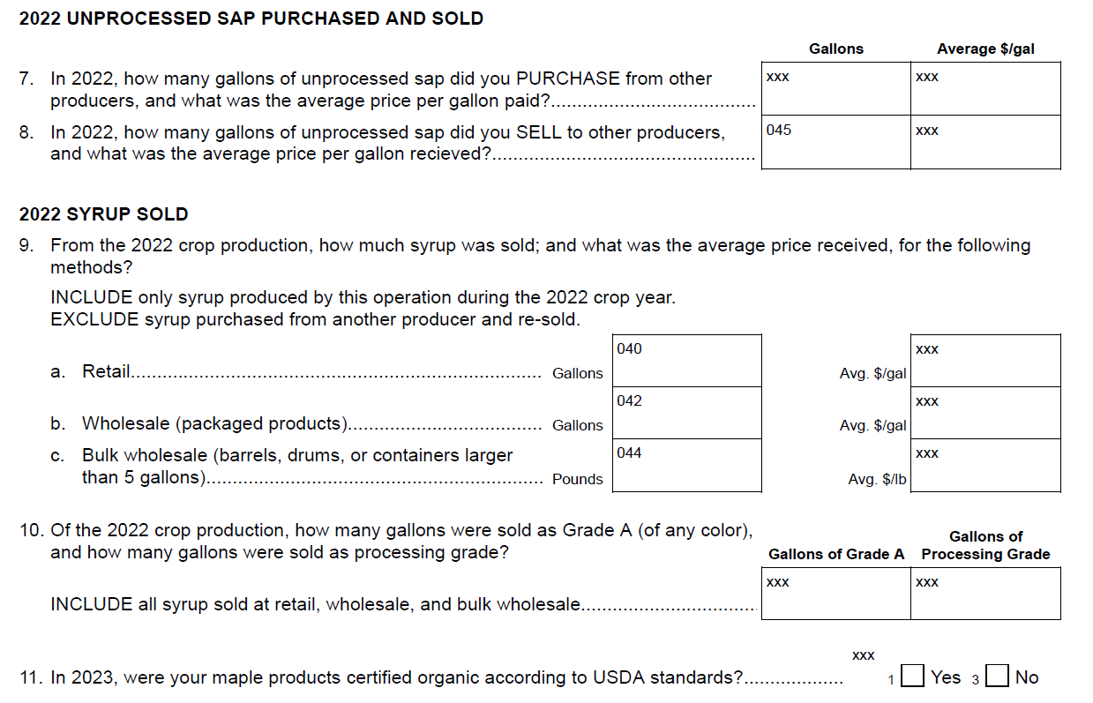

In addition, one new item has been added that is not a question, but rather is instructions how the respondent may access survey results when available.



**A. JUSTIFICATION**

**1. Circumstances making collection of information necessary.**

NASS is requesting a substantive change to the Maple Syrup survey for the 2023. Various members of the Maple Industry approached United States Department of Agriculture’s National Agricultural Statistics Service with suggestions to improve the Maple dataseries and resulting questionnaire. Specific individuals involved are noted in Item 8.

There are no other changes to the circumstances making collection of information necessary.

**2. How, by whom, and for what purpose information is to be used.**

There are no changes to the list of potential people who use the data collected by the Maple Syrup Survey. The addition, deletion, and changes of questions will help maple syrup producers and industry experts make informed decisions. The French version of the Maple Syrup questionnaire has been discontinued due to the lack of usefulness.

**3. Use of improved information technology.**

There are no changes from the original approval related to information technology.

**4. Efforts to identify duplication.**

There are no changes from the original approval related to duplication reduction.

**5. Methods to minimize burden of small businesses.**

There are no changes from the original approval related to minimizing burden of small business.

**6. Consequence if information collection were less frequent.**

There are no changes to the frequency of these surveys that was originally approved.

1. **Special circumstances.**

No special circumstances are associated with this information collection.

1. **Federal register notice and consultation with outside persons.**

Input for the questions to be updated and removed were provided by the following:

Mark Cannella

Extension Associate Professor

University of Vermont

Mobile: (802) 881-1576

327 U.S. Route 302

Berlin, VT 05641

Adam Wild

Director of the Uihlein Maple Research Forest

Cornell University

Senior Extension Associate

Lake Placid, NY

[adw94@cornell.edu](mailto:adw94@cornell.edu)

(716) 244-7723

Dave Folino

Hillsboro Sugarworks

Starksboro, VT.

802-989-5574

Mark L. Isselhardt

Maple Specialist

University of Vermont Extension

[Mark.Isselhardt@uvm.edu](mailto:Mark.Isselhardt@uvm.edu)

802-899-9926

1. **Payments or gifts to respondents.**

No payments or gifts will be given to respondents.

1. **Confidentiality provided to respondents.**

Questionnaires include a statement that individual reports are confidential. 44 U.S. Code Chapter 35; and Public Law 115-435, Title III (CIPSEA) provide for confidentiality of reported information. All employees of NASS and all enumerators hired and supervised under a cooperative agreement with the National Association of State Departments of Agriculture (NASDA) must read the regulations and sign a statement of compliance.

Additionally, NASS employees and NASS contractors comply with the OMB implementation guidance document, “Implementation Guidance for Title V of the E-Government Act, Confidential Information Protection and Statistical Efficiency Act of 2002 (CIPSEA).” CIPSEA supports NASS’s pledge of confidentiality to all respondents and facilitates the agency’s efforts to reduce burden by supporting statistical activities of collaborative agencies through designation of NASS agents, subject to the limitations and penalties described in CIPSEA.

1. **Questions of a sensitive nature.**

No questions of a sensitive nature will be asked.

**12. Provide estimates of the hour burden of the collection of information. The statement should indicate the number of respondents, frequency of response, annual hour burden, and an explanation of how the burden was estimated.**

The Maple Syrup Survey is estimated to take 10 minutes to completed, which is unchanged. There are no changes to the sample size or number of responses for the maple surveys. As a result, there are no changes to the burden that was originally approved.

**13. Provide an estimate of the total annual cost burden to respondents or record keepers resulting from the collection of information.**

There is no cost burden to respondents.

**14. Annualized costs to federal government.**

There are no changes from the original approval related to annualized costs to the federal government.

**15. Reasons for changes in burden.**

There are no changes from the current approval related to burden.

**16. Tabulation, analysis, and publication plans.**

The Maple Syrup Survey Publication Changes are listed below:

1. Data to be discontinued:

* Date season opened
* Date season closed

(Calculations based on reported data)

* Average season length
* Average season opened
* Average season closed
* Retail Price:
  + Gallon
  + Half gallon
  + Quart
  + Pint
  + Half Pint
* Wholesale Price:
  + Gallon
  + Half gallon
  + Quart
  + Pint
  + Half pint

1. New data series based on the new data being collected:

* Acres of trees that maple taps were set.
* Gallons and price of maple unprocessed maple sap purchased from others.
* Gallons and price of maple unprocessed maple sap sold to others.
* Average price of maple syrup sold retail on a gallon basis
* Average price of maple syrup sold wholesale on a gallon basis

The Maple Syrup Survey result will continue to be published in the June Crop Production Report.

<https://usda.library.cornell.edu/concern/publications/tm70mv177>

**17. Request for approval of non-display of expiration date.**

There is no request for approval of non-display of the expiration date.

**18. Exceptions to certification statement.**

There are no exceptions to the certification statement.

February 2023