Non-substantive Change Request
0535-0039 – Fruit, Nut, and Specialty Crops Surveys
Pecan Inquiry (Version 2 – TX & OK) – October 2023 and December 2023
Pecan Preliminary Production and Disposition Inquiry (Version 2 – TX & OK) – January 2024 (Version 2 – TX & OK)
Pecan Final and Preliminary Production and Disposition Inquiry (Version 1 – AZ, GA, & NM) January and February 2024
Pecan Inquiry (Version 2 – TX & OK) – Oct and Dec 2023
The changes for this version of the Pecan Inquiry are:
- Bearing acreage is collected by variety (improved / native). This change is needed to allow NASS to calculate yield per variety. NASS publishes production by variety.
- The respondent is given the option to report acreage or number of trees for the native varieties. NASS’ experience is that many growers of native trees could not report the number of acres since the trees are grown wild across their farms. For the improved type this not an issue as the trees are not wild and are usually planted in rows.
- This same change was made for the Version 2 February PDI in August of 2022.
From
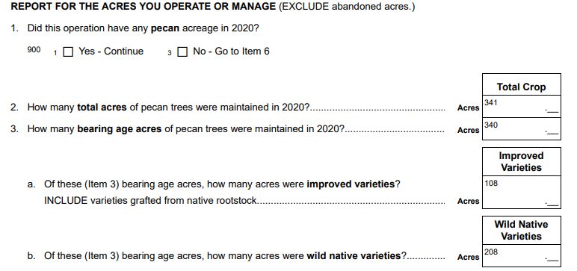
To
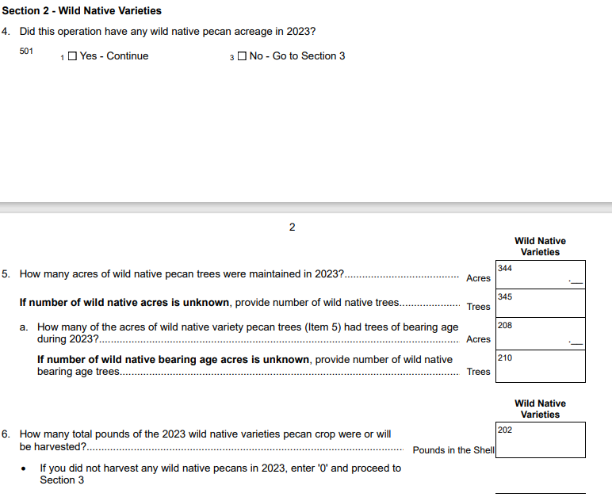

Pecan Production and Disposition Inquiry (Version 2 – TX & OK) - January 2024
The changes for this version of the Pecan Production and Disposition Inquiry are:
- Bearing acreage is collected by variety (improved / native). This change is needed to allow NASS to calculate yield per variety. NASS publishes production by variety.
- The respondent is given the option to report acreage or number of trees for the native varieties. NASS’ experience is that many growers of native trees could not report the number of acres since the tree grow wild across their farms. For the improved type this not an issue the trees are not wild and are usually planted in rows.
From
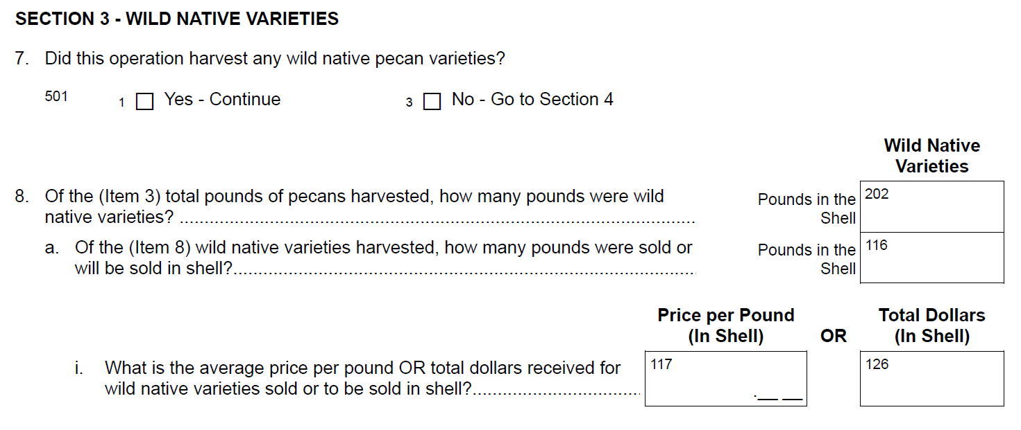
To
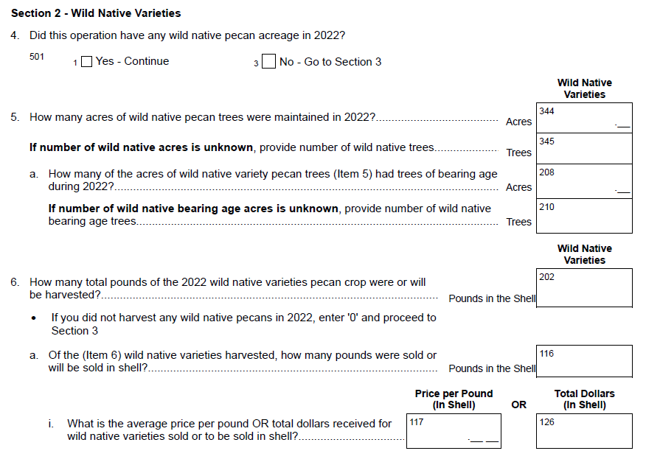

Pecan Production and Disposition Inquiry (Version 1 – AZ, GA, & NM) – January and February 2024
The changes for this version of the Pecan Production and Disposition Inquiry are:
- Reword instructions ‘if no harvest’ to “If you did not harvest any pecans in 2023, enter ‘0’ and proceed to Section 2.” This matches the wording in Version 2.
- Move Item 4 to Section 1. “Has the total 2023 crop been marketed?”

From
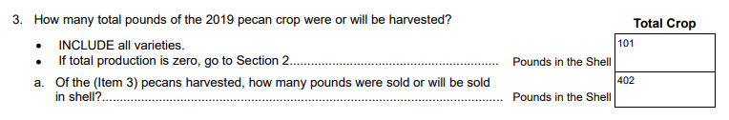
To
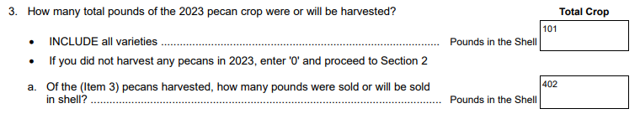
These changes will not impact the current sample size or respondent burden.

Revised questionnaires for all affected surveys are loaded to ROCIS.

