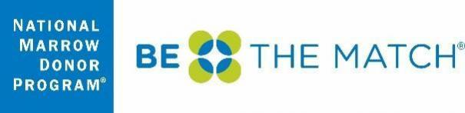
Subject of email: Be The Match® Patient Support Center wants your feedback!
From: Be The Match® Patient Support Center <BeTheMatchPSC@qualtrics-survey.com>
Hello ${m://FirstName},
We invite you to tell us about your recent contact with the Be The Match® Patient Support Center. Please take 5 minutes to complete this survey.
Participating in this survey is voluntary. Your responses are confidential. We won't link them to any identifying information, such as your name or email address. Your participation will not affect your relationship with Be The Match.
Follow this link to the Survey:
${l://SurveyLink?d=Take the Survey}
If you have any questions about the survey or would like to talk to a Patient Navigator, please contact the Patient Support Center at 1-888-999-6743 or patientinfo@nmdp.org
Your feedback matters! With your input, we can make our programs and services as useful as possible for future BMT patients and families.
Sincerely,
Be The Match Patient Support Center

