Front of Pack Nutrition Labeling Experiment Questionnaire
//Programming Notes
1. INFORMATION IN ALL CAPS IN BRACKETS IS NOT DISPLAYED; SOME ARE INSERTION DIRECTIONS;
2. RESPONSE OPTION CODES/INDICATORS ARE NOT DISPLAYED;
3. IF “GO TO” INSTRUCTIONS ARE NOT PROVIDED, PROCEED TO NEXT QUESTION;
4. SHOW “PLEASE PROVDE A RESPONSE” NOTIFICATION IF RESPONDENT SKIPS A QUESTION, BUT LET THEM PROCEED AFTER THAT WITHOUT ANSWERING;
5. MAKE SURE TO CLEARLY, VISUALLY OR SPATIALLY SEPARATE “DON’T KNOW” VISUALLY FROM THE OTHER RESPONSE OPTIONS; [This is most relevant for scale or slider questions].
6. CODE ALL “DON’T KNOW” AS “8” UNLESS “8” IS ALREADY BEING USED. THEN USE “88”;
7. CODE ALL “REFUSED” AS “-99”
8. FOR SECTION B, ENSURE THE LABEL IS VIEWABLE AT ALL TIMES;
9. PLEASE ENSURE NO SCROLLING IS NEEDED TO ANSWER ANY QUESTIONS ON A 13” MONITOR.
10. Program all survey text in Calibri (body) font style//

//DISPLAY THE FOLLOWING AND INSERT “NEXT” BUTTON//
Thank you for agreeing to participate. We are interested in your views about food labels. Please read each question carefully and then select the answer that best suits you. The information you provide will be kept secure to the extent provided by law. It will take about 15 minutes to answer all the questions. This collection of information is being conducted on behalf of the U.S. Food and Drug Administration.
Please click the “NEXT” button to begin the study.
//[NEW SCREEN]//

OMB Control No: 0910-0497 Expiration Date: 11/30/2023
Paperwork Reduction Act Statement: According to the Paperwork Reduction Act of 1995, an agency may not conduct or sponsor, and a person is not required to respond to a collection of information unless it displays a valid OMB control number. The valid OMB control number for this information collection is 0910-0497. The time required to complete this information collection is estimated to average 15 minutes per response, including the time for reviewing instructions, searching existing data sources, gathering and maintaining the data needed, and completing and reviewing the collection of information.

Send comments regarding this burden estimate or any other aspects of this collection of information, including suggestions for reducing burden to PRAStaff@fda.hhs.gov.
Please click the “NEXT” button.
//PART 1//
//NEW SCREEN//
//Covariate//
//INSERT Nutrition Facts Image. Keep image viewable for the four NFL questions that follow.//

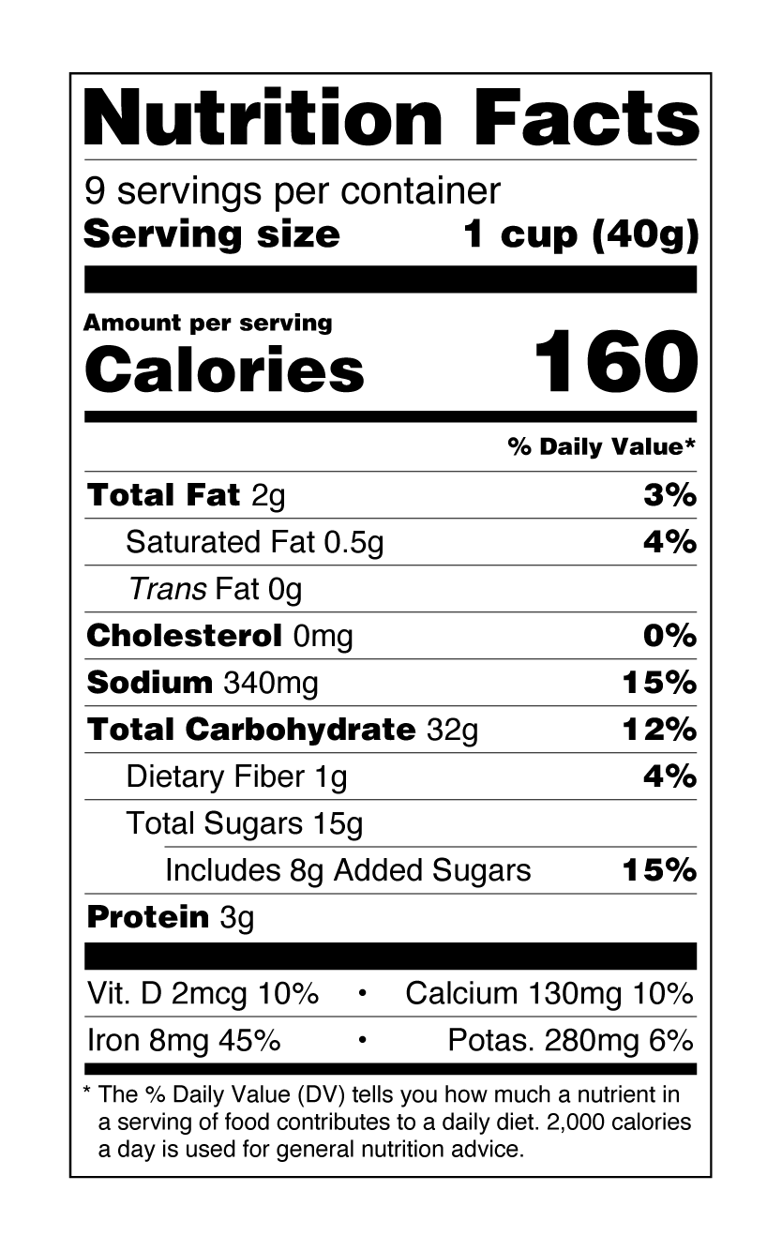

This is an example of a Nutrition Facts label. We are going to ask you a few questions about the Nutrition Facts label.

When buying a packaged food product for the first time, how often do you use the Nutrition Facts label?

// SOFT PROMPT: Please provide a response. //

Value | Value Label
1 | Never
2 | Rarely
3 | Sometimes
4 | Most of the time
5 | Always
8 | Don’t know
-99 | Refused

When you buy packaged foods for the first time, how often do you use the Nutrition Facts label to compare how healthy or nutritious different foods are?

// SOFT PROMPT: Please provide a response. //

Value | Value Label
1 | Never
2 | Rarely
3 | Sometimes
4 | Most of the time
5 | Always
8 | Don’t know
-99 | Refused

How often, if at all, do you use the Nutrition Facts label to see how high or low the food is in things like saturated fat, sodium, or added sugars? //Pulled from the 2011 HDS//

Value | Value Label
1 | Never
2 | Rarely
3 | Sometimes
4 | Most of the time
5 | Always
8 | Don’t know
-99 | Refused

How confident are you that you understand the Nutrition Facts label?
// SOFT PROMPT: Please provide a response. //

Value | Value Label
1 | Not at all confident
2 | A little confident
3 | Somewhat confident
4 | Very confident
5 | Extremely confident
-99 | Refused

On average, how often do you eat the following food products? [ROTATE ITEMS]
Breakfast Cereal
Frozen meals or entrees
Canned Soup
Daily…………………………………………….5
A few times a week……………………………..4
Once a week…………………………………….3
Once or twice a month………………………….2
Less than once a month………………………....1
Never ………………………………………..….0
Don’t know………………………………….......8

//[NEW SCREEN]//

//“EDUCATING” ALL PARTICIPANTS//

The Food and Drug Administration (FDA) is exploring the idea of developing nutrition labels for food companies to put on the front of food packages to help consumers more quickly and easily identify foods that are part of a healthy eating pattern. These labels are called Front of Package nutrition labels.

In this survey, you will be asked to look at different kinds of Front of Package nutrition labels and answer questions about them. The image below shows an example of what we mean by Front of Package nutrition labels.

//Insert Breakfast Cereal with magnified scheme Image//

//INSERT “NEXT” BUTTON//

//Comparison Task – participants will see three of the same type of scheme at a time; each set of schemes will have a healthy, middle, and least healthy nutrient profile. Nutrient profiles will be presented randomly. Participants will review three scheme types. Scheme types will also be presented randomly. Participants will be asked to identify the healthiest and least healthy scheme in each set of three. The matching Nutrition Facts Label (NFL) will be imbedded in the scheme images across each set of comparisons for participants to view if they click on image. [How quickly do participants respond to the question?]
[Do they use the NFL to answer the question?]//

//Programmer - hyperlink the matching NFL (Nutrition Facts Label) within each scheme image. Hyperlinked NFLs will need to match the nutrient profile of that scheme image for all scheme comparisons//

//Programmer- record if respondent clicks or does not click on each of the high, medium and low scheme images to display the NFL for each set of scheme comparisons//

//NFL for Nutrition Info and GDA schemes//

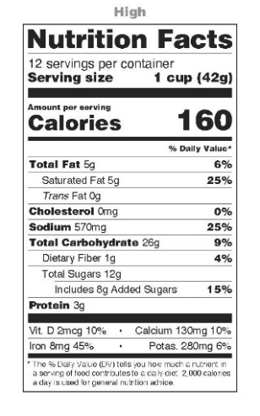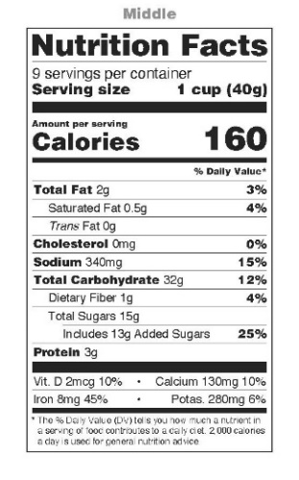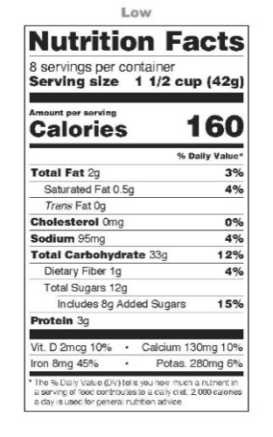

//NFL for High In schemes//

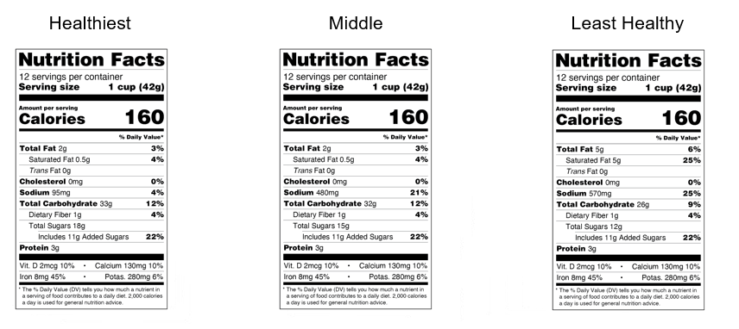
//Start timer and record in milliseconds how long it takes to choose healthiest scheme//

Please look at the three Front of Package nutrition labels below and follow the instructions as quickly as you can.

Which one of the three Front of Package nutrition labels shows the healthiest overall nutrient profile?

IF NEEDED, click image for more nutrition detail.

//Stop timer once healthiest choice has been selected//

//INSERT GRAPHIC OF SCHEME – 3 NUTRITION LEVELS IN RANDOM ORDER HORIZONTALLY//

//[Cognitive test this version to see if people who are limiting any of these nutrients can answer the question as written. Also, do participants understand “nutrient profile?”]//

//Start timer and record in milliseconds how long it takes to choose least healthy scheme//

Which one of the three Front of Package nutrition labels shows the least healthy overall nutrient profile?

IF NEEDED, click image for more nutrition detail.

//Stop timer when least healthy choice has been selected//
// SOFT PROMPT: Please provide a response. //
//Repeat until three schemes have been viewed//

//[NEW SCREEN//

//Programming note: Field question only to those who clicked on at least one of the Nutrition Facts Labels during scheme comparison task. Randomize order of response options with the “other” option always displayed last//

In the previous section, you clicked on at least one image for more nutrition detail. Can you tell us why you clicked on the image(s)? Please select all that apply.
- I needed more nutrition information to answer the question(s) ……….1
- I wanted to see more nutrition information, not just what was provided on the Front of Package nutrition label……….2
- I accidentally clicked the image……….3
- I thought clicking on the image would make it bigger……….4
- Other (specify) ________________……….5

//SECTION B – SINGLE PRODUCT EVAUATION//
[PERCEPTIONS OF PRODUCT HEALTHFULNESS]

Please take a moment to look at this food product. How much do you disagree or agree with the following statements?
//Insert Image//
// Randomize items below//
// SOFT PROMPT: Please provide a response for each row. //

Variable Name | Variable Text | Variable Label
 | I can easily find nutrition information on this label.
 | I can easily use information on this label to determine if this food can be part of a healthful dietary pattern.

Value | Value Label
1 | Strongly Disagree
2 | Disagree
3 | Slightly disagree
4 | Slightly agree
5 | Agree
6 | Strongly agree
-99 | Refused

//[NEW SCREEN//

In your opinion, how healthy is this food product?

// SOFT PROMPT: Please provide a response for each row. //

Value | Value Label
1 | Not healthy
2 | Slightly unhealthy
3 | Slightly healthy
4 | Moderately healthy
5 | Healthy
6 | Very healthy
8 | Don’t know
-99 | Refused

//[NEW SCREEN//

//HEALTHFULNESS BELIEVABILITY; Beltramini Believability Scale//

What is your reaction to how the food package is communicating the healthfulness of the food?
Drag all sliders to the placement you want (even to indicate the lowest score).
//Please use italics for the instructions on how to use a slider “Drag all sliders to the placement you want (even to indicate the lowest score).”//
//Randomize items believable through reasonable. Always present Simple - Complex as last item at end of screen.//
// INSERT same image //
//Show all sliders in the same screen and present product next to the right of sliding scale//
// SOFT PROMPT: Please provide a response for each row. //
Variable Name | Variable Text | Variable Label
 | Believable | Believable
 | Trustworthy | Trustworthy
 | Convincing | Convincing
 | Credible | Credible
 | Reasonable | Reasonable
 | Simple | Simple

Value | Value Label -
1 | Not Believable
2
3
4
5
6 | Believable
-98 | Don’t Know
-99 | Refused

Value | Value Label -
1 | Not Trustworthy
2
3
4
5
6 | Trustworthy
-98 | Don’t Know
-99 | Refused

Value | Value Label -
1 | Not Convincing
2
3
4
5
6 | Convincing
-98 | Don’t Know
-99 | Refused

Value | Value Label -
1 | Not Credible
2
3
4
5
6 | Credible
-98 | Don’t Know
-99 | Refused

Value | Value Label -
1 | Not Reasonable
2
3
4
5
6 | Reasonable
-98 | Don’t Know
-99 | Refused

Value | Value Label -
1 | Simple
2
3
4
5
6 | Complex
-98 | Don’t Know
-99 | Refused

//[NEW SCREEN//

The Dietary Guidelines for Americans recommends limiting the consumption of foods and beverages that are higher in saturated fat, sodium, or added sugar.
Please tell us how much you disagree or agree with the following statements.
[5-point Likert scale: Strongly disagree, Disagree, Neither agree nor disagree, Agree, Strongly agree, Don’t know]
- A person can eat this product regularly even if they are limiting their consumption of saturated fat, sodium, or added sugars
- A person can sometimes eat this product even if they are limiting their consumption of saturated fat, sodium, or added sugars
//Scheme Self-Efficacy//
//Participants in the control condition do not get these questions//

The next few questions are about the Front of Package nutrition label that is on the food
//Insert image magnifying the scheme//

Please use the Front of Pack nutrition label for the next set of questions.
How confident are you that you could use this Front of Package nutrition label to help you make decisions about how well the food fits into a healthful diet?

Value | Value Label
1 | No confidence
2
3
4
5 | Extremely confident
8 | Don’t Know
-99 | Refused

//Attitude toward the scheme//

For each of the following statements, please indicate how much you disagree or agree. //Program so that items are randomized in presentation//
a. This Front of Package nutrition label is useful in helping me decide whether to consume the product.
b. I like the format or layout of this Front of Package nutrition label.
c. It would be easy to use this Front of Package nutrition label to select healthful foods.
d. It is easy to understand the information in this Front of Package nutrition label.
e. It would be easy to use this Front of Package nutrition label to compare between products.

f. I would quickly notice this Front of Package nutrition label.

Value | Value Label
1 | Strongly disagree
2 | Somewhat disagree
3 | Neither agree nor disagree
4 | Somewhat agree
5 | Strongly agree
8 | Don’t Know
-99 | Refused

Using the Front of Package nutrition label, how low or high is this product in the following nutrients? Please use the scale below.
//RANDOMIZE ITEMS. INSERT RESPONSE OPTION SCALE 1 THROUGH 6 ANCHORED BY 1=LOW AND 6=HIGH; PROVIDE A SELECTION BOX FOR INDICATING “ DON’T KNOW.”//
Saturated Fat
Sodium
Added Sugars

//NEW SCREEN//
// INSERT IMAGE//

Please look at the Nutrition Facts label below. Is the %Daily Value for Total Carbohydrate “High,” “Low,” or somewhere in between?

- The %Daily Value for Carbohydrate is High
- The %Daily Value for Carbohydrate is Low
- The %Daily Value for Carbohydrate is somewhere in between High and Low

//NEW SCREEN//

In your own words, please tell us what comes to mind when you look at this Front of Package nutrition label.
// INSERT IMAGE//
//ALLOW 250 CHARACTERS//

//[NEW SCREEN//
//ALL PARTICIPANTS GET THE REST OF THE QUESTIONS//

//HEALTHY FOOD CONSUMPTION SELF-EFFICACY//

Now we have some questions about your food habits. For each of the following statements, please indicate how strongly you disagree or agree.
//Randomize items//
// SOFT PROMPT: Please provide a response for each row. //

Variable Name | Variable Text | Variable Label
 | If I eat a healthy diet I can reduce my chance of getting heart disease. | Nutrition and heart disease
 | I am confident that I know how to choose healthy foods. | Choosing healthy foods
 | Eating a healthy diet is important for my long-term health. | Nutrition and long-term health

Value | Value Label
1 | Strongly disagree
2 | Somewhat disagree
3 | Neither agree nor disagree
4 | Somewhat agree
5 | Strongly agree
8 | Don’t Know
-99 | Refused

//PERCEPTIONS OF FOOD HEALTHFULNESS – Control variable//

In general, how nutritious are these foods?
(Drag all sliders to the placement you want (even to indicate the lowest score)

//Show all sliders in the same screen//
//Randomize variables //
// SOFT PROMPT: Please provide a response for each row. //

Variable Name | Variable Text | Variable Label
 | Fresh fruit and vegetables | Fresh fruit and vegetables
 | Whole grain breakfast cereal | Whole grain breakfast cereal
 | Whole milk, unflavored | Whole milk, unflavored
 | Regular (not diet) carbonated soft drink (Soda, Pop) | Soda
 | Vegetable-based frozen meal | Vegetable-based frozen meal
 | Canned bean soup | Canned bean soup

Value | Value Label
1 | Not at all nutritious
2
3
4
5
6 | Very nutritious
8 | Don’t know
-99 | Refused

//SHOPPING HABITS//

Now we have a few questions about your food shopping habits.
How much of your household’s food shopping do you do?
//SOFT PROMPT: Please provide a response to the question.//

Value | Value Label
5 | All of the food shopping
4 | Most of it
3 | About half of it
2 | Only a little of it
1 | None of it
-99 | Refused

//INTEREST IN LABEL READING//

How interested are you in reading nutrition and health-related information at the grocery store?
//SOFT PROMPT: Please provide a response to the question.//

Value | Value Label
1 | Not Interested
2
3
4
5
6
7 | Very interested
-99 | Refused

//FOOD LABEL SELF-EFFICACY//
//RANDOMIZE ITEMS. INSERT RESPONSE OPTION SCALE 1 THROUGH 6 ANCHORED BY 1=STRONGLY DISAGREE AND 6=STRONGLY AGREE. PROVIDE SELECTION BOX INDICATING ‘DON’T KNOW’ FOR EACH ITEM.//
How much do you disagree or agree with the following statements?
I know how to use food labels to choose a nutritious diet.
The nutrition information on food labels is useful to me.
//SELF-RATED HEALTH//

Compared to other people your age, would you say your health is…?
//SOFT PROMPT: Please provide a response to the question.//

Value | Value Label
5 | Excellent
4 | Very good
3 | Good
2 | Fair
1 | Poor
-99 | Prefer not to answer

Are you paying attention to your intake of salt or sodium?
Value | Value Label
0 | No
1 | Yes
8 | Don’t know
-99 | No answer

Are you paying attention to your intake of saturated fat?
Value | Value Label
0 | No
1 | Yes
8 | Don’t know
-99 | No answer

Are you paying attention to your intake of added sugars?
Value | Value Label
0 | No
1 | Yes
8 | Don’t know
-99 | No answer

Have you ever been told by a doctor or other healthcare professional that you have any of the following health conditions? High blood pressure, diabetes, high cholesterol, heart disease, obesity, overweight, or cancer?

Yes ………………………….. 1
No ………………………….. 0
DK/NS ……. 8
RF…………… -99

How tall are you without shoes? Please enter a number in both “feet” and “inches.” If you are not sure, make your best guess.

___ ft___ inches

How much do you weigh without clothes or shoes? Please enter the number of pounds (round up or down to the closest whole number). If you are not sure, make your best guess.

Enter weight in pounds ________ lbs

___ Don't know 8
___[No answer] -99

//SELF-RATED LITERACY//
How do you rate your reading ability?
//SOFT PROMPT: Please provide a response to the question.//

Value | Value Label
5 | Excellent
4 | Very good
3 | Good
2 | Fair
1 | Poor
-99 | Refused

//DEMOGRAPHICS; MOST ARE CAPTURED ON THE SCREENER AND WILL BE INCLUDED IN THE FINAL DATA SET//

What language(s) do you speak at home? (Select all that apply.)
//SOFT PROMPT: Please provide a response to the question.//

Value | Value Label
1 | English
2 | Spanish
3 | Other (specify)
-99 | Refused

Other language (specify)
//SHOW IF Q=03//
//SHOW IN SAME SCREEN AS Q_//

How many total people, including yourself, currently live in your household?
// SOFT PROMPT: Please provide a response to the question. //
// Lower Limit: 1 //
// Upper Limit: 14 //

Value | Value Label
-99 | Refused

How many of the people in your household are children 17 years and younger?
// SOFT PROMPT: Please provide a response to the question. //
// Lower Limit: 1 //
// Upper Limit: 14 //

Value | Value Label
-99 | Refused

//Ask only if children in the household//
Are you the parent or primary caregiver to any of the children in your household?
___Yes
___No
//Ask if total people >1 and zero children in the household//
Are you a caregiver to any of the adults in your household (not including yourself)?
___Yes
___No
//OPEN-ENDED COMMENTS//
//Use the following question only for pre-test//
Please provide any comments you have about this survey. Was any part of it hard or confusing? If yes, which part? ________________________________________

//SHOW IF pretest AND FULL STUDY//

Please provide any comments you wish. __________________________________________

Thank you very much.

