Ryan White HIV/AIDS Program (RWHAP) Tree Testing Script (Test Instrument)

Welcome Message
Thank you for participating in the study for HRSA’s Ryan White HIV/AIDS Program website.
This activity will take you 15 to 20 minutes to complete.
Your response will help us understand how to organize the content on our website and make it more useful for you.

Instructions
Here's how it works:
You will be asked to find a certain item and presented with a list of links.
- Click through the list until you arrive at one that you think helps you complete the task.
- If you take a wrong turn, you can go back by clicking one of the links above.
- This is not a test of your ability, there are no right or wrong answers.
That's it, let's get started!

According to the Paperwork Reduction Act of 1995, no persons are required to respond to a collection of information unless it displays a valid OMB control number. The valid OMB control number for this information collection is 0990-0379. The time required to complete this information collection is estimated to average 30 minutes per response, including the time to review instructions, search existing data resources, gather the data needed, and complete and review the information collection. If you have comments concerning the accuracy of the time estimate(s) or suggestions for improving this form, please write to: U.S. Department of Health & Human Services, OS/OCIO/PRA, 200 Independence Ave., S.W., Suite 336-E, Washington D.C. 20201, Attention: PRA Reports Clearance Officer.

Tasks
# | Topic | Task | Success Metric
1. | Available care and services | You want to learn what support and care services the Ryan White HIV/AIDS Program offers for the people diagnosed with HIV/AIDS. Where would you expect to find information? | HIV Care > Available Care & Services
2. | Program Parts and Initiatives | You would like to learn more about how the Ryan White HIV/AIDS Program is structured. Specifically, you are interested in Special Projects of National Significance (SPNS), which is included in Part F of the Ryan White HIV/AIDS Program. Where would you expect to find more details about SPNS? | About the Program > Program Parts and Initiatives > Part F > Special Projects of National Significance (SPNS)
3. | Find a service provider | You want to find an HIV/AIDS service provider in your area. Where would you expect to find that information? | HIV Care > Find a provider  Or  Home Page > Find a Ryan White HIV/AIDS Program Medical Provider
4. | Contact the program office | You want to contact the Division of Metropolitan HIV/AIDS Programs of the Ryan White HIV/AIDS Program (Part A). Where would you expect to find this contact information? | About the Program > Contact > Division of Metropolitan HIV/AIDS Programs  Or  Home Page > Contact Us > Division of Metropolitan HIV/AIDS Programs
5. | State HIV/AIDS Hotlines | You need to call the HIV/AIDS hotline in your state. Where would you expect to find this contact information? | HIV Care > State HIV/AIDS Hotlines  Or  Home Page > State Hotlines
6. | Open grant funding opportunities | Your organization is planning to apply for a Ryan White HIV/AIDS Program grant. Where would you go to find grants currently accepting applications? | Grants > Find Funding  Or  Home Page > Find Funding
7. | Technical Assistance | Your organization is a current Ryan White HIV/AIDS Program grant awardee and you want to know who to contact for technical assistance with your grant management. Where would you expect to find this information? | Grants > Manage Your Grant > Manage Your Grant > Grant Recipient Resources
8. | Publications | You are interested in exploring the impact of the Ryan White HIV/AIDS Program. You are looking for journal articles on HIV/AIDS topics funded and authored by HRSA. Where would you expect to find a list of journal articles? | Resources > eLibrary
9. | Data Reports | You are looking for data on how the Ryan White HIV/AIDS Program responded to the coronavirus disease 2019 (COVID-19) pandemic. Where would you expect to find that data report? | Data > Data Reports and Slide Decks > COVID-19 Data Report
10. | Grant Awards | You are interested in learning about which organizations were awarded Ryan White HIV/AIDS Program Part C grants in FY2021. Where would you expect to find the list of grant awards? | About the Program > Program Parts and Initiatives > Part C
11. | Clinical Guidelines | You are a public health professional interested in learning what HIV-related protocols and clinical practices the grantees of the Ryan White HIV/AIDS Program should use. Where would you expect to find those guidelines? | Grants > Clinical Care Guidelines and Resources
12. | Policy Notice | You are looking for a new policy notice that was released by the Ryan White HIV/AIDS Program. Where would you expect to find it? | Grants > Policy Notices
13. | Data Reports | You are interested in finding data on the number of people served by the Ryan White HIV/AIDS Program by race/ethnicity and by age in 2020. Where would you expect to find this information? | Data > Data Reports and Slide Decks > RWHAP Annual Client-Level Data Report  Or  Data > Compass Data Dashboard
14. | Budget | You are looking for information about funds appropriations for each Part of the Ryan White program in FY 2020. Where would you expect to find that information? | About the Program > Budget

Post-Task Question
This question will be asked after each completed task to give participants an opportunity to explain their reasoning.
- Why did you expect to find it here?

Post-Study Questions
- What task(s) were particularly difficult for you and why?
- What task(s) were particularly easy for you and why?
- Were there any terms that you didn’t understand? If so, what were they?
- Any other comments that you’d like to share?

Thanks
All done, awesome! Thanks again for your participation. Your feedback is incredibly useful in helping to determine how our content should be organized, so we can make our website easier to use.
You may now close this window or navigate to another web page.

Information Architecture

Main Navigation
- About the Program
  - Who Was Ryan White?
  - Programs Parts & Initiatives
    - Part A
    - Part B
    - Part C
    - Part D
    - Part F
      - AIDS Education and Training Center (AETC) Program
      - Special Projects of National Significance (SPNS)
      - Dental Programs
      - Minority AIDS Initiative
  - Legislation
  - National Strategies
  - Budget
  - History
      - 30th Year Anniversary
      - Living History
  - Contact
    - Office of the Associate Administrator
    - Office of Program Support
    - Office of Operations and Management
    - Division of Community HIV/AIDS Programs
    - Division of Metropolitan HIV/AIDS Programs
    - Division of Policy and Data
    - Division of State HIV/AIDS Programs
- HIV Care
  - State HIV/AIDS Hotlines
  - Available Care & Services
  - Find a Provider
  - National Clinician Consultation Center
- Grants
  - Find Funding
  - Manage Your Grant
    - Grant Recipient Resources
    - CAREWare
    - Reporting Requirements
  - Coronavirus (COVID-19)
  - Policy Notices
  - Program Letters
  - Clinical Care Guidelines and Resources
  - Quality of Care
  - Performance Measure Portfolio
  - Audit Reports
- Data
  - Data Reports and Slide Decks
    - Slide Decks
    - RWHAP Annual Client-Level Data Report
    - Ending the HIV Epidemic in the U.S. Initiative Data Report
    - COVID-19 Data Report
    - AIDS Drug Assistance Program (ADAP) Data Report
    - Oral Health Data Report
    - AIDS Education and Training Centers (AETC) Reports
    - Special Population Reports
  - Biennial Reports
  - Compass Data Dashboard
- Resources
  - Fact Sheets
  - Infographics
  - Expert Panel Summaries
  - eLibrary
  - Newsletters
  - Provider Resources
    - Access Trainings and Curriculum
    - Get Clinical Advice
    - Follow Clinical Guidelines
  - Webinars
- Home Page
  - Search
  - Sitemap
  - Contact Us
  - Who Was Ryan White?
  - State Hotlines
  - Find Funding
  - TargetHIV
  - Find a Ryan White HIV/AIDS Program Medical Provider

Test Screenshots
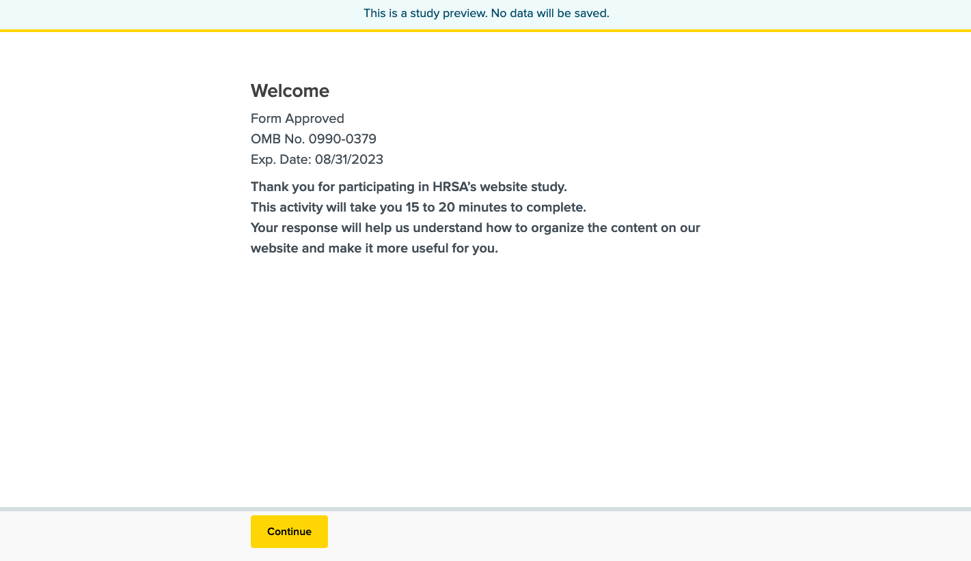Image 1: Welcome Message
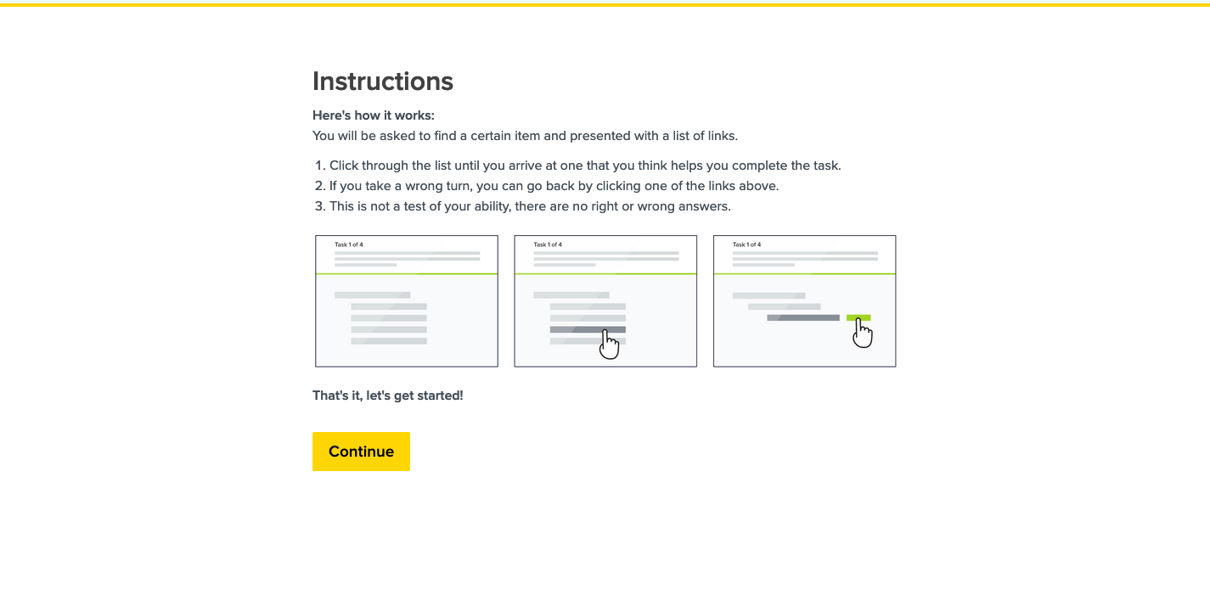
Image 2: Instructions
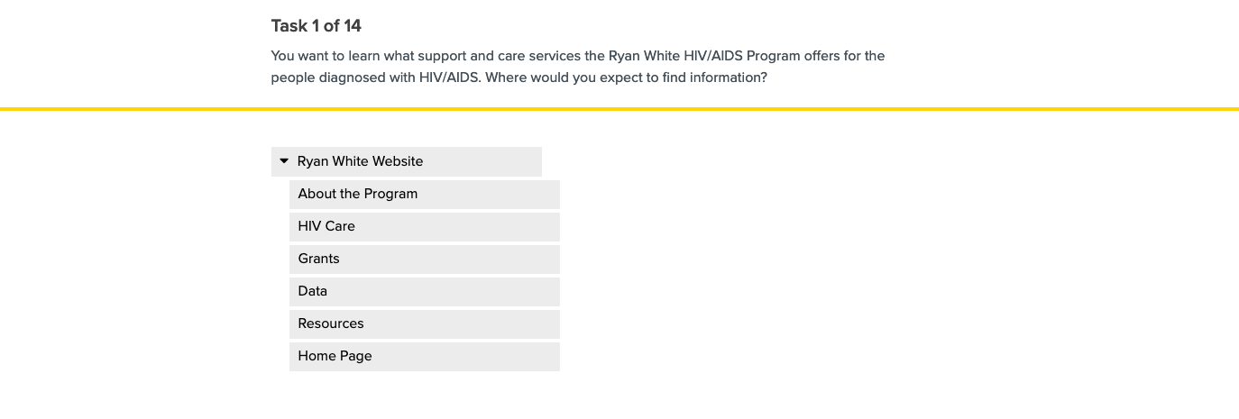
Image 3: Task 1
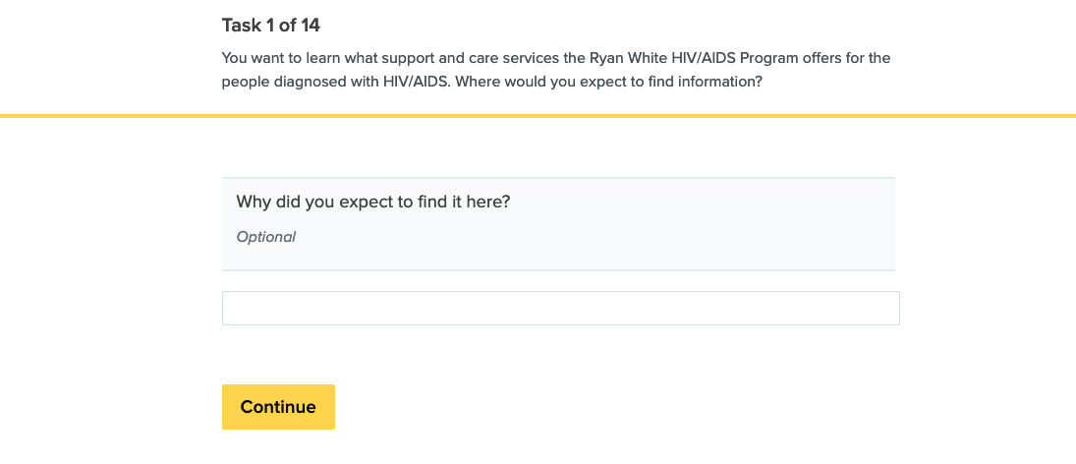
Image 4 – Task 1 post-task question
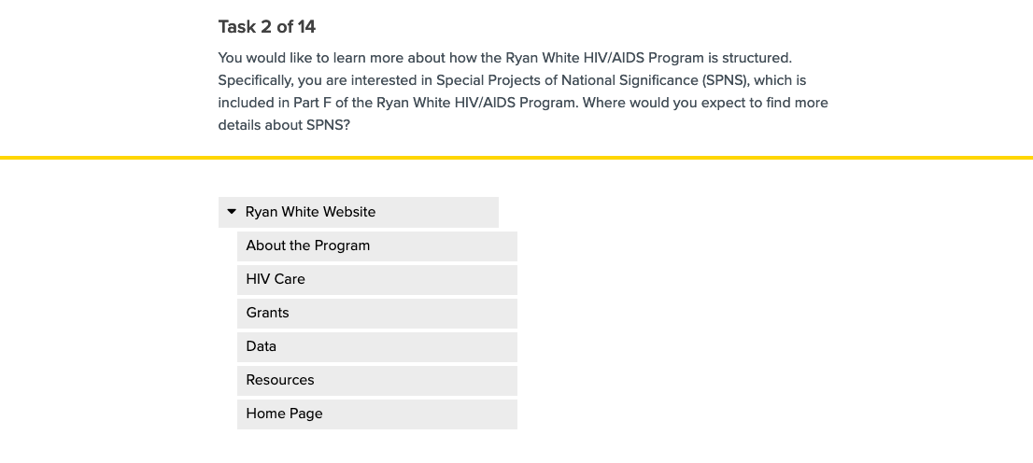
Image 5: Task 2
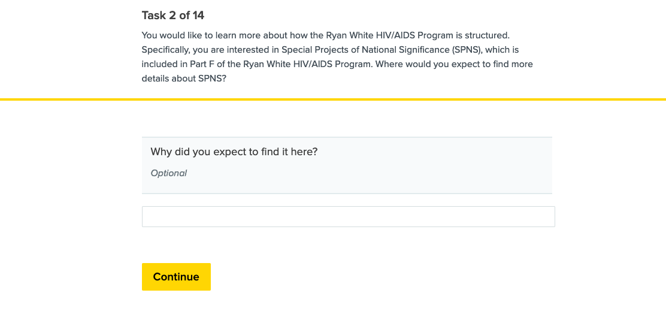
Image 6 – Task 2 post-task question
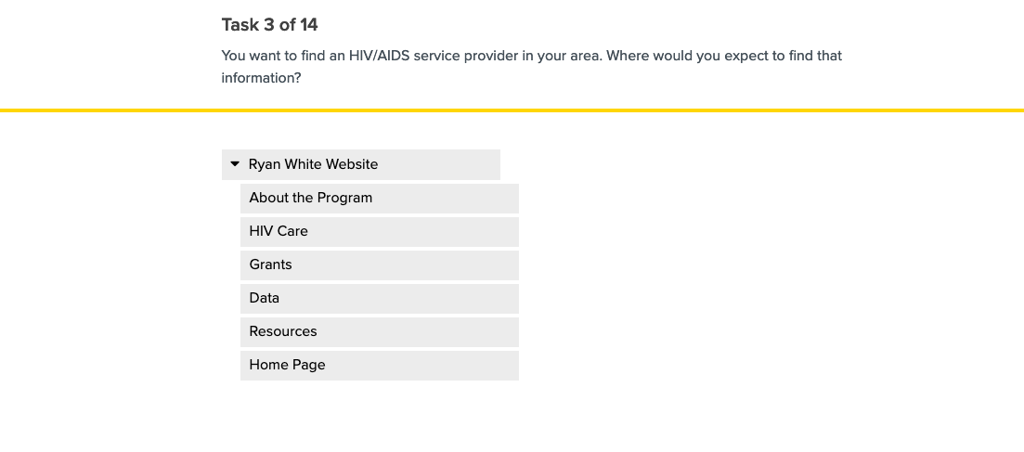
Image 7: Task 3
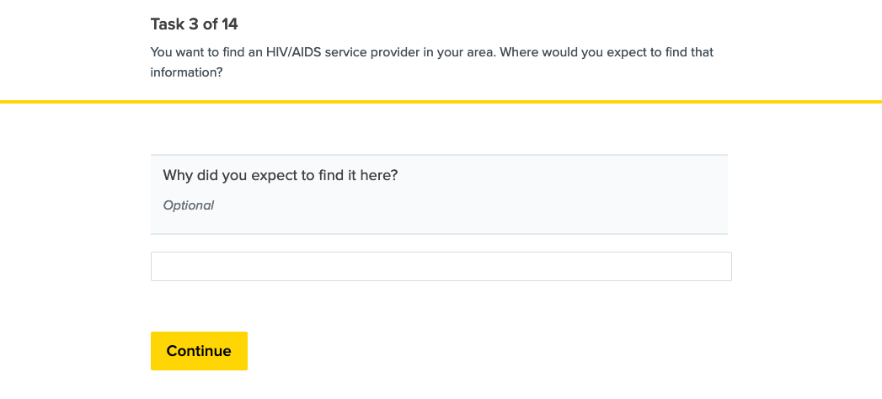
Image 8 – Task 3 post-task question
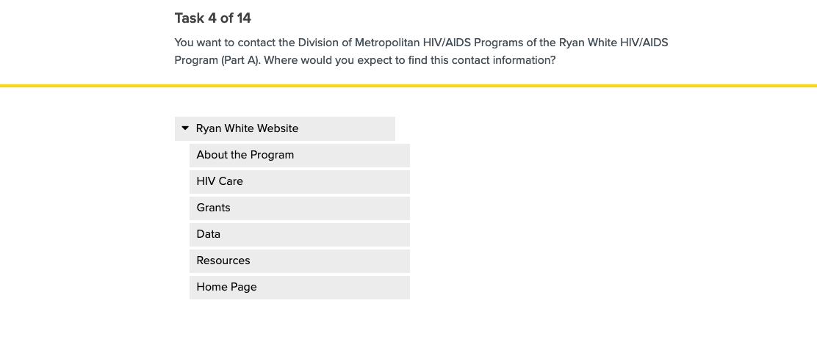
Image 9: Task 4
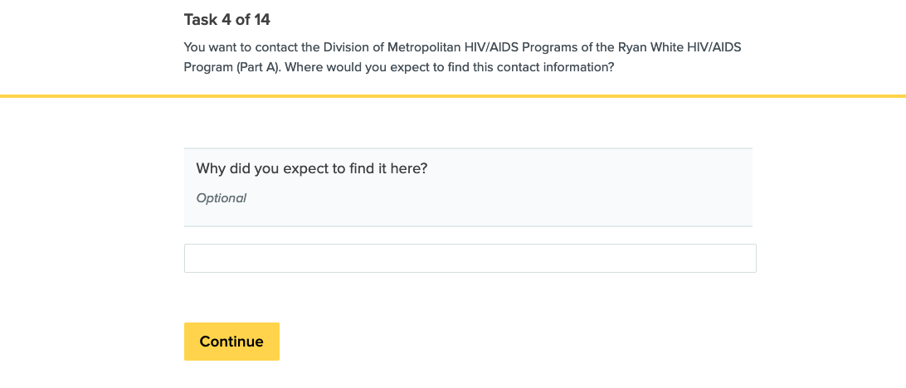
Image 10 – Task 4 post-task question
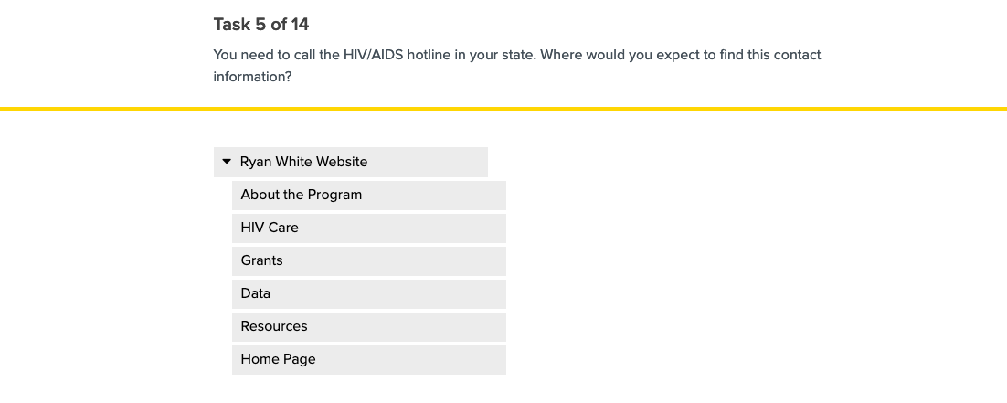
Image 11: Task 5
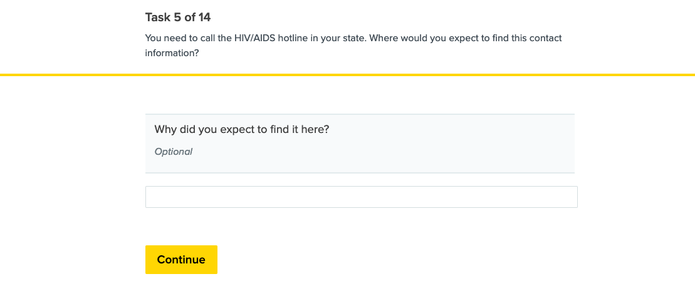
Image 12 – Task 5 post-task question
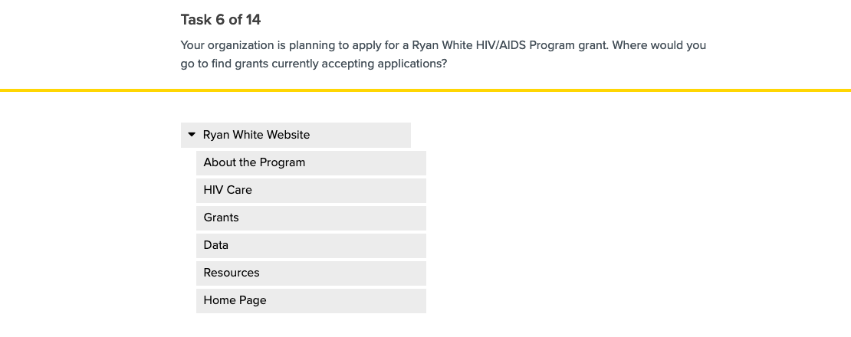
Image 13: Task 6
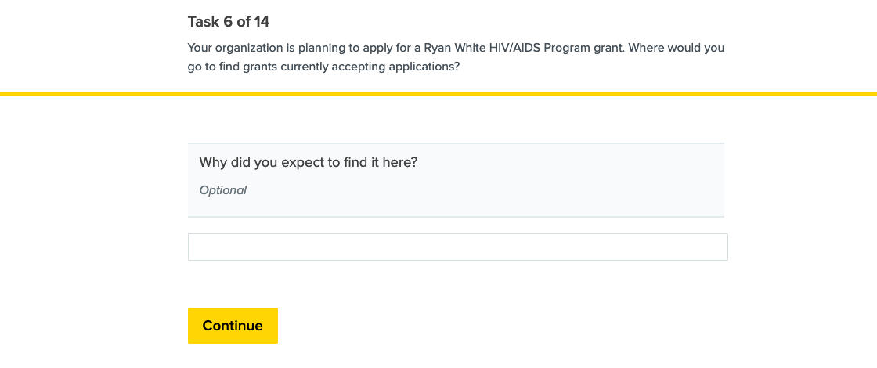
Image 14 – Task 6 post-task question
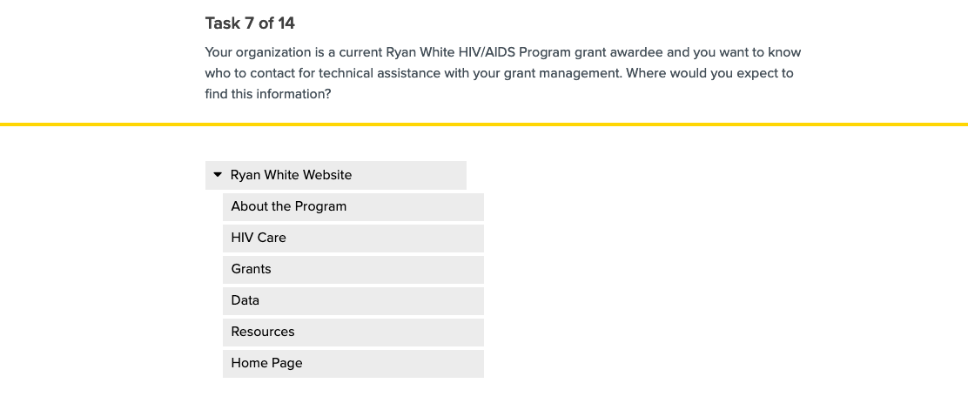
Image 15: Task 7
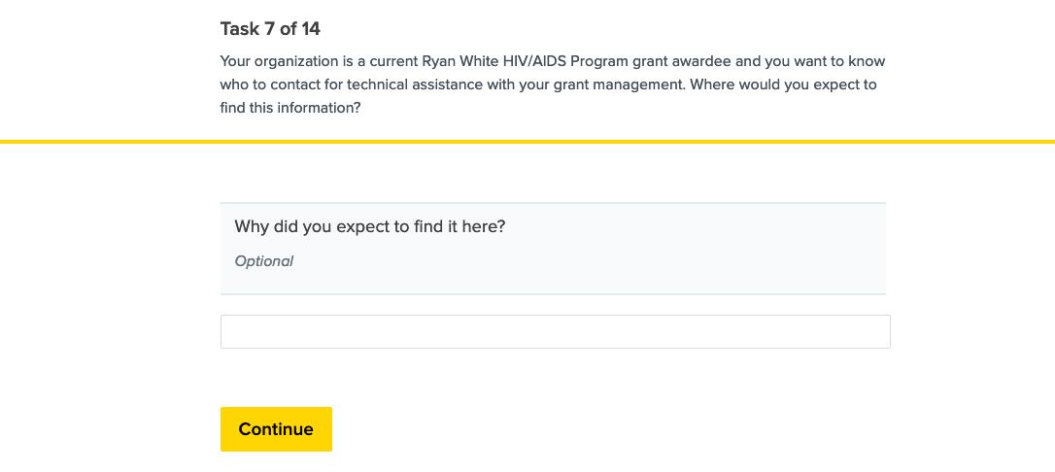
Image 16 – Task 7 post-task question
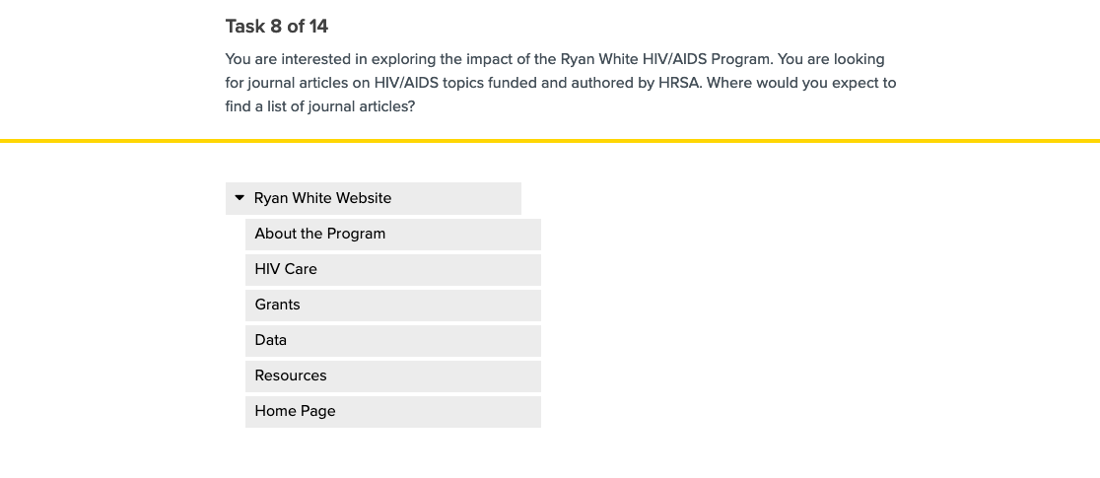
Image 17: Task 8
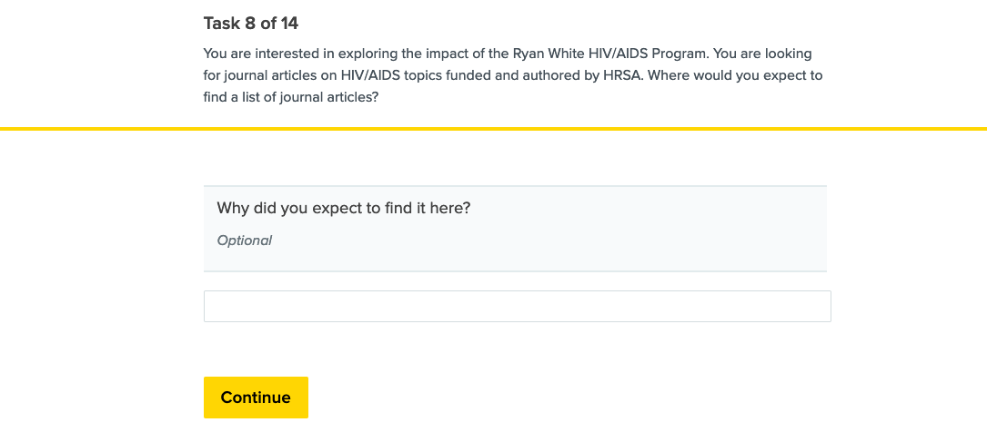
Image 18 – Task 8 post-task question
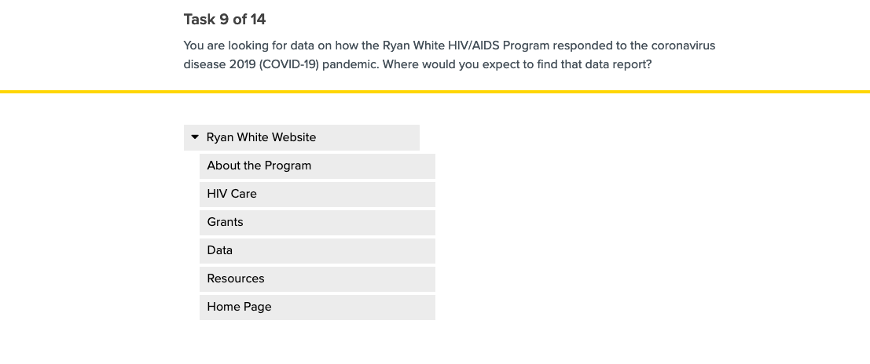
Image 19: Task 9
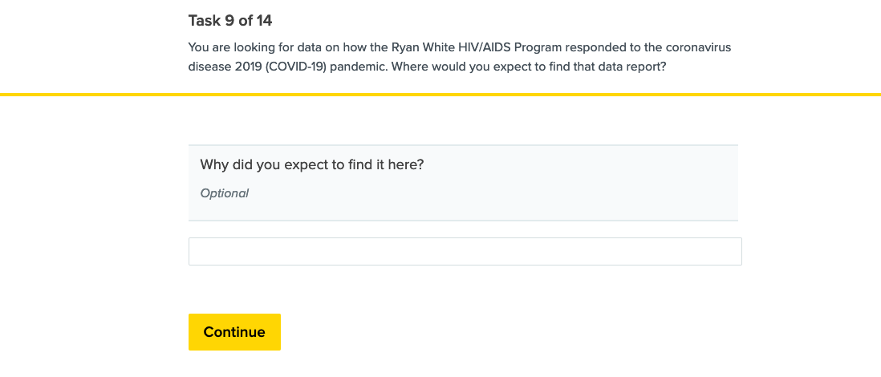
Image 20 – Task 9 post-task question
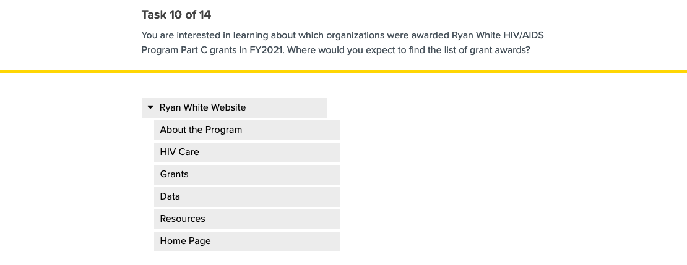
Image 21: Task 10
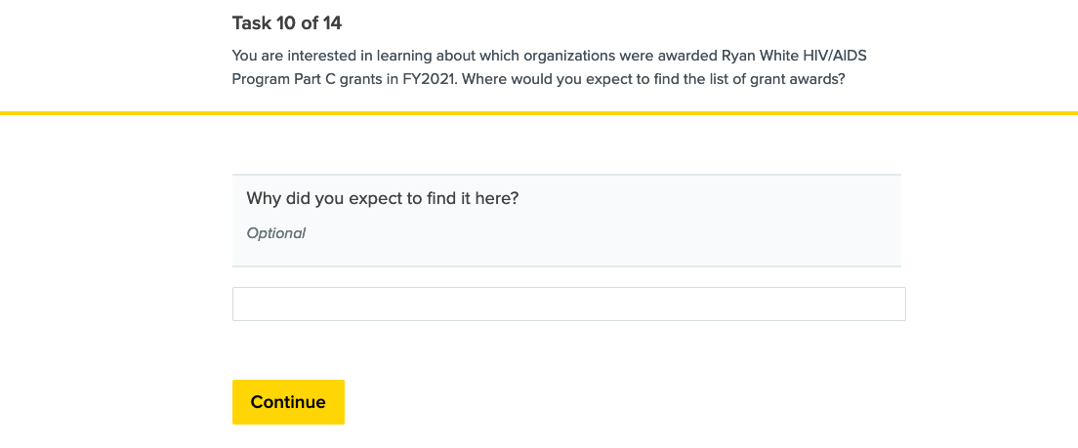
Image 22 – Task 10 post-task question
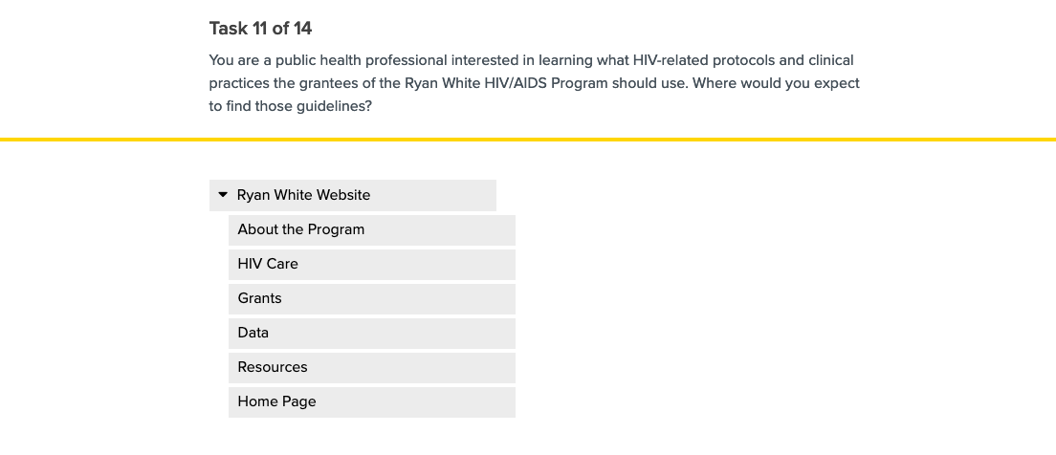
Image 23: Task 11
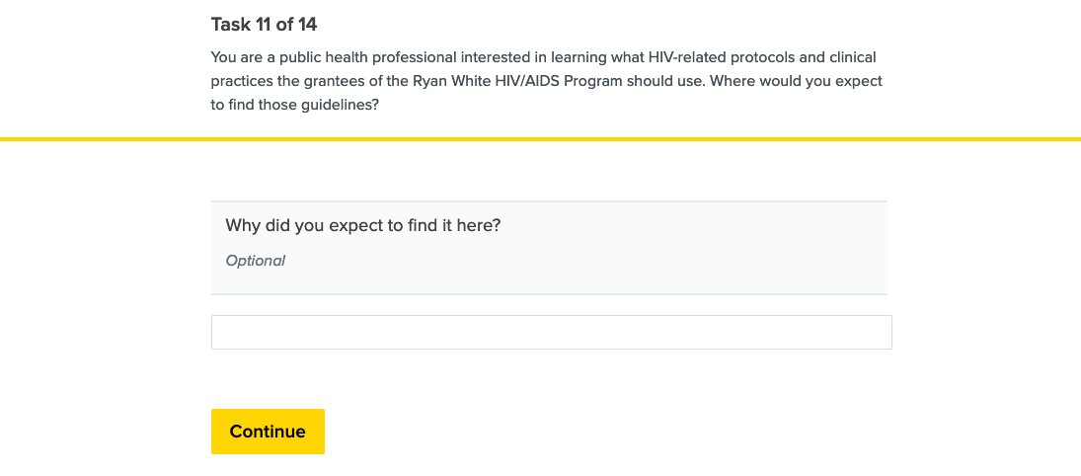
Image 24 – Task 11 post-task question
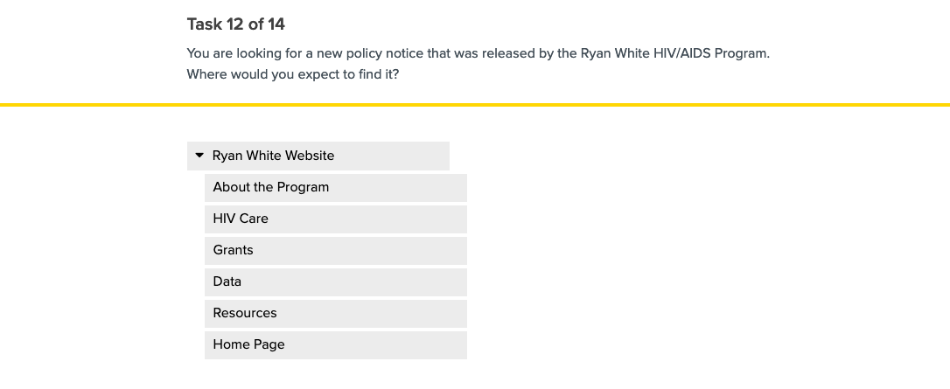
Image 25: Task 12
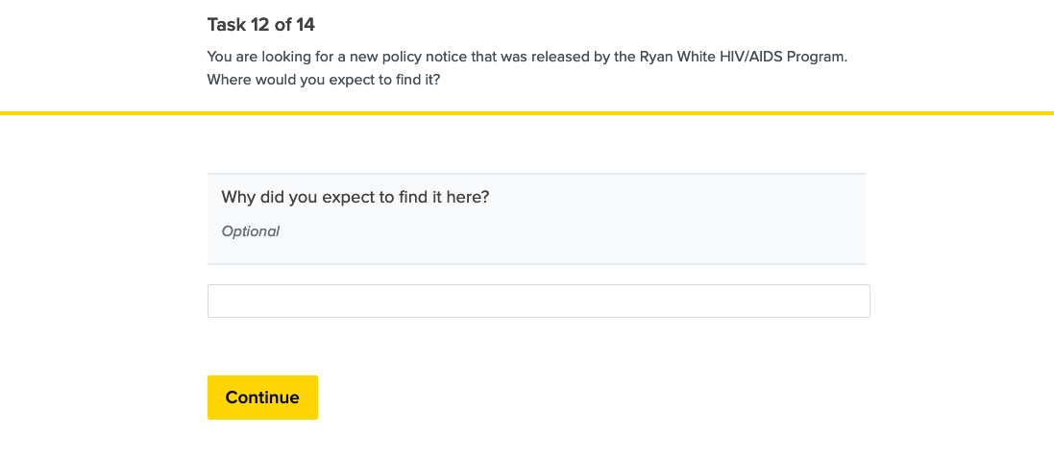
Image 26 – Task 12 post-task question
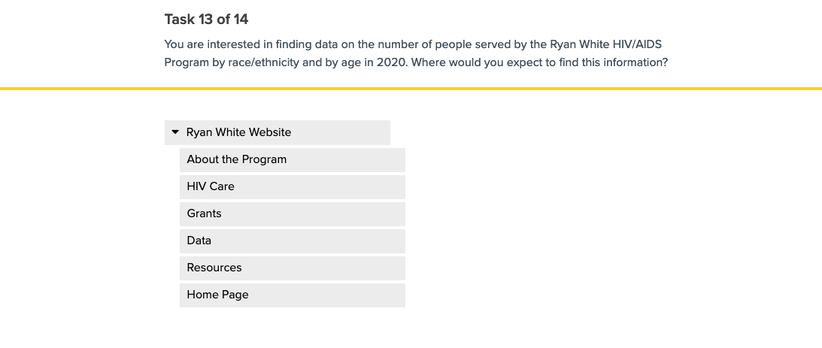
Image 27: Task 13
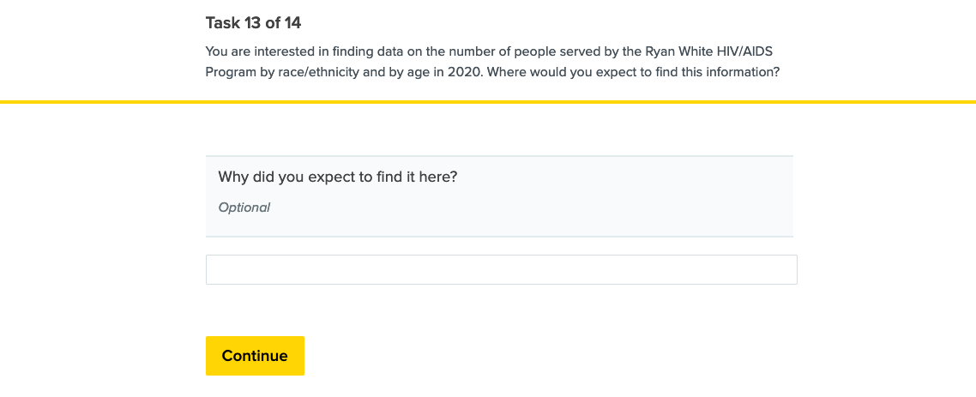
Image 28 – Task 13 post-task question
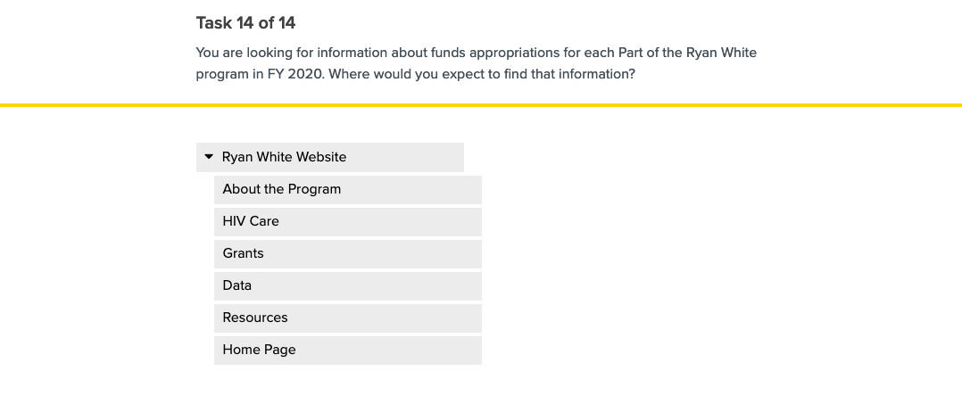
Image 29: Task 14
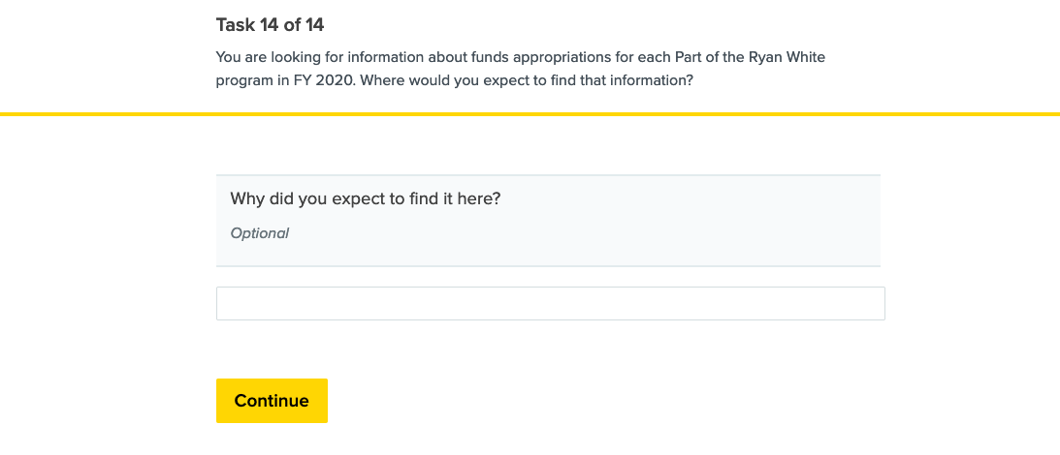
Image 30 – Task 14 post-task question
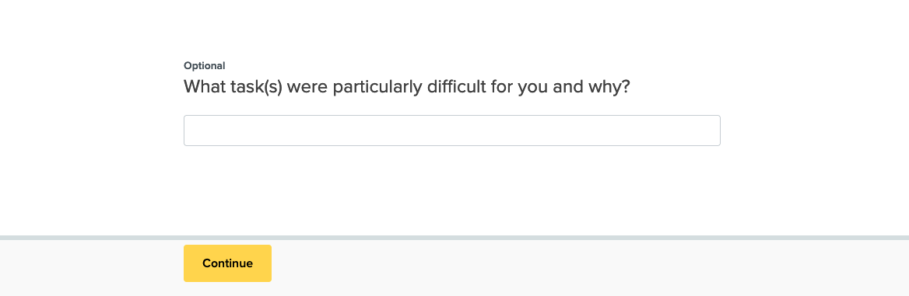
Image 31 – Post-test question 1
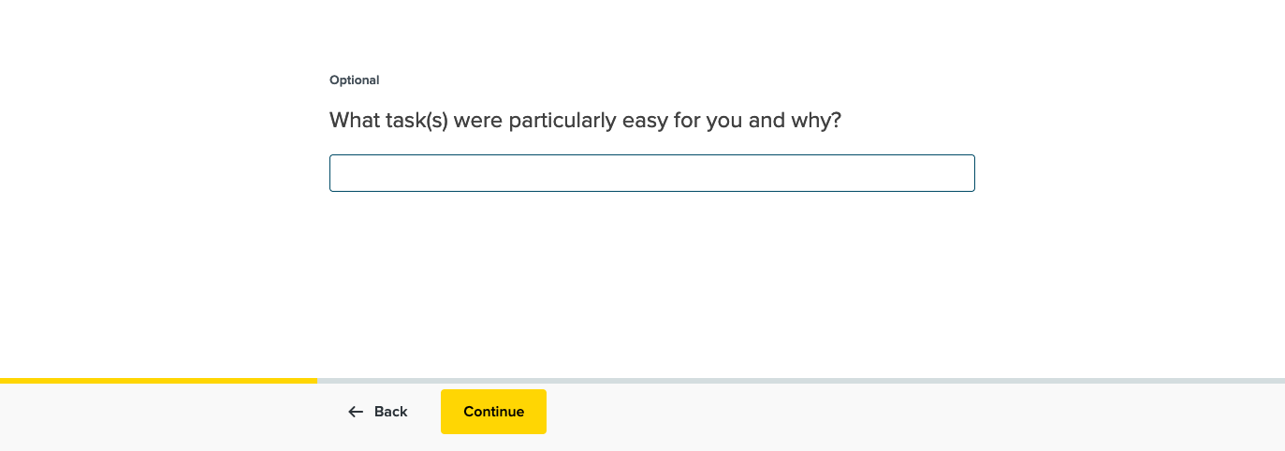
Image 30 – Post-test question 2
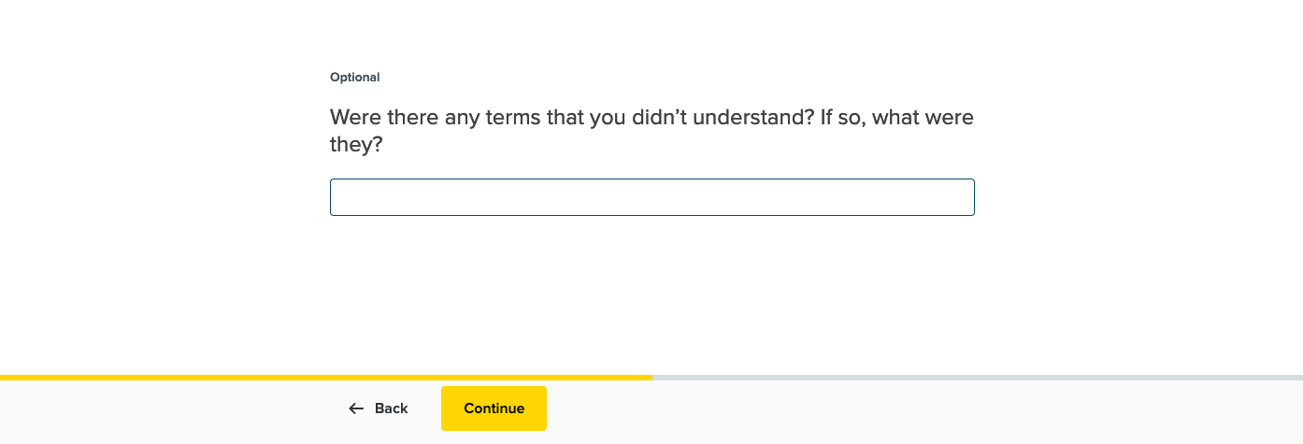
Image 32 – Post-test question 3
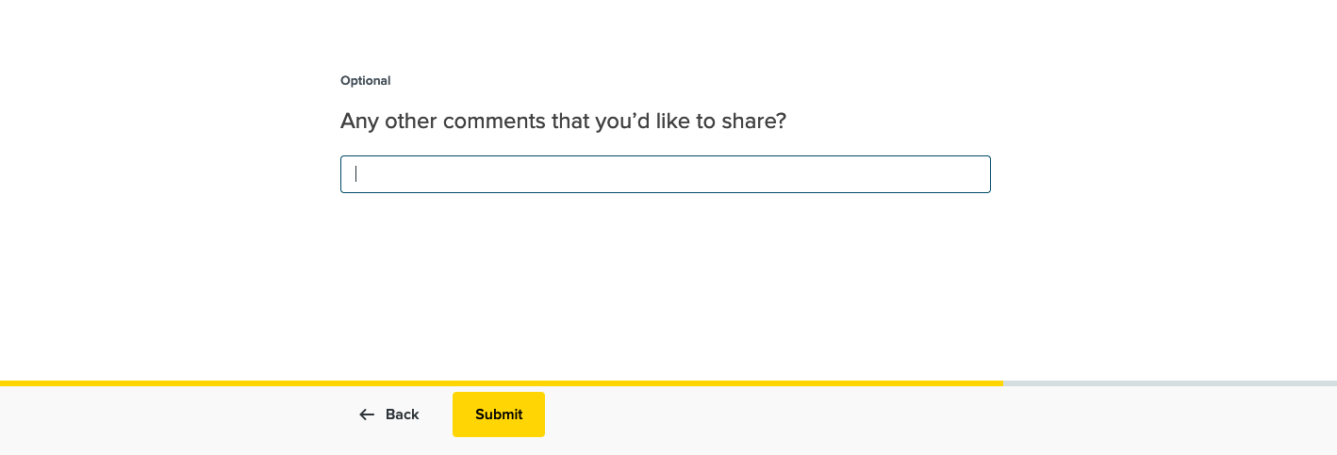
Image 33 – Post-test question 4
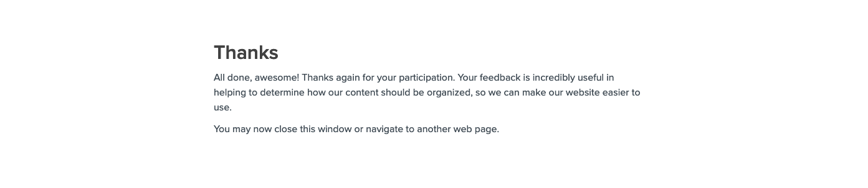
Image 34 – Thank you message

