Introduction to Draft Survey Construction

For the Health Resources and Services Administration (HRSA) under contract with JSI, this draft Health Center Workforce Survey has been developed based on an extensive literature review conducted as one of the deliverables for this contract (Literature Review Summary) and inputs from our first Technical Advisory Panel meeting. The literature review was structured around a Mayo Clinic framework of factors influencing burnout and job satisfaction, which were organized into seven broad groups of drivers of burnout (Workload, Control & Flexibility, Social Support, Work-Life Integration, Organizational/Cultural Values, Efficiency & Resources, and Meaning in Work) (Figure 1). Although the Mayo Clinic framework listed examples of drivers within each major grouping, staff supplemented and modified the list of workplace factors based on our conceptual understanding of important determinants and consequences of burnout and job satisfaction within the Health Center program environment (Figure 2). It was this full list of workplace factors that provided the focus for the literature search (Figure 3). The primary objectives of the literature search were to confirm that (a) the workplace factors indeed were supported by research findings showing there was a relationship for each with either burnout or job satisfaction and (b) to also identify questionnaire measurement tools for the workplace factors that were used in these research studies (see Literature Review Summary).
These measurement tools were compiled for consideration, often with several alternative tools available for each workplace factor. A subgroup of our project team then worked systematically over many sessions to choose the questions to include in the draft survey. In selecting the questions to measure each workplace factor, we kept in mind two objectives: (a) in order to keep the length of the total survey reasonable, the number of questions selected to measure an individual workplace factor should be relatively few; and (b) the wording of the questions should be applicable to Health Center employees (rather than hospital settings for instance). The selection team chose a subset of questions that succinctly met the definition of a workplace factor as described in the literature review. In some instances, the team made slight wording or phrasing changes to ensure relevance to health center employees and consistency of perspective. Also, for some workplace factors, the team included questions from multiple measures. One final note on the construction of this draft survey, we arranged the survey into major sections and sequenced workplace factors within these sections in a way that seemed to make sense even though they were different from the Mayo Clinic’s major groupings of workplace factors.
Based on feedback from 73 Listening Session participants representing a variety of occupations from different types of Health Centers across the country, a second draft of this survey was revised. This current draft survey will be further refined based on feedback from (a) HRSA and the TAP members, (b) results from 60 cognitive interviews, and (c) finally from pilot testing with 300-400 health center employees from across the nation.
Figure 1. “Key drivers of burnout and engagement in physicians.” 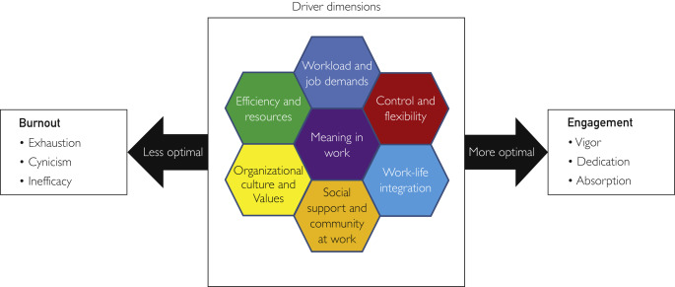
Figure 2. JSI conceptual model to guide survey development for health centers. 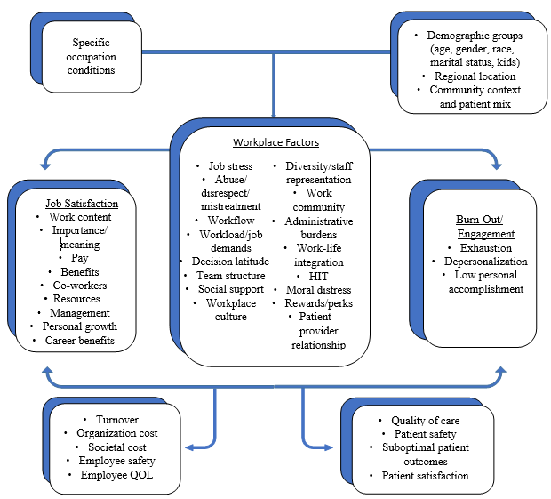
Figure 3. Integration of the JSI and Mayo Clinic frameworks.
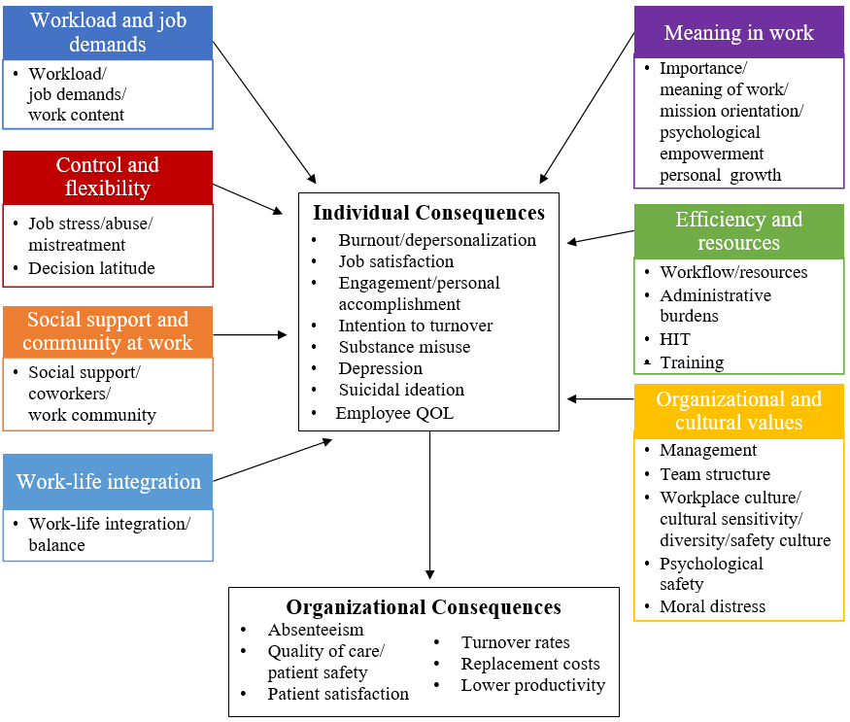

Literature Review Summary  JSI’s initial organization of workplace factors was based on the headings of burnout, job satisfaction, and then by the Mayo Clinic’s “drivers” of burnout. | Draft Survey 1.0  JSI’s workplace factors are now organized under headings that transition from the individual, interpersonal, and organizational level. The survey concludes with having the respondent reflect primarily on their job and their job satisfaction.
Burnout | Information About Your Job
Job Satisfaction | Your Work Team
Organizational and Cultural Values | Your Health Center Organization
Workload and Job Demands | Describing Your Job In More Detail
Control and Flexibility | Potential Problems For You With Your Job
Efficiency and Resources | Summing Up How You Feel About Your Job
Social Support and Community at Work | Demographics
Meaning in Work
Work-Life Integration
Draft Survey 1.0 includes the following key changes to the categories and organization of workplace factors compared to our Literature Review Summary.

Literature Review Summary  Headings/Subheadings | Draft Survey 1.0  Headings/Subheadings | Notes
 | Intention To Leave | - Added workplace factor
Management and Leadership | Leadership/Management | - Same workplace factor, shortened phrase
Team Dynamics/Team Structure | Team Dynamics | - Same workplace factor, shortened phrase
Workplace Culture | Culture | - Same workplace factor, shortened phrase
 | Resilient Organization | - Added workplace factor, derived from culture section
 | Patient Safety | - Added workplace factor
Workload And Job Demands | Workload | - Same workplace factor, shortened phrase
Job Stress | Job Stress And Bullying | - Same workplace factor, changed phrase
 | Job Discrimination | - Added workplace factor, derived concept from job stress and culture
Health Information Technology | Administrative Burden | - workplace factor merged with “Administrative Burden”
Training | Training And Resources | - Same workplace factor, changed phrase
Social Support and Community At Work | Social Support | - Same workplace factor, shortened phrase
Meaning In Work/ Psychological Empowerment | Meaning | - Same workplace factor, shortened phrase
 | Personal Growth | - Added workplace factor, derived questions from original “Meaning in Work/Psychological Empowerment” section
 | Mission Orientation | - Added workplace factor, derived questions from original “Workplace Culture” and “Meaning in Work” questions
 | Benefits | - Added workplace factor
 | Role Characteristics | - Added to survey
 | Demographics | - Added to survey

Draft Survey 2.0 includes the following key changes to survey items based on feedback gathered during the listening sessions with Health Centers.
Draft Survey 1.0 | Draft Survey 2.0 | Notes
Decision Latitude | Work Demands | - questions are the same, but concept was moved into the work demands section
Workflow | Work Demands | - questions are the same, but concept was moved into the work demands section
Culture | “This Health Center promotes the well-being of staff.”  “I can easily communicate with coworkers from all levels of this organization.” | - 1 item added to section  - Edited the language of an existing question for easier readability
Social Support | “My coworkers show recognition and appreciation for my work.”  “Management shows recognition and appreciation for my work.”  “The Health Center's patients show recognition and appreciation for our work.”  “The community shows recognition and appreciation for our work.” | - 4 items added to section
Training and Resources | “This Health Center has appropriate physical space to deliver our services.” | - 1 item added to section
Resilient Organizations | “I am confident in this Health Center’s prospects as a provider of health services in this community over the next few years.” | - 1 item removed after reviewing language, relevancy, and existing questions
Resilient Organization Item | Mission Orientation  “I work in an organization that provides essential care to people who otherwise wouldn't have it.” | - 1 item was reorganized into the mission orientation section
Benefits | “This Health Center provides the opportunity to receive economic incentives or rewards based on performance.” | - 1 item added to section
Work Load | “I do not have enough time to do the work that must be done.” | - Edited wording of existing item to include the qualifier “enough”
Perceived discrimination response categories: Yes / No | Perceived discrimination response categories: yes/no, if yes --> coworkers/Patient(s) (includes patient's family members) *revised response categories | - Added additional response categories to include the source of discrimination
Intent to Turnover | “Turnover is a problem at this Health Center.” | - 1 item added to section
“My Health Center” | “This Health Center” | - Updated all instances for consistency

Draft Survey 3.0 includes the follow key changes based on feedback from the Technical Advisory Panel members and HRSA staff.
Draft Survey 2.0 | Draft Survey 3.0 | Notes
Headings and Question Organization
- Information About Your Job  - Your Work Team  - Your Health Center Organization  - Describing Your Job in Detail  - Potential Problems for You With Your Job  - Summing Up How You Feel About Your Job  - Demographics | - Information About My Job  - My Work Team  - My Health Center  - My Work Experience  - Removed  - Overall Feelings About My Job  - My Demographics | Updated headings after comparing it to the 2019 Federal Employment Viewpoint Survey (EVS) headings.
Psychological Safety | Team Dynamics | Subheading deleted and questions merged under the Team Dynamics subheading.
Administrative Burden,  Patient Safety | Clinical Processes | Subheadings deleted and questions merged under a new Clinical Processes subheading.
Job Stress / Bullying,  Job Discrimination | Culture | Subheadings deleted and questions merged under the Culture subheading.
Personal Growth | Professional Growth | Revised heading based on TAP/HRSA feedback.
Meaning | Meaningfulness | Subheading revised.
New Items
In this Health Center, senior leaders generate high levels of motivation and commitment among staff. |  | Added after reviewing 2019 Federal Employment Viewpoint Survey (EVS) for missing concepts.
Policies and programs promote diversity in the workplace (e.g. recruiting minorities and women, training in awareness of diversity issues, mentoring). |  | Added after reviewing 2019 Federal Employment Viewpoint Survey (EVS) for missing concepts.
I get help and support from my direct supervisor. |  | Added based on HRSA comments.
My direct supervisor is willing to listen to my problems. |  | Added based on HRSA comments.
My work unit is able to recruit people with the right skills. |  | Added after reviewing 2019 Federal Employment Viewpoint Survey (EVS) for missing concepts.
This Health Center is successful at accomplishing its mission. |  | Added after reviewing 2019 Federal Employment Viewpoint Survey (EVS) for missing concepts.
I am able to take the time off from work that I need. |  | Added based on TAP comments.
I often provide less than optimal care due to pressures from insurers. |  | Added based on HRSA comments.
I would recommend this Health Center as a good place to work. |  | Added after reviewing language used in 2019 Federal Employment Viewpoint Survey (EVS) for similar concepts.
Are you an individual with a disability? |  | Added based on HRSA comments.
Languages spoken other than English? |  | Added based on HRSA comments.
We ask these questions below so that we can group your answers with similar employees and then we will be able to compare one group’s average answers to other groups’ average answers. However, we will never show a group’s average answers if the group is only made up of a small number of employees. This will be done to protect your confidentiality. |  | Added demographics introduction section based on HRSA comments.
Deleted Items
Is there anything else you would like to comment on? |  | Re-organized so that it is posed at the end of the survey instead of at the end of each section.
If a friend asked if he/she should apply for a job like yours with your employer, what would you recommend? |  | Deleted after reviewing language used in 2019 Federal Employment Viewpoint Survey (EVS) for similar concepts.
In general, how much do you like your job? |  | Deleted based on TAP and HRSA feedback on redundancy.
Changed Response Categories
A1: drop down menu of major UDS headings with some specific expansions | Uniform Data System Table 5 (2020) categories provided, but will continue to review specific expansions. | Provided the exact list from Uniform Data System (UDS), but will continue to review.
A2, A3, A5, G1: numerical ranges | Dropdown numerical field  “ ____ years” “ ___ hours” | Changed based on HRSA’s comments.
A7, A8:  Yes, a lot  Yes, some  Yes, a little  No | Routinely  Occasionally  Rarely / Never | Changed based on HRSA’s comments.
Discrimination and abuse questions: yes, no | strongly agree, agree, slightly agree, slightly disagree, disagree, strongly disagree | Changed question and response categories to parallel the rest of the survey.
Job satisfaction questions: inconsistent response categories | strongly agree, agree, slightly agree, slightly disagree, disagree, strongly disagree | Changed question and response categories to parallel the rest of the survey.
F30: moving, retiring, joining another health care organization, joining a different field, other | moving, retiring, advancing career, joining another health care organization, joining a different field, other | Added “advancing career” to offer more options for those not likely to leave.
Demographic questions | Added “choose not to disclose” | Added the response category, will also add introduction statement around confidentiality/ purpose of collecting demographic data.
Refined Language
Electronic medical record (EMR) | Electronic medical record (EMR) / electronic health record (HER) | Revised based on TAP/HRSA comments.
Personal growth | Professional growth | Revised based on TAP/HRSA comments.
Management | Senior leaders | Revised based on TAP/HRSA comments.
My health center,  Organization | This Health Center | Revised based on TAP/HRSA comments.

Draft Survey 4.0 includes the follow key changes based on HRSA’s feedback.
Draft Survey 3.0 | Draft Survey 4.0 | Notes
C12-C14: Bullying, Discrimination, Abuse | C12-C14 removed from survey. | Per HRSA’s request and concerns around sensitivity of questions.

Survey Instrument Table of Contents
A. Information about My Job 1
My Role Here 1
B. My Work Team 3
Team Dynamics 3
Leadership and Management 4
C. My Health Center 5
Culture 5
Social Support 7
Clinical Processes 8
Training and Resources 11
Resilient Organization 12
D. My Work Experience 12
Mission Orientation 12
Benefits 13
Professional Growth 13
Meaning 13
Work Load 14
Work-Life Integration 14
Moral Distress 15
F. Overall Feelings About My Job 15
Job Satisfaction 15
Burnout 16
Intention to Leave 18
G. Demographics 19

HRSA Health Center Workforce Survey Draft 4.0

A. Information about My Job

My Role Here
A1. What is your current job at this Health Center?
(drop down menu of major UDS headings with some specific expansions
*more to be added)
Physicians
- Family Physicians
- General Practitioners
- Internists
- Obstetrician/Gynecologists
- Pediatricians
- Other Specialty Physicians
NPs, PAs, and CNMs
- Nurse Practitioners
- Physician Assistants
- Certified Nurse Assistants
Medical Care Services
- Nurses
- Other Medical Personnel
- Laboratory Personnel
- X-Ray Personnel
Dental Care Services
Mental Health Services
- Psychiatrists
- Licensed Clinical Psychologists
- Licensed Clinical Social Workers
- Other Licensed Mental Health Providers
- Other Mental Health Staff
Substance Use Disorder Services
Other Professional Services _____
Vision Services
- Ophthalmologists
- Optometrists
- Other Vision Care Staff
Pharmacy Personnel
Enabling Services
- Case Managers
- Patient And Community Education Specialist
- Outreach Workers
- Transportation Staff
- Eligibility Assistance Workers
- Interpretation Staff
- Community Health Workers
- Other Enabling Services _____
Quality Improvement Staff
Facility and Non-Clinical Support Staff
- Management and Support Staff
- Fiscal and Billing Staff
- IT Staff
- Facility Staff
- Patient Support Staff

A2. For how many years have you been doing this type of job at this Health Center?
_____ years (dropdown numerical field)
A3. For how many years in total have you be doing this type of job (at this Health Center and elsewhere)?
_____ years (dropdown numerical field)
A4. For your current job, are you considered full-time, part-time, or a per diem worker?
Full Time
Part-Time
Per Diem
A5. In the past month, about how many hours a week do you usually work at your current job?
_____ hours a week (dropdown numerical field “less than 10” “10” “11” … “60” “60+”)
A6. As part of your current job, for how many people are you their direct supervisor?
None (I don’t supervise anyone)
1-4 people
5-9 people
10 or more people
A7. As part of your current job, how often do you interact directly with patients?
Routinely
Occasionally
Rarely / Never
A8. As part of your current job, how often do you interact directly with the Health Center’s electronic medical record (EMR)/electronic health record (EHR) system?
Routinely
Occasionally
Rarely / Never

B. My Work Team
These next questions are about your work group or work team. We want you to think about those people who you work with almost every day who are in the same unit as you even though you may do different tasks.

Team Dynamics
- My team members value, seek and give each other constructive feedback.
- My team members readily share ideas and information with each other.
- My team members work effectively together.
- My team members support me in the work that I do.
- Team members understand the role and responsibilities of each other.
- Members of my team are able to bring up problems and tough issues.
- If you make a mistake on my team, it is held against you.
- I feel that I am ignored or not taken seriously by others at work.
- I am encouraged by team leaders to voice my opinion on issues relating to our work.

Leadership and Management
- My direct supervisor encourages staff to contribute to decisions about our unit/department.
- My direct supervisor values my opinion about unit/department-related issues.
- My direct supervisor supports my need to balance work and other life issues.
- Communication between my direct supervisor and me is good.
- Communication between senior leaders and employees is good in this Health Center.
- My Health Center’s senior leaders are skilled and effective.
- My unit/department head is a good manager and leader.
- In this Health Center, senior leaders generate high levels of motivation and commitment among staff.

C. My Health Center

Culture
- This Health Center promotes the well-being of staff.
- Policies and programs at this Health Center promote diversity in the workplace (e.g. recruiting minorities and women, training in awareness of diversity issues, mentoring).
- Staff members are respectful to all coworkers regardless of their different backgrounds and/or identities.
- Staff members are sensitive to the diverse patient populations whom they serve.
- Staff members provide the same high quality care to all patients regardless of their different backgrounds and/or identities.
- Staff members have access to the necessary training and resources to provide culturally appropriate care.
- Opportunities for staff at this Health Center are decided primarily on merit.
- Senior leaders treat all employees fairly regardless of their different backgrounds and/or identities.
- Favoritism determines one's opportunities at this Health Center.
- I can easily communicate with coworkers from all levels of this Health Center.
- Teamwork is valued in this Health Center.
- If I were to experience mistreatment within my workplace (ex. bullying, discrimination, abuse, harassment), I would feel comfortable reporting it to someone at this Health Center.

Social Support
- I get help and support from my coworkers.
- I get help and support from my direct supervisor.
- My coworkers are willing to listen to my problems.
- My direct supervisor is willing to listen to my problems.
- My coworkers show recognition and appreciation for my work.
- Senior leaders show recognition and appreciation for my work.
- The Health Center's patients show recognition and appreciation for our work.
- The community shows recognition and appreciation for our work.

Clinical Processes
- Administrative tasks that I have to do get in the way of my primary duties.
- The electronic medical record (EMR)/electronic health record (EHR) system used at this Health Center supports high quality patient care.
- The electronic medical record (EMR)/electronic health record (EHR) system used at this Health Center supports clinical efficiency.
- I am satisfied with the electronic medical record (EMR)/electronic health record (EHR) system used at this Health Center.
- Mistakes that may affect patients happen more than they should in this Health Center.
- In this Health Center, getting more work done is more important than quality of care.
- This Health Center has systems and clinical processes in place to prevent, catch, and correct problems that have the potential to affect patient care.

Training and Resources
- My work unit is able to recruit people with the right skills.
- I have the resources I need to do my job well.
- This Health Center makes sure staff get the job training they need.
- This Health Center makes sure staff get the continuing education they need.
- This Health Center trains staff when new processes are put into place.
- This Health Center has adequate resources and procedures to protect the health and safety of staff.
- This Health Center is keeping up with changes in the delivery of medicine (e.g. technology, practice model, integration of services, etc.).
- This Health Center has appropriate physical space and conditions (e.g. noise level, temperature, privacy) to deliver our services.

Resilient Organization
- This Health Center has resources, systems, and processes to respond to crises effectively.
- I am confident about this Health Center's financial stability over the next few years.

D. My Work Experience

Mission Orientation
- I work in an organization that provides essential care to people who otherwise wouldn't have it.
- I am aware of the direction and mission of this Health Center.
- This Health Center is successful at accomplishing its mission.
- My work contributes to carrying out the mission of this Health Center.
- I feel I'm positively influencing other people's lives through my work.
- I would find it less fulfilling to work in healthcare outside of a Community Health Center setting.
- Working with underserved populations makes my job feel valuable.

Benefits
- I am well compensated given my training and experience.
- I am well compensated compared to similar jobs in this area.
- This Health Center rewards performance with bonuses or other types of recognition.

Professional Growth
- I am satisfied with my opportunities for professional growth at this Health Center.
- There are a lot of opportunities for challenging work in my job.
- There are a lot of opportunities for gaining new skills and knowledge in my job.
- My skills and knowledge are used well in my job.

Meaningfulness
- I have a meaningful career at this Health Center.
- I have a good sense of what makes my job meaningful/fulfilling to me.
- The work I do serves a greater purpose.

Work Load
- I do not have enough time to do the work that must be done.
- We have enough staff to handle our patient load.
- I know what is expected of me at work.
- I sometimes have to do things at work, which seem to be unnecessary.
- I have control over how I do my work.
- I have influence in the decisions affecting my work.

Work-Life Integration
- My work takes so much of my time that it has a negative effect on my personal life.
- I leave my work behind when I go home at the end of the workday.
- I am able to take the time off from work that I need.

Moral Distress
- I often find it difficult or impossible to do my job because of organizational rules and procedures.
- I often provide less than optimal care due to pressures from my direct supervisor or senior leaders.
- I often provide less than optimal care due to pressures from insurers.
- This Health Center has adequate resources to address patients’ medical and/or social needs.
- This Health Center is unable to improve the health of our patient population because their needs go beyond the scope of medical care and support services.

E. Overall Feelings About My Job

Job Satisfaction

- If I had to decide again, I would definitely take this job.

- I would recommend this Health Center as a good place to work.
- I feel that this is my ideal job.

- My job matches the expectations I had when I took it.
- All things considered, I am very satisfied with my current job.

Burnout
- The longer I work in this job, the less empathetic I feel toward the Health Center's patients.

- The longer I work in this job, the less empathetic I feel with my colleagues.
- The longer I work in this job, the less sensitive I feel toward others’ feelings/emotions.
- The longer I work in this job, the less interested I feel in talking with the Health Center's patients.
- The longer I work in this job, the less connected I feel with the Health Center's patients.
- The longer I work in this job, the less connected I feel with my colleagues.
- There are days when I feel tired before I arrive at work.
- After work, I tend to need more time than in the past in order to relax and feel better.
- I can tolerate the pressure of my work very well.
- During my work, I often feel emotionally drained.
- After working, I have enough energy for my leisure activities.
- After my work, I usually feel worn out and weary.
- Usually, I can manage the amount of my work well.
- When I work, I usually feel energized.
- I often find new and interesting aspects in my work.
- It happens more and more often that I talk about my work in a negative way.
- Lately, I tend to think less at work and do my job almost mechanically.
- I find my work to be a positive challenge.
- Over time, one can become disconnected from this type of work.
- Sometimes I feel sickened by my work tasks.
- This is the only type of work that I can imagine myself doing.
- I feel more and more engaged in my work.

Intention to Leave
- A year from now, it is unlikely that I will still be working at this Health Center.
- If you were to leave, which would be the main reason?

Moving

Retiring

Advancing Career

Joining another Health Care Organization
Joining a Different Field

Other
___________
- Staff turnover is a problem at this Health Center.

F. My Demographics
We ask these questions below so that we can group your answers with similar employees and then we will be able to compare one group’s average answers to other groups’ average answers. However, we will never show a group’s average answers if the group is only made up of a small number of employees. This will be done to protect your confidentiality.
- What is your age as of your last birthday?

_____ years (dropdown numerical field) Choose not to disclose
- What is your gender identity?

Male
Female
Transgender man/male
Transgender woman/female
Something else
Don't know/not sure
Choose not to disclose

- What is your sexual orientation?
Lesbian or Gay
Heterosexual or Straight
Bisexual
Something else
Don't know/not sure
Choose not to disclose
- What is your Race or Ethnicity (option to choose multiple races)?
American Indian or Alaska Native
Asian
Black or African American
Hispanic or Latino
Middle Eastern or North African
Native Hawaiian or Other Pacific Islander
White
Other ________________
Choose not to disclose
- What language(s) do you speak other than English?
Dropdown list based on U.S. Census classification
- What is the highest education level you have completed?
Some High School
Graduated High School or Equivalent (ex. GED)
Finished Trade, Vocational, or Technical School
Some College
Associate's Degree (ex. AA, AS)
Bachelor's Degree (ex. BA, BS, AB)
Graduate Degree (ex. master's, professional, doctorate)
Choose not to disclose

- What is your current marital status?

Married

Widowed

Separated

Divorced

Never Married
Choose not to disclose
- Do you have children under 18 living at home?
Yes No Choose not to disclose

- Do you have significant caregiver responsibilities for any relatives who have disabilities or who are elderly?
Yes No Choose not to disclose
F10. Are you obligated to work at this Health Center due to visa requirements or scholarship/loan repayment agreements you have made?
Yes No Choose not to disclose

Is there anything else you would like to share that wasn’t included in this survey?
__________________________________________________________________________________________________________________________________________________________________________________________________________________________________________

Shanafelt TD, Noseworthy JH. Executive Leadership and Physician Well-being: Nine Organizational Strategies to Promote Engagement and Reduce Burnout. Mayo Clin Proc. 2017 Jan;92(1):129-146. doi: 10.1016/j.mayocp.2016.10.004. Epub 2016 Nov 18. PMID: 27871627.

