Introduction to Draft Survey Construction
The initial draft Health Center Workforce Survey was developed based on an extensive literature review conducted as one of the deliverables for this contract (Literature Review Summary) and inputs from our initial Technical Advisory Panel meeting. The literature review was structured around a Mayo Clinic framework of factors influencing burnout and job satisfaction, which were organized into seven broad groups of drivers of burnout (Workload, Control & Flexibility, Social Support, Work-Life Integration, Organizational/Cultural Values, Efficiency & Resources, and Meaning in Work) (Figure 1). Although the Mayo Clinic framework listed examples of drivers within each major grouping, John Snow Inc. staff supplemented and modified the list of workplace factors based on our conceptual understanding of important determinants and consequences of burnout and job satisfaction within the Health Center program environment (Figure 2). It was this full list of workplace factors that provided the focus for the literature search (Figure 3). The primary objectives of the literature search were to confirm that (a) the workplace factors indeed were supported by research findings showing there was a relationship for each with either burnout or job satisfaction and (b) to also identify questionnaire measurement tools for the workplace factors that were used in these research studies (see Literature Review Summary).

JSI then compiled these measurement tools for consideration, often with several alternative tools available for each workplace factor. A subgroup of our project team then worked systematically over many sessions to choose the questions to include in the initial draft survey. In selecting the questions to measure each workplace factor, we kept in mind two objectives: (a) in order to keep the length of the total survey reasonable, the number of questions selected to measure an individual workplace factor should be relatively few; and (b) the wording of the questions should be applicable to Health Center staff across occupations (rather than hospital settings or limited to physicians for instance). The team chose a subset of questions that succinctly met the definition of a workplace factor as described in the literature review. In some instances, the team made slight wording or phrasing changes to ensure relevance to health center employees and consistency of perspective. Also, for some workplace factors, the team included questions from multiple measures. One final note on the construction of the survey, we arranged the survey into major sections and sequenced workplace factors within these sections in a way that made sense even though they were different from the Mayo Clinic’s major groupings of workplace factors.

Based on feedback from 73 Listening Session participants representing a variety of occupations from different types of Health Centers across the country, JSI revised a second draft of this survey. Feedback from the Technical Advisory Panel members and HRSA staff contributed towards the third and fourth drafts. The current draft (version 5.0) was further informed by cognitive interviews conducted with a diverse pool of 60 health center staff who had completed the survey. A final draft of the survey will be prepared after pilot testing of the current version with approximately 400 health center employees from across all HRSA-funded health centers.

Figure 1. “Key drivers of burnout and engagement in physicians.” 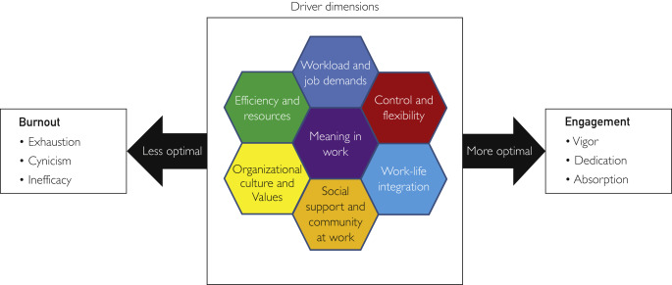
Figure 2. JSI conceptual model to guide survey development for health centers. 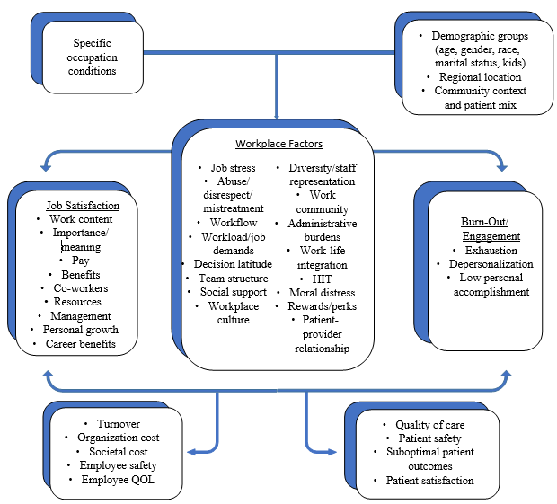

Figure 3. Integration of the JSI and Mayo Clinic frameworks.
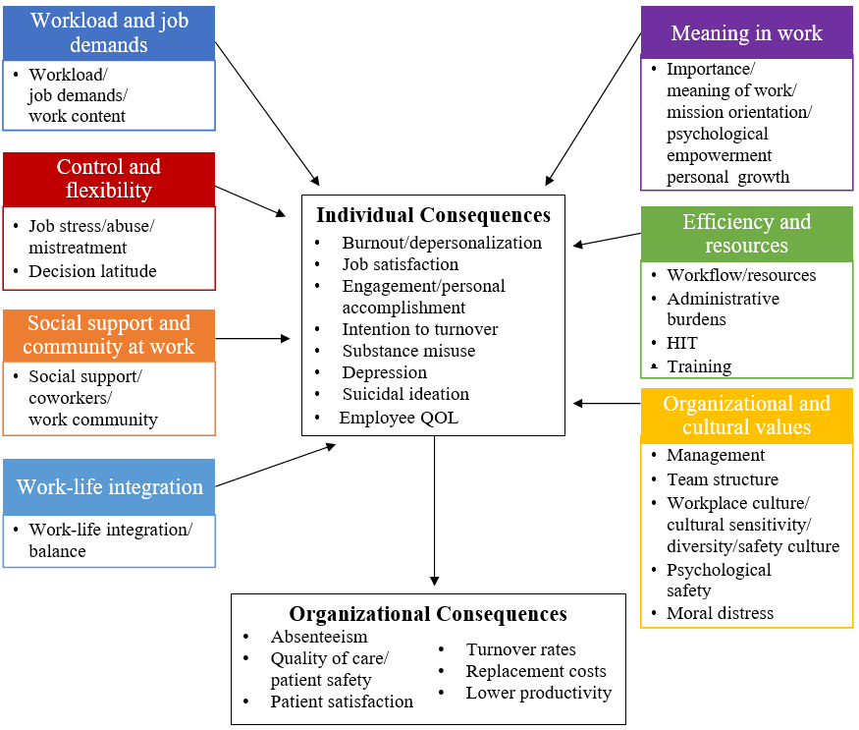

Draft Version | Summary of Major Changes
1 | Organized the survey headings, subheadings, and flow of questions.  In the Literature Review Summary, JSI categorized workplace factors under the Mayo Clinic’s “Driver dimensions” of burnout (Figure 1). In draft 1, JSI re-categorized the workplace factors under new headings that transition from the individual, interpersonal, and organizational level. Some workplace factors merged into the same subheading or separated into distinct subheadings.
2 | Added, deleted, revised, and reorganized questions based on feedback from the Listening Session participants.  Added questions or response options where the Listening Session participants noted missing concepts. Removed one question after reviewing whether the concept had been encompassed in other existing questions. Revised questions that participants found unclear or lengthy. Merged related questions into the same subheading.
3 | Updated survey headings, added and deleted questions, revised response categories, and refined the question language based on TAP and HRSA feedback.  Upon HRSA’s suggestion, JSI reviewed the 2019 Federal Employment Viewpoint Survey (EVS) to compare the survey’s organization and workplace factors. Altered survey headings based on the EVS and reorganized existing subheadings. Added an introduction to the demographics section based on HRSA’s feedback. Added questions based on TAP/HRSA’s comments as well as added EVS questions that were not already included in the survey. Deleted questions that were redundant. Revised response categories to meet HRSA’s feedback, match the existing agree-disagree scale, and offer participants an option to not disclose their demographic data. Revised some questions for clarity and consistency.
4 | Revised questions based on HRSA’s feedback.  Bullying, discrimination, and abuse questions were removed from the survey. Minor revisions to questions for clarity and consistency.
5 | Revised, deleted, and reorganized questions based on feedback from the Cognitive Interview participants.  Reworded and simplified job classification questions. Added additional job classification questions to record respondents with multiple jobs, director roles, and those currently working towards credentialing or certification. Separated race/ethnicity demographic question into two questions. Removed questions that were redundant or already encompassed by other questions. Reorganized questions and subheadings to better reflect corresponding workplace factors. Clarified and simplified questions with minor edits. Revised response categories based on Cognitive Interview participants feedback on missing options. Added or revised section introductions given participant feedback about confidentiality concerns.
6 | Revised and deleted questions based on feedback from HRSA.  Revised EMR/EHR questions to better assess burnout and not satisfaction with the operating system. Deleted sensitive moral distress questions.

Survey Instrument Table of Contents
A. Information about My Job 1
B. My Work Team 5
My Work Team Dynamics 5
Supervision and Leadership 6
C. My Health Center 7
Culture 7
Social Support and Recognition 8
Health Center Processes 9
Training 10
Resources 10
D. My Work Experience 12
Mission Orientation 12
Meaningfulness 13
Compensation and Benefits 13
Professional Growth 14
Work Load 14
Work-Life Balance 15
Moral Distress 15
E. Overall Feelings About My Job 15
Job Satisfaction 15
Burnout 16
Intention to Leave 18
F. My Demographics 19

HRSA Health Center Workforce Survey Draft 5.0

A. Information about My Job
A1. Please select the job that best matches your Primary job at this Health Center.
- Please select the category that your job falls in.
Medical (General Practitioner, Physician Assistant, Nurse, etc.)
Dental (Dental Technician, Dental Aide etc.)
Behavioral Health / Substance Use (Psychologist, Professional Counselor, Recovery Support Specialist, etc.)
Other Professional (Chiropractor, Nutritionist, Podiatrist, etc.)
Vision (Ophthalmologist, Optometric Assistant, etc.)
Lab (Pathologist, Laboratory Technician, Phlebotomist, etc.)
X-Ray (Radiologist, Ultrasound Technician, etc.)
Pharmacy (Pharmacy Clerk, Pharmacy Assistant, etc.)
Enabling (Case Manager, Transportation Staff, Interpreter, etc.)
Other Program and Services (WIC Staff, Educational Counselor, Exercise Trainer, etc.)
Patient Support (Front Desk Staff, Medical Scribe, Patient Records Clerk, etc.)
Quality Improvement (Quality Improvement Nurse, Data Analyst, etc.)
Senior Corporate Leadership (Chief Information Officer, Chief Medical Officer, etc.)
Administration and Support (Site Manager, Human Resources Staff, Communications Staff, etc.)
Fiscal and Billing (Accounts Payable Clerk, Bookkeeper, etc.)
Information and Technology (EHR Technician, IT Help Desk Technician, Programmer, etc.)
Facilities (Janitorial Staff, Security Guard, Equipment Maintenance Staff, etc.)
- Please select the title that best describes your job.

Family Physician
General Practitioner
Internist
Obstetrician / Gynecologist
Pediatrician
Other Specialty Physician: ______
Nurse Practitioner
Physician Assistant
Midwife
Nurse
Nurse Aide / Assistant (certified and uncertified)
Medical Assistant / Aide (certified and uncertified)
EMS/EMT Staff (not credentialed as a nurse)
Other Clinical Medical Staff: ______
Dentist
Dental Hygienist
Dental Therapist
Dental Assistant, Advanced Practice Dental Assistant
Dental Technician
Dental Aide
Other Clinical Dental Personnel: ______
Psychiatrist
Psychologist
Clinical Social Worker
Professional Counselor
Marriage and Family Therapist
Psychiatric Nurse Specialist
Mental Health Nurse Practitioner
Mental Health Physician Assistant
Other Licensed Mental Health Provider
Other Mental Health Staff
Alcohol/Substance Use Counselor
Recovery Support Specialist
Other Behavioral Health/Substance Use Disorder Staff: ______
Chiropractor
Dietician / Nutritionist
Therapist (Occupational, Speech, Physical, etc.)
Podiatrist
Other Professional Providers: ______
Ophthalmologist
Optometrist
Ophthalmologist / Optometric Assistant
Ophthalmologist / Optometric Aide
Ophthalmologist / Optometric Technician
Other Vision Care Staff: ______
Pathologist
Medical Technologist
Laboratory Technician
Laboratory Assistant
Phlebotomist
Other Lab Staff: ______
Radiologist
X-Ray Technician
Radiology Assistant
Ultrasound Technician
Other X-Ray Staff: ______
Pharmacist
Pharmacy Technician
Pharmacist Assistant
Pharmacy Clerk
Other Pharmacy Staff: ______
Case Manager
Patient / Community Education Specialist
Outreach Worker
Transportation Staff
Eligibility Assistance Worker
Interpreter
Community Health Worker
Other Enabling Services Staff: ______
WIC Staff
Head Start Staff
Housing Assistance Staff
Child Care Staff
Food Bank / Meal Delivery Staff
Employment / Educational Counselor
Exercise Trainer/Fitness Center Staff
Adult Day Health Care, Frail Elderly Support Staff
Other Program / Service Specific Staff: ______
Clinical Team Secretary
Patient Appointment Clerk
Patient / Medical Records Clerk
Medical Scribe
Patient Records Transcriptionist
Front Desk / Registration / Check-In Staff
Cashier / Check-Out Staff
Appointments Clerk
Other Patient Support Staff: ______
QI Nurse
QI Technician
QI Data Specialist
Statistician / Data Analyst
Other Quality Improvement Staff: ______
Chief Executive Officer / Executive Director
Chief Financial Officer / Fiscal Officer / Finance Director
Chief Information Officer
Chief Medical Officer / Medical Director (With No Clinical Practice)
Chief Operating Officer / Director Of Operations
Chief Strategy/Planning Officer
Other Corporate Leadership Team: ______
Department Manager
Site Manager
Planning And Evaluation Staff
Personnel / HR Department Staff
Marketing / Communications Staff
Receptionist (not clinical check-in)
Secretaries / Administrative Assistant
Other Administration / Support Staff: ______
Accountant
Bookkeeper
Billing Clerk
Accounts Payable Clerk
Other Fiscal and Billing Staff: ______
Data Processing Staff
Programmer
IT Help Desk Technician
EHR Technician
Data Entry Clerk
Other Information and Technology Staff: ______

Janitor / Custodian
Security Guard
Groundskeeper
Equipment Maintenance Staff
Housekeeping Staff
Other Facilities Staff: ______

- What is your actual title for this job? _____________
- For this job, do you serve as a director of the clinical or functional area in which you work, such as Medical Director, Human Resources Director, or Director of Nursing?
Yes, I am a director
No, I am not a director
- For this job, are you working as part of an educational requirement, such as an internship, residency, fellowship, or apprenticeship?
Yes, my job is part of an educational requirement
No, my job is part of an educational requirement
- Do you have a second distinct job at this Health Center? Indicate a second job if you have separate time set aside for this additional job or an agreed expectation that you will serve in a clear second capacity for a portion of your time. Do not consider a director role as a second job.
Yes, I have more than one distinct job [skip logic to A1 vii-xi questions]
No, I only have one job [skip logic to A2]
A1 Secondary Job Question Series (same responses):
Please select the job that best matches your Secondary job at this Health Center.
- Please select the category that your Secondary job falls in.
- Please select the title that best describes your Secondary job.
- What is your actual title for this job?
- For this job, do you serve as a director of the clinical or functional area in which you work, such as Medical Director, Human Resources Director, or Director of Nursing?
- For this job, are you working as part of an educational requirement, such as an internship, residency, fellowship, or apprenticeship?
For the remainder of the survey, please answer questions from the perspective of your Primary job to the degree possible, even if your answers might be different for your Secondary job.
A2. How many years have you been doing this type of job at this Health Center? Please round to the nearest year.
Less than 1 year
More than 1 year: _____ years
A3. How many years, in total, have you been doing this type of job at this Health Center and anywhere else? Please round to the nearest year.
Less than 1 year
More than 1 year: _____ years
A4. For your current job, are you paid on a salary or hourly basis?
Salary
Hourly
A5. In the past month, on average how many hours a week did you work at your current job? Include any paid time off as time worked. Do not include on-call time.
Less than 10
10 to 20
21 to 30
31 to 40
41 to 50
More than 50
A6. As part of your current job, for how many people are you their direct supervisor?
None (I don’t supervise anyone)
1-4 people
5-9 people
10 or more people
A7. As part of your current job, how often do you interact with patients?
Routinely
Occasionally
Never
A8. As part of your current job, how often do you use the Health Center’s electronic medical record (EMR) / electronic health record (EHR) system?
Routinely
Occasionally
Never

B. My Work Team
These next questions are about your work team. We want you to think about those people who you work with almost every day who are in the same unit as you even though you may do different tasks.

My Work Team Dynamics
- My team members value, seek and give each other constructive feedback.
- My team members readily share ideas and information with each other.
- My team members work effectively together.
- My team members support me in the work that I do.
- Team members understand the role and responsibilities of each other.
- Members of my team are able to bring up problems and tough issues.
- If you make a mistake on my team, it is held against you.
- I feel that I am ignored or not taken seriously by others on my team.

Supervision and Leadership
- I am encouraged by my direct supervisor to voice my opinion on issues relating to our work.
- My direct supervisor supports my need to balance work and other life issues.
- Communication between my direct supervisor and me is good.
- My direct supervisor encourages staff to contribute to decisions about work-related issues.
- Communication between senior leaders and employees is good in this Health Center.
- My direct supervisor is a good manager and leader.
- My Health Center’s senior leaders are skilled and effective.
- In this Health Center, senior leaders generate high levels of motivation and commitment among staff.

C. My Health Center
Please remember that all your answers are confidential and no one’s individual answers will ever be seen by anyone.

Culture
- This Health Center promotes the well-being of staff.
- Policies and programs at this Health Center promote diversity in the workplace such as recruiting minorities and women, training in awareness of diversity issues, and mentoring.
- Staff members are respectful to all coworkers regardless of their different backgrounds or identities.
- Staff members are respectful of the diverse patient populations whom they serve.
- Staff members provide the same high quality care to all patients regardless of their different backgrounds or identities.
- Staff members have the resources needed to provide care that is appropriate for patients of different cultures, backgrounds, or identities.
- Opportunities for staff at this Health Center are decided primarily on quality of work and abilities.
- Senior leaders treat all employees fairly regardless of their different backgrounds or identities.
- Favoritism determines one's opportunities at this Health Center.
- I feel comfortable communicating with staff at all levels of this Health Center.
- Teamwork is valued in this Health Center.
- If I were to experience mistreatment within my workplace, such as bullying, discrimination, abuse, harassment, I would feel comfortable reporting it to someone at this Health Center.

Social Support and Recognition
- I get help and support from my coworkers.
- I get help and support from my direct supervisor.
- My coworkers are willing to listen to my problems.
- My direct supervisor is willing to listen to my problems.
- My coworkers show recognition and appreciation for my work.
- My direct supervisor shows recognition and appreciation for my work.
- Senior leaders show recognition and appreciation for our work.
- The Health Center's patients show recognition and appreciation for our work.
- The community shows recognition and appreciation for our work.

Health Center Processes
- Administrative tasks that I have to do get in the way of my primary duties.
- The electronic medical record (EMR) / electronic health record (EHR) system used at this Health Center gets in my way of supporting high quality patient care.
- The electronic medical record (EMR) / electronic health record (EHR) system used at this Health Center adds burden to my work.
- I am satisfied with the electronic medical record (EMR) / electronic health record (EHR) system used at this Health Center.
- In this Health Center, getting more work done is more important than quality of care.
- This Health Center has systems in place to prevent, catch, and correct problems that have the potential to affect patient care.

Training
- This Health Center makes sure staff get the job training they need.
- This Health Center makes sure staff get the continuing education they need.
- This Health Center trains staff when new processes are put into place.

Resources
- This Health Center is able to hire people with the right skills.
- I have the resources I need to do my job well.
- This Health Center has adequate resources and procedures to protect the health and safety of staff.
- This Health Center is keeping up with the latest changes in the delivery of healthcare.
- This Health Center has appropriate physical space and conditions to deliver our services, such as adequate noise levels, temperature control, and privacy.
- This Health Center has resources, systems, and processes to respond to crises effectively.
- I am confident about this Health Center's financial stability over the next few years.

D. My Work Experience

Mission Orientation
- I work in an organization that provides essential care to people who otherwise wouldn't have it.
- I am aware of the direction and mission of this Health Center.
- This Health Center is successful at accomplishing its mission.
- My work contributes to carrying out the mission of this Health Center.

Meaningfulness
- I feel I'm positively influencing other people's lives through my work.
- I believe that working in a Community Health Center gives me a greater sense of fulfillment than I would feel working in other health care settings.
- Working with under-resourced populations makes my job feel valuable.
- I have a meaningful job at this Health Center.
- The work I do serves a greater purpose.

Compensation and Benefits
- I am well compensated given my training and experience.
- I am well compensated compared to people with similar jobs in this region.
- This Health Center rewards performance with bonuses or other monetary types of recognition.

Professional Growth
- I am satisfied with my opportunities for professional growth at this Health Center.
- There are a lot of opportunities for challenging work in my job.
- There are a lot of opportunities for gaining new skills and knowledge in my job.
- My skills and knowledge are used well in my job.

Work Load
- I don’t have enough time to do the work that must be done.
- We have enough staff to handle our patient load.
- I know what is expected of me at work.
- I sometimes have to do things at work which seem to be unnecessary.
- I have control over how I do my work.
- I have influence in the decisions affecting my work.

Work-Life Balance
- My work takes so much of my time that it has a negative effect on my personal life.
- I leave my work behind at the end of the workday.
- I am able to take the time off from work that I need.

Moral Distress
- I often find it difficult to do my job because of organizational rules or procedures.
- I am often bothered that this Health Center cannot fully address patients’ needs because they go beyond what this Health Center can offer.
- This Health Center has resources, such as dedicated staff, community programs, resources or tools, to address patients’ social needs.

E. Overall Feelings About My Job

Job Satisfaction
- If I had to decide again, I would definitely take this job.

- I would recommend this Health Center as a good place to work.
- I feel that this is my ideal job.

- My job matches the expectations I had when I took it.
- All things considered, I am very satisfied with my current job.

Burnout
- There are days when I feel tired before I arrive at work.
- After work, I tend to need more time than in the past in order to relax and feel better.
- I can tolerate the pressure of my work very well.
- During my work, I often feel emotionally drained.
- After working, I have enough energy for my leisure activities.
- After my work, I usually feel worn out and weary.
- Usually, I can manage the amount of my work well.
- When I work, I usually feel energized.
- I often find new and interesting aspects in my work.
- It happens more and more often that I talk about my work in a negative way.
- Lately, I tend to think less at work and do my job almost mechanically.
- I find my work to be a positive challenge.
- Over time, one can become disconnected from this type of work.
- Sometimes I feel sickened by my work tasks.
- This is the only type of work that I can imagine myself doing.
- I feel more and more engaged in my work.
- The longer I work in this job, the less empathetic I feel toward the Health Center's patients.

- The longer I work in this job, the less empathetic I feel with my colleagues.
- The longer I work in this job, the less sensitive I feel toward others’ feelings/emotions.
- The longer I work in this job, the less interested I feel in talking with the Health Center's patients.
- The longer I work in this job, the less connected I feel with the Health Center's patients.
- The longer I work in this job, the less connected I feel with my colleagues.

Intention to Leave
- A year from now, it is likely that I will still be working at this Health Center.
- If you were to leave, which would be the main reason(s)? Select all that apply.

Moving
Retiring
Advancing career
Joining another health care organization
Joining a different field
Better pay
Better benefits
Better working environment
Other: ___________

- Staff turnover is a problem at this Health Center.

F. My Demographics
Your confidentiality and responses will be protected. Demographic information is important in order to compare group responses with other groups across health centers. Your responses will not be provided to your health center in any way that could identify you.
- What is your age?

_____ years old Choose not to disclose
- What is your gender Identity?

Male
Female
Transgender
Something else
Don't know/not sure
Choose not to disclose

- What is your sexual orientation?
Lesbian or Gay
Heterosexual or Straight
Bisexual
Something else
Don't know/not sure
Choose not to disclose
- Are you Hispanic or Latino/a?
Yes No Choose not to disclose
- What is your race? Select all that apply.
American Indian or Alaska Native
Asian
Black or African American
Native Hawaiian or Other Pacific Islander
White
Other ________________
Choose not to disclose

- How well do you speak English?
Well
Not well
Not at all
Choose not to disclose
- Are you an individual with a disability?
Yes No Choose not to disclose
- What is the highest education level you have completed?
Less than High School
High School Diploma/GED or Equivalent
Technical or Professional Certificate
Some College (no degree)
Associate’s Degree (e.g., AA, AS)
Bachelor’s Degree (e.g., BA, BS)
Master’s Degree (e.g., MA, MS, MBA)
Doctoral/Professional Degree (e.g., MD/DO, DMD/DDS, PhD)
Choose not to disclose

- What is your current marital status?

Married / Domestic Partnership
Widowed
Separated
Divorced
Never Married
Choose not to disclose

- Do you have children under 18 living at home?
Yes No Choose not to disclose
- Do you have significant caregiver responsibilities for relatives or dependents who have disabilities or who are elderly?
Yes No Choose not to disclose
- Are you working at this Health Center because of a scholarship or loan repayment agreement or as part of a visa requirement?
Yes No Choose not to disclose

G. Survey Feedback
- How did you feel about the length of the survey?
Very long
A little long
Just about right
A little short
Very short
- Do you feel this information gathered from all employees at Health Centers across the country would provide useful data to help to improve working conditions for staff?
Absolutely yes
Probably yes
Not sure
Probably not
Absolutely not
- If the survey were rolled out at Health Centers with solid protections of confidentiality, do you think most employees would fill out the survey?
Yes, most would fill it out
Yes, many would fill it out
Not sure
No, many would not fill it out
No, most would not fill it out
- How worried are you that someone at your Health Center would find out how you answered these questions?
Very worried
Worried
Somewhat worried
A little worried
Not at all worried

- Were there any questions that were confusing or that made you feel uncomfortable? If so, which questions?
____________________________________________________________________________________________________________________________________________________________
- Is there anything else you would like to share that was not included in this survey?
____________________________________________________________________________________________________________________________________________________________

Shanafelt TD, Noseworthy JH. Executive Leadership and Physician Well-being: Nine Organizational Strategies to Promote Engagement and Reduce Burnout. Mayo Clin Proc. 2017 Jan;92(1):129-146. doi: 10.1016/j.mayocp.2016.10.004. Epub 2016 Nov 18. PMID: 27871627.

