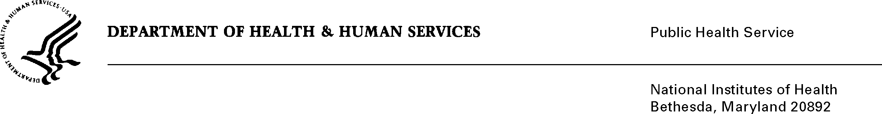

DATE: October 13, 2022

TO: NIH OMB Desk Officer
Office of Management and Budget (OMB)
Reports Clearance Officer, DHHS

FROM: Mikia P. Currie
Chief, Project Clearance Branch (PCB)

SUBJECT: Change Request to a Currently Approved Form (OMB # 0925-0689 titled, Electronic Application for NIH Certificates of Confidentialty (CoC E-application System) expiration date 4/30/2025

This is a request for OMB to approve a non-substantial modification to the above referenced clearance to correct the spelling of “Confidentiality” in the title of the submission. The revision was approved on April 26, 2022.

Your full consideration is appreciated.

