Attachment for Screenshots
When a hospital submits a waiver request, it completes one of two online forms found on the waiver landing page (https://qualitynet.cms.gov/acute-hospital-care-at-home), depending on its level of experience with this type of care. Experienced hospitals, defined as treating at least 25 patients with acute hospital care at home previously, have an expedited submission that is based on a series of attestations, seen below:
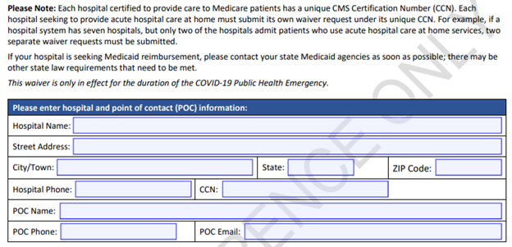
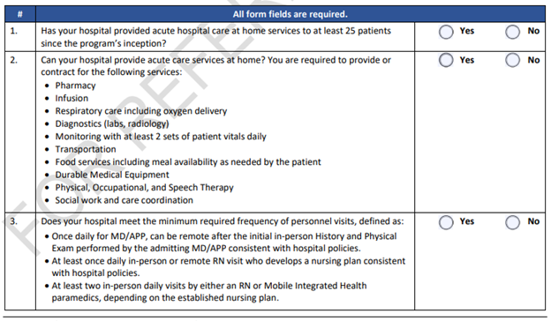
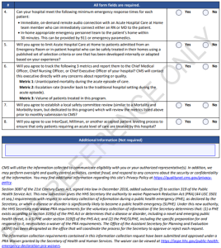

Less experienced hospitals, defined as treating fewer than 25 patients with this level of care previously, complete a more detailed waiver request, seen below:
