Appendix D

One-page Informational Documents for Implementation Study

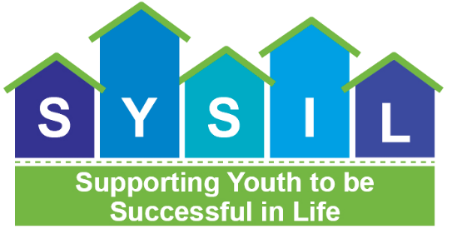

Information about the Mathematica Implementation Study Visit

- The Office of Planning, Research, and Evaluation (OPRE) at the Administration for Children and Families (ACF) at the U.S. Department of Health and Human Services has contracted with Mathematica on the Supporting Youth to be Successful in Life (SYSIL) study. Mathematica is conducting this study to understand [name of provider]’s experience delivering [Pathways to Success Program/Chafee Foster Care Program], including factors that have helped or hindered implementation.
- [For Pathways hubs: During this study, members of the Implementation Team will conduct an interview with you during the [virtual] visit to discuss several topics related to implementing Pathways, including but not limited to recruitment and enrollment; partnerships that support Pathways; service, resource, and policy context; implementation experience; program resources; and continuous quality improvement. Interviews will last an hour each and be conducted as one-on-one interviews or small group interviews.]
- [For comparison hubs: During this study, members of the Implementation Team will conduct an interview with you during the [virtual] visit to discuss several topics related to providing Chafee services, such as the design of Chafee services; and the services, resources and policy context. Interviews will last an hour each and be conducted as one-on-one interviews or small group interviews.]
- You do not need to do anything to prepare for the discussion. All of Mathematica’s question will be open-ended. There are no right or wrong answers, and you may choose not to answer any questions. You are the expert of the program and its implementation, so Mathematica would like to learn from you during the discussion.
- Your participation in this discussion is voluntary. Your responses will be kept private to the extent permitted by law and used only for research purposes. Mathematica will not share your comments with anyone other than members of the Mathematica study team. Our team will use your responses, along with other information we collect about [Pathways/Chafee], to help describe what influenced your experience delivering services under [Pathways/Chafee]. When we report information from this study, we will not attribute any comments to you or your organization, and no individuals will be quoted by name. Being part of this discussion will not affect your employment or your involvement with the [Pathways/Chafee] program.
- Mathematica will request to record the discussion. No one besides the research team will have access to or listen to the recording. If you do not want the discussion to be recorded, or request pausing or stopping the recording during the interview, Mathematica will accommodate your request.

Supporting Youth to Be Successful in Life (SYSIL)
STUDY INFORMATION FOR YOUTH AND YOUNG ADULTS PARTICIPATING IN: [PATHWAYS TO SUCCESS/CHAFEE SERVICES]

What is the purpose of the study? | - The overall goal of the study is to understand the implementation of [Pathways to Success/ Chafee] program and what factors have helped or challenged the implementation of the program.
Who is conducting the study? | - In partnership with the Office of Planning, Research, and Evaluation, this study is being conducted by Mathematica, a policy research organization whose studies of education and health programs have informed policymakers for more than 35 years. For more information about Mathematica, please visit its website at www.mathematica-mpr.com.
Who will be asked to participate in the study? | - Mathematica is asking youth and young adults to participate in a virtual focus group. The focus group will take 90 minutes.
What are young adults asked to do as part of the study? | - Discuss their experiences in the [Pathways/Chafee] program with Mathematica staff.
How will Mathematica protect the privacy of youth? | - Mathematica is committed to respecting the privacy of everyone who contributes to this study. Your name will not be attached to any of your responses and you do not have to answer any questions you do not want to answer. The information you provide will be kept private to the extent permitted by law and will not be shared with anyone outside the study team. However, if you report that you are going to hurt yourself or others, or that someone is hurting you, the study team may be required to report this to someone who can help make sure you are safe.  - In the future, information from this study may be securely shared with qualified individuals to help learn more about the experiences of youth and young adults who have been in foster care. The information that is shared will only include a study ID number and not your name.
How can I get more information about the study? | - If you have any questions, you may contact Dr. Cay Bradley at Mathematica at 202-250-3585, or cbradley@mathematica-mpr.com.
Thank you!

