SAMS Domestic Results Monitoring Module Screenshots
Grantor – Themes & Indicators
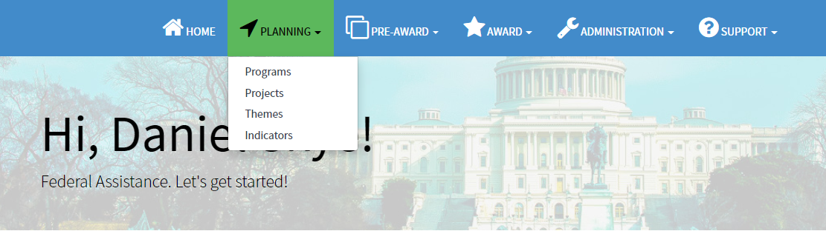
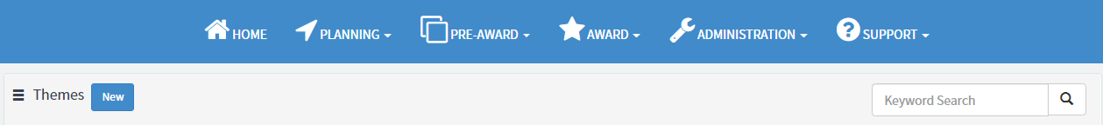
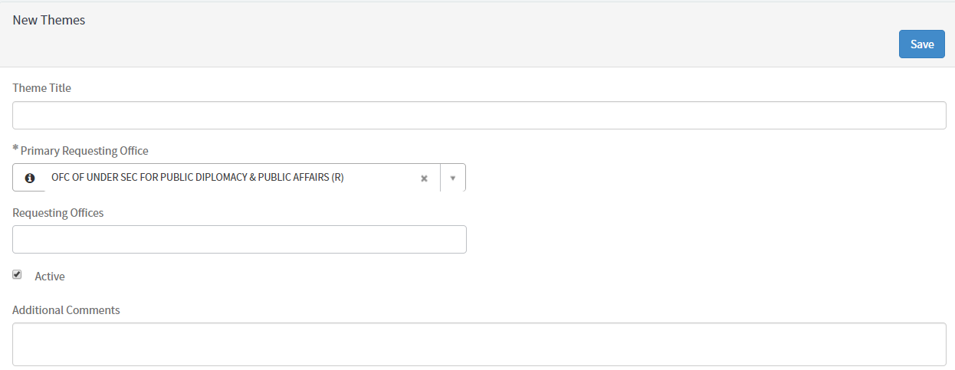
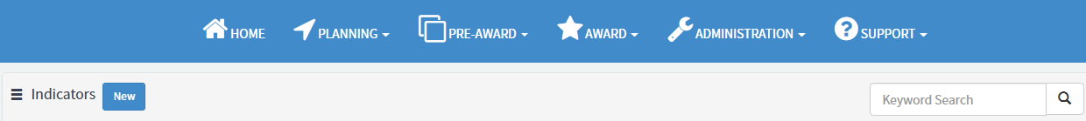
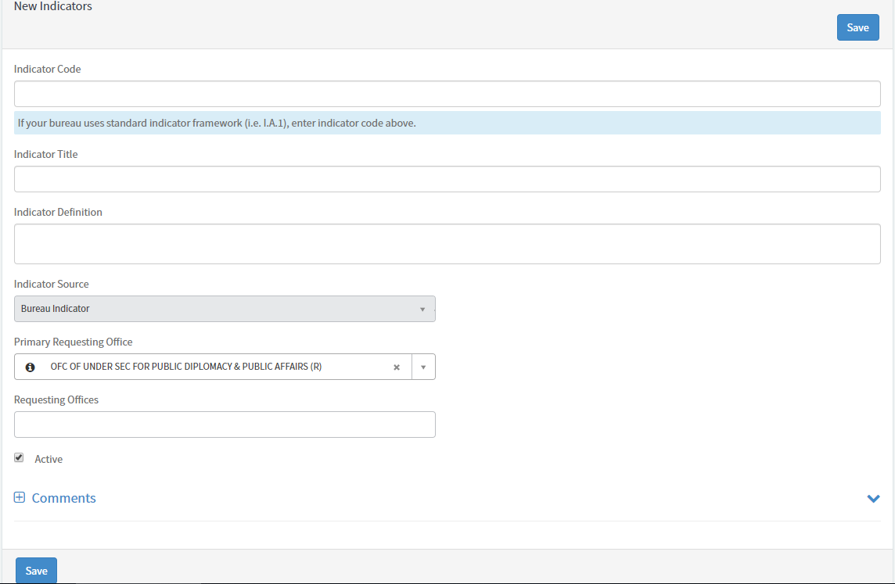
Grantor – Proposal Creation
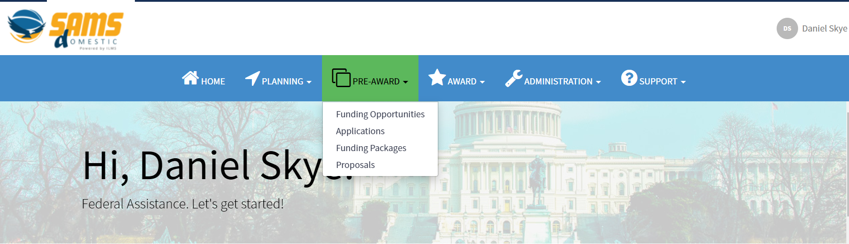
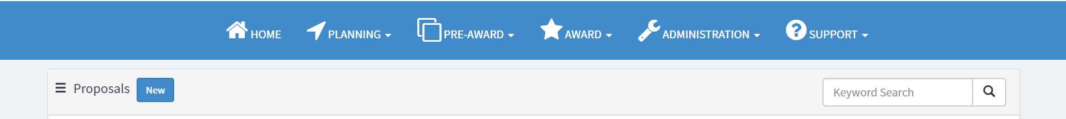
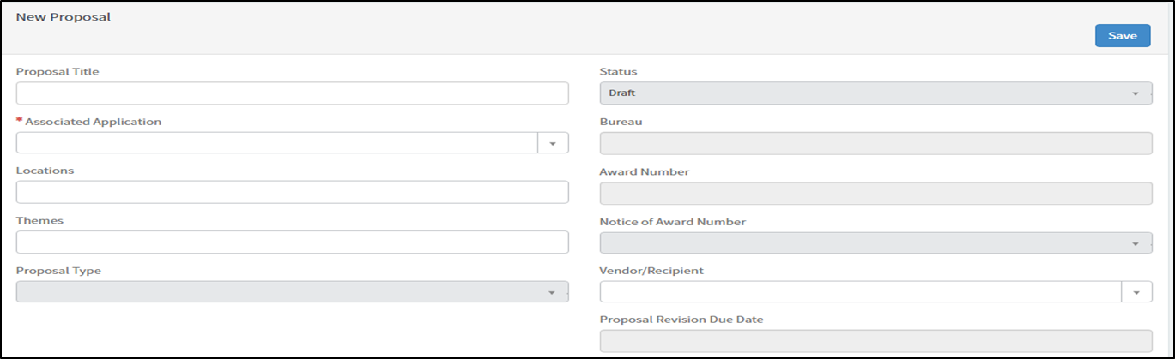
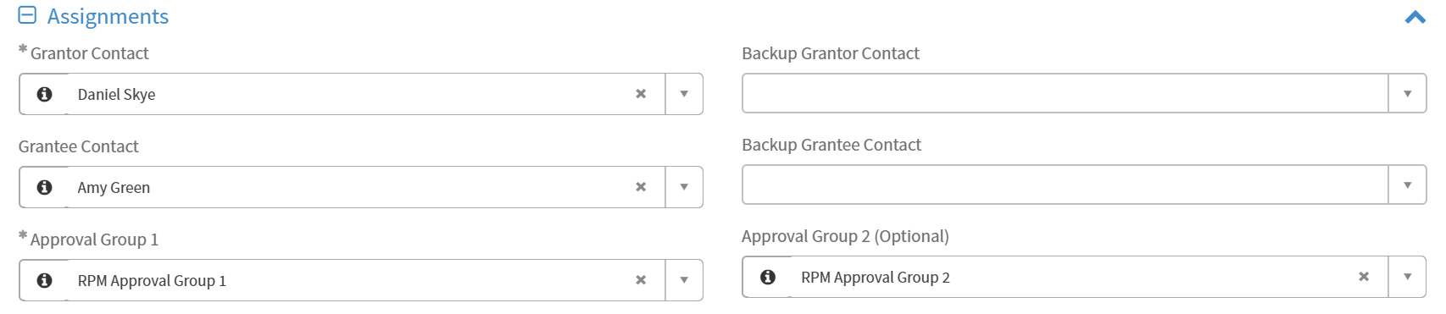
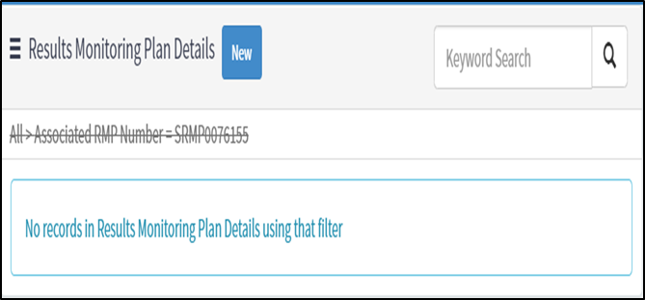

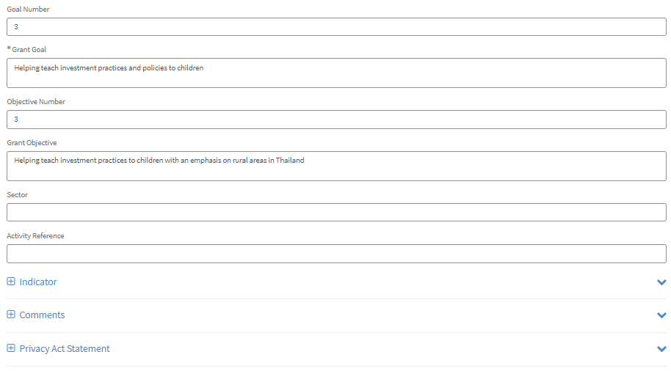
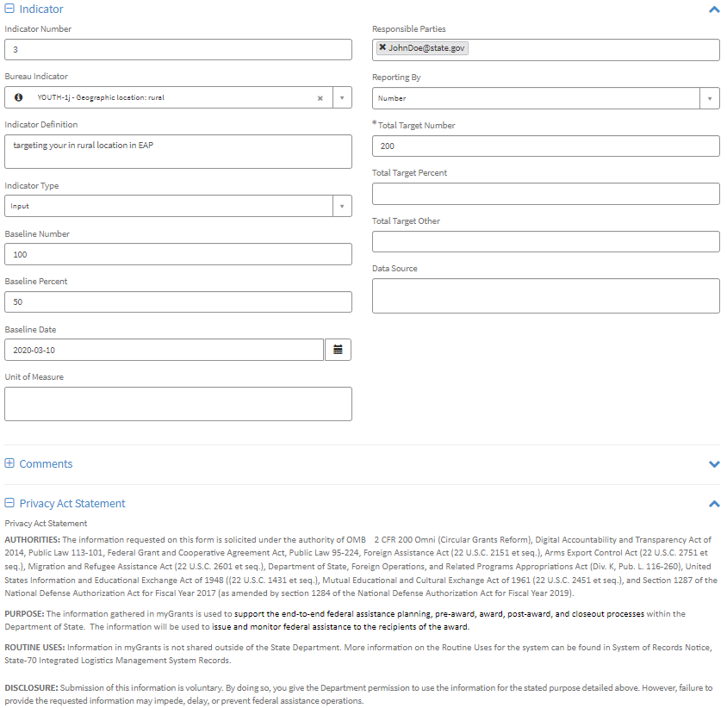

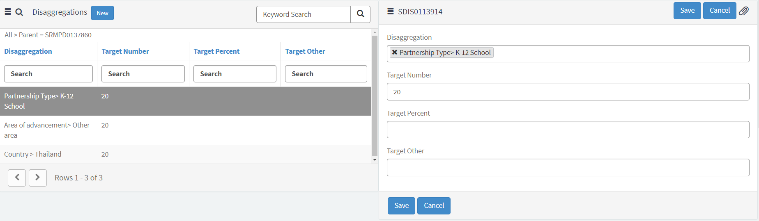

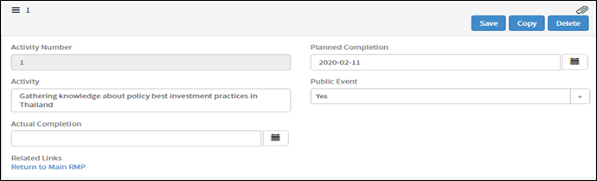

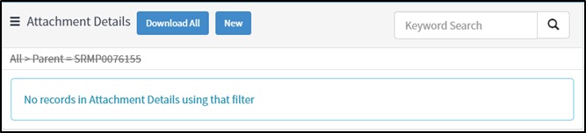

Grantor – Proposal Approval Flow, Amendments, & PDF Generation
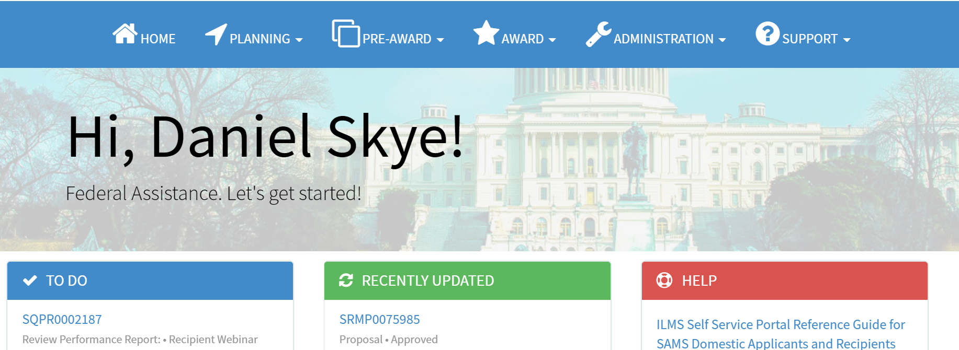
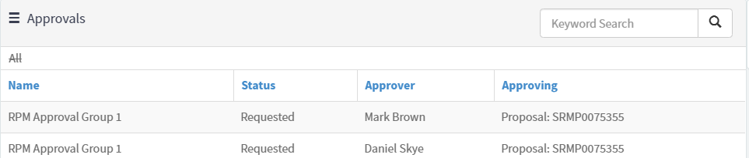
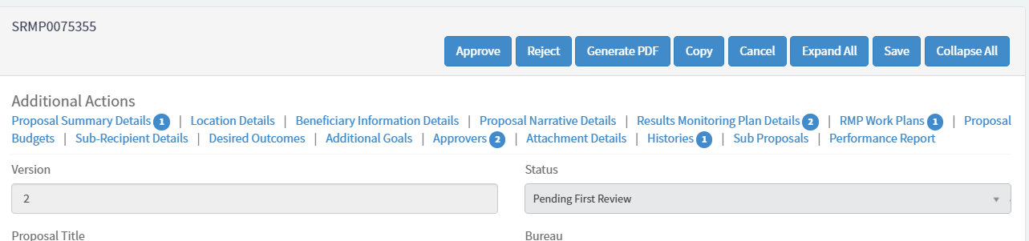
Active approvers display on the Approvers tab. Only one user per group needs to approve.

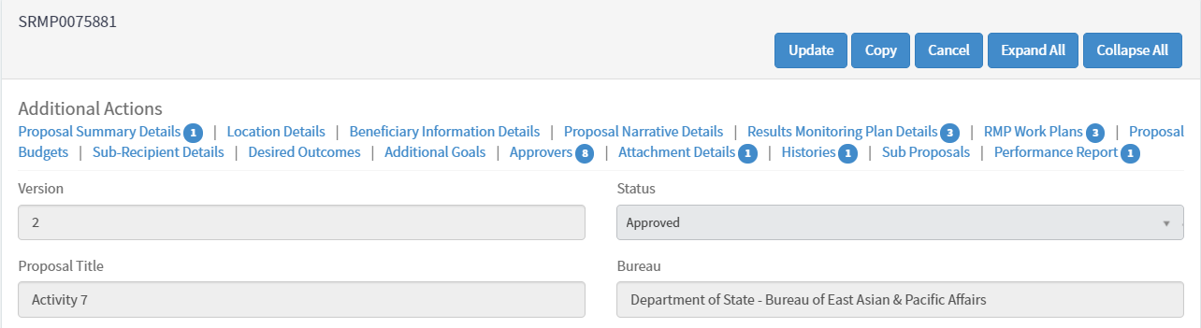

When a proposal is in Approved status, grantors can initiate a proposal amendment by clicking Update.
Click Update to initiate an amendment.

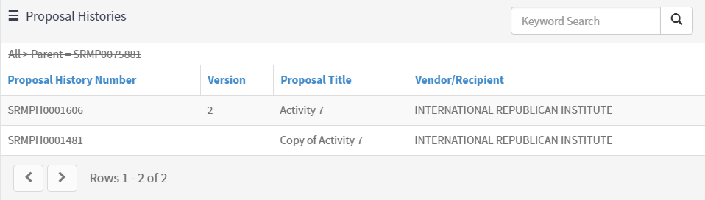
Click on the Proposal History Number to view previous versions of the proposals.

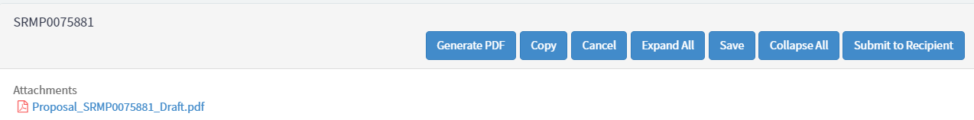

Grantor – Performance Report Creation
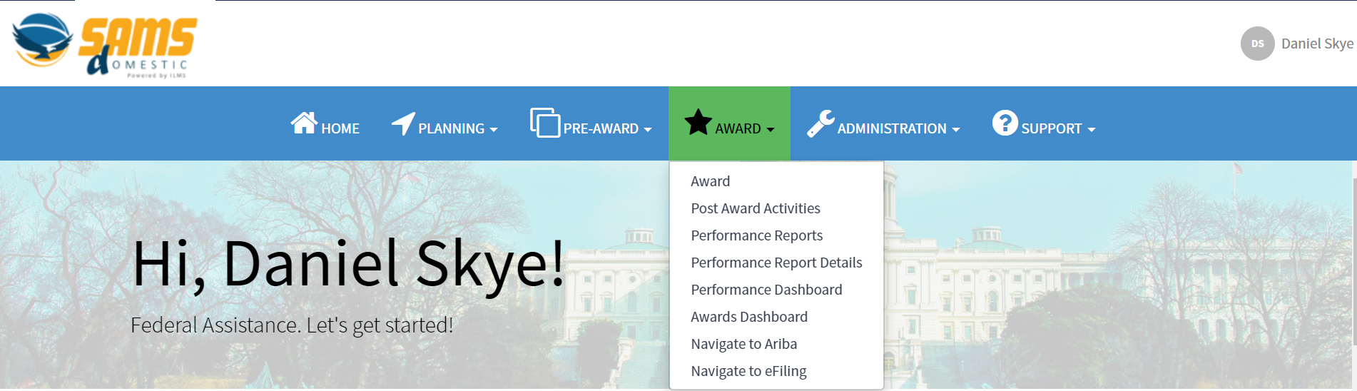
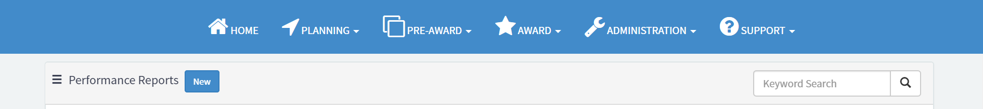

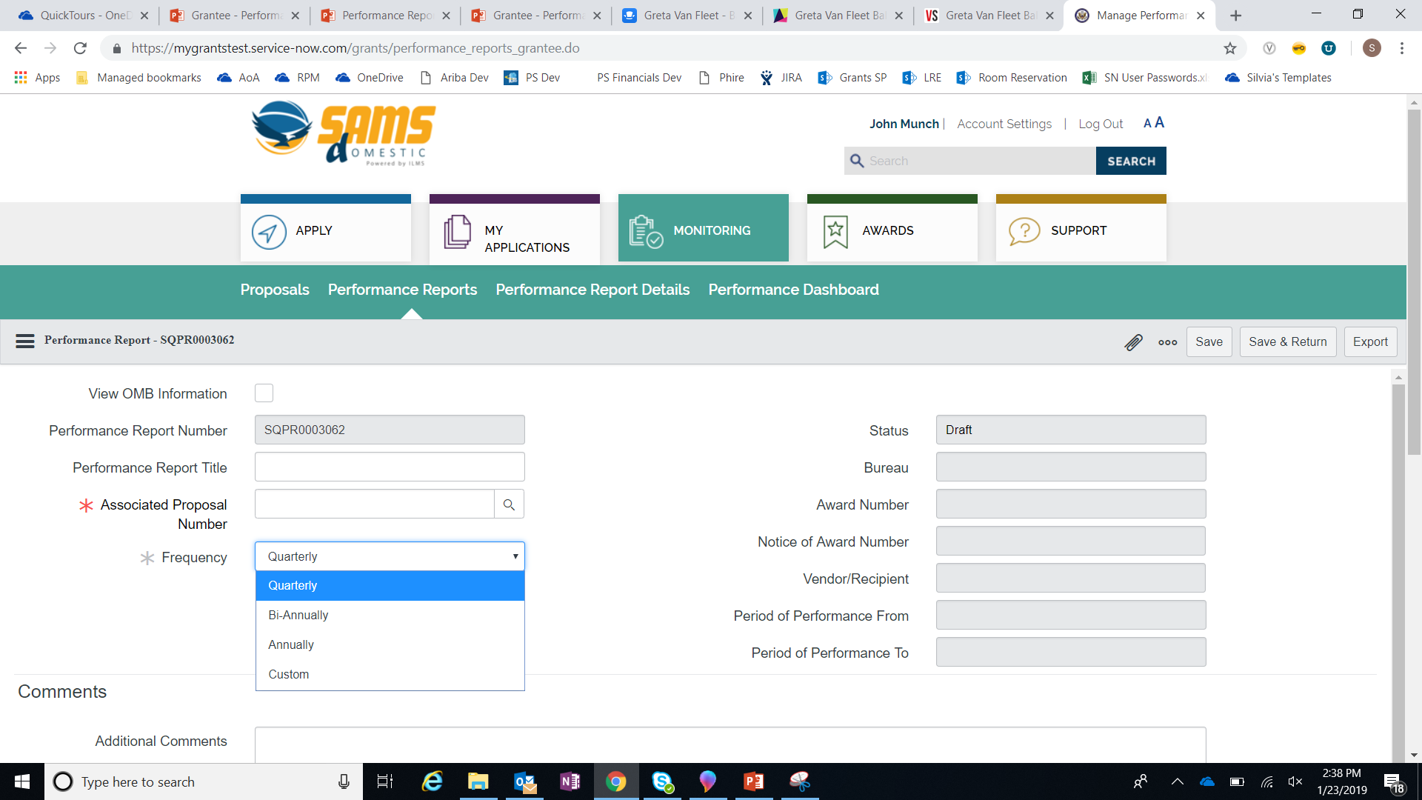
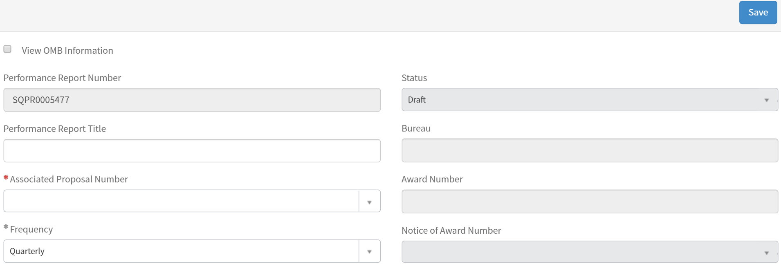

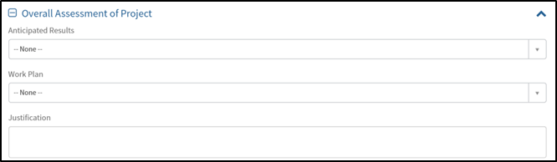
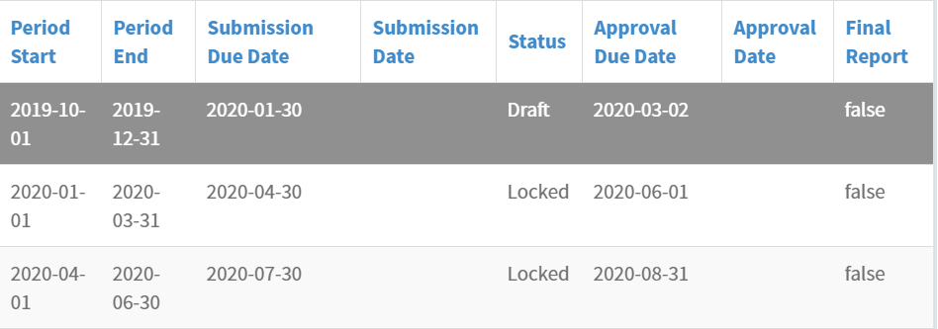
Click record to view the Performance Report Details form.
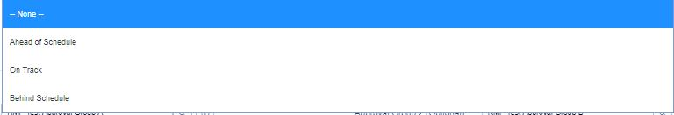

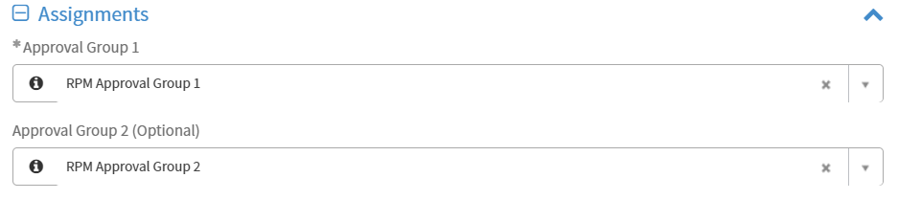
- Enter quantitative progress for the reporting period in the Performance Report Data Tab information.
- Goal, Objective, Indicator, and Disaggregation data are pulled in from the Associated Proposal to report on.
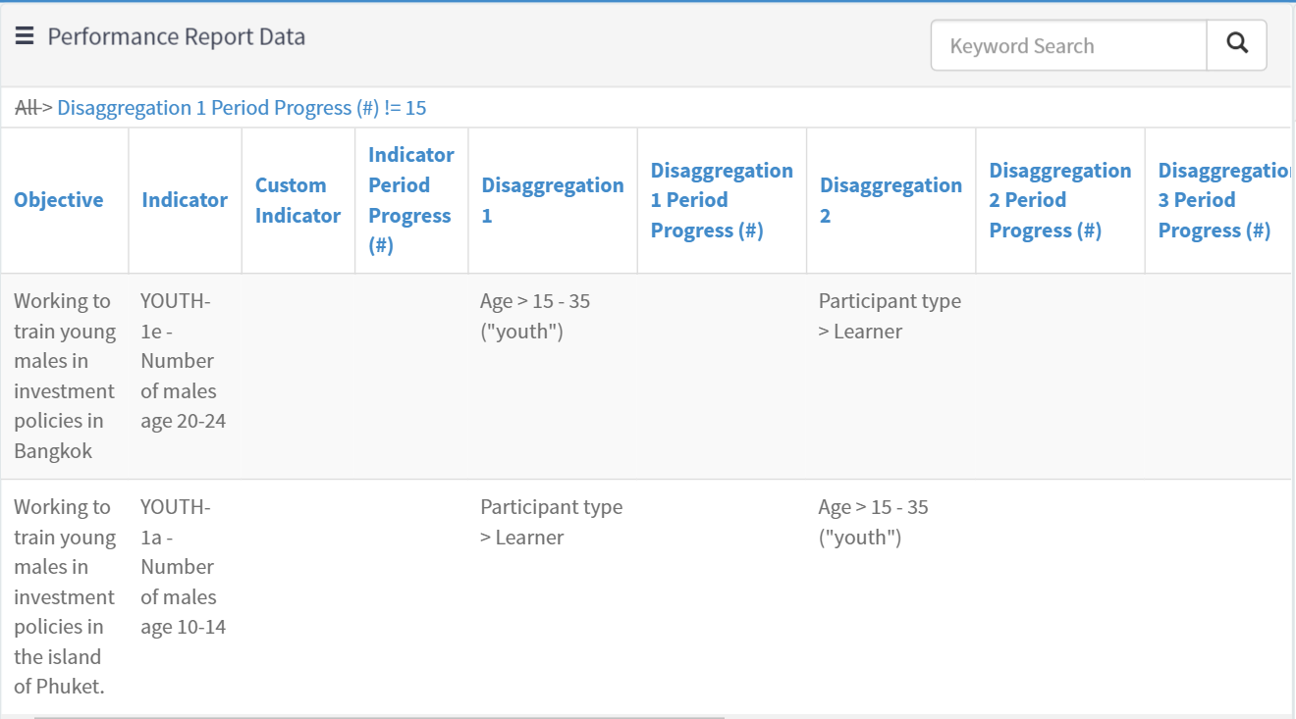
- Click into the Performance Report Totals tab to view aggregated indicator and disaggregation data across reporting periods.
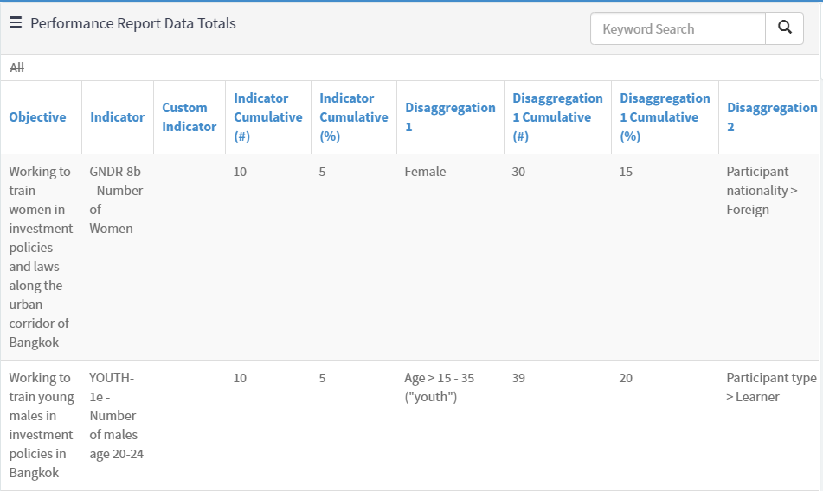
To update goal, objective, and indicator data, amend the Associated Proposal.

- Click into the Narrative Reporting Tab to enter the information relevant to the specific Performance Report Period.
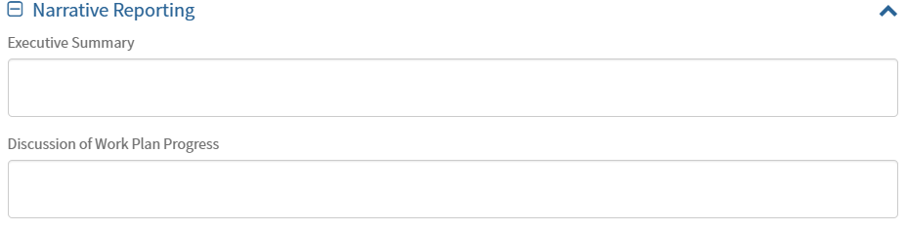
- Select the required evaluation from the Evaluation tabs to answer bureau-specific questions.
- The Grantee Evaluation is completed by grantees for grantor review.
- The Internal Evaluation is only visible for grantors.
- The External Evaluation is completed by grantors to provide feedback to grantees.
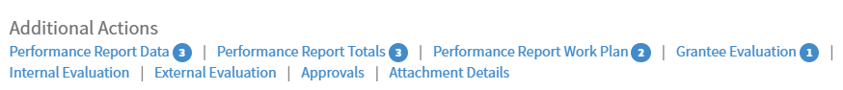
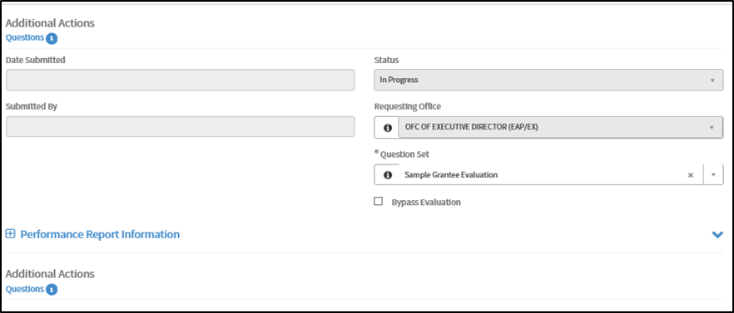
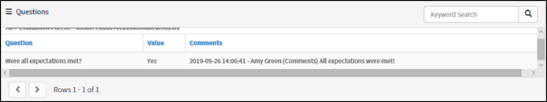
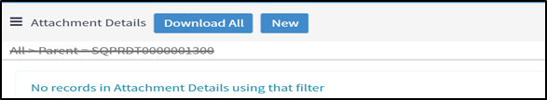
- Grantors are able to update the reporting frequency.
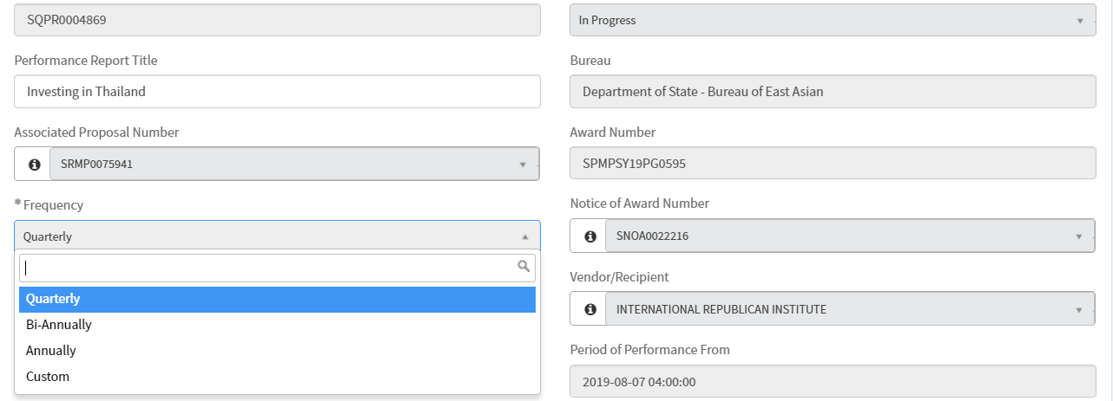
Updating the Frequency adjusts the Period Start and End dates for Performance Report Details in Locked status.
Grantor – Performance Report Approval Flow & PDF
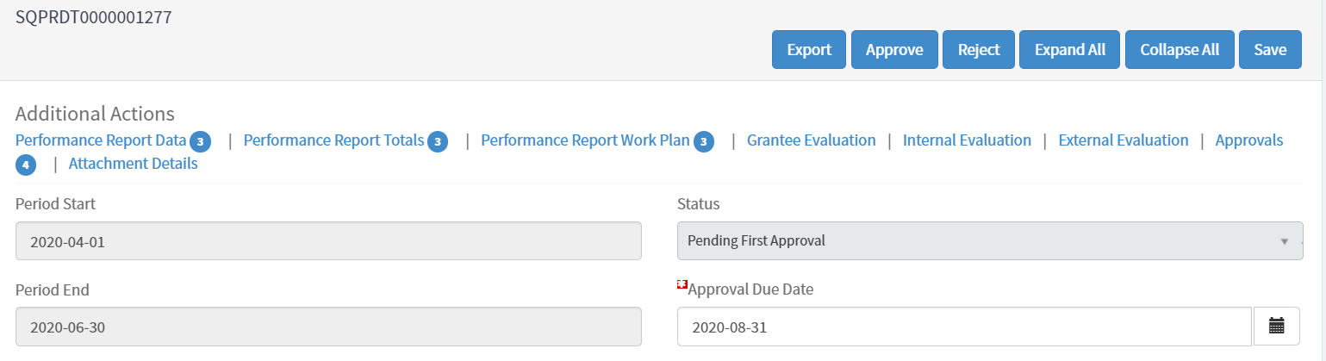
- There are two ways to unlock Performance Report Details records:
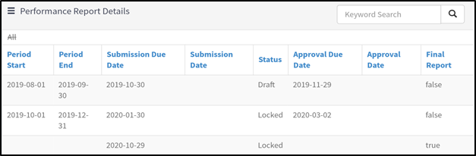
When the Performance Report is created, only the initial Performance Report Details is in Draft status.
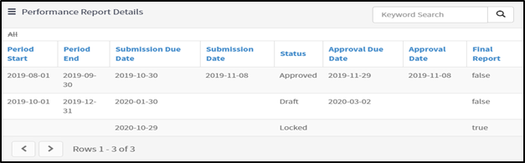
Once a Performance Report Details is fully Approved, the next record will be editable and in Draft status.
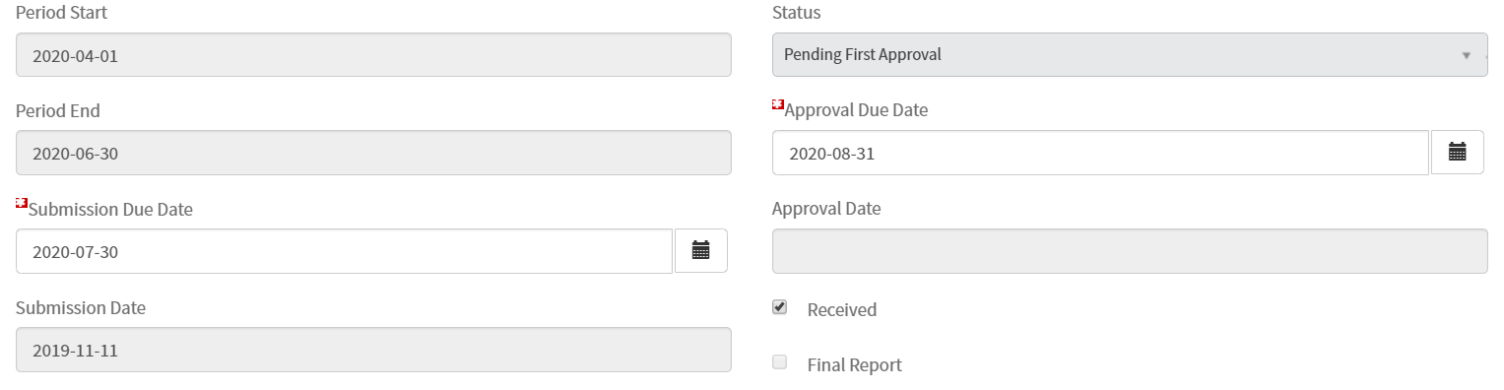
Check Received to unlock next Performance Report Details record without fully approving the current report.

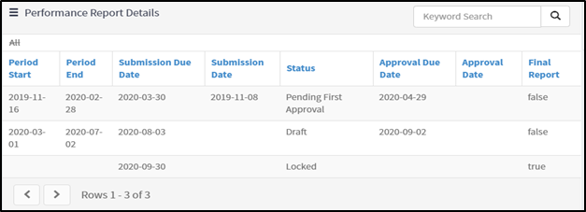
Once a Performance Report Details is checked as Received, the next record will be editable and in Draft status.

- Once a Performance Report Details form is fully Approved, a Performance Report PDF is automatically generated and stored in the Award File.
- Reporting period data, cumulative data, as well as narrative data is included in the PDF.
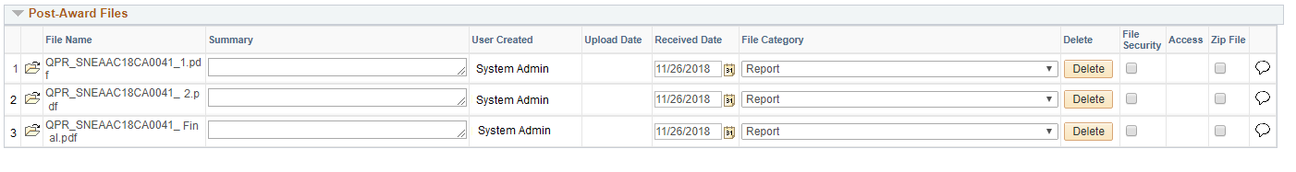
Grantee – Proposal Creation
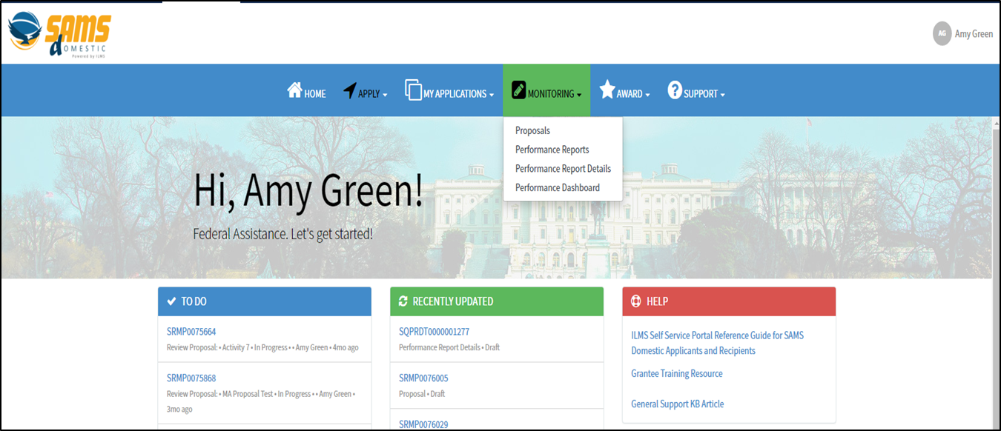
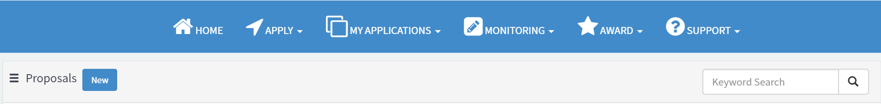
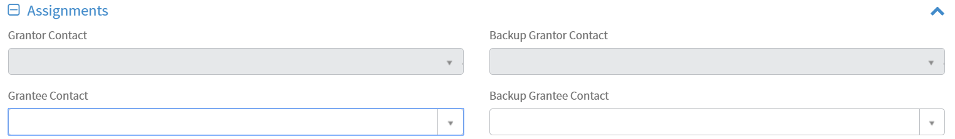

Grantee – Performance Report Creation
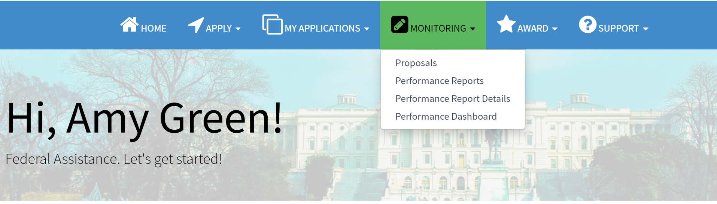
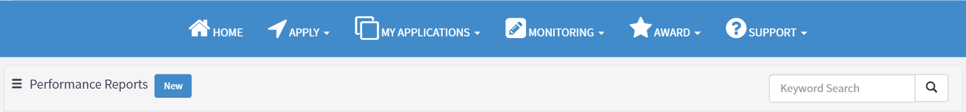
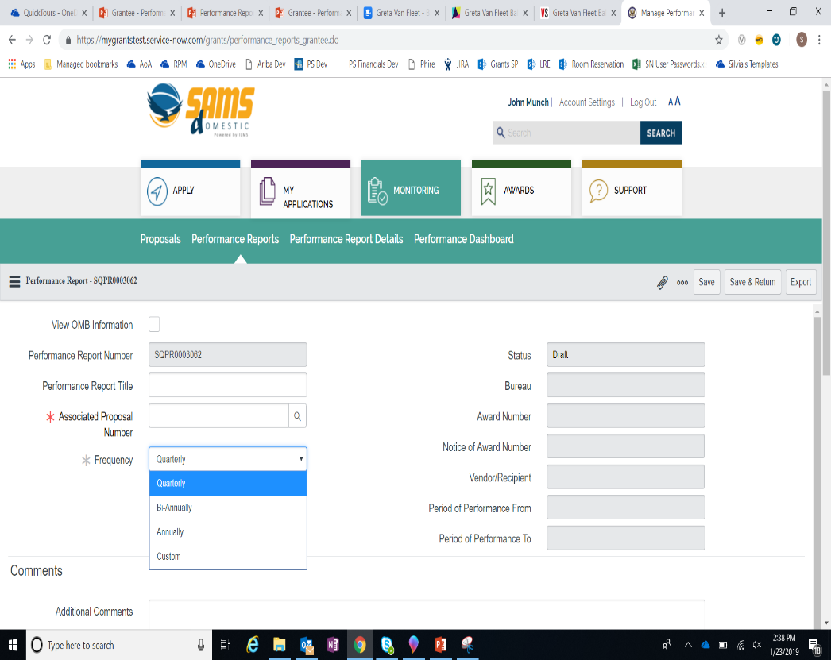
After saving, the Frequency will become read-only and can only be updated by the grantor.

Click record to view the Performance Report Details form.

- Enter quantitative progress for the reporting period in the Performance Report Data Tab information.
- Goal, Objective, Indicator, and Disaggregation data are pulled in from the Associated Proposal to report on.

- Click into the Performance Report Totals tab to view aggregated indicator and disaggregation data across reporting periods.

To update goal, objective, and indicator data, grantees can request an amendment to the Associated Proposal.

- Click into the Narrative Reporting Tab to enter the information relevant to the specific Performance Report Period.
- Select the required evaluation from the Evaluation tabs to answer bureau-specific questions.
- The External Evaluation is completed by grantors to provide feedback to grantees.
- The Grantee Evaluation is completed by grantees for grantor review.
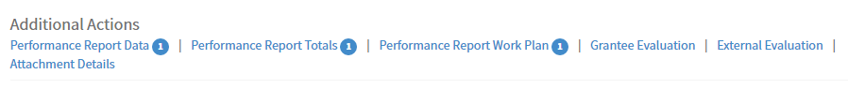
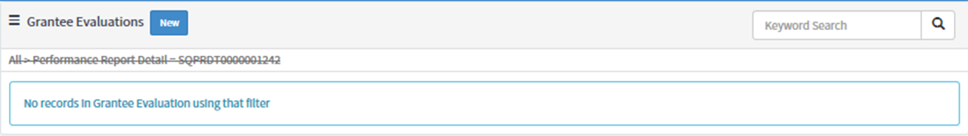
Fill out the Value and Comments fields to answer questions;
