OMB Control Number: 1660-0117
Expiration Date: 5/31/2021

PAPERWORK BURDEN DISCLOSURE NOTICE
Biannual Strategy Implementation Report (BSIR)
Public reporting burden for this data collection is estimated to average 15.25 hours per response. The burden estimate includes the time for reviewing instructions, searching existing data sources, gathering and maintaining the data needed, and completing and submitting this form. This collection of information is required to obtain or retain benefits. You are not required to respond to this collection of information unless a valid OMB control number is displayed on this form. Send comments regarding the accuracy of the burden estimate and any suggestions for reducing the burden to: Information Collections Management, Department of Homeland Security, Federal Emergency Management Agency, 500 C Street, SW., Washington, DC 20472-3100, Paperwork Reduction Project (1660-0117) NOTE: Do not send your completed form to this address.

PRIVACY NOTICE

The collection of this information is authorized by the Homeland Security Act of 2002, as amended by the Post Katrina Emergency Management Reform Act of 2006, 6 U.S.C. § 238. The collection is also authorized by Homeland Security Presidential Directives Five and Eight (HSPD-5, 8). This information is being collected for the primary purpose of supporting the Department of Homeland Security (DHS) in the storage and management of Biannual Strategy Implementation Reports (BSIR). By providing interactive capabilities to store and manage these reports, DHS empowers state employees to provide grant-related funding information from an environment that is available throughout the year. The disclosure of information on this form is voluntary; however, failure to provide the information requested may delay or prevent the organization from receiving grant funding

Grant Reporting Tool – Screenshots

Log-in Screen

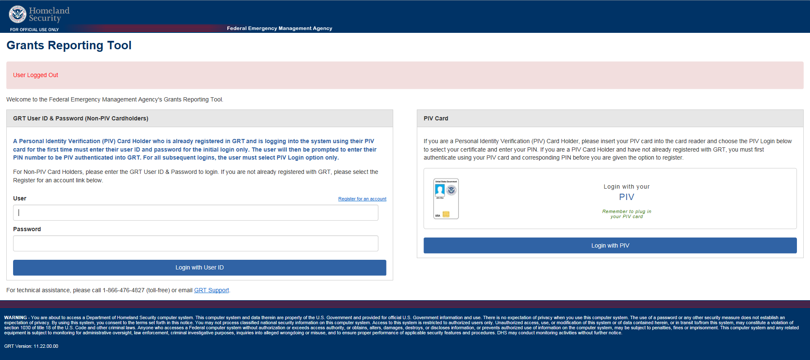

Landing Page

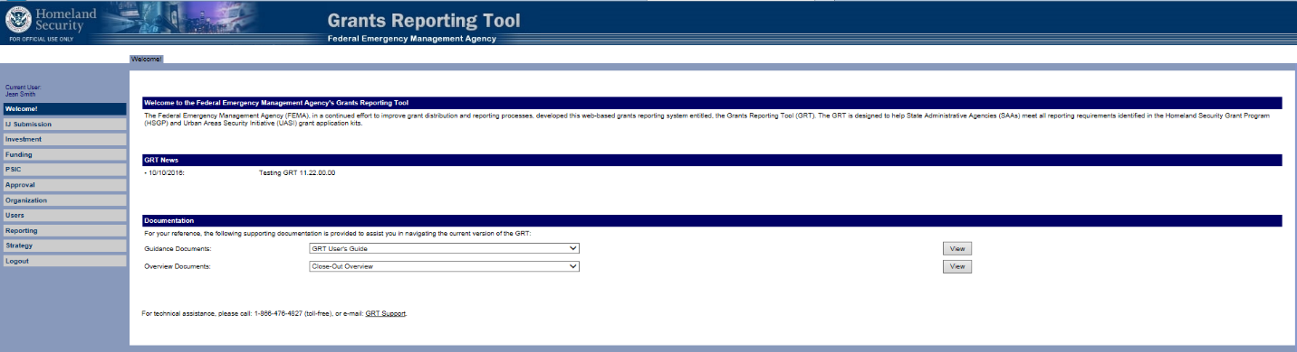

BSIR Workflow





