Student Survey

Instructions:
Please complete this brief survey to help us better understand how teachers can best support students in math class. Note that the information you provide here falls under the confidentiality and data protection requirements of the Institute of Education Sciences (The Education Sciences Reform Act of 2002, Title I, Part E, Section 183), and the data collected will be securely protected. You may opt out of responding to a question or the entire instrument at any time without any consequences. None of your responses will be individually attributed to you or your school/district. Your responses will be used for statistical purposes only.

Think about your current math class while you answer the following questions.

 | Not at all sure | Slightly sure | Somewhat sure | Quite sure | Extremely sure
1a. How sure are you that you can complete all of the work that is assigned in your math class?
1b. When complicated ideas are discussed in your math class, how sure are you that you can understand them?
1c. How sure are you that you can learn all the topics taught in your math class?
1d. How sure are you that you can do the hardest work that is assigned in your math class?
1e. How sure are you that you will remember what you learned in your current math class, next year?

 | Totally Untrue | Mostly Untrue | Somewhat True | Mostly True | Totally True
2a. My math teacher checks to make sure we understand what he/she is teaching us.
2b. When he/she is teaching us, my teacher asks us whether we understand.
2c. My teacher knows when the class understands, and when we do not.
2d. In this class, we learn to correct our mistakes.
2e. My math teacher wants us to share our thoughts.
2f. In this class, we get to make enough choices.
2g. Students speak up and share their ideas about math work.
2h. My teacher wants me to explain my answers – why I think what I think.

Please complete this brief assessment to help us better understand how to best support students in math class.

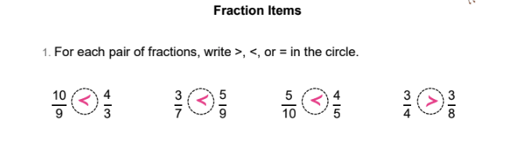
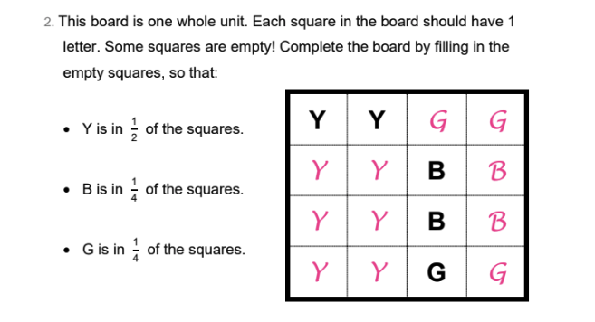
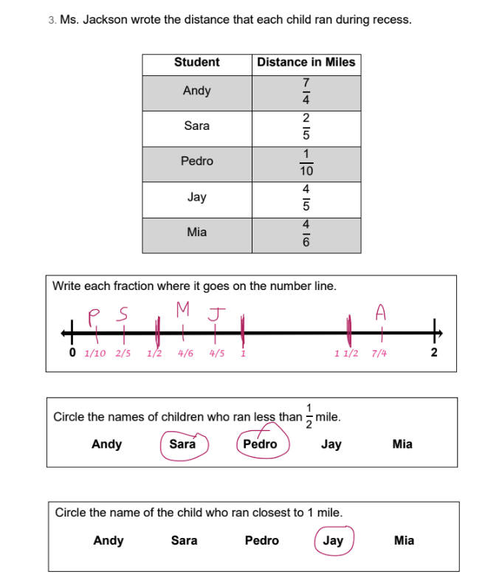
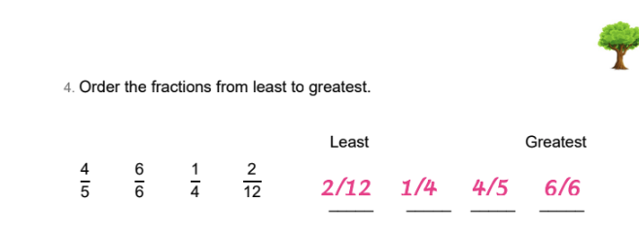
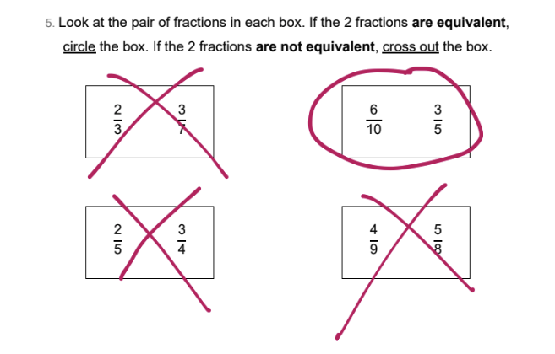
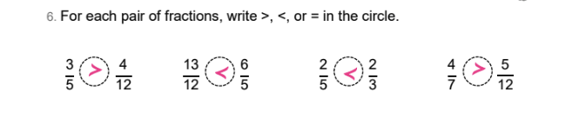
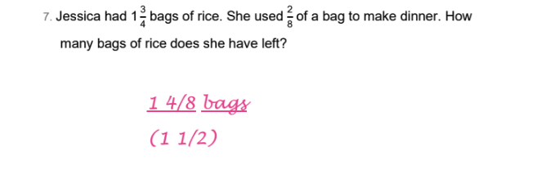
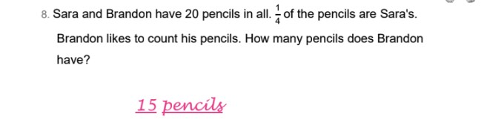
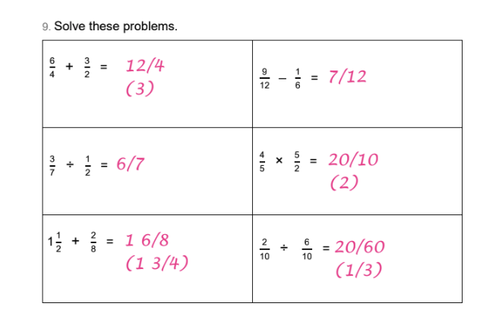
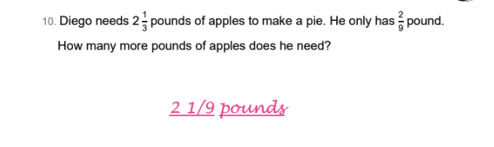
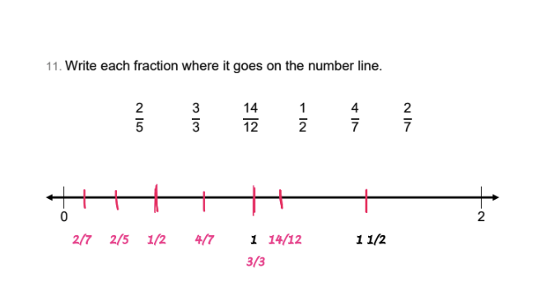

According to the Paperwork Reduction Act of 1995, no persons are required to respond to a collection of information unless such collection displays a valid OMB control number. The valid OMB control number for this information collection is 1850-xxxx. Public reporting burden for this collection of information is estimated to average 50 minutes per response, including time for reviewing instructions, searching existing data sources, gathering and maintaining the data needed, and completing and reviewing the collection of information. The obligation to respond to this collection is voluntary. If you have any comments concerning the accuracy of the time estimate, suggestions for improving this individual collection, or if you have comments or concerns regarding the status of your individual form, application or survey, please contact Janelle Sands at the Institute of Education Sciences (IES) at janelle.sands@ed.gov directly.

