**Memorandum United States Department of Education**

**Institute of Education Sciences**

**National Center for Education Statistics**

**DATE**: June 20, 2023

**TO**: Robert Sivinski and Bev Pratt, OMB

**THROUGH**: Carrie Clarady, NCES

**FROM**: Ryan Iaconelli, Acting Project Officer, Private School Universe Survey (PSS), Cross-sectional and Sample Surveys Division, NCES

**SUBJECT**: Private School Universe Survey (PSS) 2023-24 Data Collection Revision (OMB# 1850-0641 v.15)

The National Center for Education Statistics (NCES), within the U.S. Department of Education, conducts the Private School Universe Survey (PSS), a national survey of private elementary and secondary schools. The PSS is designed to collect biennial data on the total number of private schools, teachers, and students; and to create an NCES universe frame of private schools that serve as a sampling frame for NCES surveys. This survey is an ongoing project to improve NCES universe and sample data on private schools.

The request to conduct the 2023-24 data collection and the 2025-26 PSS list frame building operations was approved in April 2022 (1850-0641 v.14). This revision addresses changes to communication materials and modifications to the questionnaire. Changes to the communications reflect a shift towards focusing on the benefits of participating in the PSS, including a school’s listing on NCES Private School Search website and having an active NCES ID. Modifications to the questionnaire include the addition of an item assessing the use of virtual learning in private schools and modifying item wording to better align item with item wording on the National Teacher and Principal Survey (NTPS), which will be in the field for a sample of private schools during the 2023-24 school year as well.

This request does not introduce changes to the estimated respondent burden or the costs to the federal government. This request contains revisions to Part A, the School Contacting Materials in Appendix C, and the PSS Questionnaire in Appendix D. Detailed changes are shown below, with red font indicating additions and ~~struck red font~~ indicating deletions.

# Changes to Part A

A.1 Importance of Information

The request to conduct the 2023-24 data collection and the 2025-26 PSS list frame building operations was approved in April 2022 (1850-0641 v.14). In June 2023 NCES submitted a revision for 30D public comment for the purpose of revisions to the School Contacting Materials (Appendix C) and the PSS Questionnaire (Appendix D).

# Changes to Appendix C

## C2. Internet Option First Letter & FAQ

Dear Administrator:

The National Center for Education Statistics (NCES) within the U.S. Department of Education requests your participation in the 2023-24 Private School Survey (PSS), a national data collection effort ~~that is very valuable to private schools across the country~~ administered every two years that is invaluable to private schools across the country. The purpose of the PSS is to obtain current information from all private elementary and secondary schools in recognition of the importance of private education in the United States. Your participation is critical to the success of this survey and ensures that your school is represented in important national data on private schools.

**Please complete the survey online within two weeks.** You can access the secure website using the information provided below.

Respond at **https://respond.census.gov/pss**

Log in using this User ID:

~~If you are unable to complete the survey on the Internet, you also have the option to participate in this survey by completing a paper form that will be mailed to you in approximately one week.~~

The Private School Survey is used to generate an NCES ID number for your school which many private and federal grants require as part of their application process. Your response to this survey ensures your school retains this NCES ID and is listed on the NCES site.

If you have any questions about this voluntary survey, please contact the U.S. Census Bureau at 1-888-329-5890. Staff will be available to take your call Monday through Friday between 8:00 am and 8:00 pm (Eastern Time). You can also contact the U.S. Census Bureau via e-mail at: [pss@census.gov.](mailto:pss@census.gov)

~~NCES conducts this survey in recognition of the importance of private education in the United States. While there is no penalty for not responding, a high response rate is very important to accurately representing private education in the United States. We encourage you to participate in this voluntary survey.~~

~~To learn more about the Private School Survey, please go to~~ [~~http://nces.ed.gov/surveys/pss~~](http://ncec.ed.gov/surveys/pss)~~.~~

This data collection is administered by the U.S. Census Bureau for NCES. To learn more about the PSS, please go to https://nces.ed.gov/surveys/pss/. Thank you in advance for your cooperation in this very important effort.

Sincerely,

Peggy Carr

Commissioner

National Center for Education Statistics (NCES)

U.S. Department of Education

Paperwork Burden Statement

According to the Paperwork Reduction Act of 1995, no persons are required to respond to a collection of information unless it displays a valid OMB control number. The valid OMB control number for this voluntary information collection is 1850-0641. The time required to complete this information collection is estimated to average 20 minutes per response, including the time to review instructions, search existing data resources, gather the data needed, and complete and review the information collection. If you have any comments concerning the accuracy of the time estimate, suggestions for improving this collection, or comments or concerns about the contents or the status of your individual submission of this questionnaire, please e-mail: [pss@census.gov,](mailto:pss@census.gov) or write directly to: Private School Survey (PSS), National Center for Education Statistics, Potomac Center Plaza, 550 12th Street SW, Room #4010, Washington, DC 20202.

Endorsed by:

Agudath Israel of America

American Association of Christian Schools

American Montessori Society

Association of Christian Schools International

Association of Christian Teachers and Schools

Association of Military Colleges and Schools

Christian Schools International

Council for American Private Education

Council of Islamic Schools in North America

Evangelical Lutheran Church of America

Evangelical Lutheran Education Association

General Conference of the Seventh-Day Adventist Church

Islamic School League of America

Jesuit Schools Network

Lutheran Church-Missouri Synod

National Association for the Education of Young Children

National Association of Episcopal Schools

National Association of Independent Schools

National Association of Private Special Education Centers

National Catholic Educational Association

National Christian School Association

National Council for Private School Accreditation

National Independent Private Schools Accreditation

Oral Roberts University Educational Fellowship

The Association of Boarding Schools

United States Conference of Catholic Bishops

Wisconsin Evangelical Lutheran Synod



**WHO AUTHORIZES THIS SURVEY?**

The National Center for Education Statistics (NCES), within the U.S. Department of Education, is authorized to conduct this survey by the Education Sciences Reform Act of 2002 (ESRA 2002, 20 U.S.C. §9543). The U.S. Census Bureau will administer this survey on behalf of the NCES.

**WHO SHOULD PARTICIPATE IN THIS SURVEY?**

The 2023-24 Private School Survey includes all private schools and early childhood programs that provide educational instruction to students in kindergarten or *at least* one grade from 1 to 12.

**~~WHY SHOULD YOUR SCHOOL PARTICIPATE IN THIS SURVEY?~~**

~~Private schools are a significant segment of the nation’s educational system. Results from previous surveys show that approximately 23 percent of all elementary and secondary schools in the United States are private institutions; these schools enroll approximately 9 percent of the nation’s children and employ 13 percent of the nation’s teachers. NCES has instituted this survey in recognition of the important role of private education in the United States. While there is no penalty for not responding, a high response rate is very important to maintain high data quality about private education. We encourage you to participate in this voluntary survey.~~

**WHY IS MY SCHOOL’S RESPONSE IMPORTANT?**

Private education is a critical part of the U.S. education system. Without accurate information about the nation’s private schools, policy makers have an incomplete picture of education more broadly and cannot make effective decisions on a range of important issues including those around the topic of school choice. A response to this survey ensures that YOUR school is represented in key data and reports produced by the National Center for Education Statistics about private education and school choice. The National Center for Education Statistics is the primary source of statistical information on education for the country. Your school’s response is needed to provide a complete picture of U.S. educational institutions.

**HOW DOES THIS HELP MY SCHOOL?**

The Private School Survey is used to generate an NCES ID number for your school which many private and federal grants require as part of their application process. NCES also uses the survey to update the private school search tool on our website: https://nces.ed.gov/surveys/pss/privateschoolsearch/. This resource is used by parents looking to find a private school for their children. Importantly, your response to this survey ensures that your school’s voice will be heard in policy decisions.

**WHAT ARE RESULTS FROM PREVIOUS SURVEYS?**

NCES produces summaries of the data that help parents, educators, and policy makers understand the current state of education in the United States. For example, results from the 2021-22 Private School Survey show that:

* Approximately 23 percent of all elementary and secondary schools in the United States are private institutions; these schools enroll approximately 8 percent of the nation’s children and employ 13 percent of the nation’s teachers.
* The pupil/teacher ratio was 9.8 at private schools, which was lower than the ratio of 15.8 at public schools.
* Of the 29,750 private elementary and secondary schools in the United States, 21 percent were Catholic schools, 12 percent were conservative Christian schools, 12 percent were affiliated religious schools, 22 percent were unaffiliated religious schools, and 34 percent were nonsectarian schools.

In addition to the reports that NCES produces, researchers use the data in their own studies of private schools and policy makers use the data to inform decisions.

**WHAT HAPPENS IF I DO NOT RESPOND?**

There is no penalty for not responding. However, if you do not respond, your school, teachers, and the students you serve will be missing from the education picture. A high response rate is very important to make sure the data represent the private education sector accurately. Accurate representation of the private education sector is critical to the design and interpretation of education research for governmental, university based, and private research. The Private School Survey is used to generate an NCES ID number for your school which many private and federal grants require as part of their application process. Your response to this survey ensures your school retains this NCES ID and is listed on the NCES site. We encourage you to participate in this voluntary survey.

## C3. Internet Option Second Letter

Dear Administrator:

We recently sent you ~~a letter in reference~~ a request to complete the 2023-24 Private School Survey (PSS). If you have not completed the survey yet, ~~but would like to do so over the Internet, please follow these simple steps to complete the survey online~~ please do so as soon as possible. Data from this survey will be instrumental in assisting government agencies with policy decisions, in research conducted by private organizations, and in reports generated by news and media organizations to inform the public about the status of private education in the United States.

The internet link to the secure survey website and your personalized User ID are below. ~~Your responses will be collected on a secure website. To complete the survey~~: Your response is vital to provide a complete picture of private school education in this country.

Respond now at **https://respond.census.gov/pss**

Log in using this User ID:

~~If you would prefer to complete the Private School Survey on paper rather than the Internet, please complete and return the enclosed paper questionnaire in the postage-paid return envelope as soon as possible.~~

As a reminder, the Private School Survey is used to generate an NCES ID number for your school which

many private and federal grants require as part of their application process. Without your response to

this survey your school's NCES ID cannot remain active and will no longer be listed on the NCES site.

If you have any questions about this voluntary survey, please contact the U.S. Census Bureau at 1-888-329-5890 or by email at [pss@census.gov.](mailto:pss@census.gov) Staff will be available to take your call or answer your email from Monday through Friday between 8:00 am and 8:00 pm (Eastern Time).

To learn more about the PSS, please go to https://nces.ed.gov/surveys/pss/. Thank you in advance for ~~your cooperation in this very important survey~~ your assistance with this national survey recognizing the importance of private education in the United States.

Sincerely,

Peggy Carr

Commissioner

National Center for Education Statistics (NCES)

U.S. Department of Education

Paperwork Burden Statement

According to the Paperwork Reduction Act of 1995, no persons are required to respond to a collection of information unless it displays a valid OMB control number. The valid OMB control number for this voluntary information collection is 1850-0641. The time required to complete this information collection is estimated to average 20 minutes per response, including the time to review instructions, search existing data resources, gather the data needed, and complete and review the information collection. If you have any comments concerning the accuracy of the time estimate, suggestions for improving this collection, or comments or concerns about the contents or the status of your individual submission of this questionnaire, please e-mail: [pss@census.gov,](mailto:pss@census.gov) or write directly to: Private School Survey (PSS), National Center for Education Statistics, Potomac Center Plaza, 550 12th Street SW, Room #4010, Washington, DC 20202.

Endorsed by:

Agudath Israel of America

American Association of Christian Schools

American Montessori Society

Association of Christian Schools International

Association of Christian Teachers and Schools

Association of Military Colleges and Schools

Christian Schools International

Council for American Private Education

Council of Islamic Schools in North America

Evangelical Lutheran Church of America

Evangelical Lutheran Education Association

General Conference of the Seventh-Day Adventist Church

Islamic School League of America

Jesuit Schools Network

Lutheran Church-Missouri Synod

National Association for the Education of Young Children

National Association of Episcopal Schools

National Association of Independent Schools

National Association of Private Special Education Centers

National Catholic Educational Association

National Christian School Association

National Council for Private School Accreditation

National Independent Private Schools Accreditation

Oral Roberts University Educational Fellowship

The Association of Boarding Schools

United States Conference of Catholic Bishops

Wisconsin Evangelical Lutheran Synod

## C4. Internet Option Third Letter

Dear Administrator:

We recently ~~contacted you in reference to the~~ sent you several requests to complete the 2023-24 Private School Survey (PSS). Your participation will help us continue to provide comprehensive data on private school education in the United States and completing this survey will ensure that your school’s National Center for Education Statistics (NCES) ID number and information stay current on our website.

If you have already completed the survey, thank you. ~~If you have not had the opportunity to take the survey yet, you can do so by completing the enclosed questionnaire and returning it in the postage-paid return envelope~~. If you have not had the opportunity to take the survey yet, please complete the enclosed paper questionnaire as soon as possible and return it to us in the postage-paid envelope. Alternatively, you may still complete the PSS online using the secure survey website and your personalized User ID.

Respond now at **https://respond.census.gov/pss**

Log in using this User ID:

NCES produces summaries of the data that help parents, educators, and policy makers understand the current state of education in the United States. For example, results from the 2021-22 Private School Survey show that:

* Approximately 23 percent of all elementary and secondary schools in the United States are private institutions; these schools enroll approximately 8 percent of the nation’s children and employ 13 percent of the nation’s teachers.
* The pupil/teacher ratio was 9.8 at private schools, which was lower than the ratio of 15.8 at public schools.
* Of the 29,750 private elementary and secondary schools in the United States, 21 percent were Catholic schools, 12 percent were conservative Christian schools, 12 percent were affiliated religious schools, 22 percent were unaffiliated religious schools, and 34 percent were nonsectarian schools.

In addition to the reports that NCES produces, researchers use the data in their own studies of private schools and policy makers use the data to inform decisions. We encourage you to participate in this voluntary survey.

If you have any questions about the survey, please contact the U.S. Census Bureau by phone at 1-888-329-5890 or by e-mail at: [pss@census.gov.](mailto:pss@census.gov) To learn more about the PSS, please go to https://nces.ed.gov/surveys/pss/.

Thank you in advance for your participation in this very important ~~survey~~ effort.

Sincerely,

Peggy Carr Commissioner

National Center for Education Statistics (NCES)

U.S. Department of Education

Paperwork Burden Statement

According to the Paperwork Reduction Act of 1995, no persons are required to respond to a collection of information unless it displays a valid OMB control number. The valid OMB control number for this voluntary information collection is 1850-0641. The time required to complete this information collection is estimated to average 20 minutes per response, including the time to review instructions, search existing data resources, gather the data needed, and complete and review the information collection. If you have any comments concerning the accuracy of the time estimate, suggestions for improving this collection, or comments or concerns about the contents or the status of your individual submission of this questionnaire, please e-mail: [pss@census.gov,](mailto:pss@census.gov) or write directly to: Private School Survey (PSS), National Center for Education Statistics, Potomac Center Plaza, 550 12th Street SW, Room #4010, Washington, DC 20202.

Endorsed by:

Agudath Israel of America

American Association of Christian Schools

American Montessori Society

Association of Christian Schools International

Association of Christian Teachers and Schools

Association of Military Colleges and Schools

Christian Schools International

Council for American Private Education

Council of Islamic Schools in North America

Evangelical Lutheran Church of America

Evangelical Lutheran Education Association

General Conference of the Seventh-Day Adventist Church

Islamic School League of America

Jesuit Schools Network

Lutheran Church-Missouri Synod

National Association for the Education of Young Children

National Association of Episcopal Schools

National Association of Independent Schools

National Association of Private Special Education Centers

National Catholic Educational Association

National Christian School Association

National Council for Private School Accreditation

National Independent Private Schools Accreditation

Oral Roberts University Educational Fellowship

The Association of Boarding Schools

United States Conference of Catholic Bishops

Wisconsin Evangelical Lutheran Synod

## C5. Non-Internet Option First Letter & FAQ

Dear Administrator:

The National Center for Education Statistics (NCES) within the U.S. Department of Education requests your participation in the 2023-24 Private School Survey (PSS), a national data collection ~~that is very valuable to private schools across the country~~ effort administered every two years that is invaluable to private schools across the country. The purpose of the PSS is to obtain current information from all private elementary and secondary schools in recognition of the importance of private education in the United States. Your participation is critical to the success of this survey and ensures that your school is represented in important national data on private schools.

~~If you have any questions, please contact the U.S. Census Bureau at 1-888-329-5890 or by email at pss@census.gov. Staff will be available to take your call or answer your email from Monday through Friday between 8:00 am and 8:00 pm (Eastern Time).~~

~~NCES conducts this survey in recognition of the importance of private education in the United States. While there is no penalty for not responding, a high response rate is very important to accurately representing private education in the United States. We encourage you to participate in this voluntary survey.~~

~~To learn more about the Private School Survey, please go to http://nces.ed.gov/surveys/pss.~~

Take the time now to ensure your school is counted. **Please complete the enclosed questionnaire as soon as possible and return it in the postage-paid envelope.**

The Private School Survey is used to generate an NCES ID number for your school which many private

and federal grants require as part of their application process. Your response to this survey ensures

your school retains this NCES ID and is listed on the NCES site. Your response also helps provide a

complete picture of private education in the United States.

This data collection is administered by the U.S. Census Bureau for NCES. If you have any questions about this voluntary survey, please contact the U.S. Census Bureau at 1-888-329-5890. Staff will be available to take your call Monday through Friday between 8:00 am and 8:00 pm (Eastern Time).

Thank you in advance for your cooperation in this important data collection effort! Sincerely,

Peggy Carr Commissioner

National Center for Education Statistics (NCES)

U.S. Department of Education

Paperwork Burden Statement

According to the Paperwork Reduction Act of 1995, no persons are required to respond to a collection of information unless it displays a valid OMB control number. The valid OMB control number for this voluntary information collection is 1850-0641. The time required to complete this information collection is estimated to average 20 minutes per response, including the time to review instructions, search existing data resources, gather the data needed, and complete and review the information collection. If you have any comments concerning the accuracy of the time estimate, suggestions for improving this collection, or comments or concerns about the contents or the status of your individual submission of this questionnaire, please e-mail: [pss@census.gov,](mailto:pss@census.gov) or write directly to: Private School Survey (PSS), National Center for Education Statistics, Potomac Center Plaza, 550 12th Street SW, Room #4010, Washington, DC 20202.

Endorsed by:

Agudath Israel of America

American Association of Christian Schools

American Montessori Society

Association of Christian Schools International

Association of Christian Teachers and Schools

Association of Military Colleges and Schools

Christian Schools International

Council for American Private Education

Council of Islamic Schools in North America

Evangelical Lutheran Church of America

Evangelical Lutheran Education Association

General Conference of the Seventh-Day Adventist Church

Islamic School League of America

Jesuit Schools Network

Lutheran Church-Missouri Synod

National Association for the Education of Young Children

National Association of Episcopal Schools

National Association of Independent Schools

National Association of Private Special Education Centers

National Catholic Educational Association

National Christian School Association

National Council for Private School Accreditation

National Independent Private Schools Accreditation

Oral Roberts University Educational Fellowship

The Association of Boarding Schools

United States Conference of Catholic Bishops

Wisconsin Evangelical Lutheran Synod



**WHO AUTHORIZES THIS SURVEY?**

The National Center for Education Statistics (NCES), within the U.S. Department of Education, is authorized to conduct this survey by the Education Sciences Reform Act of 2002 (ESRA 2002, 20 U.S.C. §9543). The U.S. Census Bureau will administer this survey on behalf of the NCES.

**WHO SHOULD PARTICIPATE IN THIS SURVEY?**

The 2023-24 Private School Survey includes all private schools and early childhood programs that provide educational instruction to students in kindergarten or *at least* one grade from 1 to 12.

**~~WHY SHOULD YOUR SCHOOL PARTICIPATE IN THIS SURVEY?~~**

~~Private schools are a significant segment of the nation’s educational system. Results from previous surveys show that approximately 23 percent of all elementary and secondary schools in the United States are private institutions; these schools enroll approximately 9 percent of the nation’s children and employ 13 percent of the nation’s teachers. NCES has instituted this survey in recognition of the important role of private education in the United States. While there is no penalty for not responding, a high response rate is very important to maintain high data quality about private education. We encourage you to participate in this voluntary survey.~~

**WHY IS MY SCHOOL’S RESPONSE IMPORTANT?**

Private education is a critical part of the U.S. education system. Without accurate information about the nation’s private schools, policy makers have an incomplete picture of education more broadly and cannot make effective decisions on a range of important issues including those around the topic of school choice. A response to this survey ensures that YOUR school is represented in key data and reports produced by the National Center for Education Statistics about private education and school choice. The National Center for Education Statistics is the primary source of statistical information on education for the country. Your school’s response is needed to provide a complete picture of U.S. educational institutions.

**HOW DOES THIS HELP MY SCHOOL?**

The Private School Survey is used to generate an NCES ID number for your school which many private and federal grants require as part of their application process. NCES also uses the survey to update the private school search tool on our website: https://nces.ed.gov/surveys/pss/privateschoolsearch/. This resource is used by parents looking to find a private school for their children. Importantly, your response to this survey ensures that your school’s voice will be heard in policy decisions.

**WHAT ARE RESULTS FROM PREVIOUS SURVEYS?**

NCES produces summaries of the data that help parents, educators, and policy makers understand the current state of education in the United States. For example, results from the 2021-22 Private School Survey show that:

* Approximately 23 percent of all elementary and secondary schools in the United States are private institutions; these schools enroll approximately 8 percent of the nation’s children and employ 13 percent of the nation’s teachers.
* The pupil/teacher ratio was 9.8 at private schools, which was lower than the ratio of 15.8 at public schools.
* Of the 29,750 private elementary and secondary schools in the United States, 21 percent were Catholic schools, 12 percent were conservative Christian schools, 12 percent were affiliated religious schools, 22 percent were unaffiliated religious schools, and 34 percent were nonsectarian schools.

In addition to the reports that NCES produces, researchers use the data in their own studies of private schools and policy makers use the data to inform decisions.

**WHAT HAPPENS IF I DO NOT RESPOND?**

There is no penalty for not responding. However, if you do not respond, your school, teachers, and the students you serve will be missing from the education picture. A high response rate is very important to make sure the data represent the private education sector accurately. Accurate representation of the private education sector is critical to the design and interpretation of education research for governmental, university based, and private research. The Private School Survey is used to generate an NCES ID number for your school which many private and federal grants require as part of their application process. Your response to this survey ensures your school retains this NCES ID and is listed on the NCES site. We encourage you to participate in this voluntary survey.

## C6. Non-Internet Option Second Letter

Dear Administrator:

We recently ~~contacted you in reference to the~~ sent you several requests to complete the 2023-24 Private School Survey (PSS). Your participation will help us continue to provide comprehensive data on private school education in the United States and completing this survey will ensure that your school’s National Center for Education Statistics (NCES) ID number and information remain active.

If you have already completed the survey, thank you for your participation in this important national data collection effort. If you have not had the opportunity to take the survey yet, please complete the enclosed paper questionnaire as soon as possible and return it to us in the postage-paid envelope.

NCES produces summaries of the PSS data that help parents, educators, and policy makers understand the current state of education in the United States. For example, results from the 2021-22 Private School Survey show that:

* Approximately 23 percent of all elementary and secondary schools in the United States are private institutions; these schools enroll approximately 8 percent of the nation’s children and employ 13 percent of the nation’s teachers.
* The pupil/teacher ratio was 9.8 at private schools, which was lower than the ratio of 15.8 at public schools.
* Of the 29,750 private elementary and secondary schools in the United States, 21 percent were

Catholic schools, 12 percent were conservative Christian schools, 12 percent were affiliated religious schools, 22 percent were unaffiliated religious schools, and 34 percent were nonsectarian schools.

In addition to the reports that NCES produces, researchers use the data in their own studies of private schools and policy makers use the data to inform decisions. We encourage you to participate in this voluntary survey.

If you have any questions, please contact the U.S. Census Bureau at 1-888-329-5890. Staff will be available to take your call Monday through Friday between 8:00 am and 8:00 pm (Eastern Time).

Thank you in advance for your cooperation in this ~~very important survey~~ national survey recognizing the importance of private education in the United States.

Sincerely,

Peggy Carr

Commissioner

National Center for Education Statistics (NCES)

U.S. Department of Education

Paperwork Burden Statement

According to the Paperwork Reduction Act of 1995, no persons are required to respond to a collection of information unless it displays a valid OMB control number. The valid OMB control number for this voluntary information collection is 1850-0641. The time required to complete this information collection is estimated to average 20 minutes per response, including the time to review instructions, search existing data resources, gather the data needed, and complete and review the information collection. If you have any comments concerning the accuracy of the time estimate, suggestions for improving this collection, or comments or concerns about the contents or the status of your individual submission of this questionnaire, please e-mail: [pss@census.gov,](mailto:pss@census.gov) or write directly to: Private School Survey (PSS), National Center for Education Statistics, Potomac Center Plaza, 550 12th Street SW, Room #4010, Washington, DC 20202.

Endorsed by:

Agudath Israel of America

American Association of Christian Schools

American Montessori Society

Association of Christian Schools International

Association of Christian Teachers and Schools

Association of Military Colleges and Schools

Christian Schools International

Council for American Private Education

Council of Islamic Schools in North America

Evangelical Lutheran Church of America

Evangelical Lutheran Education Association

General Conference of the Seventh-Day Adventist Church

Islamic School League of America

Jesuit Schools Network

Lutheran Church-Missouri Synod

National Association for the Education of Young Children

National Association of Episcopal Schools

National Association of Independent Schools

National Association of Private Special Education Centers

National Catholic Educational Association

National Christian School Association

National Council for Private School Accreditation

National Independent Private Schools Accreditation

Oral Roberts University Educational Fellowship

The Association of Boarding Schools

United States Conference of Catholic Bishops

Wisconsin Evangelical Lutheran Synod

## C8. Reminder Postcard #1

**JUST A REMINDER**

Recently the U.S. Census Bureau contacted you about this year’s ~~national survey~~ Private

School Survey (PSS) that we are conducting. Many thanks to those who

have already completed the survey.

If you have received the questionnaire but have not yet had time to complete

it, please do so as soon as possible. Your response is ~~important for the success of this survey~~ critical to having an accurate picture of private education in the United States.

If you have any questions about the survey, please contact the U.S. Census

Bureau at 1-888-329-5890. Staff will be available to take your call Monday

through Friday between 8:00 a.m. and 8:00 p.m. (Eastern Time).

Thank You.

## C9. Reminder Email #1 – Post-Mailing Email to Schools

Subject line: U.S. Department of Education Survey Reminder

Dear <ADMINISTRATOR>:

We at the National Center for Education Statistics (NCES) within the U.S. Department of Education request your participation in the 2023-24 Private School Survey (PSS), ~~a national data collection effort recognizing the importance of private schools in the United States~~. Data from this survey will be instrumental in assisting government agencies with policy decisions, in research conducted by private organizations, and in reports generated by news and media organizations to inform the public about the status of private education in the United States.

We have attempted to reach your school by mail and have not yet received your response. If you have recently completed the ~~questionnaire~~ PSS, thank you. **If you have not completed the survey yet, please do so within the next two weeks**.

~~We are collecting this data from all private elementary and secondary schools. Many private and federal grant organizations require that schools are listed on the NCES site to apply for a grant or service. While there is no penalty for not responding, your school’s information, including its NCES ID, which serves as proof that the entity is listed on the site, will not be listed on the NCES site without a completed response.~~

The secure link to the website and your personalized User ID are below. We encourage you to participate in this voluntary survey.

**Respond now at https://respond.census.gov/pss**

**Log in using this User ID: <USERID>**

As a reminder, the Private School Survey is used to generate an NCES ID number for your school which many private and federal grants require as part of their application process. Without your response to this survey your school's NCES ID cannot remain active and will no longer be listed on the NCES site.

If you have any questions, please contact the U.S. Census Bureau at 1-888-329-5890 or by email at [pss@census.gov](mailto:pss@census.gov). Staff will be available to take your call or answer your email from Monday through Friday between 8:00 am and 8:00 pm (Eastern Time).

To learn more about the PSS, please go to <https://nces.ed.gov/surveys/pss/>. Thank you in advance for your assistance with this national survey recognizing the importance of private education in the United States.

Sincerely,

Private School Survey Team  
U.S. Census Bureau, on behalf of  
Peggy Carr, Commissioner

National Center for Education Statistics (NCES)

U.S. Department of Education

Paperwork Burden Statement

According to the Paperwork Reduction Act of 1995, no persons are required to respond to a collection of information unless it displays a valid OMB control number. The valid OMB control number for this voluntary information collection is 1850-0641. The time required to complete this information collection is estimated to average 20 minutes per response, including the time to review instructions, search existing data resources, gather the data needed, and complete and review the information collection. If you have any comments concerning the accuracy of the time estimate, suggestions for improving this collection, or comments or concerns about the contents or the status of your individual submission of this questionnaire, please e-mail: pss@census.gov, or write directly to: Private School Universe Survey (PSS), National Center for Education Statistics, Potomac Center Plaza, 550 12th Street SW, Room #4012, Washington, DC 20202.

## C10. Reminder Email #2 – Pre-CATI Email to Schools

Subject line: ~~Calling About U.S. Dept. of Education Survey Soon!~~ Expect a call soon about the U.S. Department of Education Survey

Dear <ADMINISTRATOR>:

We recently contacted you regarding the 2023-24 Private School Survey (PSS), which obtains current information about private schools across the country in recognition of the importance of private education in the United States. We understand that you are busy and thank you in advance for your participation in this important national data collection. The survey ~~questionnaire~~ will only take about 20 minutes to complete.

In January, we will begin calling schools that have not responded ~~in January~~ to provide the opportunity to respond over the phone. Or ~~In the meantime~~, our convenient online instrument allows you to respond on a secure website, without the need for survey staff to call your school.

**Respond now at https://respond.census.gov/pss**

**Log in using this User ID: <USERID>**

Data from this survey will be instrumental in assisting government agencies with policy decisions, and to construct reports that describe the status of private schools in the United States. Researchers in private organizations use the data to conduct analyses for projects and studies. Reports and tabulations generated from PSS data are also used by news and media organizations to inform the public about the status of private education in the United States.

If you have any questions, please contact the U.S. Census Bureau at 1-888-329-5890 or by email at [pss@census.gov](mailto:pss@census.gov). Staff will be available to take your call or answer your email from Monday through Friday between 8:00 am and 8:00 pm (Eastern Time).

To learn more about PSS, visit <https://www.nces.ed.gov/surveys/pss>. ~~Thank you in advance for your cooperation in this important national data collection effort!~~

Sincerely,

Private School Survey Team  
U.S. Census Bureau, on behalf of  
Peggy Carr, Commissioner

National Center for Education Statistics (NCES)

U.S. Department of Education

Paperwork Burden Statement

According to the Paperwork Reduction Act of 1995, no persons are required to respond to a collection of information unless it displays a valid OMB control number. The valid OMB control number for this voluntary information collection is 1850-0641. The time required to complete this information collection is estimated to average 20 minutes per response, including the time to review instructions, search existing data resources, gather the data needed, and complete and review the information collection. If you have any comments concerning the accuracy of the time estimate, suggestions for improving this collection, or comments or concerns about the contents or the status of your individual submission of this questionnaire, please e-mail: pss@census.gov, or write directly to: Private School Universe Survey (PSS), National Center for Education Statistics, Potomac Center Plaza, 550 12th Street SW, Room #4012, Washington, DC 20202.

## ~~C11. Reminder Email #3 – Post-CATI Email to Schools~~

~~Subject line: U.S. Department of Education Survey Reminder~~

~~Dear <ADMINISTRATOR>:~~

~~There is still time for your school to participate in the 2023-24 Private School Survey (PSS), a biennial national data collection effort recognizing the importance of private education in the United States. If you have already completed and returned your questionnaire, thank you!~~

~~If not, in order for your school to be included in this survey, which is used by policymakers, private researchers, and the media to understand the status of private education in the United States,~~ **~~it is critical that you respond now~~**~~.~~

**~~Respond at~~** [~~https://respond.census.gov/pss~~](https://respond.census.gov/pss)

**~~Log in using this User ID: <USERID>~~**

~~As a reminder, many private and federal grant organizations require that schools are listed on the National Center for Education Statistics (NCES) site to apply for a grant or service. While there is no penalty for not responding, your school’s information, including its NCES ID, which serves as proof that the entity is listed on the site, will not be listed without a completed response. We encourage you to participate in this voluntary survey.~~

~~If you have any questions, please contact the U.S. Census Bureau at 1-888-329-5890 or by email at~~ [~~pss@census.gov~~](mailto:pss@census.gov)~~. Staff will be available to take your call or answer your email from Monday through Friday between 8:00 am and 8:00 pm (Eastern Time).~~

~~To learn more about PSS, visit~~ [~~https://www.nces.ed.gov/surveys/pss~~](https://www.nces.ed.gov/surveys/pss)~~. Thank you in advance for your cooperation in this important national data collection effort!~~

~~Sincerely,~~

~~Private School Survey Team  
U.S. Census Bureau, on behalf of  
Peggy Carr, Commissioner~~

~~National Center for Education Statistics (NCES)~~

~~U.S. Department of Education~~

~~Paperwork Burden Statement~~

~~According to the Paperwork Reduction Act of 1995, no persons are required to respond to a collection of information unless it displays a valid OMB control number. The valid OMB control number for this voluntary information collection is 1850-0641. The time required to complete this information collection is estimated to average 20 minutes per response, including the time to review instructions, search existing data resources, gather the data needed, and complete and review the information collection. If you have any comments concerning the accuracy of the time estimate, suggestions for improving this collection, or comments or concerns about the contents or the status of your individual submission of this questionnaire, please e-mail: pss@census.gov, or write directly to: Private School Universe Survey (PSS), National Center for Education Statistics, Potomac Center Plaza, 550 12th Street SW, Room #4012, Washington, DC 20202.~~

## C11. Email Reminder ~~#4~~ ~~#~~3 – Pre-Field NRFU Email to Schools

Subject line: Expect ~~Upcoming~~ In-Person Visit for U.S. Dept. of Education Survey

Dear <ADMINISTRATOR>:

We have been trying to contact your school by mail and phone to participate in the 2023-24 Private School Survey (PSS), but we do not yet have your response. ~~which seeks to collect crucial data about all private schools in the United States. If you have already completed and returned your questionnaire, thank you!~~

Census Bureau representatives will begin visiting schools in April to provide a replacement paper questionnaire and the opportunity to respond in person. Or, our online instrument is still available for you to respond without the need for survey staff to visit your school in person. ~~We understand the many difficulties surrounding schools, their staff, and students, due to the ongoing COVID-19 pandemic. Our convenient online instrument allows your school to respond on a secure website, without the need for survey staff to travel to your school in person.~~

**Respond now at** <https://respond.census.gov/pss>

**Log in using this User ID: <USERID>**

Your participation is vital to the success of this survey as higher response rates give us confidence that the findings are accurate. **~~It is critical that you respond now~~** ~~using the information below.~~

If you have any questions, please contact the U.S. Census Bureau at 1-888-329-5890 or by email at [pss@census.gov](mailto:pss@census.gov). Staff will be available to take your call or answer your email from Monday through Friday between 8:00 am and 8:00 pm (Eastern Time).

To learn more about PSS, visit <https://www.nces.ed.gov/surveys/pss>. Thank you in advance for your cooperation in this important national data collection effort!

Sincerely,

Private School Survey Team  
U.S. Census Bureau, on behalf of  
Peggy Carr, Commissioner

National Center for Education Statistics (NCES)

U.S. Department of Education

Paperwork Burden Statement

According to the Paperwork Reduction Act of 1995, no persons are required to respond to a collection of information unless it displays a valid OMB control number. The valid OMB control number for this voluntary information collection is 1850-0641. The time required to complete this information collection is estimated to average 20 minutes per response, including the time to review instructions, search existing data resources, gather the data needed, and complete and review the information collection. If you have any comments concerning the accuracy of the time estimate, suggestions for improving this collection, or comments or concerns about the contents or the status of your individual submission of this questionnaire, please e-mail: pss@census.gov, or write directly to: Private School Universe Survey (PSS), National Center for Education Statistics, Potomac Center Plaza, 550 12th Street SW, Room #4012, Washington, DC 20202.

## C12. Email Reminder ~~#5~~ #4 – Final Email to Schools

Subject line: U.S. Dept. of Education Survey FINAL NOTICE

Dear <ADMINISTRATOR>:

This is your school’s last chance to participate in the 2023-24 Private School Survey (PSS). ~~a biennial national data collection effort recognizing the importance of private education in the United States.~~ If you have already completed and returned your questionnaire, thank you!

If not, **we must receive your completed response as soon as possible**. The Private School Survey is used to generate an NCES ID number for your school which many private

and federal grants require as part of their application process. Your response to this survey ensures your school retains this NCES ID and is listed on the NCES [private school search tool](https://nces.ed.gov/surveys/pss/privateschoolsearch/). Your response also helps provide a complete picture of private education in the United States.

~~If we do not receive a completed response, your school’s information, including your school’s National Center for Education Statistics (NCES) ID, will not be listed on the NCES~~ [~~private school search tool~~](https://nces.ed.gov/surveys/pss/privateschoolsearch/)~~. Many private and federal grant organizations require that schools are listed on the NCES site to apply for a grant or service. The NCES ID serves as proof that the entity is listed on the site.~~

It is critical that you respond now by clicking on the secure link below and logging in with your personalized User ID.

**Respond now at** <https://respond.census.gov/pss>

**Log in using this User ID: <USERID>**

Census Bureau representatives are currently visiting schools to provide the opportunity to respond on a paper questionnaire. However, you can still respond online using the secure website above without the need for survey staff to visit your school in person. ~~We understand the many difficulties surrounding schools, their staff, and students, due to the ongoing COVID-19 pandemic. Our convenient online instrument allows you to respond on a secure website in about 20 minutes, without the need for survey representatives to visit your school in person~~.

If you have any questions, please contact the U.S. Census Bureau at 1-888-329-5890 or by email at [pss@census.gov](mailto:pss@census.gov). Staff will be available to take your call or answer your email from Monday through Friday between 8:00 am and 8:00 pm (Eastern Time).

To learn more about PSS, visit <https://www.nces.ed.gov/surveys/pss>. ~~Thank you in advance for your cooperation in this important national data collection effort!~~

Sincerely,

Private School Survey Team  
U.S. Census Bureau, on behalf of  
Peggy Carr, Commissioner

National Center for Education Statistics (NCES)

U.S. Department of Education

Paperwork Burden Statement

According to the Paperwork Reduction Act of 1995, no persons are required to respond to a collection of information unless it displays a valid OMB control number. The valid OMB control number for this voluntary information collection is 1850-0641. The time required to complete this information collection is estimated to average 20 minutes per response, including the time to review instructions, search existing data resources, gather the data needed, and complete and review the information collection. If you have any comments concerning the accuracy of the time estimate, suggestions for improving this collection, or comments or concerns about the contents or the status of your individual submission of this questionnaire, please e-mail: pss@census.gov, or write directly to: Private School Universe Survey (PSS), National Center for Education Statistics, Potomac Center Plaza, 550 12th Street SW, Room #4012, Washington, DC 20202.

## C13. Non-Internet Thank You Postcard

THANK YOU

Thank you for your participation in this year’s Private School Survey

(PSS). Your response ensures that your school is represented in

important national data on private schools and helps to provide a

complete picture of private education in the United States.

We look forward to your continued participation in the PSS, which will

be administered in the fall of 2025. If you have any questions about the

current or future survey, please contact the U.S. Census Bureau at

1-800-221-1204. Staff will be available to take your call Monday through

Friday between 8:00 a.m. and 5:00 p.m. (Eastern Time).

## C14. Reminder Postcard #2

We recently contacted you about the 2023-24 Private School Survey (PSS). If you have not

yet had time to complete the survey, please do so as soon as possible. The link to the secure

survey website and your personalized User ID are listed below.

**Please complete the survey online within two weeks.**

Respond now at **https://respond.census.gov/pss**

Log in using this User ID

Completing the PSS will also ensure that your school’s National Center for Education Statistics

(NCES) ID number and information stay current on our website. This ID is required for many

private and federal grant application processes. Without the most current information based on

your survey response, your school’s NCES ID cannot remain active and will no longer be listed

on the NCES site.

If you have any questions about this voluntary survey, please contact the U.S. Census Bureau

at 1-888-329-5890. Staff will be available to take your call Monday through Friday between

8:00 a.m. and 8:00 p.m. (Eastern Time).

Thank You.

Peggy Carr

Commissioner

National Center for Education Statistics (NCES)

U.S. Department of Education

Paperwork Burden Statement

According to the Paperwork Reduction Act of 1995, no persons are required to respond to a collection of information unless it displays a valid OMB control number. The valid OMB control number for this voluntary information collection is 1850-0641. The time required to complete this information collection is estimated to average 20 minutes per response, including the time to review instructions, search existing data resources, gather the data needed, and complete and review the information collection. If you have any comments concerning the accuracy of the time estimate, suggestions for improving this collection, or comments or concerns about the contents or the status of your individual submission of this questionnaire, please e-mail: pss@census.gov, or write directly to: Private School Survey (PSS), National Center for Education Statistics, Potomac Center Plaza, 550 12th Street SW, Room #4010, Washington, DC 20202.

## C15. Initial Email to Schools

Subject line: U.S. Department of Education Survey

Dear <ADMINISTRATOR>:

The National Center for Education Statistics (NCES) within the U.S. Department of Education requests your participation in the 2023-24 Private School Survey (PSS), a national data collection effort administered every two years that is invaluable to private schools across the country.

We encourage you to participate in this voluntary 20-minute survey, which includes questions about school characteristics including the number of students and teachers. The secure link to the website and your personalized User ID are below.

**Respond now at https://respond.census.gov/pss**

**Log in using this User ID: <USERID>**

We are collecting data from all private elementary and secondary schools. The Private School Survey is used to generate an NCES ID number for your school which many private and federal grants require as part of their application process. Your response to this survey ensures that your school retains this NCES ID and is listed on the NCES site.

If you have any questions, please contact the U.S. Census Bureau at 1-888-329-5890 or by email at [pss@census.gov](mailto:pss@census.gov). Staff will be available to take your call or answer your email from Monday through Friday between 8:00 am and 8:00 pm (Eastern Time).

To learn more about the PSS, please go to <https://nces.ed.gov/surveys/pss/>. Thank you in advance for your assistance with this national survey recognizing the importance of private education in the United States.

Sincerely,

Private School Survey Team  
U.S. Census Bureau, on behalf of  
Peggy Carr, Commissioner

National Center for Education Statistics (NCES)

U.S. Department of Education

Paperwork Burden Statement

According to the Paperwork Reduction Act of 1995, no persons are required to respond to a collection of information unless it displays a valid OMB control number. The valid OMB control number for this voluntary information collection is 1850-0641. The time required to complete this information collection is estimated to average 20 minutes per response, including the time to review instructions, search existing data resources, gather the data needed, and complete and review the information collection. If you have any comments concerning the accuracy of the time estimate, suggestions for improving this collection, or comments or concerns about the contents or the status of your individual submission of this questionnaire, please e-mail: pss@census.gov, or write directly to: Private School Universe Survey (PSS), National Center for Education Statistics, Potomac Center Plaza, 550 12th Street SW, Room #4010, Washington, DC 20202.

# Changes to Appendix D

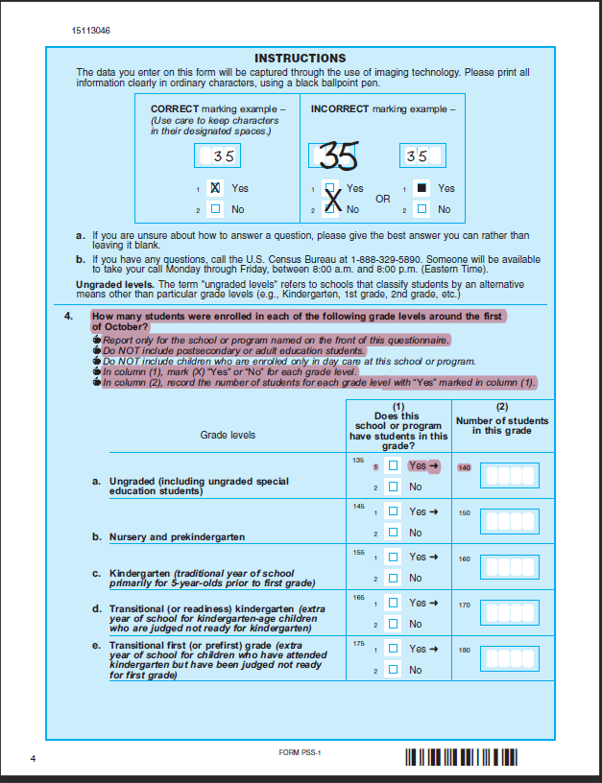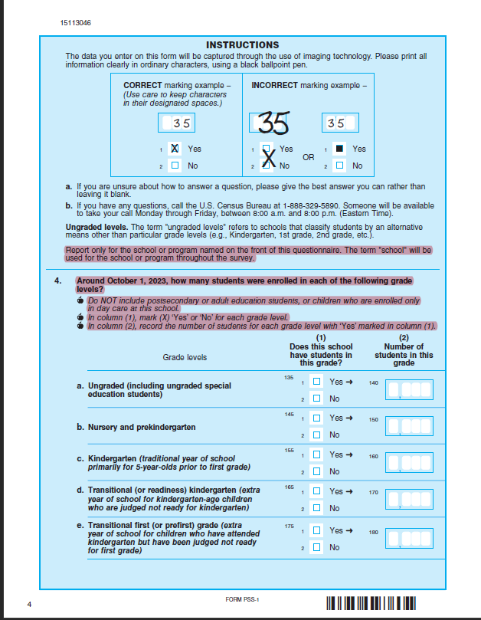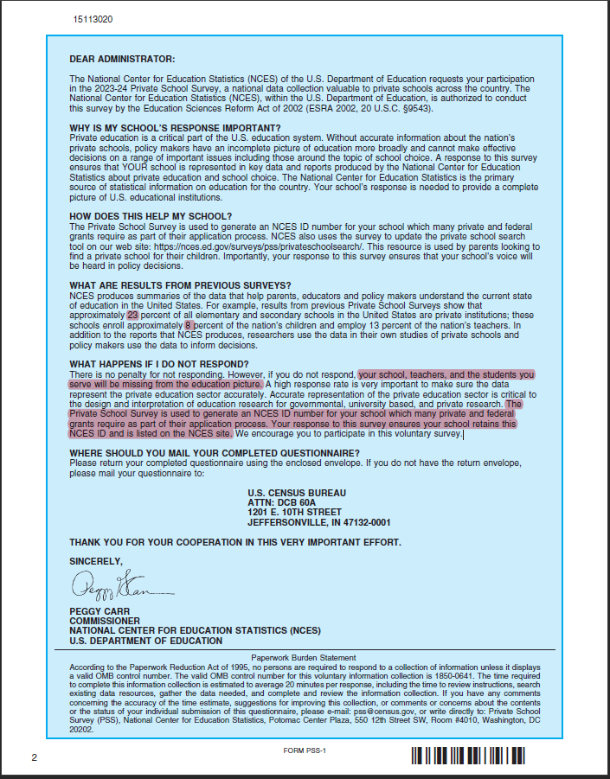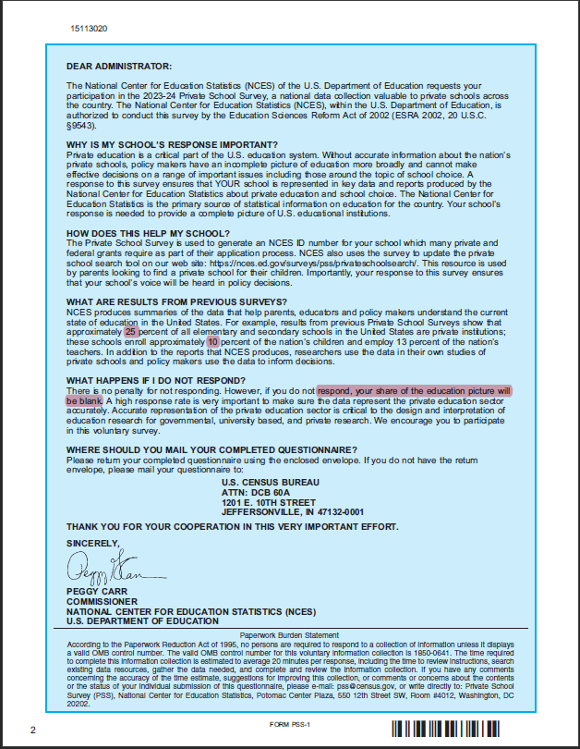Previous Revised

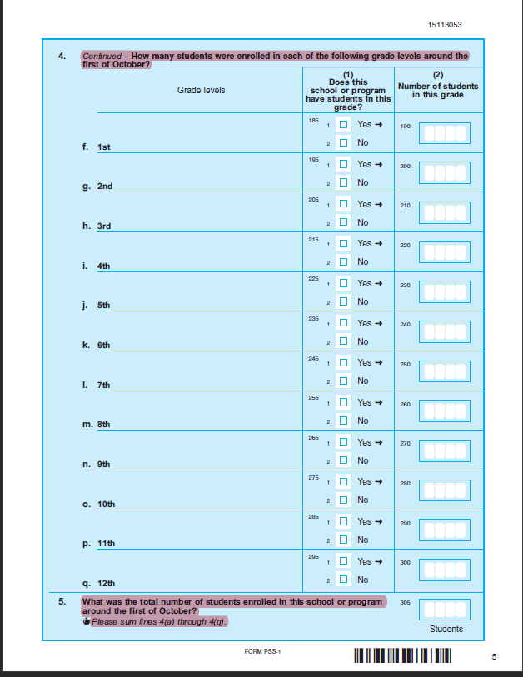Previous Revised

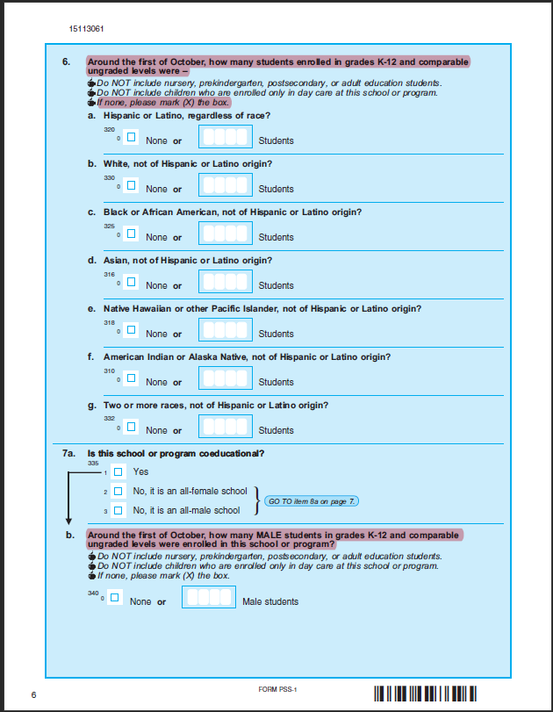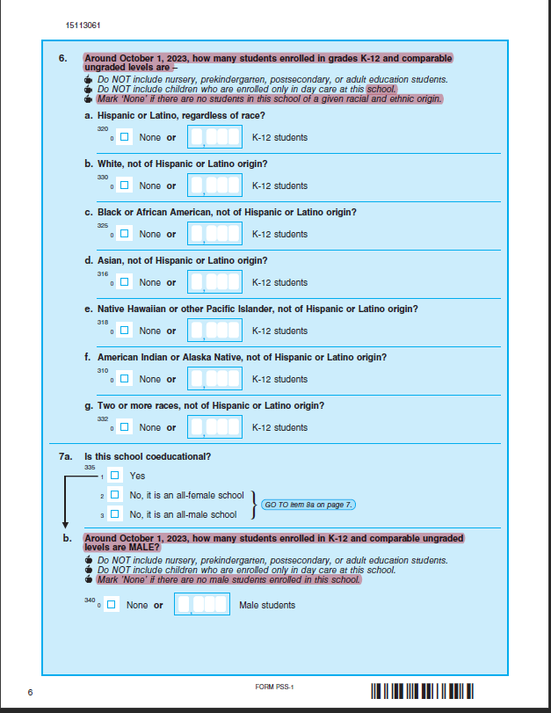

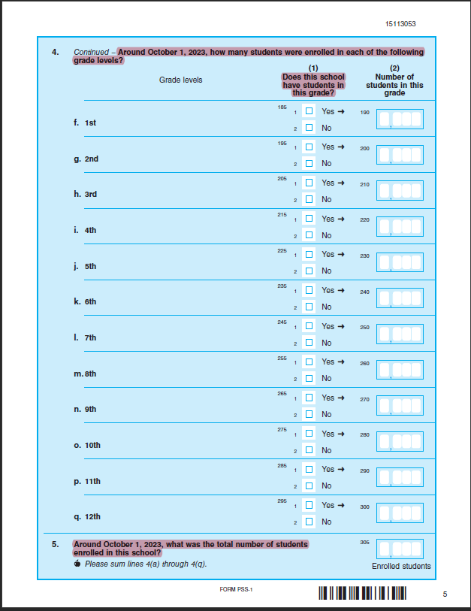

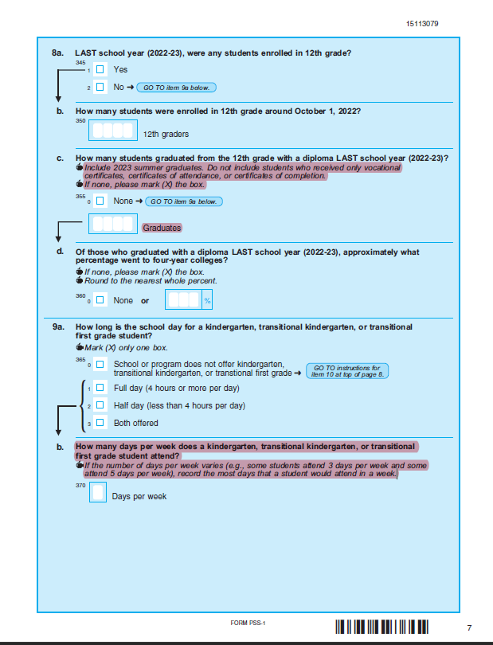Previous Revised

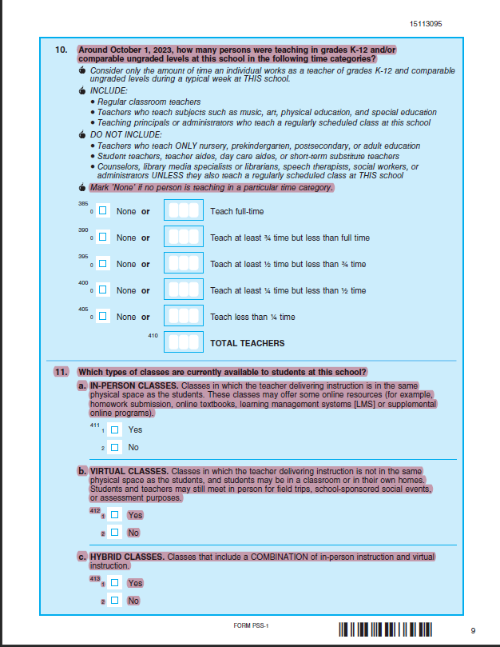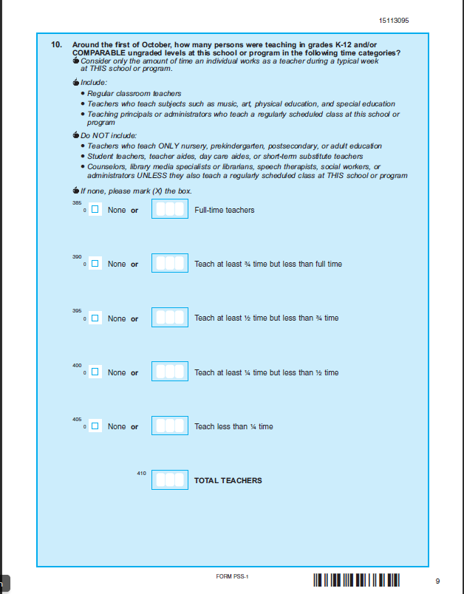

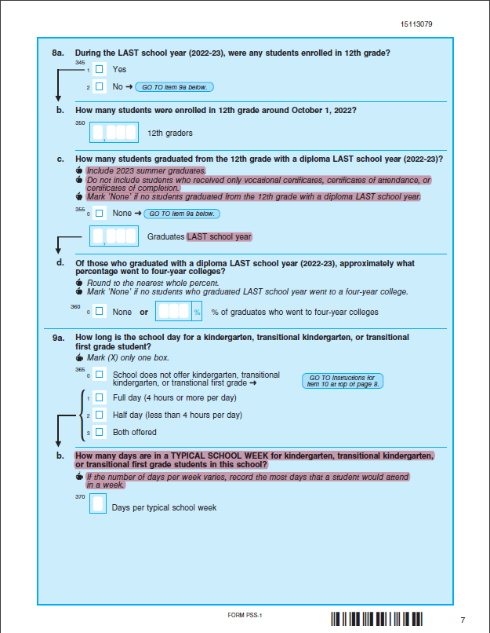

Previous Revised

