NATIONAL CENTER FOR EDUCATION STATISTICS NATIONAL ASSESSMENT OF EDUCATIONAL PROGRESS

National Assessment of Educational Progress (NAEP) 2024

Appendix J1
2024 Student Questionnaires

OMB# 1850-0928 v.30



June 2023

Appendix J1 provides the student survey questionnaires that will be administered in 2024. Grades 4 and 8 Core, Math, and Reading questionnaires were previously approved in 2022 (OMB# 1850-0928 v.28), and any changes to the items from the 2022 administration are reflected in summary tables. Additionally, grade 8 Science and grade 12 Core, Math, and Reading were previously approved in 2019 (OMB# 1850-0928 v.15), and any changes to the items from the 2019 administration are reflected in summary tables. New COVID-19 Learning Recovery and NIES SQs, are available in this document. Any changes to the NIES SQs since the 2019 administration are reflected in summary tables. Please note, some of the numbers of the items may be missing or out of order in these printed versions. This will be corrected in the platform view.

Table of Contents
Student Questionnaires
Student Login Screen 4
Appendix J1-1: Summary of Changes Operational Grade 4 (Core, Mathematics) 5
Appendix J1-2: Operational Grade 4 (Core, Mathematics) 8
Appendix J1-3: Summary of Changes Operational Grade 4 (Core, Reading) 13
Appendix J1-4: Operational Grade 4 (Core, Reading) 16
Appendix J1-5: Summary of Changes Operational Grade 8 (Core, Mathematics) 21
Appendix J1-6: Operational Grade 8 (Core, Mathematics) 24
Appendix J1-7: Summary of Changes Operational Grade 8 (Core, Reading) 35
Appendix J1-8: Operational Grade 8 (Core, Reading) 38
Appendix J1-9: Summary of Changes Operational Grade 12 (Core, Mathematics) 50
Appendix J1-10: Operational Grade 12 (Core, Mathematics) 53
Appendix J1-11: Summary of Changes Operational Grade 12 (Core, Reading) 62
Appendix J1-12: Operational Grade 12 (Core, Reading) 65
Appendix J1-13: Summary of Changes Operational Grade 4 (Mathematics) 73
Appendix J1-14: Operational Grade 4 (Mathematics) 74
Appendix J1-15: Summary of Changes Operational Grade 8 (Mathematics) 78
Appendix J1-16: Operational Grade 8 (Mathematics) 79
Appendix J1-17: Summary of Changes Operational Grade 12 (Mathematics) 84
Appendix J1-18: Operational Grade 12 (Mathematics) 87
Appendix J1-19: Summary of Changes Operational Grade 4 (Reading) 105
Appendix J1-20: Operational Grade 4 (Reading) 106
Appendix J1-21: Summary of Changes Operational Grade 8 (Reading) 110
Appendix J1-22: Operational Grade 8 (Reading) 111
Appendix J1-23: Summary of Changes Operational Grade 12 (Reading) 115
Appendix J1-24: Operational Grade 12 (Reading) 116
Appendix J1-25: Operational Grade 8 (Science) 125
Appendix J1-26: Operational Grade 4 (Debrief) 130
Appendix J1-27: Operational Grade 8 and 12 (Debrief) 131
Appendix J1-28: Summary of Changes Operational Grade 4 (NIES) 132
Appendix J1-29: Operational Grade 4 (NIES) 135
Appendix J1-30: Summary of Changes Operational Grade 8 (NIES) 145
Appendix J1-31: Operational Grade 8 (NIES) 148
Appendix J1-32: Pilot Grade 4 (Core) 161
Appendix J1-33: Pilot Grade 8 (Core) 163
Appendix J1-34: Pilot Grade 4 (Mathematics) 164
Appendix J1-35: Pilot Grade 8 (Mathematics) 167
Appendix J1-36: Pilot Grade 4 (Reading) 174
Appendix J1-37: Pilot Grade 8 (Reading) 177

Student Login Screen
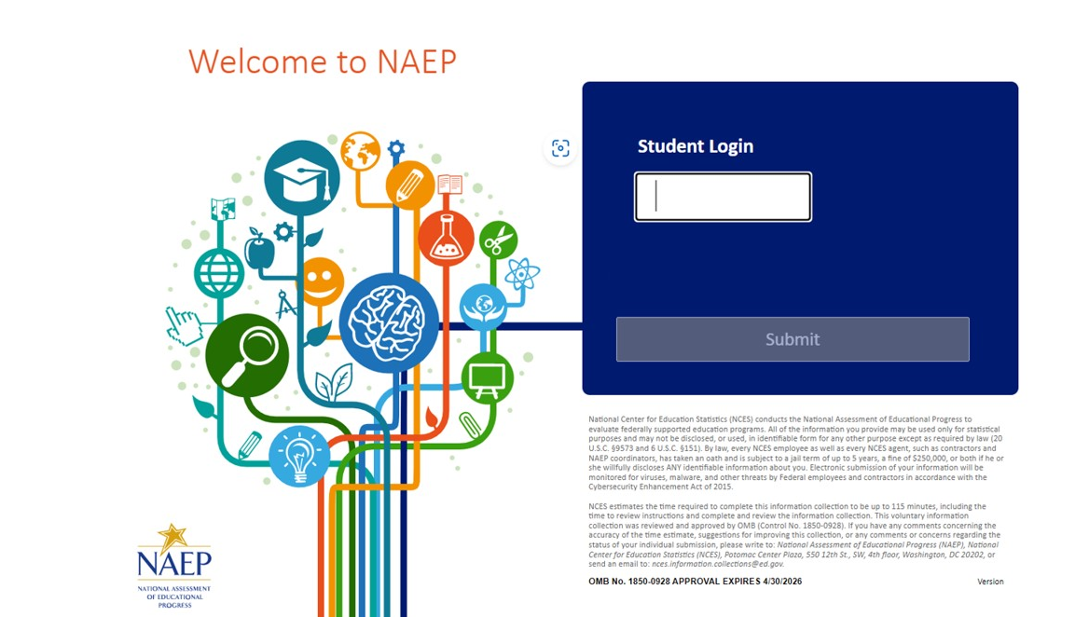

Appendix J1-1: Summary of Changes Operational Grade 4 (Core, Mathematics)

2024 Operational Grade 4 Core Mathematics Student
Previous Item | 2024 Item | D/A/ R+ | Rationale
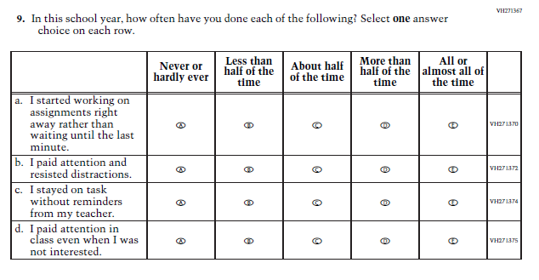  (2022 Grades 4 and 8, 2019 Grade 12) | N/A  Issue: Grit | D | This Item was selected to be dropped to reduce burden due to the addition of the Learning Recovery Items.
N/A | 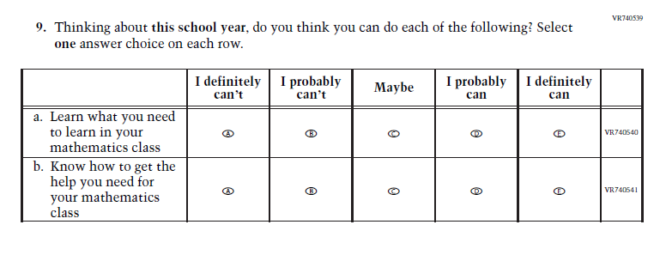  Issue: Learning Recovery | A | This Item was added to address gaps in learning that have developed due to the extended period of remote and hybrid learning that took place during the pandemic.
N/a | 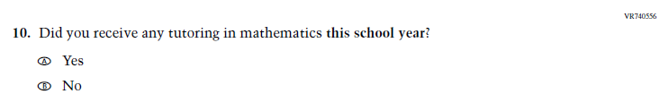  Issue: Learning Recovery | A | This Item was added to address gaps in learning that have developed due to the extended period of remote and hybrid learning that took place during the pandemic.
N/A | 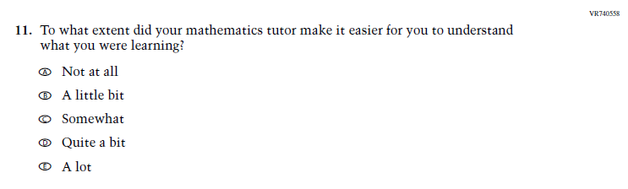  Issue: Learning Recovery | A | This Item was added to address gaps in learning that have developed due to the extended period of remote and hybrid learning that took place during the pandemic.

N/A | 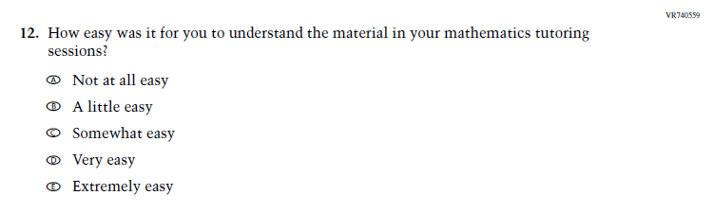  Issue: Learning Recovery | A | This Item was added to address gaps in learning that have developed due to the extended period of remote and hybrid learning that took place during the pandemic.
N/A | 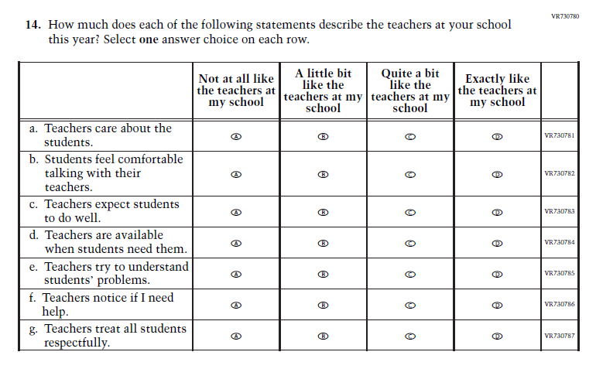  Issue: Learning Recovery | A | This Item was added to address gaps in learning that have developed due to the extended period of remote and hybrid learning that took place during the pandemic.

Appendix J1-2: Operational Grade 4 (Core, Mathematics)
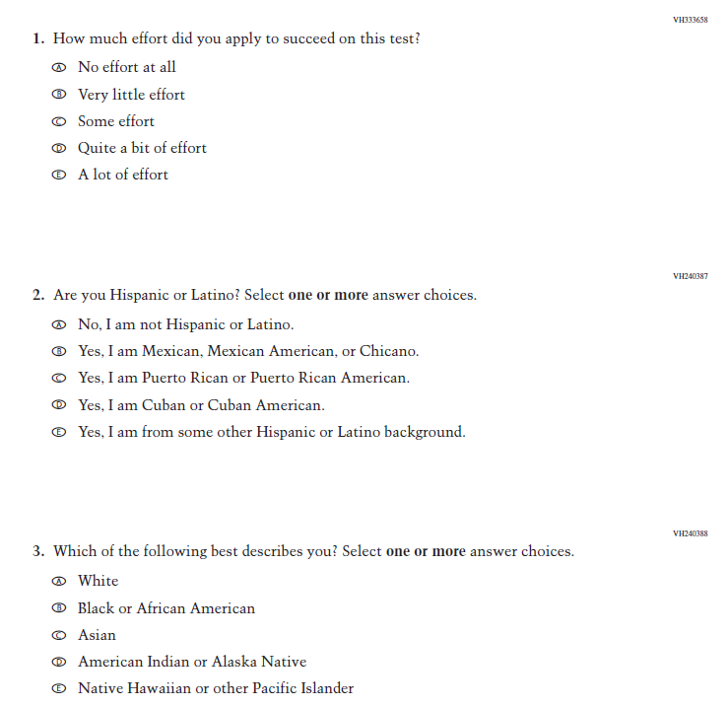
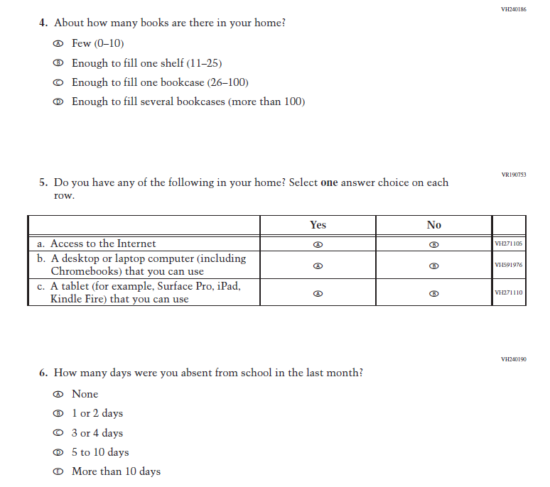
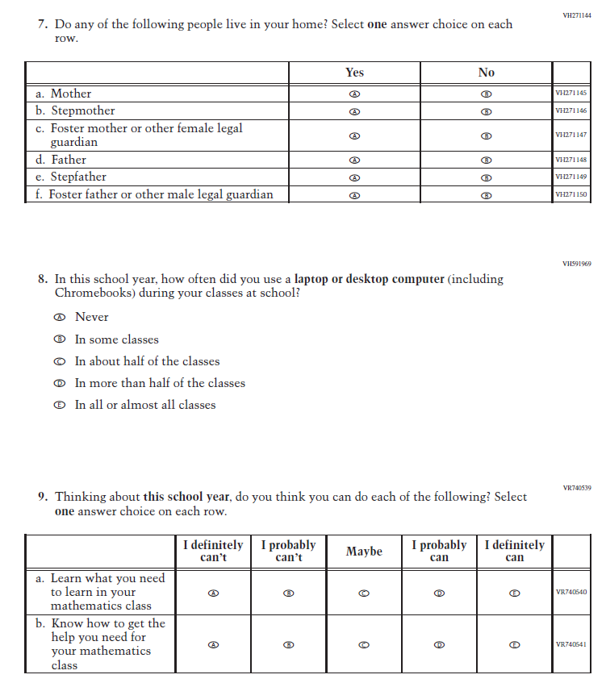
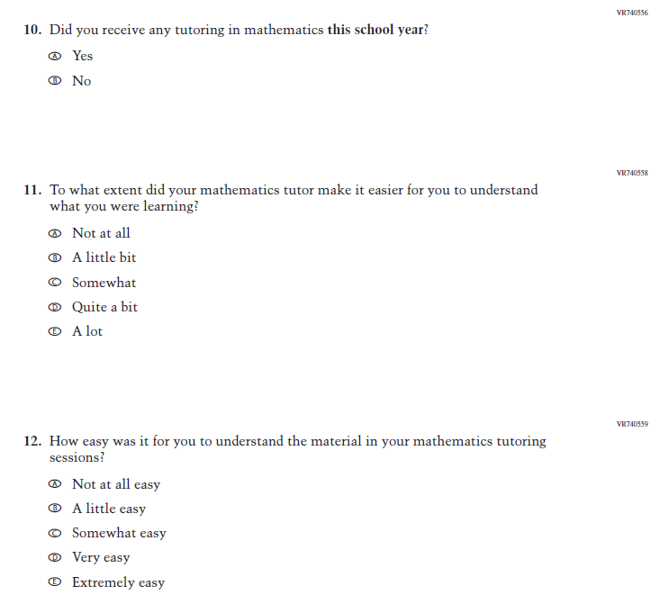
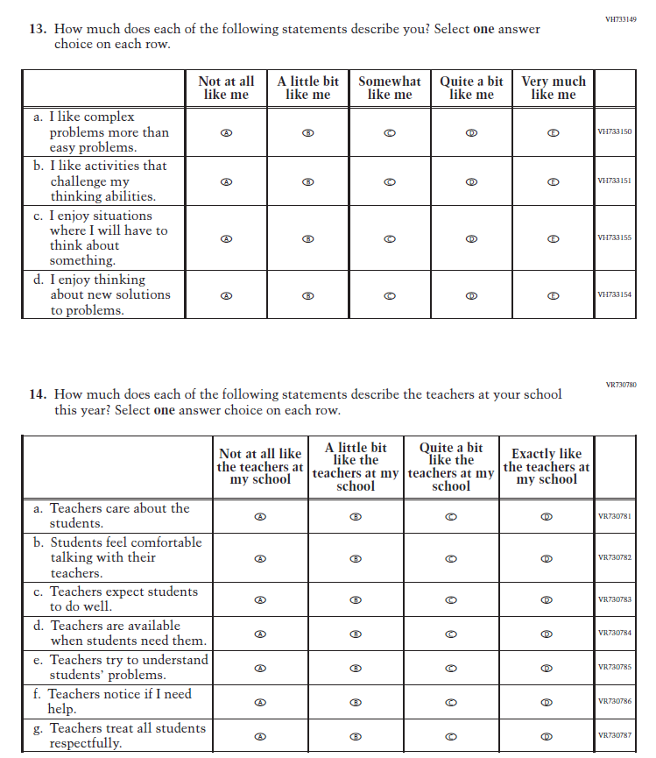

Appendix J1-3: Summary of Changes Operational Grade 4 (Core, Reading)

2024 Operational Grade 4 Core Reading Student
Previous Item | 2024 Item | D/A/ R+ | Rationale
(2022 Grades 4 and 8, 2019 Grade 12) | N/A  Issue: Grit | D | This Item was selected to be dropped to reduce burden due to the addition of the Learning Recovery Items.
N/A | 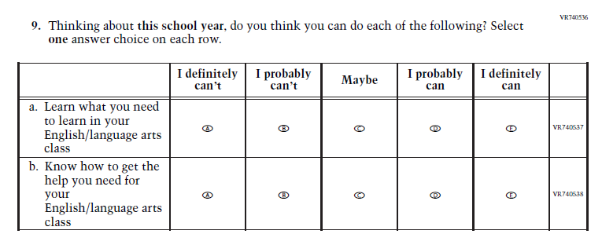  Issue: Learning Recovery | A | This Item was added to address gaps in learning that have developed due to the extended period of remote and hybrid learning that took place during the pandemic.

N/A | 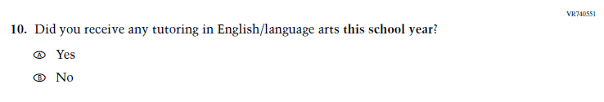  Issue: Learning Recovery | A | This Item was added to address gaps in learning that have developed due to the extended period of remote and hybrid learning that took place during the pandemic.
N/A | 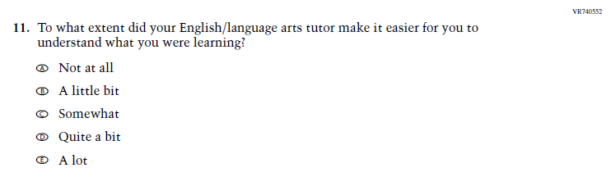  Issue: Learning Recovery | A | This Item was added to address gaps in learning that have developed due to the extended period of remote and hybrid learning that took place during the pandemic.

N/A | 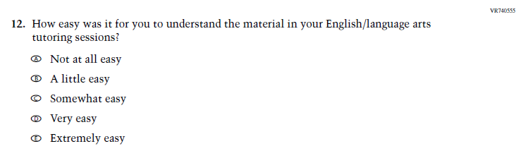  Issue: Learning Recovery | A | This Item was added to address gaps in learning that have developed due to the extended period of remote and hybrid learning that took place during the pandemic.
N/A | Issue: Learning Recovery | A | This Item was added to address gaps in learning that have developed due to the extended period of remote and hybrid learning that took place during the pandemic.

Appendix J1-4: Operational Grade 4 (Core, Reading)
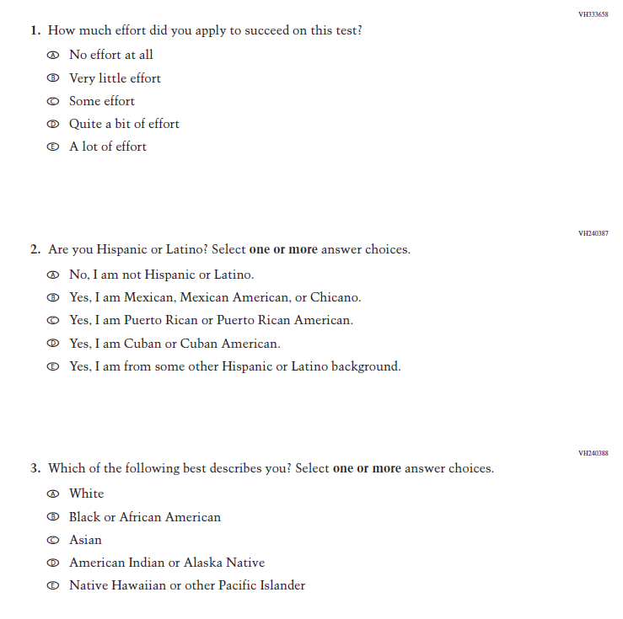
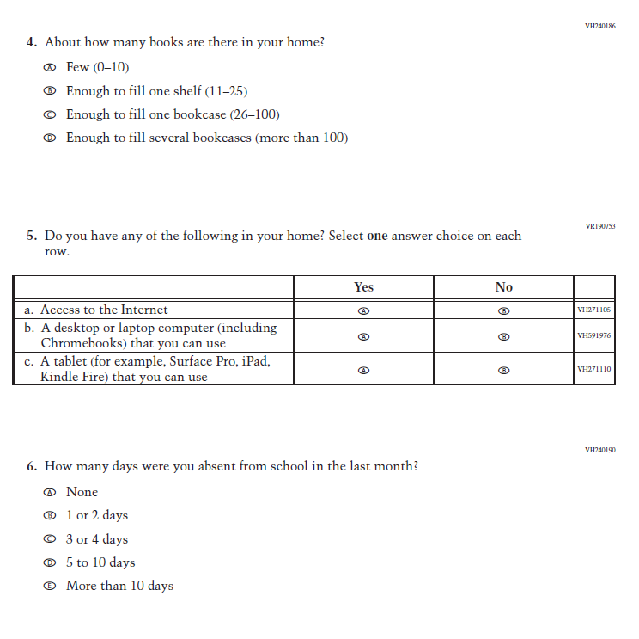
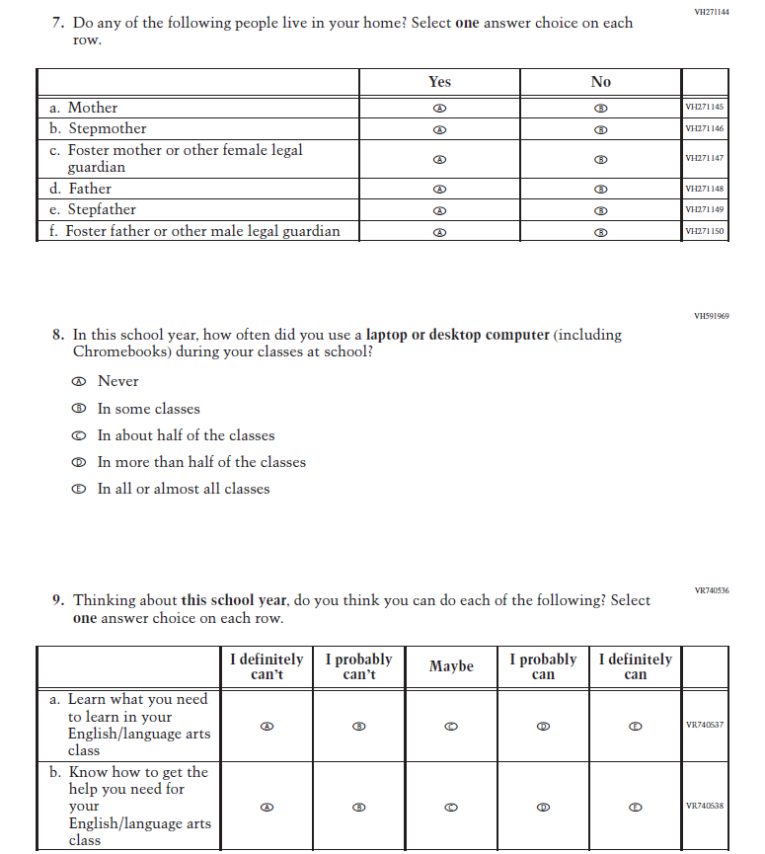
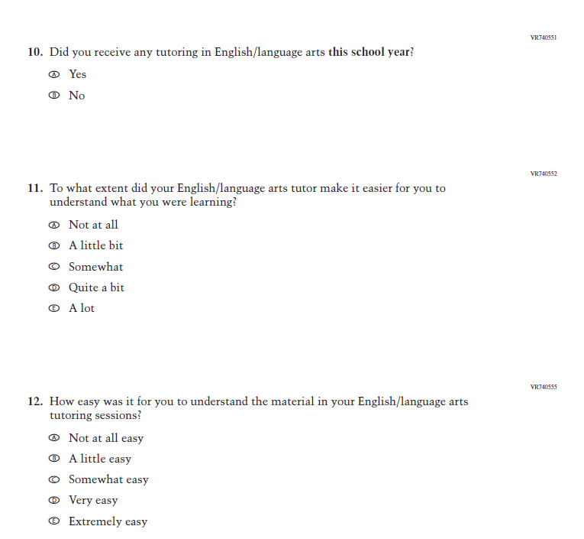
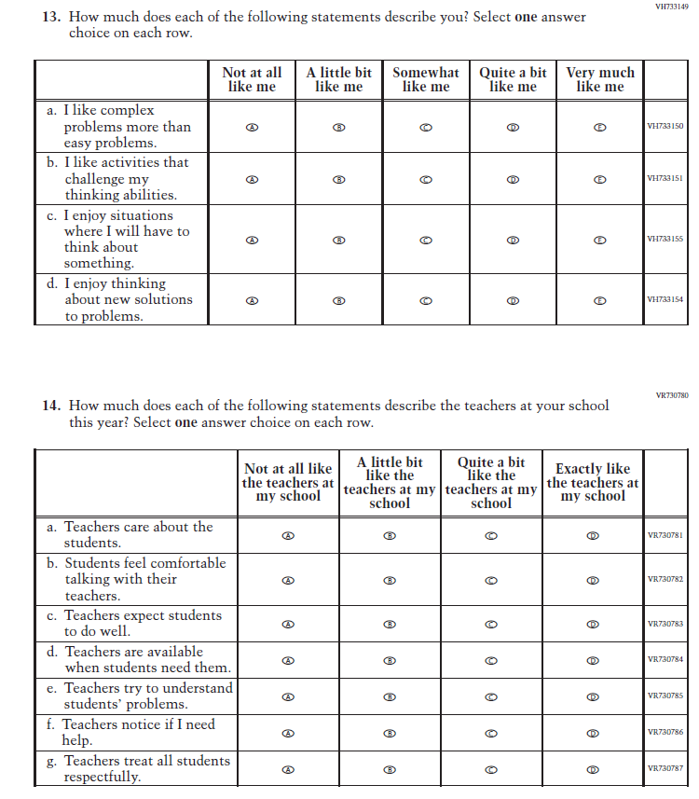

Appendix J1-5: Summary of Changes Operational Grade 8 (Core, Mathematics)
2024 Operational Grade 8 Core Mathematics Student
Previous Item | 2024 Item | D/A/ R+ | Rationale
(2022 Grades 4 and 8, 2019 Grade 12) | N/A  Issue: Grit | D | This Item was selected to be dropped to reduce burden due to the addition of the Learning Recovery Items.
N/A | Issue: Learning Recovery |  | This Item was added to address gaps in learning that have developed due to the extended period of remote and hybrid learning that took place during the pandemic.
N/a | Issue: Learning Recovery |  | This Item was added to address gaps in learning that have developed due to the extended period of remote and hybrid learning that took place during the pandemic.
N/A | Issue: Learning Recovery |  | This Item was added to address gaps in learning that have developed due to the extended period of remote and hybrid learning that took place during the pandemic.

N/A | Issue: Learning Recovery |  | This Item was added to address gaps in learning that have developed due to the extended period of remote and hybrid learning that took place during the pandemic.
N/A | Issue: Learning Recovery |  | This Item was added to address gaps in learning that have developed due to the extended period of remote and hybrid learning that took place during the pandemic.

Appendix J1-6: Operational Grade 8 (Core, Mathematics)
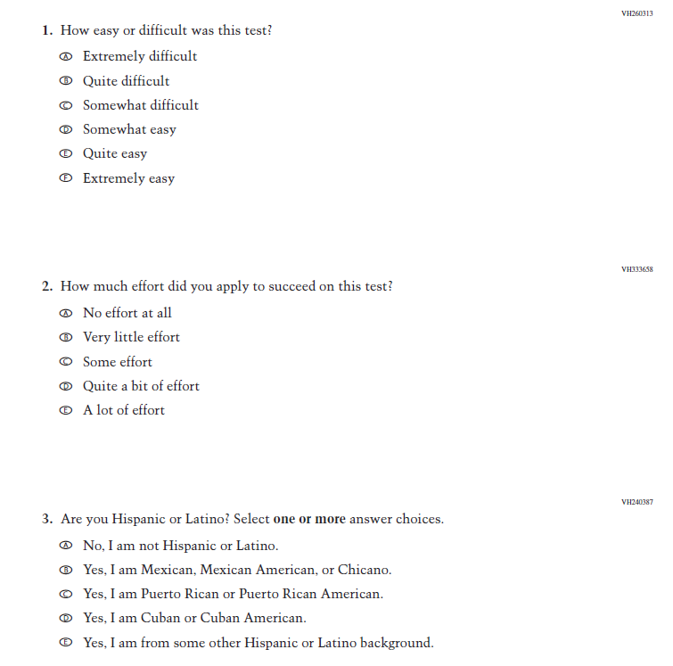
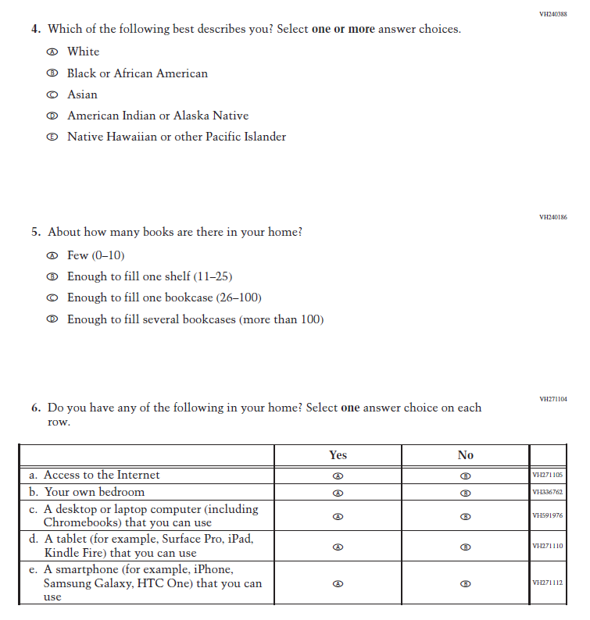
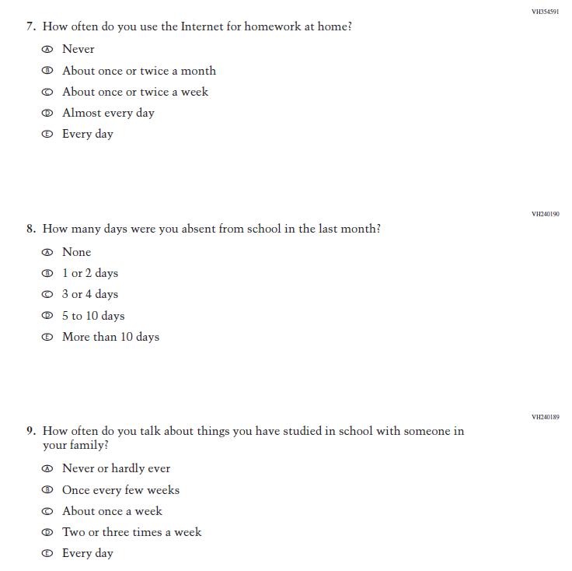
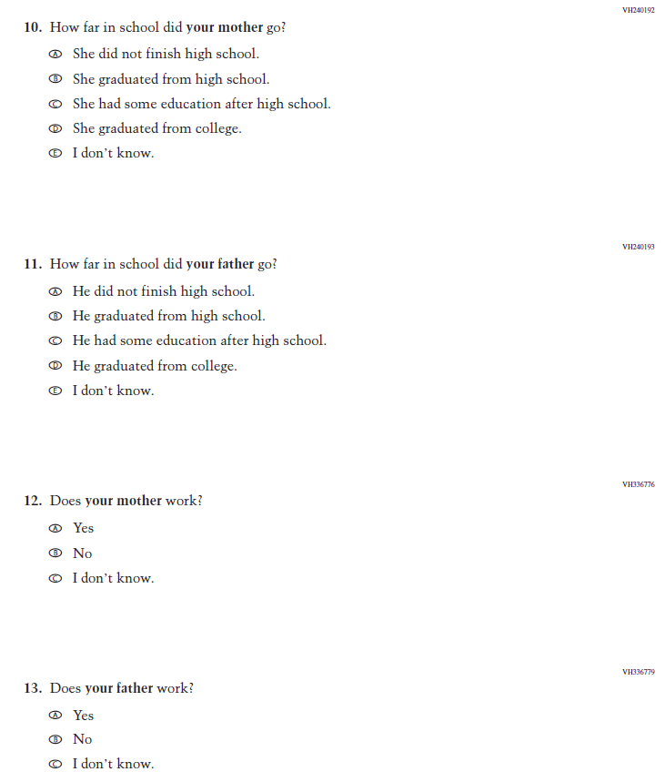
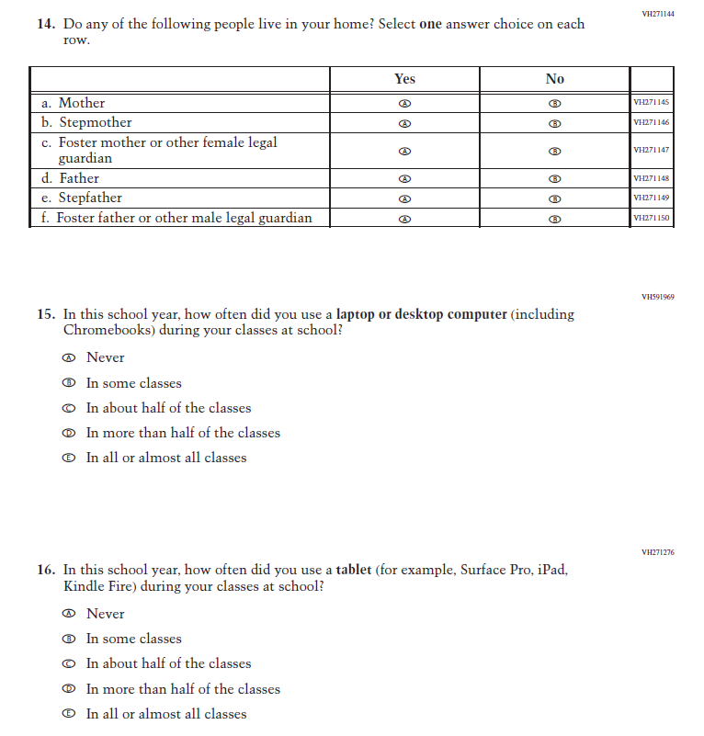
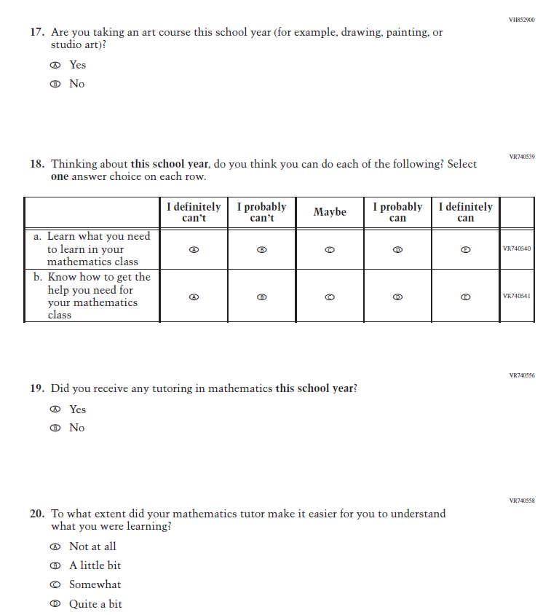
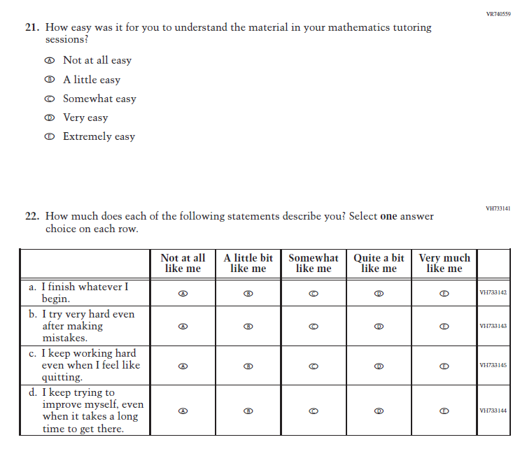
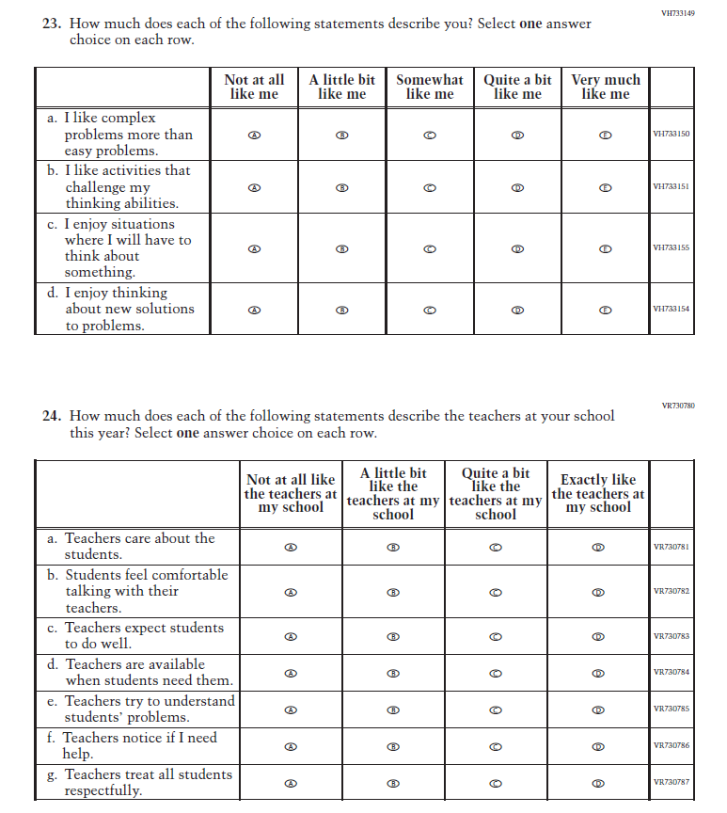

NAEP Student Parent/Guardian Item Set for Grade 8
The parent/guardian item set is a dynamic set of contextual questionnaire items designed to allow grade 8 students with a variety of parent/guardian types to report a) who their parents/guardians are, b) the educational attainment of those adults, and c) the employment status of those adults. The item set allows for a more inclusive approach to collecting this information, which is relevant to the measurement of student socioeconomic status (SES). These items are intended for use at grade 8 only as some grade 4 students have difficulty providing this information. In the pilot administration of the parent/guardian items, these items will be included within the core contextual questionnaire and will be preceded and followed by other questionnaire items.
-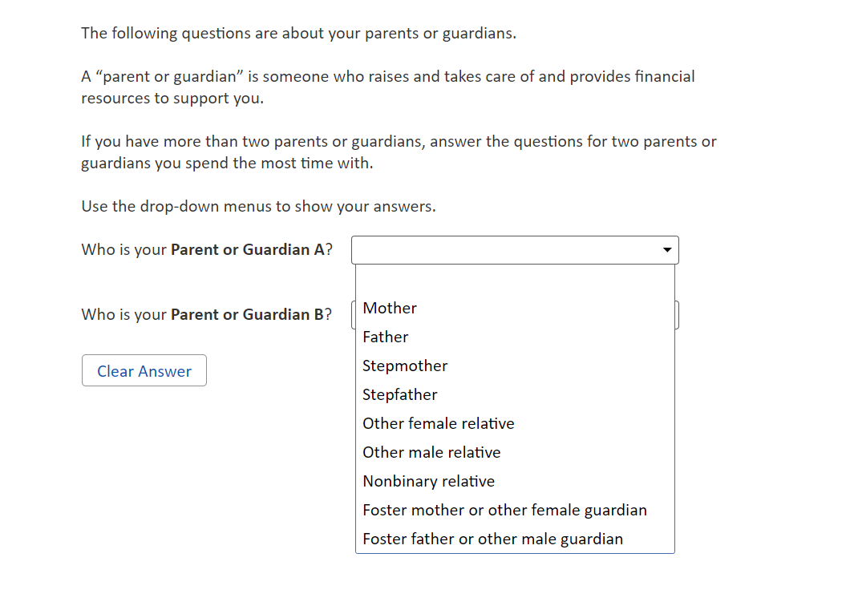
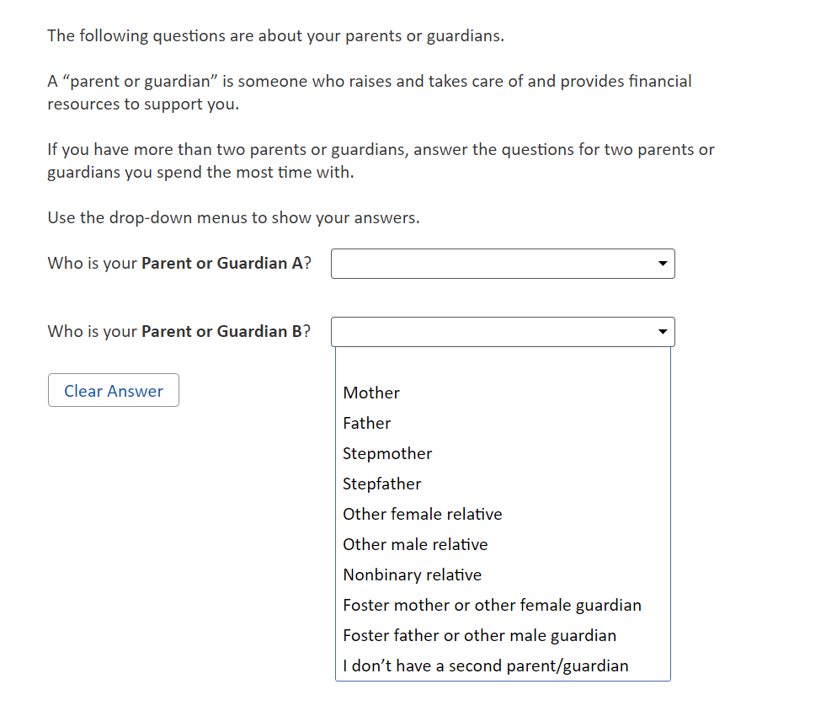
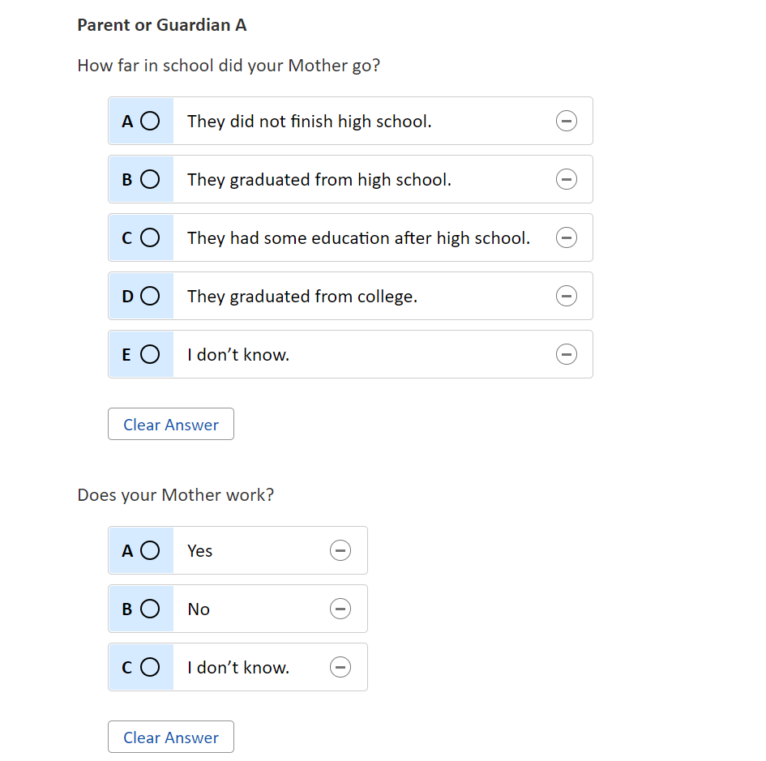
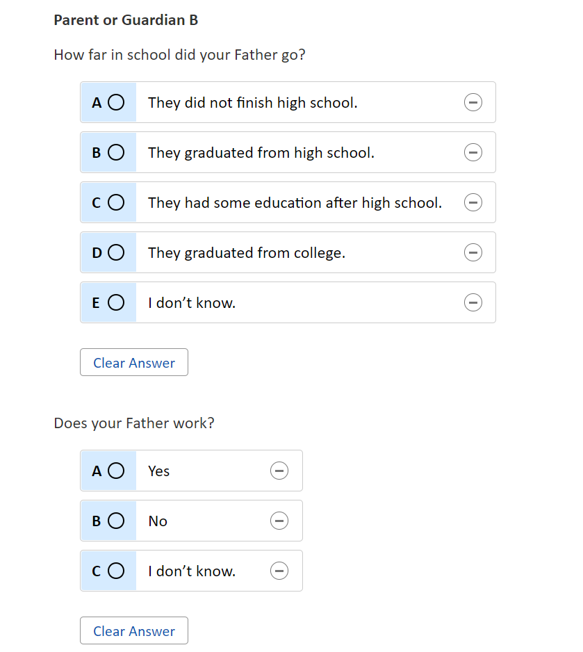

Appendix J1-7: Summary of Changes Operational Grade 8 (Core, Reading)
2024 Operational Grade 8 Core Reading Student
Previous Item | 2024 Item | D/A/ R+ | Rationale
(2022 Grades 4 and 8, 2019 Grade 12) | N/A  Issue: Grit | D | This Item was selected to be dropped to reduce burden due to the addition of the Learning Recovery Items.
N/A | Issue: Learning Recovery | A | This Item was added to address gaps in learning that have developed due to the extended period of remote and hybrid learning that took place during the pandemic.

N/A | Issue: Learning Recovery | A | This Item was added to address gaps in learning that have developed due to the extended period of remote and hybrid learning that took place during the pandemic.
N/A | Issue: Learning Recovery | A | This Item was added to address gaps in learning that have developed due to the extended period of remote and hybrid learning that took place during the pandemic.

N/A | Issue: Learning Recovery | A | This Item was added to address gaps in learning that have developed due to the extended period of remote and hybrid learning that took place during the pandemic.
N/A | Issue: Learning Recovery | A | This Item was added to address gaps in learning that have developed due to the extended period of remote and hybrid learning that took place during the pandemic.

Appendix J1-8: Operational Grade 8 (Core, Reading)
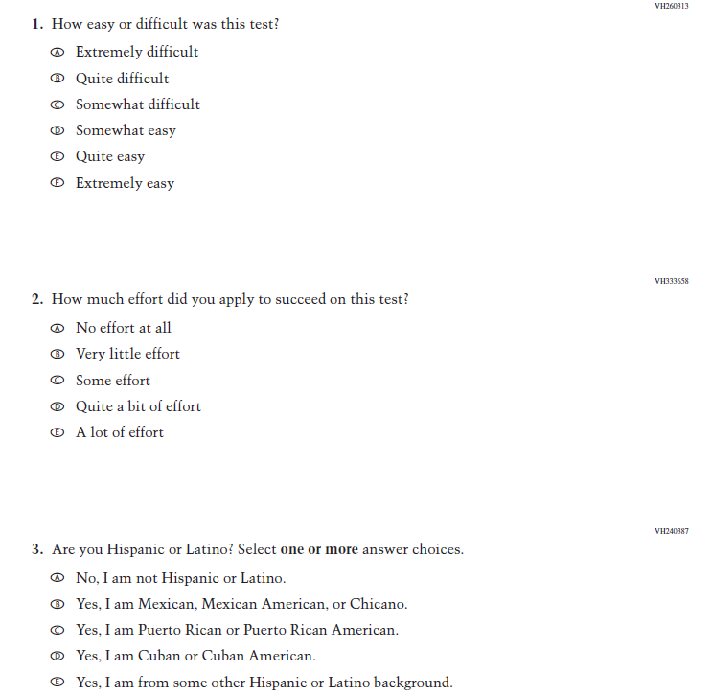
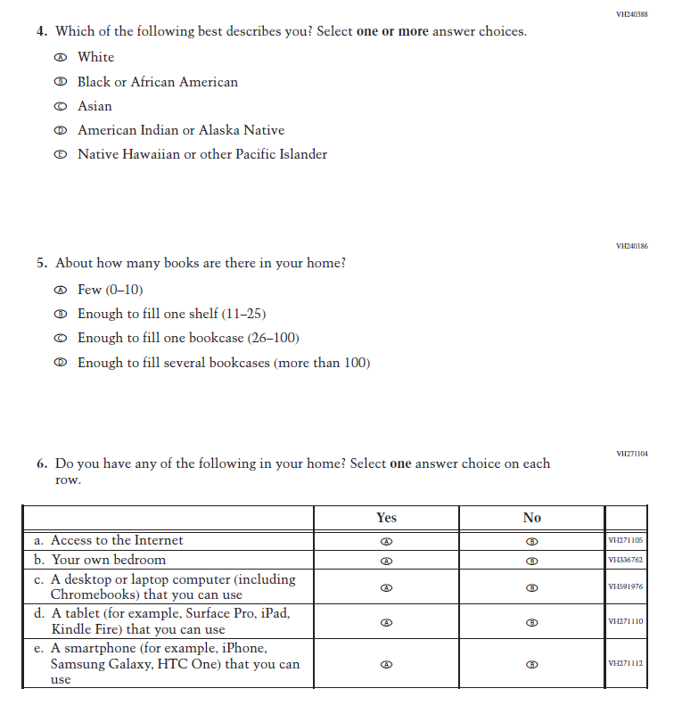
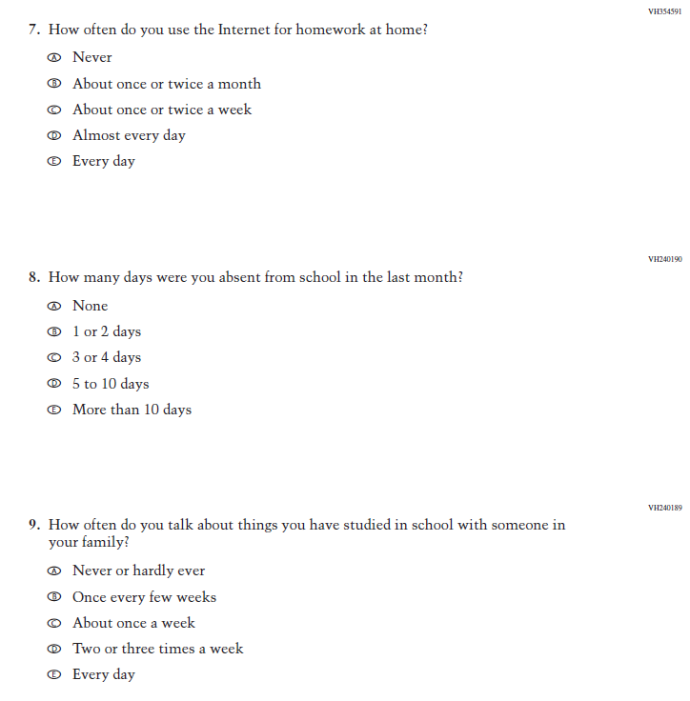
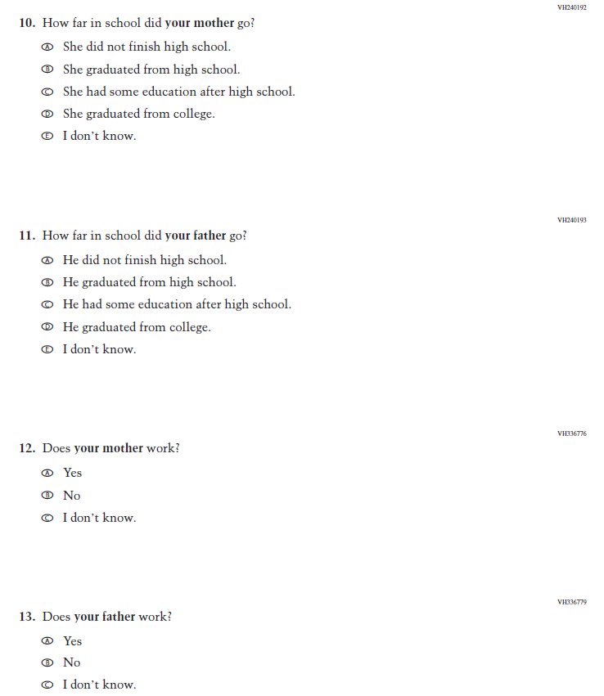
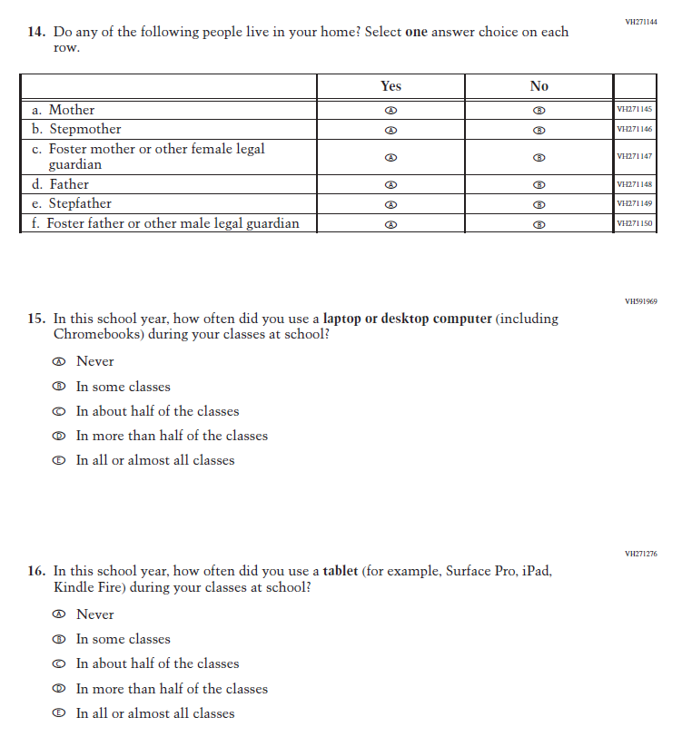
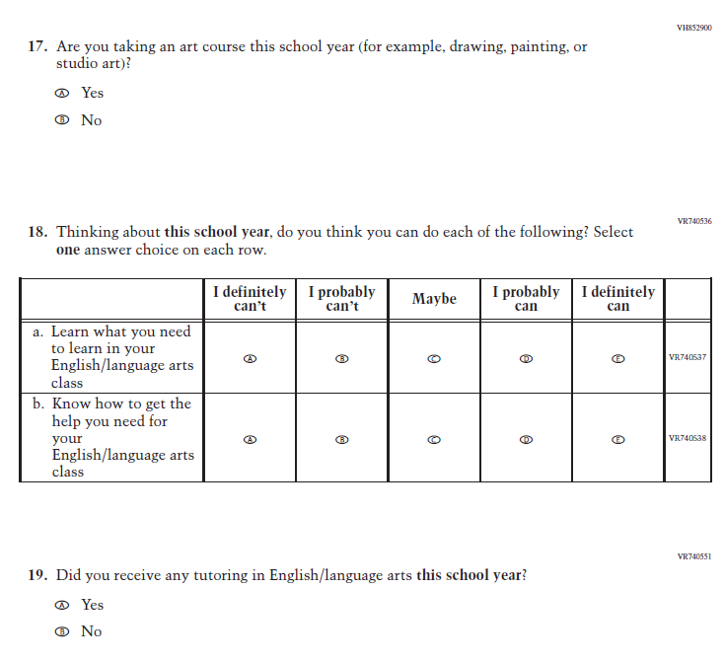
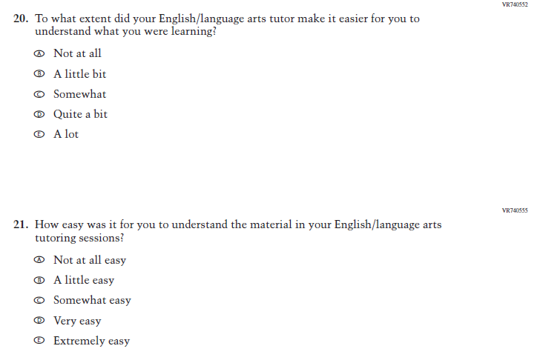
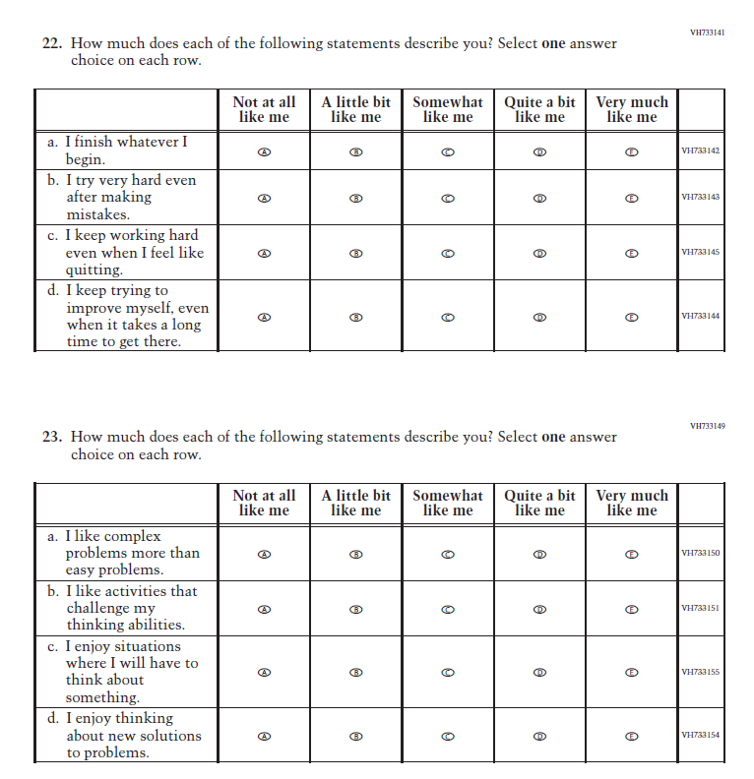
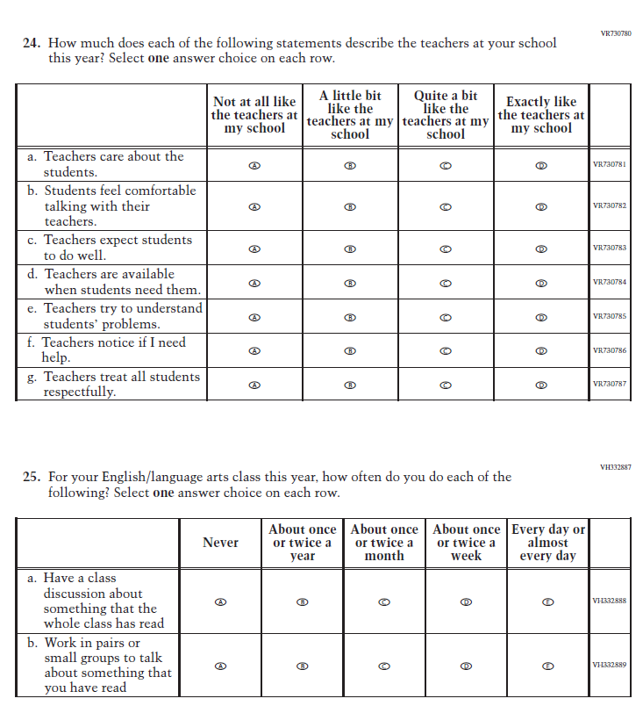
NAEP Student Parent/Guardian Item Set for Grade 8
The parent/guardian item set is a dynamic set of contextual questionnaire items designed to allow grade 8 students with a variety of parent/guardian types to report a) who their parents/guardians are, b) the educational attainment of those adults, and c) the employment status of those adults. The item set allows for a more inclusive approach to collecting this information, which is relevant to the measurement of student socioeconomic status (SES). These items are intended for use at grade 8 only as some grade 4 students have difficulty providing this information. In the pilot administration of the parent/guardian items, these items will be included within the core contextual questionnaire and will be preceded and followed by other questionnaire items.
-

Appendix J1-9: Summary of Changes Operational Grade 12 (Core, Mathematics)
2024 Operational Grade 12 Core Mathematics Student
Previous Item | 2024 Item | D/A/ R+ | Rationale
(2022 Grades 4 and 8, 2019 Grade 12) | N/A  Issue: Grit | D | This Item was selected to be dropped to reduce burden due to the addition of the Learning Recovery Items.
N/A | Issue: Learning Recovery |  | This Item was added to address gaps in learning that have developed due to the extended period of remote and hybrid learning that took place during the pandemic.
N/a | Issue: Learning Recovery |  | This Item was added to address gaps in learning that have developed due to the extended period of remote and hybrid learning that took place during the pandemic.
N/A | Issue: Learning Recovery |  | This Item was added to address gaps in learning that have developed due to the extended period of remote and hybrid learning that took place during the pandemic.

N/A | Issue: Learning Recovery |  | This Item was added to address gaps in learning that have developed due to the extended period of remote and hybrid learning that took place during the pandemic.
N/A | Issue: Learning Recovery |  | This Item was added to address gaps in learning that have developed due to the extended period of remote and hybrid learning that took place during the pandemic.

Appendix J1-10: Operational Grade 12 (Core, Mathematics)
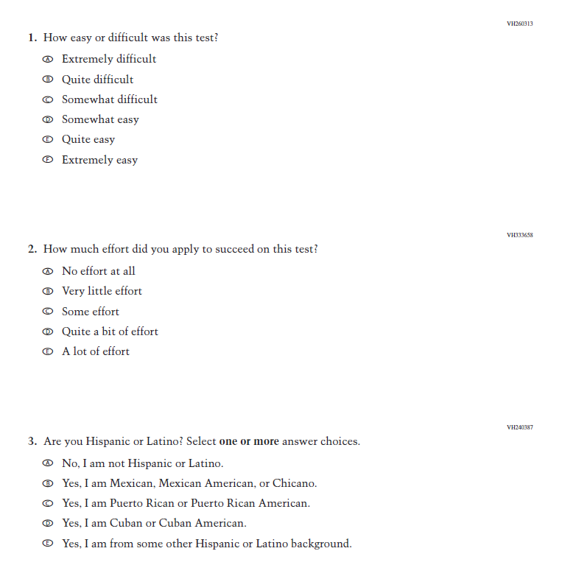
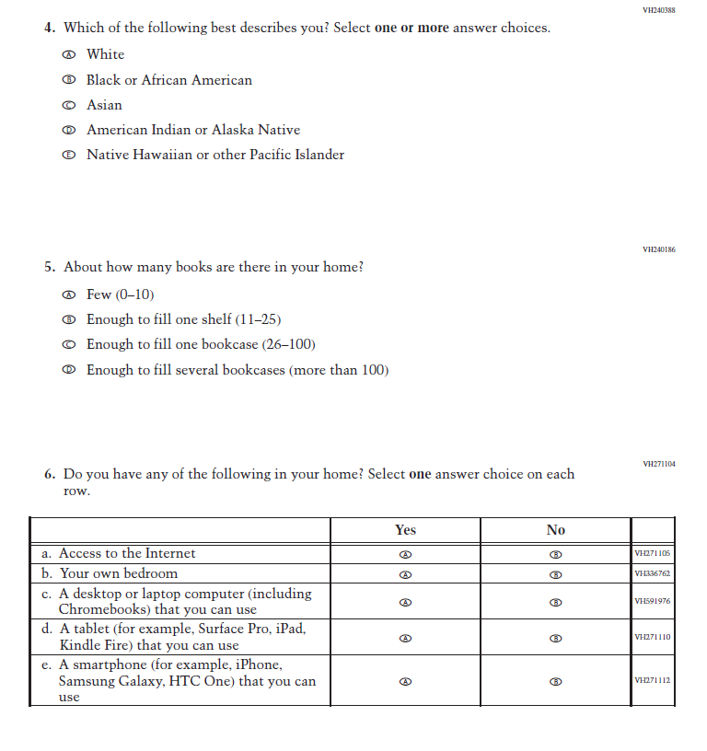
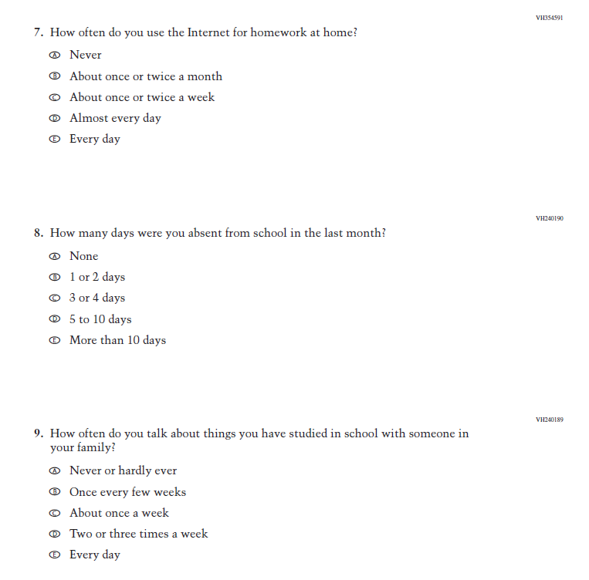
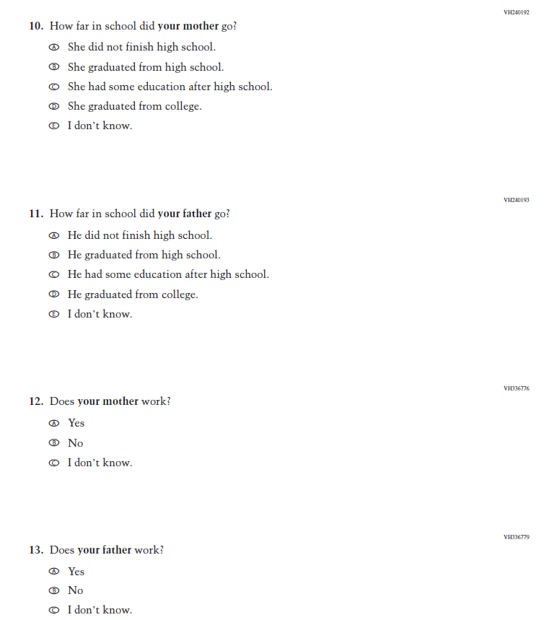
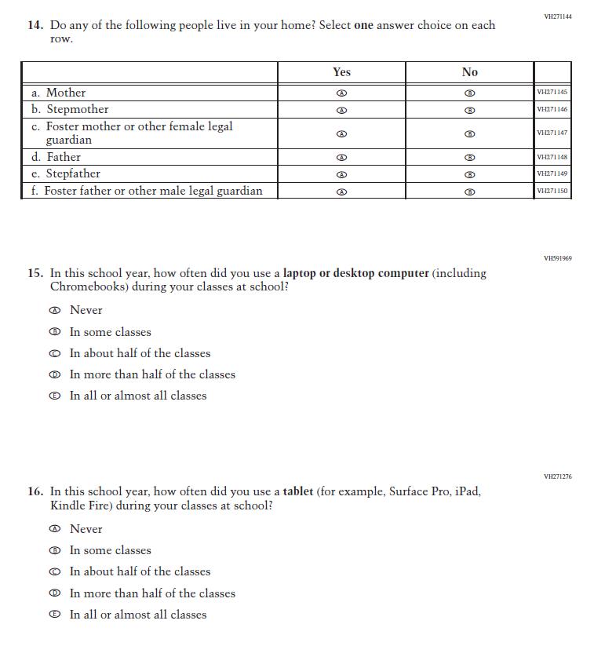
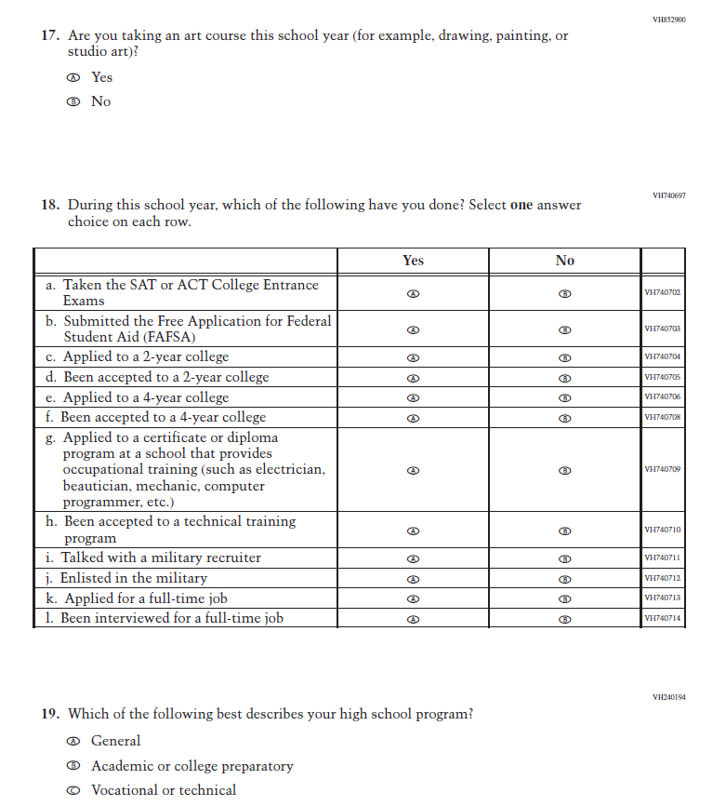
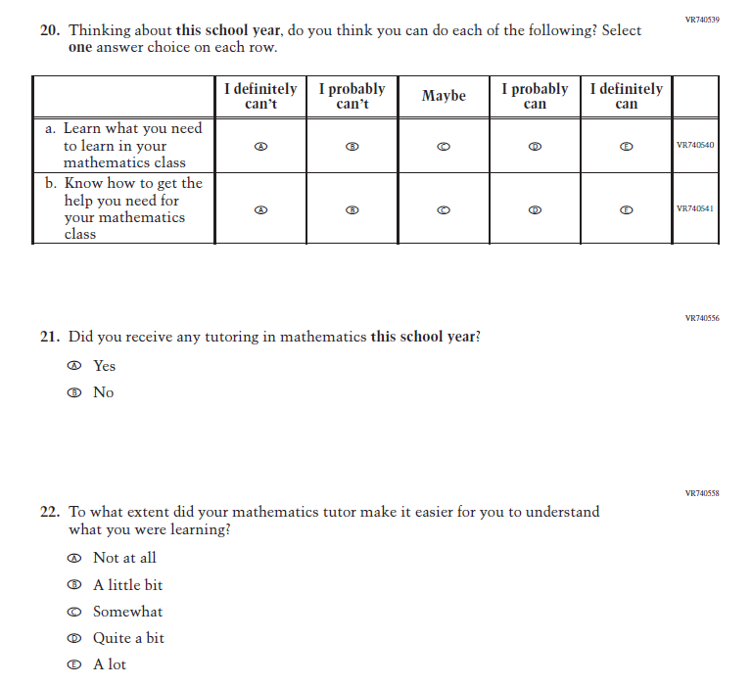
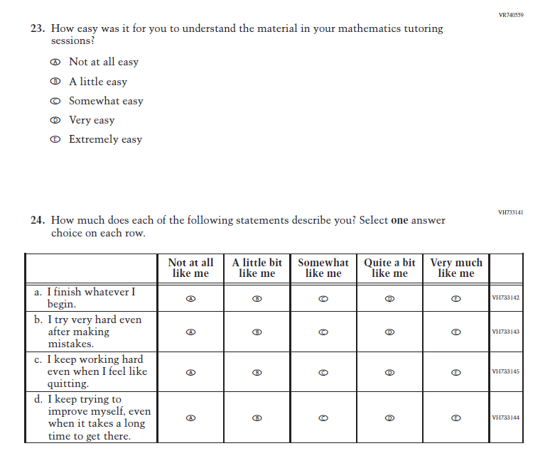
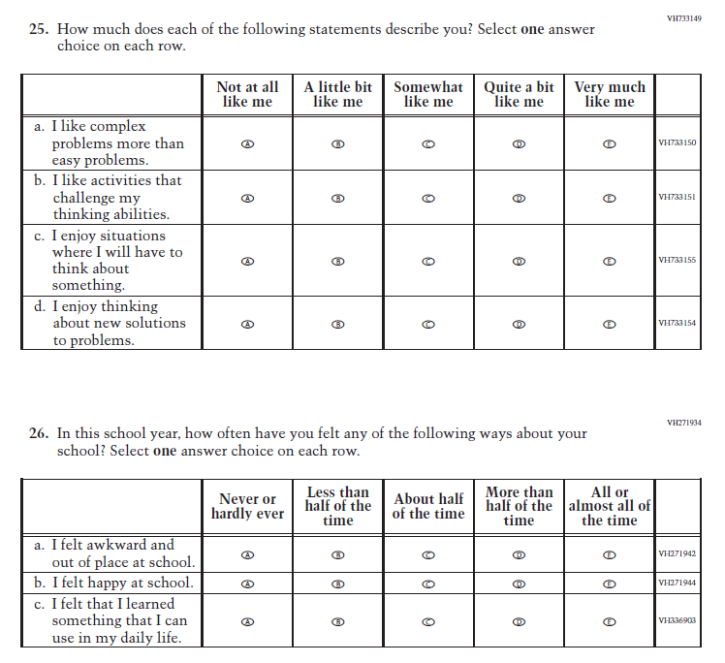
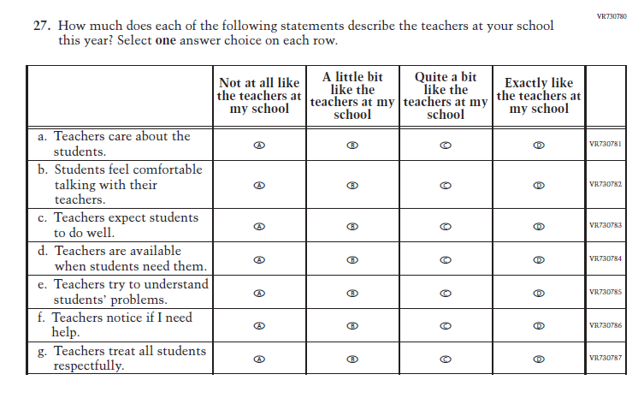

Appendix J1-11: Summary of Changes Operational Grade 12 (Core, Reading)

2024 Operational Grade 12 Core Reading Student
Previous Item | 2024 Item | D/A/ R+ | Rationale
(2022 Grades 4 and 8, 2019 Grade 12) | N/A  Issue: Grit | D | This Item was selected to be dropped to reduce burden due to the addition of the Learning Recovery Items.
N/A | Issue: Learning Recovery | A | This Item was added to address gaps in learning that have developed due to the extended period of remote and hybrid learning that took place during the pandemic.

N/A | Issue: Learning Recovery | A | This Item was added to address gaps in learning that have developed due to the extended period of remote and hybrid learning that took place during the pandemic.
N/A | Issue: Learning Recovery | A | This Item was added to address gaps in learning that have developed due to the extended period of remote and hybrid learning that took place during the pandemic.

N/A | Issue: Learning Recovery | A | This Item was added to address gaps in learning that have developed due to the extended period of remote and hybrid learning that took place during the pandemic.
N/A | Issue: Learning Recovery | A | This Item was added to address gaps in learning that have developed due to the extended period of remote and hybrid learning that took place during the pandemic.

Appendix J1-12: Operational Grade 12 (Core, Reading)
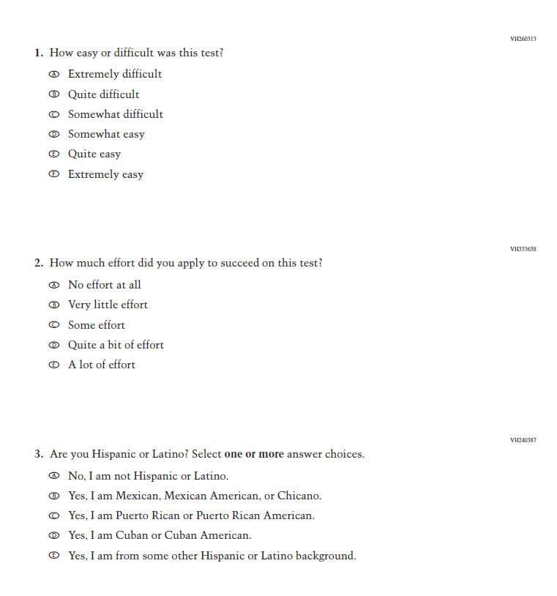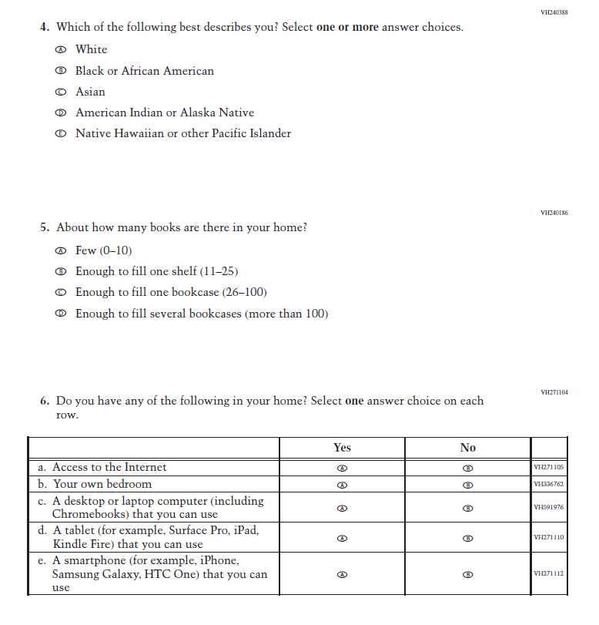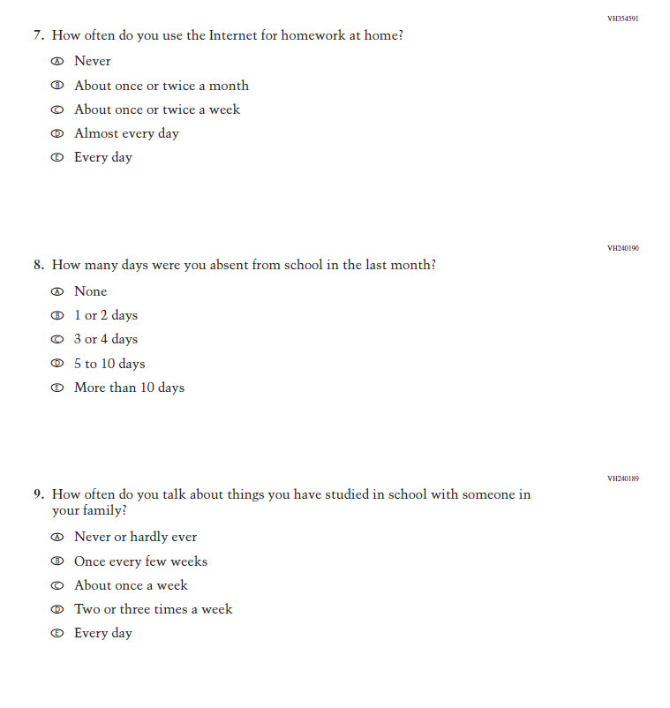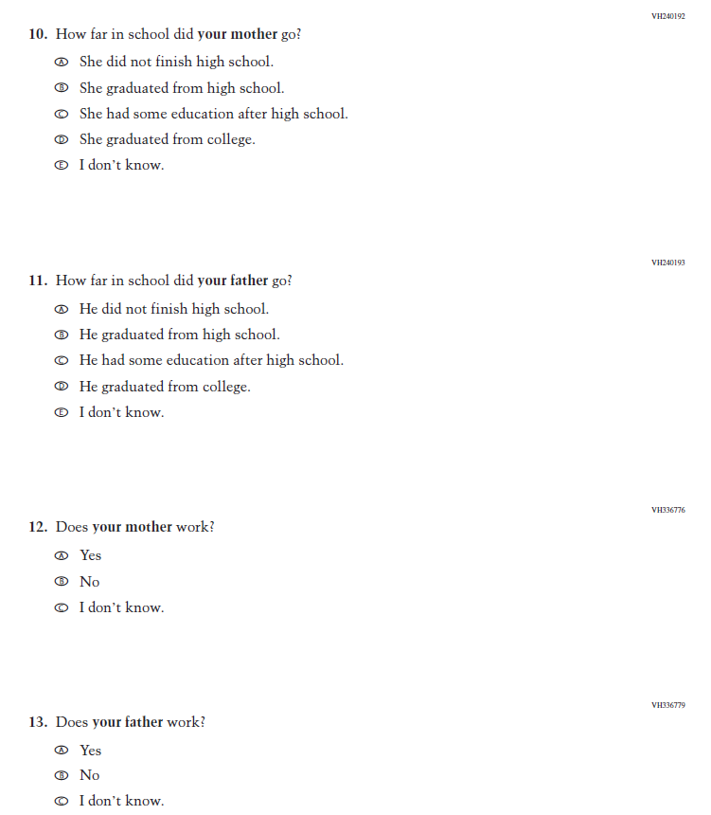
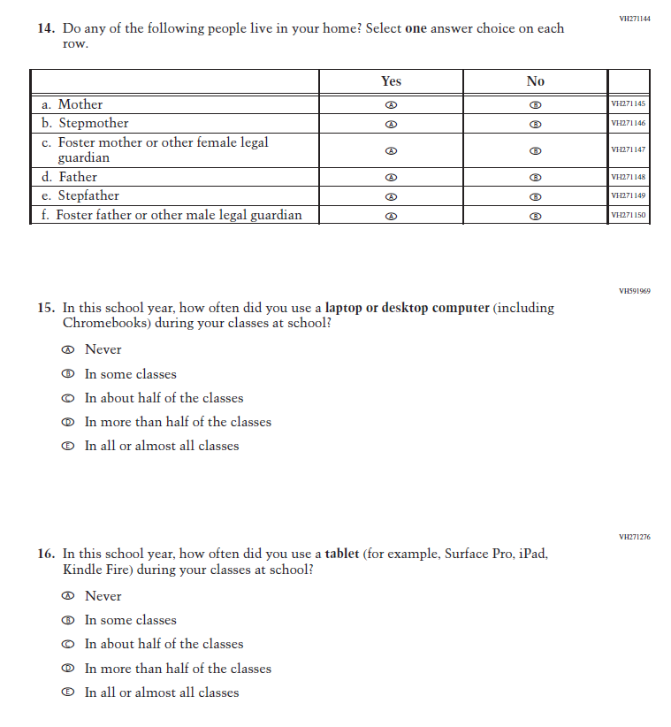
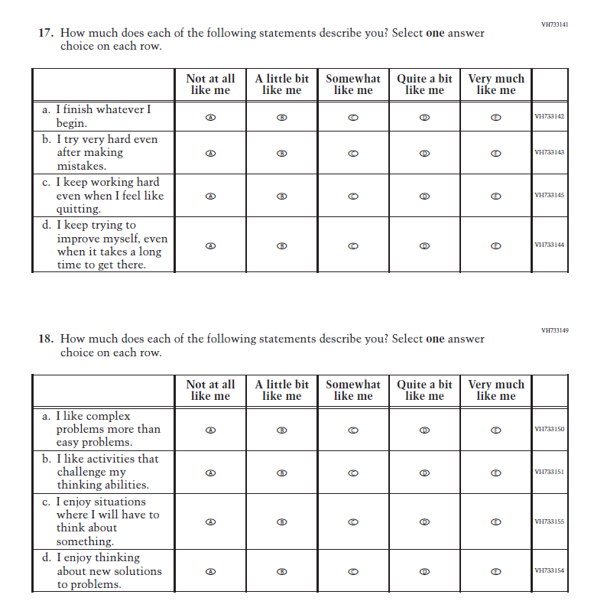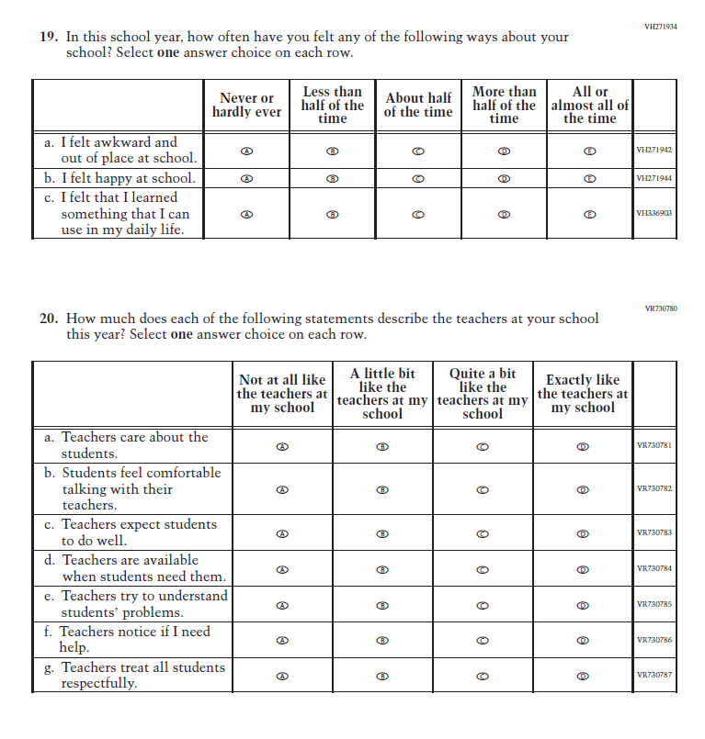
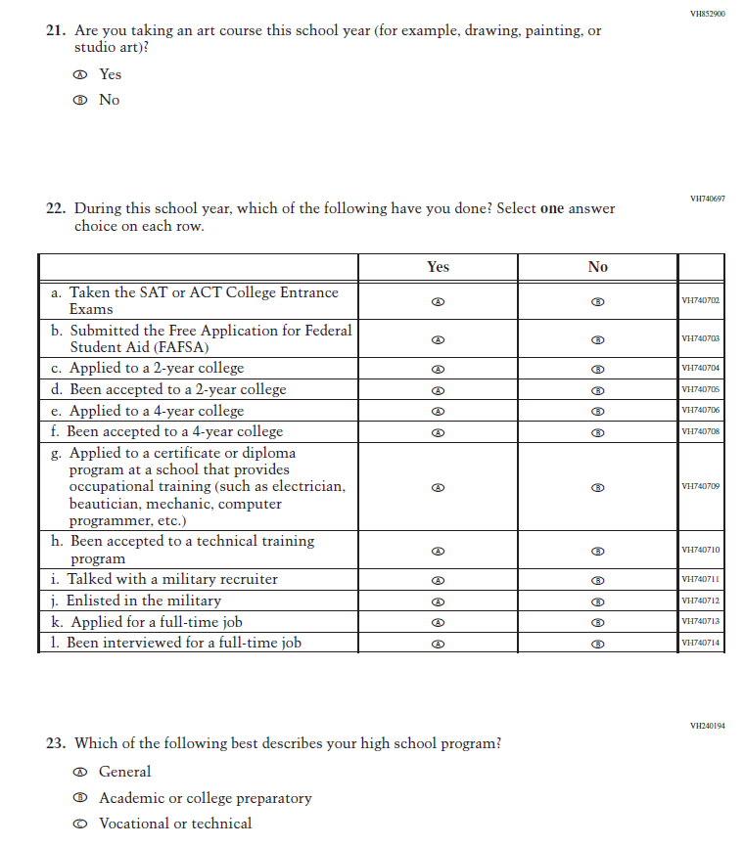
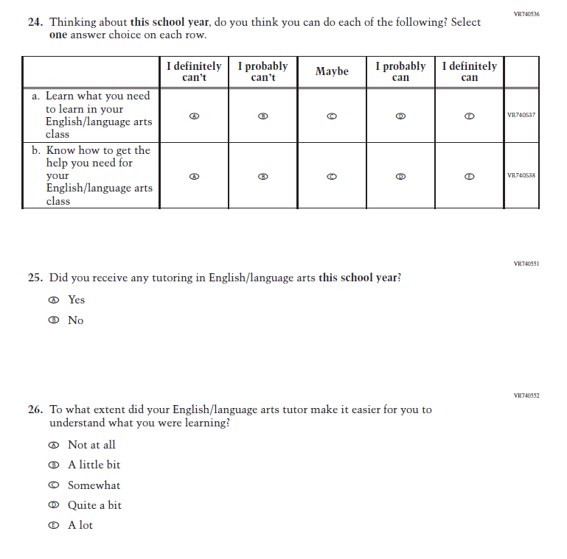
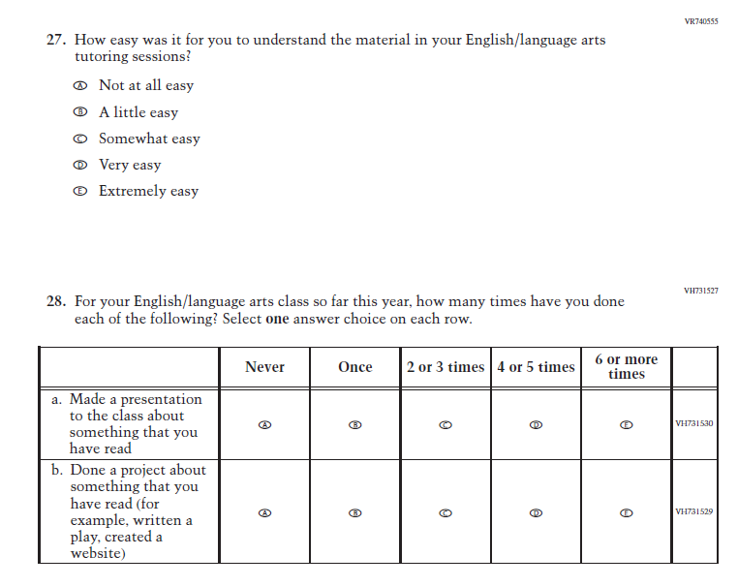

Appendix J1-13: Summary of Changes Operational Grade 4 (Mathematics)

2024 Operational Grade 4 Mathematics Student
Previous Item | 2024 Item | D/A/ R+ | Rationale
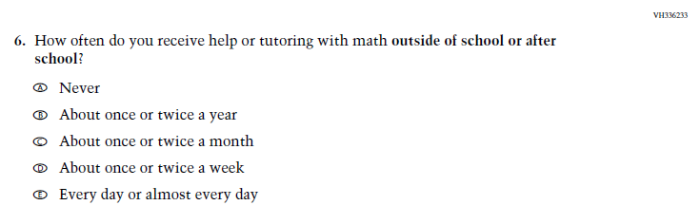  (2022 Grade 4) | N/A  Issue: Resources for Learning and Instruction | D | This Item was selected to be dropped to reduce burden due to the addition of the Learning Recovery Items.

Appendix J1-14: Operational Grade 4 (Mathematics)
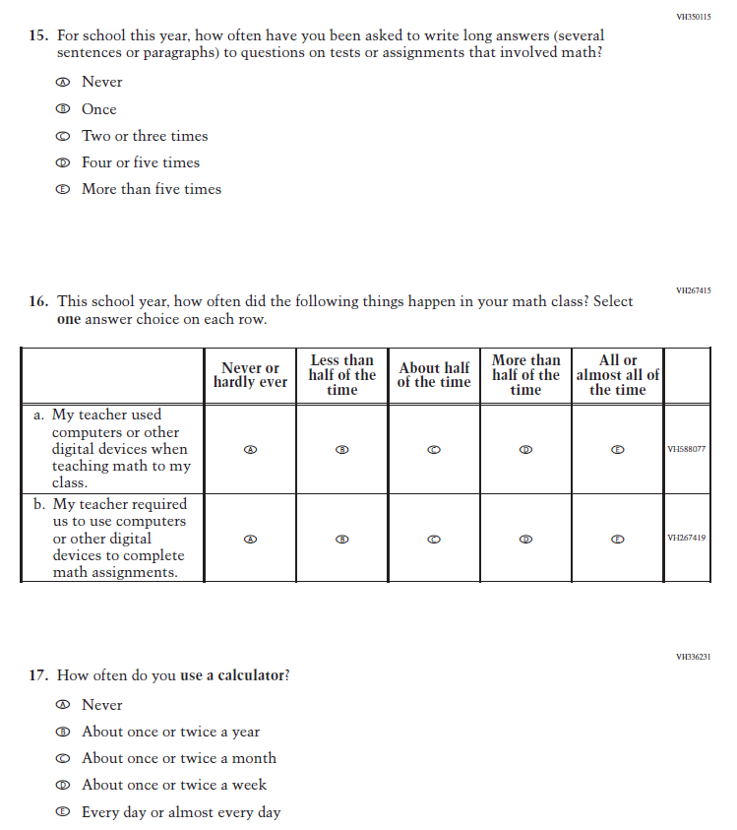
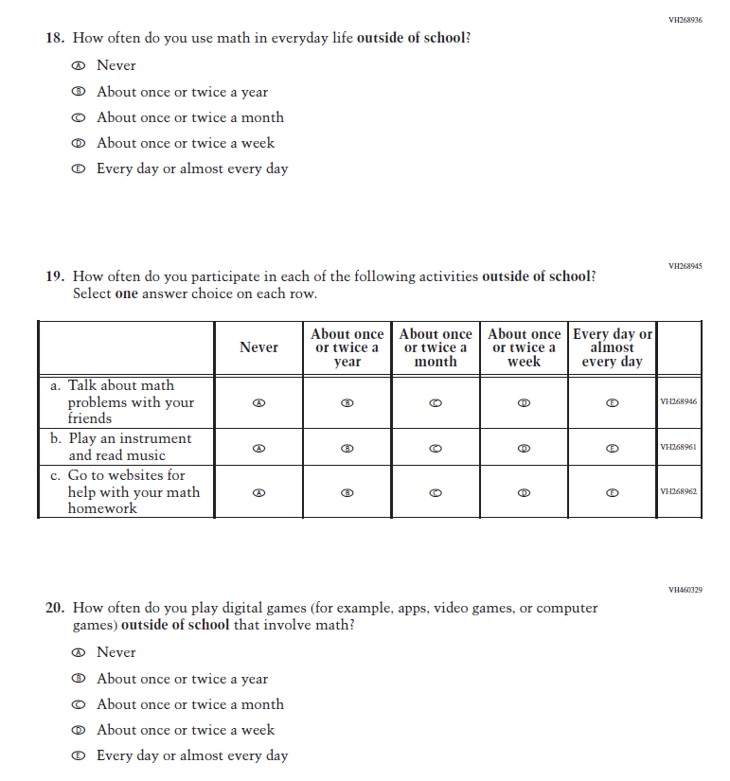
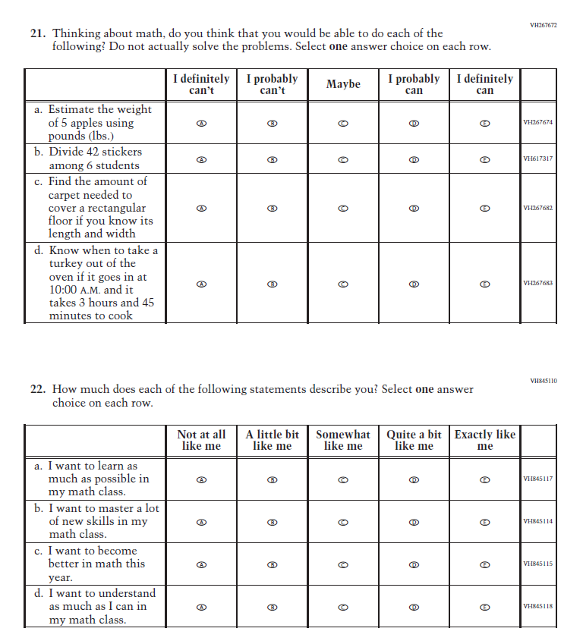
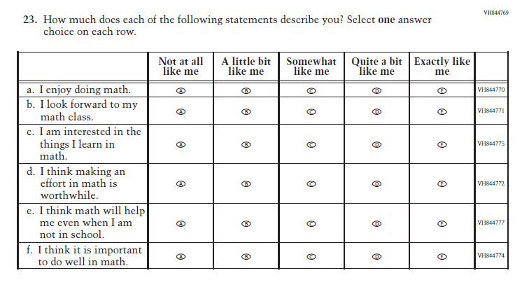

Appendix J1-15: Summary of Changes Operational Grade 8 (Mathematics)
2024 Operational Grade 8 Mathematics Student
Previous Item | 2024 Item | D/A/ R+ | Rationale
(2022 Grade 8) | N/A  Issue: Resources for Learning and Instruction | D | This Item was selected to be dropped to reduce burden due to the addition of the Learning Recovery Items.
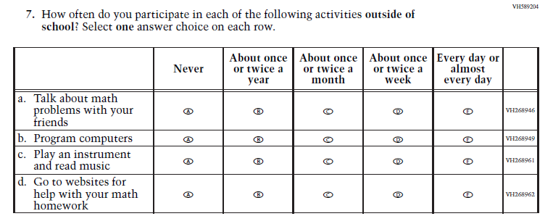  (2022 Grade 8) | 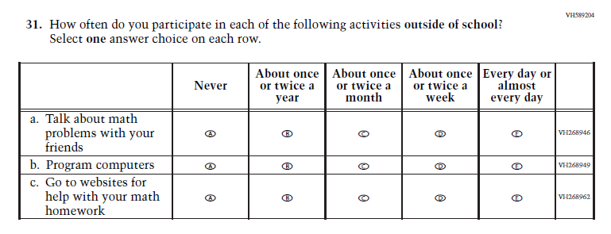  Issue: Resources for Learning and Instruction | R | This Item was selected to be revised to reduce burden due to the addition of the Learning Recovery Items.
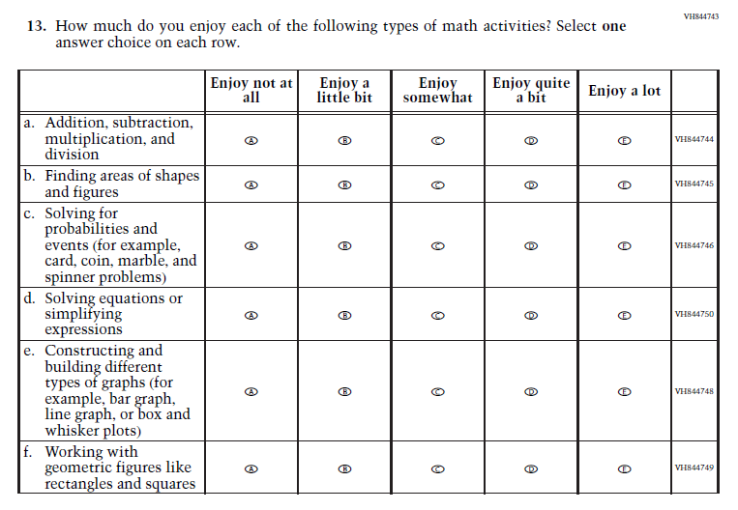  (2022 Grade 8) | N/A  Issue: Student Factors | D | This Item was selected to be dropped to reduce burden due to the addition of the Learning Recovery Items.

Appendix J1-16: Operational Grade 8 (Mathematics)

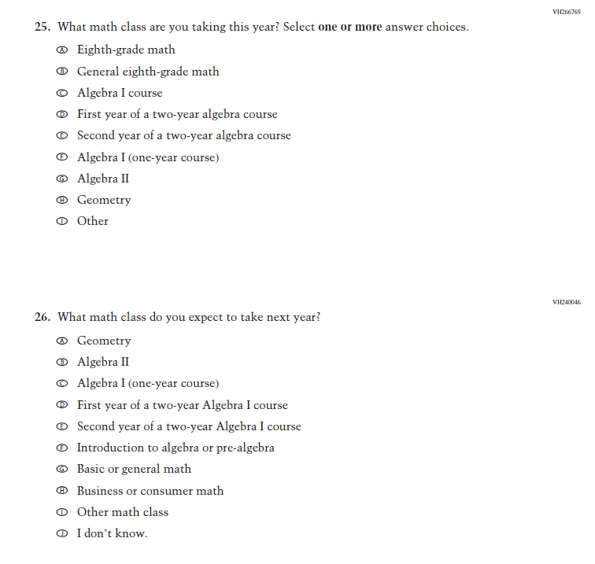
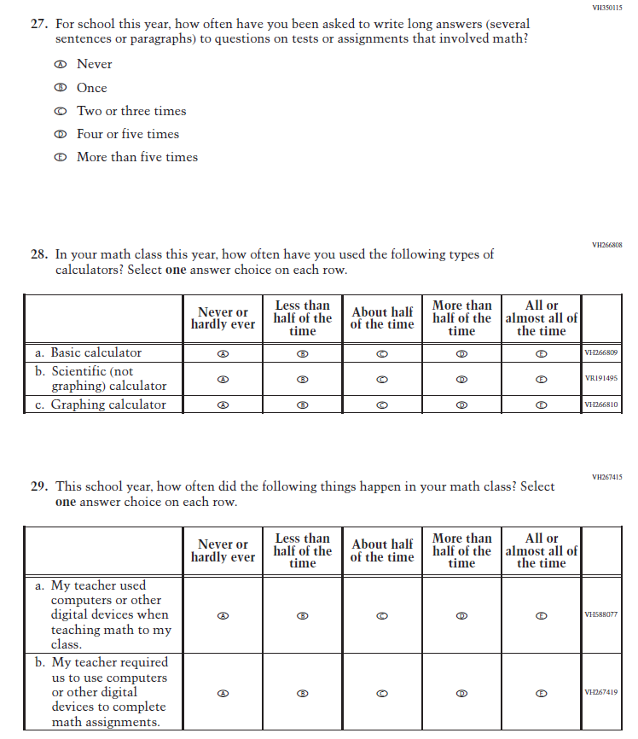
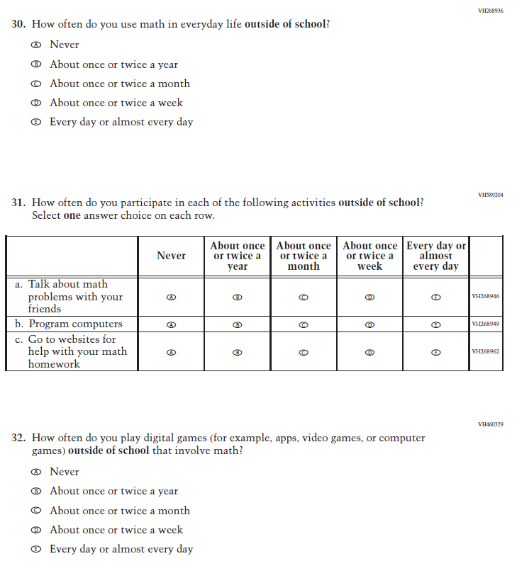
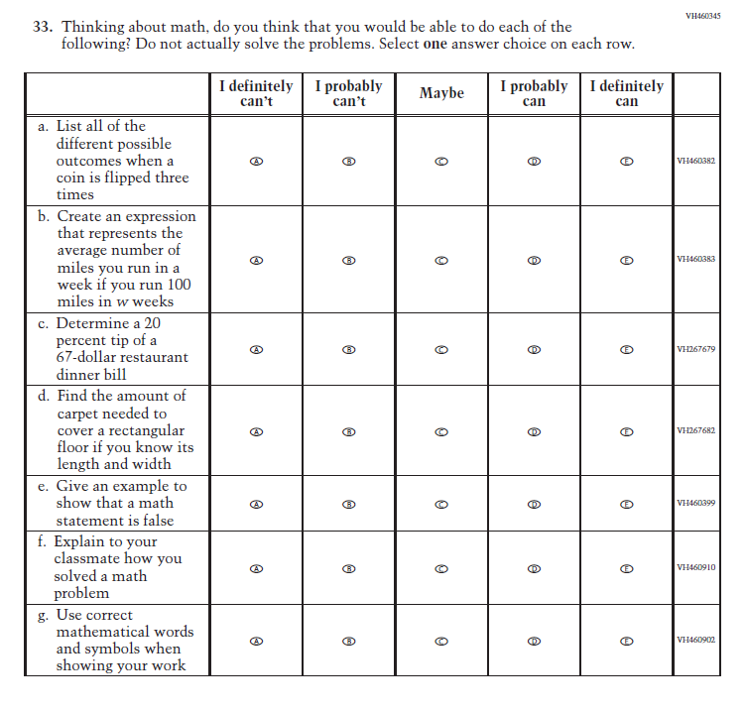
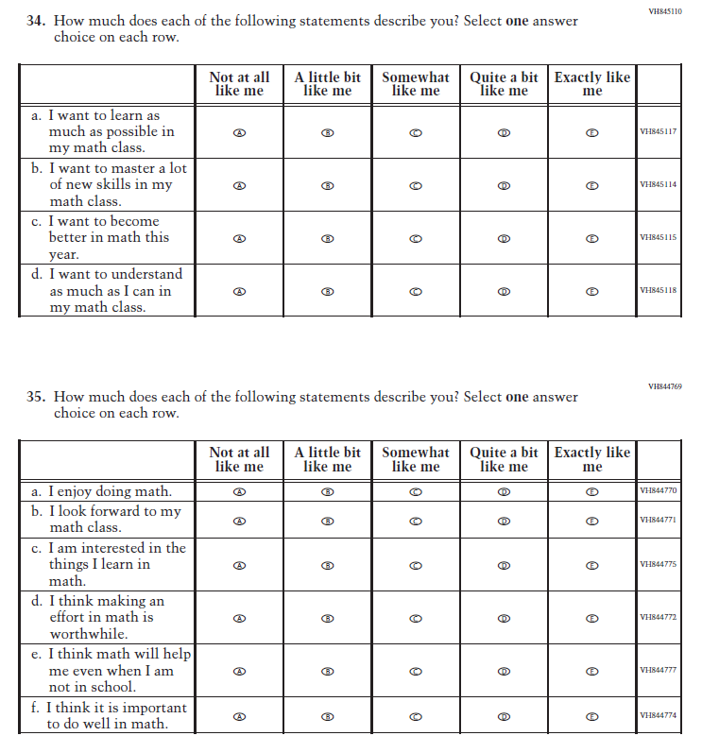

Appendix J1-17: Summary of Changes Operational Grade 12 (Mathematics)
2024 Operational Grade 12 Mathematics Student
Previous Item | 2024 Item | D/A/ R+ | Rationale
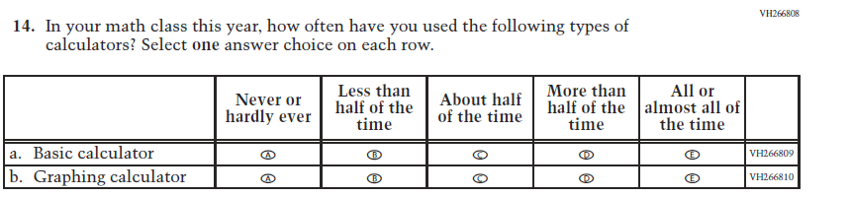  (2019 Grade 12) | 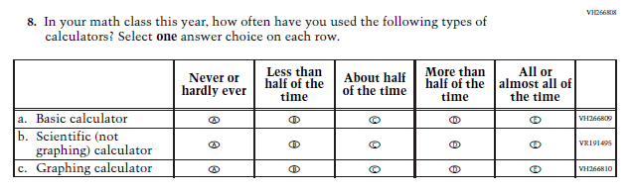  Issue: Resources for Learning and Instruction | R | SubItem “b.” added to match the Grade 8 Item that was administered in 2022.
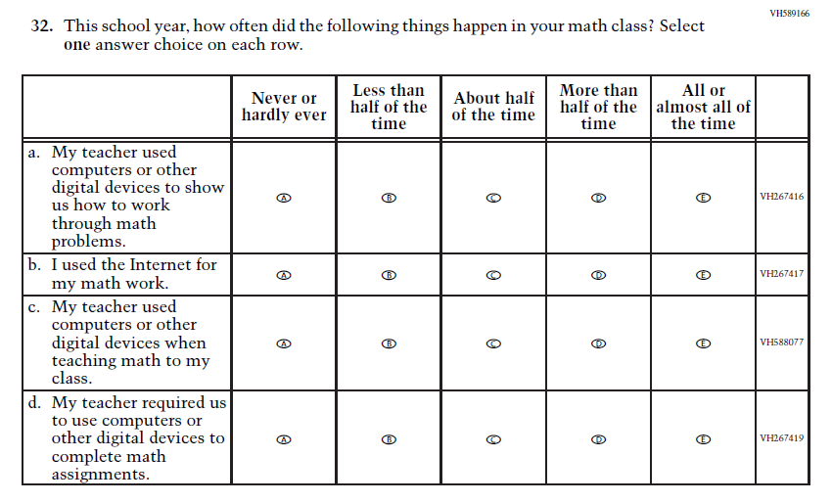  (2019 Grade 12) | N/A  Issue: Resources for Learning and Instruction | D | Due to the addition of the Learning Recovery Items, and to further reduce the expected response time at Grade 12, this Item was selected to be dropped.
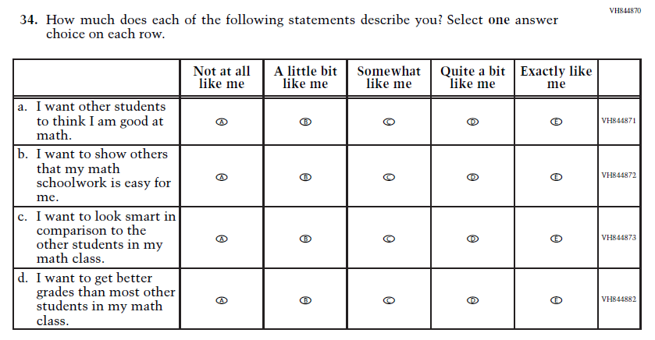  (2019 Grade 12) | N/A  Issue: Student Factors | D | Due to the addition of the Learning Recovery Items, and to further reduce the expected response time at Grade 12, this Item was selected to be dropped.
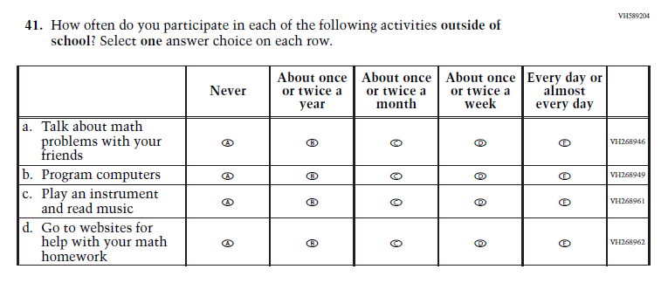  (2019 Grade 12) | 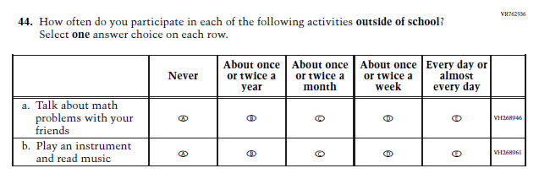  Issue: Resources for Learning and Instruction | R | Due to the addition of the Learning Recovery Items, and to further reduce the expected response time at Grade 12, this Item was revised.
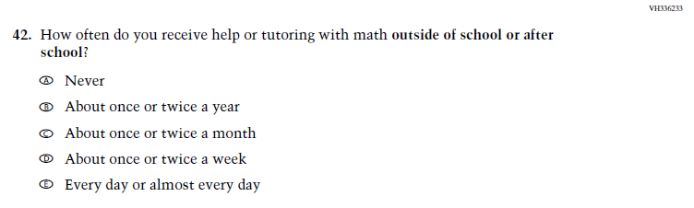  (2019 Grade 12) | N/A  Issue: Resources for Learning and Instruction | D | Due to the addition of the Learning Recovery Items, and to further reduce the expected response time at Grade 12, this Item was selected to be dropped.

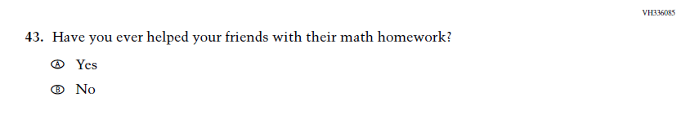  (2019 Grade 12) | N/A  Issue: Outside of School Learning | D | Due to the addition of the Learning Recovery Items, and to further reduce the expected response time at Grade 12, this Item was selected to be dropped.
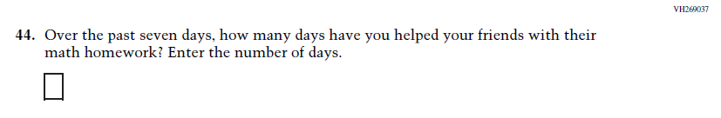  (2019 Grade 12) | N/A  Issue: Student Factors | D | Due to the addition of the Learning Recovery Items, and to further reduce the expected response time at Grade 12, this Item was selected to be dropped.

Appendix J1-18: Operational Grade 12 (Mathematics)
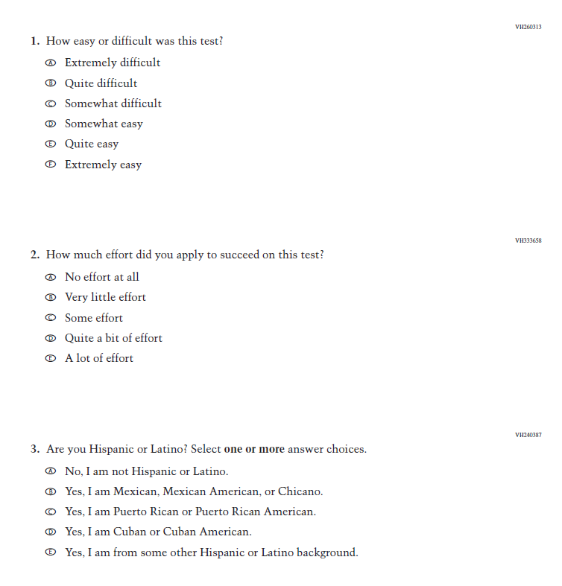
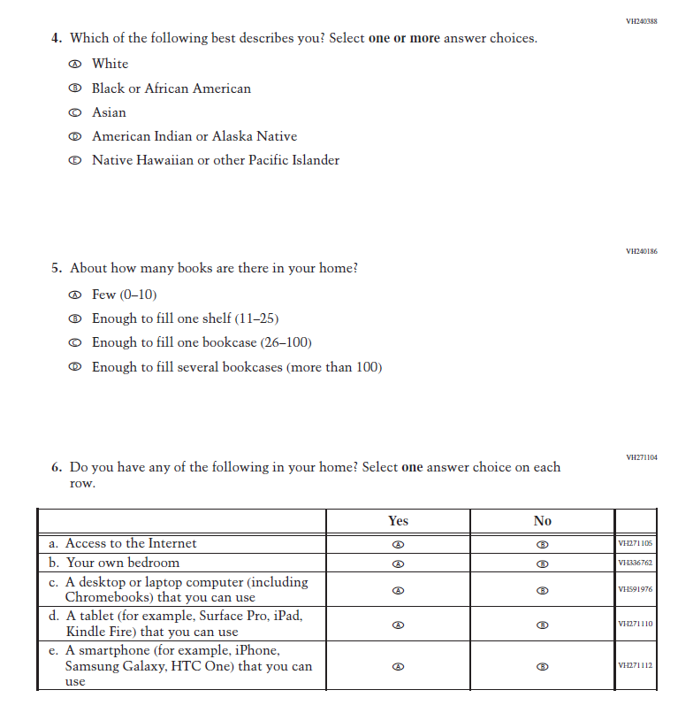
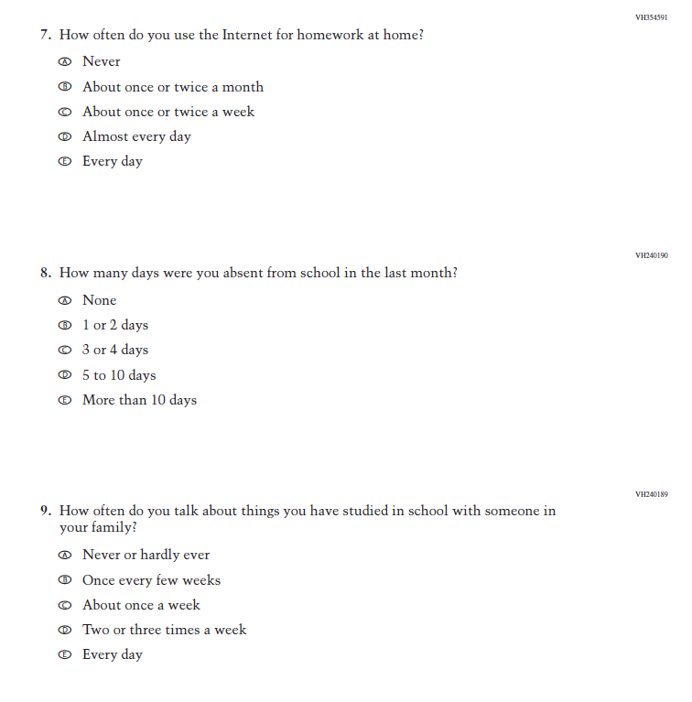
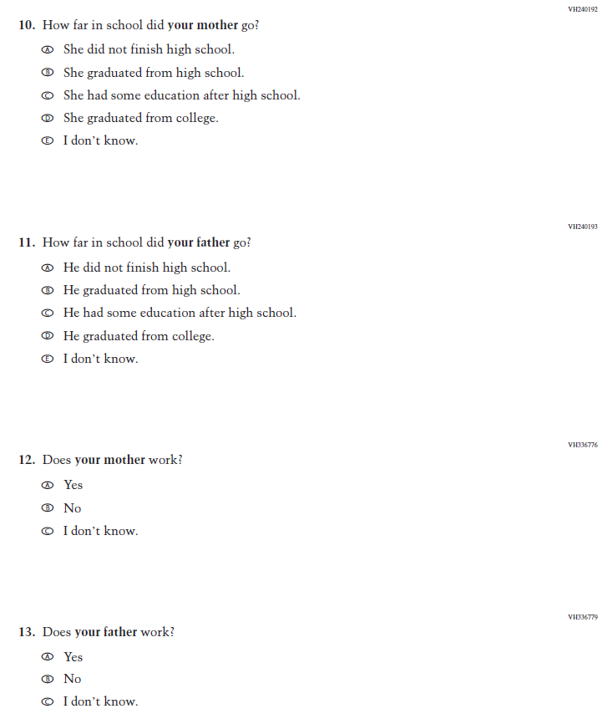
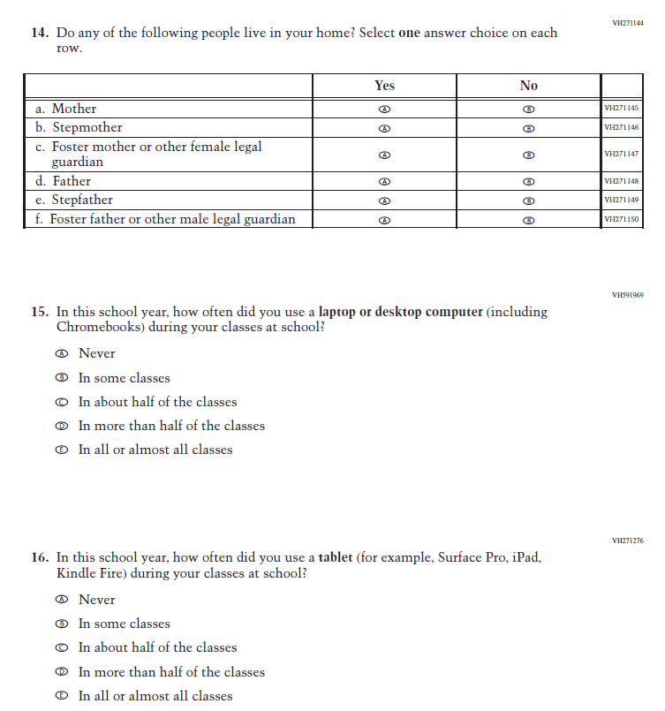
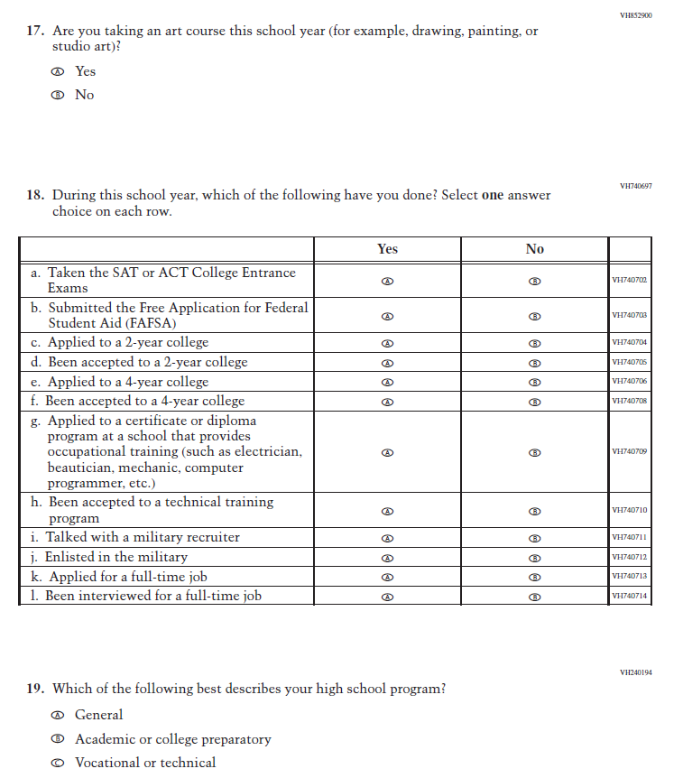
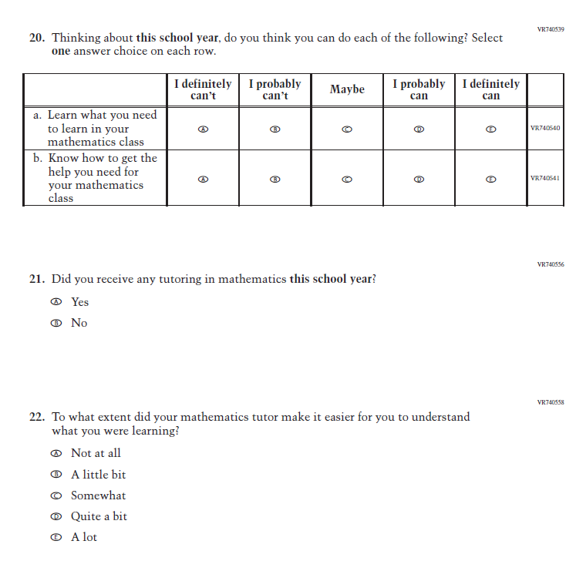
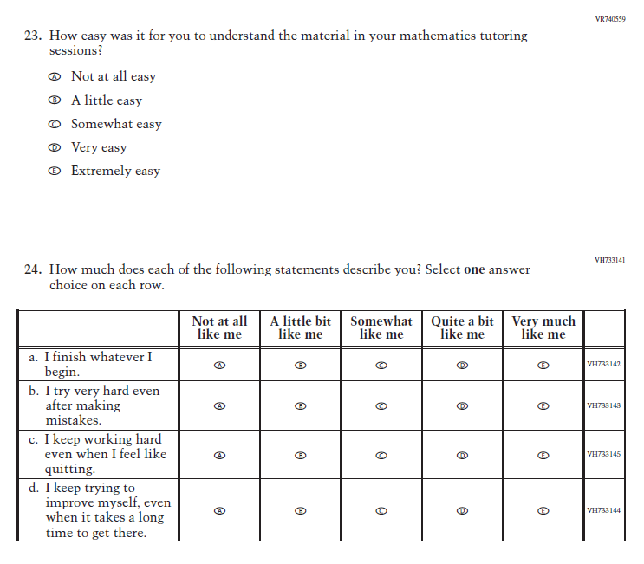
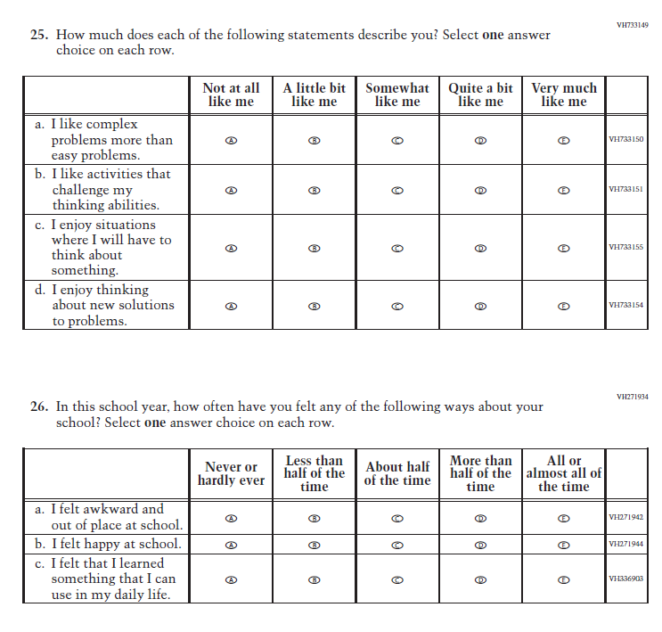
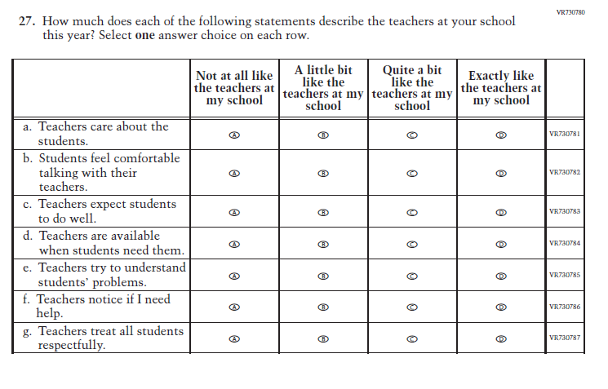
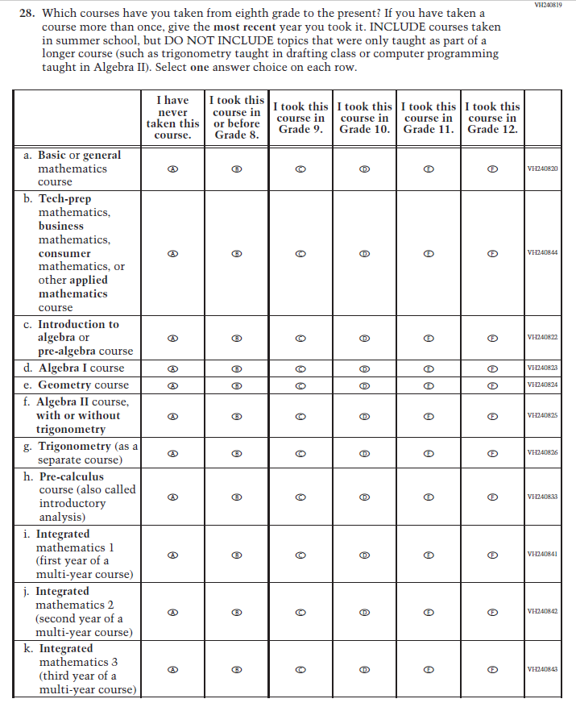
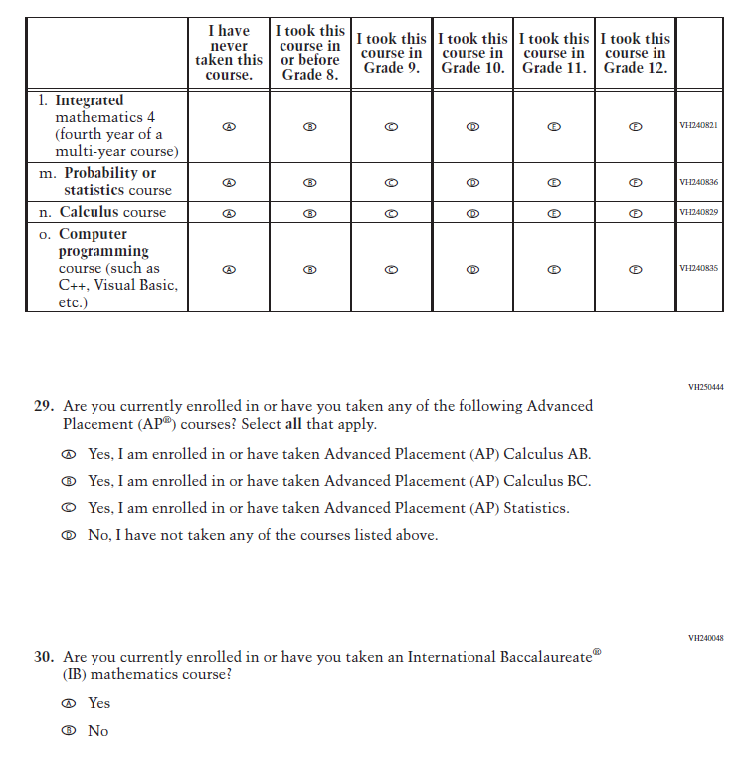
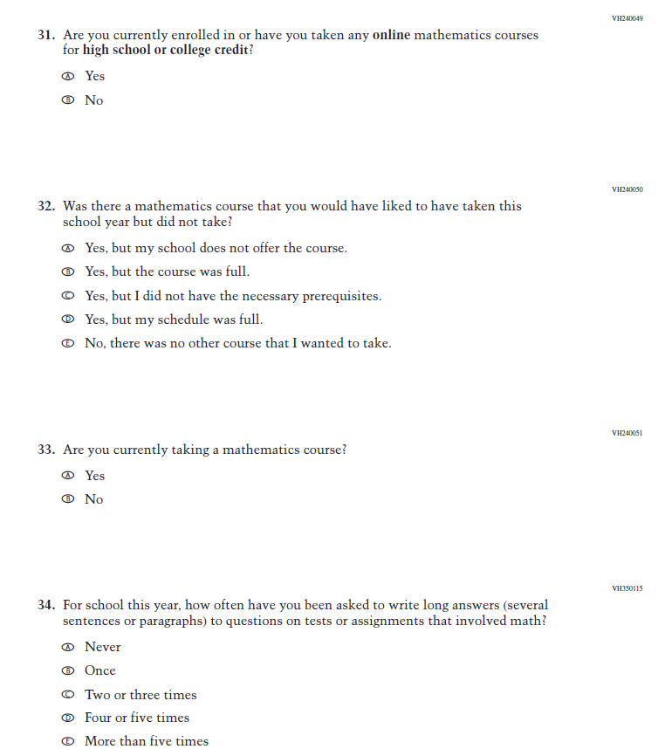
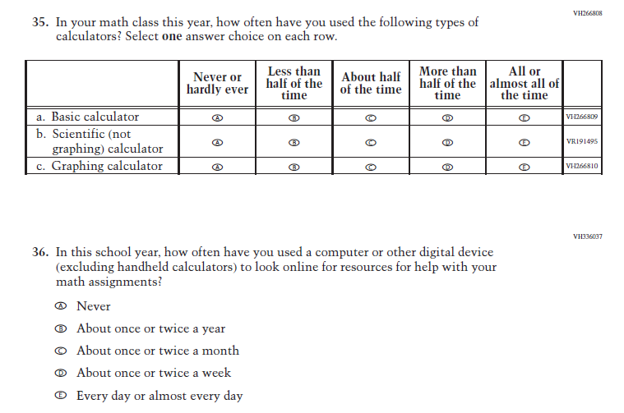
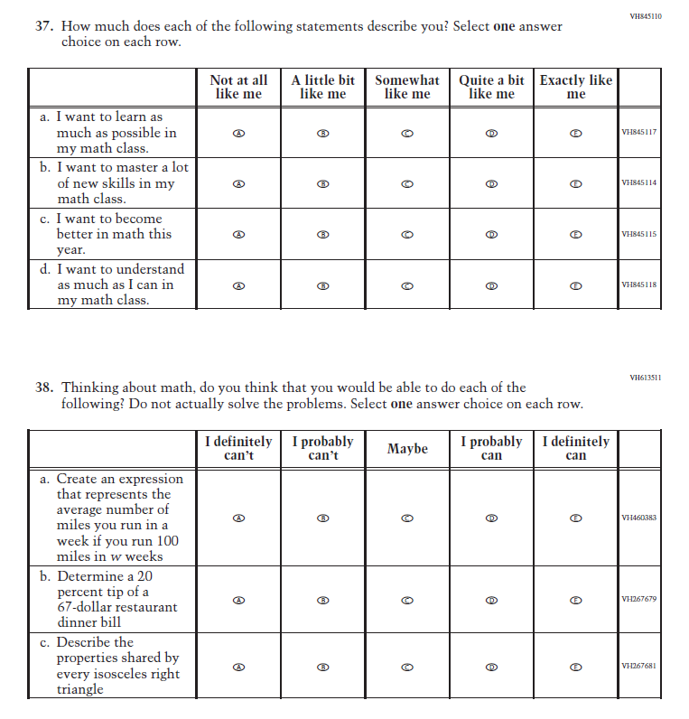
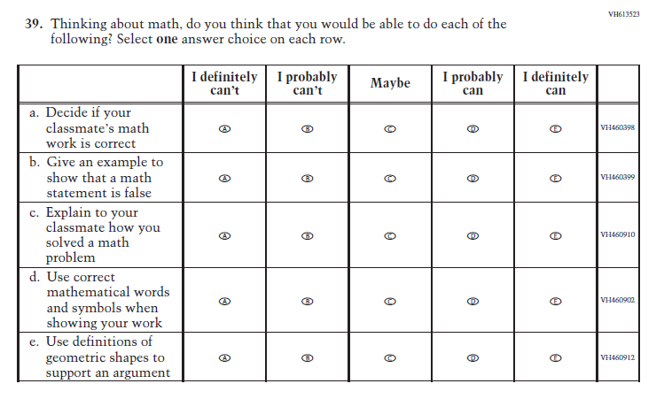
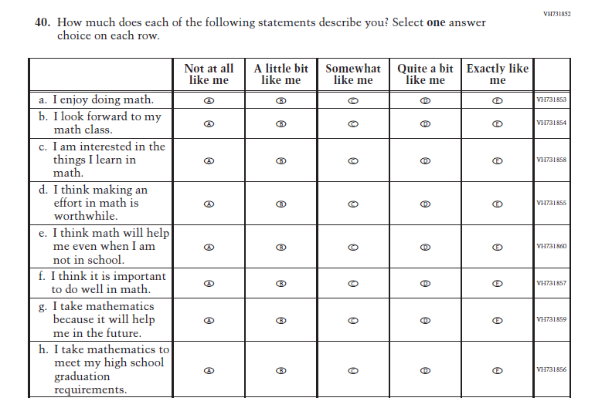
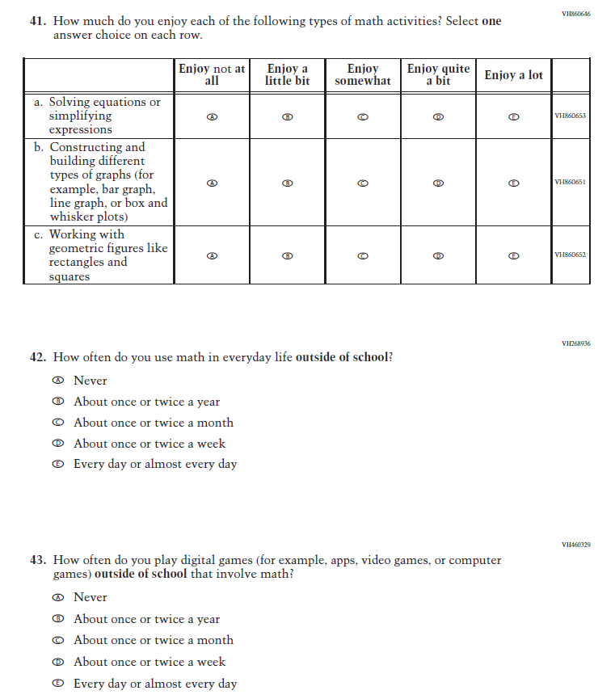
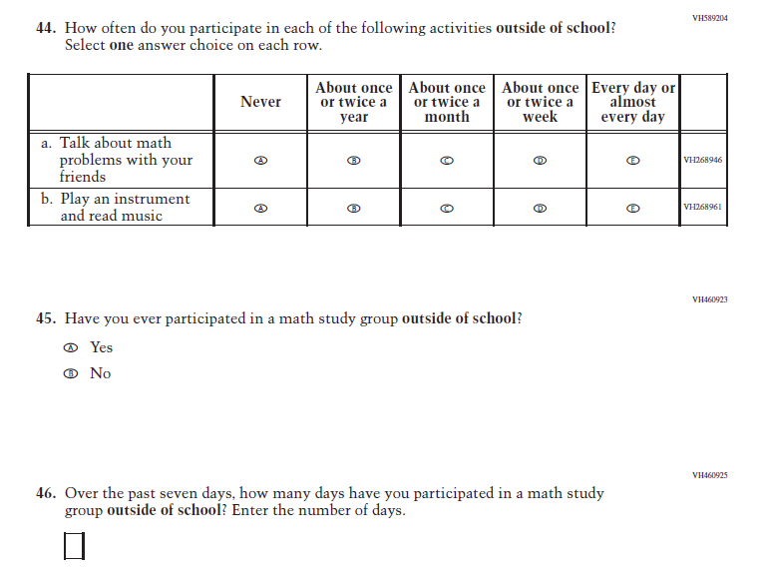

Appendix J1-19: Summary of Changes Operational Grade 4 (Reading)
2024 Operational Grade 4 Reading Student
Previous Item | 2024 Item | D/A/ R+ | Rationale
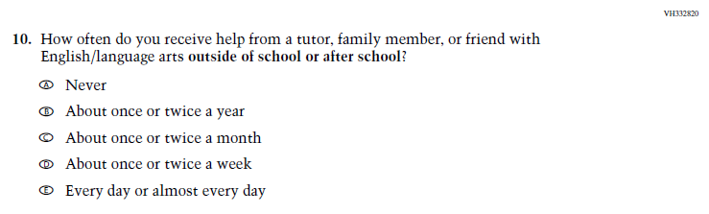  (2022 Grade 4) | N/A  Issue: Resources for Learning and Instruction | D | This Item was selected to be dropped to reduce burden due to the addition of the Learning Recovery Items.

Appendix J1-20: Operational Grade 4 (Reading)
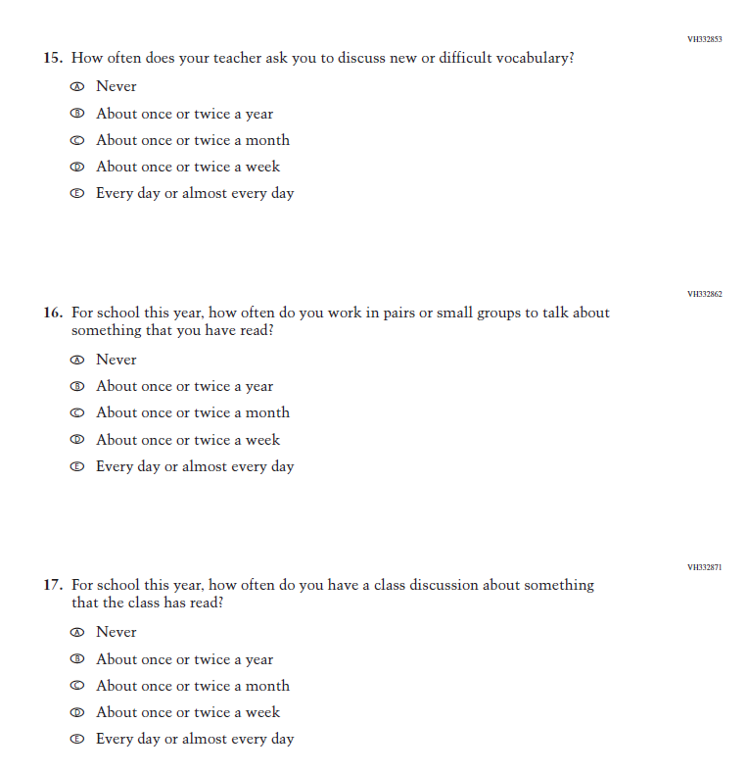
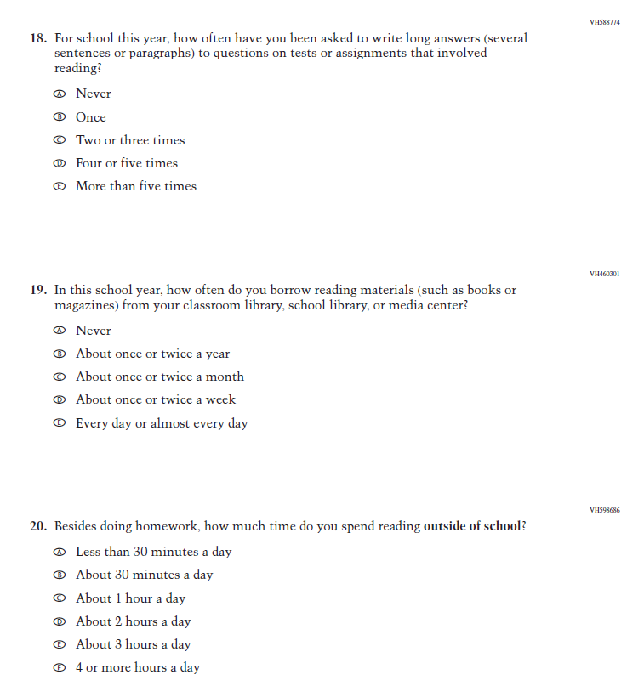
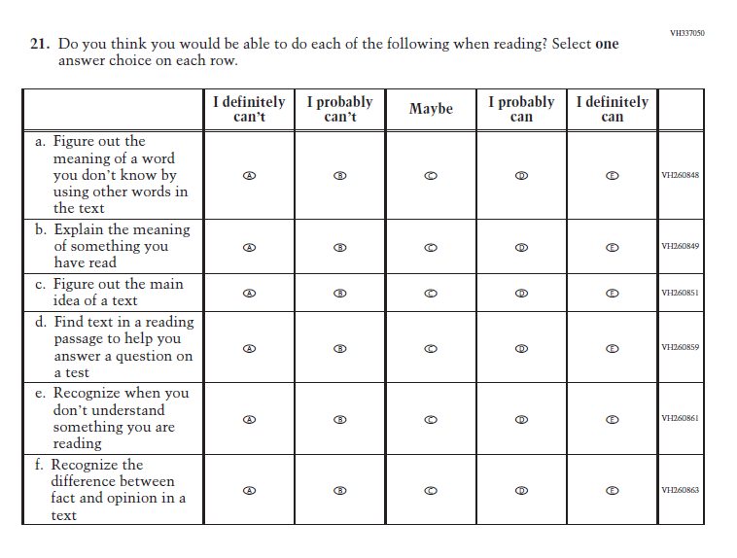
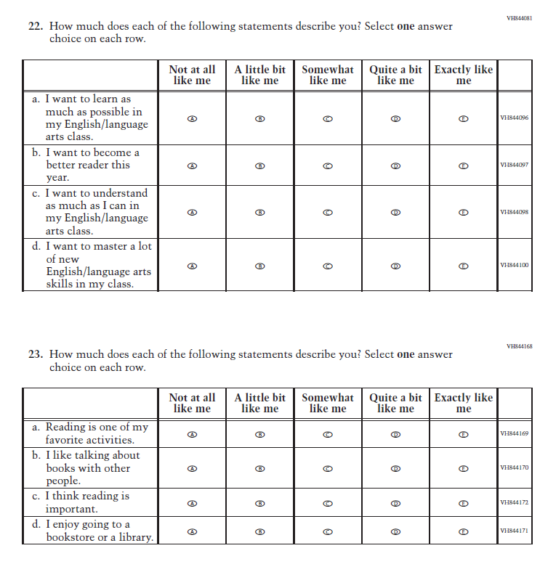
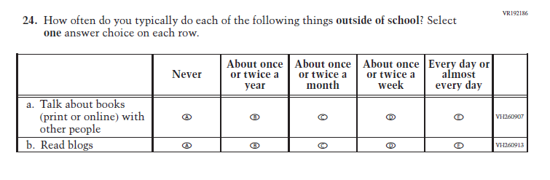

Appendix J1-21: Summary of Changes Operational Grade 8 (Reading)
2024 Operational Grade 8 Reading Student
Previous Item | 2024 Item | D/A/ R+ | Rationale
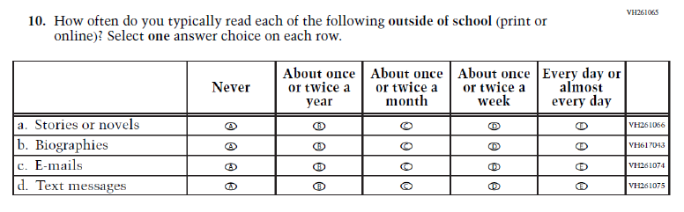  (2022 Grade 8) | N/A  Issue: Student Factors | D | This Item was selected to be dropped to reduce burden due to the addition of the Learning Recovery Items.
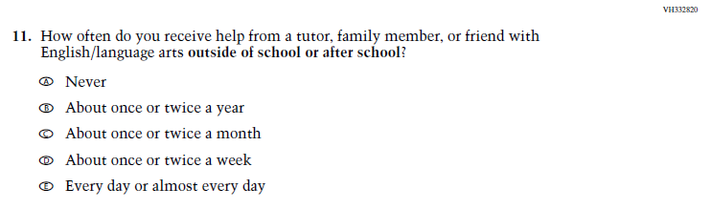  (2022 Grade 8) | N/A  Issue: Resources for Learning and Instruction | D | This Item was selected to be dropped to reduce burden due to the addition of the Learning Recovery Items.
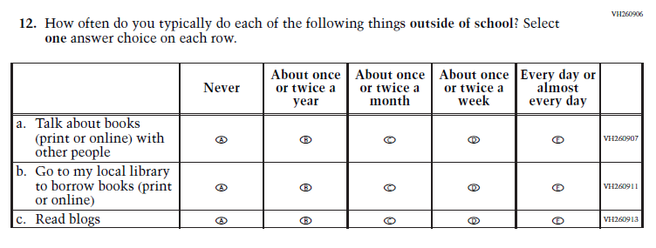  (2022 Grade 8) | N/A  Issue: Student Factors | D | This Item was selected to be dropped to reduce burden due to the addition of the Learning Recovery Items.

Appendix J1-22: Operational Grade 8 (Reading)
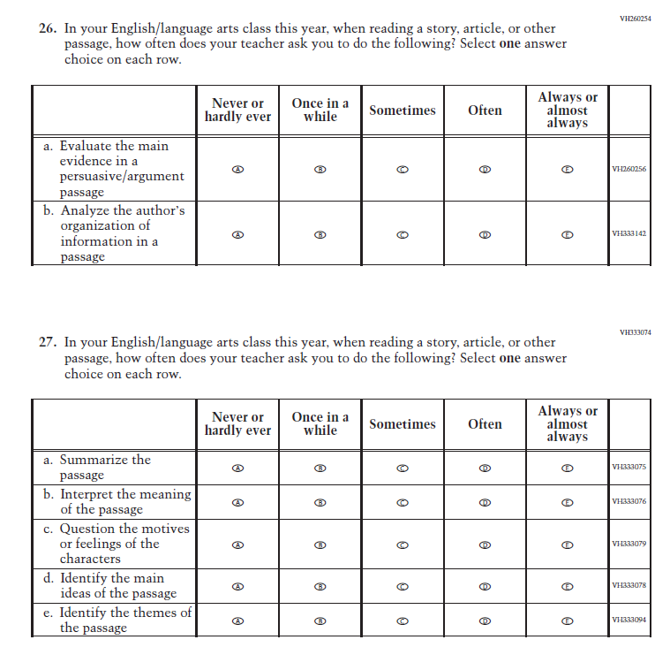
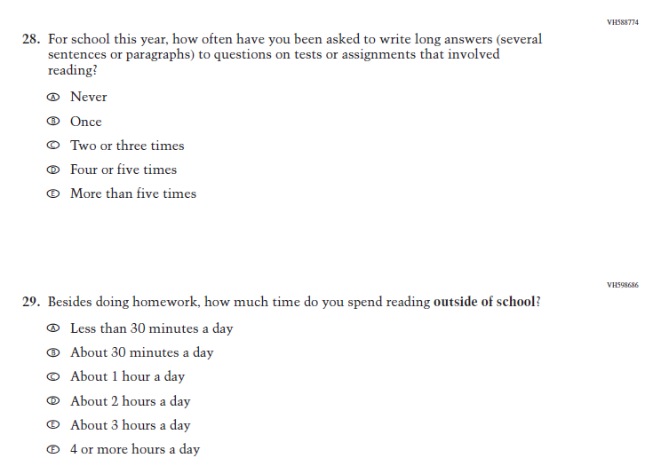
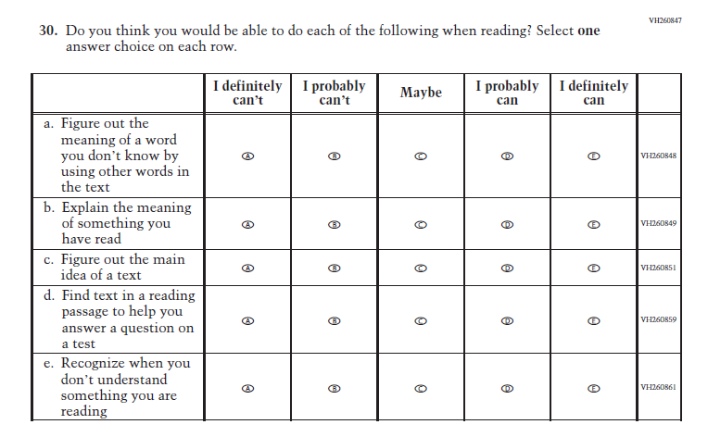
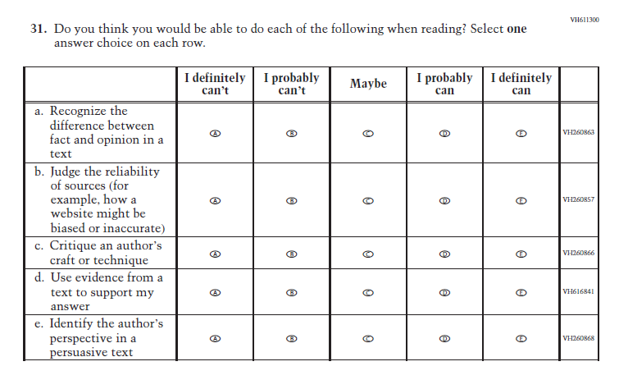
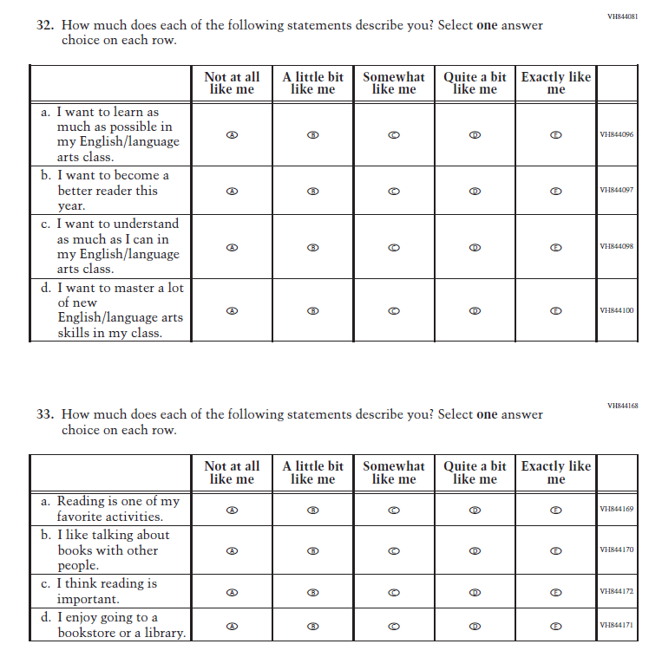

Appendix J1-23: Summary of Changes Operational Grade 12 (Reading)

2024 Operational Grade 12 Reading Student
Previous Item | 2024 Item | D/A/ R+ | Rationale
(2022 Grade 12) | N/A  Issue: Resources for Learning and Instruction | D | This Item was selected to be dropped to reduce burden due to the addition of the Learning Recovery Items.

Appendix J1-24: Operational Grade 12 (Reading)

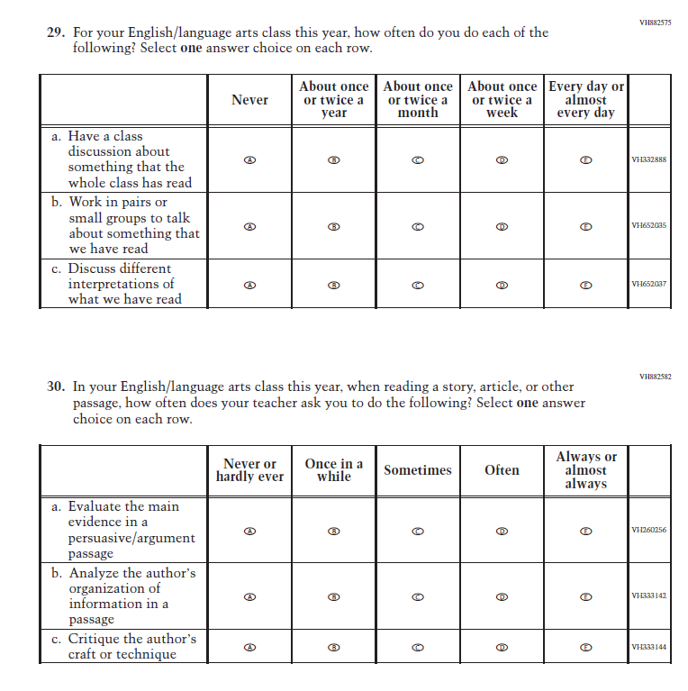
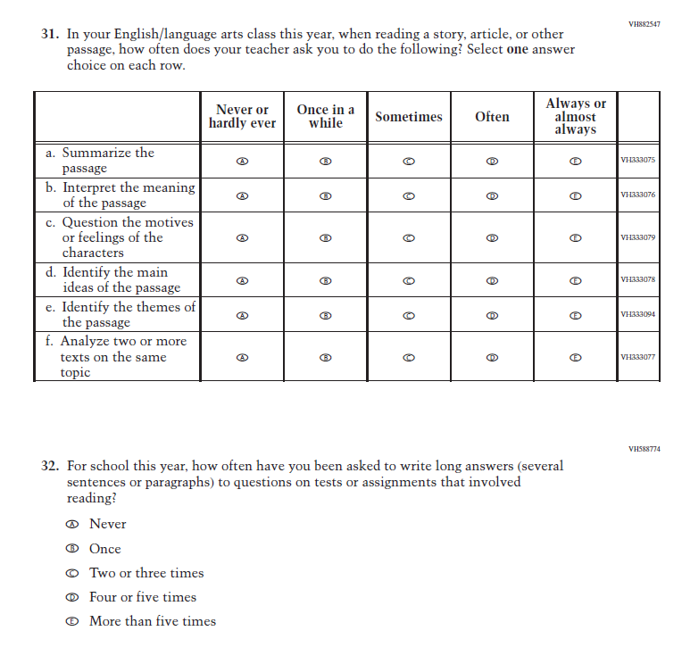
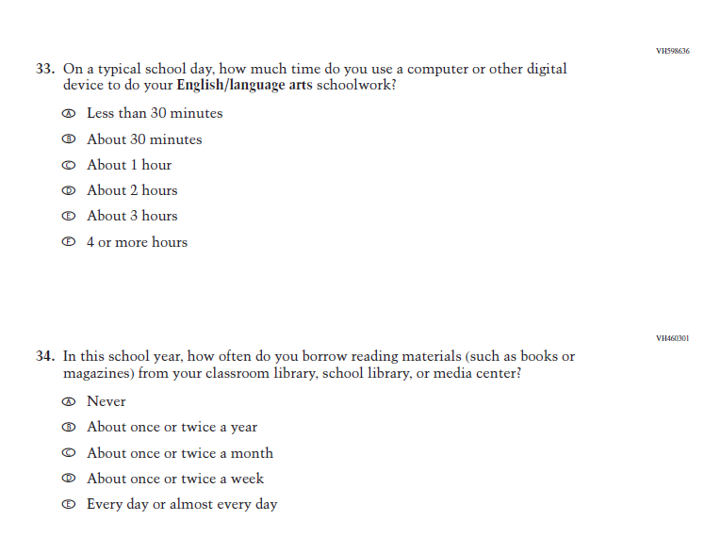
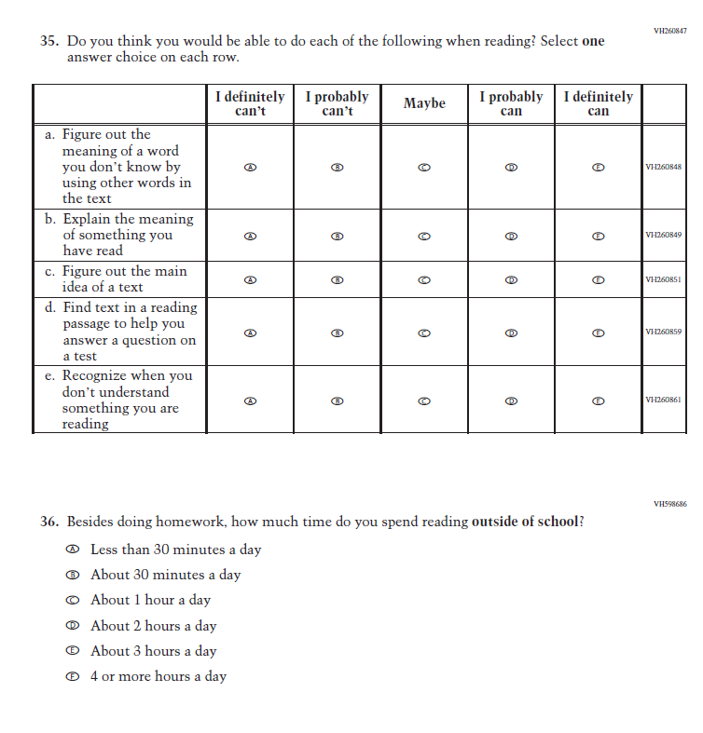
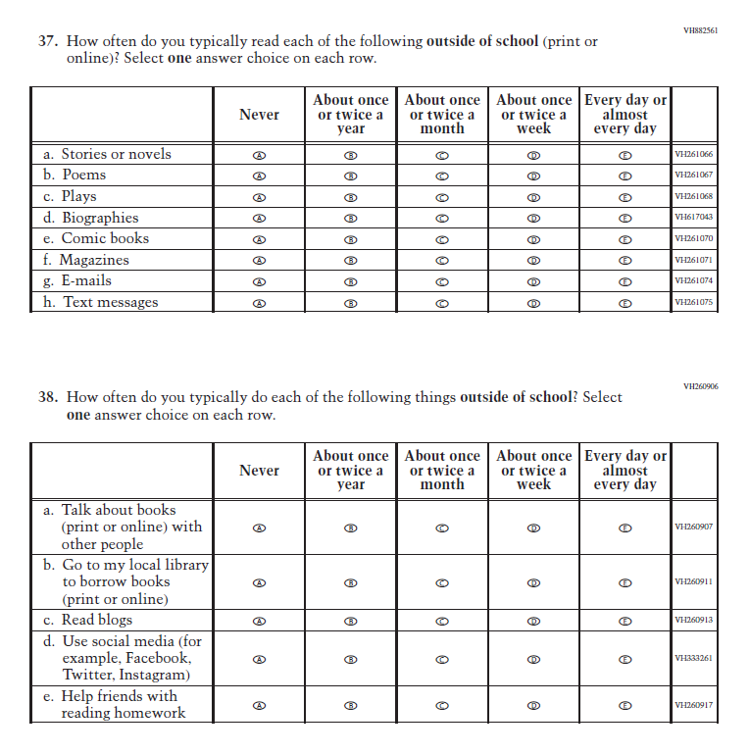
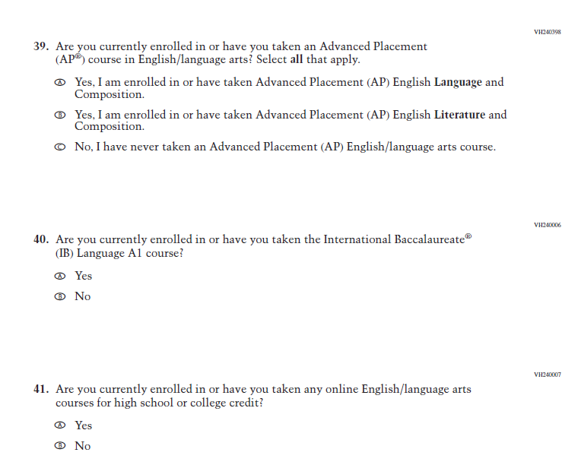
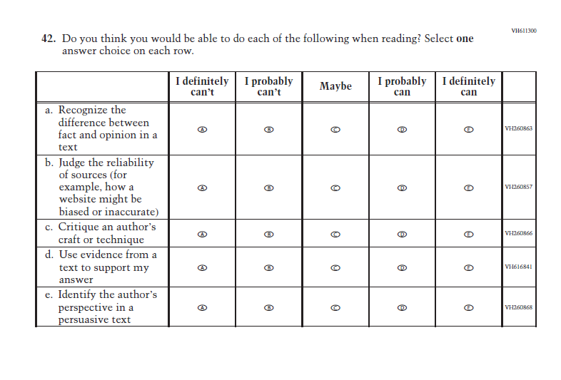
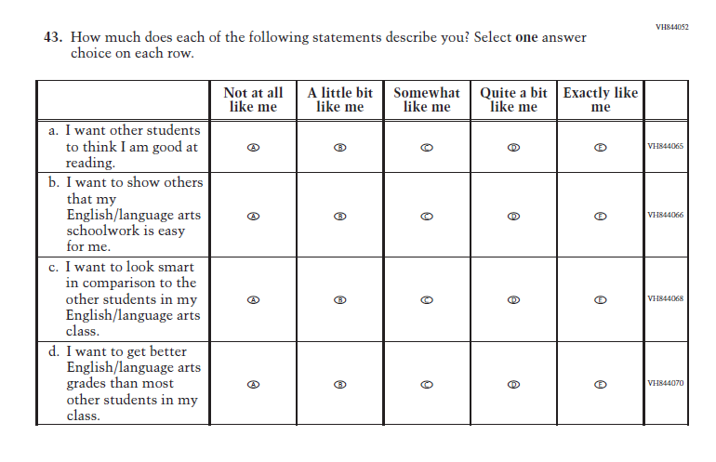
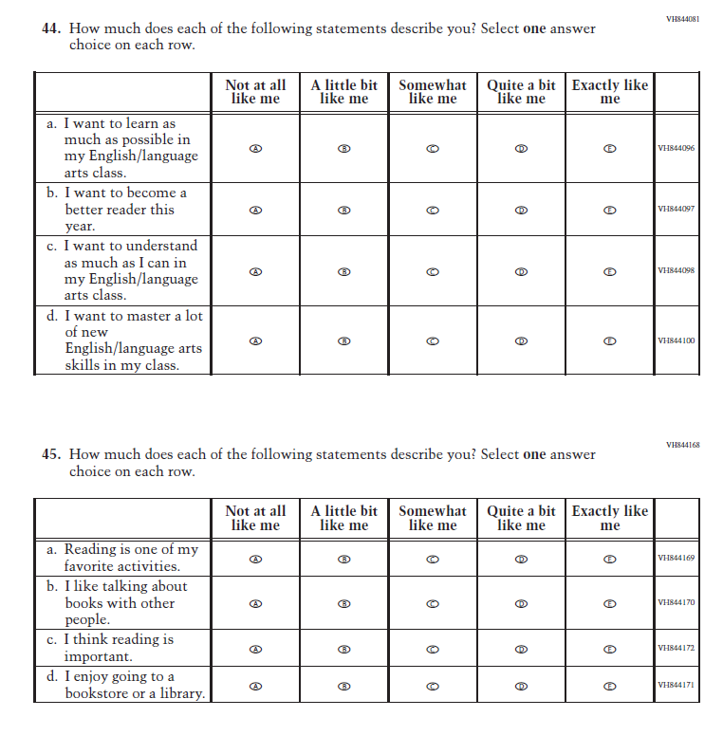

Appendix J1-25: Operational Grade 8 (Science)
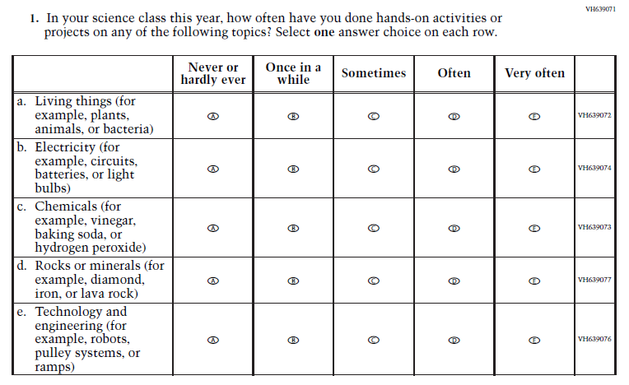
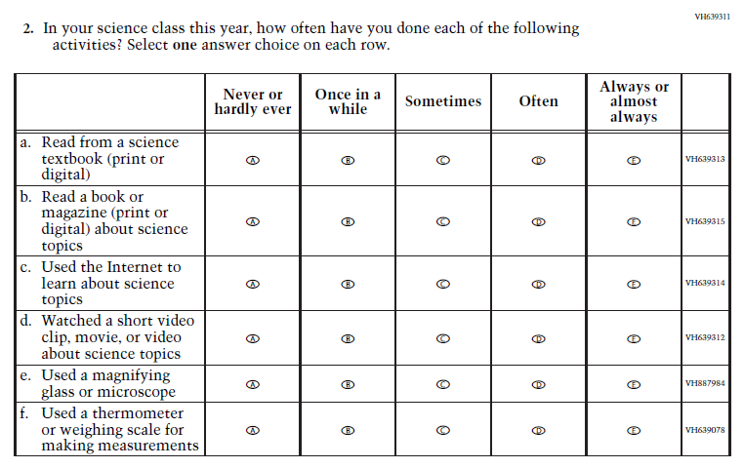

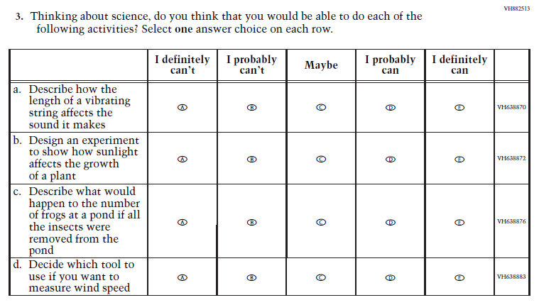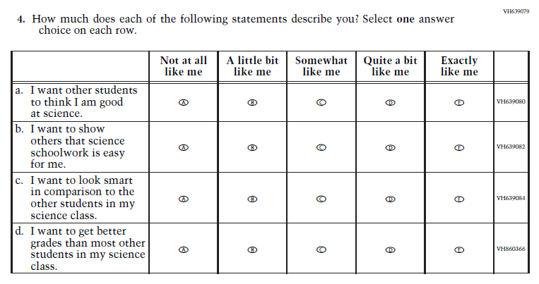

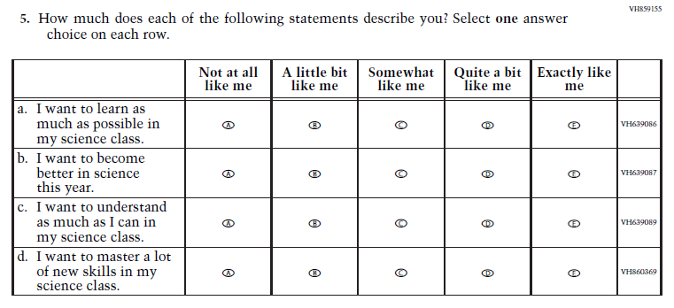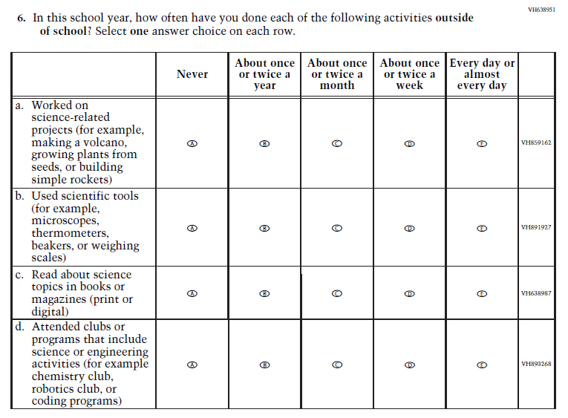

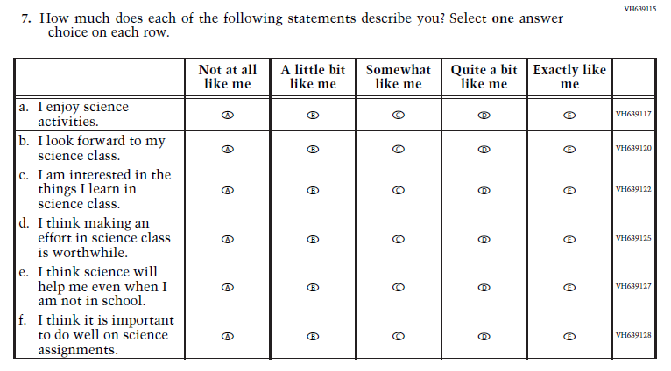
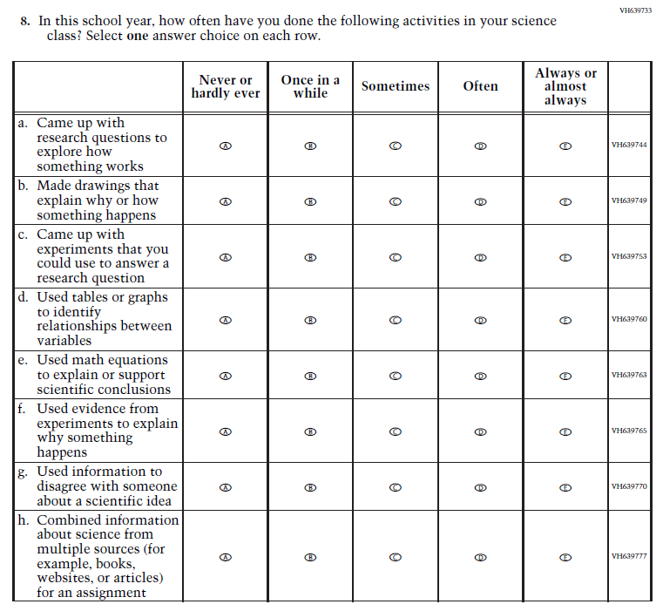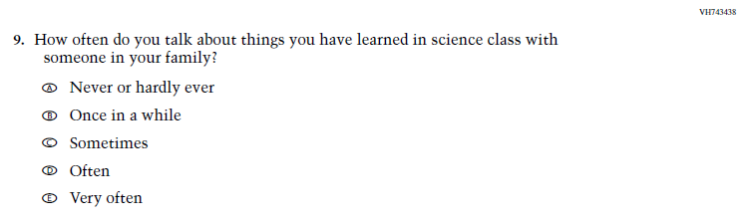

Appendix J1-26: Operational Grade 4 (Debrief)

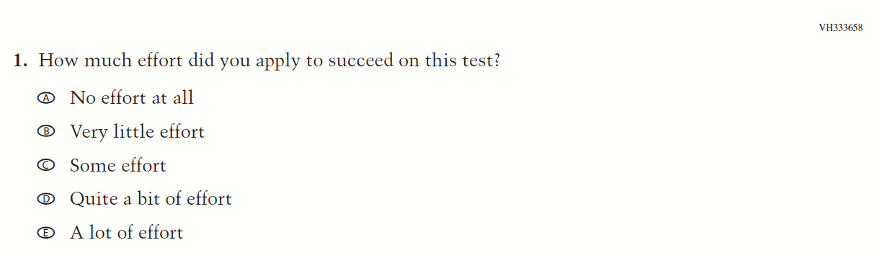

Appendix J1-27: Operational Grade 8 and 12 (Debrief)
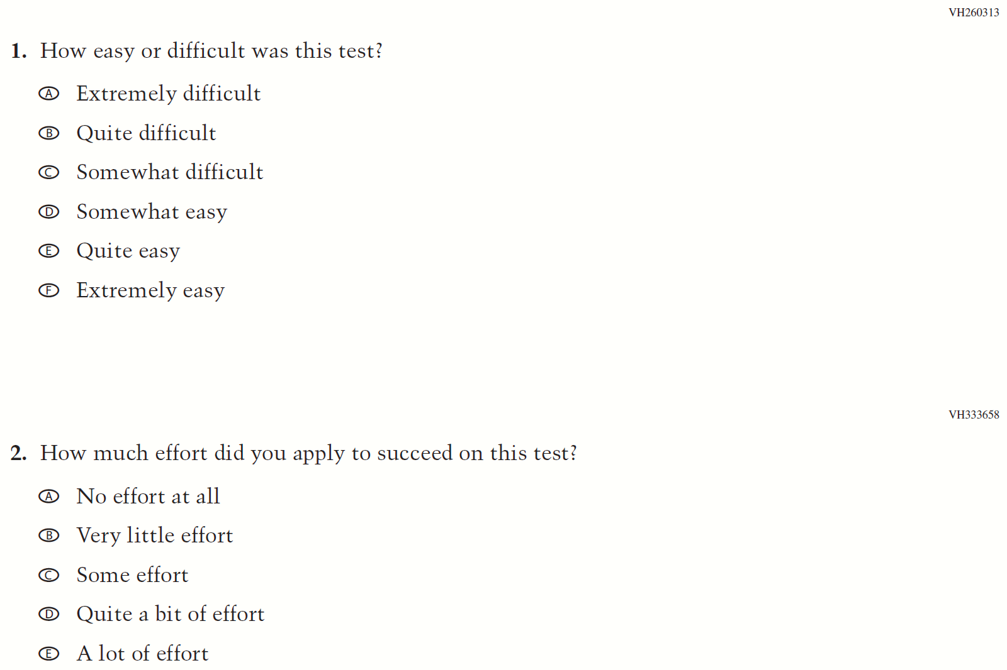

Appendix J1-28: Summary of Changes Operational Grade 4 (NIES)
2024 Operational Grade 4 NIES Student
Previous Item | 2024 Item | D/A/ R+ | Rationale
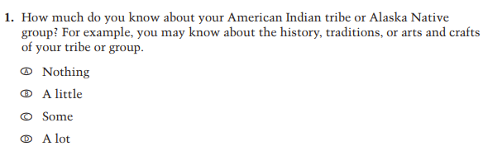 | 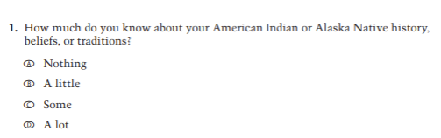 | R | Revised based on expert group feedback.
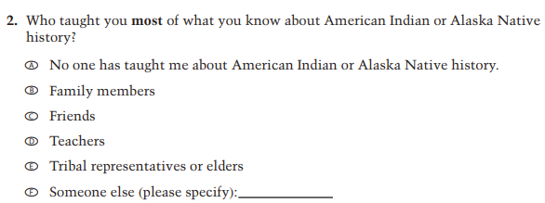 |  | R | Revised based on expert group feedback.
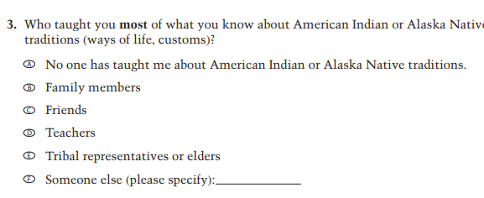 |  | R | Revised based on expert group feedback.
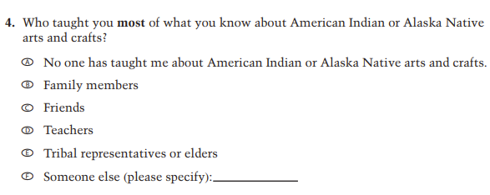 | N/A | D | Dropped due to expert group feedback.
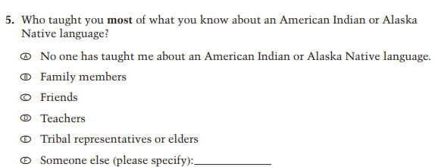 | 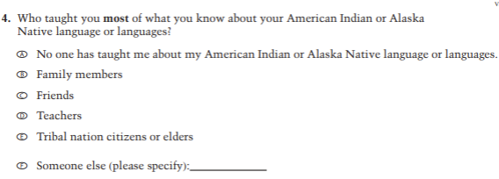 | R | Revised based on expert group feedback.
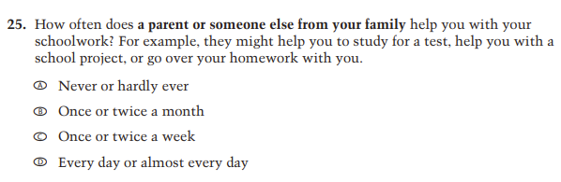 | N/A | D | Dropped due to content redundancy.
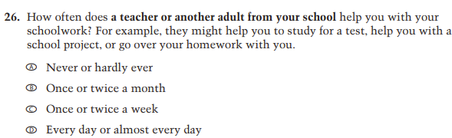 | N/A | D | Dropped due to content redundancy.
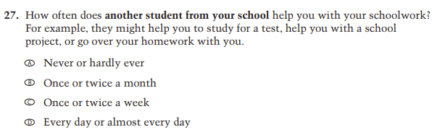 | N/A | D | Dropped due to content redundancy.
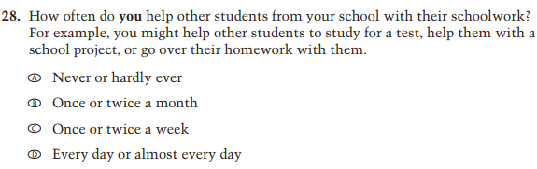 | N/A | D | Dropped due to content redundancy.
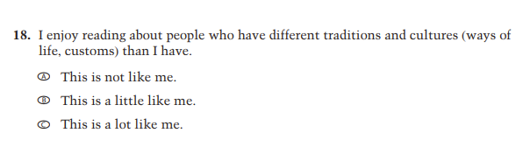 | N/A | D | Dropped due to expert group feedback.
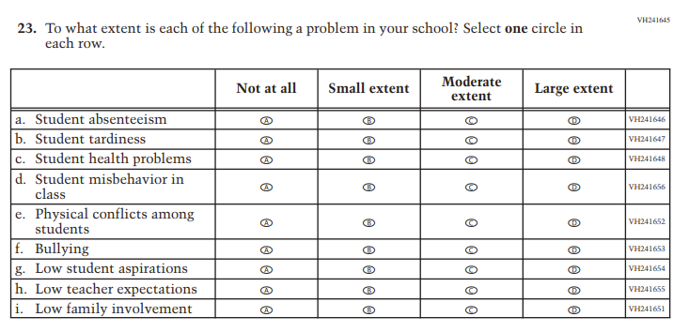 | N/A | D | Dropped due to expert group feedback.
N/A | 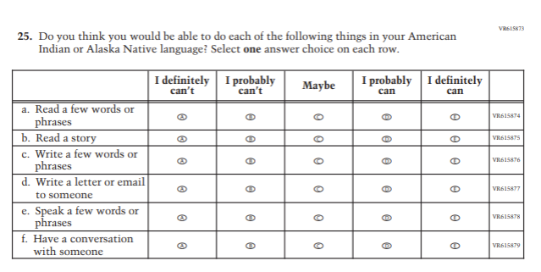 | A | Added to extend coverage of language use.
N/A | 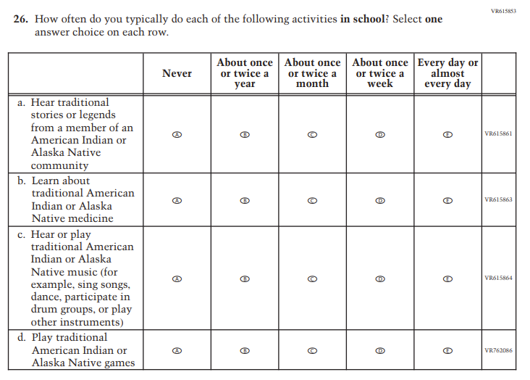 | A | Added to extend coverage of cultural activities.
N/A | 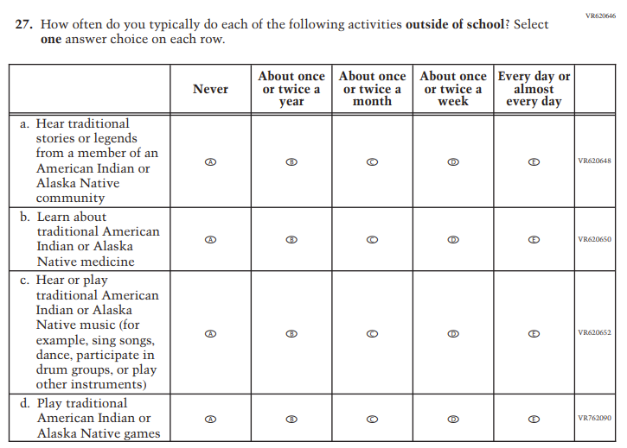 | A | Added to extend coverage of cultural activities.
N/A | 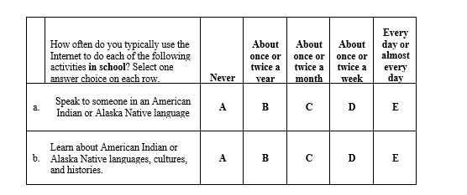 | A | Added to extend coverage of language use.
N/A | 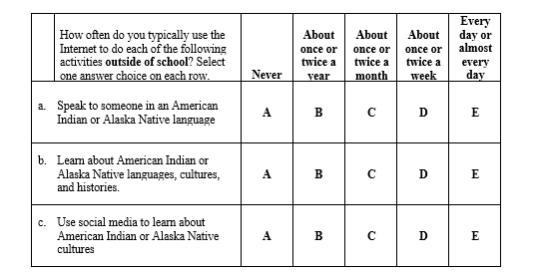 | A | Added to extend coverage of language use.
N/A | 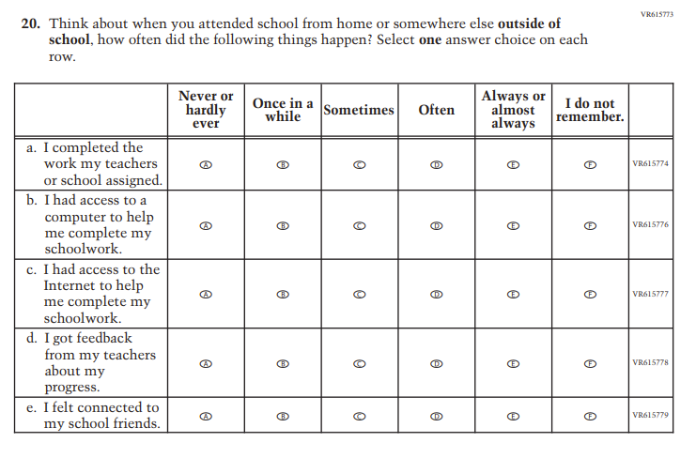 | A | Added to cover remote learning experiences

Appendix J1-29: Operational Grade 4 (NIES)
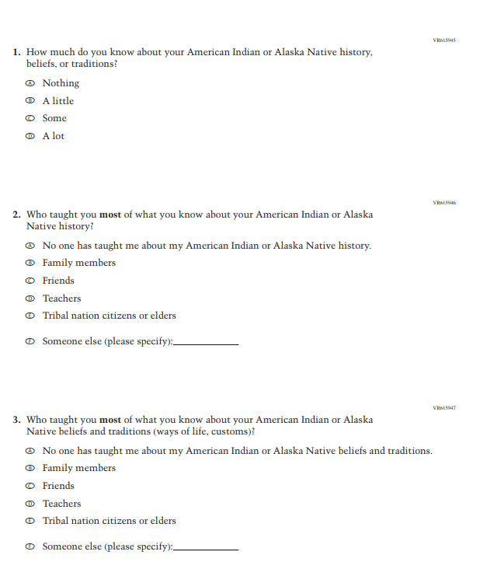
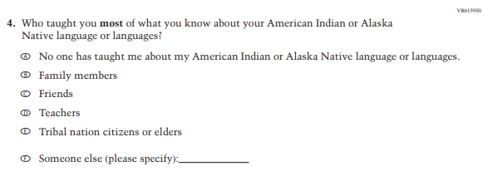
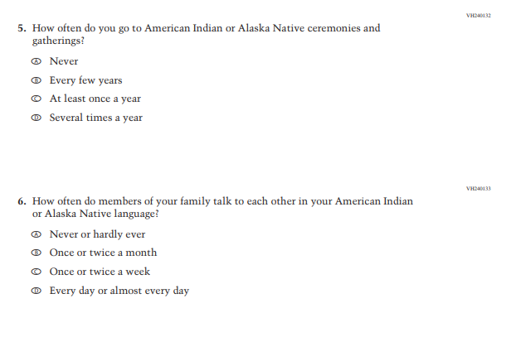
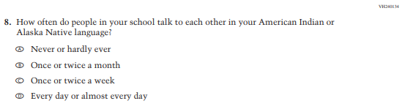
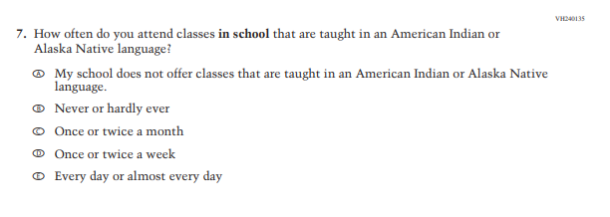
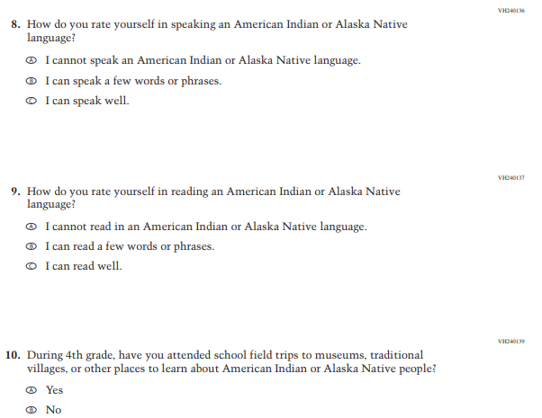
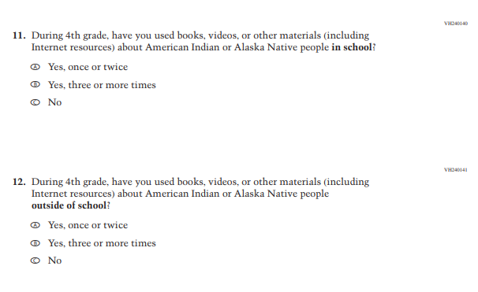
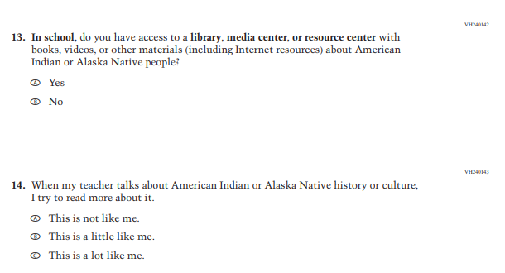
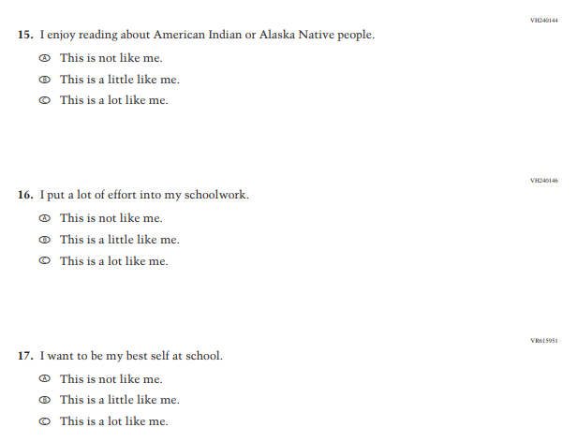

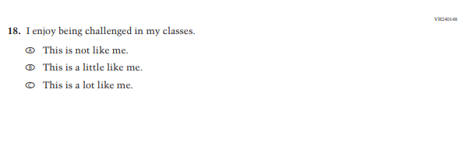
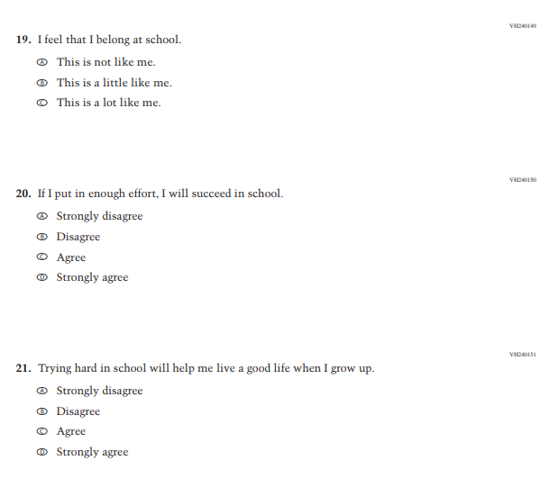
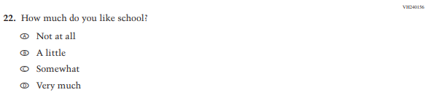
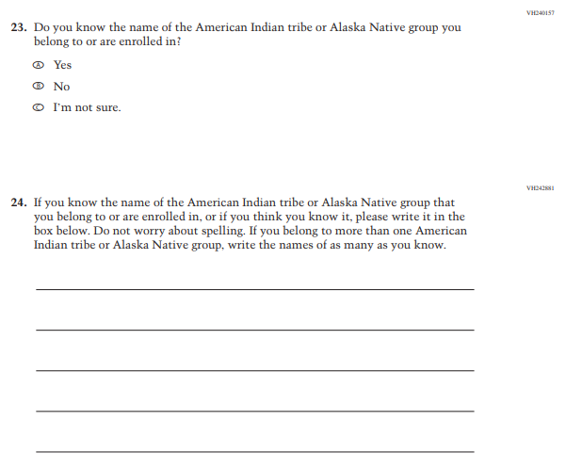

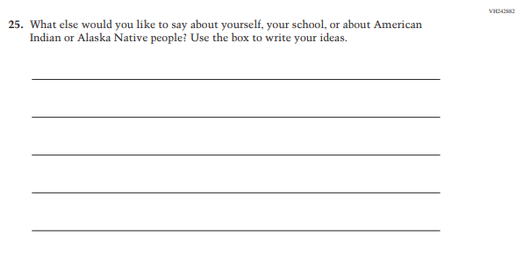
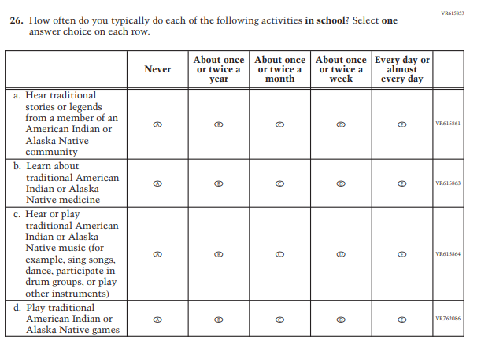

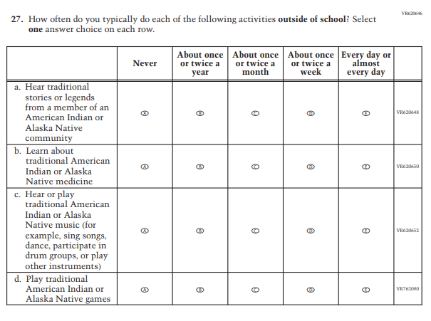

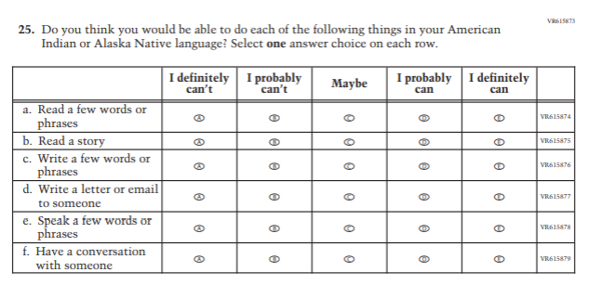

 | How often do you typically use the Internet to do each of the following activities in school? Select one answer choice on each row. | Never | About once or twice a year | About once or twice a month | About once or twice a week | Every day or almost every day
a. | Speak to someone in an American Indian or Alaska Native language | A | B | C | D | E
b. | Learn about American Indian or Alaska Native languages, cultures and histories. | A | B | C | D | E

 | How often do you typically use the Internet to do each of the following activities outside of school? Select one answer choice on each row. | Never | About once or twice a year | About once or twice a month | About once or twice a week | Every day or almost every day
- Speak to someone in an American Indian or Alaska Native language |  | A | B | C | D | E
- Learn about American Indian or Alaska Native languages, cultures, and histories. |  | A | B | C | D | E
- Use social media to learn about American Indian or Alaska Native cultures |  | A | B | C | D | E

Appendix J1-30: Summary of Changes Operational Grade 8 (NIES)
2024 Operational Grade 8 NIES Student
Previous Item | 2024 Item | D/A/ R+ | Rationale
 |  | R | Revised based on expert group feedback.
 |  | R | Revised based on expert group feedback.
 |  | R | Revised based on expert group feedback.
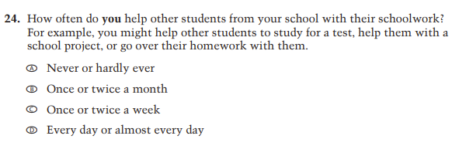 | N/A | D | Dropped due to expert group feedback.
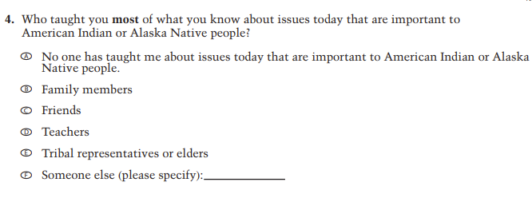 | 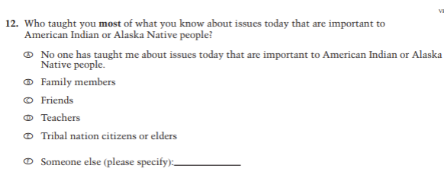 | R | Revised based on expert group feedback.
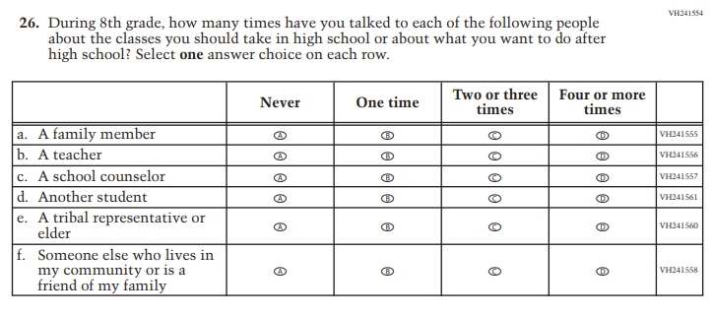 | 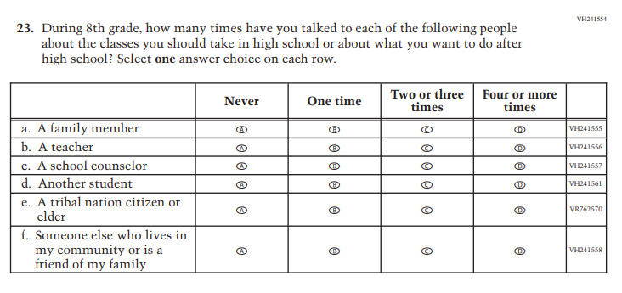 | R | Sub-item e only. Revised based on expert group feedback.
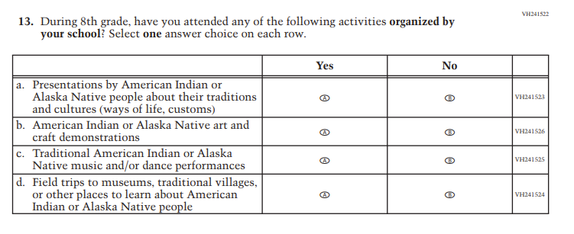 | N/A | D | Sub-item b only. Dropped due to expert group feedback.
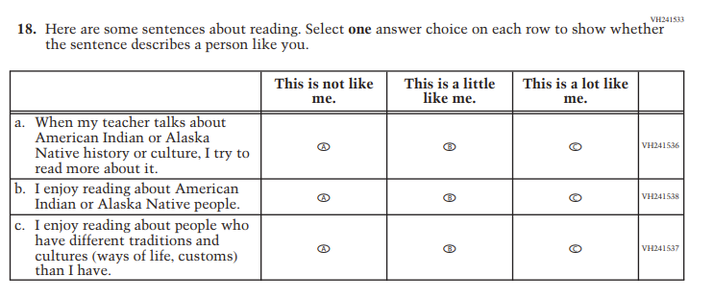 | N/A | D | Sub-item c only. Dropped due to expert group feedback.
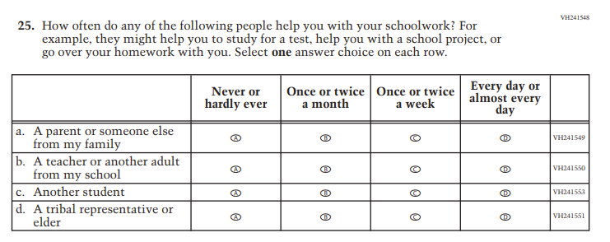 | N/A | D | Dropped due to expert group feedback.
 | 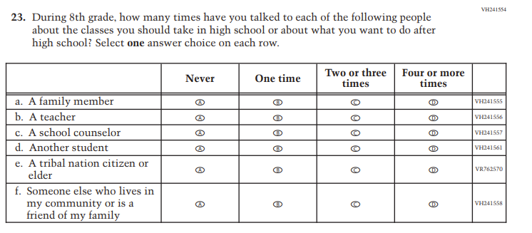 | R | Sub-item e only. Revised due to expert group feedback.
 | N/A | D | Dropped due to expert group feedback.
N/A |  | A | Added to extend coverage of language use.
N/A |  | A | Added to extend coverage of cultural activities.
N/A |  | A | Added to extend coverage of cultural activities.
N/A |  | A | Added to extend coverage of language use.
N/A |  | A | Added to extend coverage of language use.
N/A |  | A | Added to cover remote learning experiences

Appendix J1-31: Operational Grade 8 (NIES)
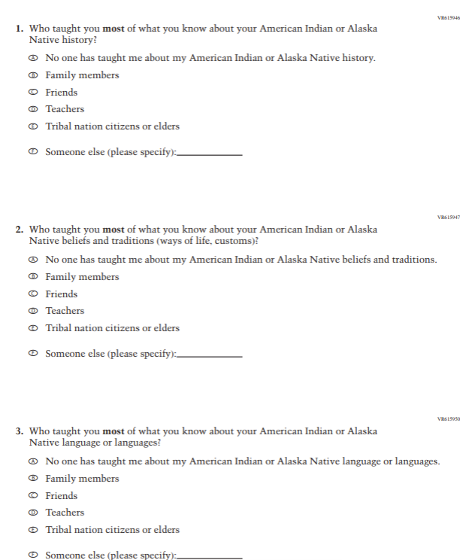
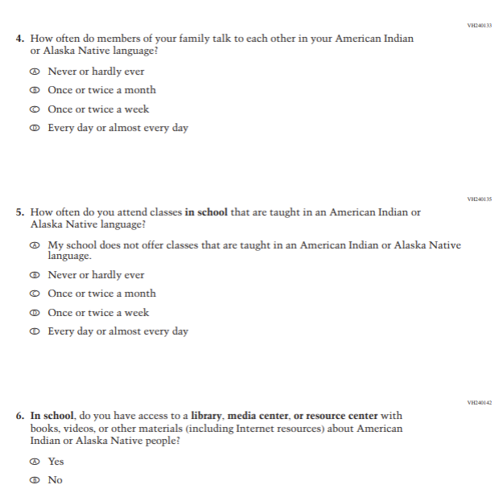
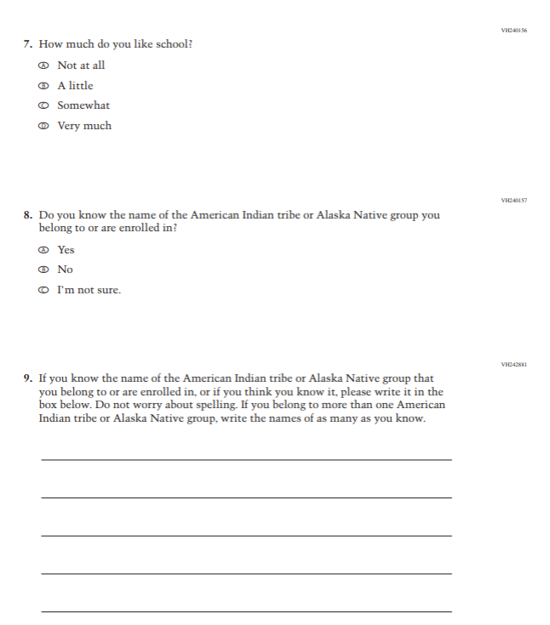

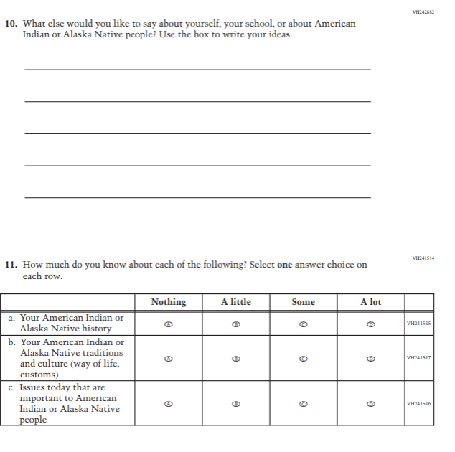
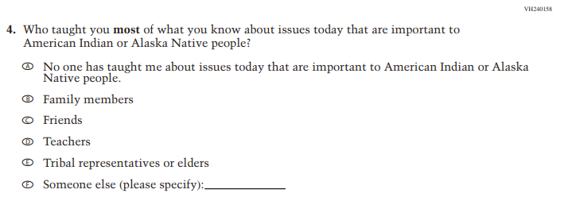
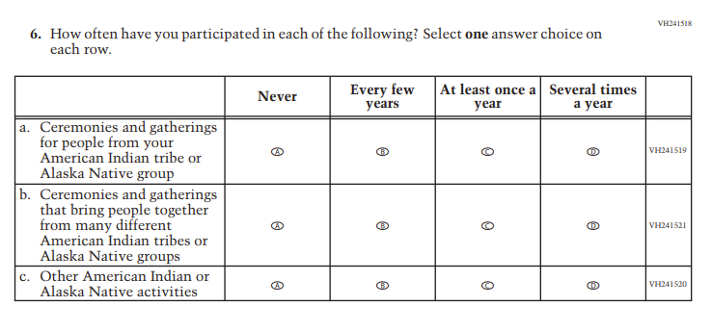

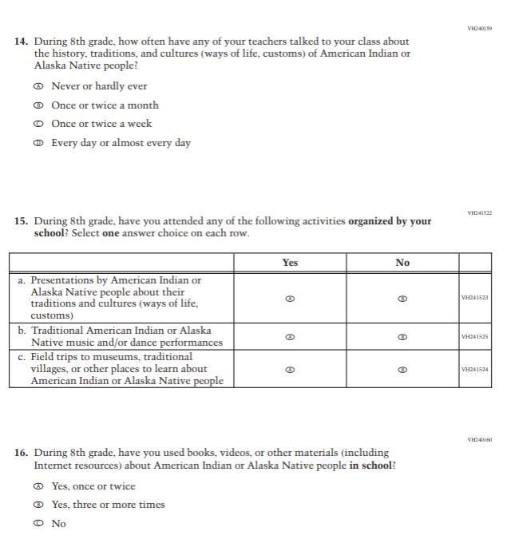

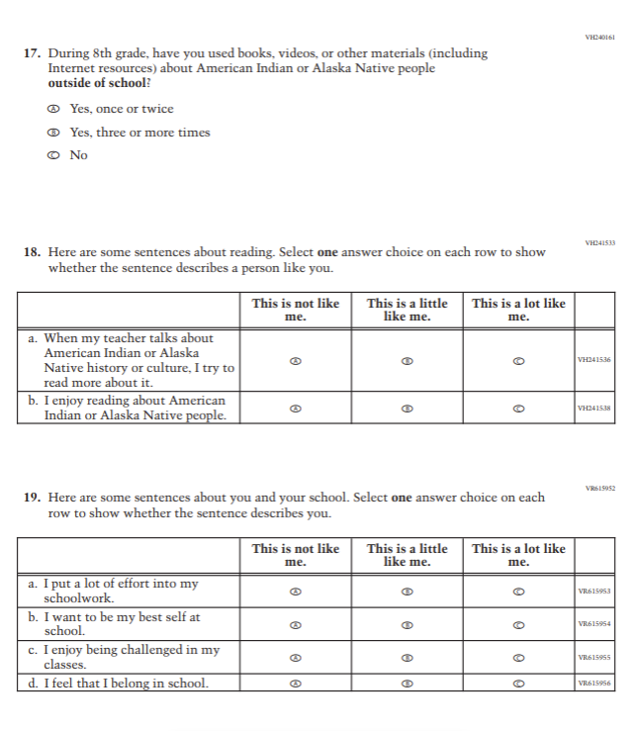

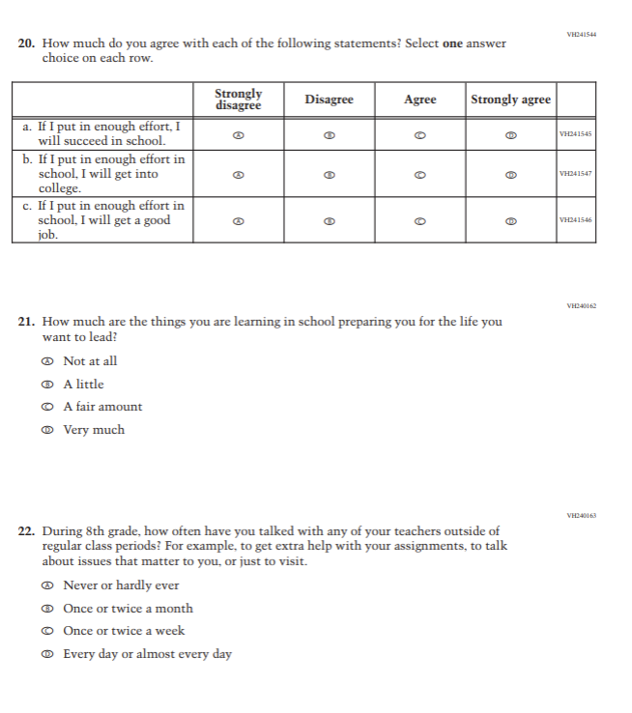

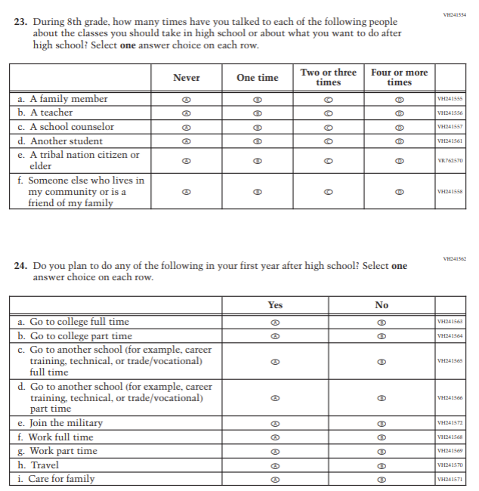
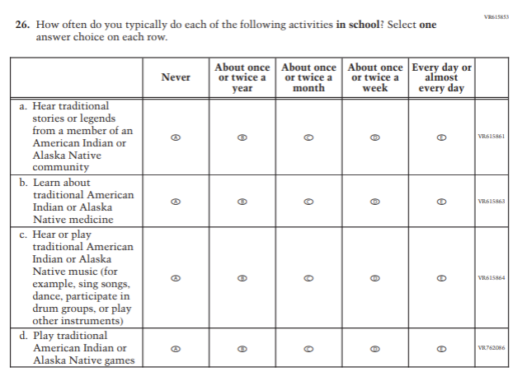

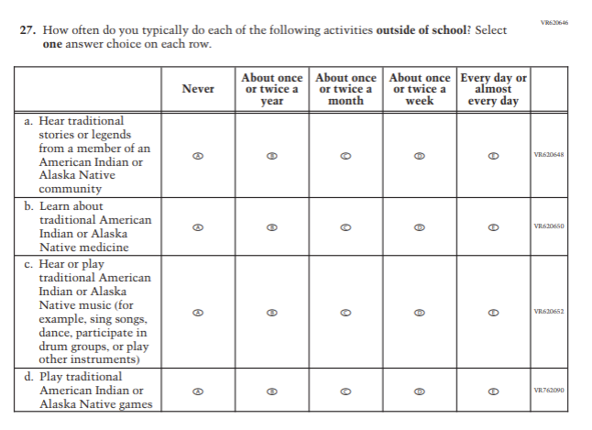

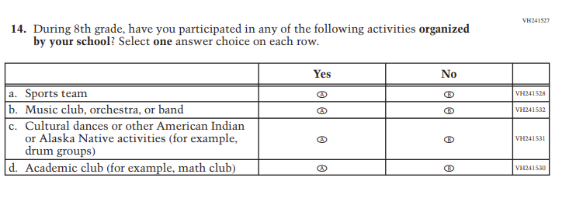

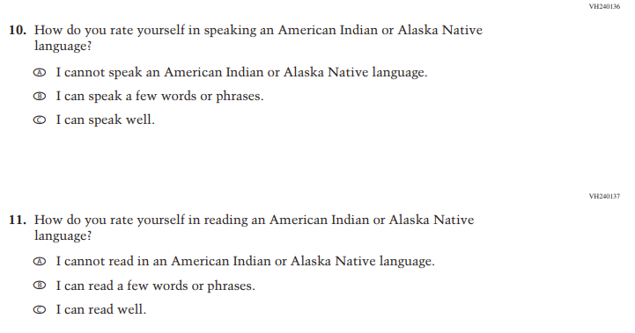

 | How often do you typically use the Internet to do each of the following activities in school? Select one answer choice on each row. | Never | About once or twice a year | About once or twice a month | About once or twice a week | Every day or almost every day
a. | Speak to someone in an American Indian or Alaska Native language | A | B | C | D | E
b. | Learn about American Indian or Alaska Native languages, cultures, and histories. | A | B | C | D | E

 | How often do you typically use the Internet to do each of the following activities outside of school? Select one answer choice on each row. | Never | About once or twice a year | About once or twice a month | About once or twice a week | Every day or almost every day
- Speak to someone in an American Indian or Alaska Native language |  | A | B | C | D | E
- Learn about American Indian or Alaska Native languages, cultures, and histories. |  | A | B | C | D | E
- Use social media to learn about American Indian or Alaska Native cultures |  | A | B | C | D | E

Appendix J1-32: Pilot Grade 4 (Core)
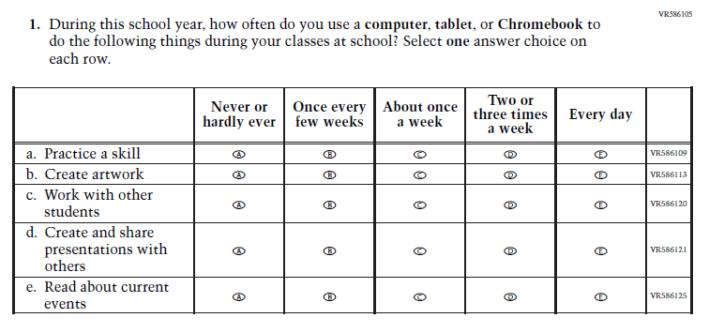
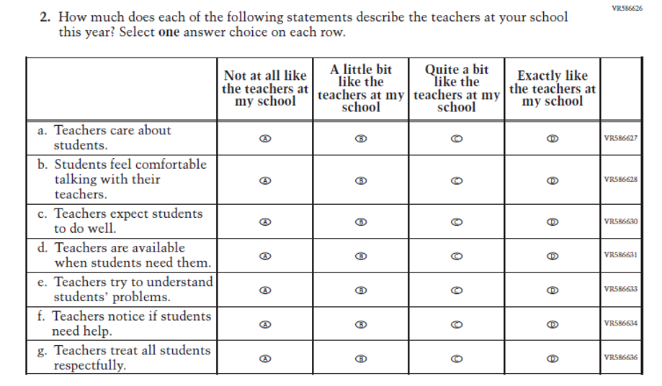
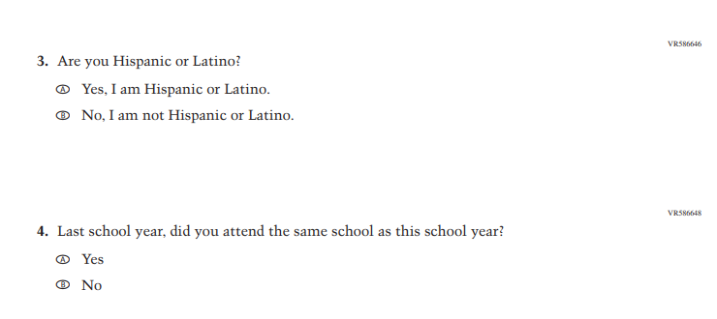

Appendix J1-33: Pilot Grade 8 (Core)
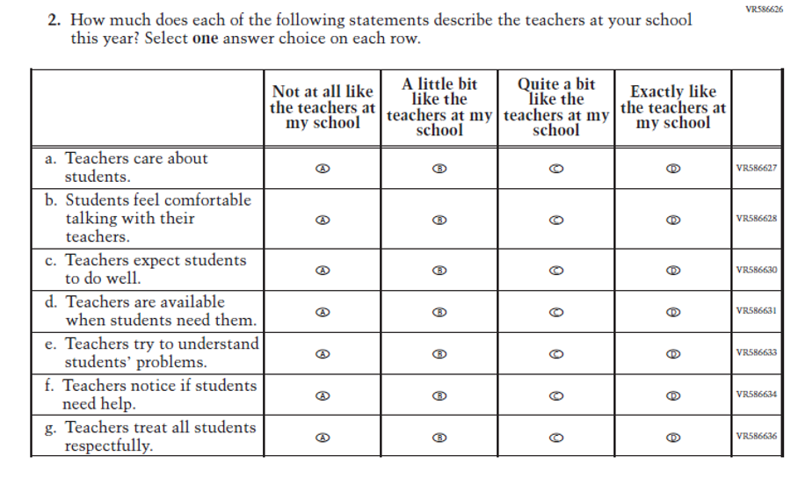
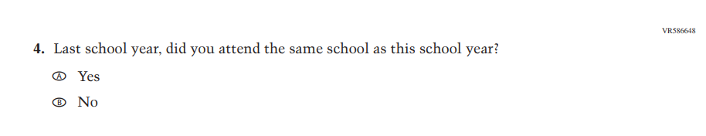

Appendix J1-34: Pilot Grade 4 (Mathematics)
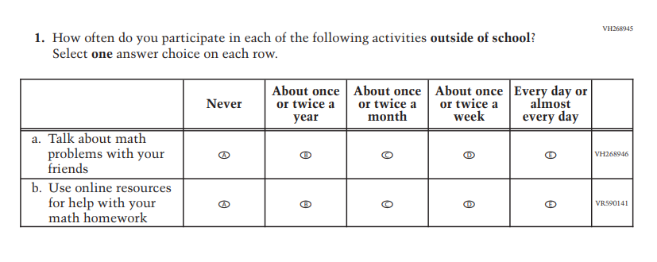
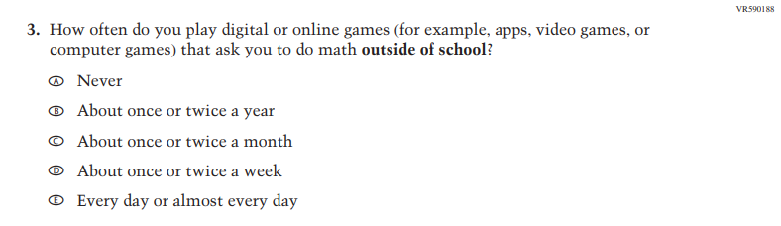
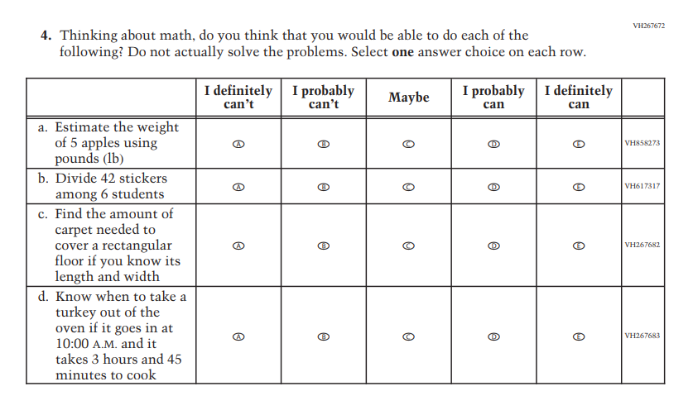
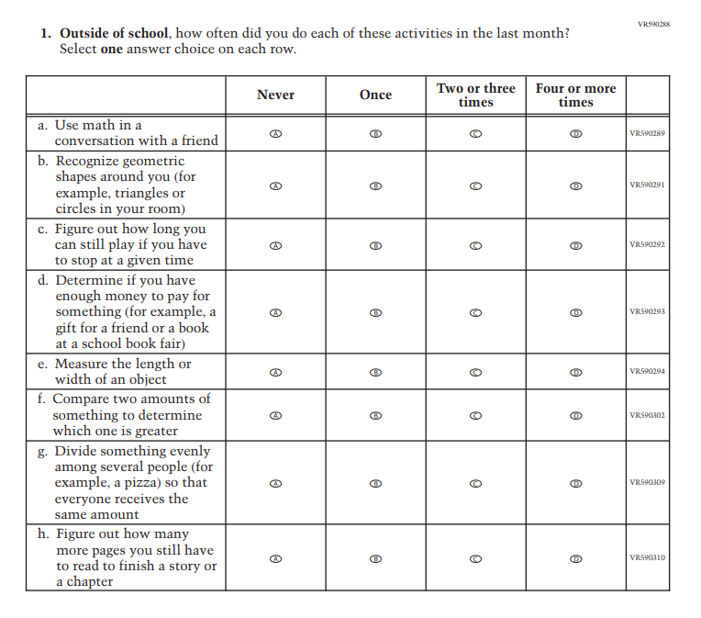
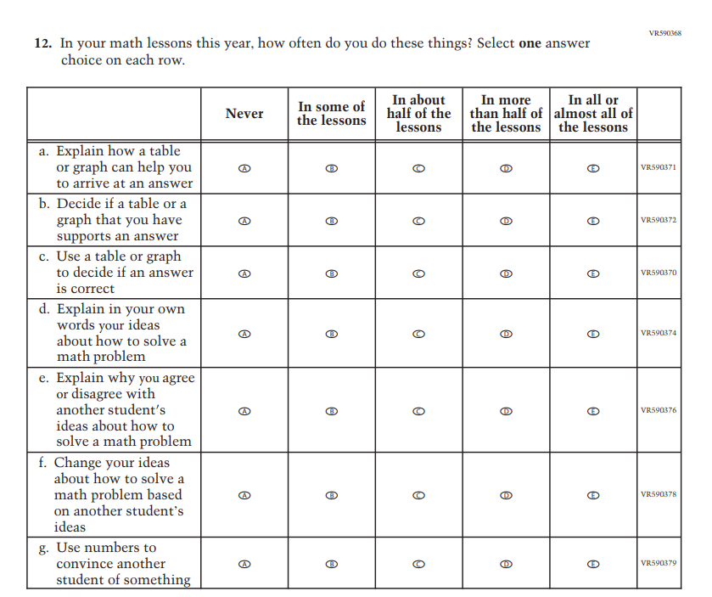
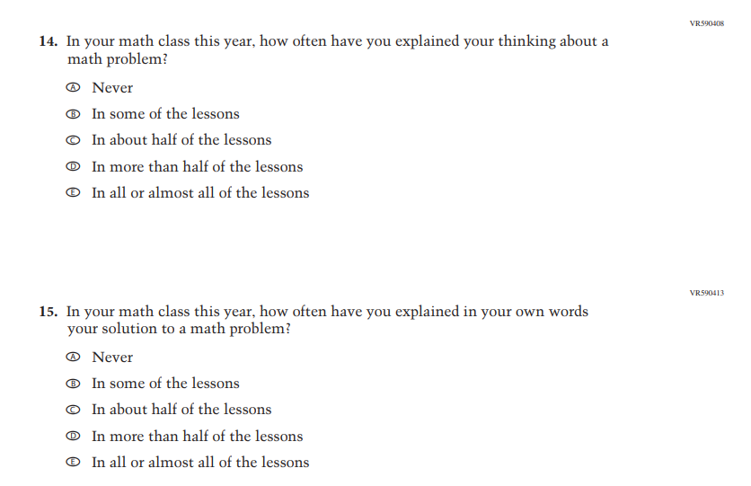

Appendix J1-35: Pilot Grade 8 (Mathematics)
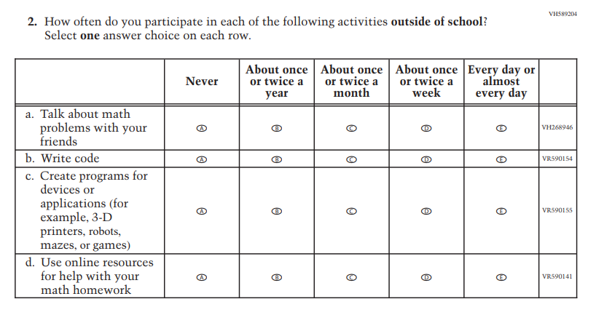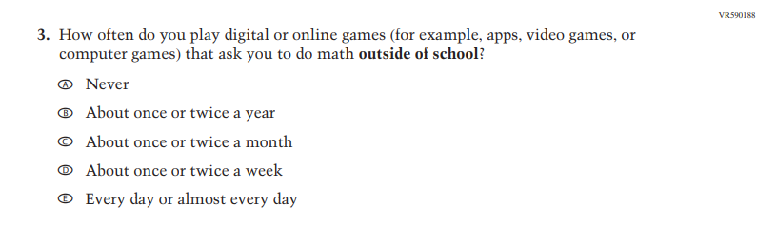
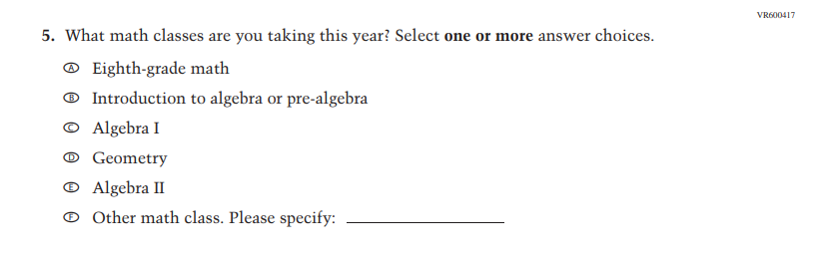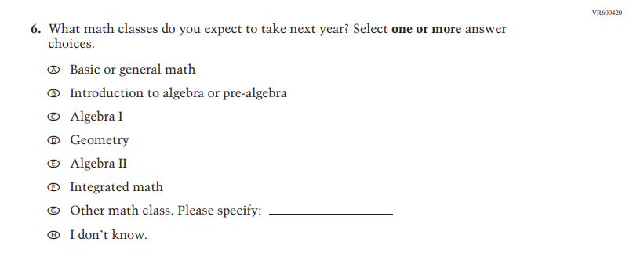
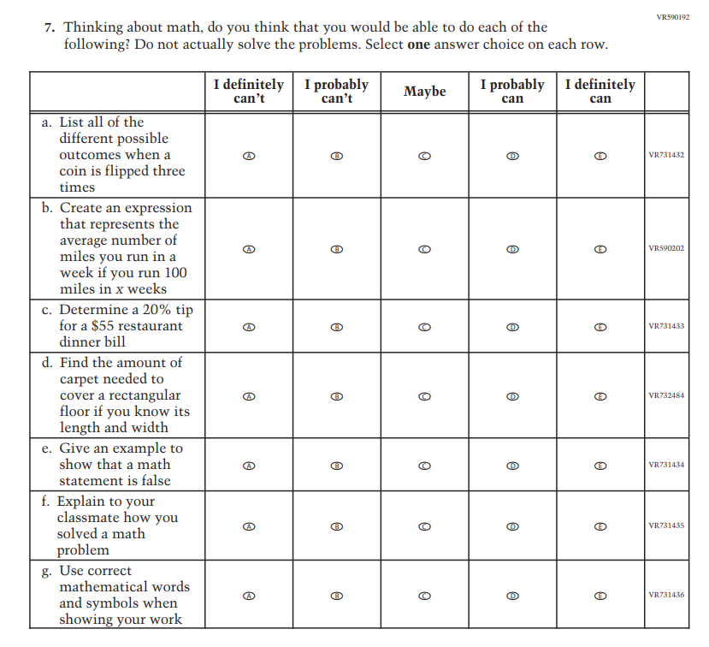
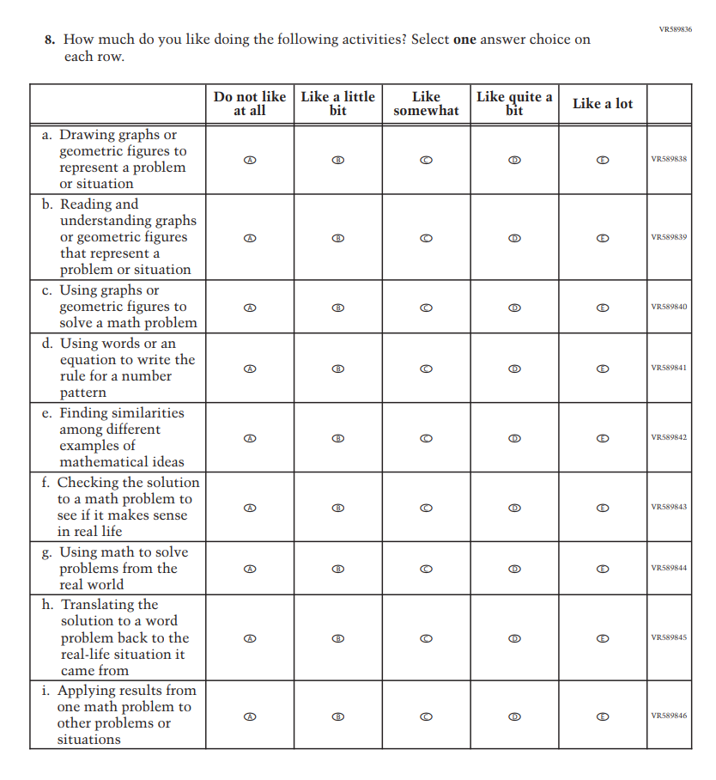
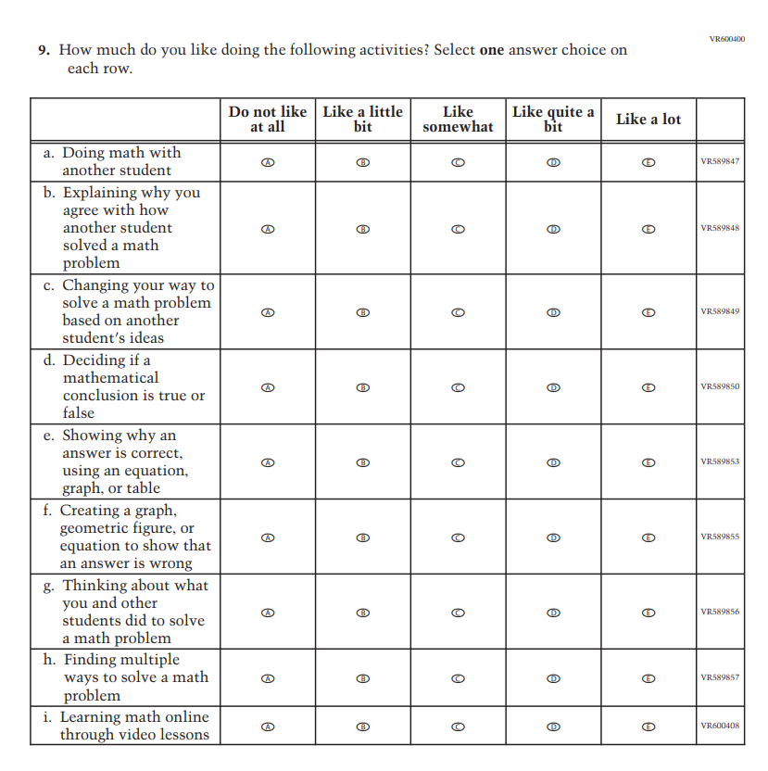
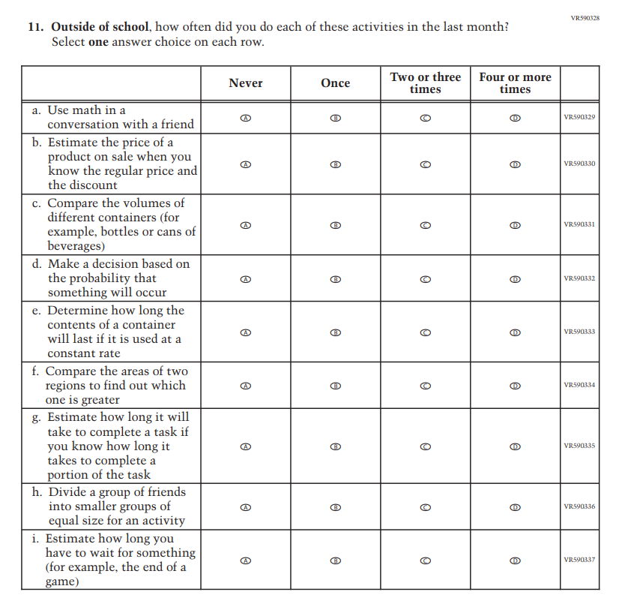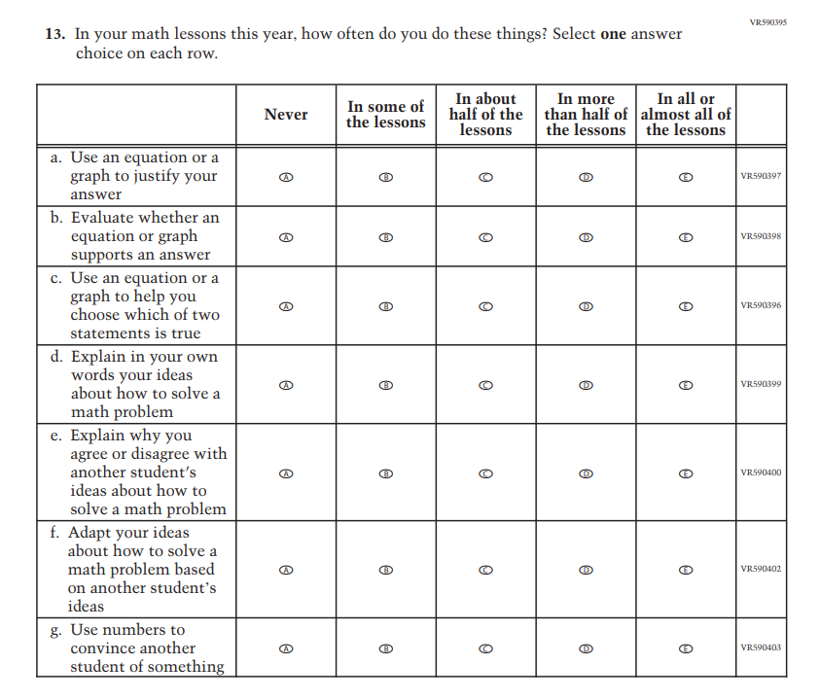
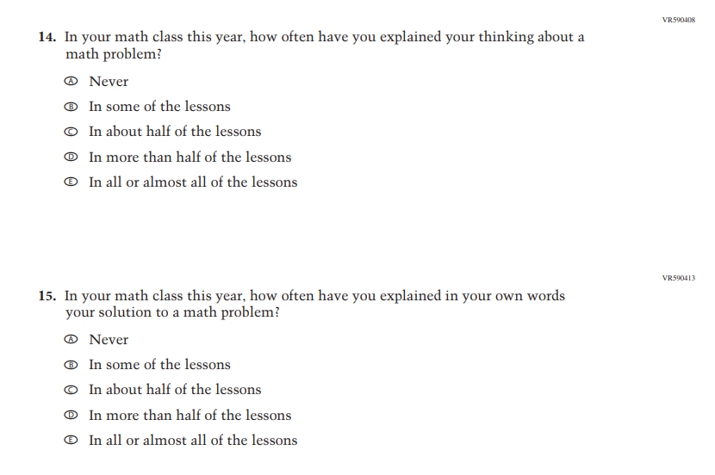

Appendix J1-36: Pilot Grade 4 (Reading)
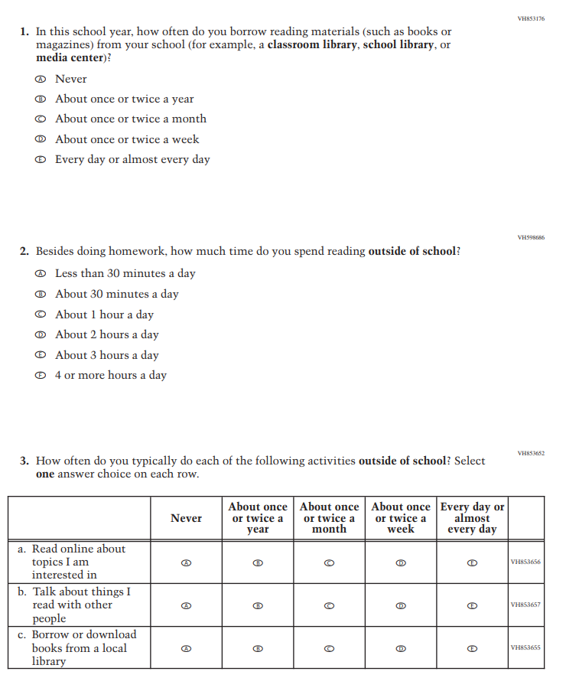
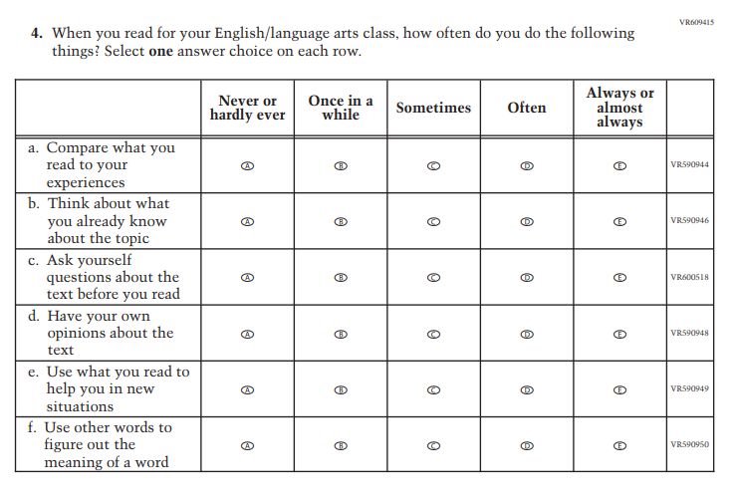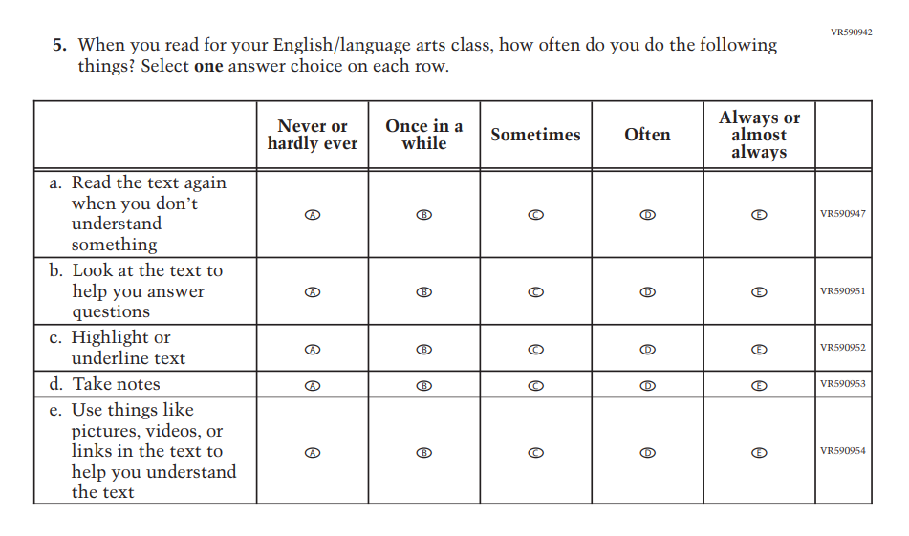
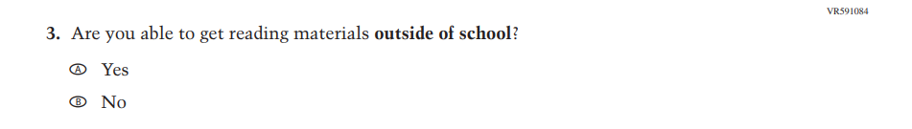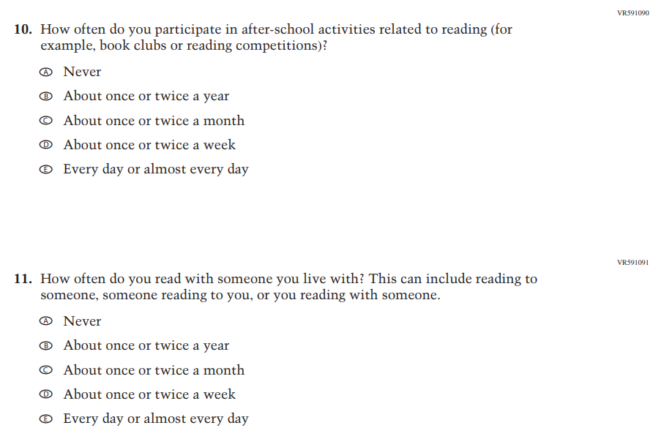

Appendix J1-37: Pilot Grade 8 (Reading)
