NATIONAL CENTER FOR EDUCATION STATISTICS NATIONAL ASSESSMENT OF EDUCATIONAL PROGRESS

National Assessment of Educational Progress (NAEP)2024

Appendix J2
2024 Teacher Questionnaires

OMB# 1850-0928 v.30

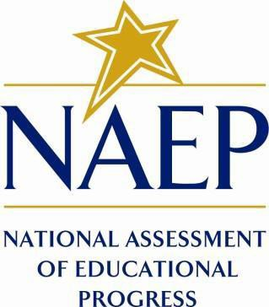

June 2023

Appendix J2 provides the teacher survey questionnaires that will be administered in 2024. Grades 4 and 8 Core, Math, and Reading questionnaires were previously approved in 2022 (OMB# 1850-0928 v.28), and any changes to the items from the 2022 administration are reflected in summary tables. Additionally, grade 8 Science was previously approved in 2019 (OMB# 1850-0928 v.15), and any changes to the items from the 2019 administration are reflected in summary tables. New COVID-19 Learning Recovery and NIES SQs, are available in this document. Any changes to the NIES SQs since the 2019 administration are reflected in summary tables. Please note, some of the numbers of the items may be missing or out of order in these printed versions. This will be corrected in the platform view.
Table of Contents
Teacher Questionnaires
Sample Teacher Questionnaire Login Screens 3
Sample Teacher Questionnaire Booklet Covers 4
Appendix J2-1: Summary of Changes Operational Grade 4 (Core, Reading and Mathematics) 5
Appendix J2-2: Operational Grade 4 (Core, Reading and Mathematics) 8
Appendix J2-3: Summary of Changes Operational Grade 8 (Core, Reading, Mathematics, Science) 16
Appendix J2-4: Operational Grade 8 (Core, Reading, Mathematics, Science) 21
Appendix J2-5: Operational Grade 4 (Mathematics) 33
Appendix J2-6: Operational Grade 8 (Mathematics) 41
Appendix J2-7: Operational Grade 4 (Reading) 50
Appendix J2-8: Operational Grade 8 (Reading) 57
Appendix J2-9: Operational Grade 8 (Science) 64
Appendix J2-10: Summary of Changes Operational Grade 4 (NIES) 70
Appendix J2-11: Operational Grade 4 (NIES) 74
Appendix J2-12: Summary of Changes Operational Grade 8 (NIES) 92
Appendix J2-13: Operational Grade 8 (NIES) 96
Appendix J2-14: Pilot Reading and Mathematics Grade 4 (Core) 116
Appendix J2-15: Pilot Mathematics Grade 8 (Core) 126
Appendix J2-16: Pilot Reading Grade 8 (Core) 136
Appendix J2-17: Pilot Grade 4 (Mathematics) 146
Appendix J2-18: Pilot Grade 8 (Mathematics) 155
Appendix J2-19: Pilot Grade 4 (Reading) 167
Appendix J2-20: Pilot Grade 8 (Reading) 175

Sample Teacher Questionnaire Login Screens
(Screenshots will be updated in Amendment 3 with appropriate burden times)

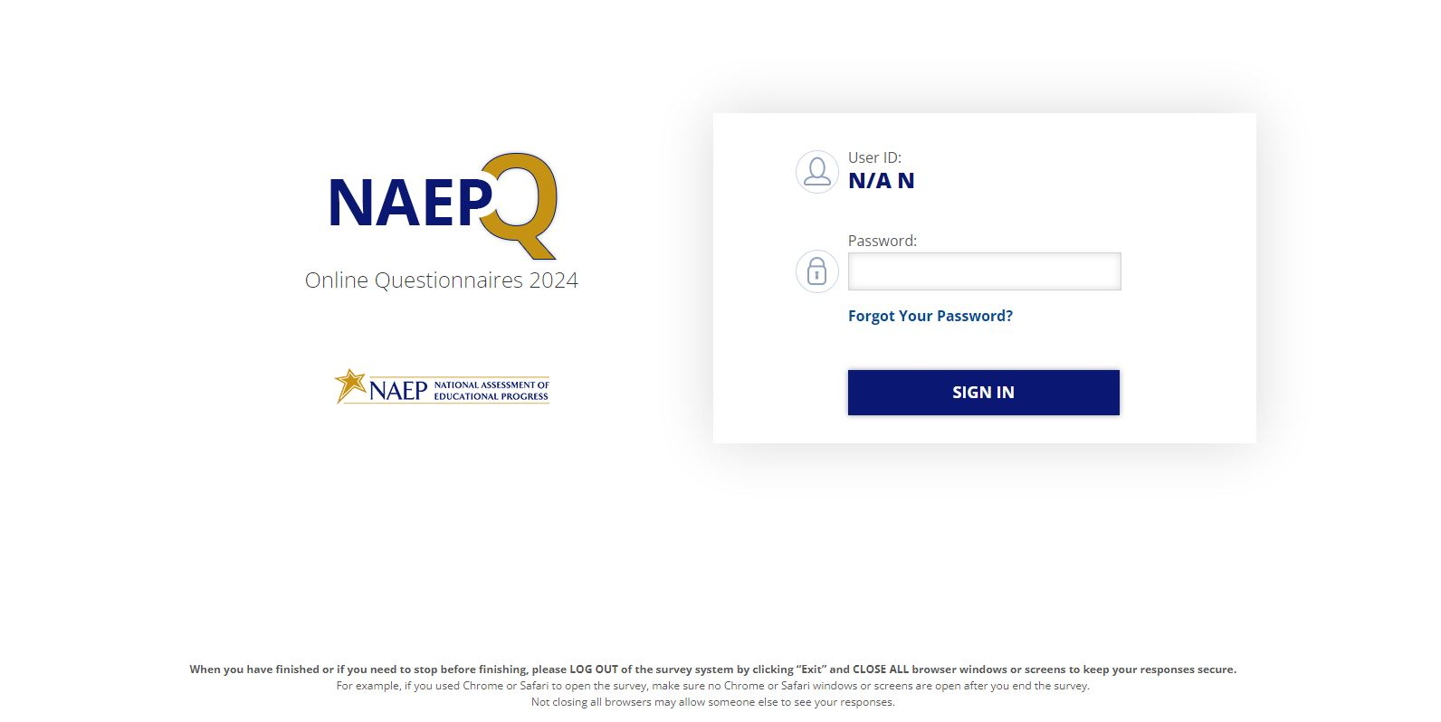
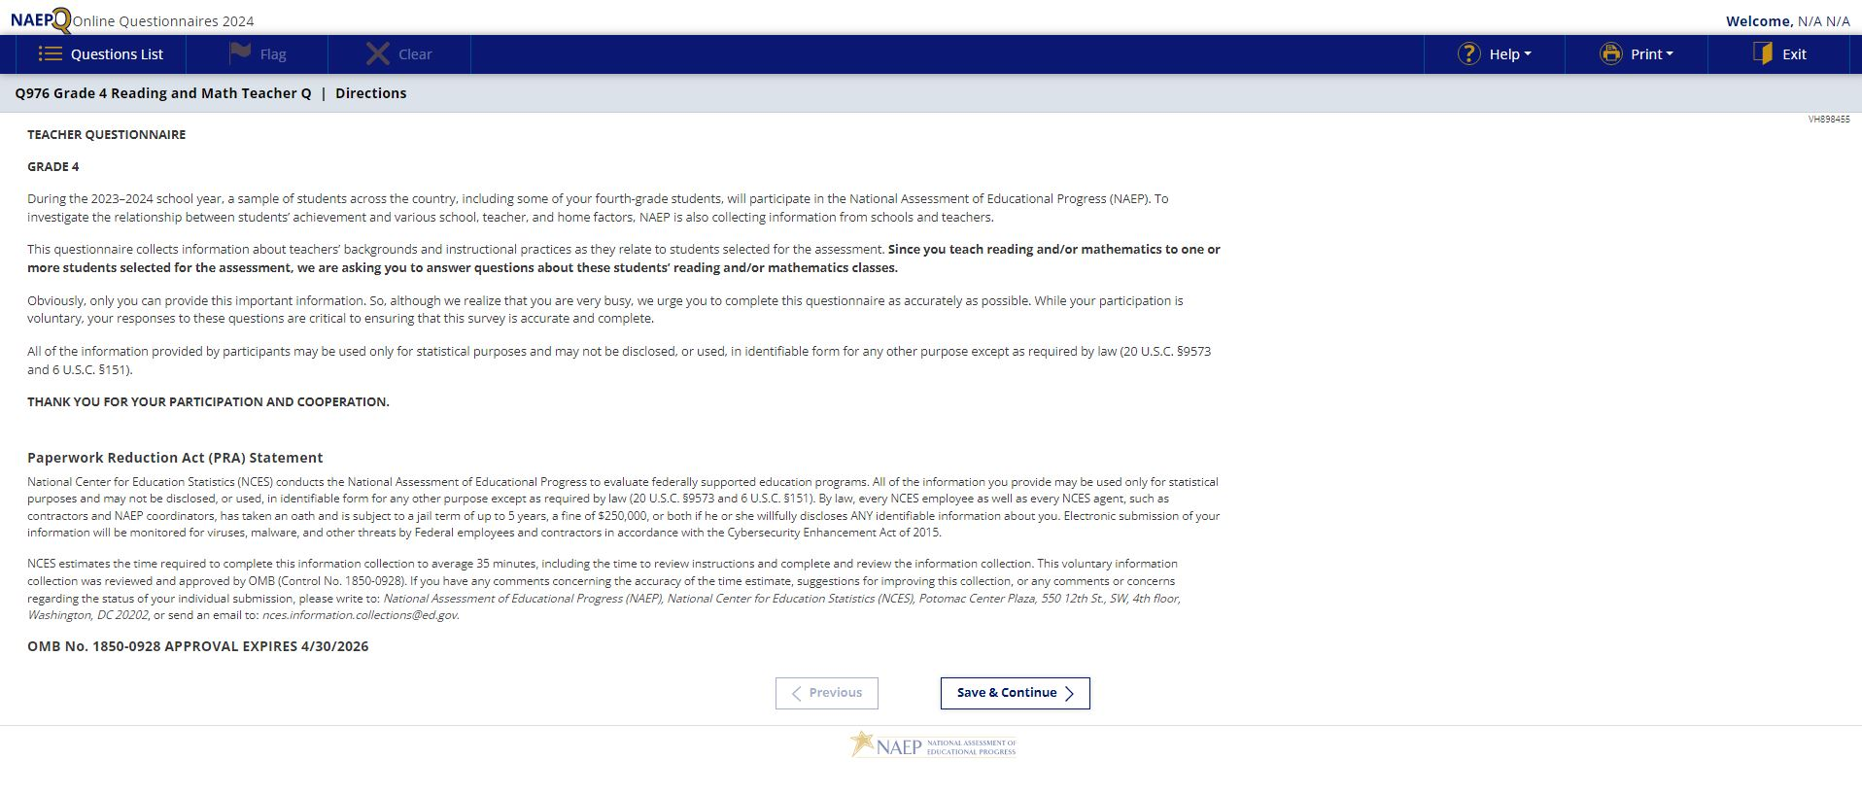

Sample Teacher Questionnaire Booklet Covers
(Screenshots will be updated in Amendment 3 with appropriate burden times)

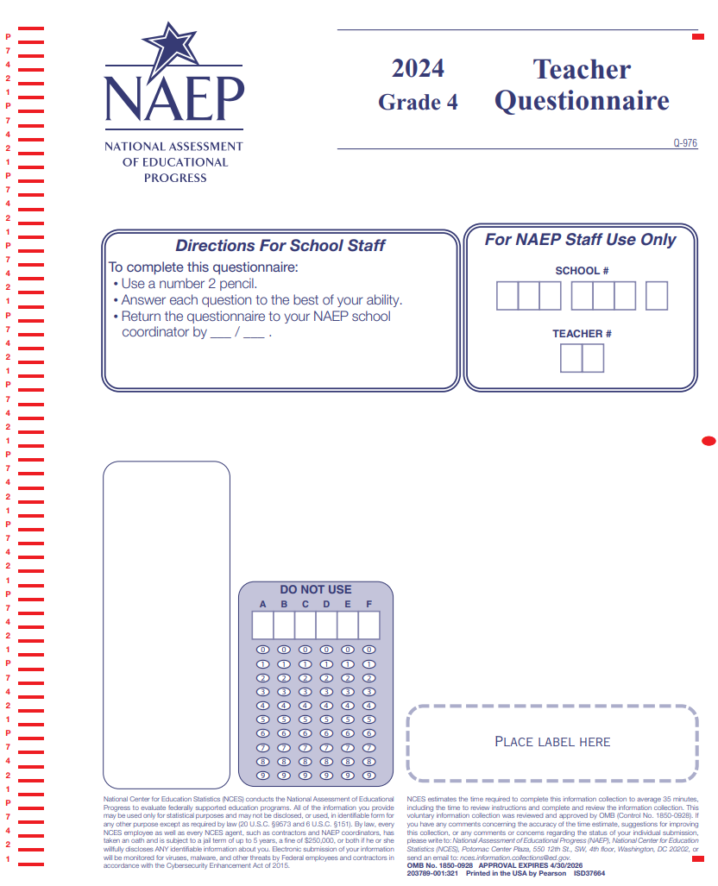

Appendix J2-1: Summary of Changes Operational Grade 4 (Core, Reading and Mathematics)
2024 Operational Grade 4 Core Teacher
Previous Item | 2024 Item | D/A/ R+ | Rationale
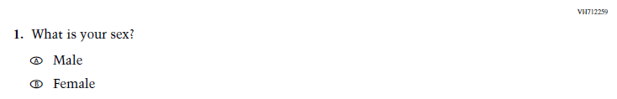  (2022 Grade 4) | 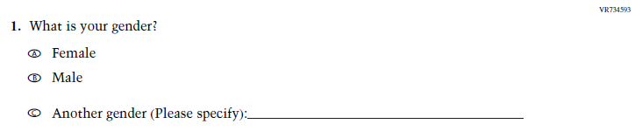  Issue: Gender | R | This Item was revised to be more inclusive and is now in line with an NCES-wide change.
N/A | 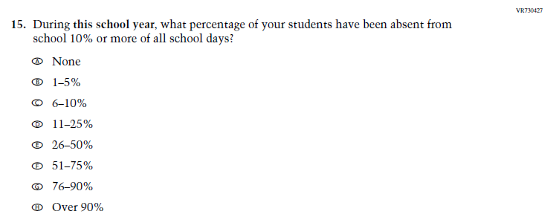  Issue: Learning Recovery | A | This Item was added to address gaps in learning that have developed due to the extended period of remote and hybrid learning that took place during the pandemic.
N/A | 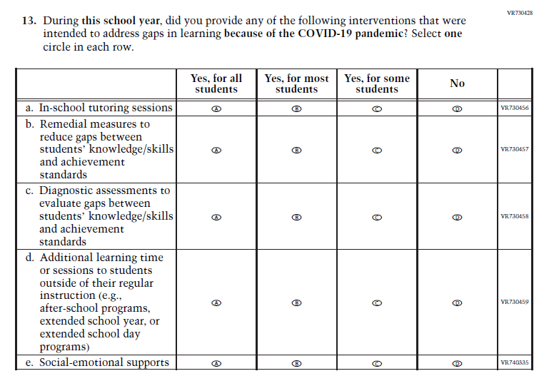  Issue: Learning Recovery | A | This Item was added to address gaps in learning that have developed due to the extended period of remote and hybrid learning that took place during the pandemic.
N/A | 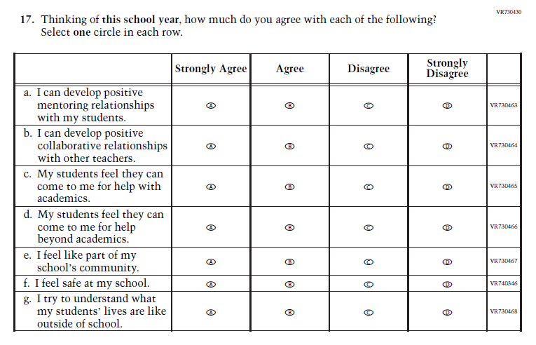  Issue: Learning Recovery | A | This Item was added to address gaps in learning that have developed due to the extended period of remote and hybrid learning that took place during the pandemic.

N/A | 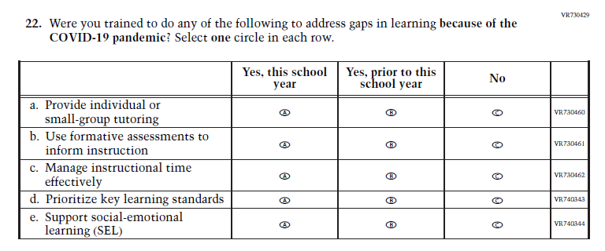  Issue: Learning Recovery | A | This Item was added to address gaps in learning that have developed due to the extended period of remote and hybrid learning that took place during the pandemic.

Appendix J2-2: Operational Grade 4 (Core, Reading and Mathematics)
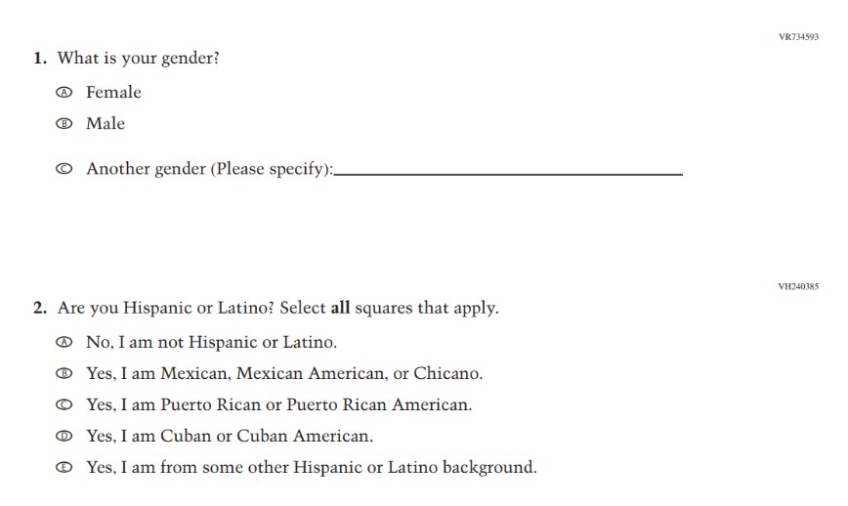
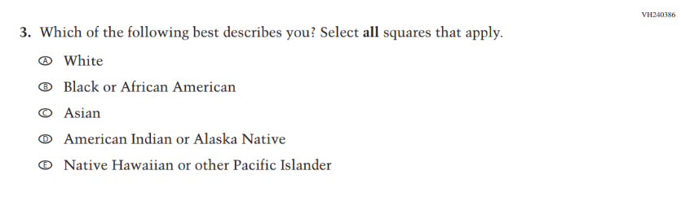
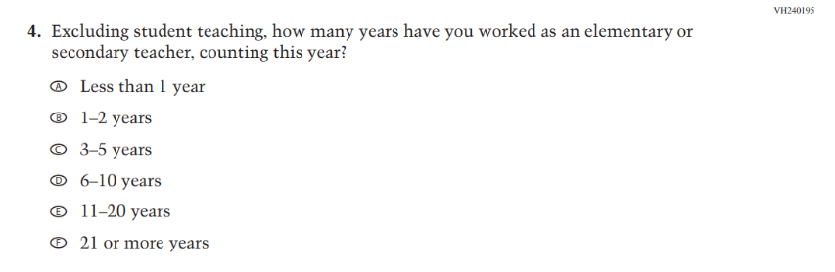

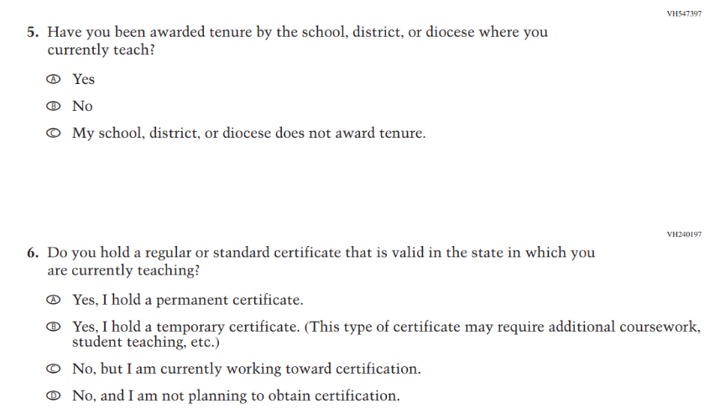
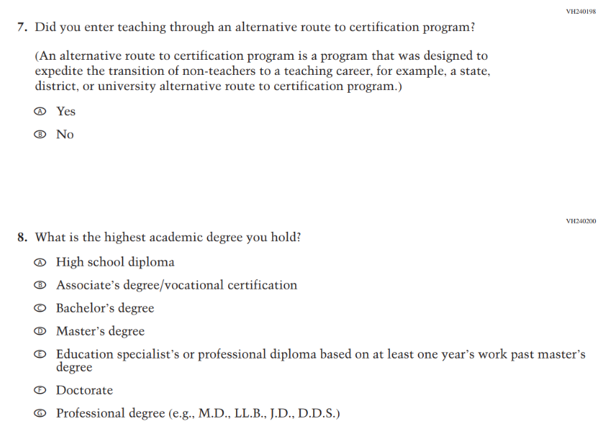

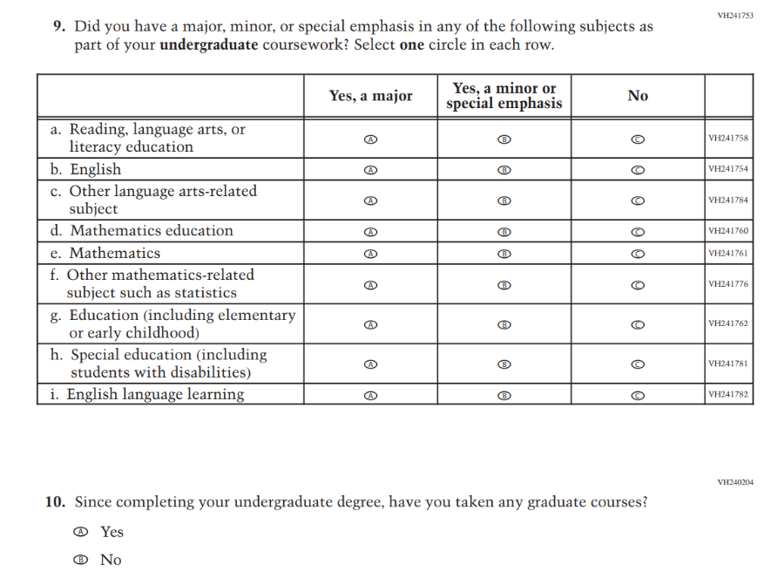

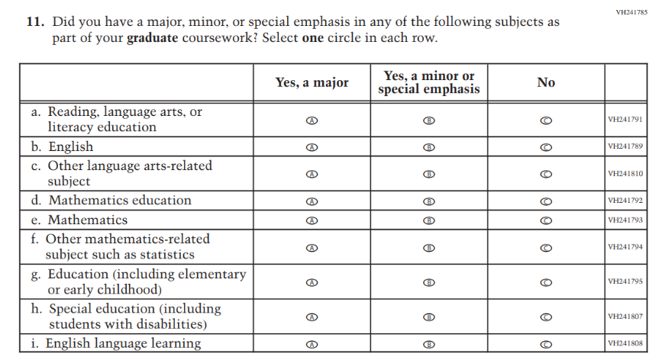
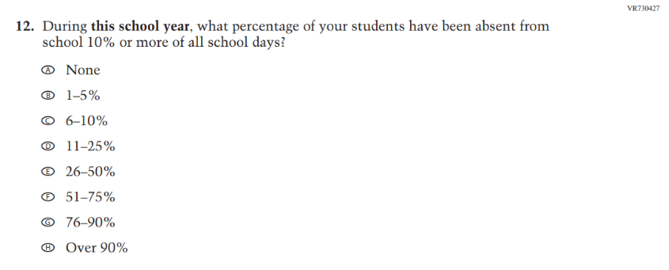
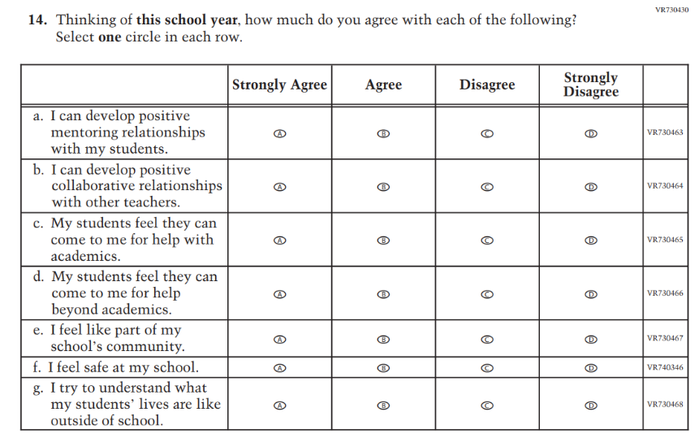
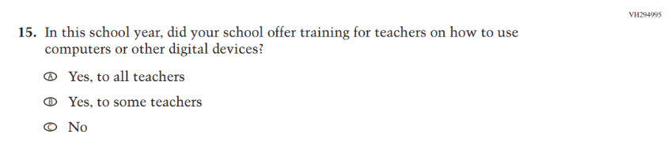
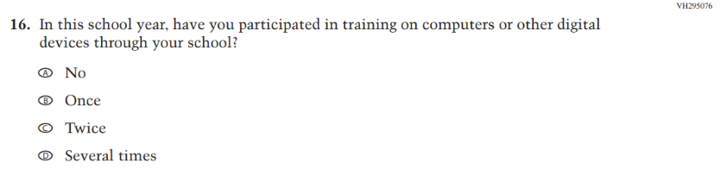
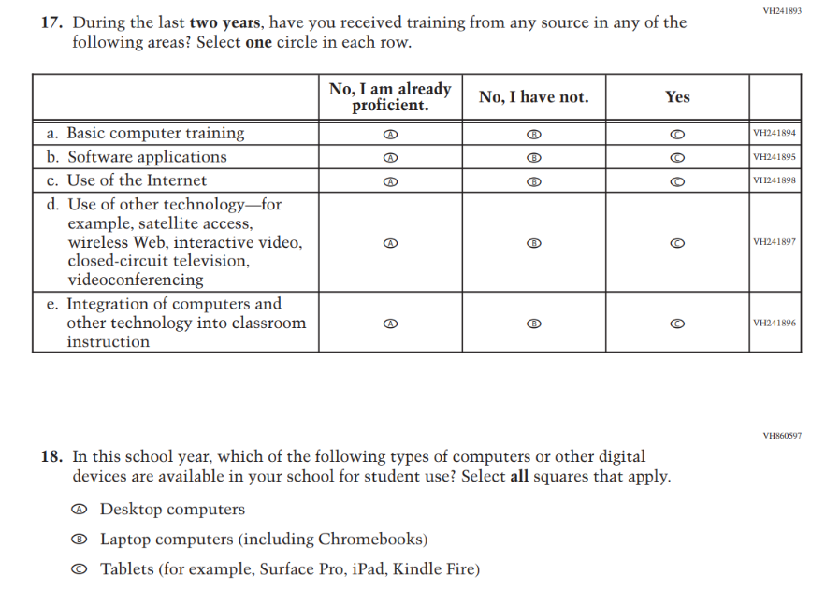
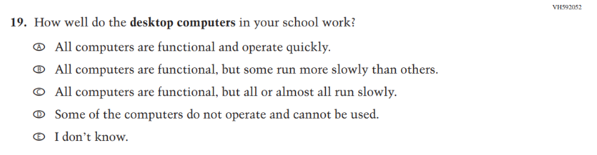
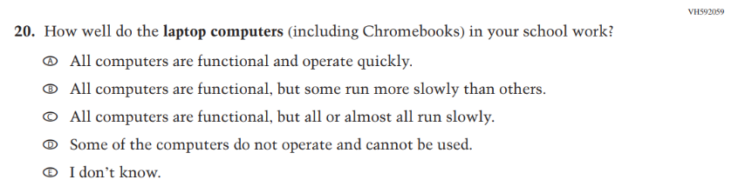
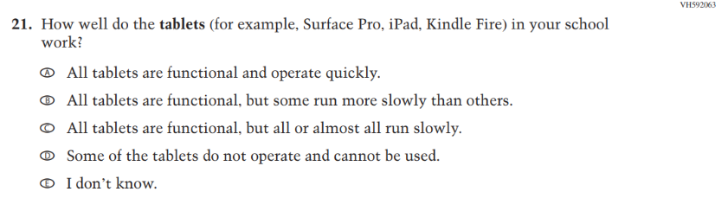
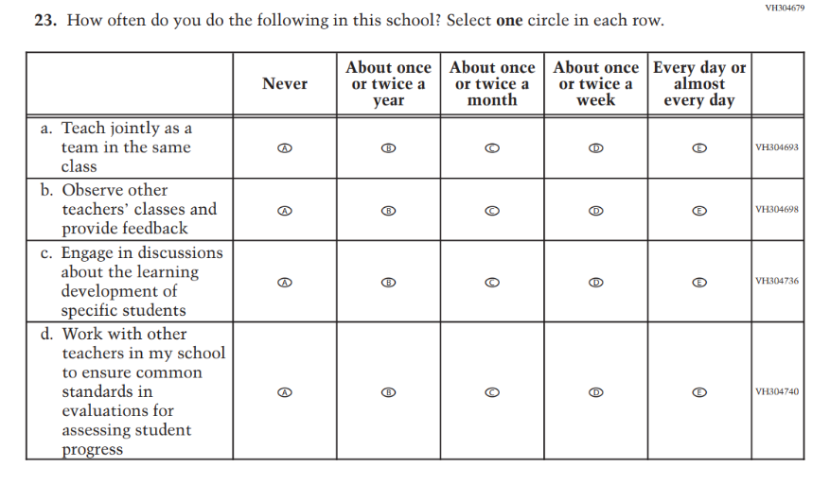
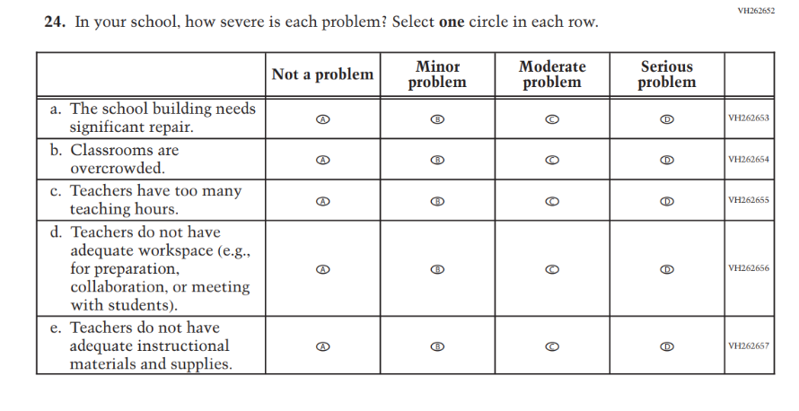
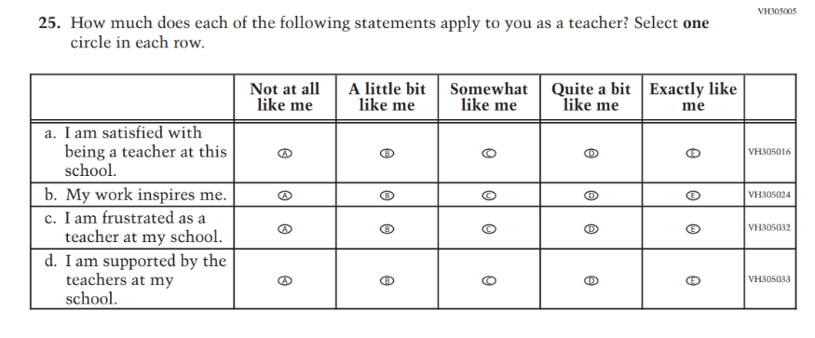
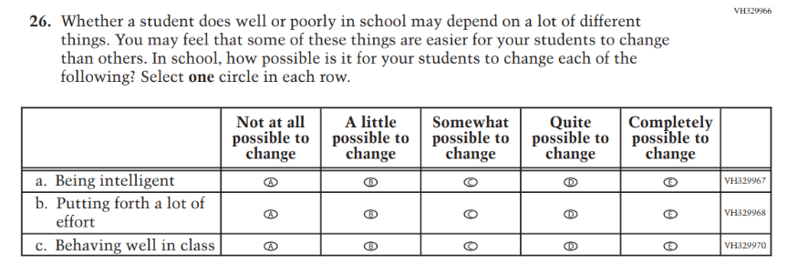

Appendix J2-3: Summary of Changes Operational Grade 8 (Core, Reading, Mathematics, Science)
2024 Operational Grade 8 Core Teacher
Previous Item | 2024 Item | D/A/ R+ | Rationale
(2022 Grade 8) | Issue: Gender | R | This Item was revised to be more inclusive and is now in line with an NCES-wide change.
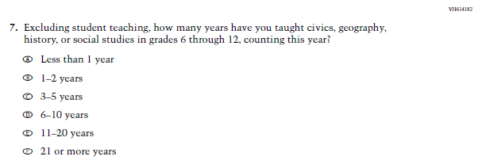  (2022 Grade 8) | 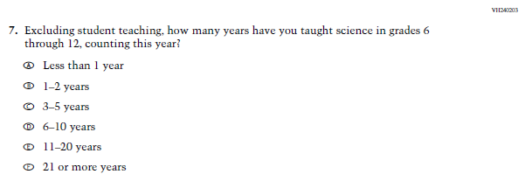  Issue: Teacher Preparation | R | The 2022 version of the Item, which references Social Studies, was replaced with the Item that references Science. Social Studies is not in the 2024 NAEP Assessment. Science is being administered at Grade 8.
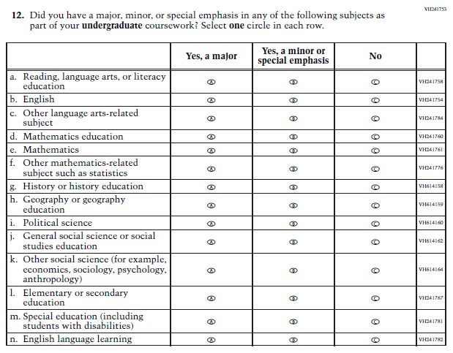  (2022 Grade 8) | 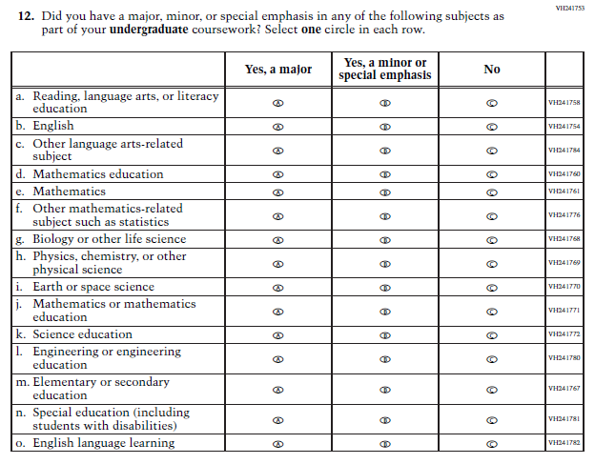  Issue: Teacher Preparation | R | SubItems “g.” through “k.” in the 2022 version of the Item, which reference Social Studies, have been replaced with SubItems that reference Science. SubItem “l.” also references Science. Social Studies is not in the 2024 NAEP Assessment. Science is being administered at Grade 8.
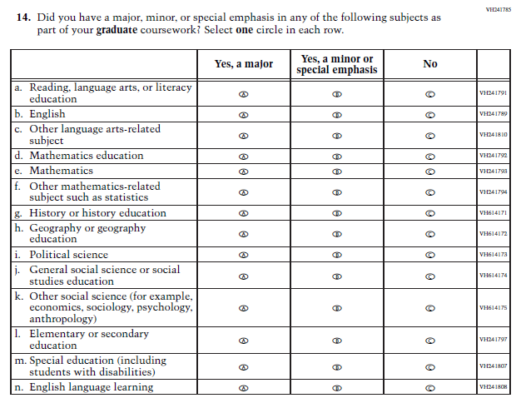  (2022 Grade 8) | 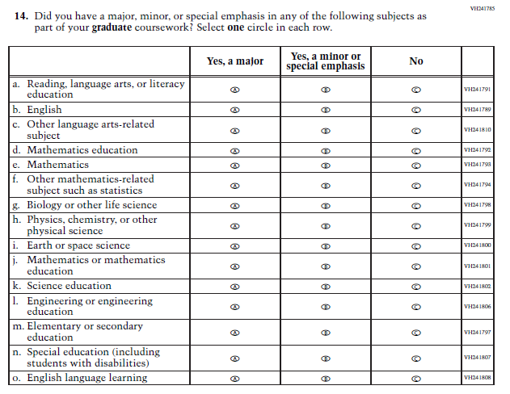  Issue: Teacher Preparation | R | SubItems “g.” through “k.” in the 2022 version of the Item, which reference Social Studies, have been replaced with SubItems that reference Science. SubItem “l.” also references Science. Social Studies is not in the 2024 NAEP Assessment. Science is being administered at Grade 8.
N/A | Issue: Learning Recovery | A | This Item was added to address gaps in learning that have developed due to the extended period of remote and hybrid learning that took place during the pandemic.
N/A | Issue: Learning Recovery | A | This Item was added to address gaps in learning that have developed due to the extended period of remote and hybrid learning that took place during the pandemic.
N/A | Issue: Learning Recovery | A | This Item was added to address gaps in learning that have developed due to the extended period of remote and hybrid learning that took place during the pandemic.

N/A | Issue: Learning Recovery | A | This Item was added to address gaps in learning that have developed due to the extended period of remote and hybrid learning that took place during the pandemic.

Appendix J2-4: Operational Grade 8 (Core, Reading, Mathematics, Science)
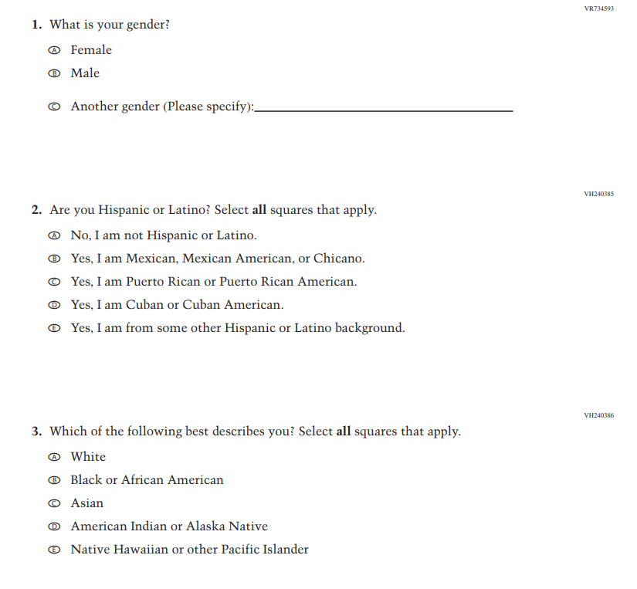
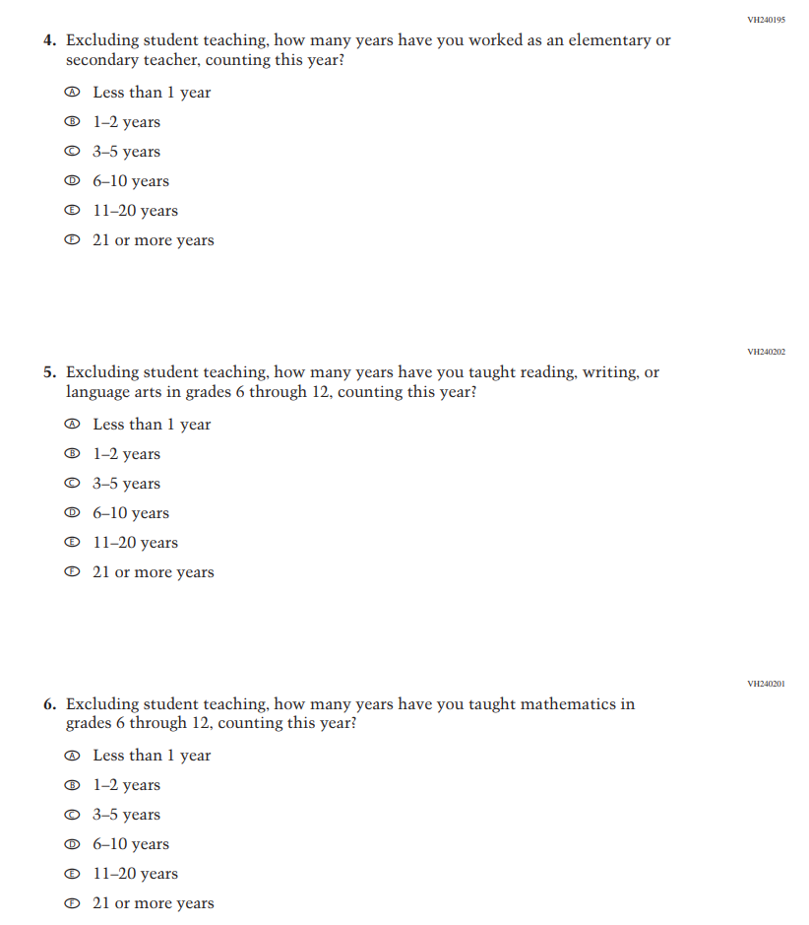
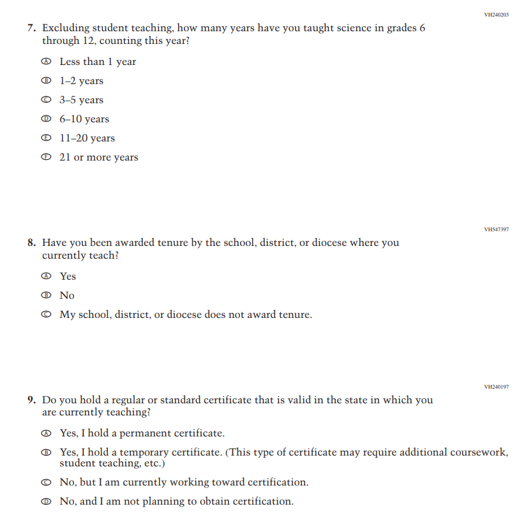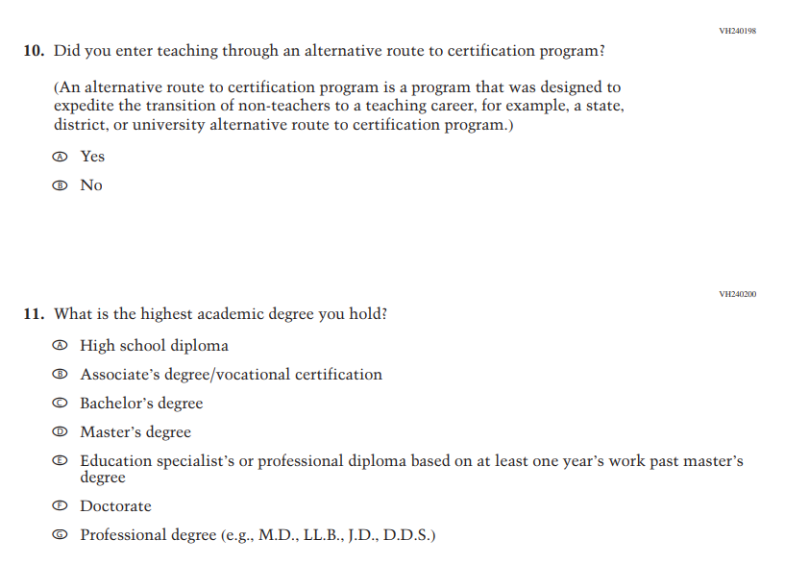
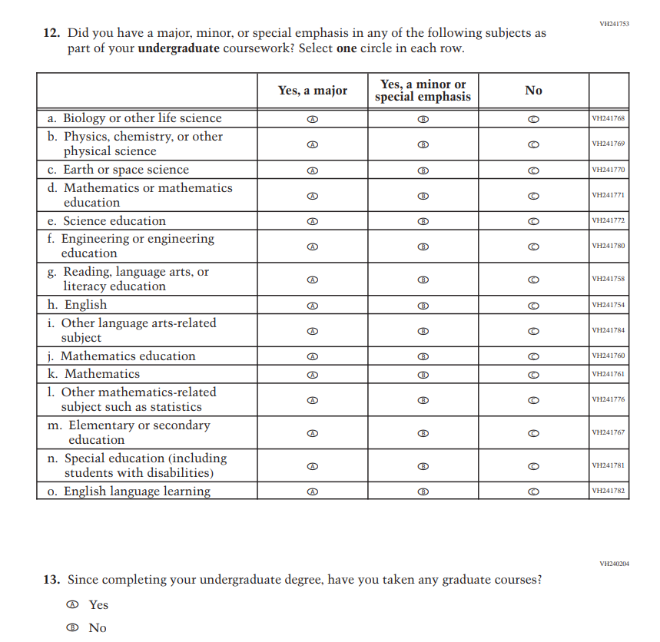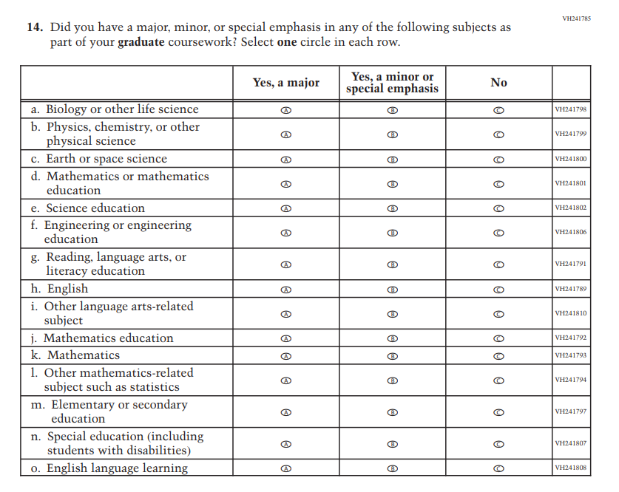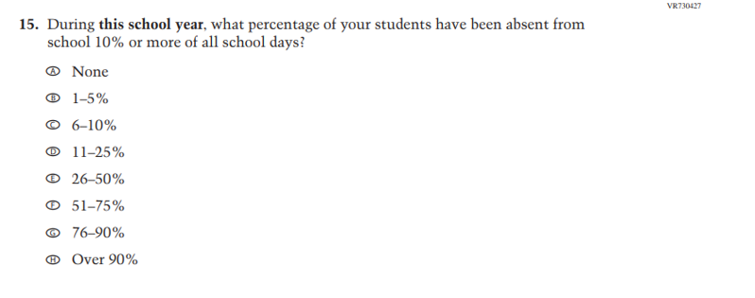
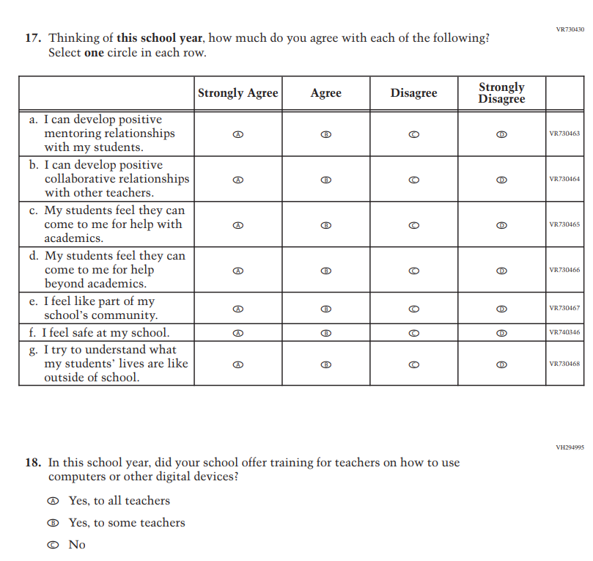
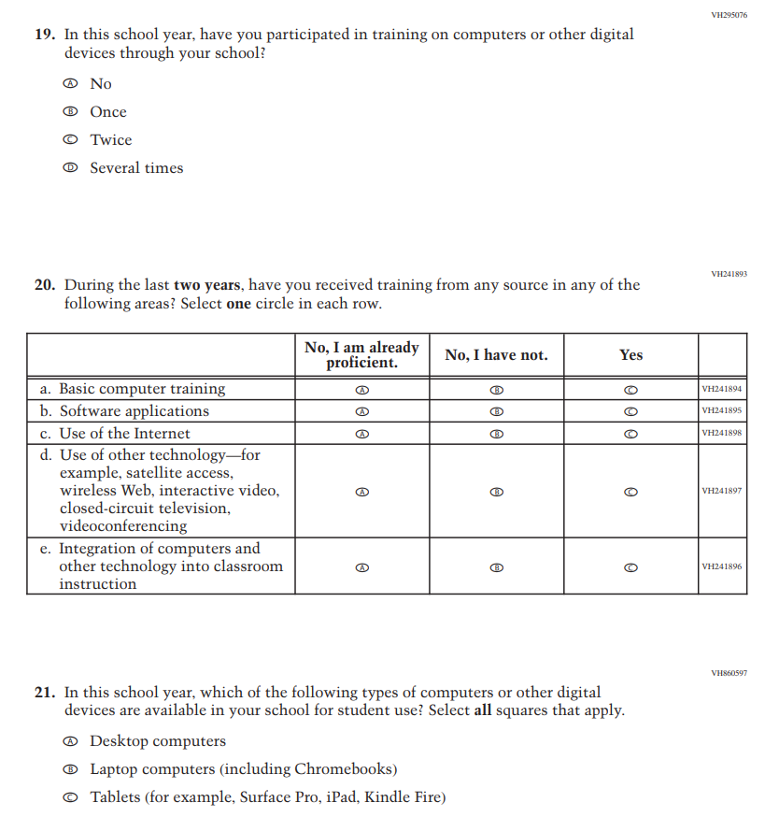
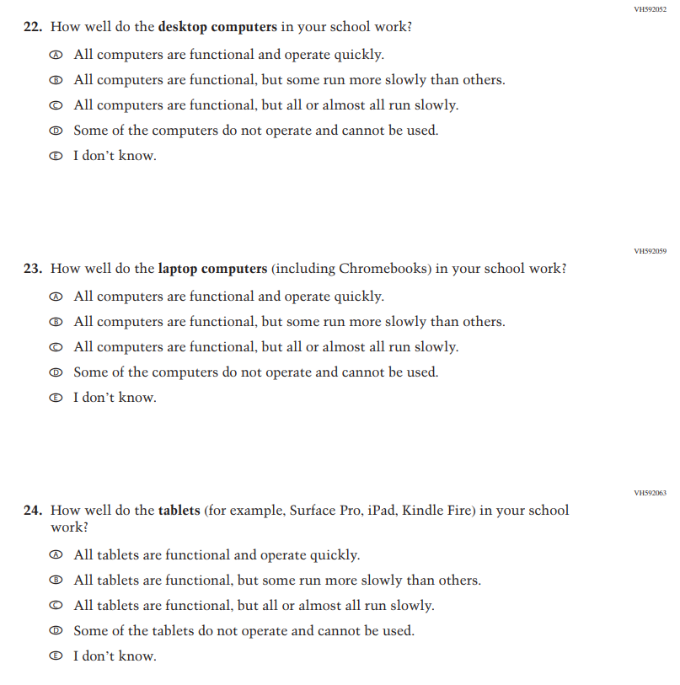
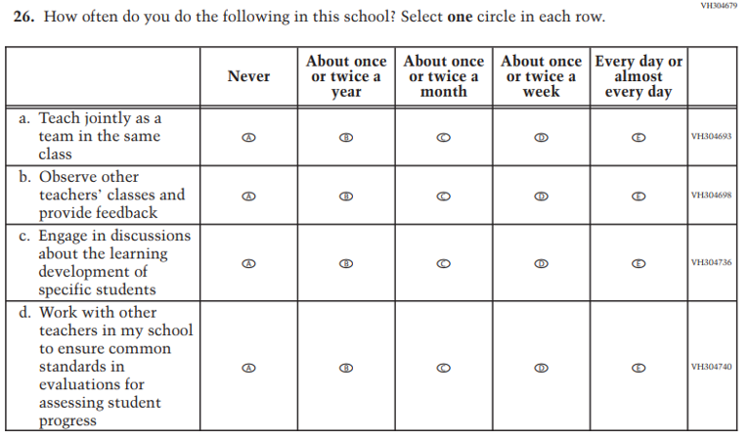
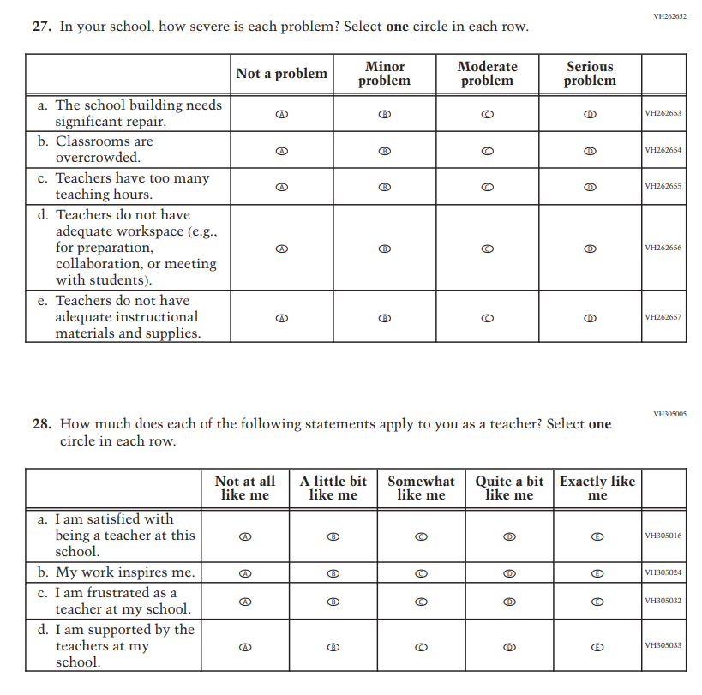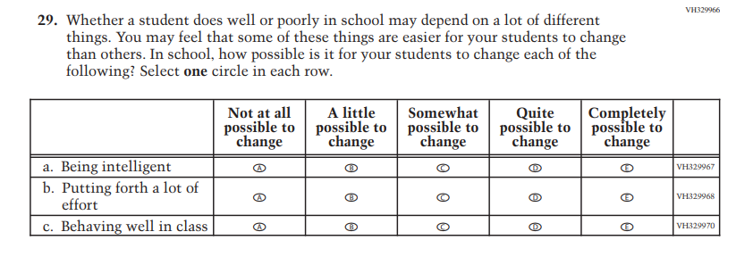

Appendix J2-5: Operational Grade 4 (Mathematics)
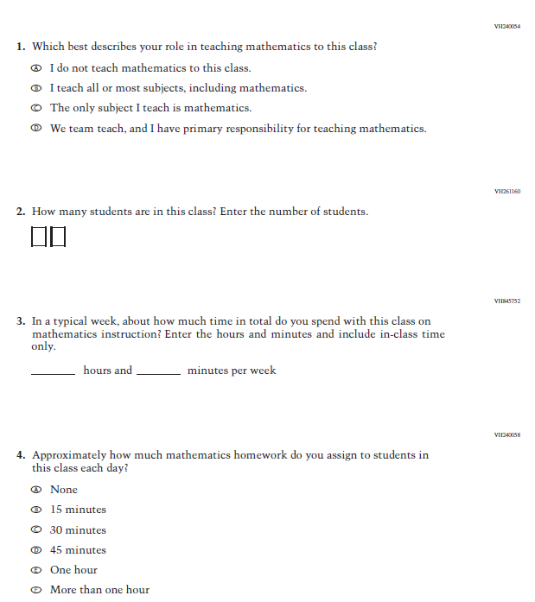

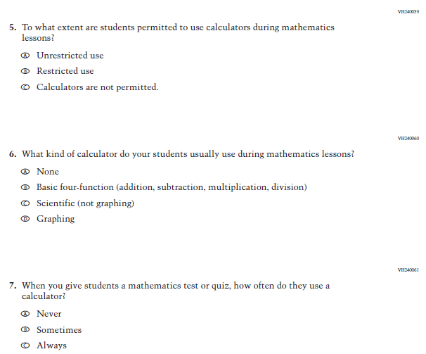

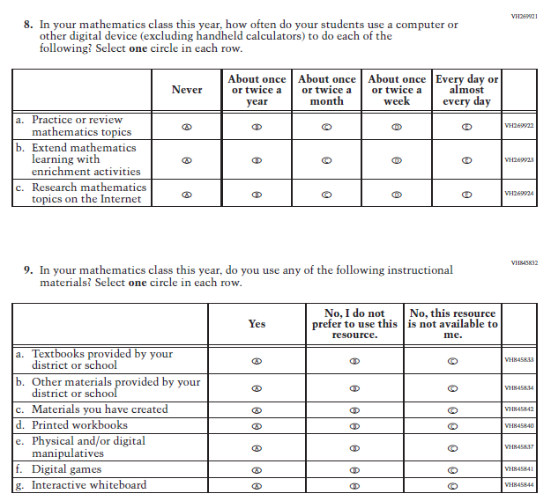

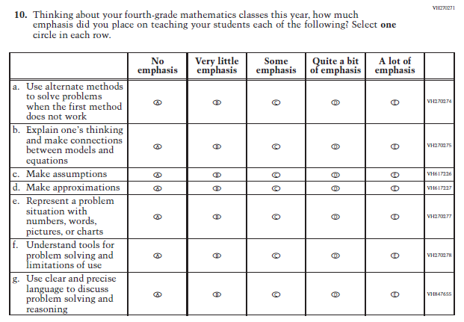

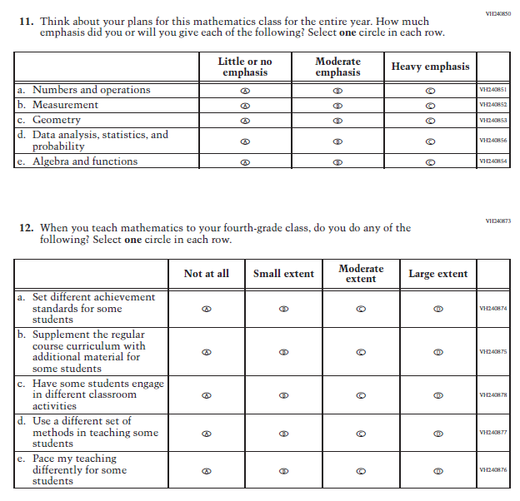

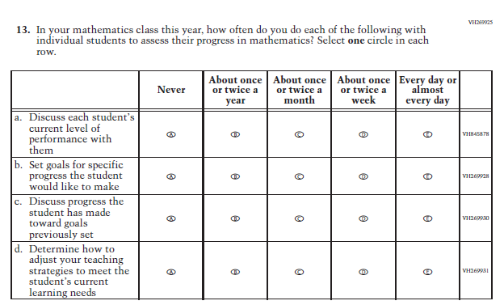

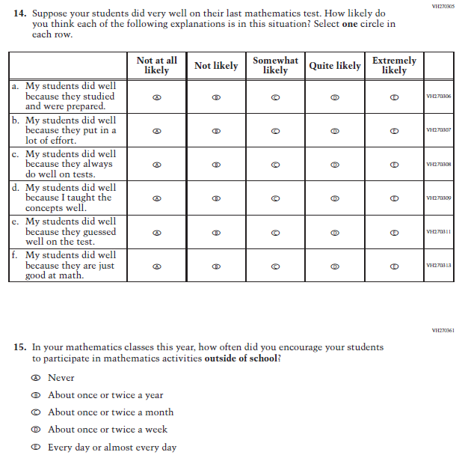

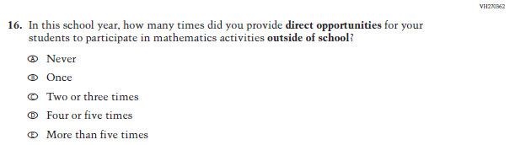

Appendix J2-6: Operational Grade 8 (Mathematics)
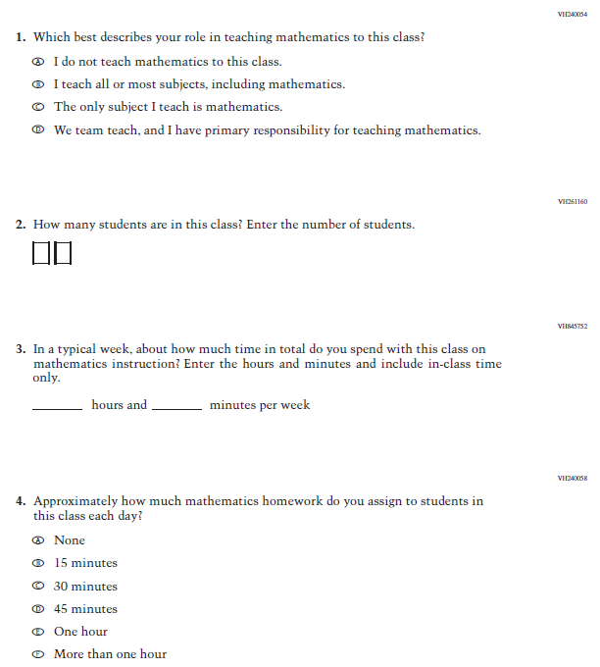

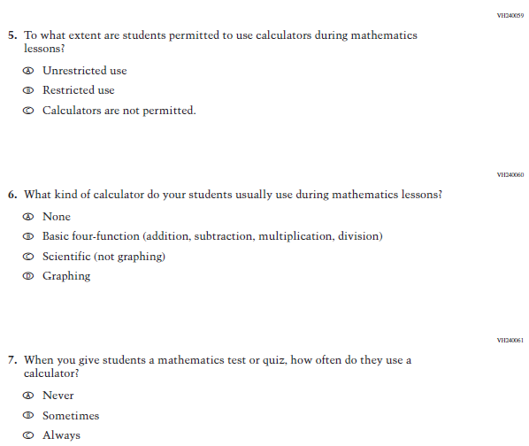

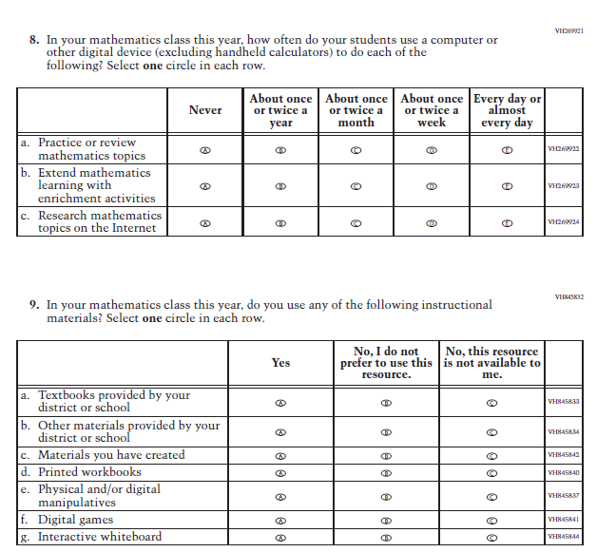

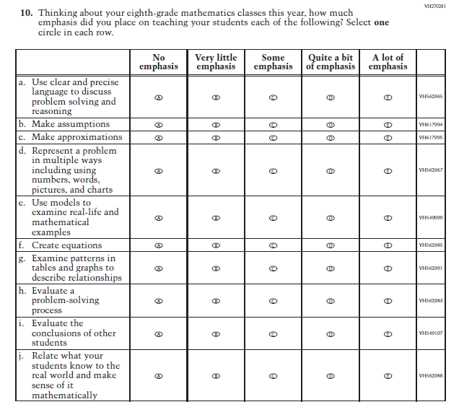

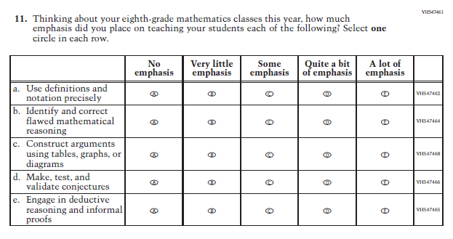

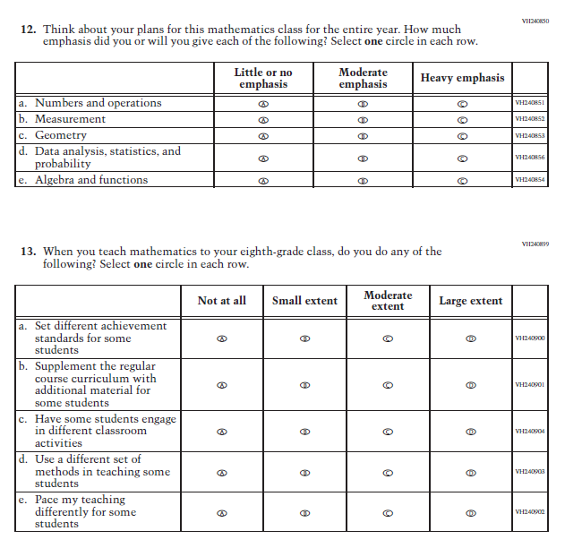

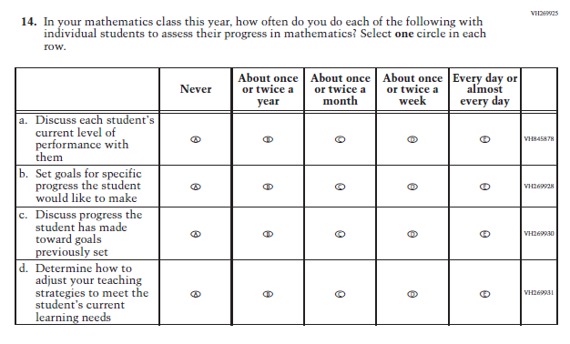

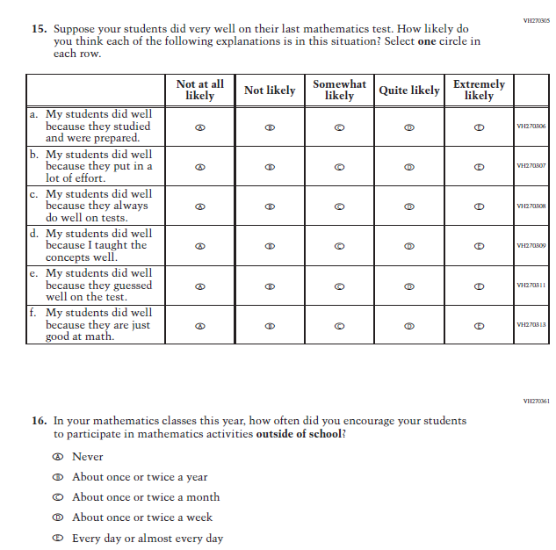

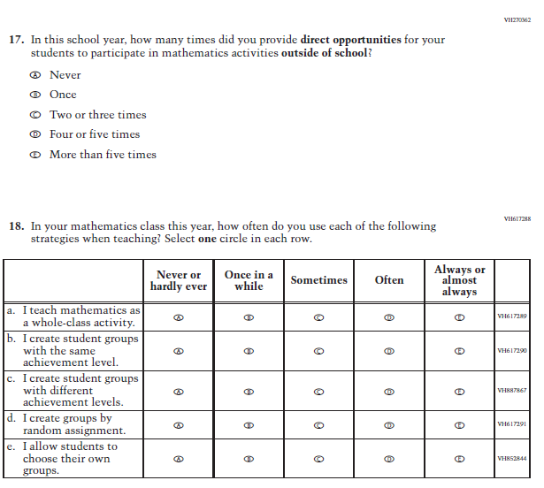

Appendix J2-7: Operational Grade 4 (Reading)
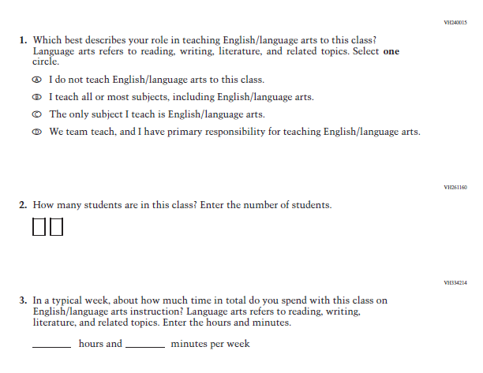

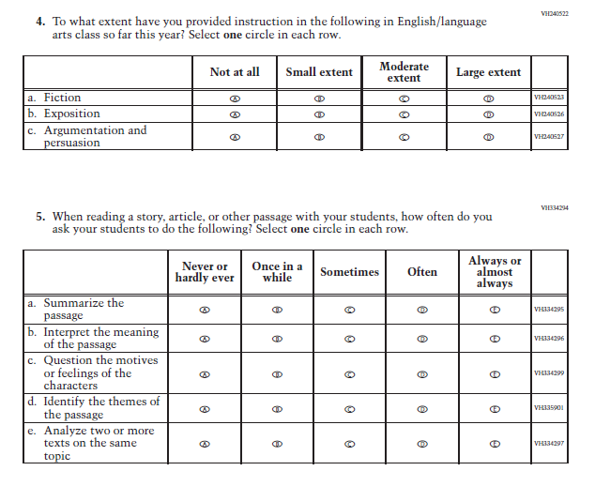

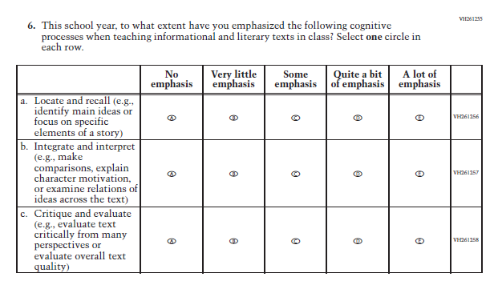

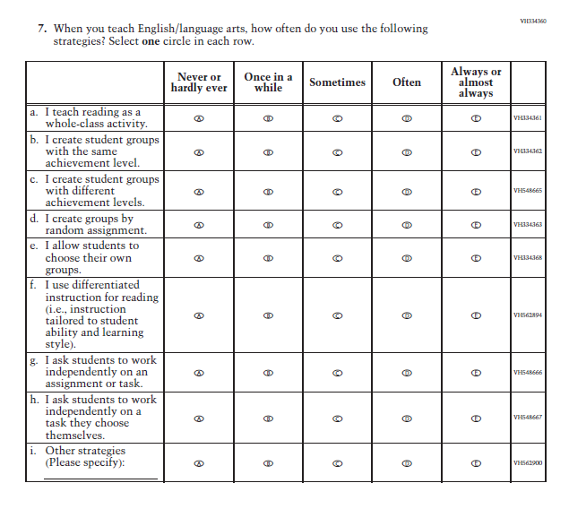

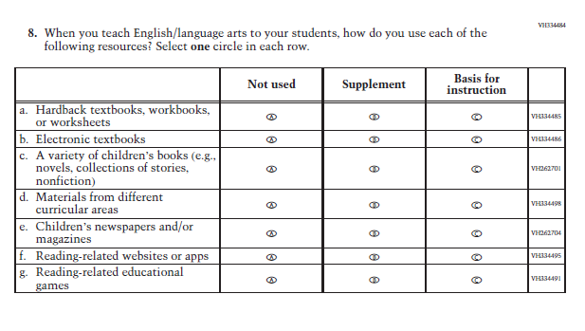

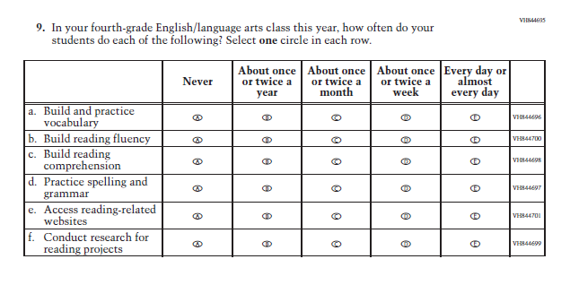

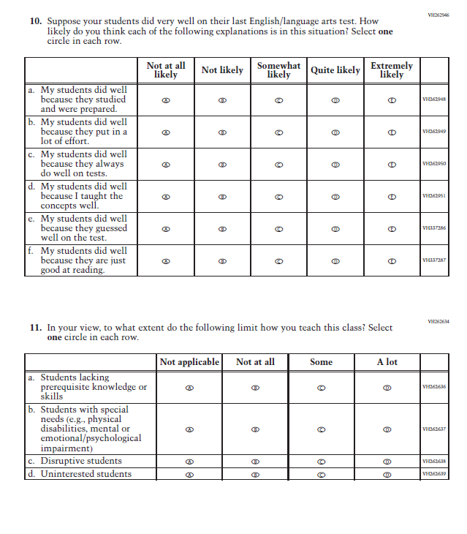

Appendix J2-8: Operational Grade 8 (Reading)
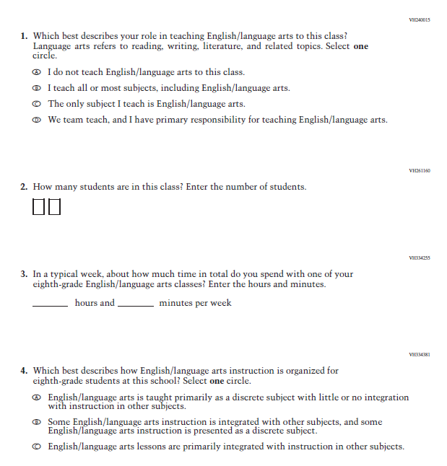

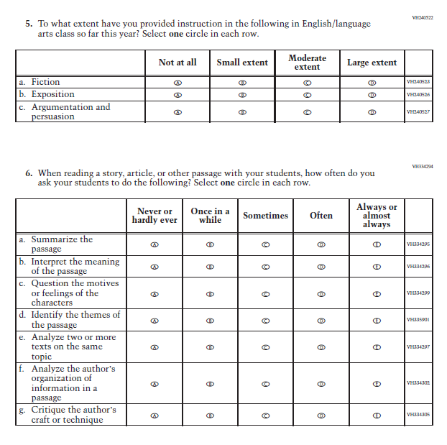

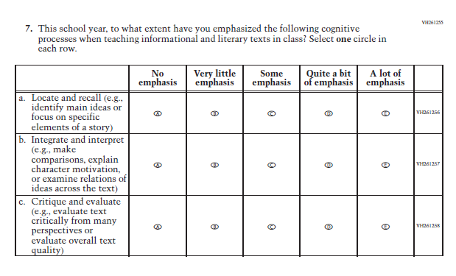

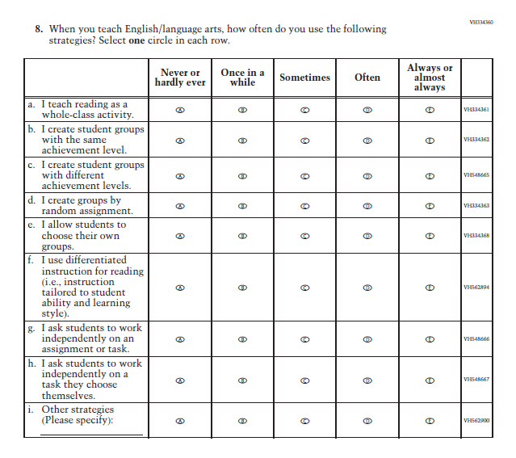

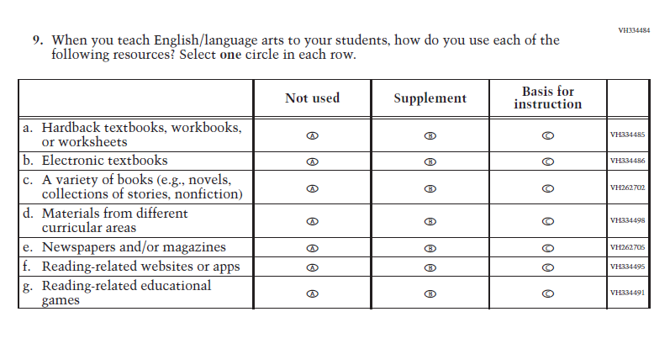

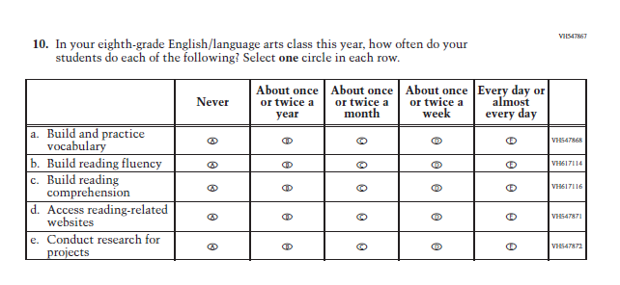

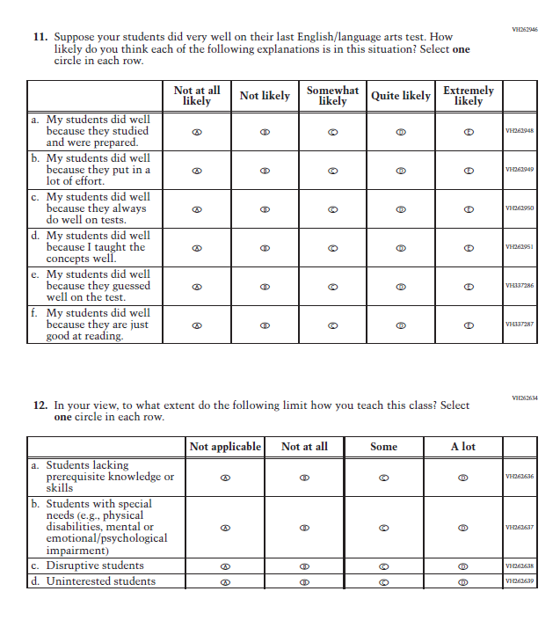

Appendix J2-9: Operational Grade 8 (Science)
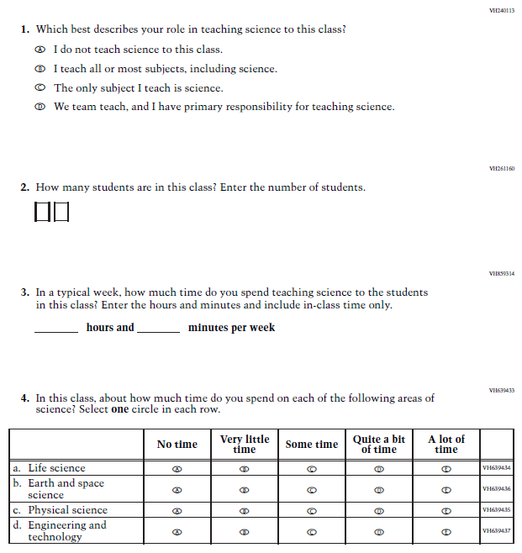

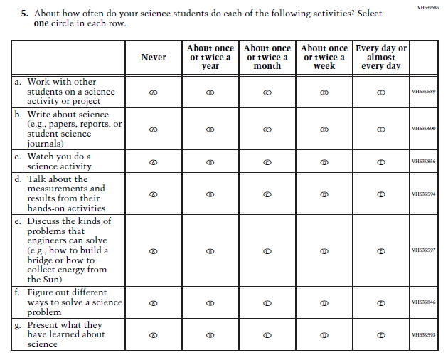

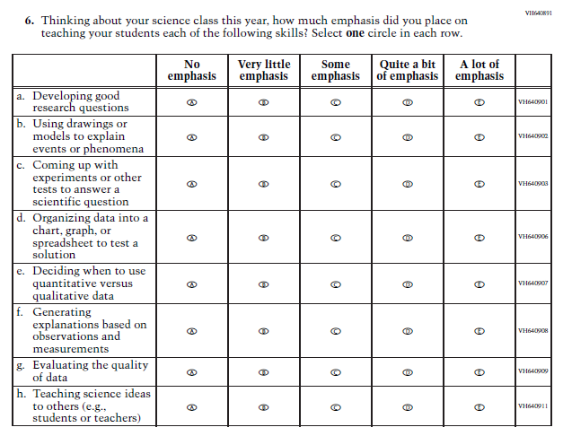
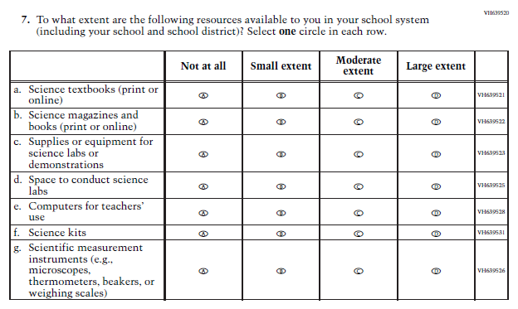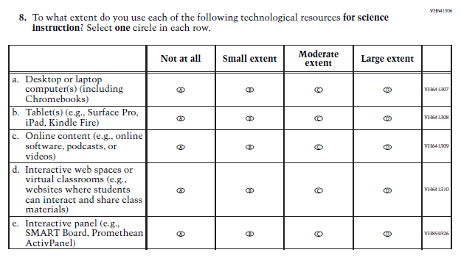

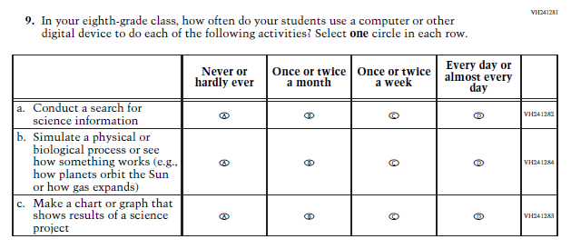
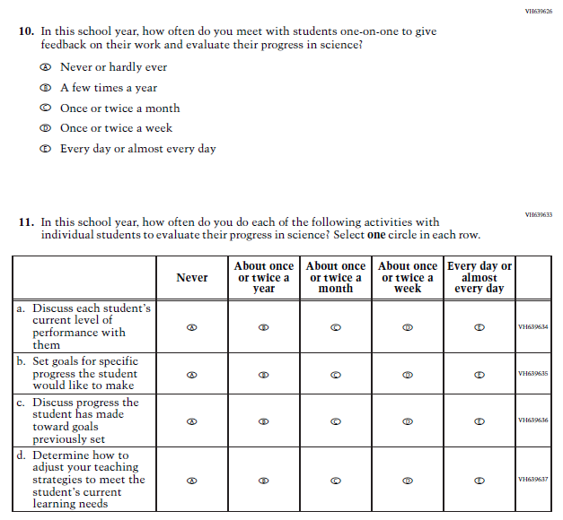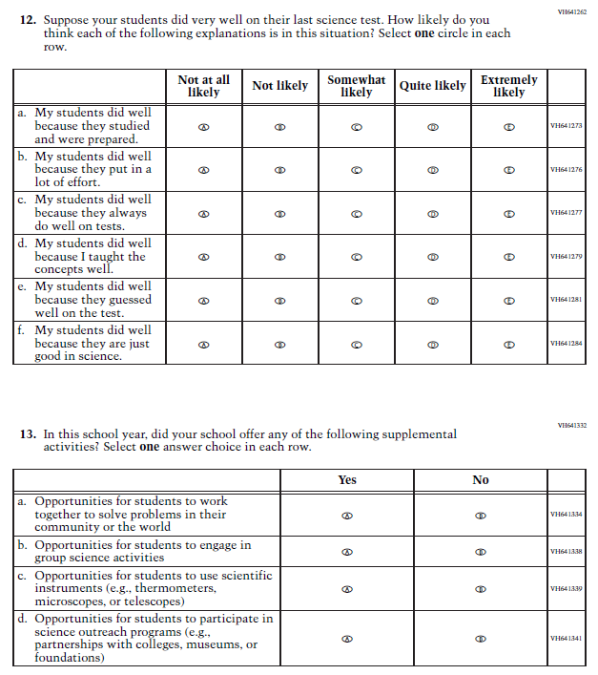

Appendix J2-10: Summary of Changes Operational Grade 4 (NIES)
2024 Operational Grade 4 NIES Teacher
Previous Item | 2024 Item | D/A/ R+ | Rationale
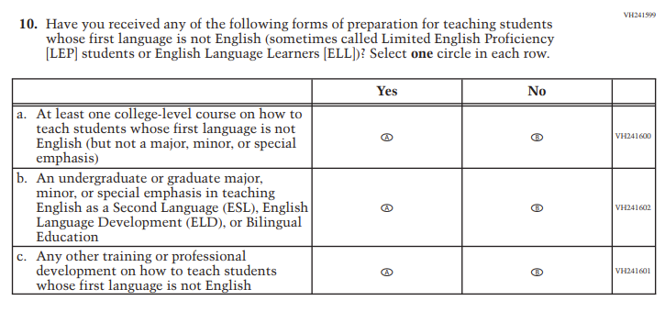 | 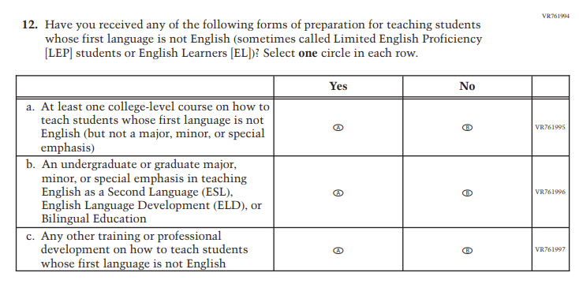 | R | Revised due to updated NCES language conventions.
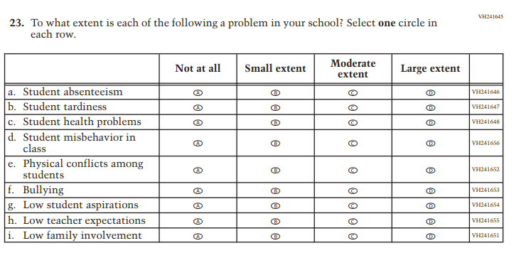 | N/A | D | Dropped due to expert group feedback.
N/A | 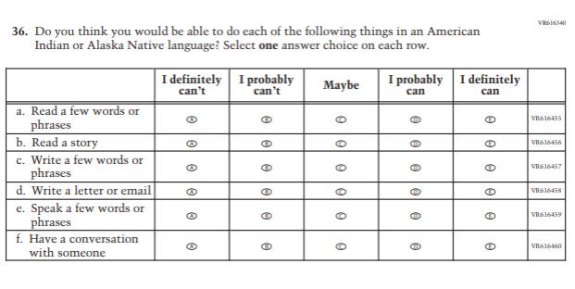 | A | Added to extend coverage of language use.
N/A | 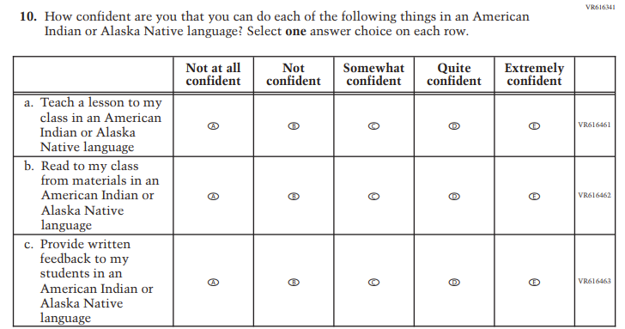 | A | Added to extend coverage of language use.
N/A | 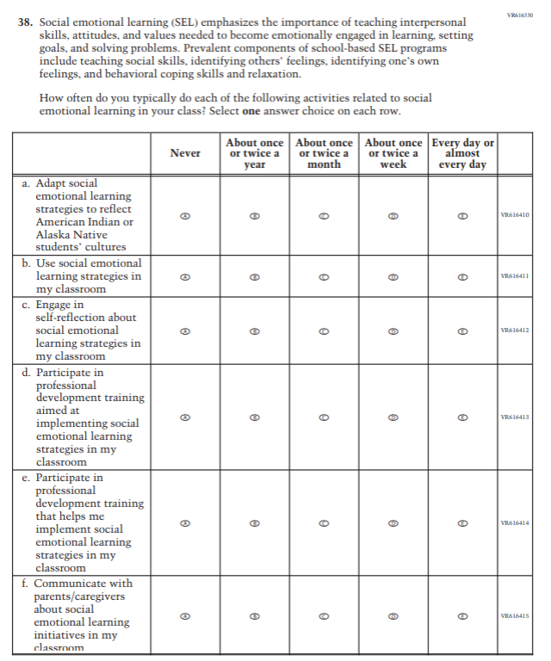 | A | Added to cover social emotional learning.
N/A | 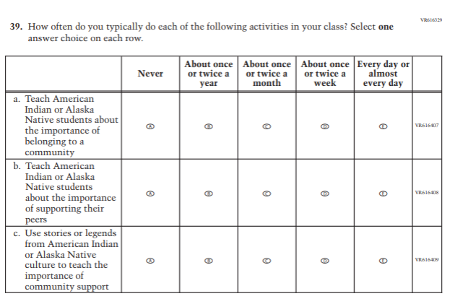 | A | Added to cover social emotional learning.
N/A | 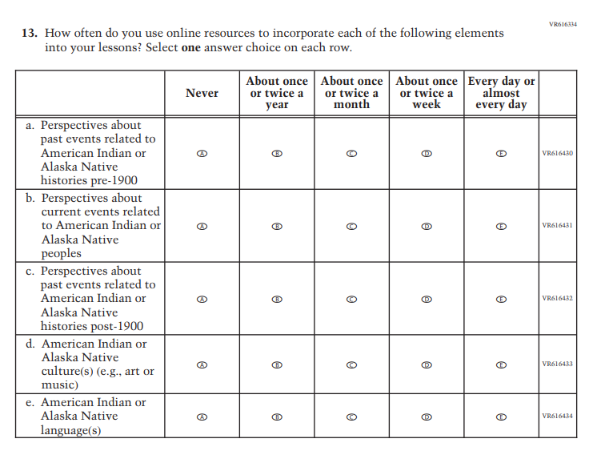 | A | Added to cover instructional practices.
N/A | 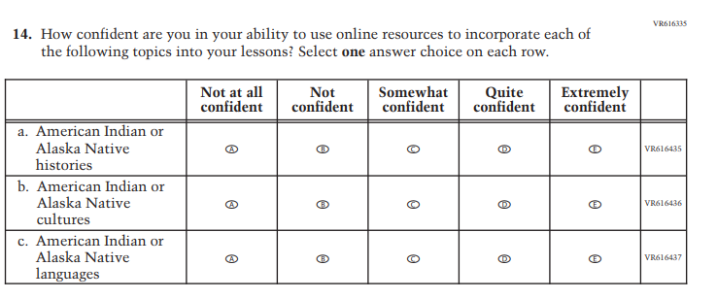 | A | Added to cover new aspects of instructional practices.
N/A | 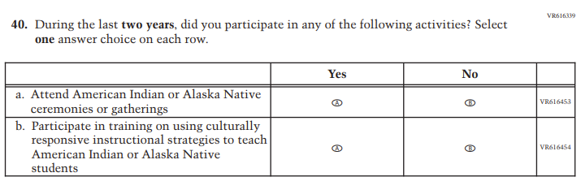 | A | Added to cover new aspects of professional development.
N/A | 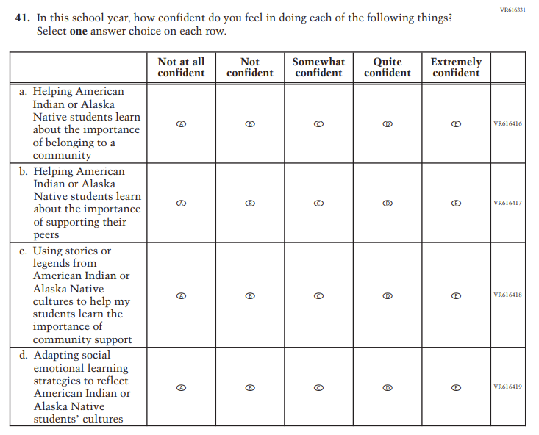 |  | Added to cover social emotional learning.
N/A | 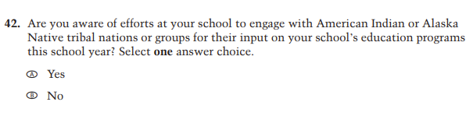  VR616316 | A | Added to cover American Indian/Alaska Native engagement.
N/A | 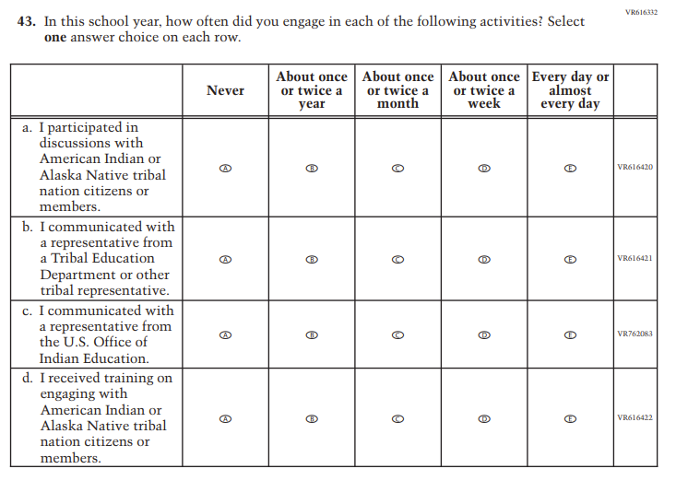 | A | Added to cover American Indian/Alaska Native engagement.
N/A | 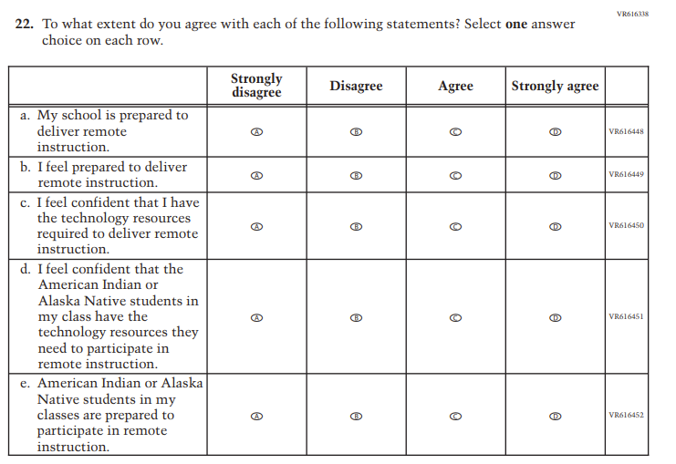 | A | Added to cover remote learning experiences.
N/A | 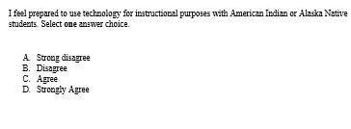 | A | Added to cover use of technology.

Appendix J2-11: Operational Grade 4 (NIES)
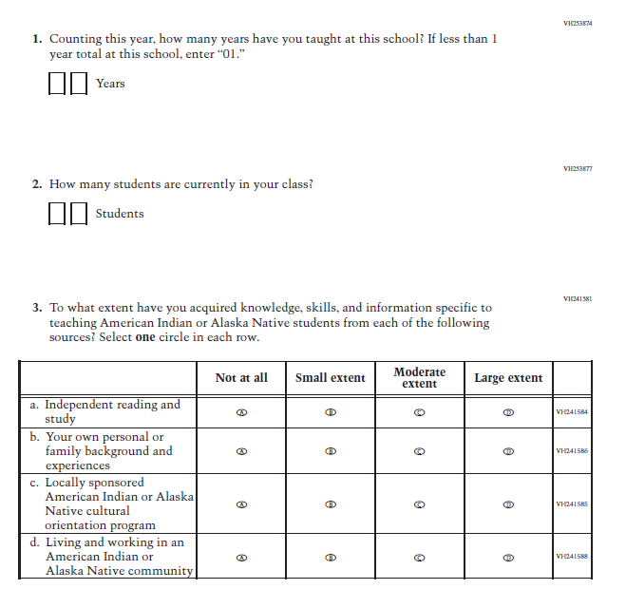
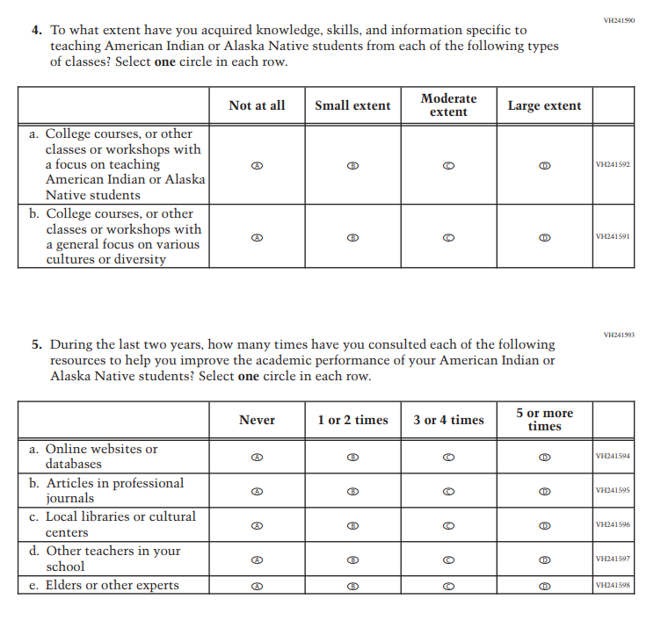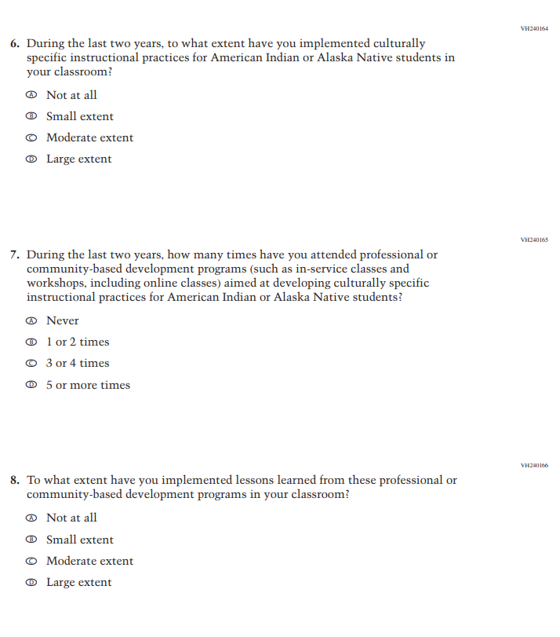
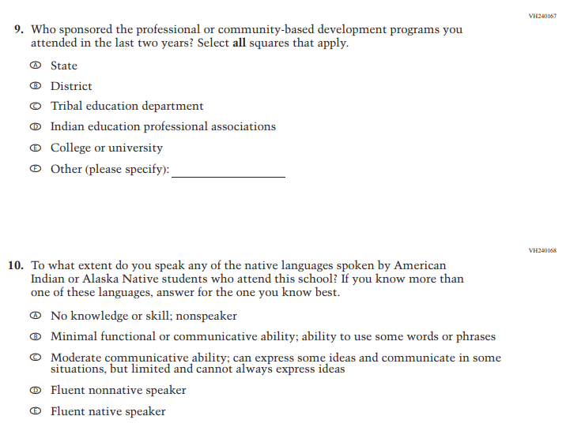
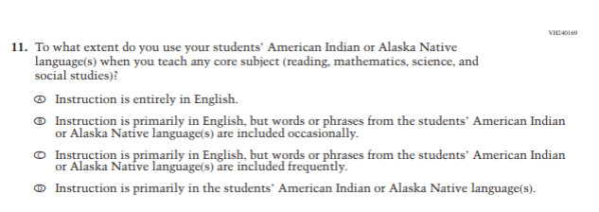
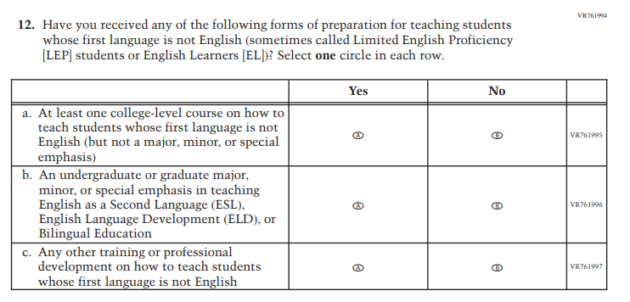

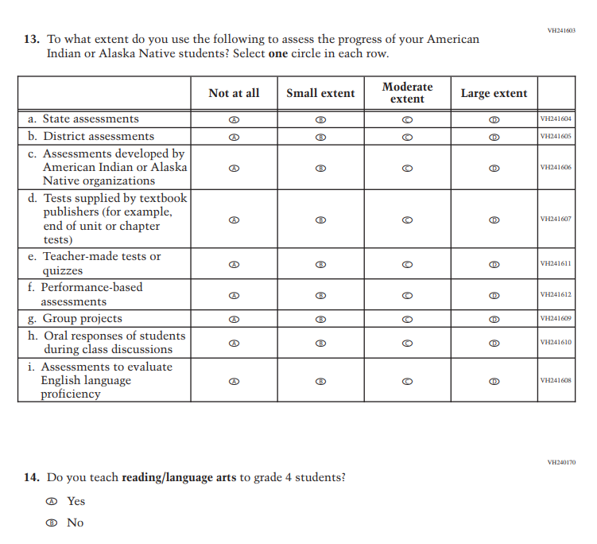
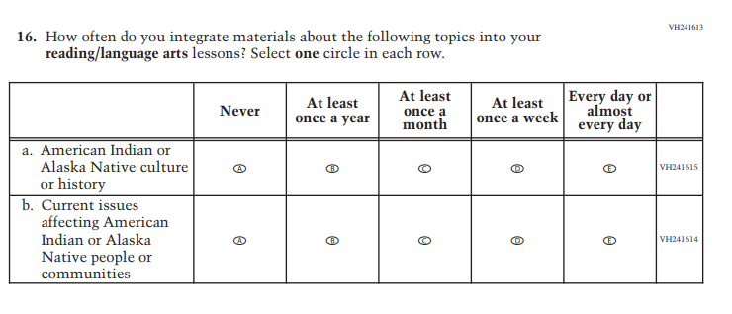
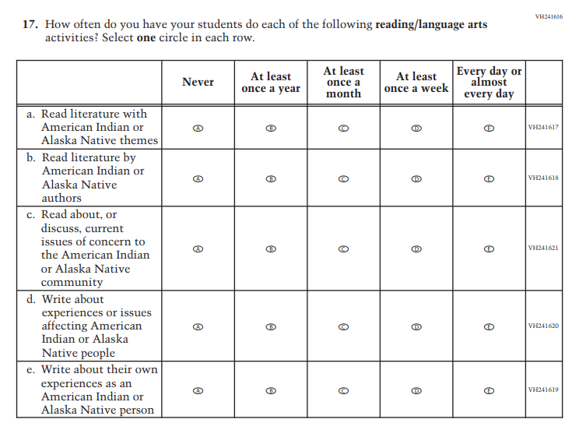
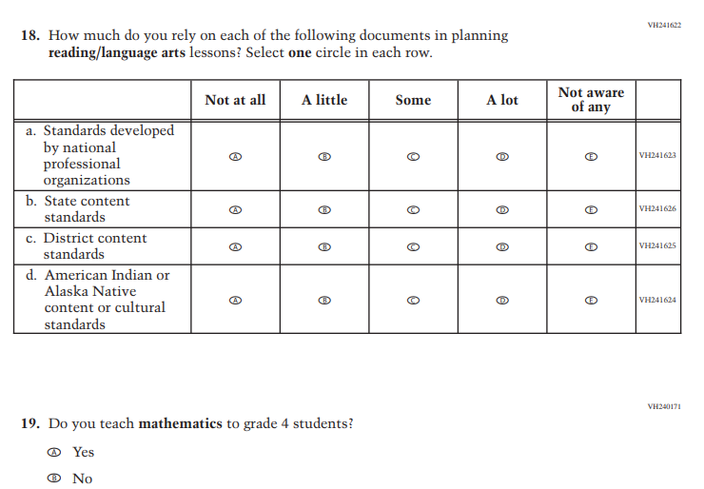
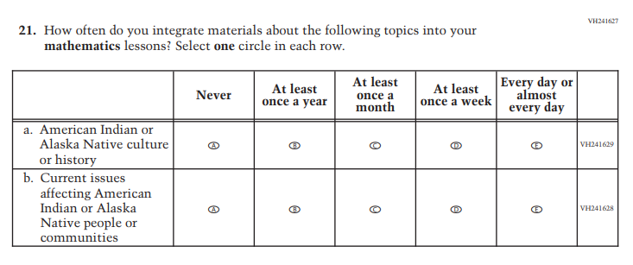
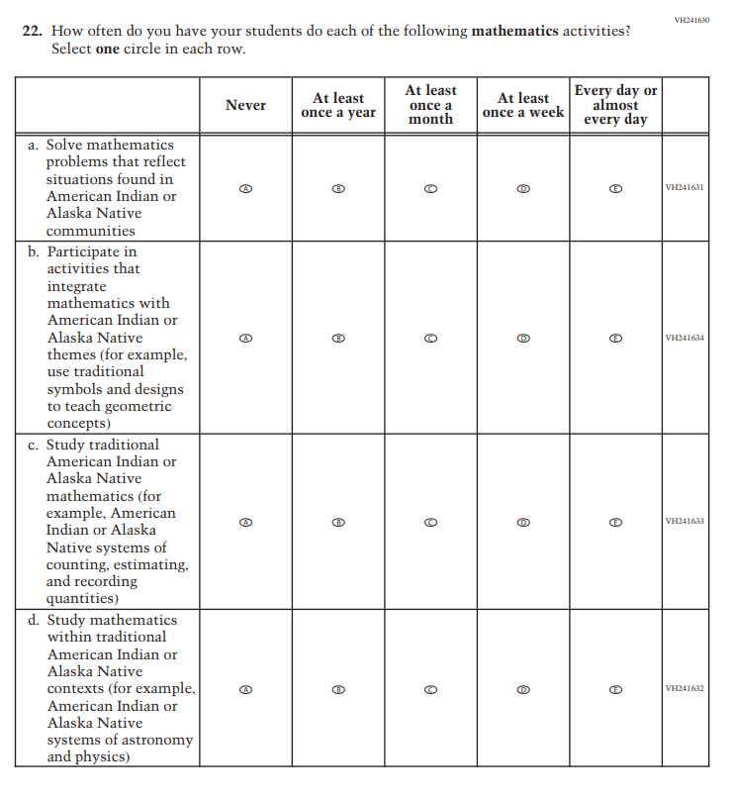
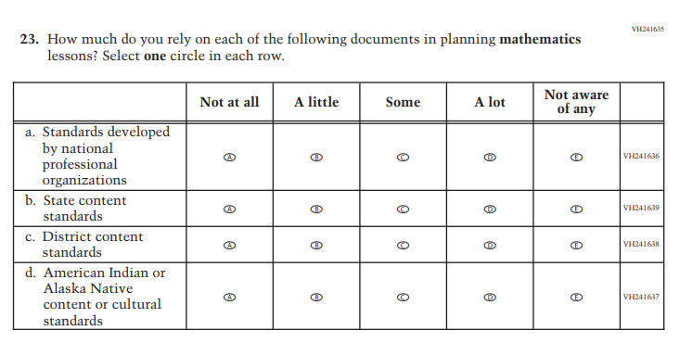
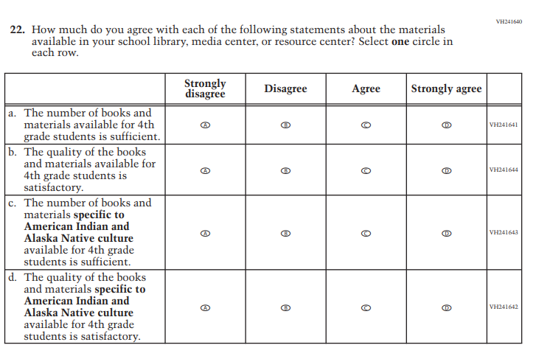
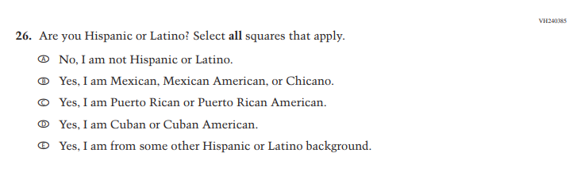
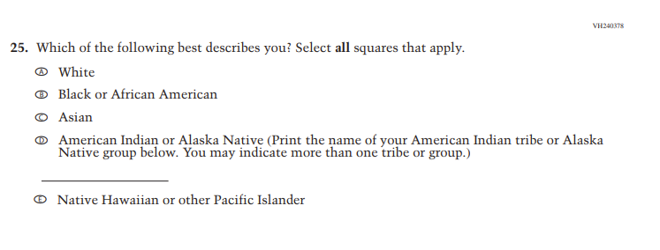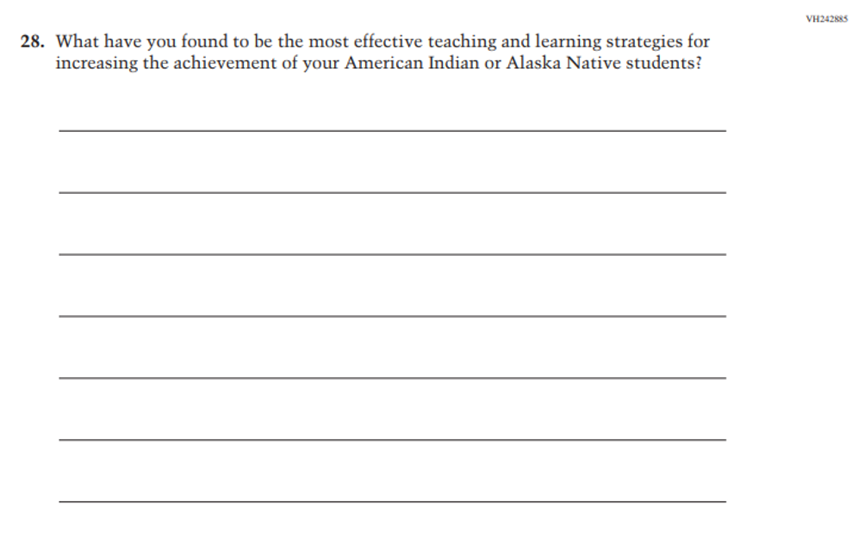
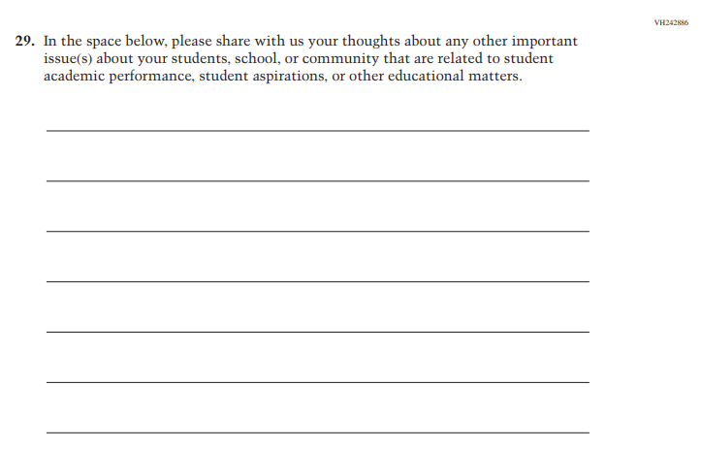
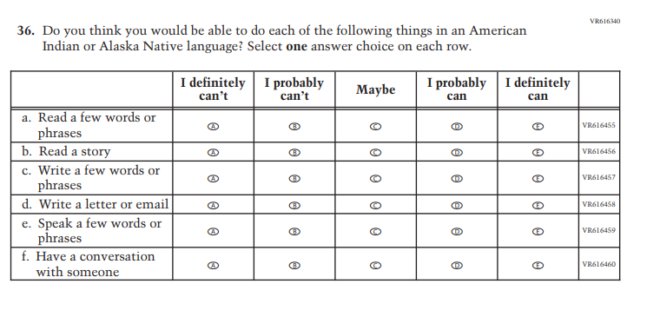
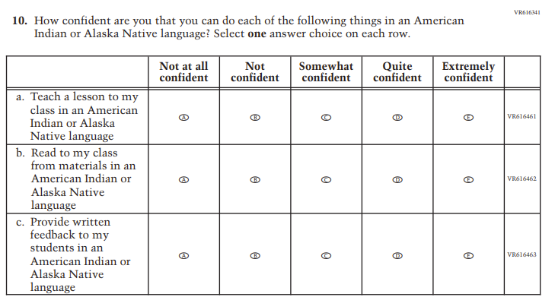

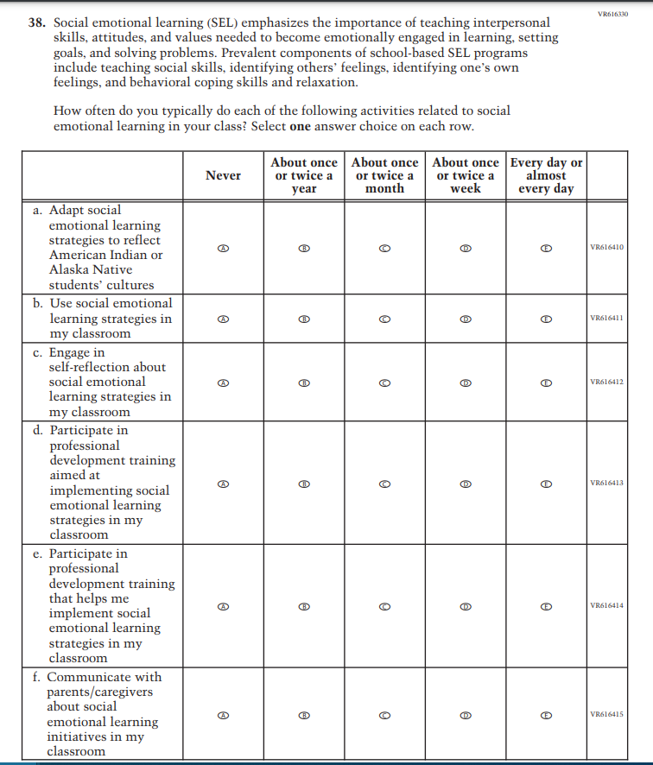
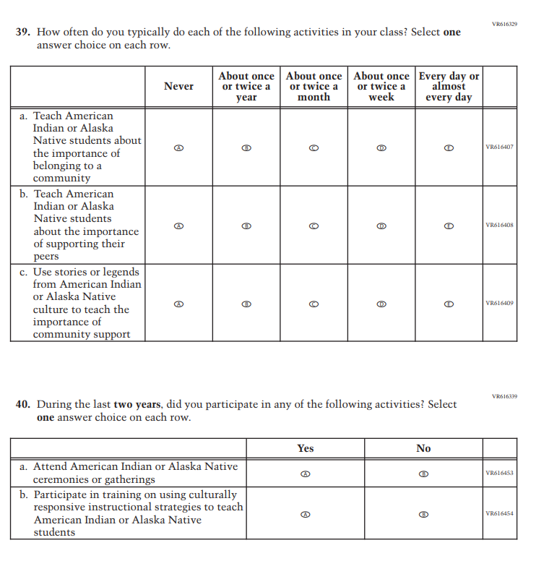
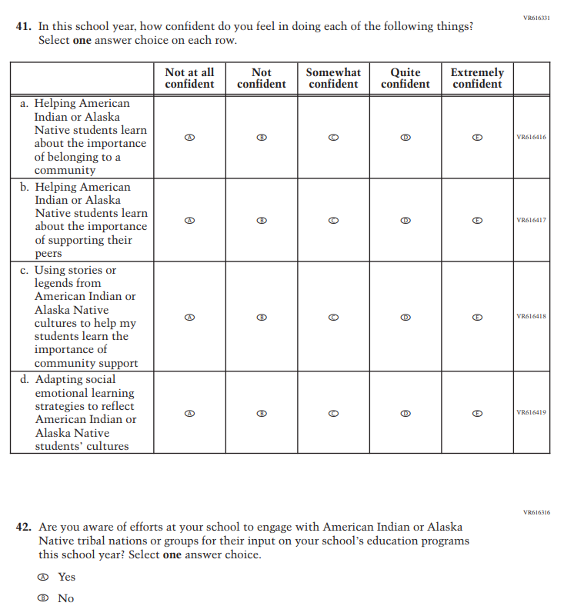
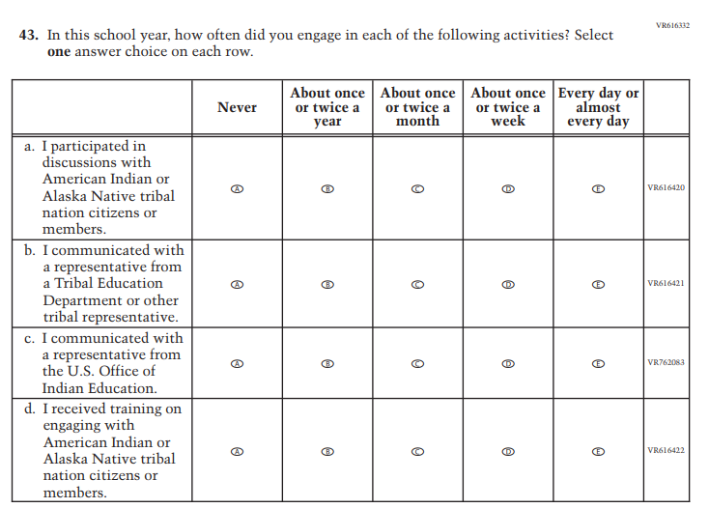

I feel prepared to use technology for instructional purposes with American Indian or Alaska Native students. Select one answer choice.

- Strong disagree
- Disagree
- Agree
- Strongly Agree

Appendix J2-12: Summary of Changes Operational Grade 8 (NIES)
2024 Operational Grade 8 NIES Teacher
Previous Item | 2024 Item | D/A/ R+ | Rationale
 |  | R | Revised due to updated NCES language conventions.
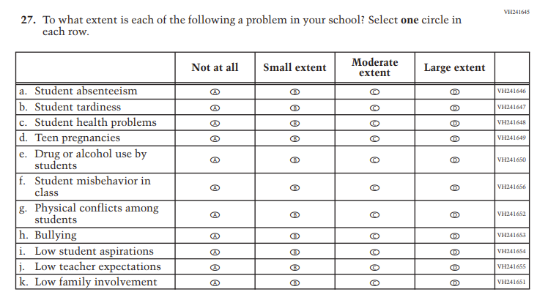 | N/A | D | Dropped due to expert group feedback.
N/A |  | A | Added to extend coverage of language use.
N/A |  | A | Added to extend coverage of language use.
N/A |  | A | Added to cover social emotional learning.
N/A |  | A | Added to cover social emotional learning.
N/A |  | A | Added to cover instructional practices.
N/A |  | A | Added to cover instructional practices.
N/A |  | A | Added to cover professional development.
N/A |  |  | Added to cover social emotional learning.
N/A | VR616316 | A | Added to cover American Indian/Alaska Native engagement.
N/A |  | A | Added to cover American Indian/Alaska Native engagement.
N/A |  | A | Added to cover remote learning experiences.
N/A |  | A | Added to cover use of technology.

Appendix J2-13: Operational Grade 8 (NIES)
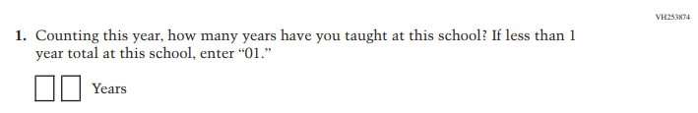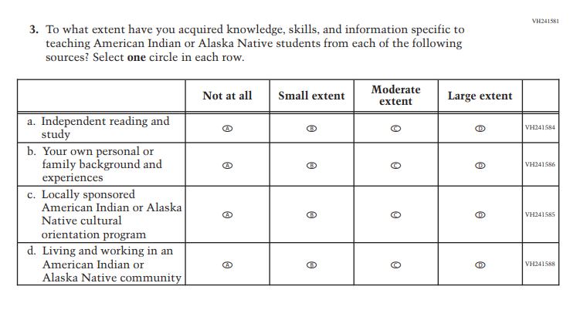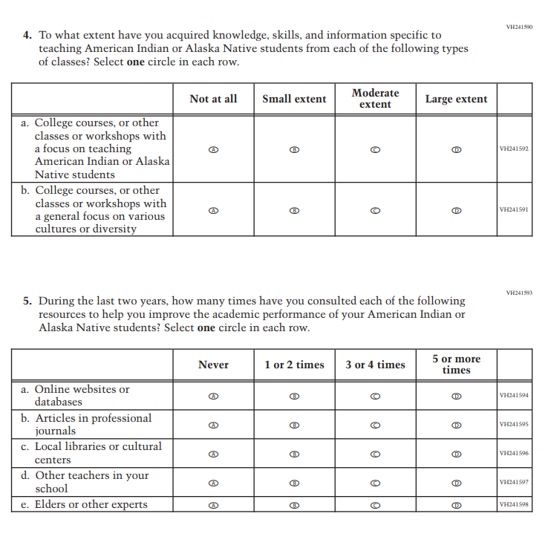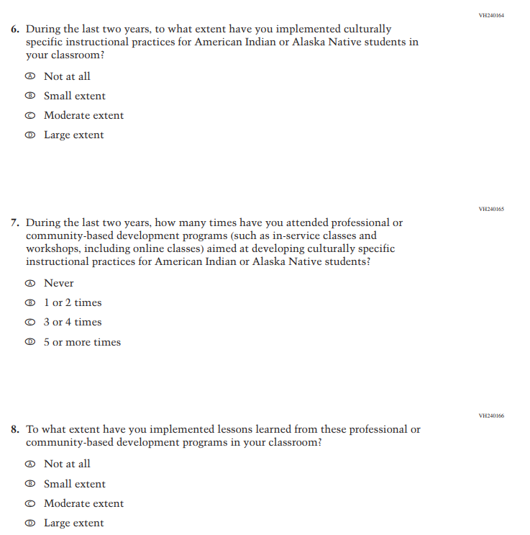
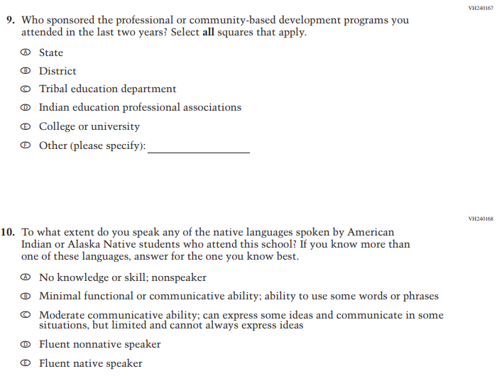

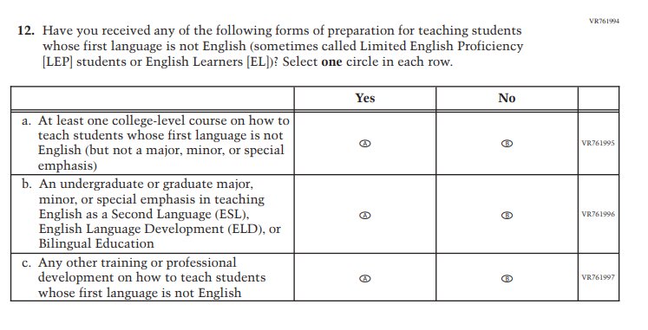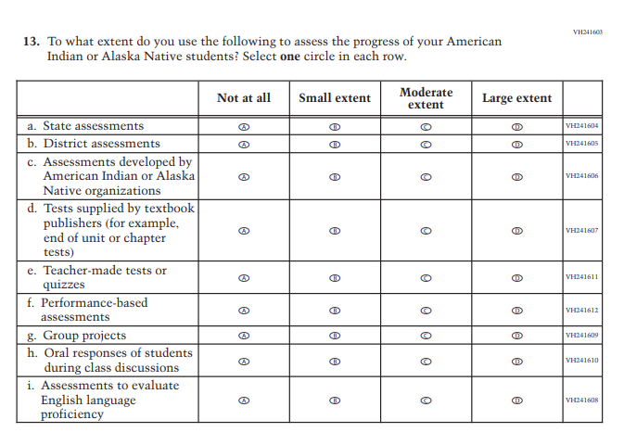
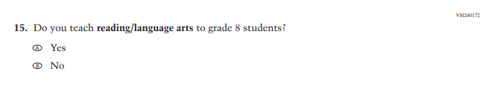
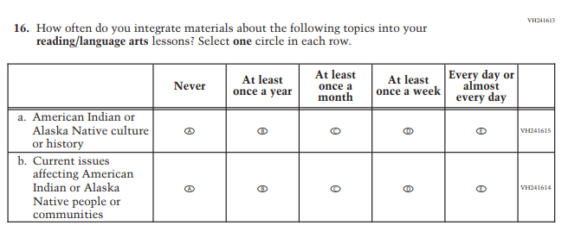
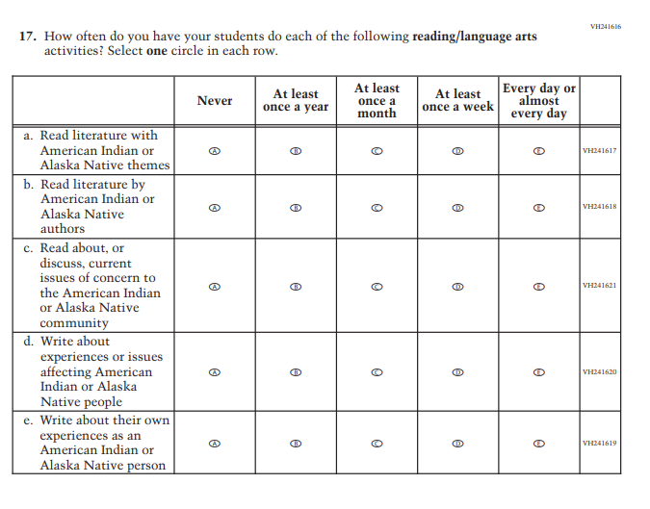
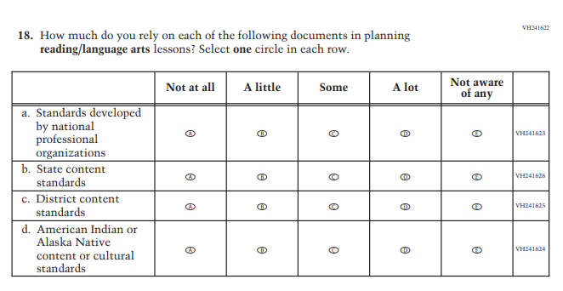
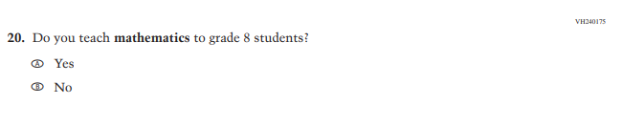
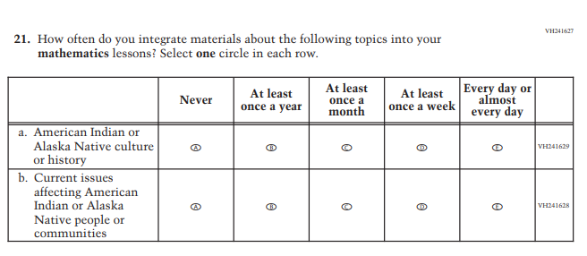
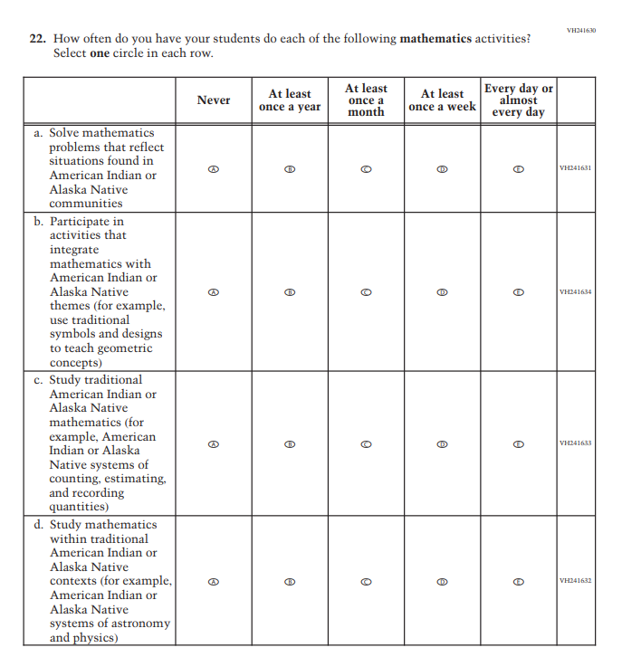
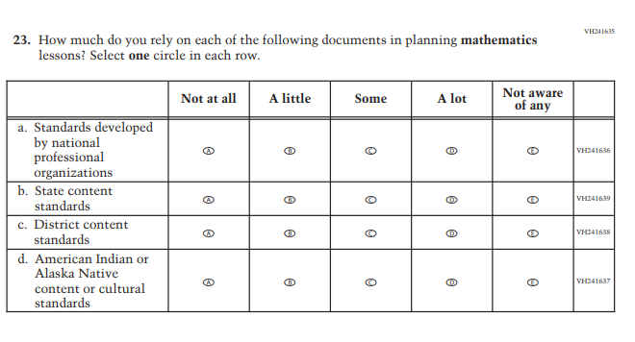
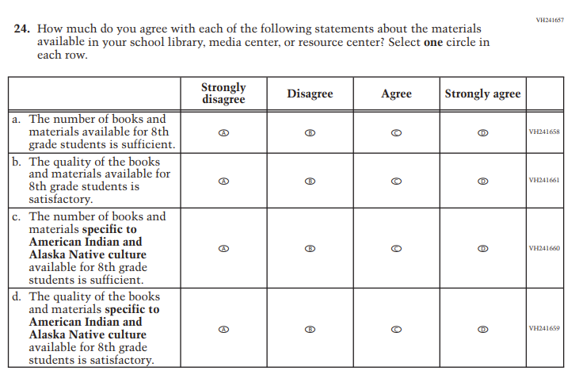
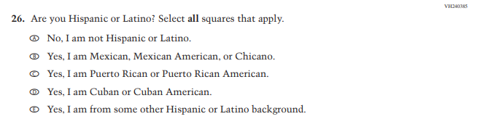
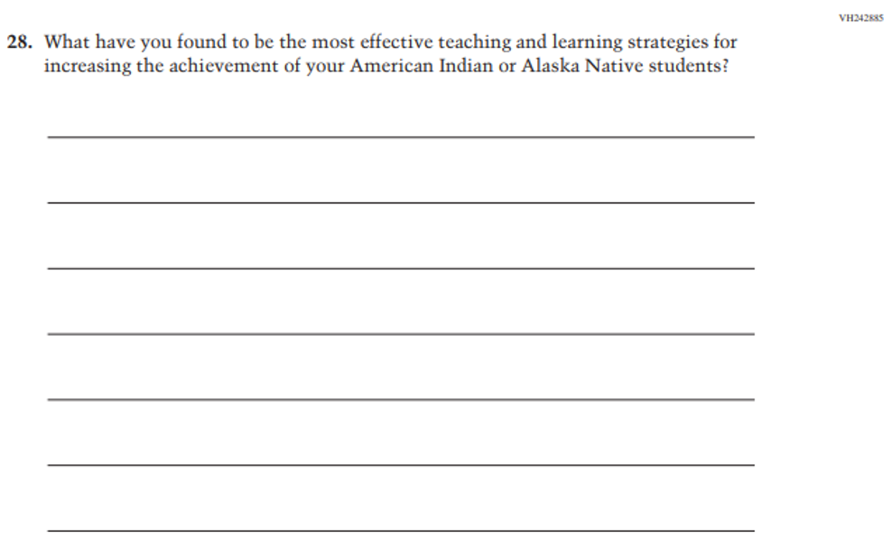
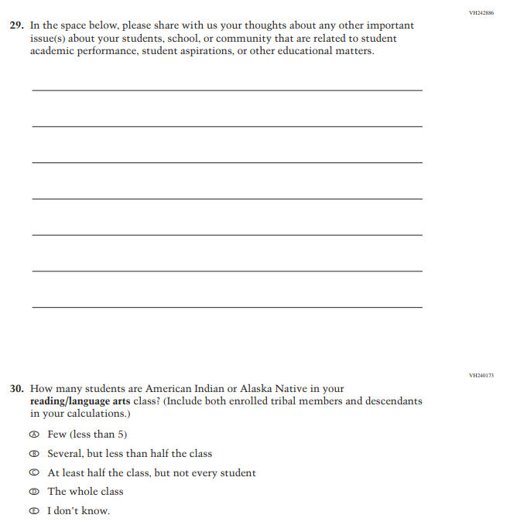
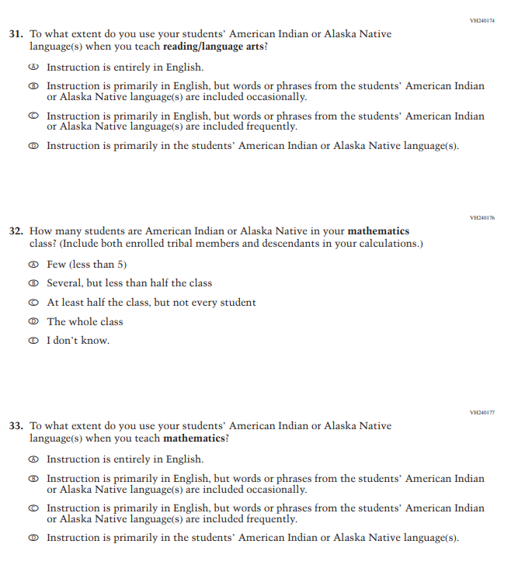
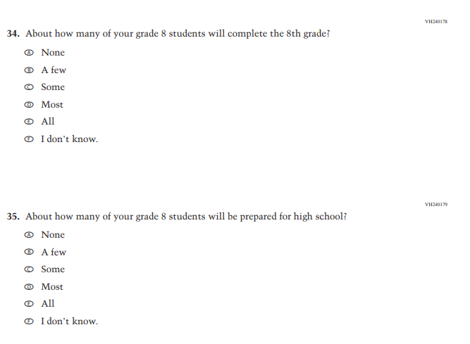
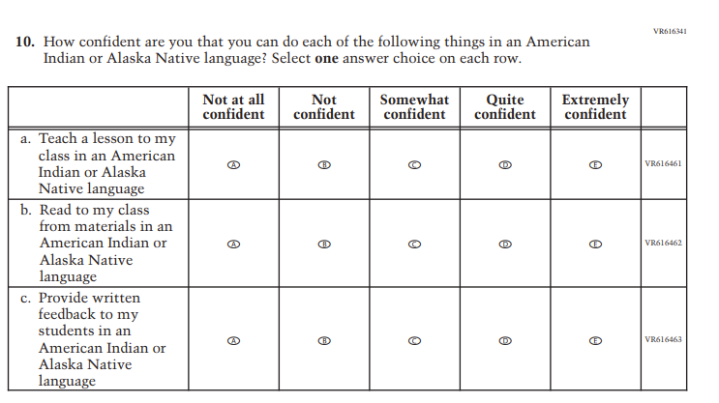
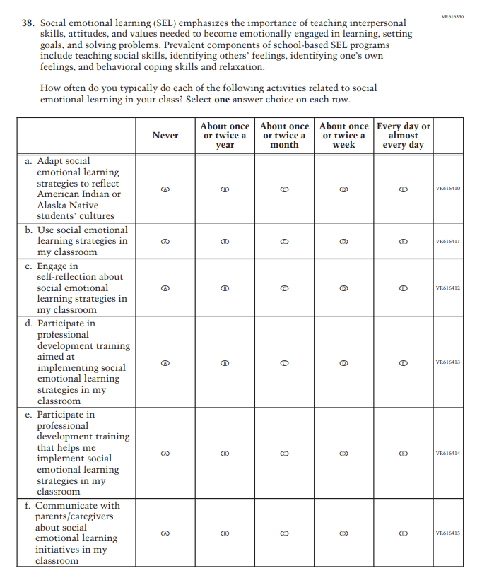
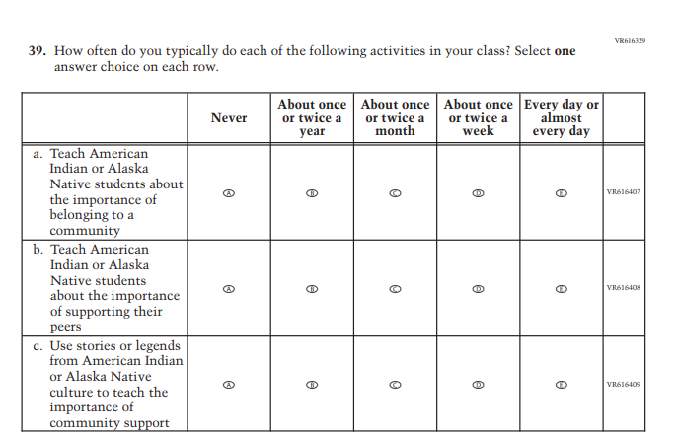
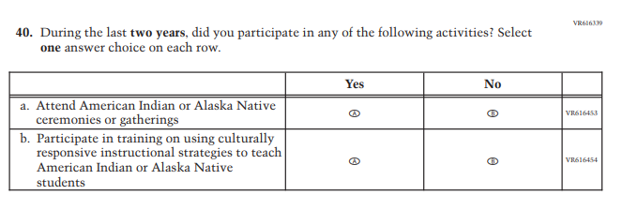
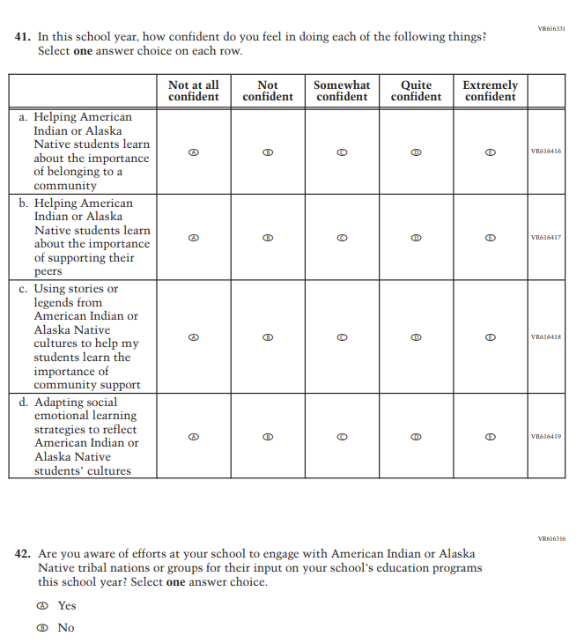
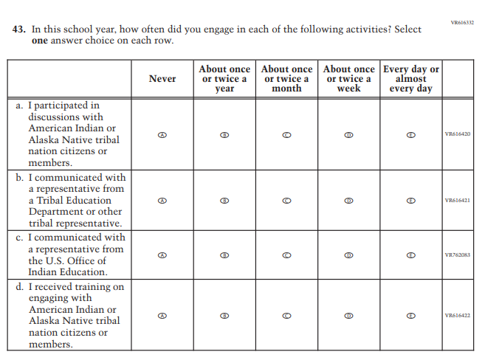

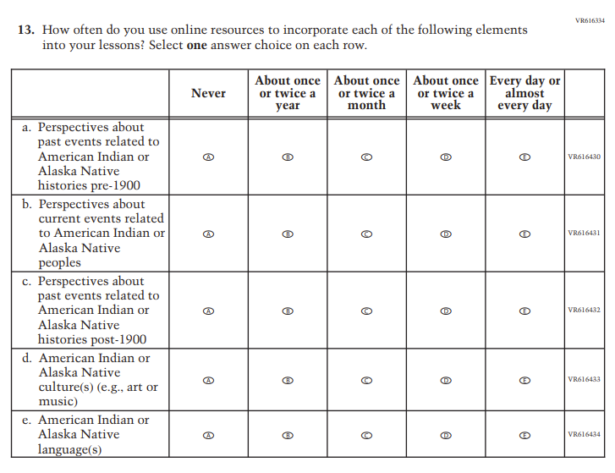
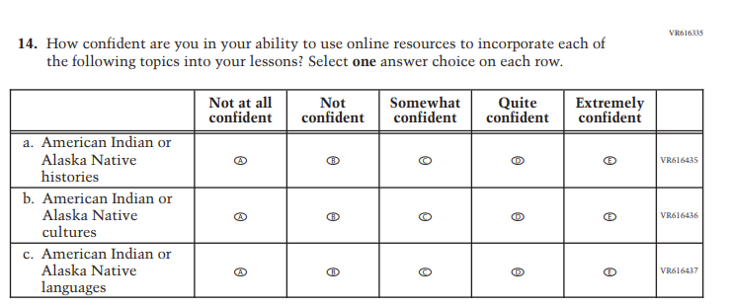

I feel prepared to use technology for instructional purposes with American Indian or Alaska Native students. Select one answer choice.

- Strong disagree
- Disagree
- Agree
- Strongly Agree

Appendix J2-14: Pilot Reading and Mathematics Grade 4 (Core)
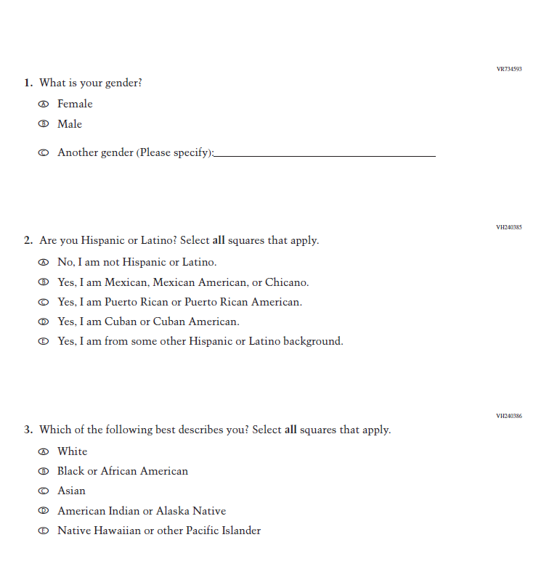
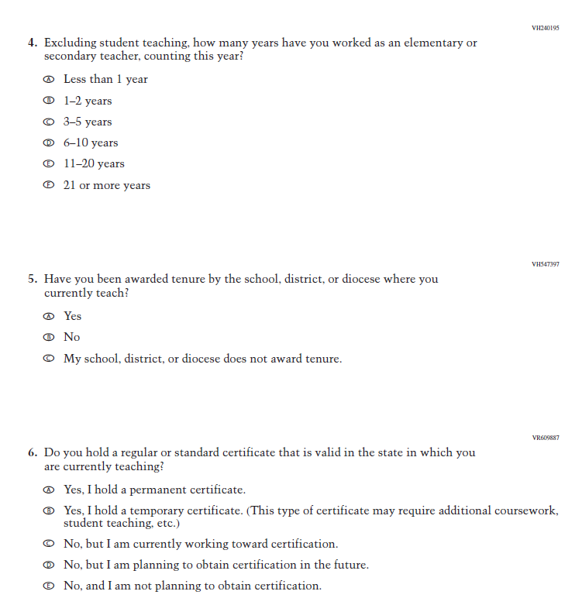
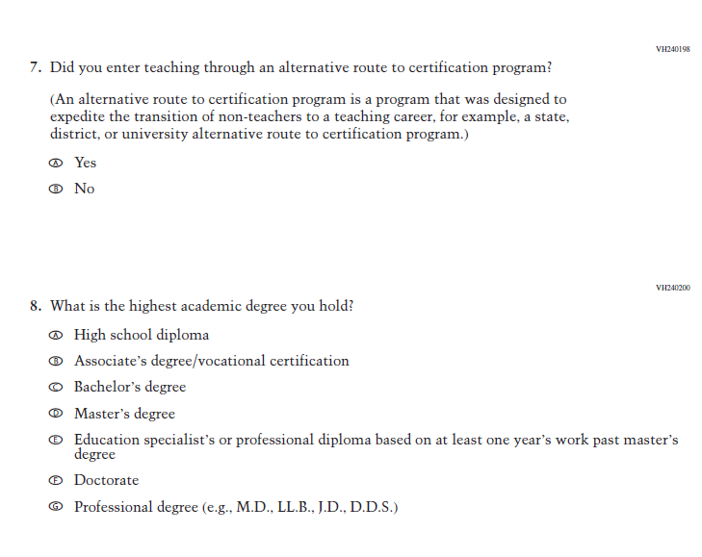
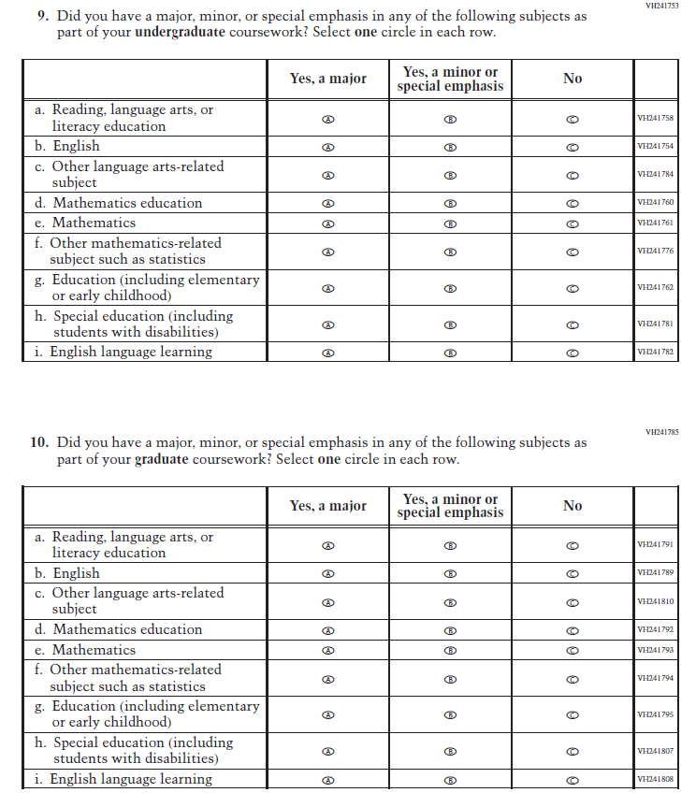
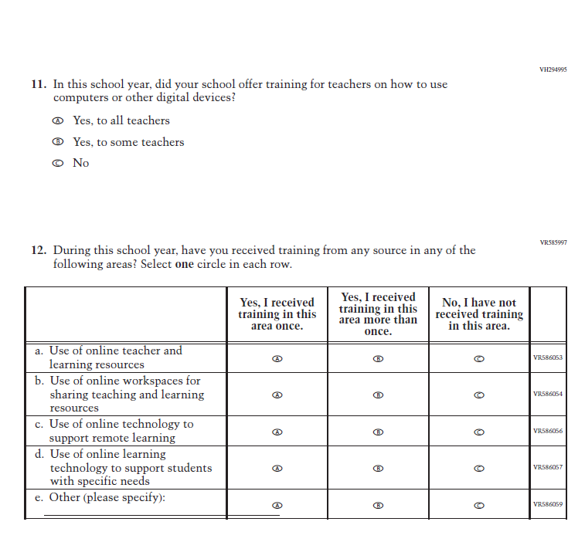
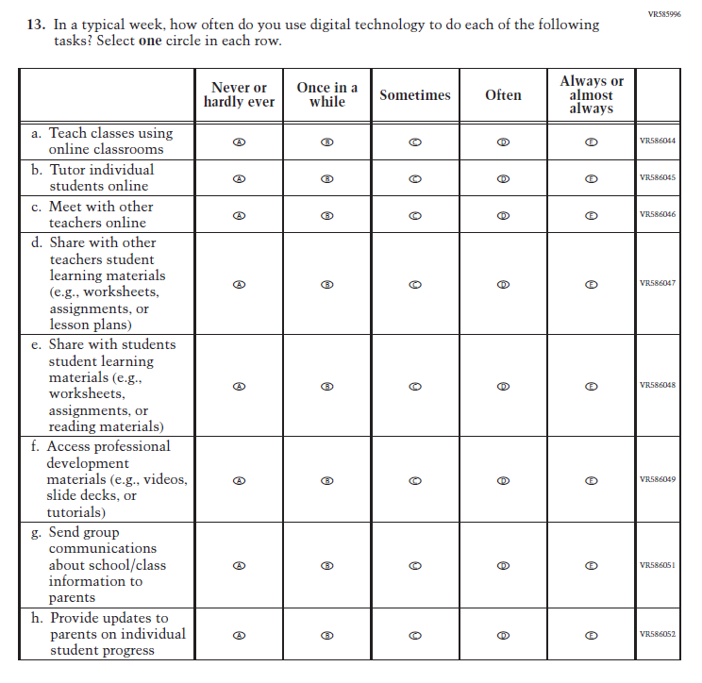
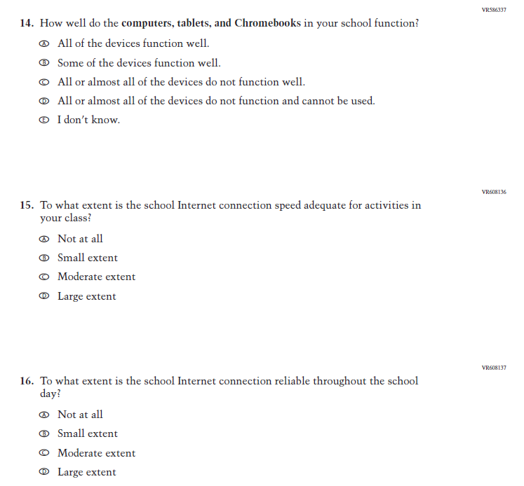
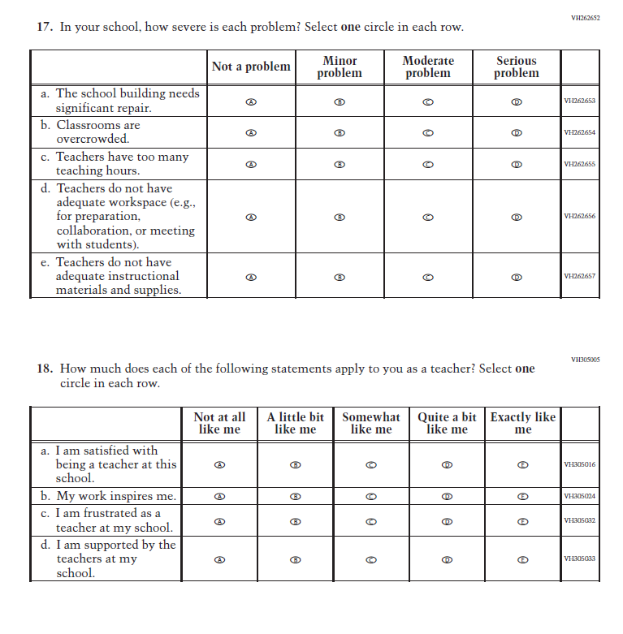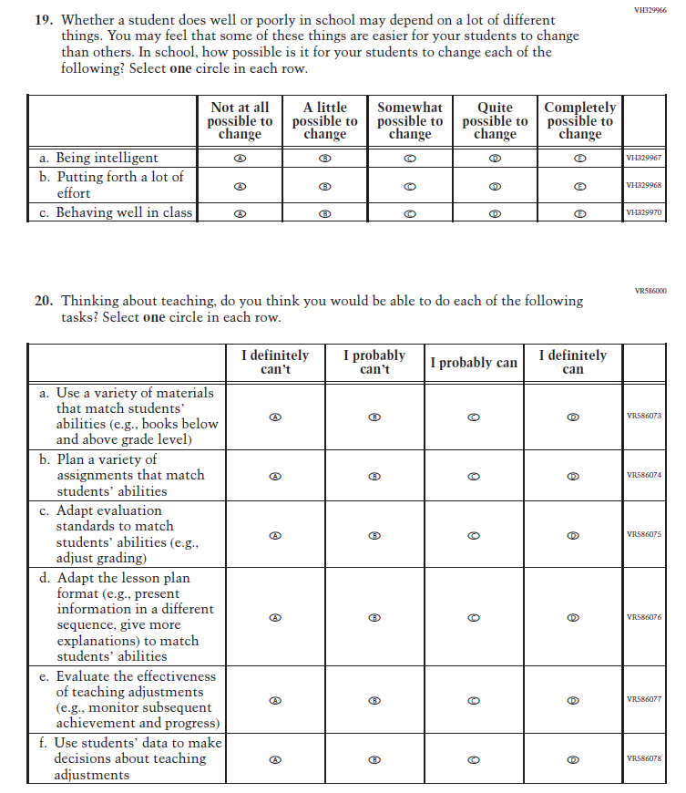
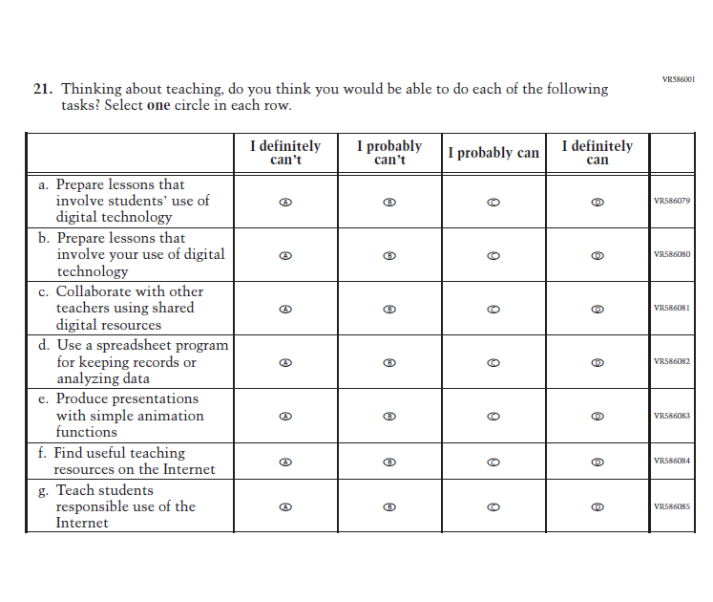

Appendix J2-15: Pilot Mathematics Grade 8 (Core)
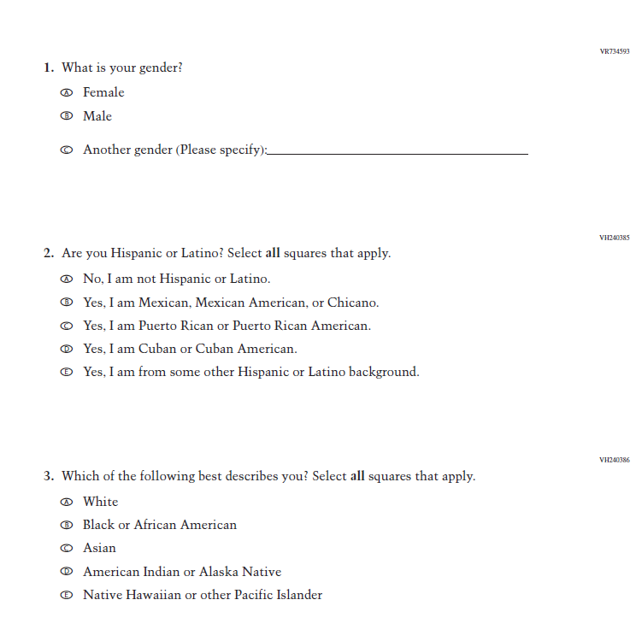
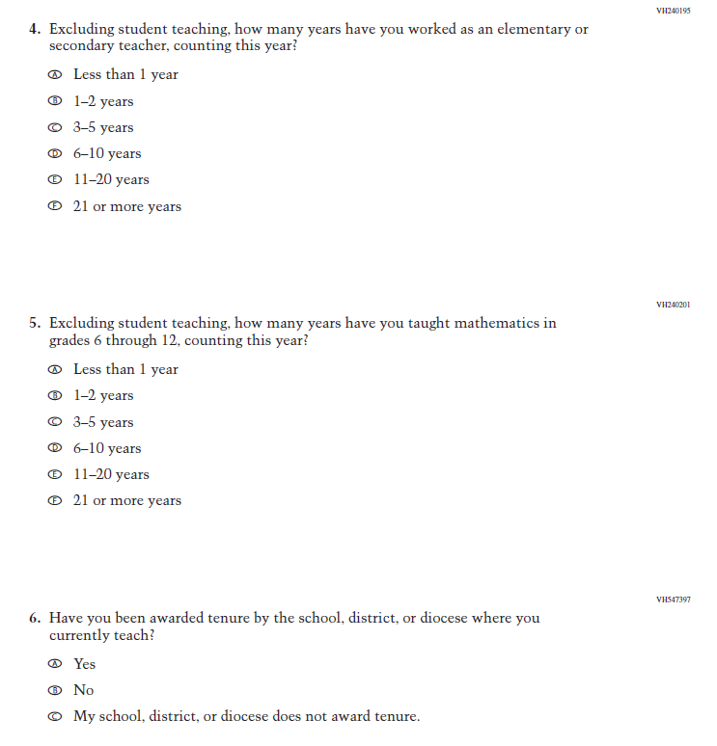
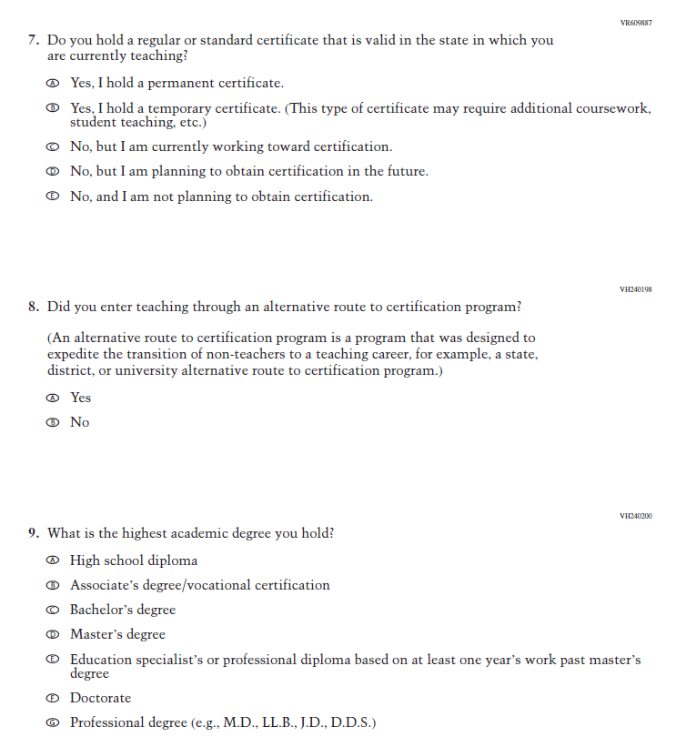
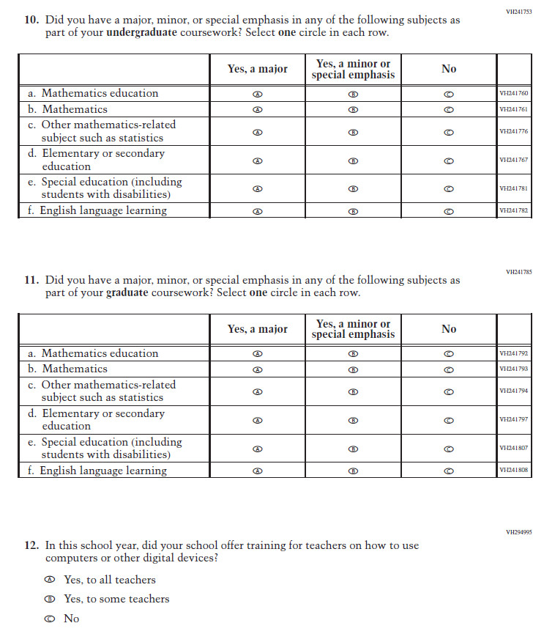
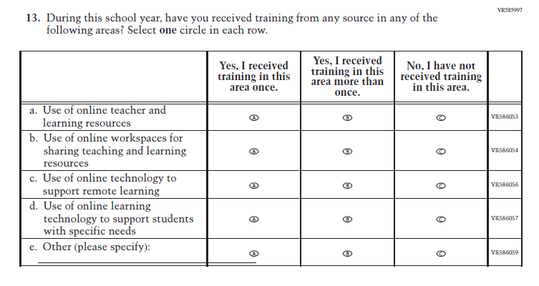
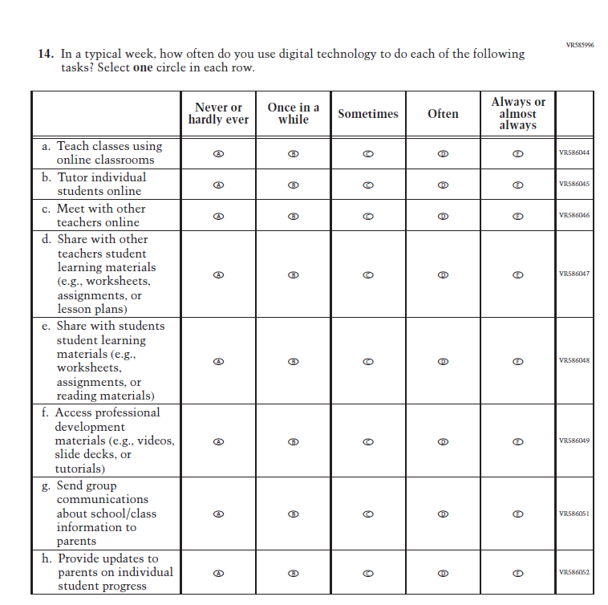
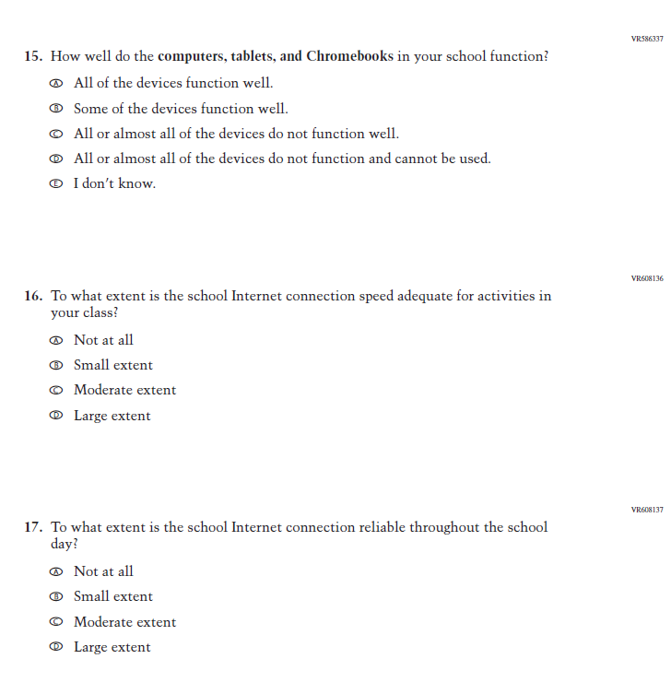
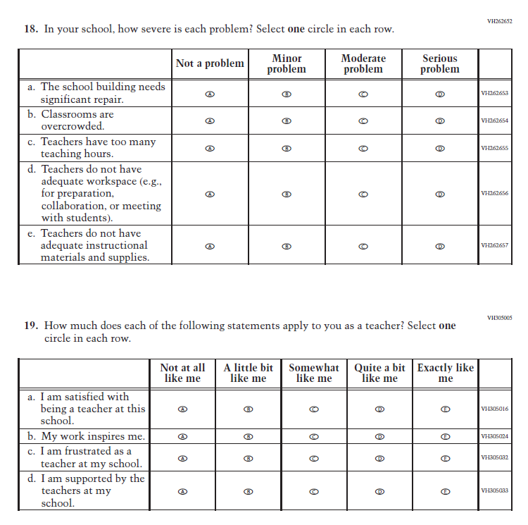
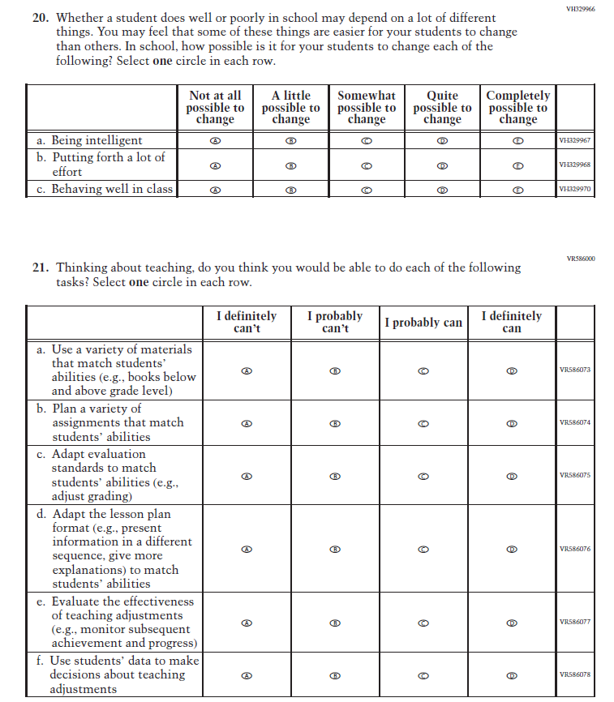
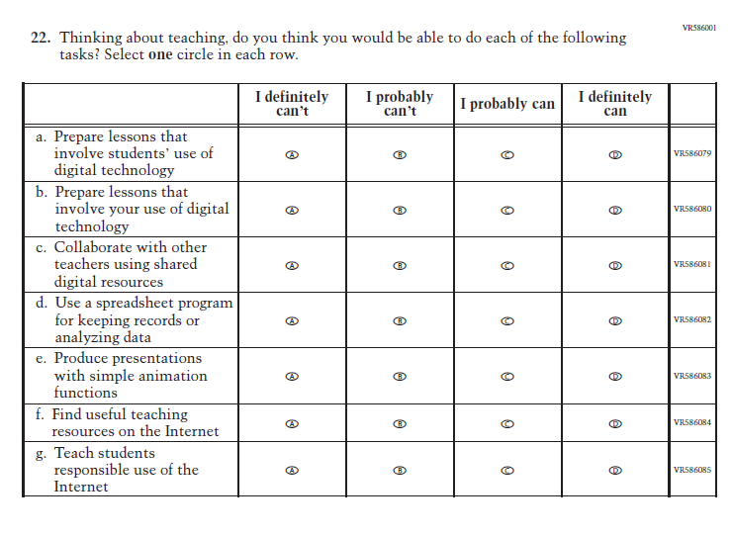

Appendix J2-16: Pilot Reading Grade 8 (Core)
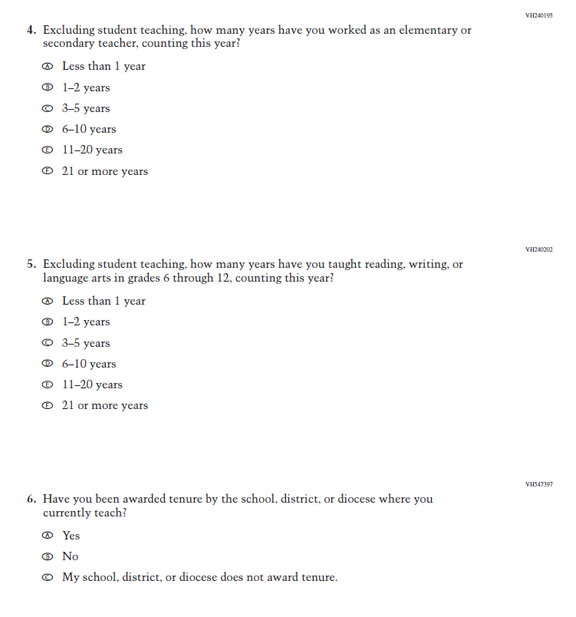
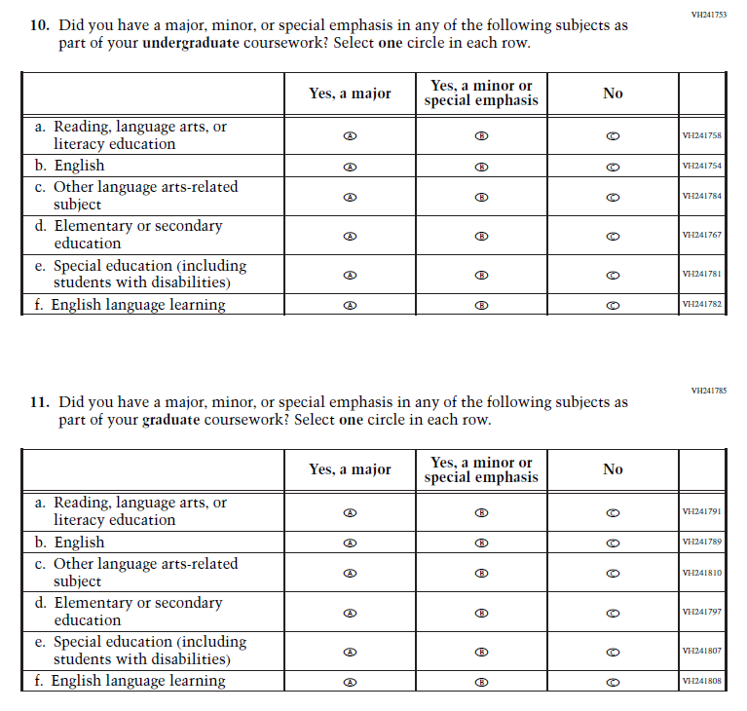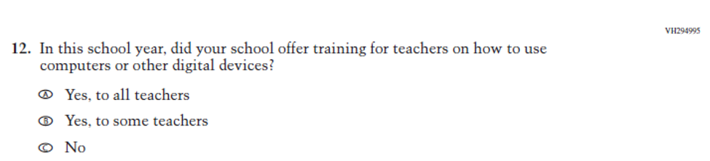

Appendix J2-17: Pilot Grade 4 (Mathematics)
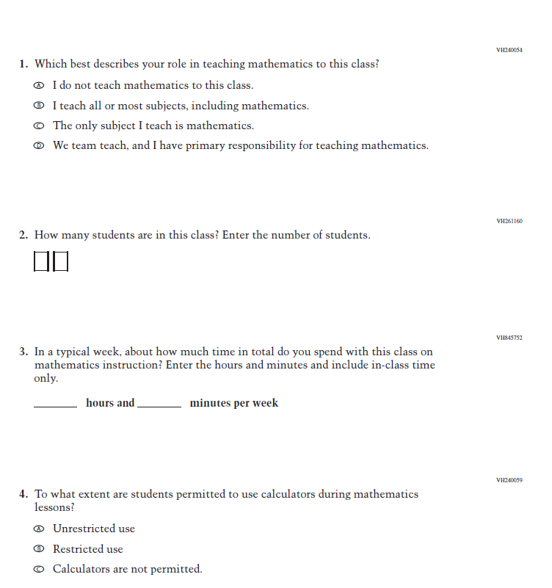
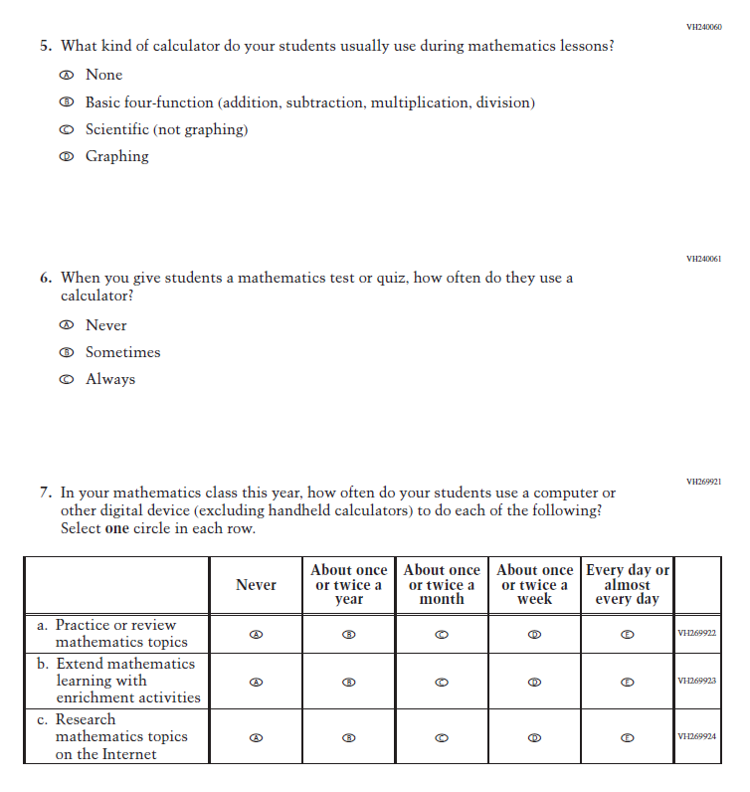
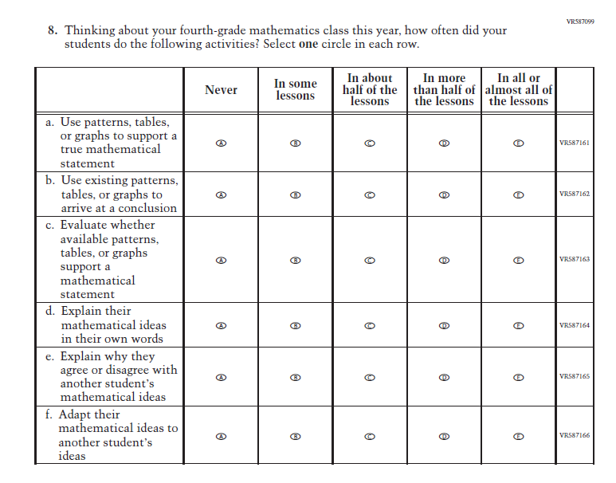
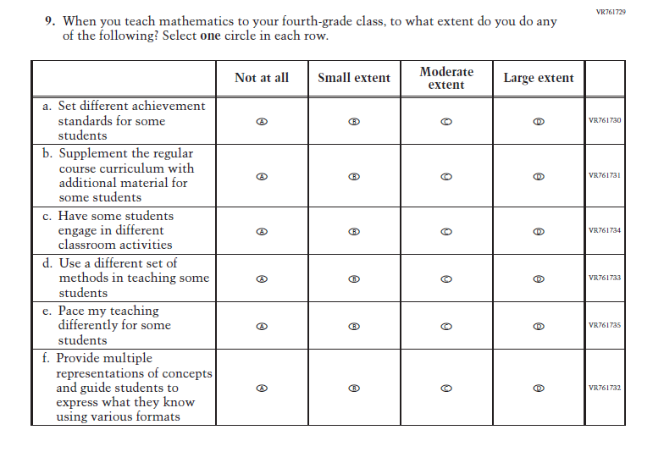
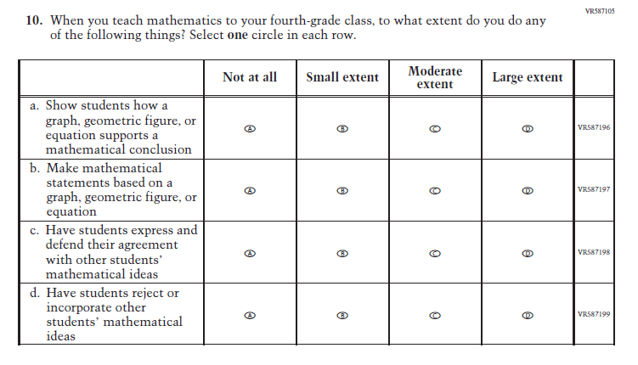
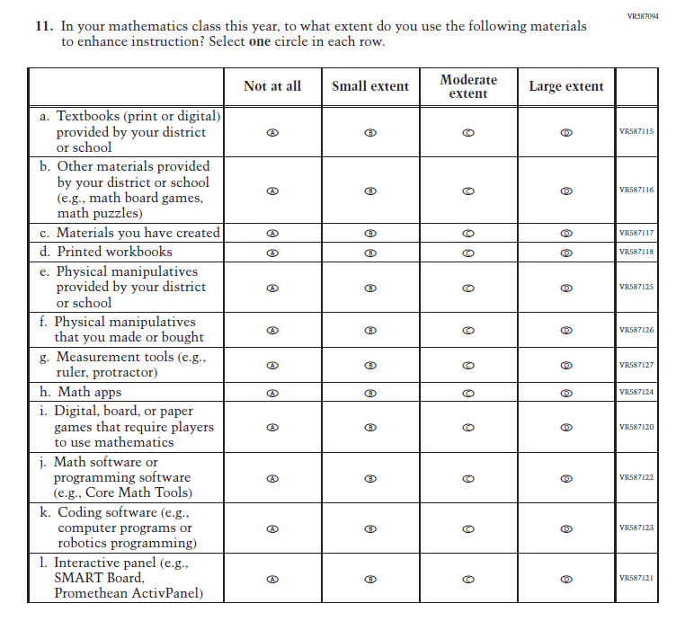
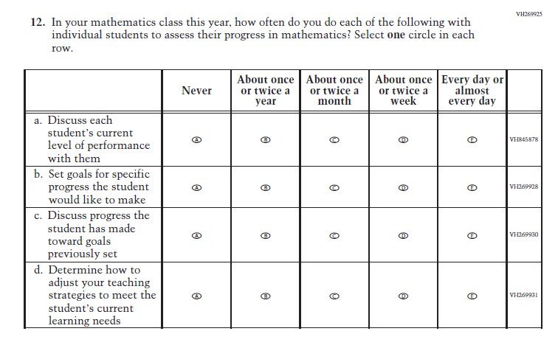
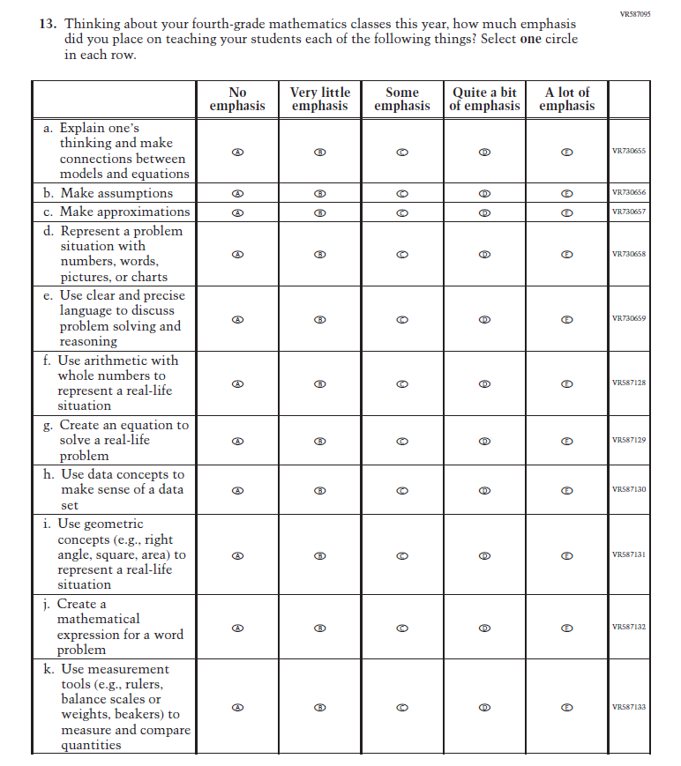
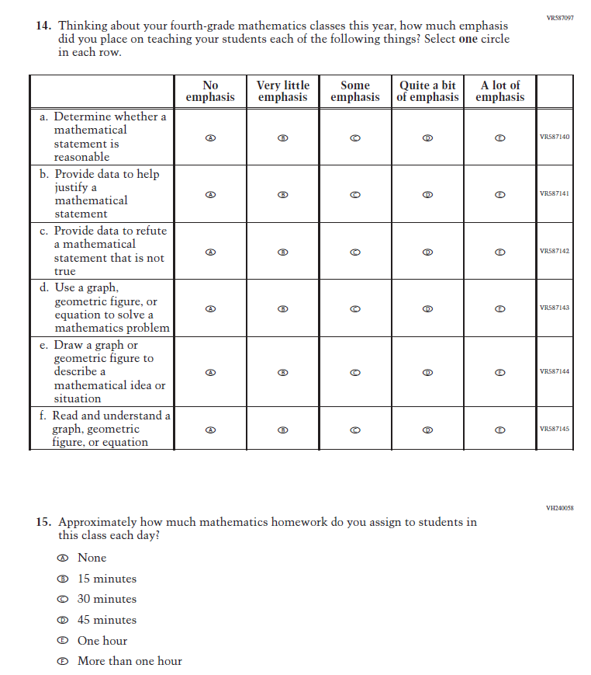
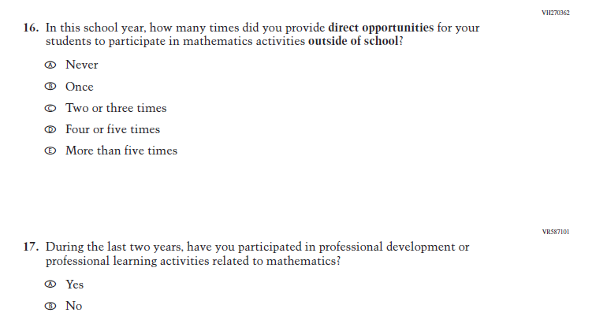
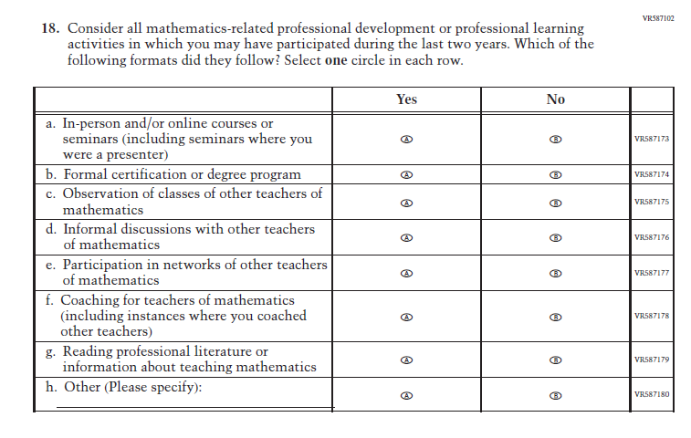
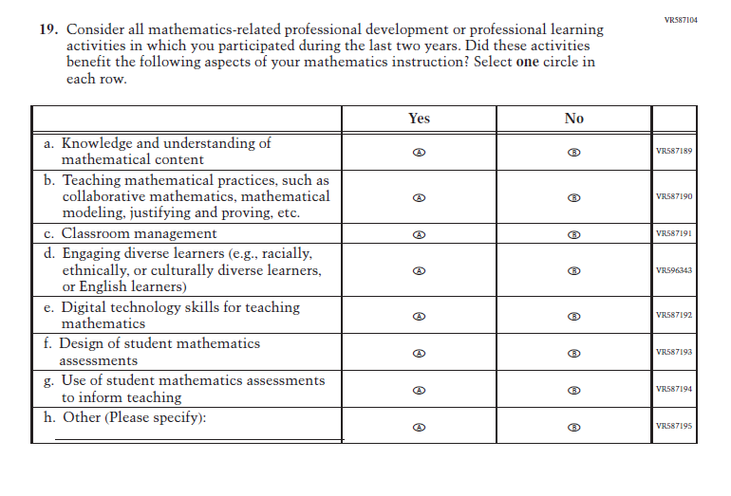

Appendix J2-18: Pilot Grade 8 (Mathematics)
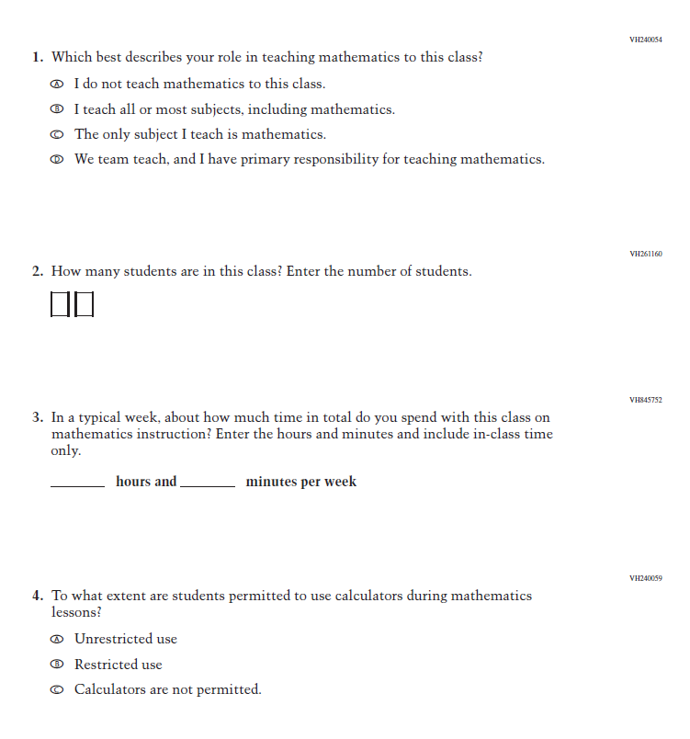
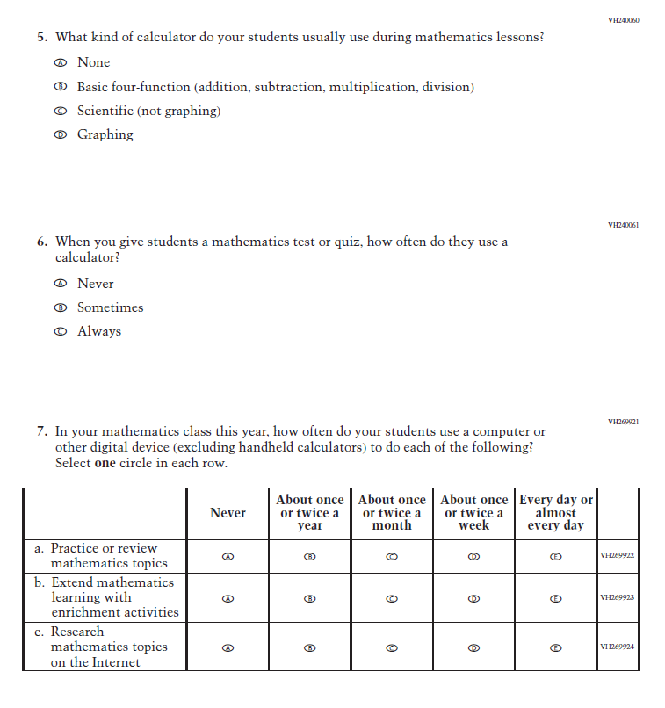
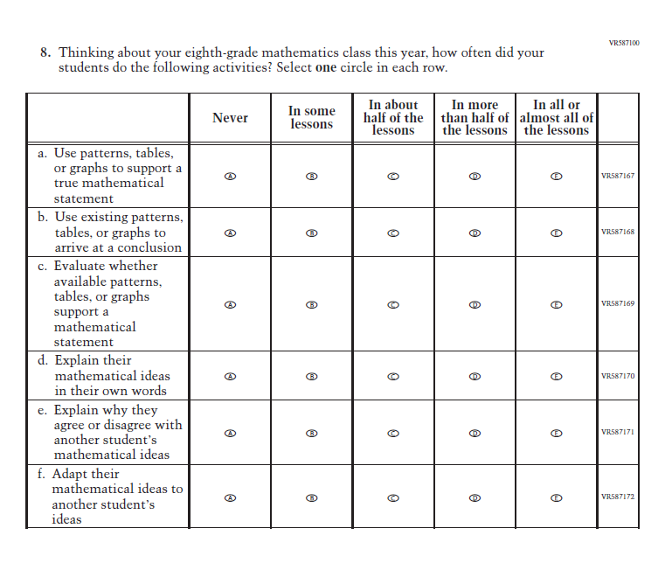
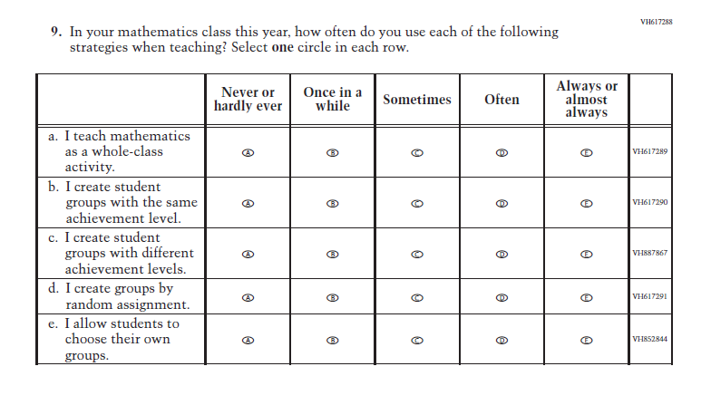
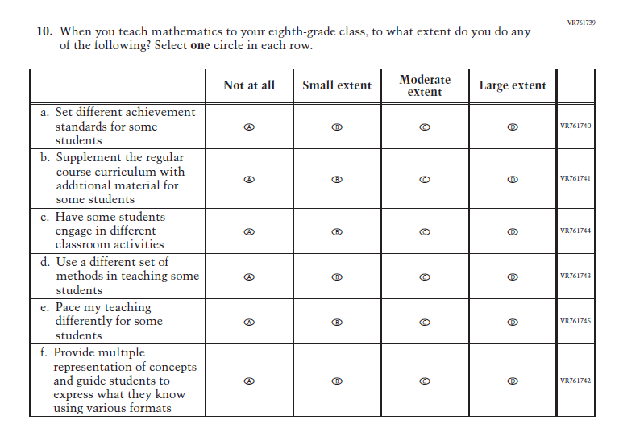
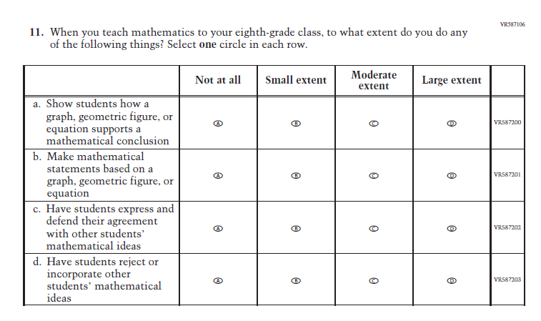
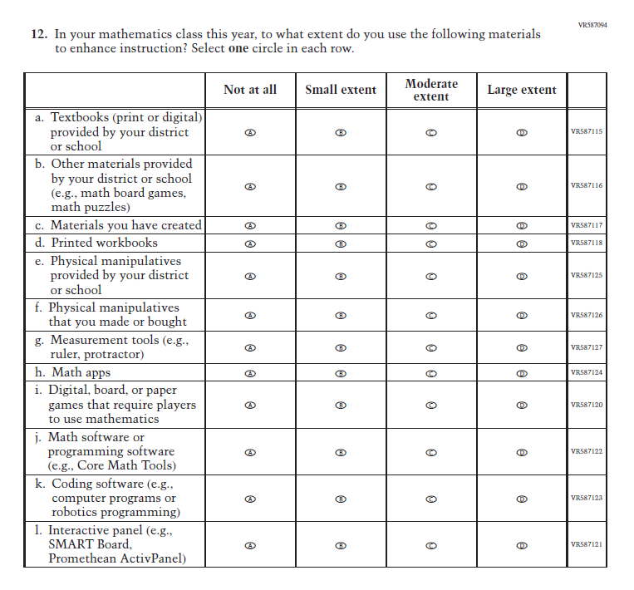
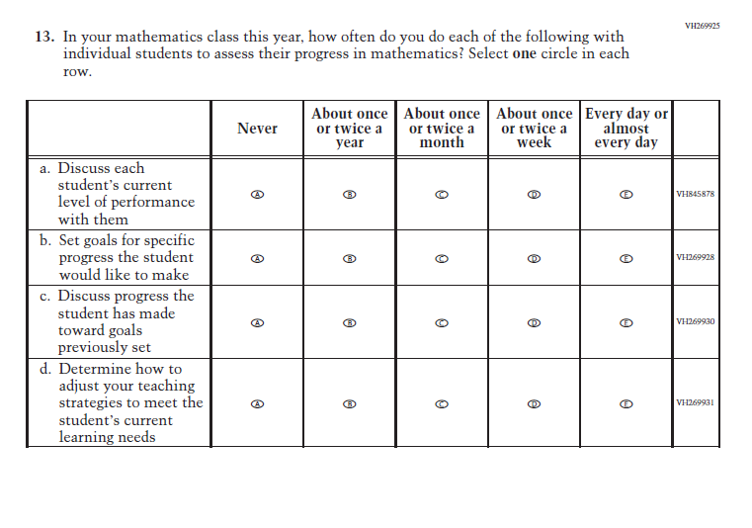
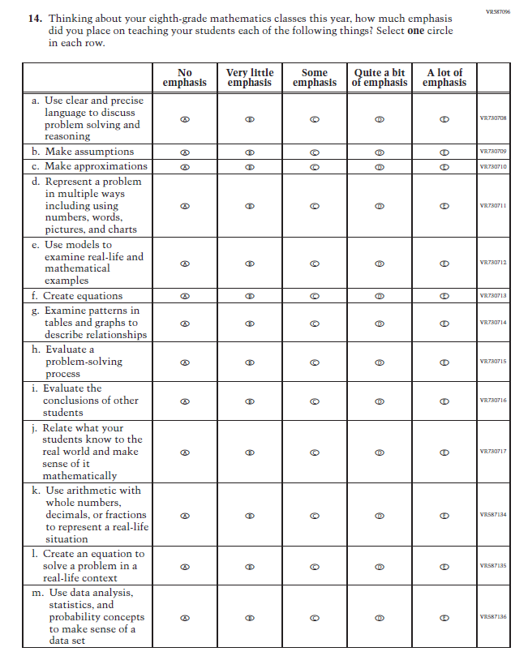
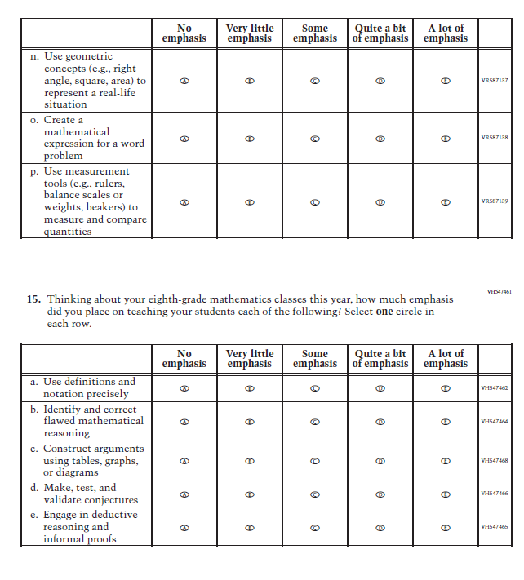
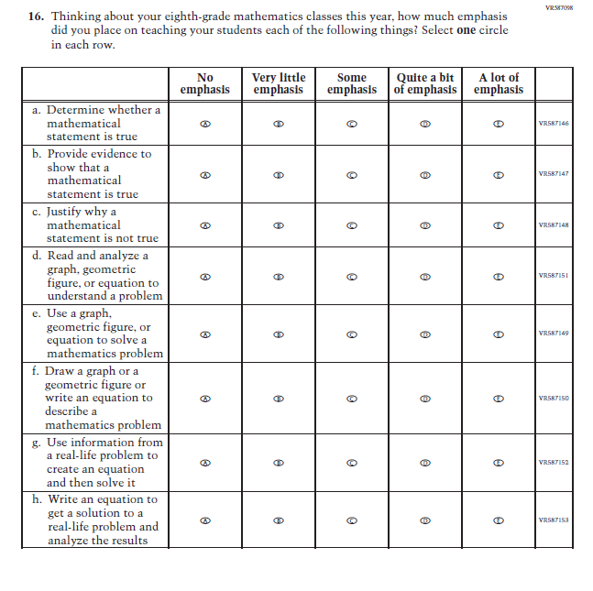
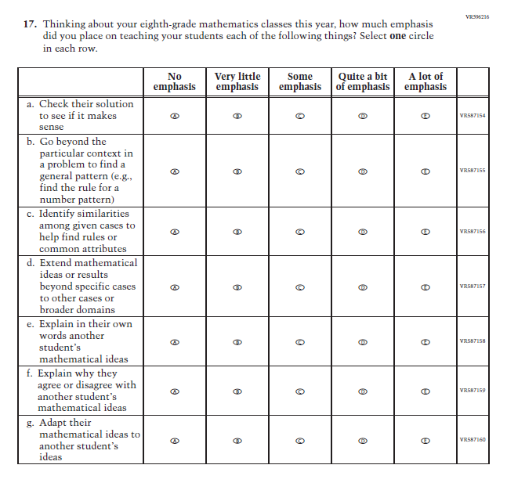
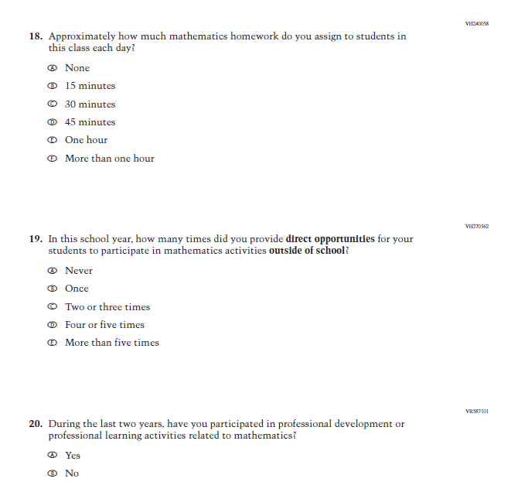
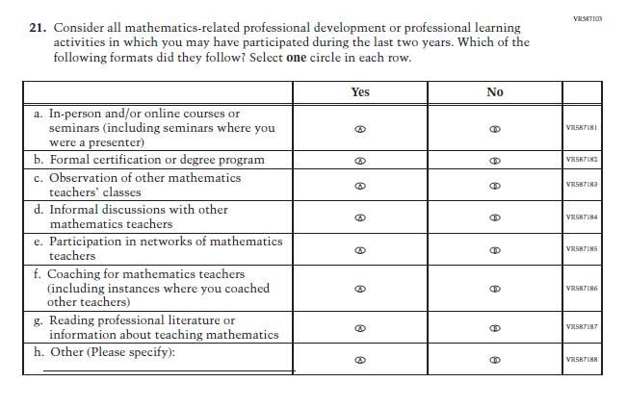
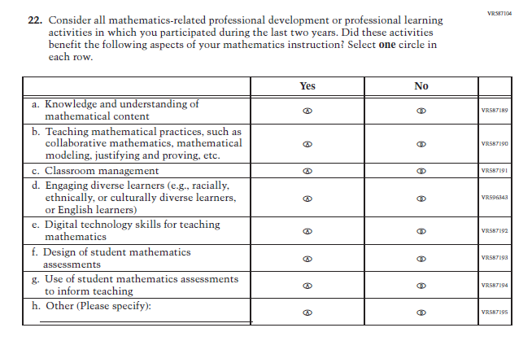

Appendix J2-19: Pilot Grade 4 (Reading)
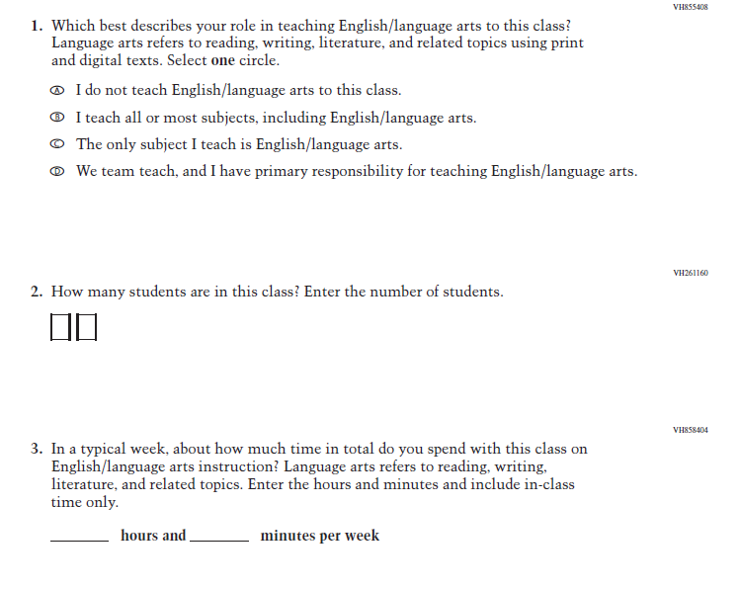
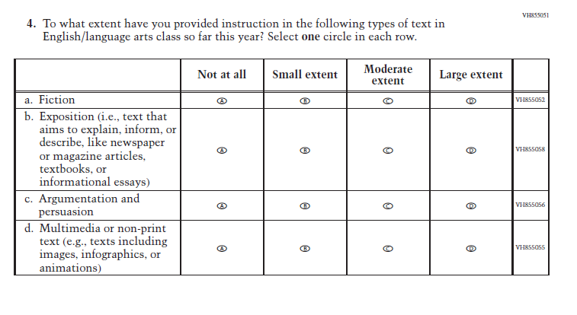
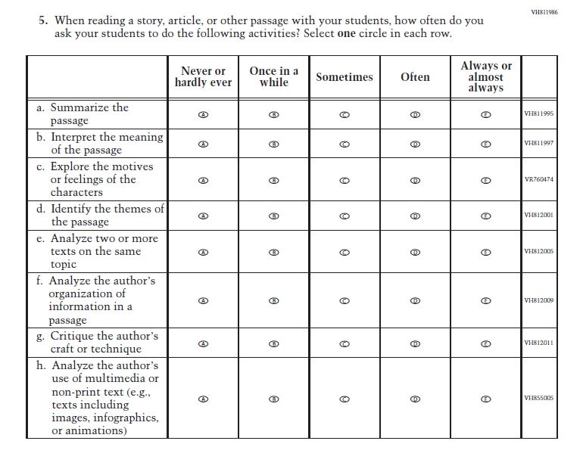
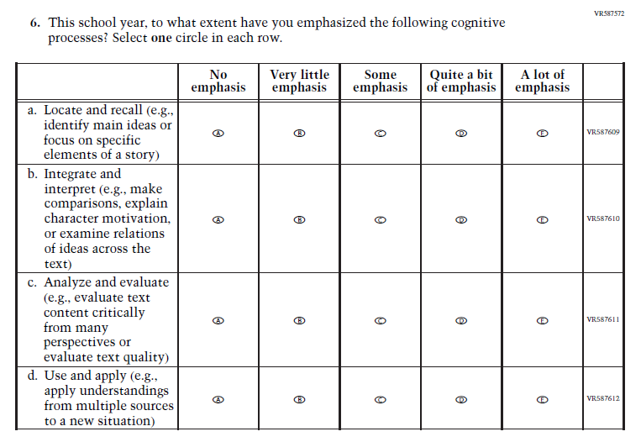
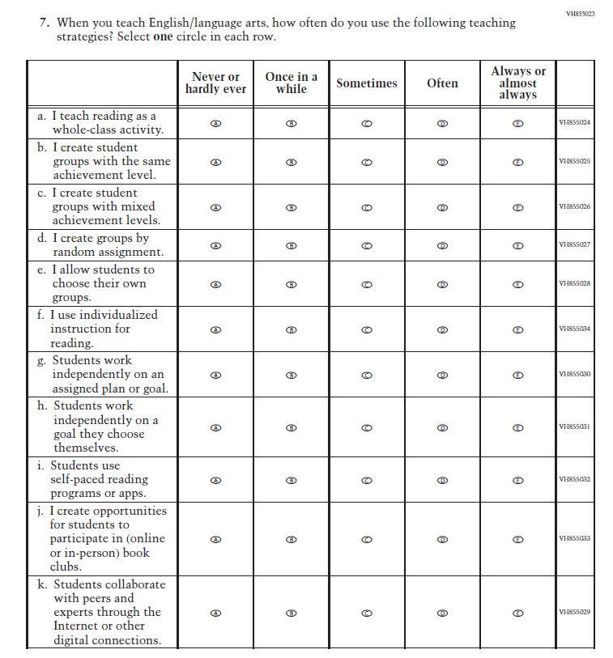
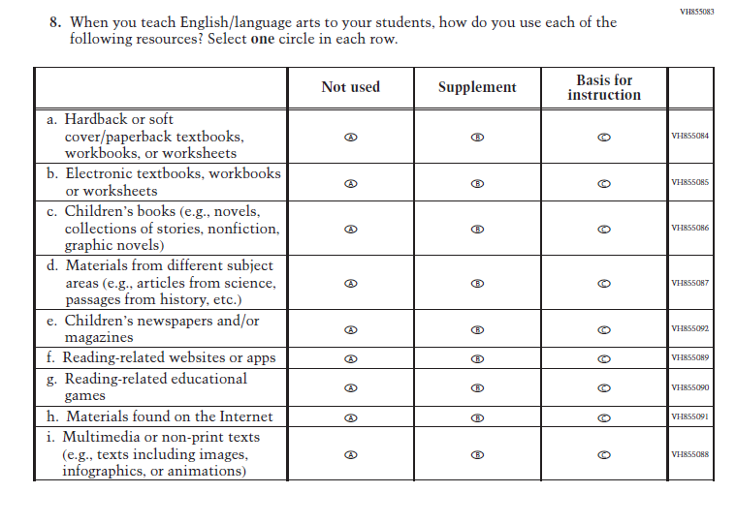
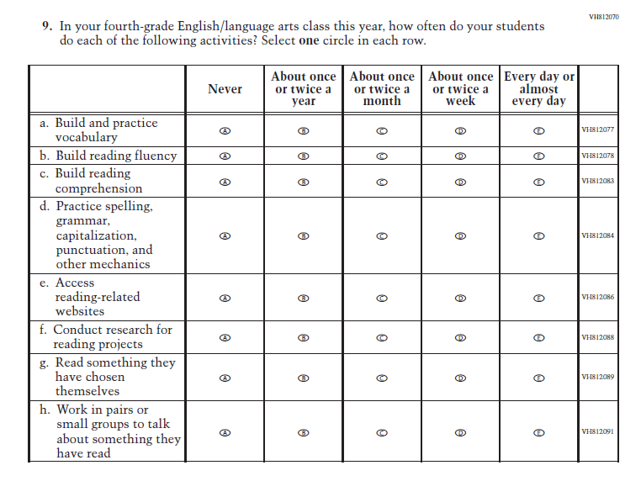
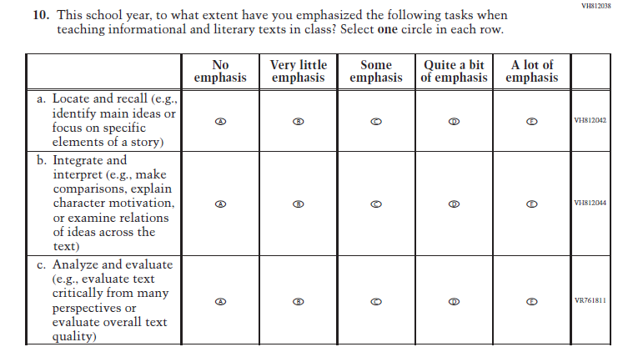
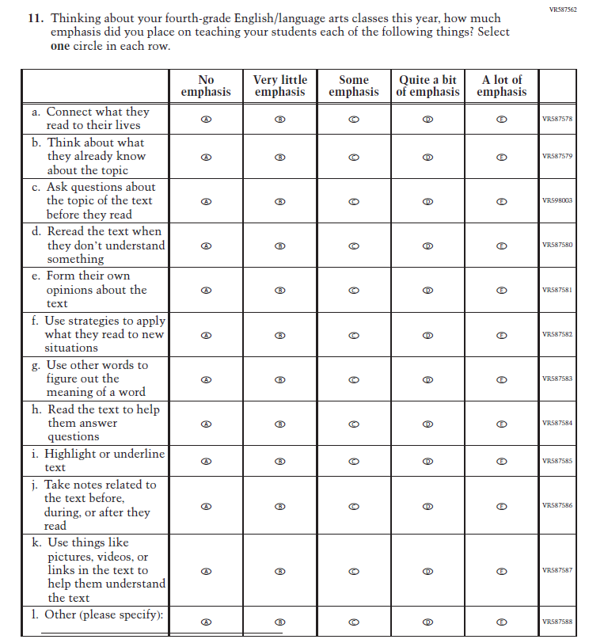
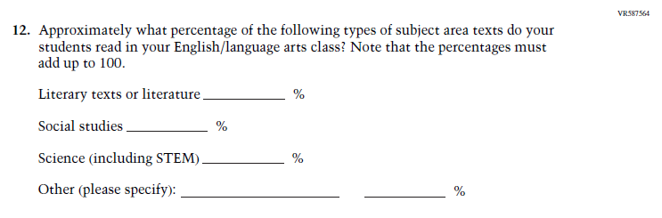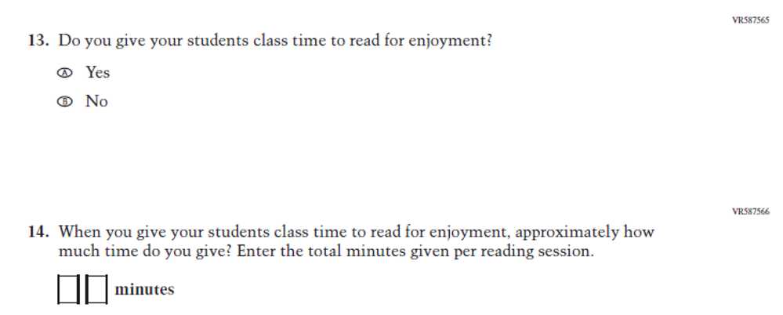

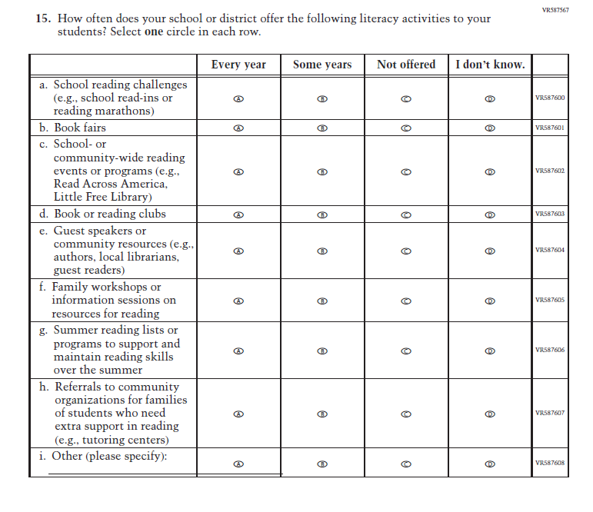
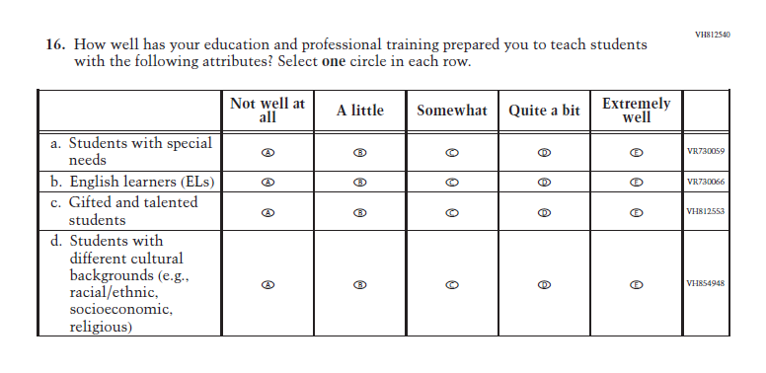

Appendix J2-20: Pilot Grade 8 (Reading)
