Attachment B
Sample Data Collection Screenshots

Automated Vehicle Testing Tracker

These sample screen shots illustrate the online platform voluntary participants in the AV TEST program would use to enter their relevant data. Potential participants and the public are encouraged to provide input toward shaping this interface as we move forward to providing a mature webpage for public use.

Upon OMB approval, the below public burden statement will be added to the first page of the online platform:

Under the Paperwork Reduction Act, a Federal agency may not conduct or sponsor, and a person is not required to respond to collection of information subject to the requirements of the Paperwork Reduction Act unless that collection of information displays a current valid OMB Control number. The OMB Control Number for this information collection is 2127-NEW (expiration date: MM/DD/YYYY). NHTSA estimates that each State or local participant will spend approximately 30 hours per year providing information to the AV TEST Initiative and estimates that each private industry participant will spend approximately 48 hours per year providing information to the AV TEST Initiative. All responses to this collection of information are voluntary. If you have comments regarding this burden estimate or any other aspect of this collection of information, including suggestions for reducing this burden send them to Information Collection Clearance Officer, National Highway Traffic Safety Administration, 1200 New Jersey Ave, S.E., Washington, DC, 20590.

NHTSA Form 1586

Additionally, “OMB Control Number: 2127-XXXX | Expiration Date: XX/XX/XXXX” will be added to the bottom of the webpage.

Title Tab
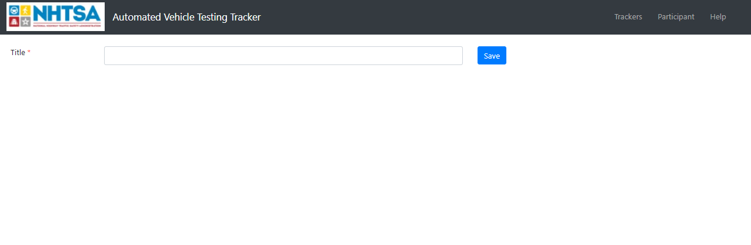
Summary Tab
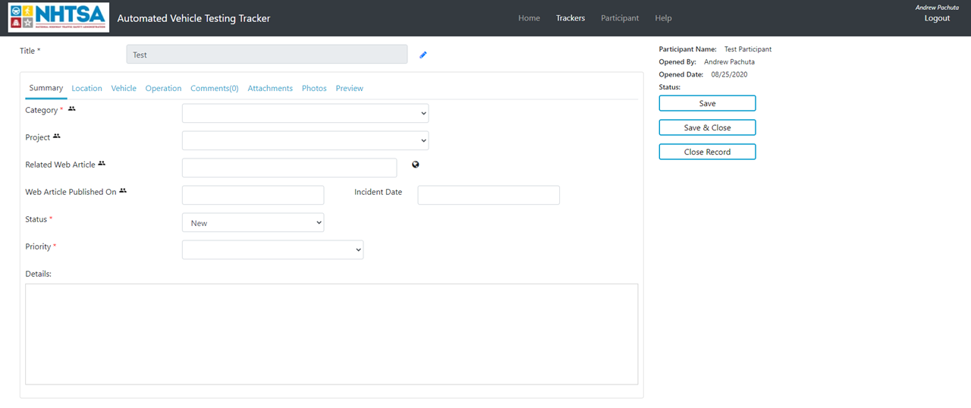

Location Tab
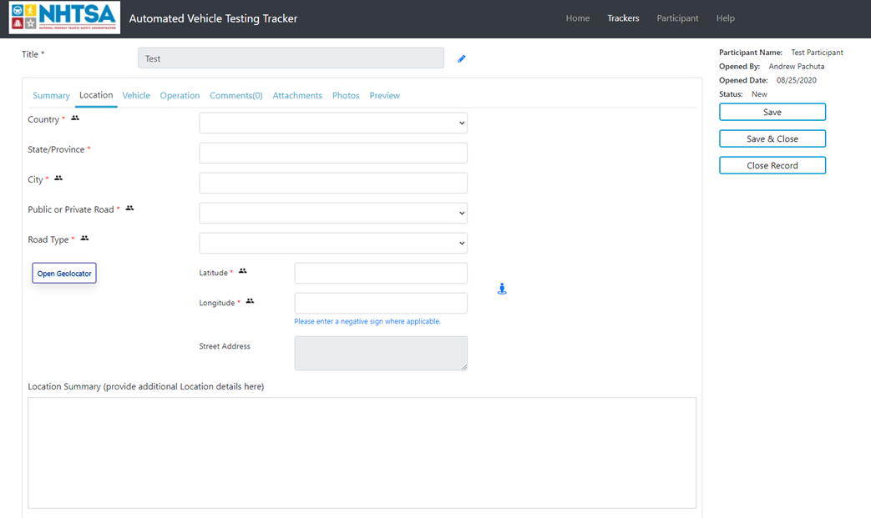
Vehicle Tab
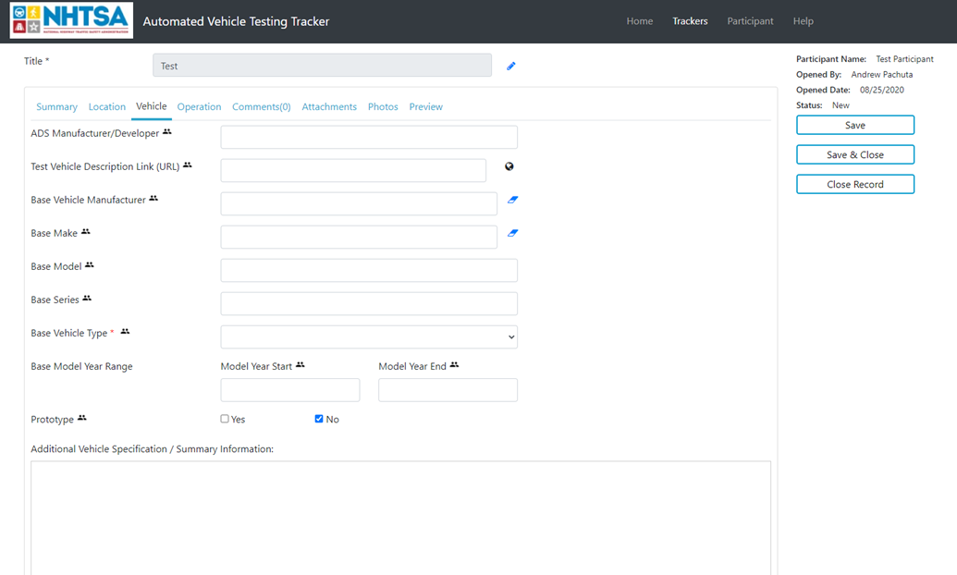
Operation Tab
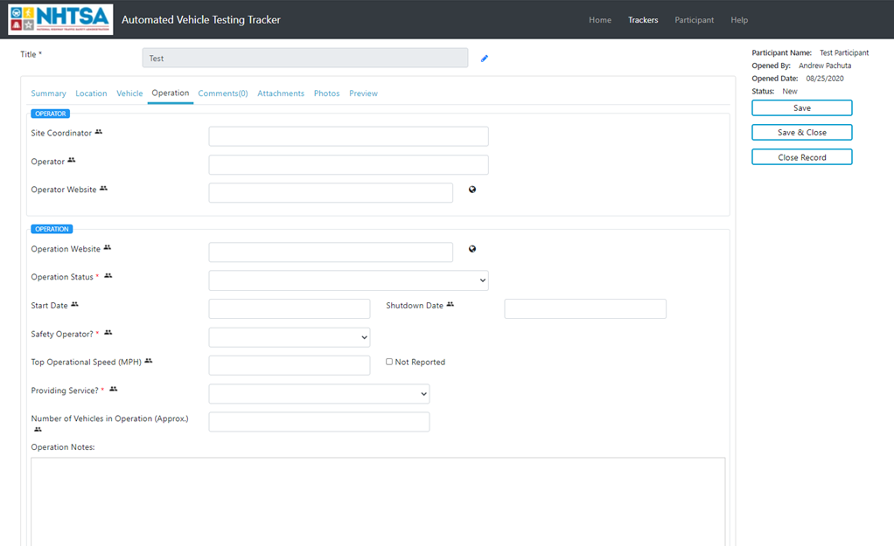
Comments Tab
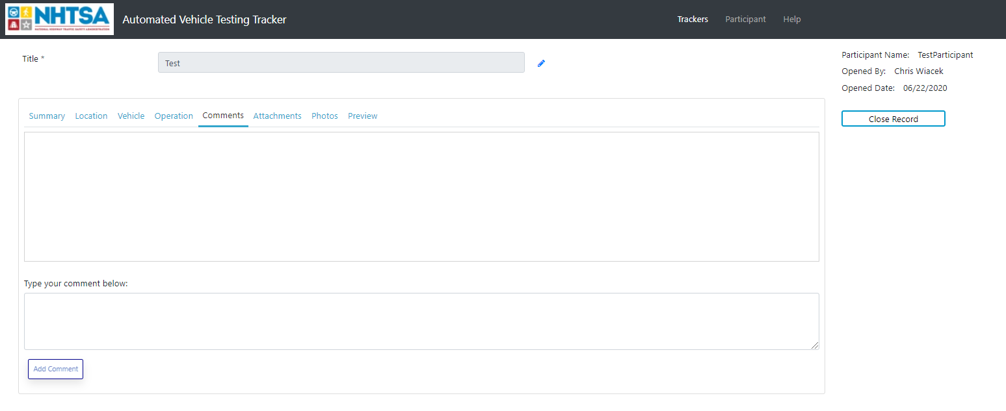

Attachments Tab
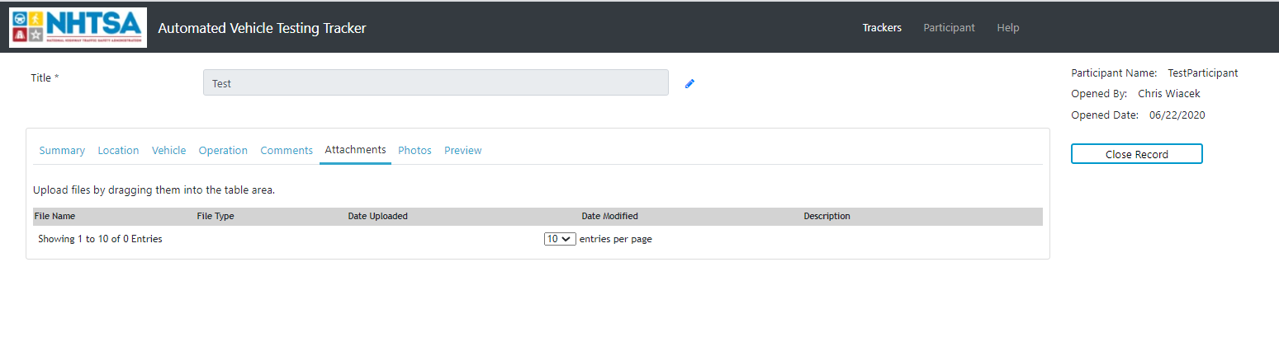
Photos Tab
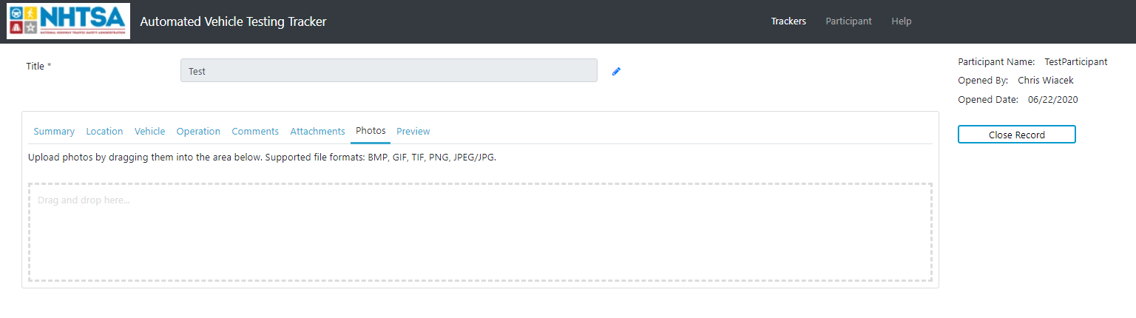
Data Preview
