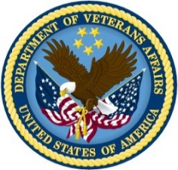 | DEPARTMENT OF VETERANS AFFAIRS  Veterans Benefits Administration  Washington, D.C. 20420

[NAME]
[ADDRESS] [PIN: ]

Dear [NAME],

I am writing to ask you for your assistance in a study that allows us to assess and continually improve the services provided by the Veteran Readiness & Employment (VR&E) Program (previously known as the Vocational Rehabilitation & Employment Program). As stated in Public Law 110-389 Sec. 334, Congress has asked VR&E to complete a 20-year Longitudinal Study, and submit a report to them every year that assesses the progress of Veterans who have participated in the VR&E Chapter 31 program. The purpose of the study is to monitor the effectiveness of this program so that we can find ways to improve it and increase the support we provide to Veterans. The results of this study will help shape VR&E policies and practices to increase benefits to Veterans who participate in the Chapter 31 program in the future. I encourage everyone who has ever participated in the VR&E program to complete the survey, even if you have already completed your program.

Participation in this study is voluntary and your responses will be kept private to the extent of the law. You can choose to stop participation at any time. The information that you supply is protected by law (the Privacy Act of 1974, 5 U.S.C. 522a, and section 5701 of Title 38 of the United States Code) and any data collected will not impact any current or future benefits you may apply for.

The survey takes between 15 and 20 minutes to complete and asks about your participation in the VR&E program, recent employment or educational experiences, and any recent visits to medical facilities.

If you agree to participate, please complete the survey included with this letter, then return it using the postage-paid envelope provided. If you have already completed the survey online, you do not need to return this one to us in the mail. You may also complete the survey by visiting https://www.vresurvey.org. The PIN at the top right of this letter is your personal identification code that you will need to complete the survey using this method.

If you have any questions about this survey or any questions about your rights as a study participant, please contact us at 1-844-367-5971 or Support@VRESurvey.org.

I hope you will agree to participate in this very important survey. Your participation will assist current and future Veterans using VR&E services to receive the highest quality and most comprehensive services possible. Thank you for your service to our country!

Sincerely,
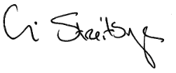
William Streitberger
Executive Director, Veteran Readiness and Employment Program

Attachments: Copy of Public Law

