FORM 80s – ONLINE ORDERING
#1 – Form 80 Start
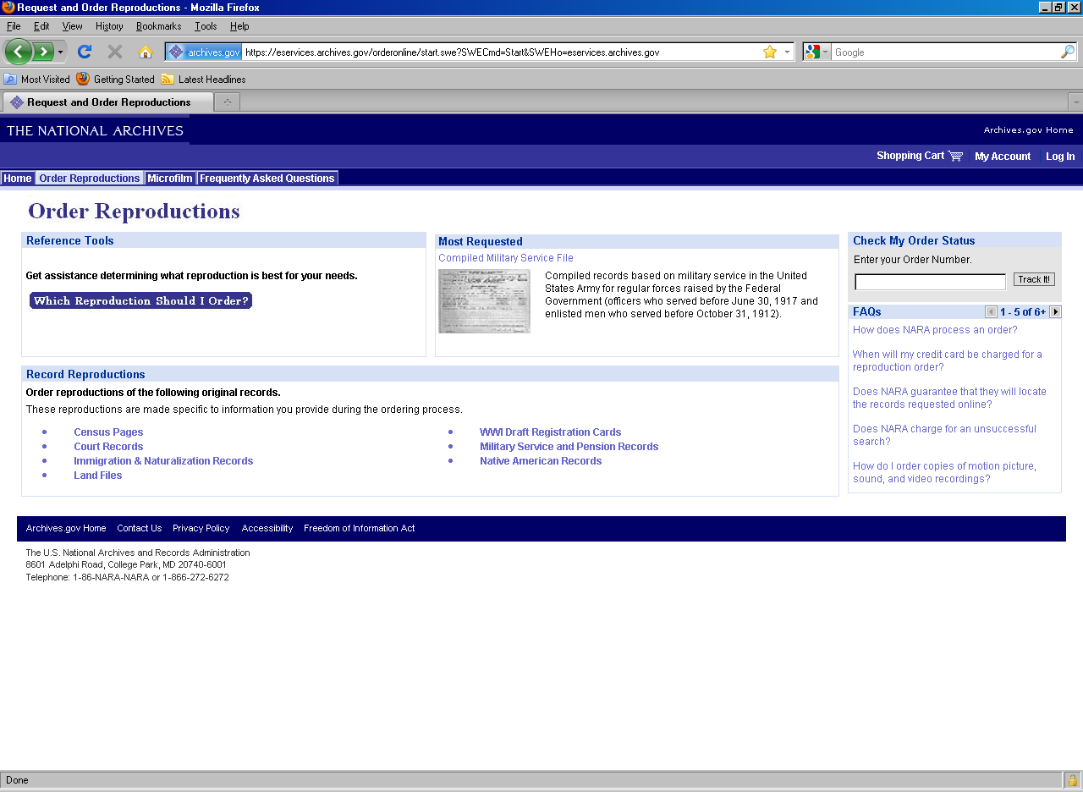

#2a – Form 81 and Price List
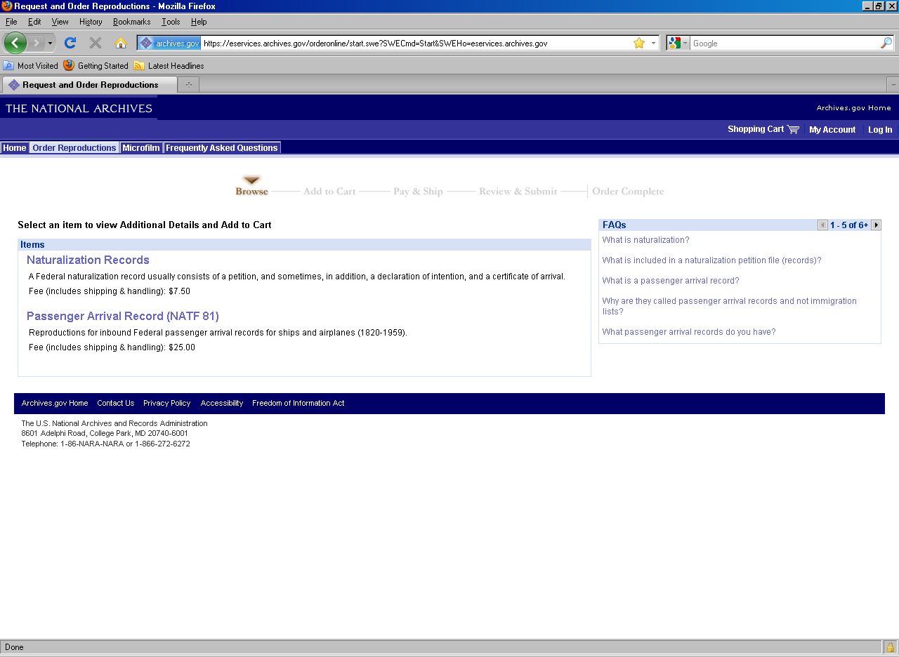
#2b – Form 82 and Price List
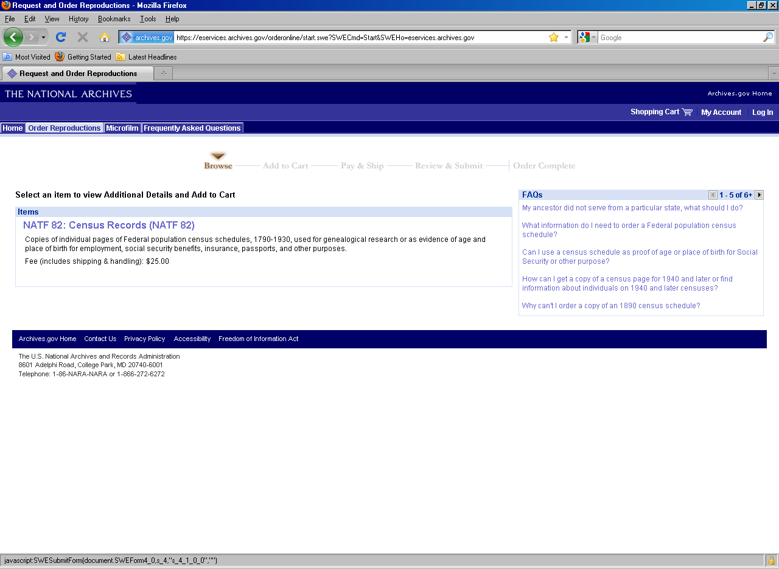
#2c – Form 83 and Price List
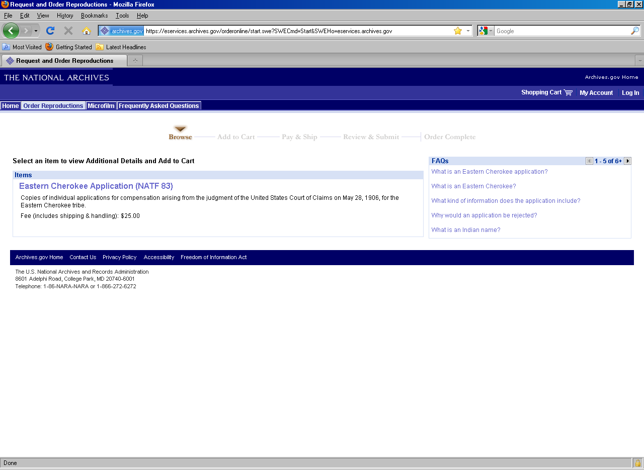
#2d – Forms 84 and 85C and Price List
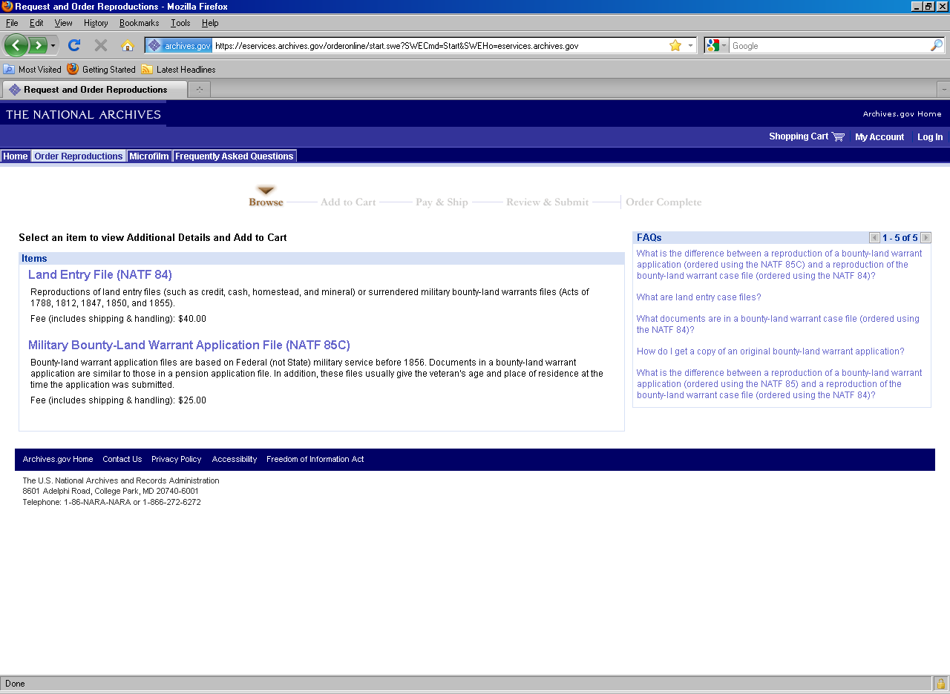
#2b – Forms 85A, 85B, 85C, 85D and 86 and Price List
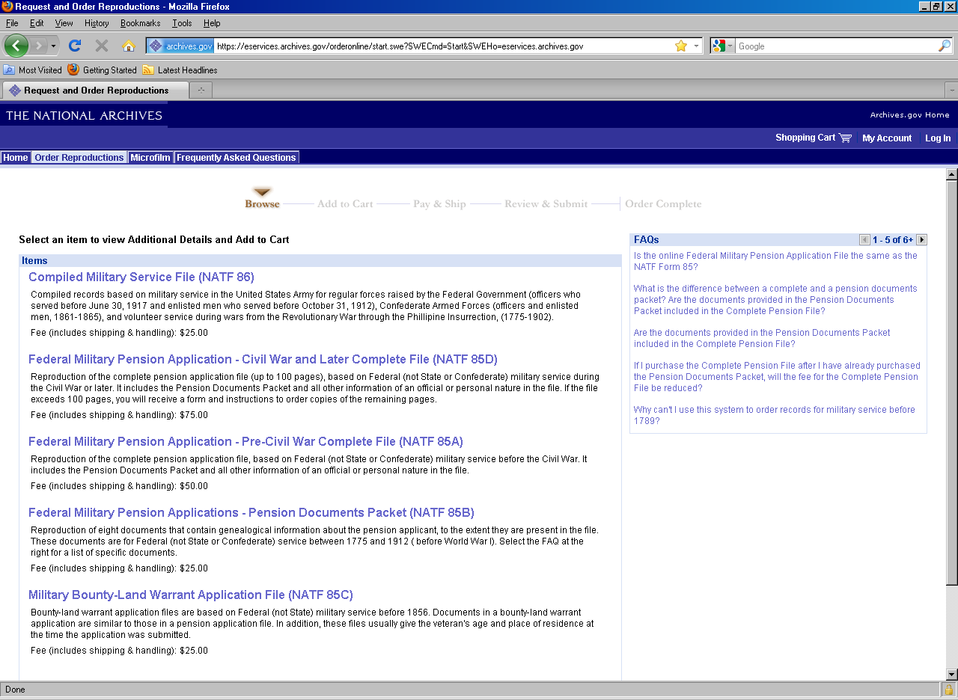
#3 – Media Type Option
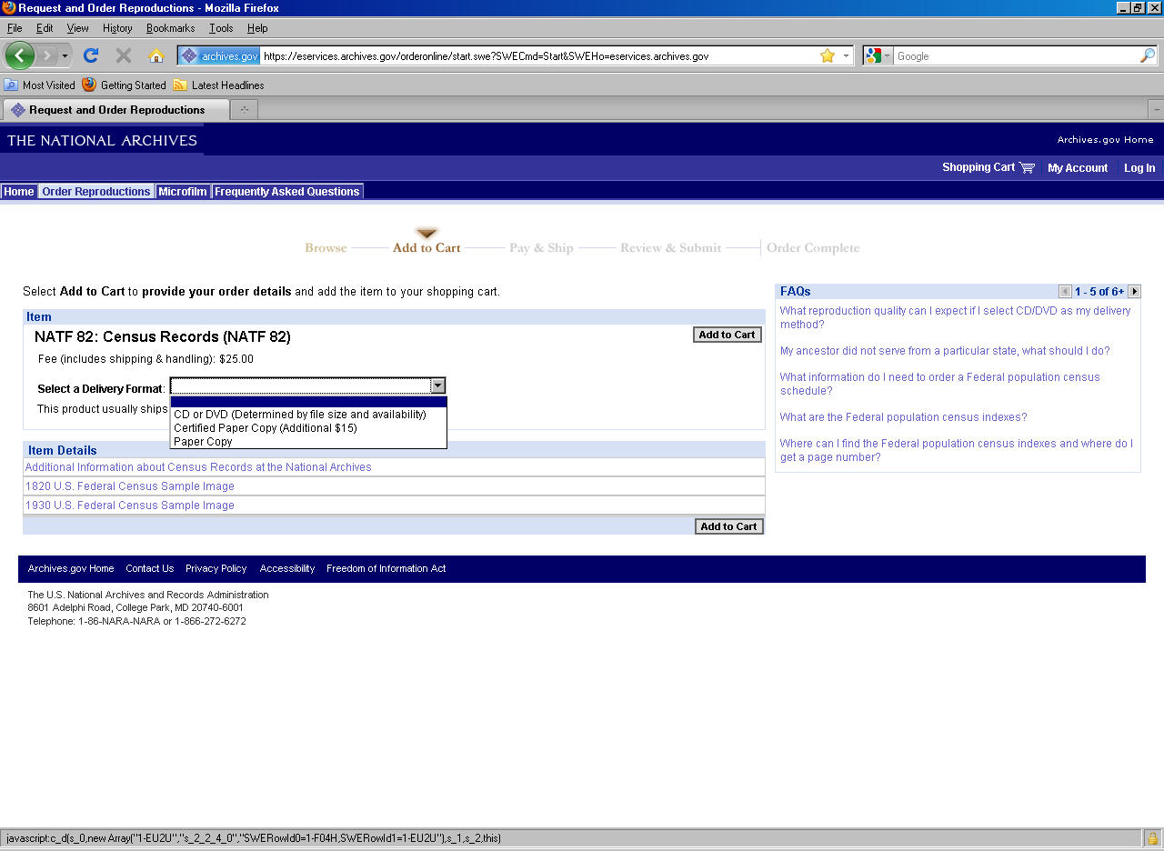
#4 – Data Collection Area
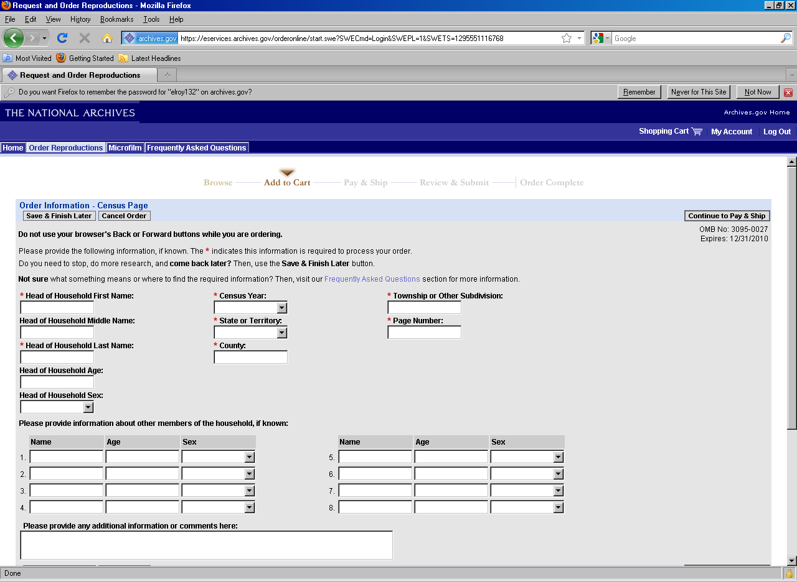
#5 – Shipping Information
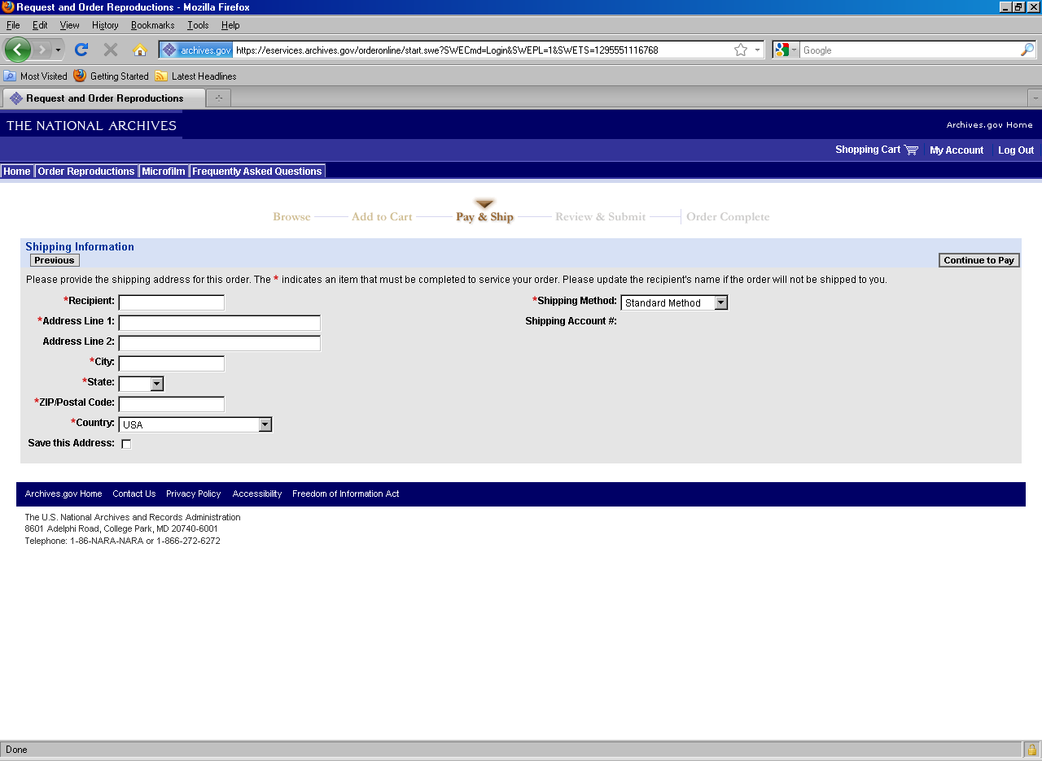
#6 – Billing Information
