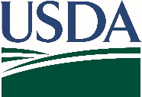
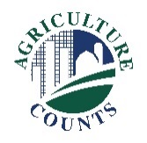
United States Department of Agriculture
National Agricultural Statistics Service

September 21, 2022

Why am I getting this packet?
You have been selected to participate in this year’s Agricultural Resource Management Survey (ARMS). Please join us in helping U.S. agriculture and the wheat industry by working with us to complete this survey. The survey has questions about your nutrient and fertilizer use as well as your production, tillage, and pest management practices for wheat acreage.

An interviewer will call you and set up an interview to assist in the completion of your questionnaire.

What is in this packet and what do I need to do?
A sample survey questionnaire labeled “For Informational Purposes Only” and a respondent booklet are enclosed to guide you through the survey with assistance from our interviewer.
- Please do not complete and return the paper questionnaire. Instead, use it to help gather the information needed for your interview.
- Please have your spray records available. If you used a commercial chemical company, please make sure those records are accessible.

How will the survey data be used?
Your response will help ensure that accurate use rates of necessary crop protection products will be widely available for your industry. These data are frequently used in re-registration and other decisions affecting the use of these crop protection products.

The information you provide will be used for statistical purposes only. In accordance with federal law, your responses will be kept confidential and will not be published in identifiable form. For more information on this survey, visit nass.usda.gov/go/arms.

Thank you for your partnership and support of U.S. agriculture. If you have any questions, please contact us at 888-424-7828.

Sincerely,

Joseph L. Parsons
Chair, Agricultural Statistics Board
Enclosure

