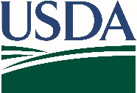
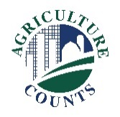
United States Department of Agriculture
National Agricultural Statistics Service

October 28, 2022

Why am I getting this packet?

You have been selected to participate in the 2022 Vegetable Chemical Use Survey. It will ask questions about fertilizer and pesticide use for your crops as well as your pest management practices for vegetable acreage.

What is in this packet and what do I need to do?

A sample survey questionnaire labeled “For Informational Purposes Only” and a respondent booklet are enclosed to guide you through the survey with assistance from our interviewer.

- Please do not complete and return the paper questionnaire. Instead, use it to help plan ahead so that your time spent with our representative will be shorter.
- Our interviewer will call to set up an appointment to complete the questionnaire with you by phone or in person.
- Please have your spray records available. If you used a commercial chemical company, please make sure you give consent to have those records available.

How will the data be used?

Your response will help illustrate the industry’s fertilizer and pesticide practices and assure the quality of U.S. food to consumers here and around the world. It is important that real-world information from you and your fellow growers are used to produce these statistics.

NASS safeguards the privacy of all respondents. The information you provide will be used for statistical purposes only. In accordance with federal law, your responses will be kept confidential and will not be disclosed in identifiable form. For more information on this survey, visit nass.usda.gov/Surveys/Guide_to_NASS_Surveys/Chemical_Use.

Thank you for your time, cooperation, and support of U.S. agriculture. If you have any questions, please contact us at 888-424-7828.
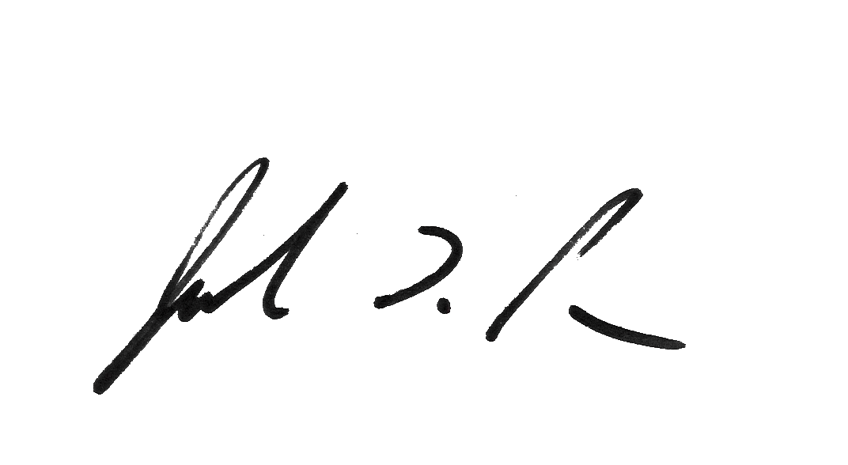

Sincerely,

Joseph L. Parsons
Chair, Agricultural Statistics Board
Enclosure

