Non-substantive Change Request
0535-0218 – Agricultural Resource Management Survey (ARMS) Phase 2 & Fruit Chemical Use Survey
Barley Production Practices Report
Oat Production Practices and Cost Report
Peanut Production Practices and Cost Report
Soybean Production Practices and Cost Report
Fruit Chemical Use Survey – CA Version
Fruit Chemical Use Survey – Enterprise Version

Following a review of the ARMS 2 and Fruit Chemical Use questionnaires that were recently approved by OMB through a renewal on June 5, 2023, the USDA Economic Research Service, with consultation with NASS updated the question text and enumerator instruction based on further consultation.
There are more changes for oats and peanuts than the other questionnaires because the questionnaires submitted for the recent OMB renewal were based on the previous survey data for that commodity was collected for peanuts, oats, and soybeans.
- Peanuts last conducted in 2013, and
- Oats last conducted in 2015
Compared with soybeans last enumerated in 2018. This relates to the changes in agriculture since 2013 and 2015 respectively.
The changes are described below. Changes will be documented by each version and section separately. The sections:
- Field Selection | - Pest Management Practices
- Field Characteristics | - Field Operations
- Nutrient or Fertilizer Applications | - Irrigation
- Biocontrol or Pesticide Applications

remain the same as previous.

Barley Production Practices Report
Section A – Barley Field Selection
The field selection process has been updated to accommodate for Computer Assisted Personal Interview (CAPI) data collection. This allows NASDA enumerators to complete interviews by phone, if requested by the respondent.
From
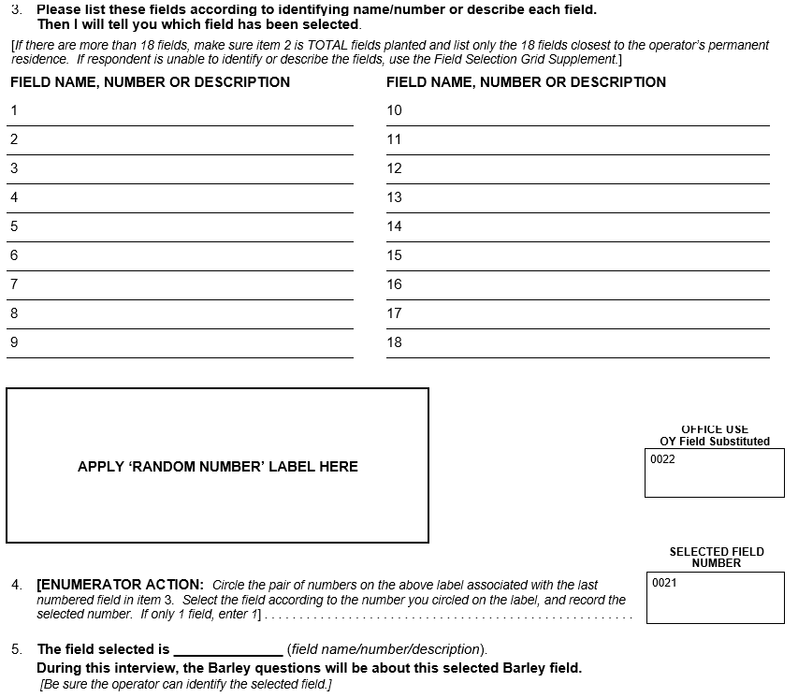

To
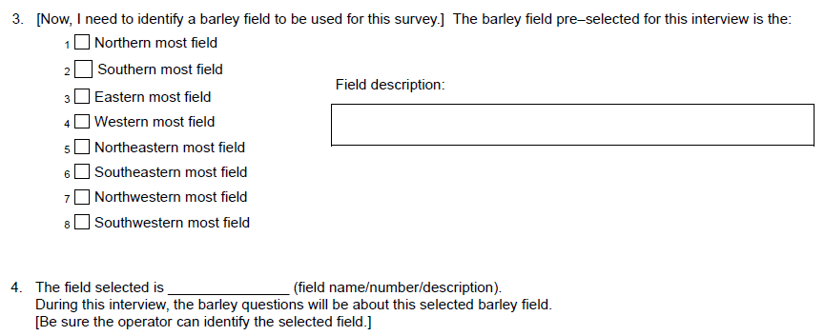

Section C – Nutrient or Fertilizer Applications
There is an additional column in the “Materials Used” sub-table to collect information on the Source/Form of Nitrogen Used: Choose from
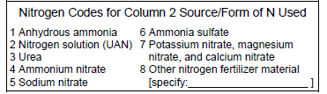
Section E – Pest Management Practices
The following questions have been added prior to the “In 2023, how was this field primarily scouted for insects, weeds, diseases, and/or beneficial organisms?” question:
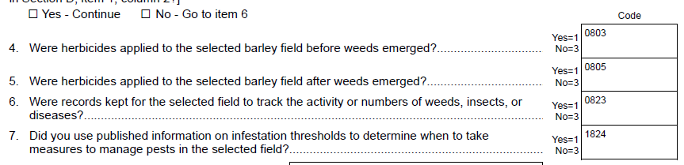
The following questions have been removed:
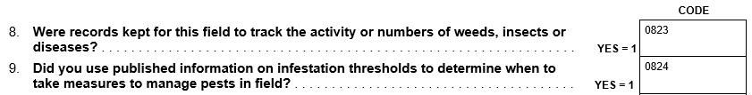
Oat Production Practices and Cost Report
Section A – Oat Field Selection
The following questions were added to collect information for the whole farm:
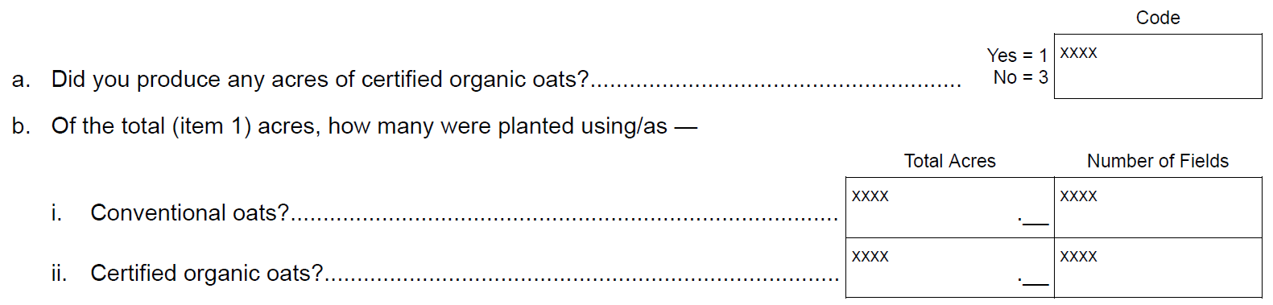

The field selection process has been updated to accommodate for Computer Assisted Personal Interview (CAPI) data collection. This allows NASDA enumerators to complete interviews by phone, if requested by the respondent.
From

To
Section B – Field Characteristics
A new question on the cost for third party organic certification.
A question for the cost to the contractor (if under a production contract) was removed.
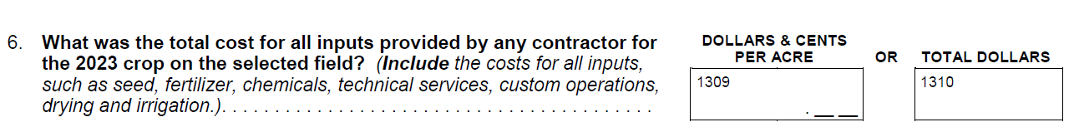
Additional questions for seed treatment and/or commercial seed product were added.
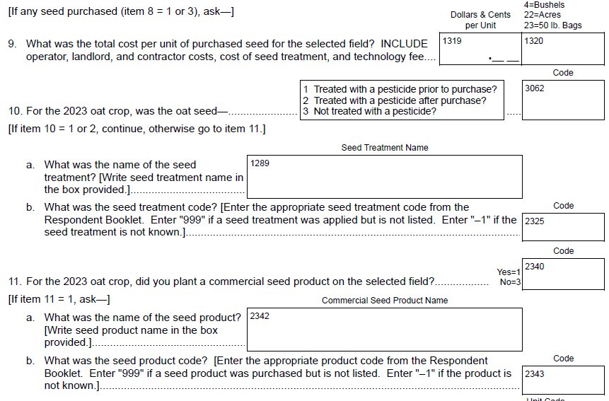
The table in question 18 was modified as follows:
Columns removed: “How did you manage this crop?” and “Was this field irrigated?”
Column added: “If a cover crop was planted, how did you terminate this cover crop?”
The following questions were removed:
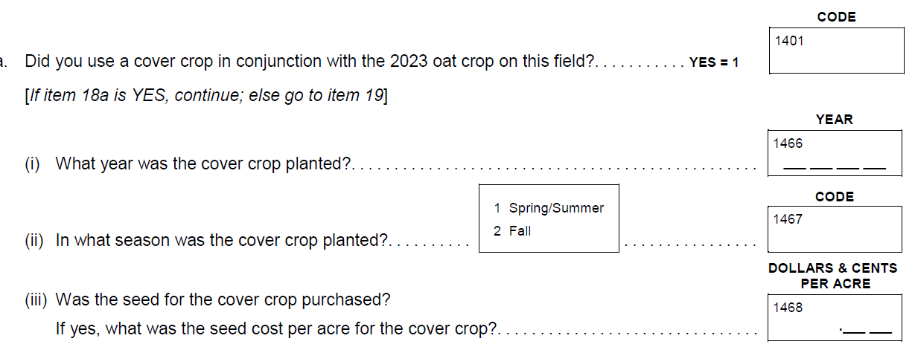

And replaced by the following
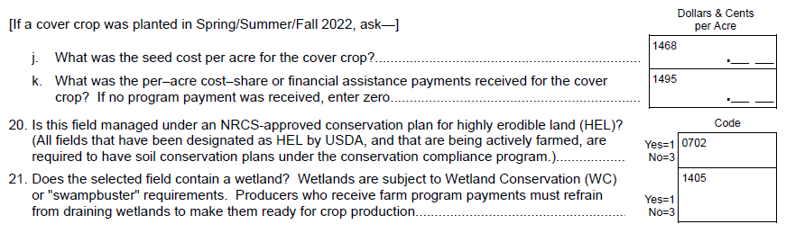
Question 19 (and table) – removed.
Question 21 (and table) – removed.
Question 23 – removed.
Question 24 (and table) – removed.
Question 25 and 26 – removed.
Question 30 – one additional sub question for water availability.
New questions added are:
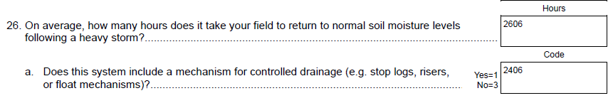

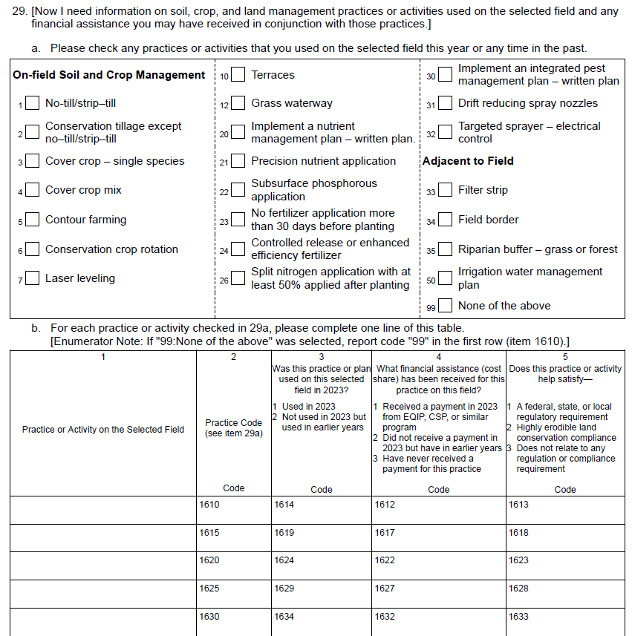

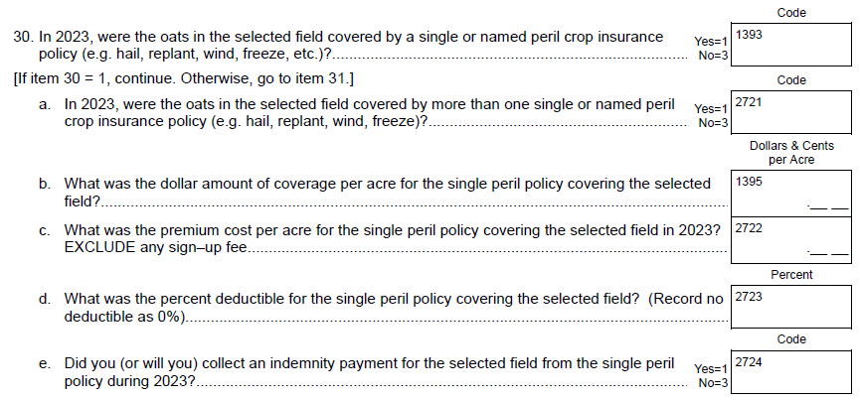

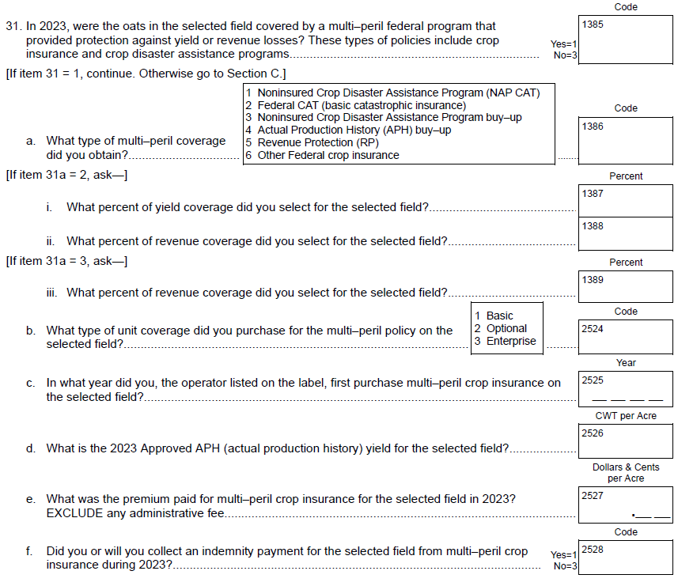

Section C – Nutrient or Fertilizer Applications
There is an additional column in the “Materials Used” sub-table to collect information on the Source/Form of Nitrogen Used: Choose from
New questions for nitrogen inhibitors are included:
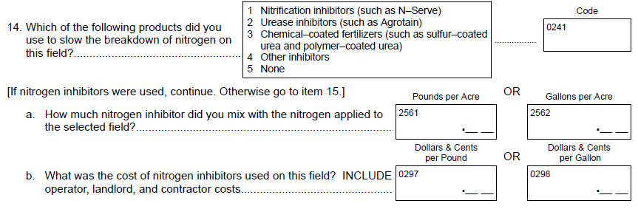
Item 14d – Removed.
Items 15 and 17 – Combined into a new question 16 for “manure or compost”.
Questions added for manure or compost (New item 16):
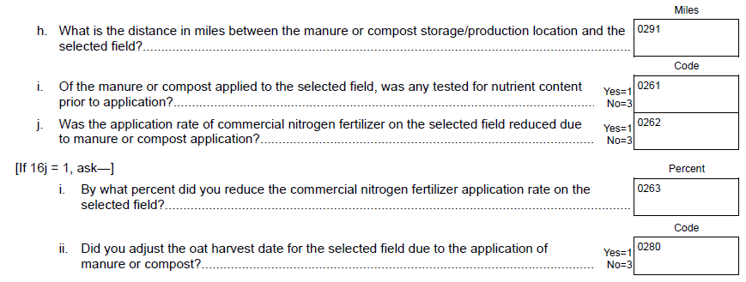

Section D – Biocontrol or Pesticide Applications
New Item 4c:
New Questions:
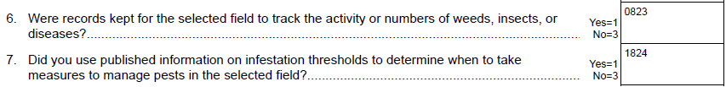
Item 9 – Removed.
New Questions:
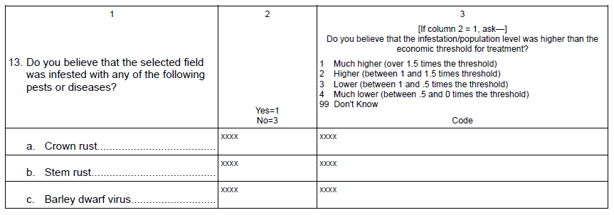
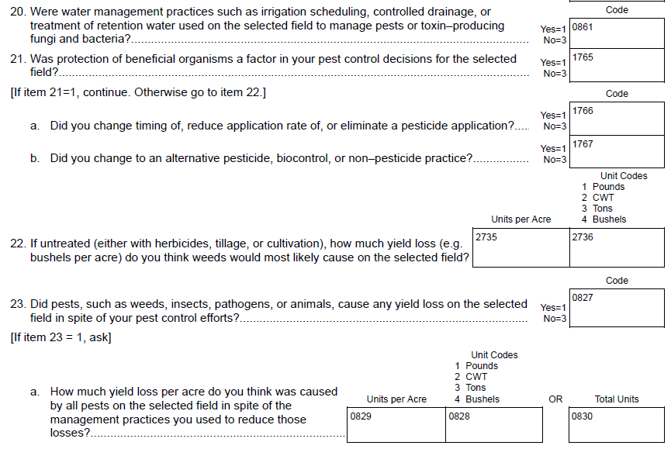
Section F – Field Operations
New questions on machine purchases:
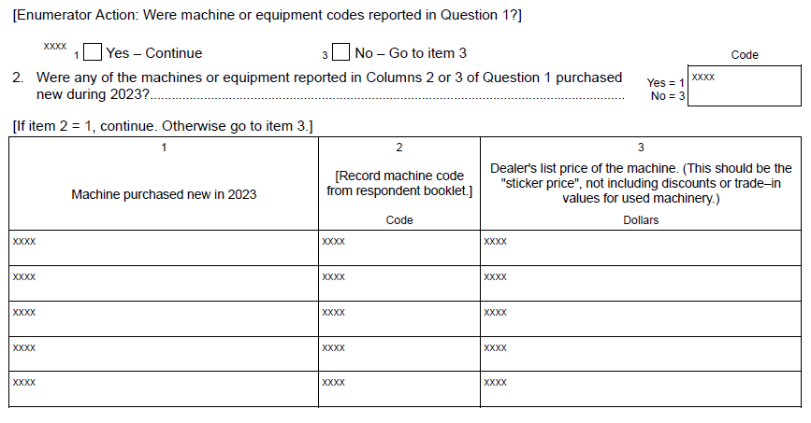

New questions:
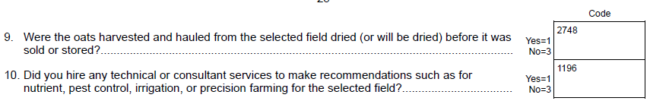
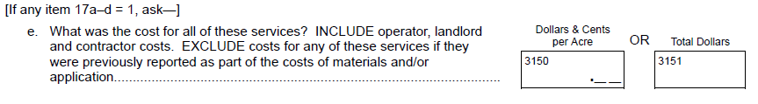
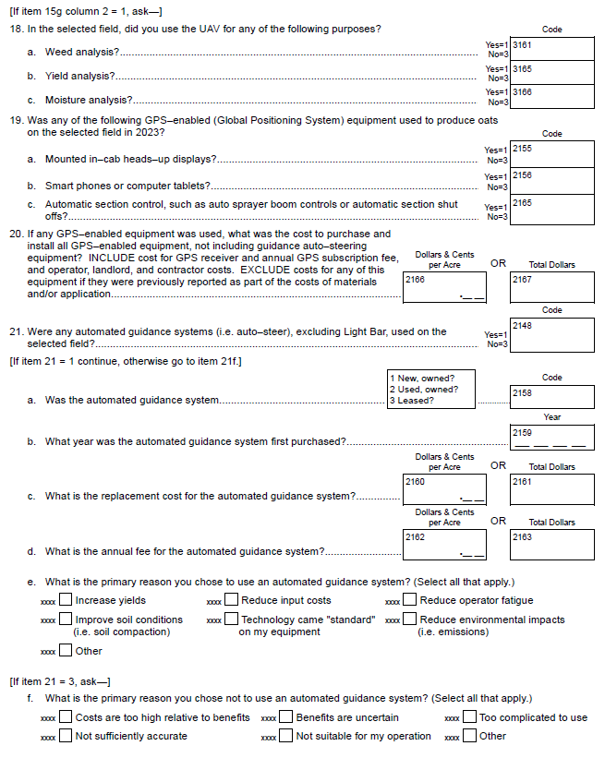
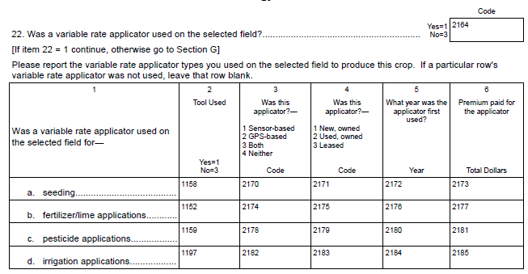

Section G – Irrigation
New screening item:

Peanut Production Practices and Cost Report
Section A – Peanut Field Selection
The field selection process has been updated to accommodate for Computer Assisted Personal Interview (CAPI) data collection. This allows NASDA enumerators to complete interviews by phone, if requested by the respondent.

From
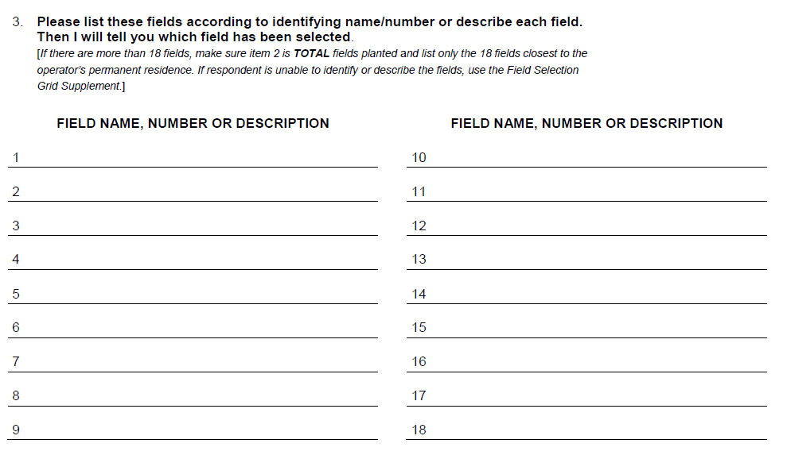
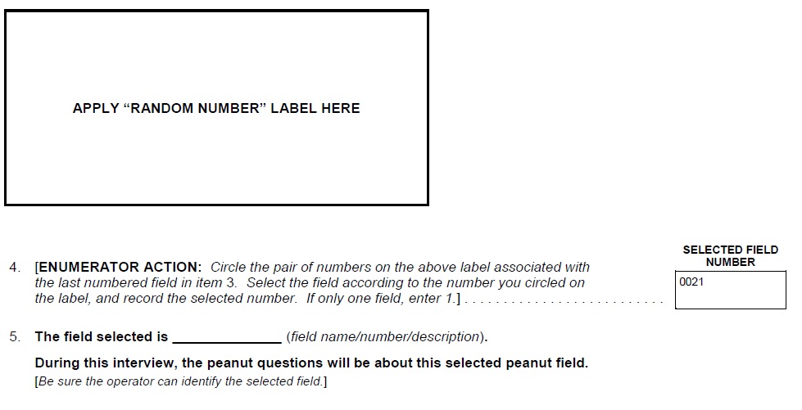
To
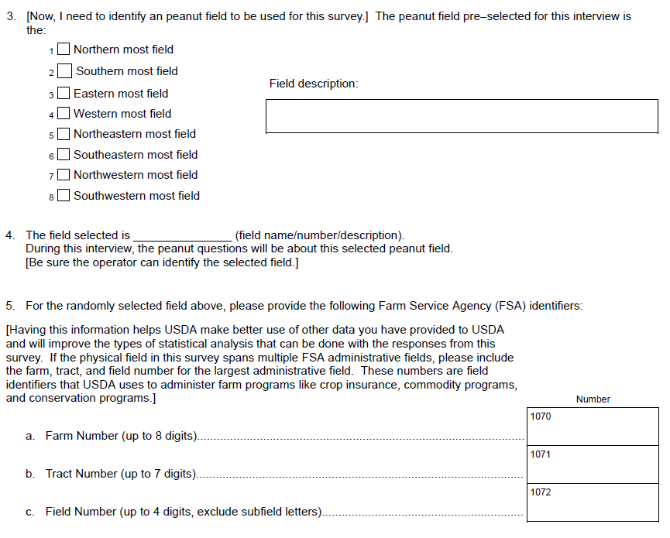
Section B – Field Characteristics
A new question was added about planting intentions:
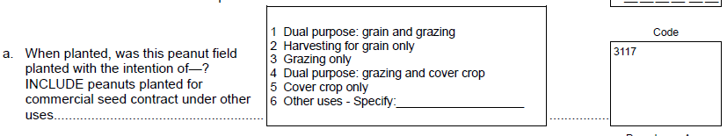

A new question was added to obtain the type of peanuts planted:
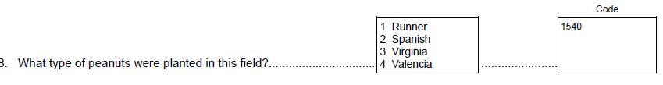

Item 9a – removed.
The following questions were added for seed treatment and commercial seed:
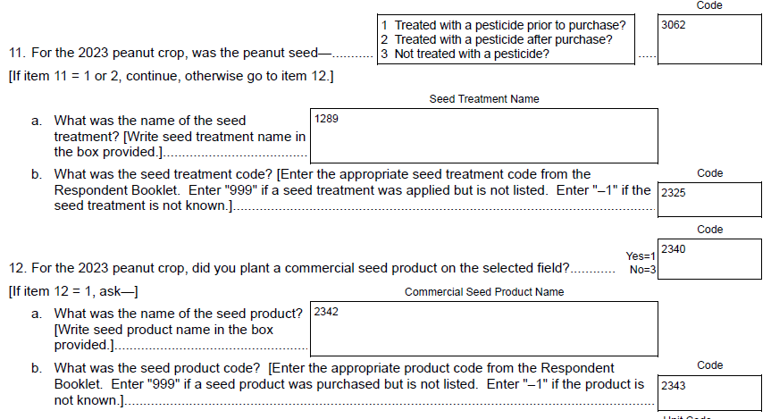
The land use questions were changed from:
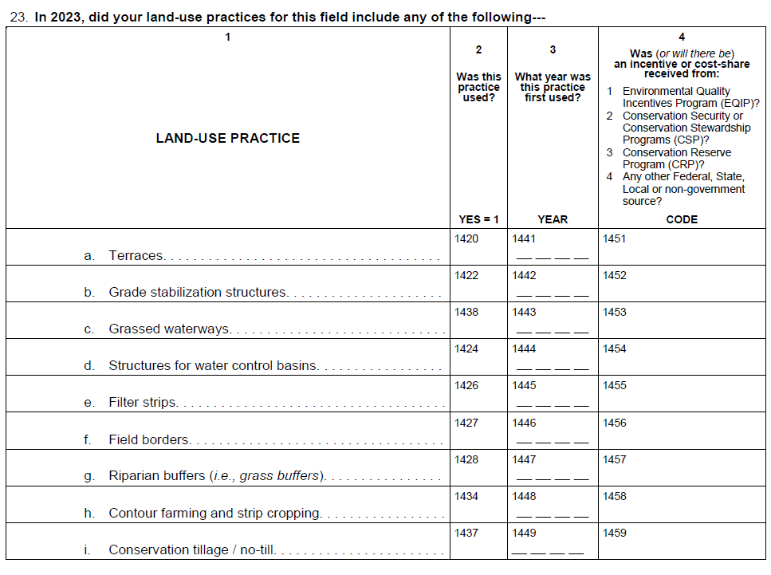
To
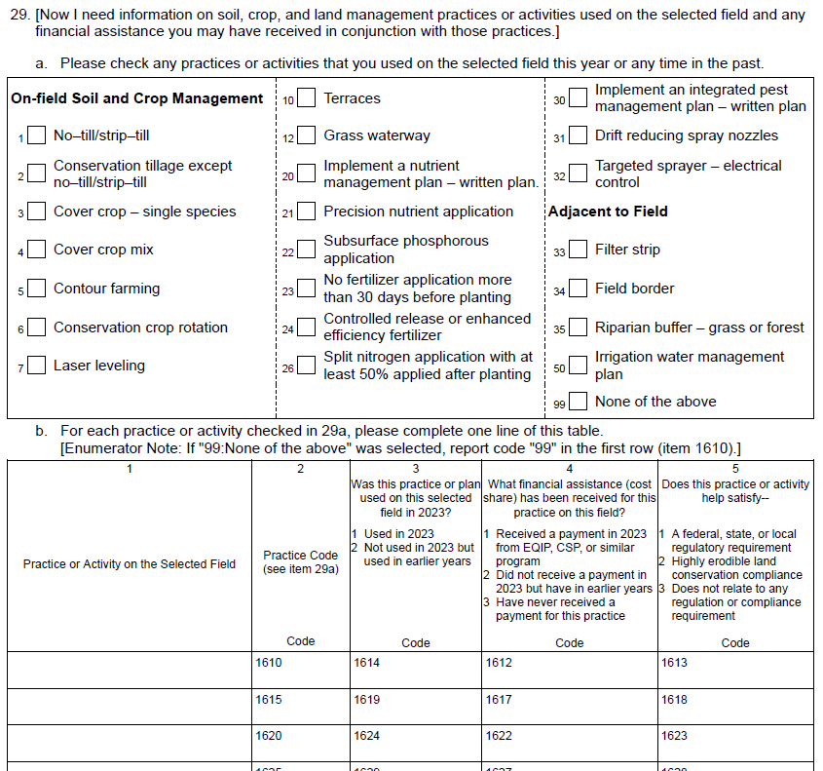
Item 26 and table – Removed.
The following questions were added:
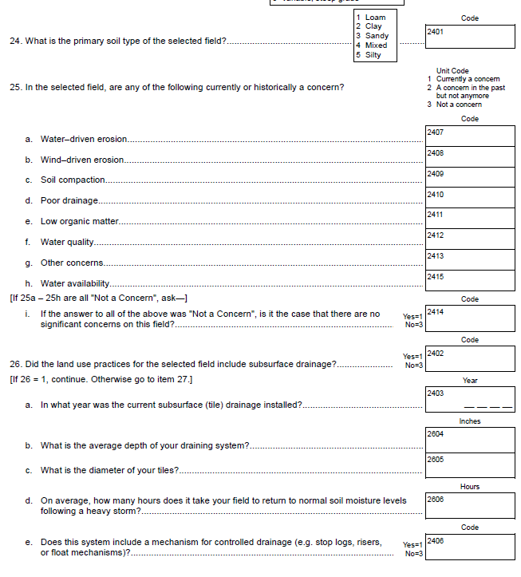
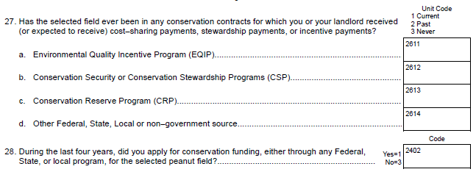
Items 29 and 32 – Removed.
The following questions were added:
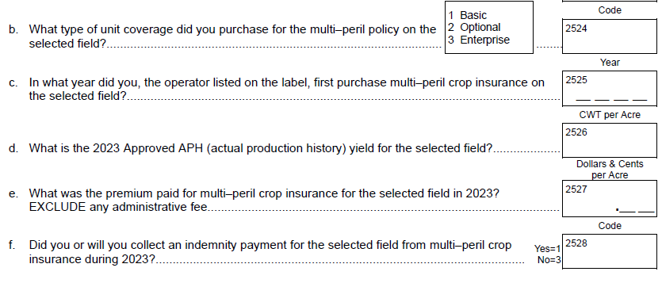
Section C – Nutrient or Fertilizer Applications
There is an additional column in the “Materials Used” sub-table to collect information on the Source/Form of Nitrogen Used: Choose from
The following questions were added for organic matter:
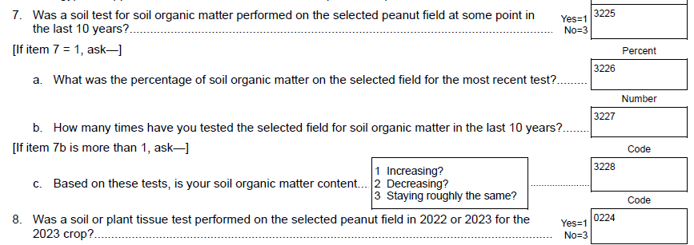
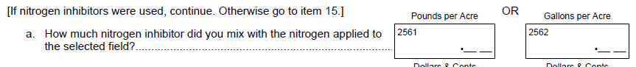
Item 15d – Removed.
Items 16 and 18 – Combined into a new question 16 for “manure or compost”.
Item 19 – Removed.
Section D – Biocontrol or Pesticide Applications
New Item 4a,b,c:
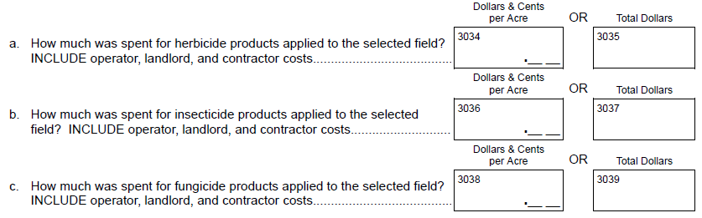
Item 11 – Removed.
Item 13 – Removed.
Item 22 – Removed.
New questions added:
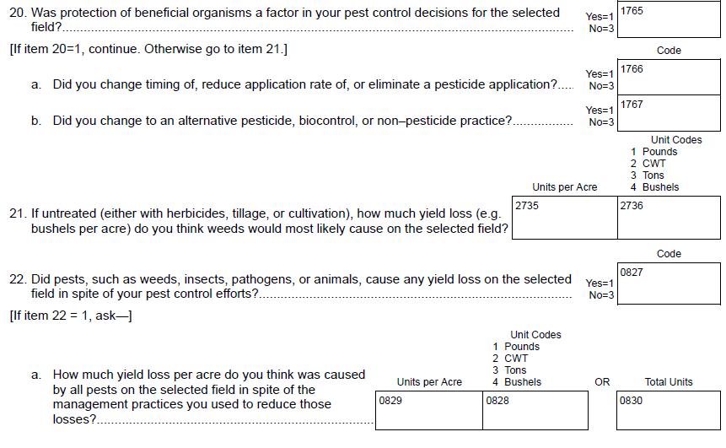

Section F – Field Operations
New questions added for machine purchases:
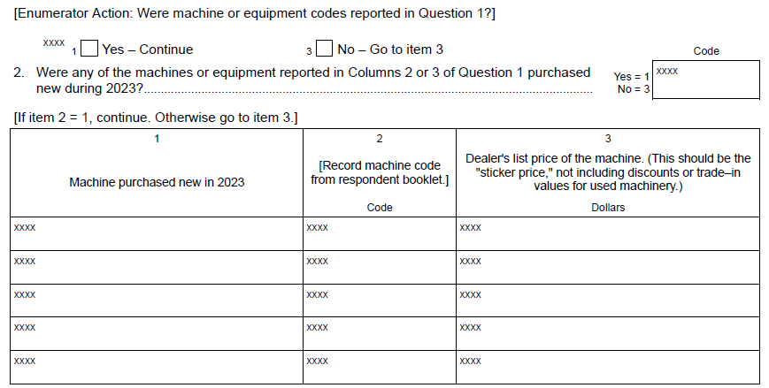
The following questions were added:
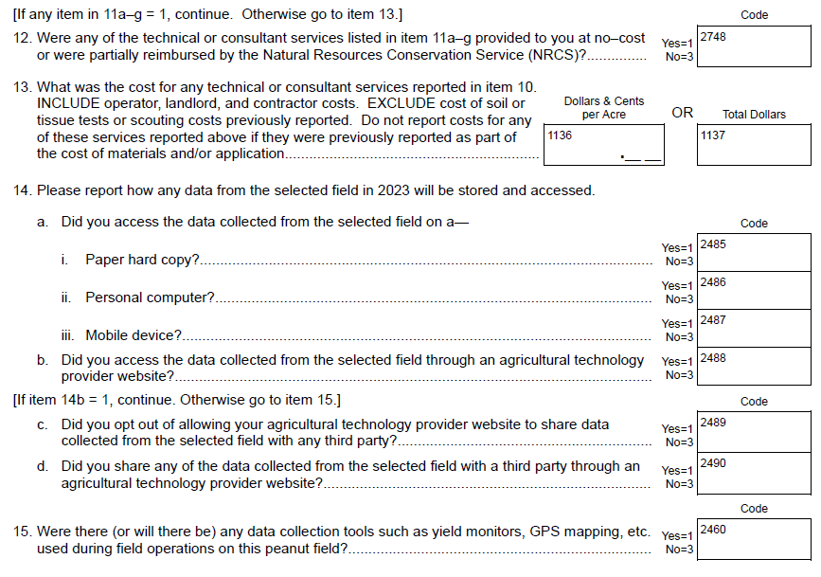
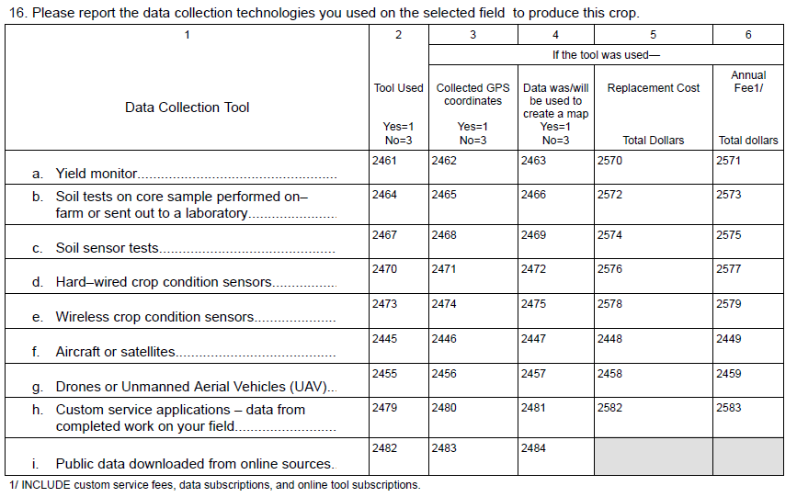
Item 10b(i) – Removed.
Items 11-14 – Removed.
New questions added:
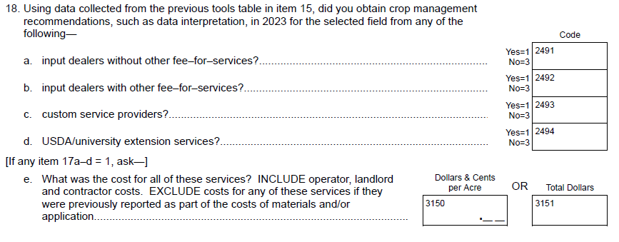
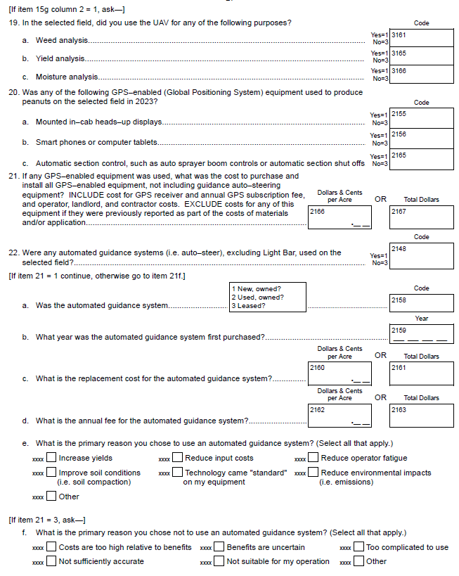
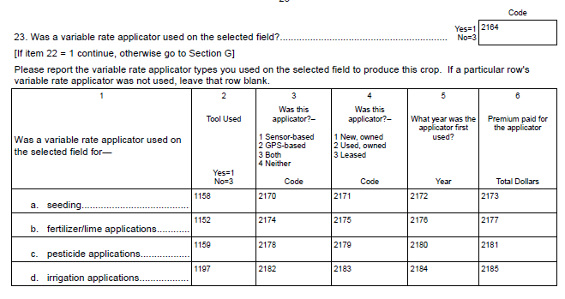
Section G – Irrigation
Item 8d – Removed.
New question:
Item 10 – Removed.

Soybean Production Practices and Cost Report
Section A – Soybean Field Selection
New questions on certified organic acres for the farm:
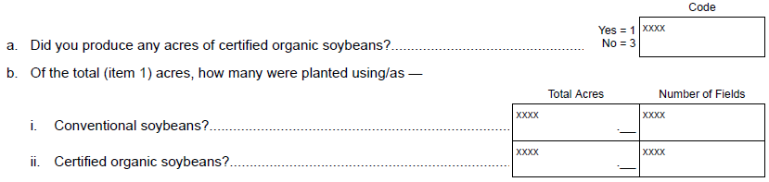

The field selection process has been updated to accommodate for Computer Assisted Personal Interview (CAPI) data collection. This allows NASDA enumerators to complete interviews by phone, if requested by the respondent.

From:
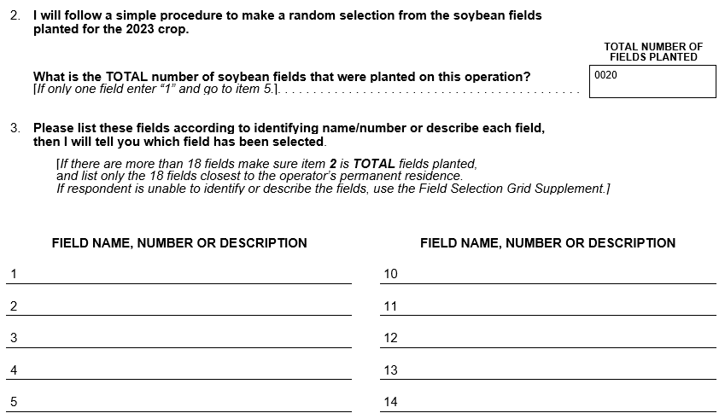
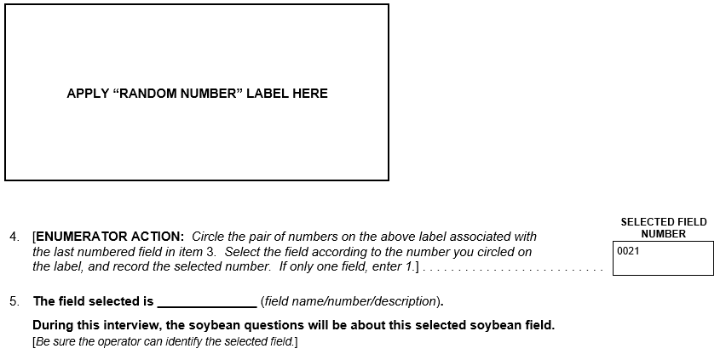
To:
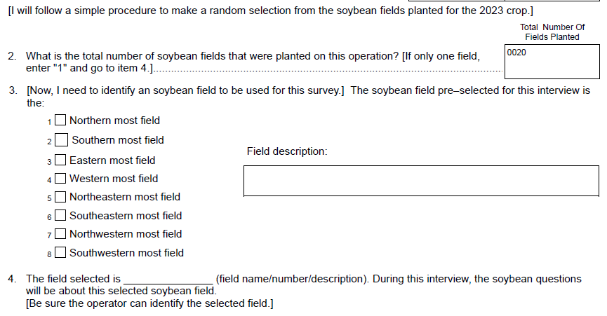
A question was added for the cost for third part certification:
Question 8a – Removed.
A new screening question was added to determine if seed was treated:
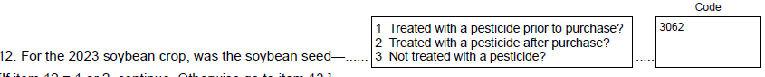
Items 15 and 16 – Removed.
The following questions were added about genetically modified/genetically engineered traits:
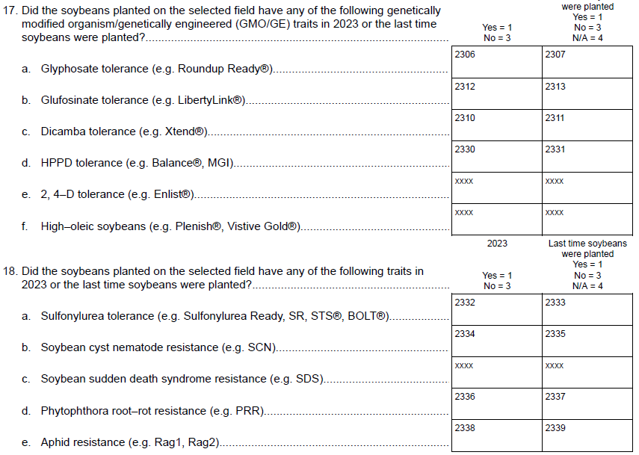
The columns were removed from the table on Item 21 (crops planted on the field previously):
- Type of Crop Grown on the Field,
- Was the field Irrigated

The table on Item 26 was reduced:

From:
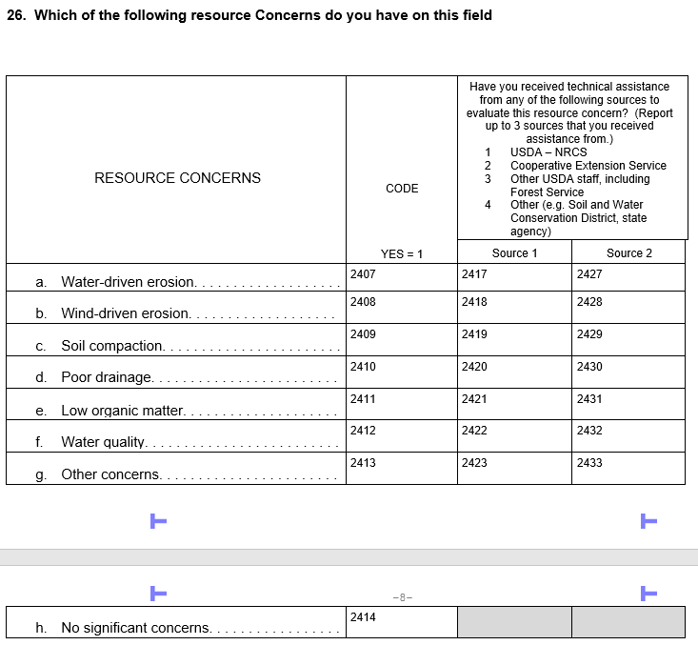

To:
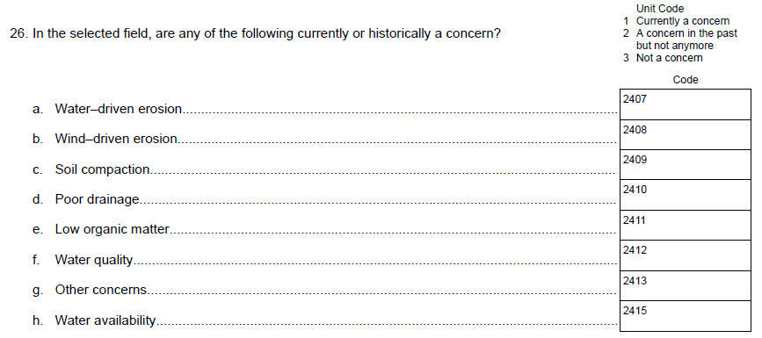

There has been change in the questions for subsurface drainage.
From:
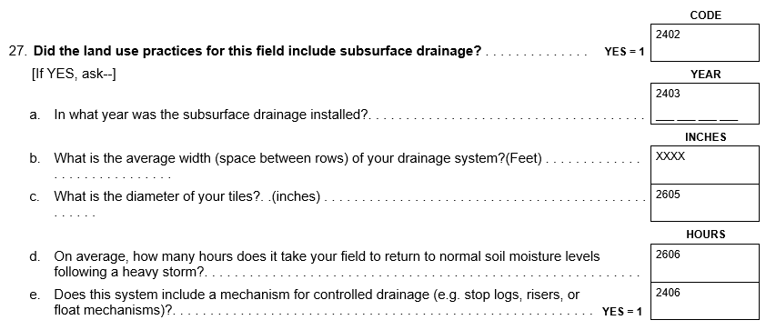
To:
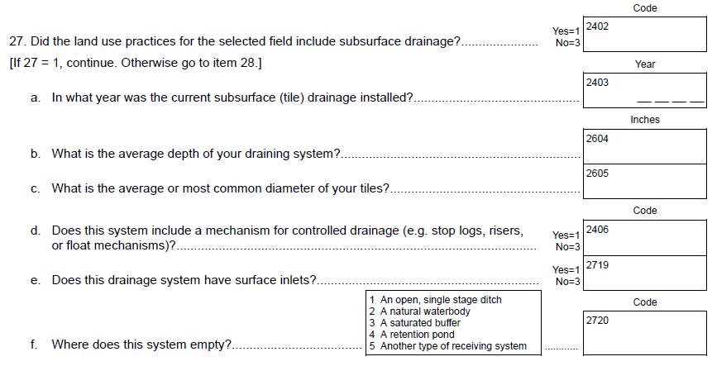

Item 31 – The technical or planning assistance column has been removed.
Item 32 – Removed questions on private insurance.
The private insurance question were replaced with a single or named peril crop
insurance policy (i.e. hail, replant, wind, freeze, etc.)
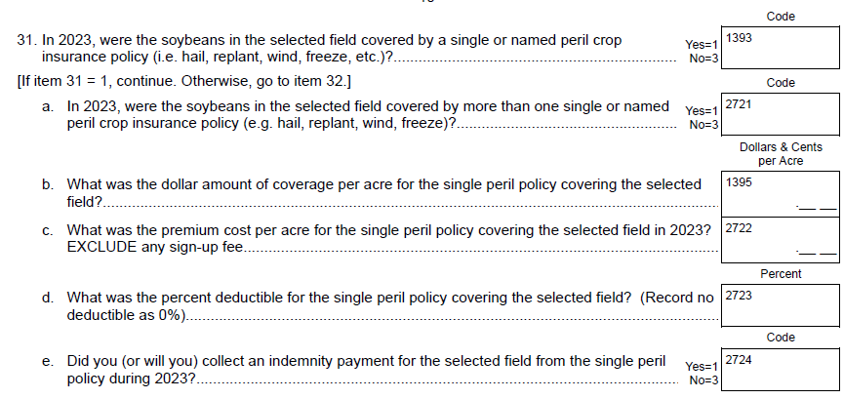
The following questions were added for Federal Crop insurance:
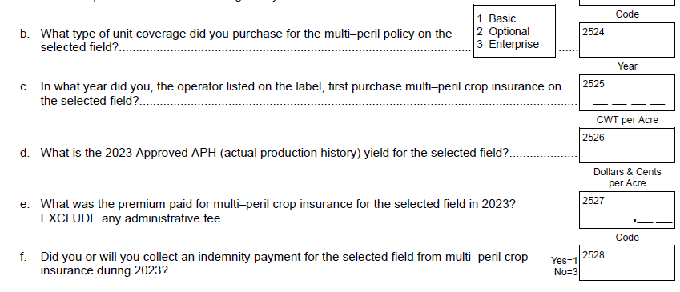
Section C – Nutrient or Fertilizer Applications
There is an additional column in the “Materials Used” sub-table to collect information on the Source/Form of Nitrogen Used: Choose from
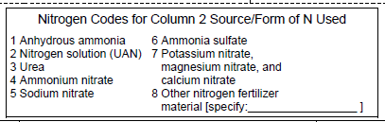
A few questions on custom application of nitrogen and manure/compost were added:
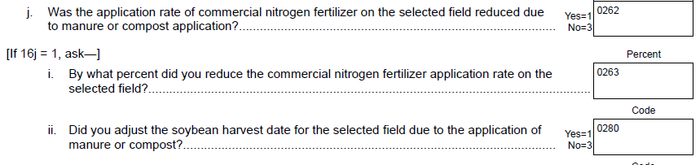
Section D – Biocontrol or Pesticide Applications
A new item 4c was added:
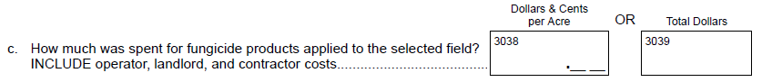
Section E – Pest Management Practices
Item 11 (table) – Removed.
Item 25a – Removed.
New Items 25a and 25b:
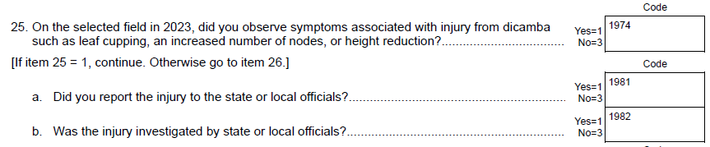
Items 32 and 33 – Removed.
Section F – Field Operations
New Items added on items purchased in 2023:
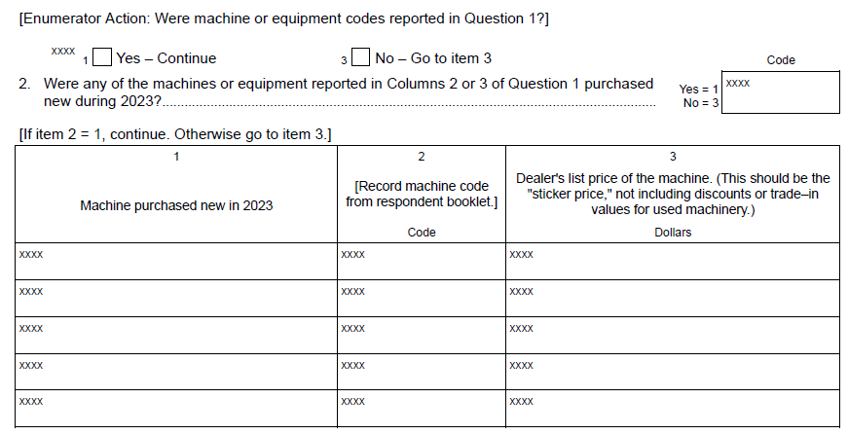
Item 7g – Removed.
New Item added:
Item 14(1) – Removed.
The following questions were added:
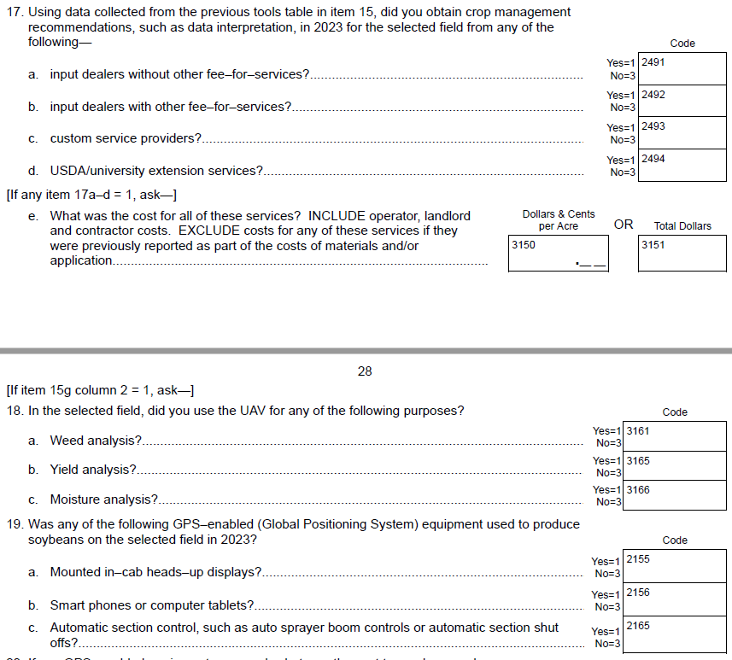
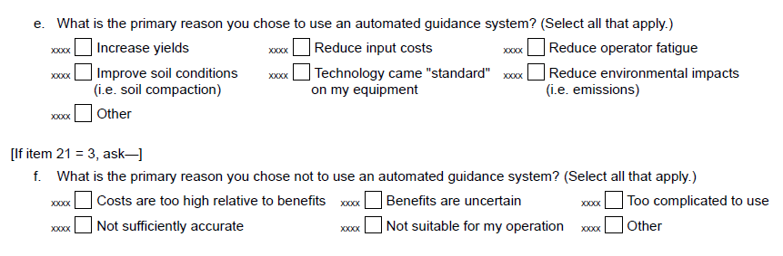
Item 17: A new row was added for “irrigation applications”

Fruit Chemical Use Survey – CA Version
Section C –Fertilizer Applications
New questions on the fertilizers applied to bearing acres for the target commodity.:

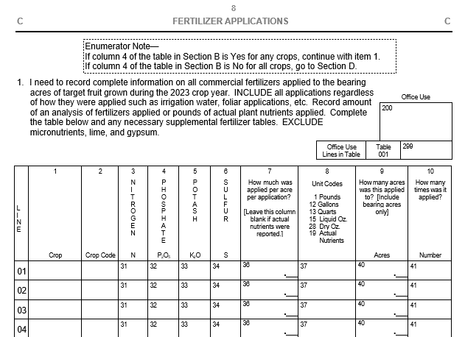

Fruit Chemical Use Survey – Enterprise Version
Section C –Fertilizer Applications
New questions on the fertilizers applied to bearing acres for the target commodity.:

These changes listed above will not impact the current sample size or overall respondent burden.

