Non-substantive Change Request
0535-0037 – Vegetable Surveys
Vegetable Grower Inquiry - November 2023 - New Mexico Version (Chile Variety)
This non-substantive change request affects the 2023 Vegetable Grower Inquiry New Mexico version. The New Mexico Vegetable Inquiry Chile Varieties questions are funded by the New Mexico Department of Agriculture under a cooperative agreement.
The specific change is listed below:
These changes will not impact the current sampling methodology, sample size or respondent burden.
The revised New Mexico master questionnaire is loaded to ROCIS.

Old version
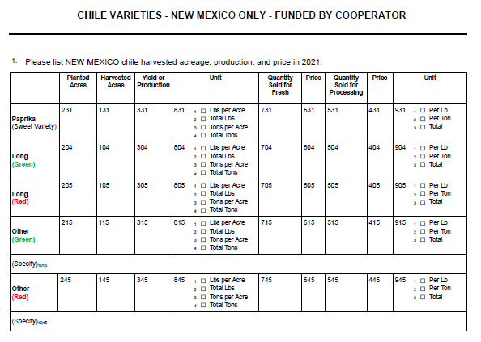

New Version
