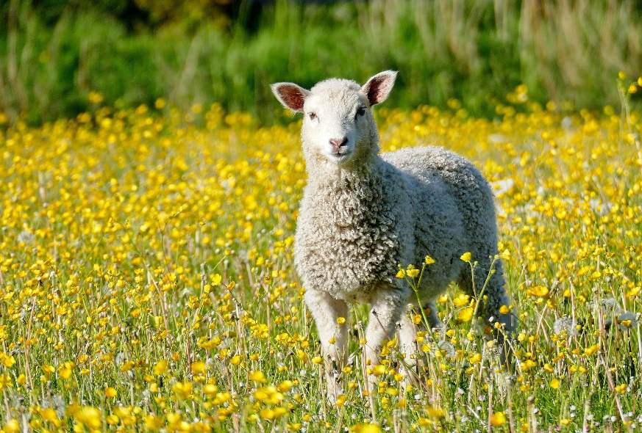

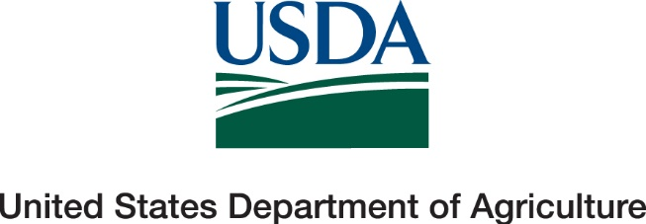

Thank you for participating in the NAHMS Sheep 2024 study. We appreciate the time you took to answer all our questions. We know these studies can be time consuming, however they provide valuable information to the U.S. sheep industry. These studies could not be completed without you. To view reports from the Sheep 2024 study please visit our website at http://www.aphis.usda.gov/nahms
Thanks again,
NAHMS Sheep 2024 Team

