Lameness Reference Card
Causes | Description | Photo
Foot Scald | The skin between the claws is swollen, red and may be covered by a thin layer of white discharge, may be only slightly lame | 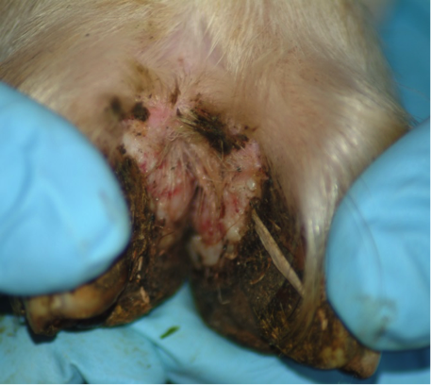
Foot rot | More severe than foot scald, often effects more than one foot, may have a smell and may attract flies, will be more lame than a sheep with foot scald | 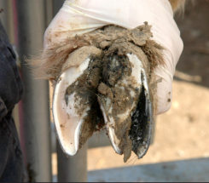
Contagious Ovine Digital Dermatitis (CODD) | Severe lameness, typically affecting one claw of one foot. Small ulcers develop at the coronary band, the whole hoof capsule may detach. | 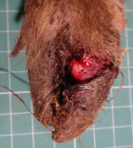
Foot abscess | Sheep will be lame with obvious acute pain, foot will be swollen, in some cases there may be a purulent discharge above the hoof or between the toes, usually only one foot affected | 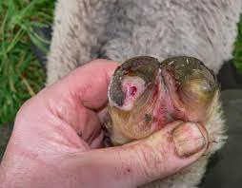
Shelly hoof/ white line disease | In severe cases, there will be lameness, separation of the horn from the hoof, with a visible white line | 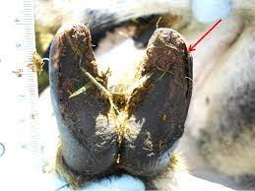
Granuloma | Painful, red swelling from growing tissue caused by over-trimming or chronic irritation from untreated lesions or chemical irritation. | 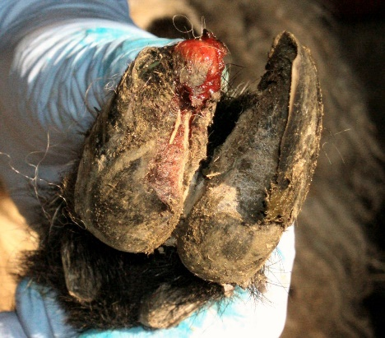
Injury | May be acute or chronic, hooves likely look okay | 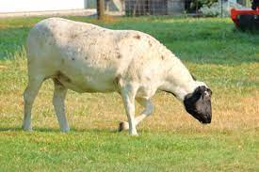
Swollen joints/ Joint ill | Lameness, with potentially multiple legs or joints affected, early signs include hot/swollen joints, likely seen in lambs, hooves themselves may look okay. | 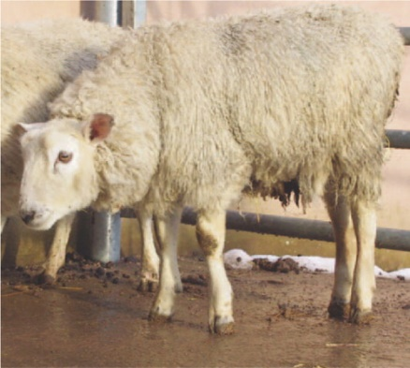
Other causes | Other disease such as sore mouth or grain overload may cause transient lameness | 