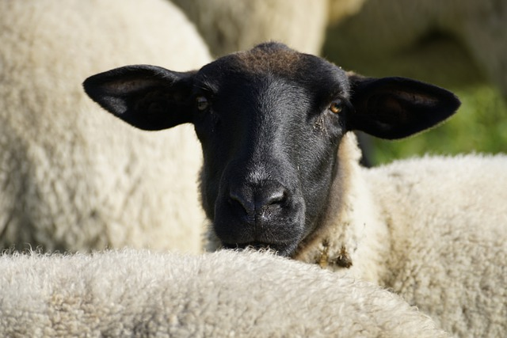

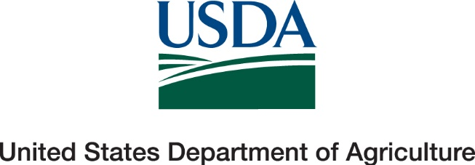

Thank you for all your hard work on the NAHMS Sheep 2024 Study. We appreciate the effort you put forward to ensure that producers were contacted, questionnaires were completed, and biologic samples were collected. We know these studies can be time consuming and difficult, however they provide valuable information to the industry. These studies could not be completed without you!
Thanks again,
NAHMS Sheep 2024 Team

