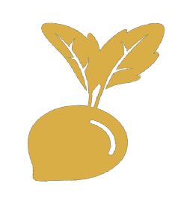
TURNIP THE BEET
with high quality summer meals!
The Turnip the Beet Award, by the U.S. Department of Agriculture’s (USDA) Food and Nutrition Service (FNS), recognizes outstanding Summer Meal Program sponsors who work hard to offer high quality meals that are appetizing, appealing, and nutritious.

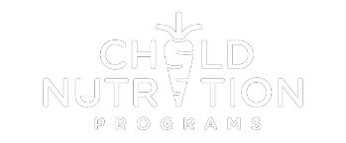

Who is eligible, and how do they apply?
All Summer Meal Programs sponsors in good standing, including Summer Food Service Program (SFSP) sponsors and National School Lunch Program Seamless Summer Option (SSO) sponsors, may be eligible for a Turnip the Beet Award. Sponsors may self-nominate or be nominated by another party. Each State agency determines their own deadline for nominations. The nomination must include a completed Nomination Form and a detailed one-month menu. FNS evaluates and scores the nominations and notifies the winners in writing. The Nomination Form is available on the Turnip the Beet webpage https://www.fns.usda.gov/sfsp/turnip-the-beet.

How are nominations evaluated?
Nominations must clearly illustrate how the meals are appetizing, appealing, and nutritious. The Nomination Form includes short-answer questions and menu criteria based on the Dietary Guidelines for Americans. The criteria include serving local foods, a variety of vegetables and fruit, whole grains, and low-fat and fat-free milk. For more detailed information on the Turnip the Beet Award and the evaluation criteria, check out the Turnip the Beet webpage.

What are the prizes?

Three award levels are available: gold; silver; and bronze. All winners will receive a certificate and will be featured on the Turnip the Beet webpage.
Questions?
OMB Burden Disclosure Statement: This information is being collected to assist the Food and Nutrition Service (FNS) in recognizing high quality summer meals. This is a voluntary collection and FNS will use the information to determine Turnip the Beet award winners. This collection does request personally identifiable information under the Privacy Act of 1974. According to the Paperwork Reduction Act of 1995, an agency may not conduct or sponsor, and a person is not required to respond to, a collection of information unless it displays a valid OMB control number. The valid OMB control number for this information collection is 0584-0658. The time required to complete this information collection is estimated to average 1 hour per response, including the time for reviewing instructions, gathering the data needed, and completing and reviewing the collection of information. Send comments regarding this burden estimate or any other aspect of this collection of information, including suggestions for reducing this burden, to: U.S. Department of Agriculture, Food and Nutrition Service, Office of Policy Support, 1320 Braddock Place, 5th Floor, Alexandria, VA 22306 ATTN: PRA (0584-0658). Do not return the completed form to this address.

Questions regarding the Turnip the Beet Awards

should be directed to your Summer Meals State
agency: https://www.fns.usda.gov/sfsp/sfsp-contacts.
Resources
FNS has an abundance of resources available for sponsors to help make the summer meals they serve more appetizing, appealing, and nutritious:

- The Nutrition Guide for Sponsors (https://www.fns.usda.gov/sfsp/2018-nutrition-guide) includes tips for serving high quality meals and incorporating local foods, as well as sample cycle menus.

- The Farm to Summer Fact Sheet (https://www.fns.usda.gov/cfs/farm-summer-ripe-local-foods) describes how to “bring the farm” to summer sites.

- The Summer Meals Toolkit (http://www.fns.usda.gov/sfsp/summer-meals-toolkit) offers healthy menu planning ideas and tips for serving meals family style.

- The Team Nutrition Resource Library (https://www.fns.usda.gov/tn/resource-library) has free nutrition education materials.

