Appendix D.1. Web-based Household Survey Instrument in English

# INTRO1

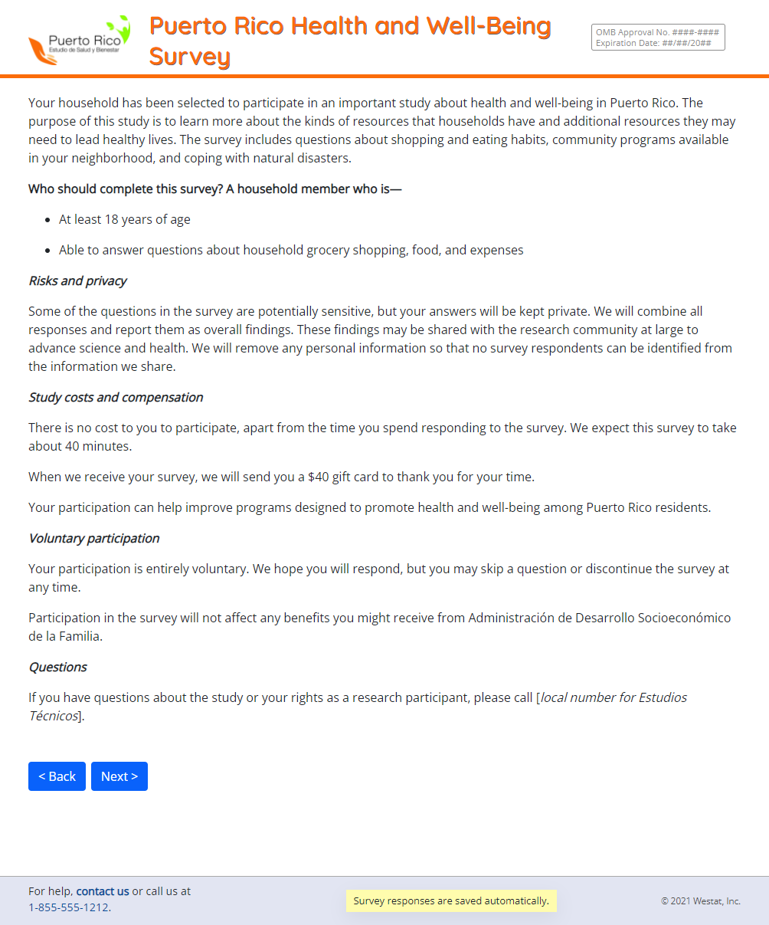

# INTRO2

# A_1_INTRO

# A_1_

# A_2_

# A_3_

# A_4_

# A_5_

# A_6_

# A_7_MATRIX

# A_8_MATRIX

# A_9_MATRIX

# A_10_

# B_1_INTRO

# B_1_

# B_2_

# B_3_

# B_4_INTRO

# B_4_

# B_5_

# B_6_

# B_7_

# B_8_

# B_9_INTRO

# B_9_

# B_10_

# B_11_

# B_12_INTRO

# B_12_

# B_13_

# B_14_

# B_15_

# C_1_MATRIX

# C_2_MATRIX

# C_3_

# C_3A_MATRIX

# C_4_INTRO

# C_4_

# C_5_

# C_6_

# C_7_

# C_8_

# C_9_

# C_10_

# C_11_INTRO

# C_11_

# C_11_A

# C_12_MATRIX

# C_13_INTRO

# C_13_MATRIX

# D_1_1

# D_1_2

# D_1_3

# D_2_

# D_2A_

# D_3_

# D_4_

# D_5_

# D_5_A1

# D_6_MATRIX

# D_7_

# D_8_

# D_9_

# E_1_INTRO

# E_1_

# E_1_A_1

# E_1_B_

# E_1_C_

# E_1_D_

# E_1_E_

# E_2_MATRIX

# F_1_INTRO

# F_1_1

# F_1_2

# F_1_3

# F_2_

# F_2A_

# F_3_

# F_3A_1

# F_3A_2

# F_3A_3

# F_5_

# F_4_

# F_6_

# F_7_MATRIX

# G_1_MATRIX

# G_2_

# G_3_

# G_4_MATRIX

# G_5_

# G_6_

# G_7_

# G_8_

# H_1_

# H_2_

# H_3_

# H_4_

# H_5_

# H_6_

# I_2_

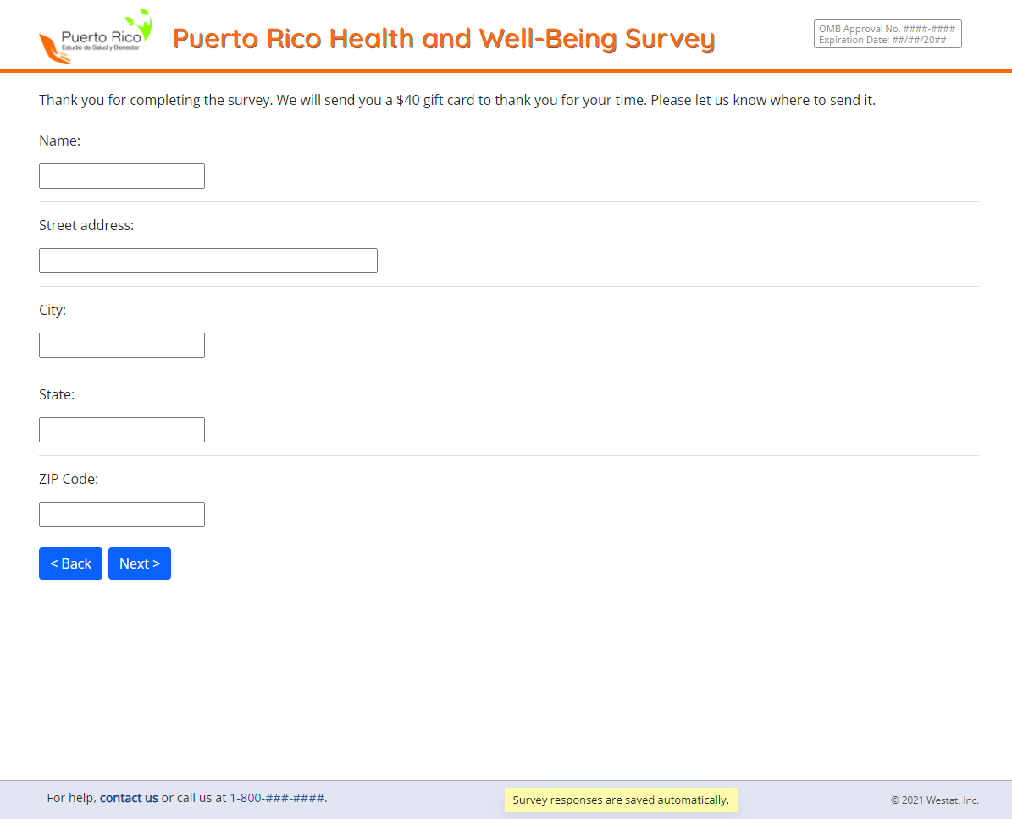

# I_4_

# I_5_

# I_6_