Appendix I.3. Study Announcement for Local Community Partners in English
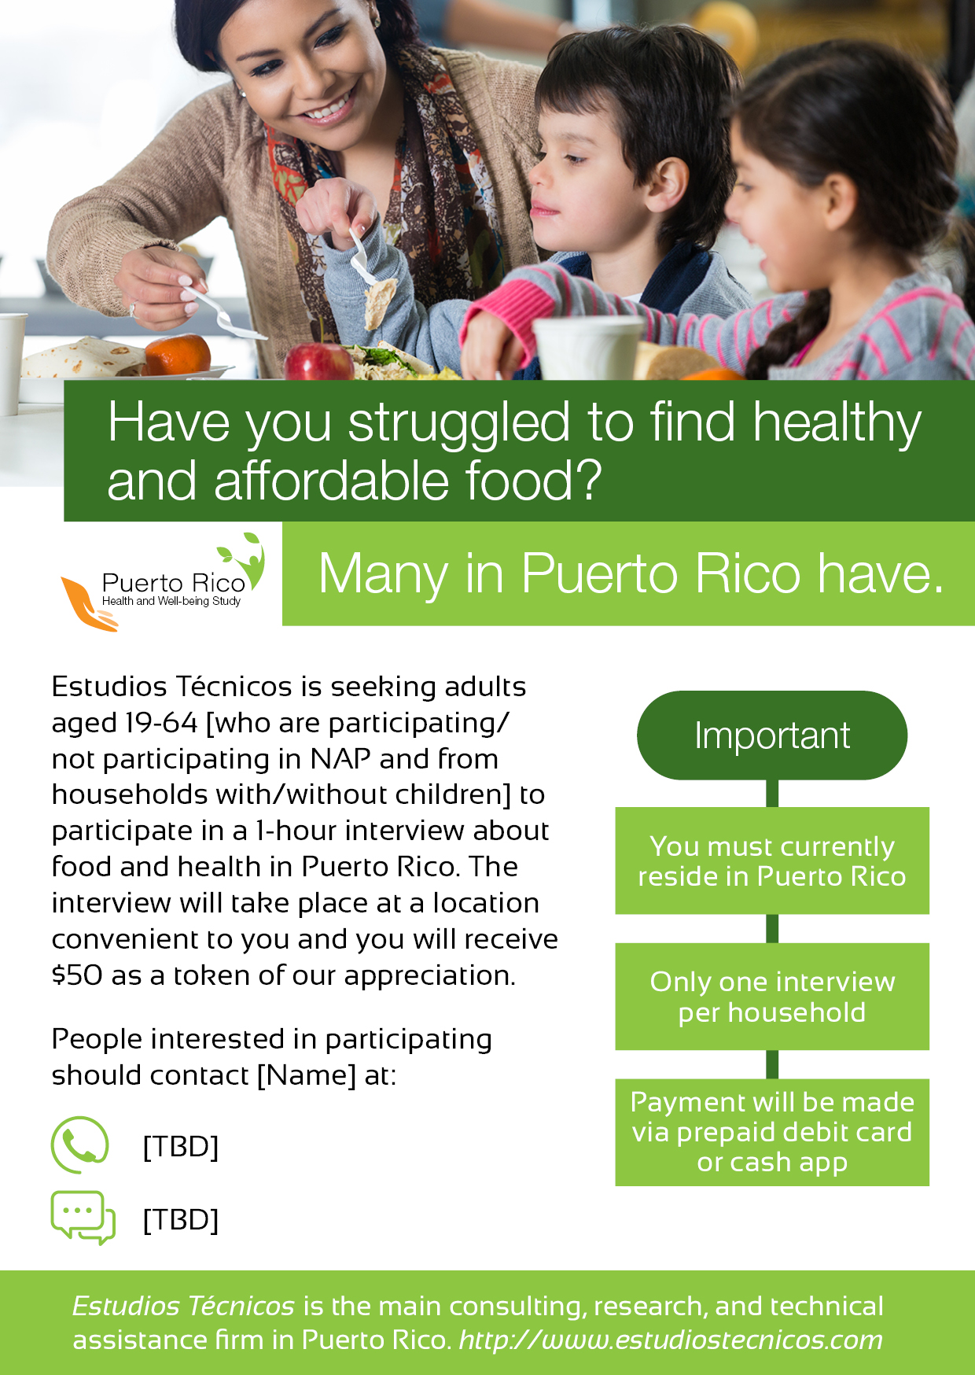
Public Burden Statement
This information is being collected to assist the Food and Nutrition Service (FNS) in understanding food security status and economic well-being among Puerto Rico residents. This is a voluntary collection. FNS will use the information as a baseline for future assessments of food security and the Nutrition Assistance Program, particularly in the context of natural disasters. This collection does not request personally identifiable information under the Privacy Act of 1974. According to the Paperwork Reduction Act of 1995, an agency may not conduct or sponsor, and a person is not required to respond to, a collection of information unless it displays a valid OMB control number. The valid OMB control number for this information collection is 0584-XXXX. The time required to read this information is estimated to average 1 minute. Send comments regarding this burden estimate or any other aspect of this collection of information, including suggestions for reducing this burden, to: U.S. Department of Agriculture, Food and Nutrition Service, Office of Policy Support, 1320 Braddock Place, Alexandria, VA 22314. ATTN: PRA (0584-XXXX). Do not return the completed form to this address.

