MarineNet Account Registration

1. To sign up for a MarineNet Account go to: [https://www.marinenet.usmc.mil](https://www.marinenet.usmc.mil/)
2. 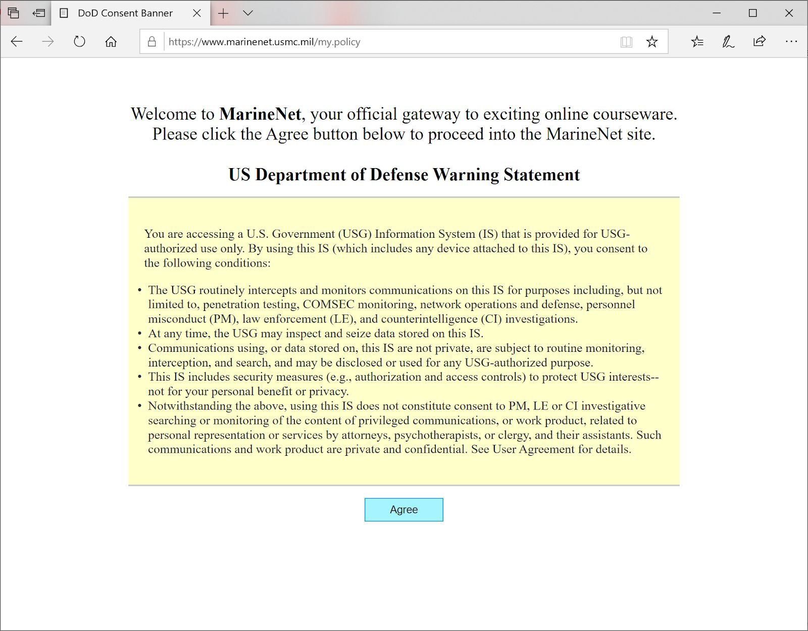Click Agree and select Cancel if prompted for a CAC certificate.
3. 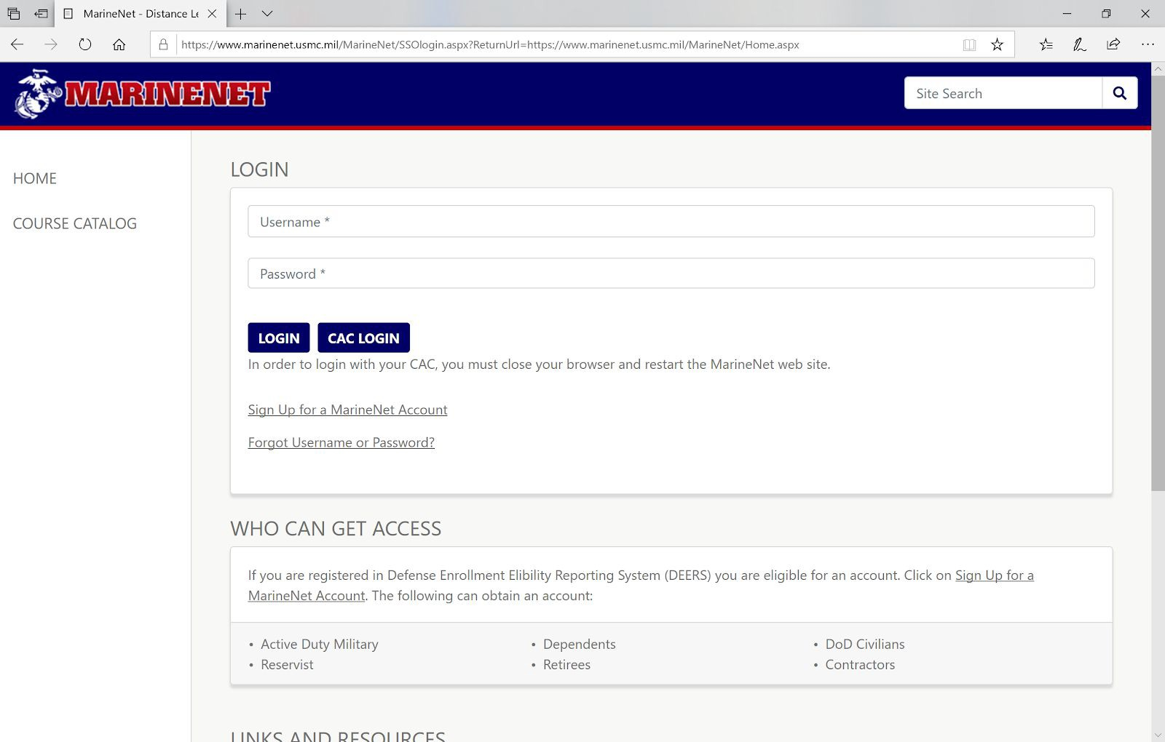Click Sign up for a MarineNet Account
4. All users fill out the “short form” with SSN, Name, and Date of Birth. If the user has a CAC, they check the box for Create account using CAC. Click Next. If the data can be validated in DEERs, the account is created.

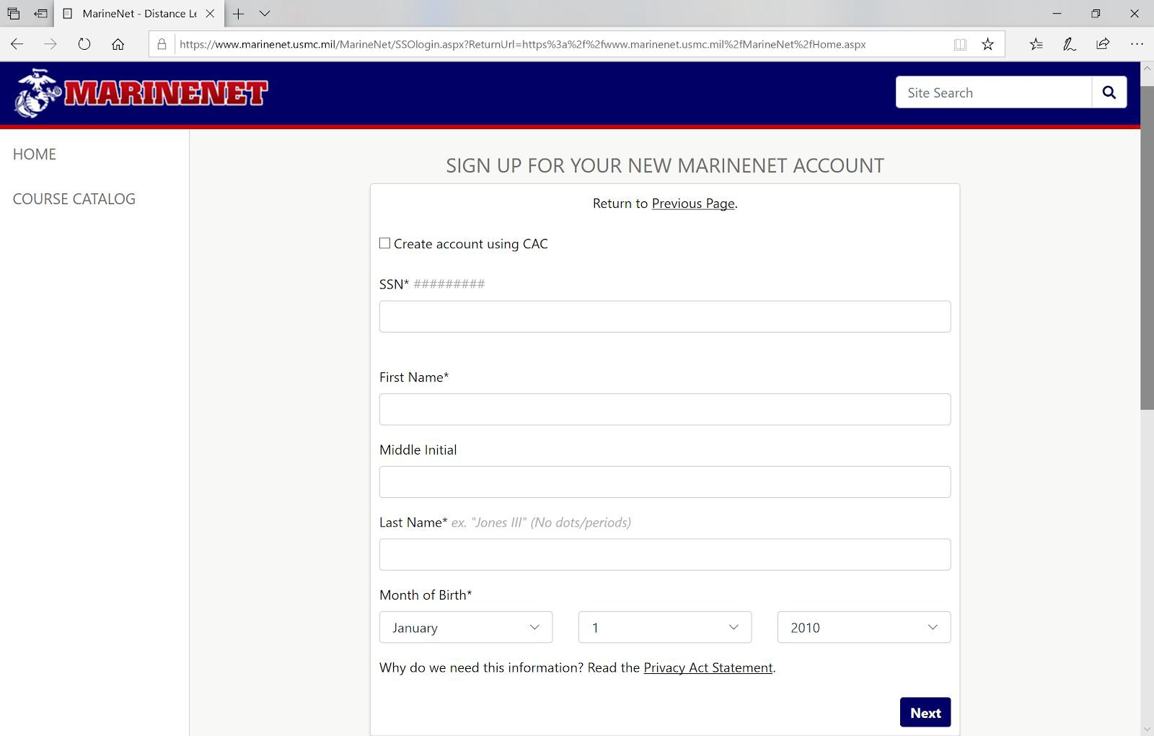

OMB CONTROL NUMBER: 0712-XXXX

OMB EXPIRATION DATE: XX/XX/XXXX

AGENCY DISCLOSURE NOTICE

The public reporting burden for this collection of information, 0712-XXXX, is estimated to average five (5) minutes per response, including the time for reviewing instructions, searching existing data sources, gathering and maintaining the data needed, and completing and reviewing the collection of information. Send comments regarding the burden estimate or burden reduction suggestions to the Department of Defense, Washington Headquarters Services, at whs.mc-alex.esd.mbx.dd-dod-information-collections@mail.mil. Respondents should be aware that notwithstanding any other provision of law, no person shall be subject to any penalty for failing to comply with a collection of information if it does not display a currently valid OMB control number.

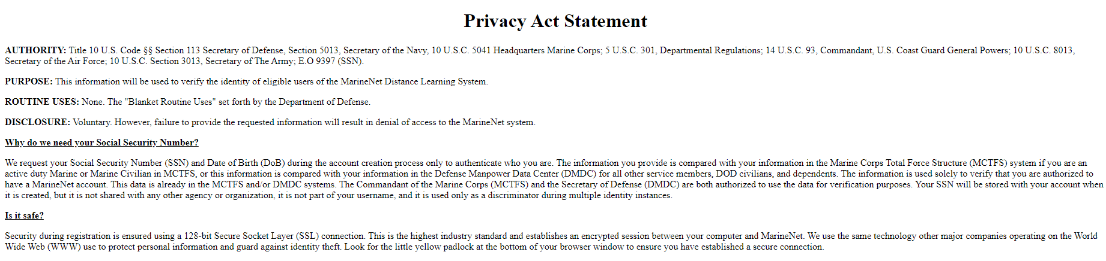

1. Users who can’t be verified in DEERS are automatically directed to an extended registration tool and will be required to enter additional information, including identifying a sponsor of O-4 or GS-12 rank or above, to be considered for an account.

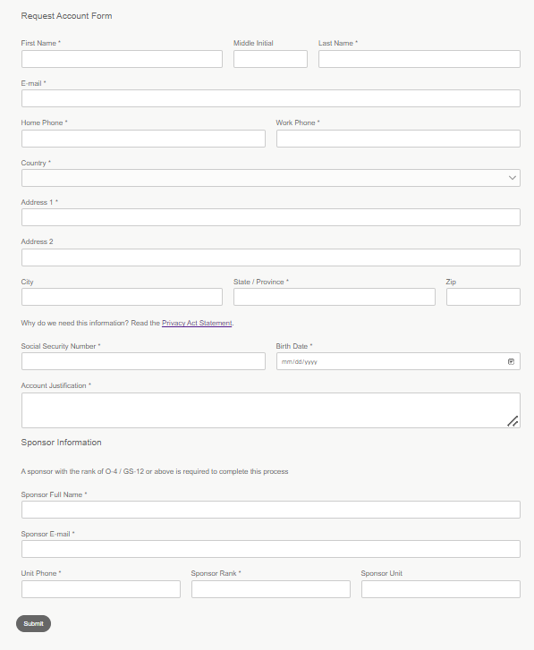

1. If an account already exists for the provided information, users are prompted to contact MarineNet support at: [cdet.student_support@usmc.mil](mailto:cdet.student_support@usmc.mil) or 888-435-8762 select option 2 (MarineNet Student Support).