Application

# Introduction



Form Approved OMB No. 0917-0009

Exp. Date 08/31/2023

The Federal Health Program for American Indians/Alaska Natives

The overall mission of the Indian Health Service is to raise the physical, mental, and social and spiritual health of American Indians and Alaska Natives (AI/AN) to the highest level.

To ensure that comprehensive, culturally acceptable personal and public health services are available and accessible to American Indians & Alaska Native people.

Enter all pertinent information, as applicable. Fill out all required sections and ﬁelds that are marked in ; these are mandatory and must be completed to submit the application. At any point, the application may be saved by clicking and completed at a later time. The blue toolbar at the top right provides additional help. The deﬁnition of "applicant" within this application is the individual requesting medical staﬀ membership and/or clinical privileges.

included on the previous home screen are . These must be viewed and/or ﬁlled out and uploaded into the section on this application. Please note

that any documents that require electronic signature are found at the end of the application. at the top right allows the applicant to change or reset the password and



authorize account access to a delegate.

provides support if technical diﬃculties are encountered.

after submitting the application, where the completed application and supporting documents may be viewed, downloaded, or printed.

Completed documents and forms must be uploaded in the section of this application. Please contact the Medical Staﬀ Credentialing Coordinator for other delivery methods if technical diﬃculties are encountered.

Each text ﬁeld in this application has a limit of two lines. If a response exceeds two lines of text, please upload the response as a Word or PDF document in the Files section of this application.

Misrepresentations, inaccuracies, or falsiﬁcation of any information may be grounds for denial or termination of medical staﬀ appointment and/or associated clinical privileges, and may be subject to the reporting requirements of the National Practitioner Data Bank (NPDB), and state and federal licensing boards.

Applications with incomplete information or missing documents will be returned to the applicant and delay the processing of the application. If the applicant does not respond within 30 days of the request and/or the time speciﬁed in the local medical staﬀ bylaws, the applications (initial or reappointment) will be deemed incomplete and ineligible for processing. The applicant has the responsibility for furnishing information that will help resolve any questions concerning these qualiﬁcations.

According to the Paperwork Reduction Act of 1995, no persons are required to respond to a collection of information unless it displays a valid OMB control number. The valid OMB control number for this information collection is [####-####]. This information collection is to be used in verifying an applicant’s credentials to meet agency policy, Centers for Medicare Conditions of Participation requirements, and accrediting body standards. The time required to complete this information collection is estimated to average less than 15 minutes per response, including the time to review instructions, search existing data resources, gather the data needed, to review and complete the information collection. This information collection is required to determine an applicant’s credentials to provide healthcare (IHS IHM 3-1.4 C. (1-2), CMS CoP §482.12(a)(6) and

§482.22(c)(4) and [the nature and extent of conﬁdentiality to be provided, if any (5 U.S.C. 552a and 25 U.S.C. 1675)]. If you have comments concerning the accuracy of the time estimate(s) or suggestions for improving this form, please write to: Indian Health Service, 5600 Fishers Lane, mailstop: 09E07, Rockville, MD 20857, Attention: Information Collections Clearance Oﬃcer

# Personal Information



Enter the requested information.

Mandatory ﬁelds are in . Click to modify this section and to save the information entered.

Preﬁx

Suﬃx

Degree 2

Degree 3

Gender

Marital Status Spouse Name Pager

Answering Service

Preferred Contact Language 1

Language 2



Addresses

List home and oﬃce addresses.

Mandatory ﬁelds are in

ﬁnished.

. Additional addresses may be added by clicking the **Add** button. Click **Save** when

|  |
| --- |
| Oﬃce Address |
|  |



Education/Training

List all institutions and colleges where education and training was received.

If the exact start or end date is unknown, please ensure

that the month and year are correct.

If applicable,

information MUST be entered in this section.

If a residency or fellowship was completed, please indicate the specialty and program name in the Subject ﬁeld. If internship information is submitted, please add if the internship was rotating, mixed, or straight in the Subject box. If a straight residency was complete, please also include the discipline.

Mandatory ﬁelds are in

. Education may be added by clicking the

, then search the name or city in the box. Click

button. Select the appropriate when ﬁnished.

Address 2

Telephone Fax

E-Mail

# Alisa/Other Names Used

List ALL aliases or other names used.

Additional aliases may be added by clicking the button. Click when ﬁnished.

|  |
| --- |
| Maiden |

OtherGivenName

|  |
| --- |
| MedicalEducation |

Medical Education



Address

Address 2

Postal Code

Telephone Fax

Email Website

End Date

Subject Contact



Hospital Aﬃliations

List all current and historical healthcare organizations where medical staﬀ membership and/or privileges were granted (including employment, self-employment, or service as an independent contractor) since completion of medical or professional school.

DO NOT include fellowships, internships and/or residencies previously reported under Education/Training. If a time gap greater than 30 days exists between organizations, please add and explain in the Gaps section.

Mandatory ﬁelds are in

. Additional healthcare organizations may be added by clicking the

button. Click when ﬁnished.

|  |
| --- |
|  |
|  |

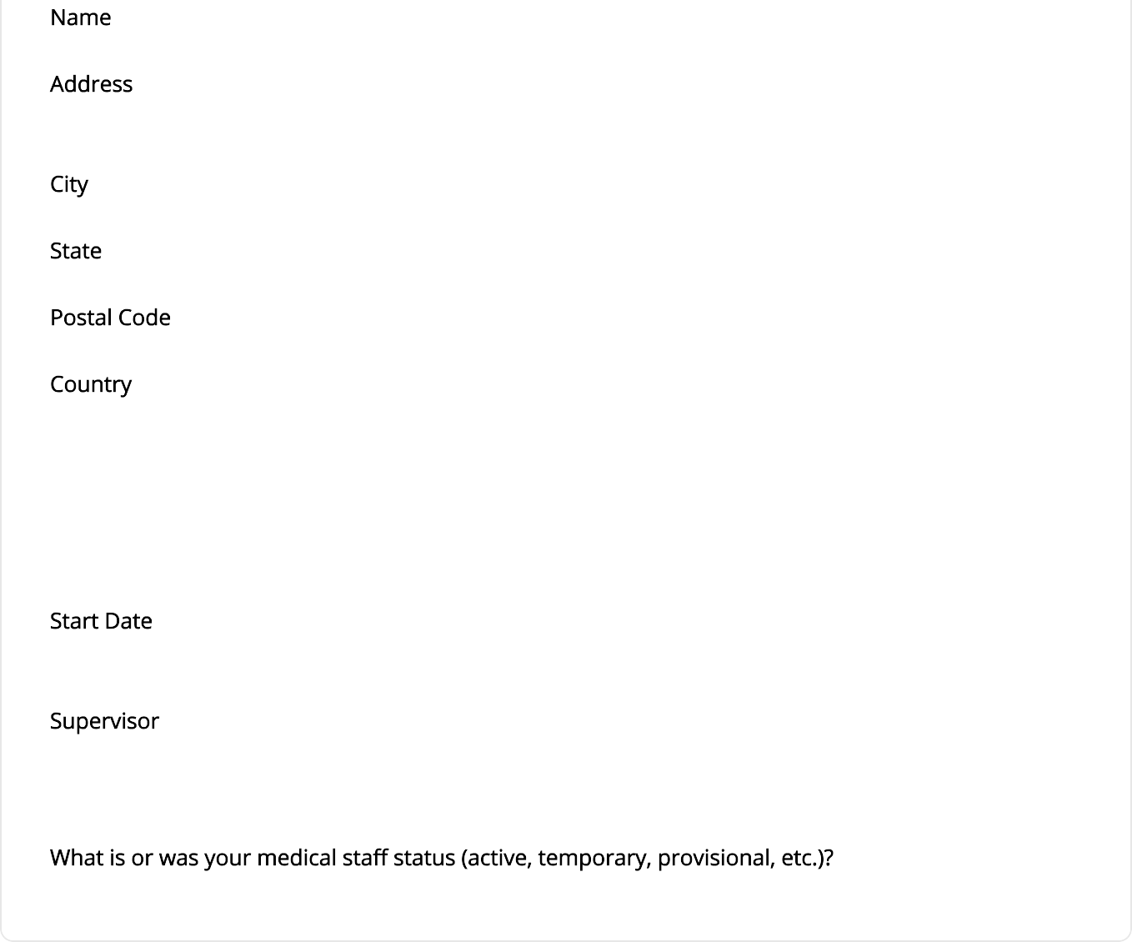

Address 2

Telephone

Fax Email Website

End Date

Relationship Reason for Leaving

Comments

# Work History

List all current and past work history since completion of medical or professional school. Add engagements not already listed in the Hospital Aﬃliations section, including employment, self- employment, service as an independent contractor, assistantships, corporations, medical oﬃces, universities, teaching, military assignments, and government agencies.

If a gap greater than 30 days exists between organizations, please add and explain in the Gaps section.

Mandatory ﬁelds are in . Additional work history may be added by clicking the button. Click when ﬁnished.

|  |
| --- |
| Test |
| Other Test |



Address 2

Fax Email Website

End Date

Supervisor Contact3 Comments

# Gaps

Please explain any time periods or gaps longer than thirty (30) days in duration since graduation from professional school. If the application is found to have any unexplained time period or gaps, the application will not be processed and will be returned to the applicant as incomplete.

Mandatory ﬁelds are in . Additional gaps may be added by clicking the button. Click when ﬁnished.

|  |
| --- |
| Gap |

Peer Professional References 1 of 3 Required



List names and contact information of at least three (3) individuals who have equal or greater credentials, who are unrelated by blood or marriage, and have personal knowledge of the applicant's current clinical abilities, ethical character, and interpersonal skills, within the last 24 months.

For applicants who have recently completed training (within one year) or are currently in training, one reference must be from the training program director.

Mandatory ﬁelds are in . Additional peer references may be added by clicking the button. Click when ﬁnished.

|  |
| --- |
|  |

Address Address 2 City

State

Postal Code Country

Fax



Licenses/Credentials

All the following credentials listed below are required (please note that other credentials may be required by the facility in which you are applying:

1.

2.

inactive and active professional state licenses

inactive and active DEA, CDS, or other licenses or registrations

3. Current life support certiﬁcations (Example: BLS, ACLS, ATLS, NRP, PALS, ALSO, etc.)

The License Number and State ﬁelds are required to submit the application. If a license or credential does not have a license number associated with it, please add N/A to the License Number ﬁeld. If a license or credential does not have a state associated with it, add a state that you are licensed in or reside in. Please include any additional information in the Comments ﬁeld.



Mandatory ﬁelds are in . Begin by clicking , then selecting the . Click when ﬁnished.

|  |
| --- |
|  |

Address Address 2 City

State

Postal Code Country Telephone Fax

Email Website

Issue Date

Status Comments



Board Certiﬁcations

List all board certiﬁcations currently and previously held. (Note that state licenses granted by state licensing boards should be added in the Licenses/Credentials section.)

Also document if an application was submitted for board certiﬁcation and the examination date, if applicable.

Mandatory ﬁelds are in

. List your primary board certiﬁcation ﬁrst. Begin by clicking the

button,

and type the board acronym and/or name in the box. Once selected, it will pre-populate ﬁelds.

|  |
| --- |
|  |
|  |

Address

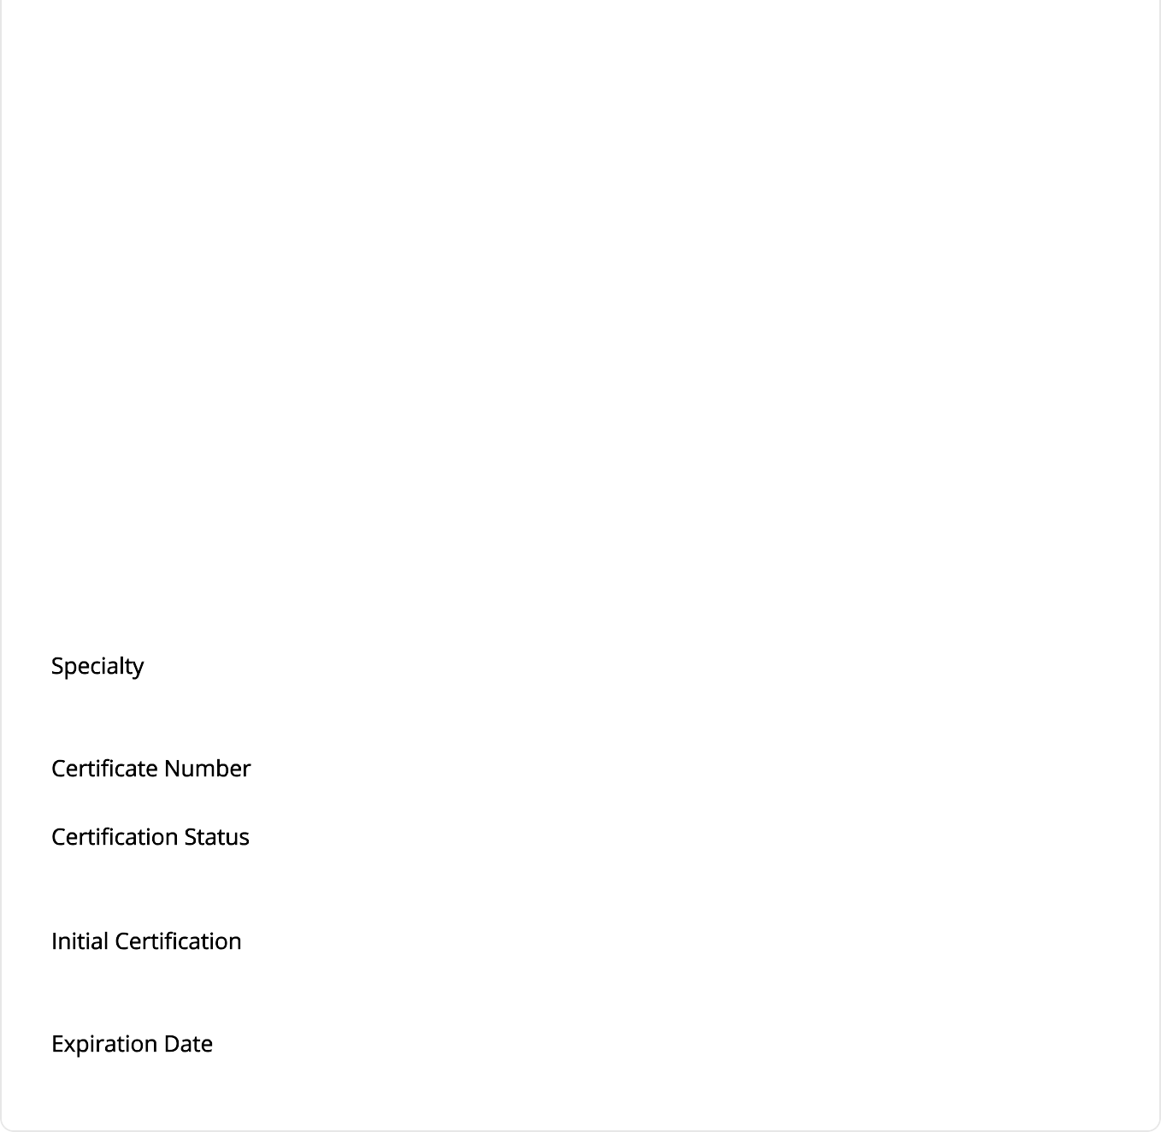

Address 2 City

State

Postal Code

Country

Telephone

Fax

Email

Website

Certiﬁed In

Exam Date

Recertiﬁcation

Comments



Medical Societies

List any current or previous professional medical society memberships. Begin by clicking on

, then

type the acronym and/or name in the box. Once selected, it will pre-populate the application ﬁelds.

Mandatory ﬁelds are in when ﬁnished.

. Additional medical societies may be added by clicking the

button. Click

|  |
| --- |
|  |
|  |



Address Address 2 City

State

Postal Code Country Telephone Fax

Email Website

End Date Title

# Malpractice Coverage

List all current, previous (within the last 5 years), and any future malpractice insurance carriers

Begin by clicking on , then type the insurance carrier's name in the . Once selected, it will pre-populate the application ﬁelds.

Mandatory ﬁelds are in . Additional malpractice insurance carriers may be added by clicking the button. Click when ﬁnished.

|  |
| --- |
|  |
| Address Address 2 City  State  Postal Code Country    Fax    [I](mailto:INASURANC.MAIL@ISSUES.COM)  Website    N/A |



Retroactive Date

Unlimited

Terms

# Malpractice Claims

Provide information regarding any current (open or pending) and previous lawsuits or complaints against the applicant or a hospital, corporation, or the United States Government based on a case with which the applicant is or was professionally associated. External veriﬁcation (i.e., statement from an attorney, court records, etc.) may be requested.

Begin by clicking , then type in the insurance company name associated with the incident in the box, and the healthcare organization where the incident occurred in the

box. Once selected, the ﬁelds will prepopulate. If the status of the malpractice claim is not available under , please provide the information in the box. If the Status selected is "Settled," please place the settlement amount in the ﬁeld. Click when ﬁnished.

The section is limited to 300 characters. If a response is more than 300 characters, upload the information as a Word or PDF document in the Files section.

|  |
| --- |
|  |
| Status Action Date Filed  Date Closed Amount History Allegation  Status Comments Notes  Hospital Name Hospital Address Hospital Address 2 Hospital City Hospital State Hospital Postal Code Hospital Country Hospital Telephone Hospital Fax Insurance Name Insurance Address |



Insurance Address 2 Insurance City Insurance State Insurance Postal Code Insurance Country Insurance Telephone Insurance Fax

# Health Screen/Immunizations

Proof of receipt of immunizations administered that meet current CDC Healthcare Worker vaccination recommendations, and agency and facility vaccination requirements must be provided.

Applicants requesting hospital/clinic privileges are required to submit evidence of MMR immunity to being granted privileges.

If the titer is negative, the applicant must receive the MMR vaccine. Please submit documentation in the Files section.

Applicants requesting hospital/clinic privileges are required to submit documentation of a PPD skin test or chest x-ray if the skin test was previously positive. Please submit documentation in the Files section of this application.

Health care professionals are at risk of acquiring Hepatitis B virus (HBV) infection due to occupational exposure to blood and other potentially infectious materials. The Indian Health Service strongly encourages applicant to obtain the Hepatitis B vaccination series. However, this is not required as a condition of employment.

If you have received the Hepatitis B vaccine or you have had a Hepatitis B antibody test result that indicates prior exposure, please note that in the Result Section.

By selecting that you decline the Hepatitis B vaccine, you are acknowledging "I have been given the opportunity to be vaccinated with Hepatitis B vaccine at no charge to myself; however I decline the Hepatitis B vaccine at this time. I understand that by declining this vaccine, I continue to be at risk of acquiring Hepatitis B virus (HBV) infection, a serious disease, due to my occupational exposure to blood or other potentially infectious materials. If in the future I continue to have occupational exposure to blood or other potentially infectious materials and I want to be vaccinated with the Hepatitis B vaccine, I can receive the vaccination series at the service unit where I am employed or contracted at no charge to me.

Mandatory ﬁelds are in . Select immunization/vaccination type from the drop down menu and provide the required information at a minimum for MMR, PPD and Hep B. Additional Medical History may be added by clicking the button. Click when ﬁnished. You can add as many as you would like by clicking .

|  |
| --- |
|  |



Files 5 of 6 Required



Vaccine -

Date Expired Result

Comments

Upload the following documents, the first six documents are require. If you do not upload six documents you will not be able to submit your application. Note that additional forms may not be required by some facilities. Forms that require signature are either housed on the login screen, at the end of the application for electronic signature, or will be emailed to you.

1. Copies of life support certiﬁcations
2. Copy of immunization record to include MMR, PPD, and Hep B
3. Last 2 years of CMEs (including IHS Opioid Prescriber Training Certiﬁcate, if currently or previously an IHS employee)
4. Current curriculum vitae or resume
5. Bylaws Attestation
6. Completed Conditions of Application & Release Form
7. Completed Medicare Statement Form (if applicable)
8. Any other documents with information that supports this application

1. Select
2. Select a
3. Enter a (Optional)
4. Click on to browse for the ﬁle
5. Click to complete the upload

If unable to perform a document upload, please contact MD-App Support at 1-800-736-7276 or the Medical Staﬀ Oﬃce.

|  |
| --- |
| Statement of Health |
|  |

File Description Expiration Date



|  |
| --- |
| Continuing Education |

Continuing Education File Description Expiration Date

|  |
| --- |
| Statement of Release |

Statement of Release File Description Expiration Date

|  |
| --- |
| Identiﬁcation |

Identiﬁcation File Description Expiration Date

|  |
| --- |
| Controlled Substance |

Controlled Substance File Description Expiration Date

Attestation Questions

Please answer **ALL** attestation questions. For any "Yes" answers , please explain in the space provided. Answering yes to questions will not necessarily disqualify an applicant.

false

Has your license to practice in any jurisdiction ever been or ever attempted to have been denied, restricted, limited, suspended, revoked, canceled, reprimanded, or censured, and/or have you ever practiced without a license?

false

Has your license to practice ever been subject to probation, either voluntarily or involuntarily?

false

Has your license ever been voluntarily or involuntarily withdrawn?

false

Has any disciplinary actions or investigations ever been initiated against you by any state licensure board?

false

Have you ever been subject to informal or formal proceedings (including hearing processes) by the federal government or any branch of the military, licensing board, hospital, healthcare organization, agency or professional association to revoke, suspend, restrict or limit a professional license/registration/permit?

false

Have you ever been the subject of a complaint, or have you ever been notiﬁed in writing that you have been investigated as the possible subject of a criminal or civil action by any state or federal agency that licenses providers?

false

Have you ever been notiﬁed in writing that you are being investigated as the possible subject of a criminal or disciplinary action by any health care organization (e.g., hospital, HMO, PPA, IPA), professional group or society, licensing board, certiﬁcation board, PSRO or PRO?

false

Have you ever been cautioned, reprimanded, or disciplined by any institution, any local, state, or national professional society, regulatory agency, or place of employment?

false

Has your employment and or clinical privileges at any hospital, clinic, or other health care setting ever been denied, suspended, revoked, reduced, restricted, not renewed, voluntarily or involuntarily relinquished, denied renewal, or has probation ever been invoked?

false

Have you ever voluntarily or involuntarily withdrawn your application for clinical privileges or terminated clinical privileges prior to a hospital or health facility's governing board's ﬁnal decision?

false

Have you ever been reprimanded, censured, excluded, suspended, disqualiﬁed and/or participation voluntarily withdrawn, to avoid an investigation by Medicare, Medicaid, TRICARE, and/or any other governmental health related programs?

false

Have Medicare, Medicaid, TRICARE, PRO authorities, and/or any other third party payers ever brought charges against you for alleged inappropriate fees, and/or quality of care issues?

false

Has any information pertaining to you, including malpractice judgements and/or disciplinary action, ever been reported to the National Practitioner Data Bank or any other practitioner data bank, or any other federal or state board oversight authority?

false

Has your federal DEA number, state controlled substance license, or other controlled substance license ever been suspended, revoked, restricted, limited, or relinquished either voluntarily or involuntarily?

false

Have you ever been notiﬁed in writing that you are being investigated as the possible subject of a criminal or disciplinary action with respect to a DEA or other controlled substance registration or license?

false

Have you ever had a claim for professional negligence asserted against you? If yes, you are required to note your ﬁnal judgement and settlements in the Malpractice Claims section of this application.

false

Have liability claims, judgements or settlements ever been made against a hospital, corporation, or the United States Government in professional liability suits based on a case with which you were professionally associated? If yes, you are required to note the ﬁnal judgement and settlements involving yourself as a practitioner in the Malpractice Section of this application.

false

Have you ever had professional liability coverage denied, refused, or canceled by a professional liability insurance company?

false

Have you ever withdrawn from or been suspended, dismissed or expelled from a professional school or postgraduate training program, or has any third party ever attempted to have you withdrawn, suspended, dismissed, or expelled from a professional school or postgraduate training program?

false

Have you ever been placed on probation or taken a leave of absence from medical, dental, or other graduate school or postgraduate training program?

false

Have you ever been the subject of a civil or criminal complaint or administrative action, or are you being investigated as the possible subject of a civil, criminal, or administrative action regarding sexual misconduct, child abuse, domestic violence, elder abuse, or any other violent crimes?

false

Are you aware of any impairment, including but not limited to a medical impairment, that you or an objective third party might think would limit your ability to meet the duties associated with clinical staff membership? (If a reasonable accommodation would allow you to exercise your clinical privileges and clinical staff duties completely and safely, please refer to the Indian Health Manual, Part 1, Chapter 14, for additional information on requesting an accommodation.)

false

Are you currently engaged in illegal use of any legal or illegal substances?

false

Do you have any reason to believe that you could pose a risk to the safety or well-being of patients?

false

Has it been more than 12 months since you have provided patient care in a professional setting?

false

Have you ever been arrested, cited, charged with or convicted of a felony or misdemeanor other than minor traffic violations, regardless of the outcome? This includes withheld judgements and matters that have been expunged.

false

Were you ever the subject of any disciplinary action at any educational (college) or training (residency, fellowship, internship, etc.) programs?

Certiﬁcation of Professional Licenses

true

I certify that I have listed all active and inactive state medical licenses and controlled substance registrations/licenses on this application.

true

I certify that my professional licenses and certiﬁcations (nurse, medical, dental, or other health profession) have not been terminated, suspended, or revoked in any state or a territory of the United States.

true

I certify, as required by the false statements provisions of the Program Fraud Civil Remedies Act of 1986, 45 Code of Federal Regulations (CFR) 79, that to the best of my knowledge, each of the above statements are true, accurate, and do not omit any material or facts which would render the

statement false, ﬁctitious, or fraudulent as a result of omission.

# Privileges

Review and request any privileges by clicking on the checkbox. If you have cases to provide, please include them. You may also include more details in the **Comments** section. If applicable, please review the core privileges and uncheck any core privileges for which you do not have current competency to perform.

|  |
| --- |
| Area Specific Privileges are listed here |

# Review & Submit Application



1. Read the Applicant’s Certiﬁcation Statement:

By signing this application, I certify that all the information submitted by me in this application is true and complete to the best of my knowledge. I agree to immediately disclose to the governing body if any answer to a question above becomes “Yes” while on staff membership and/or privileges are pending or have been granted. I agree to abide by all lawful standards, policies, rules, regulations, and bylaws of the facility, the Area, the Indian Health Service, the U.S. Public Health Service, and the Department of Health and Human Services, as they apply to my responsibilities and practice as a member of the clinical staﬀ. I further agree to answer any questions concerning the contents of this application either during the application process or subsequent to having been granted privileges. I agree that inquiries may be made to any federal or private sector facility with which I have been aﬃliated. I pledge to maintain an ethical practice and to provide for the continuous care of all my patients.

1. Click Submit Application. (Once the application has been submitted, you may go back to edit your data by clicking on the main login page. You may also print the application by clicking

.)

1. On the Electronic Signature page enter your complete and legal name, check the box indicating that you have read and agree to be bound by the Applicant’s Certiﬁcation Statement, and that to the best of your knowledge, all information provided on the application is true and accurate, and that no material or facts which would render the statement false, ﬁctitious, or fraudulent is omitted.