Reappointment Application

# Introduction



Form Approved OMB No. XXXX-XXXX

Exp. Date XX/XX/XXXX

The Federal Health Program for American Indians/Alaska Natives

The overall mission of the Indian Health Service is to raise the physical, mental, and social and spiritual health of American Indians and Alaska Natives (AI/AN) to the highest level.

To ensure that comprehensive, culturally acceptable personal and public health services are available and accessible to American Indians & Alaska Native people.

Enter all pertinent information, as applicable. Fill out all required sections and ﬁelds that are marked in ; these are mandatory and must be completed to submit the application. At any point, the application may be saved by clicking and completed at a later time. The blue toolbar at the top right provides additional help. The deﬁnition of "applicant" within this application is the individual requesting medical staﬀ membership and/or clinical privileges.

included on the previous home screen are . These must be viewed and/or ﬁlled out and uploaded into the section on this application.

Please note that any documents that require electronic signature are found at the end of the application.



at the top right allows the applicant to change or reset the password and authorize account access to a delegate.

provides support if technical diﬃculties are encountered.

after submitting the application, where the completed application and supporting documents may be viewed, downloaded, or printed.

Completed documents and forms must be uploaded in the section of this application. Please contact the Medical Staﬀ Credentialing Coordinator for other delivery methods if technical diﬃculties are encountered.

Each text ﬁeld in this application has a limit of two lines. If a response exceeds two lines of text, please upload the response as a Word or PDF document in the Files section of this application.

Misrepresentations, inaccuracies, or falsiﬁcation of any information may be grounds for denial or termination of medical staﬀ appointment and/or associated clinical privileges, and may be subject to the reporting requirements of the National Practitioner Data Bank (NPDB), and state and federal licensing boards.

Applications with incomplete information or missing documents will be returned to the applicant and delay the processing of the application. If the applicant does not respond within 30 days of the request and/or the time speciﬁed in the local medical staﬀ bylaws, the applications (initial or reappointment) will be deemed incomplete and ineligible for processing. The applicant has the responsibility for furnishing information that will help resolve any questions concerning these qualiﬁcations.

According to the Paperwork Reduction Act of 1995, no persons are required to respond to a collection of information unless it displays a valid OMB control number. The valid OMB control number for this information collection is [####-####]. This information collection is to be used in verifying an applicant’s credentials to meet agency policy, Centers for Medicare Conditions of Participation requirements, and accrediting body standards. The time required to complete this information collection is estimated to average less than 15 minutes per response, including the time to review instructions, search existing data resources, gather the data needed, to review and complete the information collection. This information collection is required to determine an applicant’s credentials to provide healthcare (IHS IHM 3-1.4 C. (1-2), CMS CoP §482.12(a)(6) and

§482.22(c)(4) and [the nature and extent of conﬁdentiality to be provided, if any (citing authority)]. If you have comments concerning the accuracy of the time estimate(s) or suggestions for improving this form, please write to: Indian Health Service, 5600 Fishers Lane, mailstop: 09E07, Rockville, MD 20857, Attention: Information Collections Clearance Oﬃcer.

# Personal Information



Review the current entries below and update information, as applicable.

Mandatory ﬁelds are in . Click to modify the entry, and to save the information entered.

Preﬁx

Middle Name

Suﬃx

Degree 2

Degree 3

Preferred Name Gender

Lookout Citizenship Marital Status Spouse Name Pager

Answering Service

Preferred Contact Method Language 1

Language 2



Addresses

Review the current entries below and update information, as applicable.

Mandatory ﬁelds are in add a new entry. Click

. Click

to modify an existing entry,

to delete an entry, and

to

to save the information entered.

|  |
| --- |
| Oﬃce Address |

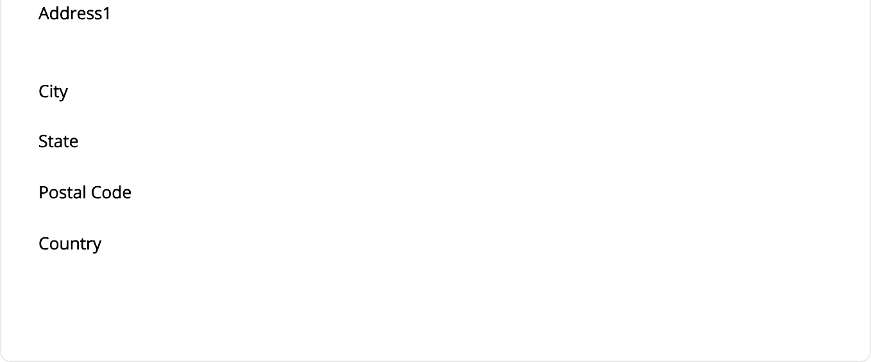

Education/Training

Review the current entries below and update any new education or training (including new college degrees, residencies, fellowships, etc.) , as applicable.

If the exact start or end date is unknown, please ensure that the month and year are correct.

If a residency or fellowship was completed, please indicate the specialty and program name in the Subject ﬁeld. If internship information is submitted, please add if the internship was rotating, mixed, or straight in the Subject box. If a straight residency was complete, please also include the discipline.

Mandatory ﬁelds are in add a new entry. Click

. Click

to modify an existing entry,

to delete an entry, and

to

to save the information entered.

Address 2

Telephone Fax

E-Mail

# Alias/Other Names

Review the current entries below and update information, as applicable.

Mandatory ﬁelds are in . Click to modify an existing entry, to delete an entry, and to add a new entry. Click to save the information entered.

|  |
| --- |
| Maiden |

OtherGivenName

|  |
| --- |
| MedicalEducation |

Medical Education



Address

Address 2

Postal Code

Telephone

Fax Email Website

End Date

None

Contact



Hospital Aﬃliations

Review the current entries below and add any current or new work history since last appointment, as applicable.

Include all current and new healthcare organizations where medical staff membership and/or privileges are granted (including employment, self-employment, or service as an independent contractor) since last appointment.

DO NOT include fellowships, internships and/or residencies previously listed or reported under Education/Training.

Mandatory ﬁelds are in

. Additional healthcare organizations may be added by clicking the

button. Click when ﬁnished.

|  |
| --- |
| Hospitals |



Address 2

United States

Fax Email Website

End Date

Relationship Reason For Leaving

Comments



Work History

Review the current entries below and add any current or past work history applicable.

, as

Mandatory ﬁelds are in add a new entry. Click

. Click

to modify an existing entry,

to delete an entry, and

to

to save the information entered.

|  |
| --- |
| Work History |
|  |



Address Address 2

Postal Code Country

Fax Email Website

End Date

Relationship Contact3 Comments

# Peer Professional References

List names and contact information of at least three (3) individuals who have equal or greater credentials, who are unrelated by blood or marriage, and have personal knowledge of the applicant's current clinical abilities, ethical character, and interpersonal skills, within the last 24 months.

Please note that some facilities may require more or less peer references depending on the facility’s peer review processes for reappointment.

Mandatory fields are in **Red**. Additional peer references may be added by clicking the **Add** button. Click **Save** when finished.

|  |
| --- |
| Peer References |
| Address  Address2  City  State  Postal Code  Years Known  Relationship  Telephone  Fax  Email |

# Licenses/Credentials

Review the current entries below and ensure current and new credentials are listed, as applicable.

All the following credentials listed below are required (please note that other credentials may be required by the facility in which you are applying.):

1. ALL active professional state licenses, and state licenses that have become inactive since last appointment.
2. ALL active DEA, CDS, or other licenses or registrations, as well as those that have become inactive since last appointment.
3. Current life support certiﬁcations (Example: BLS, ACLS, ATLS, NRP, PALS, ALSO, etc.)
4. Signed Practitioner Conditions of Application and Release Form

Please document any limitations or restrictions in the Status section.

The License Number and State ﬁelds are required to submit the application. If a license or credential does not have a license number associated with it, please add N/A to the License Number ﬁeld. If a license or credential does not have a state associated with it, add a state that you are licensed in or reside in. Please include any additional information in the Comments ﬁeld.

Mandatory ﬁelds are in red. Click Edit to modify an existing entry, Delete to delete an entry, and Add to add a new entry. Click Save to save the information entered.

|  |
| --- |
| Licenses/Credentials |
| Address Address 2 City  State  Postal Code Country |

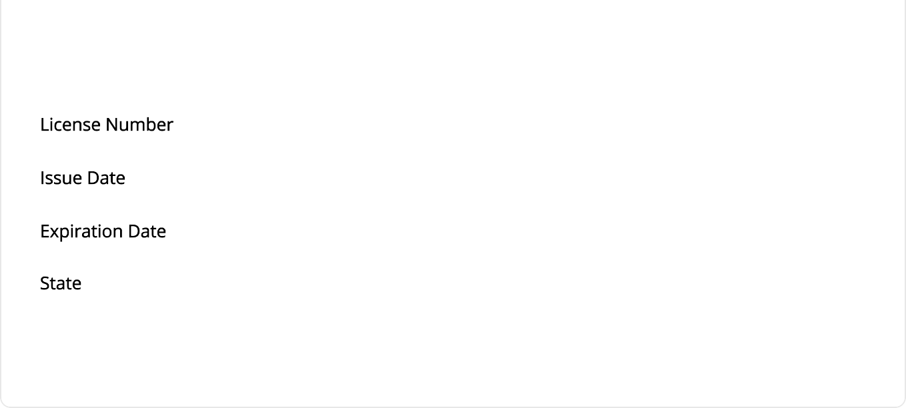

Telephone Fax

Email Website

Limitations Status Comments

# Board Certiﬁcations

Review the current entries below and update or add any new board certiﬁcation , as applicable. (Note that state licenses granted by state licensing boards should be added in the Licenses/Credentials section.)

Also document if an application was submitted for board certiﬁcation and the examination date, if applicable.

Mandatory ﬁelds are in . List your primary board certiﬁcation ﬁrst. Begin by clicking the button, and type the board acronym and/or name in the box. Once selected, it will pre-populate ﬁelds.

|  |
| --- |
| Board Certifications |
| Address  Address 2  City  State  Postal Code  Country Telephone  Fax Email |

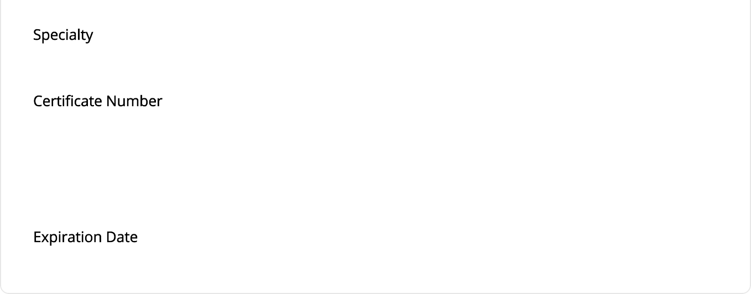

Website

Certiﬁed In

Certiﬁcation Status Exam Date

Initial Certiﬁcation Recertiﬁcation

Comments

# Medical Societies

Review the current entries below and update or add any new medical society memberships

, as applicable.

Mandatory ﬁelds are in . Click to modify an existing entry, to delete an entry, and to add a new entry. Click to save the information entered.

|  |
| --- |
| Medical Societies |

Address

Address 2

City

State

Postal Code

Telephone

Fax

Email

Website

Start Date

End Date Title

# Malpractice Coverage



Review the current entries below and update or add any new malpractice coverage

, as applicable, including name, policy number, and dates held.

Mandatory ﬁelds are in . Click to modify an existing entry, to delete an entry, and to add a new entry. Click to save the information entered.

|  |
| --- |
| Malpractice Coverage |

Address

Address 2

City

State

Postal Code Country Telephone

Fax

Email

Website

12345615

Issued Date

Retroactive Date Coverage

Terms



Malpractice Claims

Provide information regarding any current (open or pending) and previous lawsuits or complaints against the applicant or a hospital, corporation, or the United States Government based on a case with which the applicant is or was professionally associated , as applicable. External veriﬁcation (i.e., statement from an attorney, court records, etc.) may be requested.

Begin by clicking , then type in the insurance company name associated with the incident in the  box, and the healthcare organization where the incident occurred in the   box. Once selected, the ﬁelds will prepopulate. If the status of the malpractice claim is not available under , please provide the information in the  box. If the Status selected is "Settled," please place the settlement amount in the  ﬁeld. Click  when ﬁnished.

The  section is limited to 300 characters. If a response is more than 300 characters, upload the information as a Word or PDF document in the Files section.

|  |
| --- |
| Malpractice Claims |
| Status Action    Date Closed Amount    Notes    Hospital Address Hospital Address 2  Hospital Postal Code Hospital Country    Hospital Fax    Insurance Address Insurance Address 2 Insurance City Insurance State Insurance Postal Code Insurance Country |



Insurance Fax

Files 1 of 4 Required

Upload the following required documents. If you do not upload two documents you will be unable to submit your application. Note that some forms may not be required by some facilities. Forms that require signature are either housed on the login screen, at the end of the application for electronic signature, or will be emailed to you.

1. CMEs since last appointment
2. Signed IHS Conditions of Application & Release Form (MUST be uploaded to submit application.)

Please upload the following, if applicable:

* 1. IHS Opioid Prescriber Training Certiﬁcate (if renewed since your last appointment)
  2. Copies of life support certiﬁcations (if renewed since your last appointment)
  3. Any new malpractice claims information since your last appointment (if applicable)
  4. Current curriculum vitae or resume (if any new aﬃliations since your last appointment)
  5. Any other documents in the download section or provided to you by email

1. Select
2. Select a
3. Enter a (Optional)
4. Click on to browse for the ﬁle
5. Click to complete the upload

If unable to perform a document upload, please contact MD-App Support at 1-800-736-7276 or the Medical Staﬀ Oﬃce.

|  |
| --- |
| Files |

File Description Expiration Date

Attestation Questions

Please answer **ALL** attestation questions. For any "Yes" answers, please explain in the space provided. Answering yes to questions will not necessarily disqualify an applicant.

false

Has your license to practice in any jurisdiction ever been or ever attempted to have been denied, restricted, limited, suspended, revoked, canceled, reprimanded, or censured, and/or have you ever practiced without a license?

false

Has your license to practice ever been subject to probation, either voluntarily or involuntarily?

false

Has any disciplinary actions or investigations ever been initiated against you by any state licensure board?

false

Have you ever been reprimanded and/or ﬁned, by any local, state, or federal agency that licenses providers?

False

Have you ever been subject to informal or formal proceedings (including hearing processes) by the federal government or any branch of the military, licensing board, hospital, healthcare organization, agency or professional association to revoke, suspend, restrict or limit a professional license/registration/permit?

false

Have you ever been the subject of a complaint, or have you ever been notiﬁed in writing that you have been investigated as the possible subject of a criminal or civil action by any state or federal agency that licenses providers?

false

Have you ever been notiﬁed in writing that you are being investigated as the possible subject of a criminal or disciplinary action by any health care organization (e.g., hospital, HMO, PPA, IPA), professional group or society, licensing board, certiﬁcation board, PSRO or PRO?

false

Have you ever been cautioned, reprimanded, or disciplined by any institution, any local, state, or national professional society, regulatory agency, or place of employment?

false

Has your employment and or clinical privileges at any hospital, clinic, or other health care setting ever been denied, suspended, revoked, reduced, restricted, not renewed, voluntarily or involuntarily relinquished, denied renewal, or has probation ever been invoked?

false

Have you ever voluntarily or involuntarily withdrawn your application for clinical privileges or terminated clinical privileges prior to a hospital or health facility's governing board's ﬁnal decision?

false

Have you ever been reprimanded, censured, excluded, suspended, disqualiﬁed and/or participation voluntarily withdrawn, to avoid an investigation by Medicare, Medicaid, TRICARE, and/or any other governmental health related programs?

false

Have Medicare, Medicaid, TRICARE, PRO authorities, and/or any other third party payers ever brought charges against you for alleged inappropriate fees, and/or quality of care issues?

false

Has any information pertaining to you, including malpractice judgements and/or disciplinary action, ever been reported to the National Practitioner Data Bank or any other practitioner data bank, or any other federal or state board oversight authority?

false

Has your federal DEA number, state controlled substance license, or other controlled substance license ever been suspended, revoked, restricted, limited, or relinquished either voluntarily or involuntarily?

false

Have you ever been notiﬁed in writing that you are being investigated as the possible subject of a criminal or disciplinary action with respect to a DEA or other controlled substance registration or license?

false

Have you ever had a claim for professional negligence asserted against you? If yes, you are required to note your ﬁnal judgement and settlements in the Malpractice Claims section of this application.

false

Have liability claims, judgements or settlements ever been made against a hospital, corporation, or the United States Government in professional liability suits based on a case with which you were professionally associated? If yes, you are required to note the ﬁnal judgement and settlements involving yourself as a practitioner in the Malpractice Section of this application.

false

Have you ever had professional liability coverage denied, refused, or canceled by a professional liability insurance company?

false

Have you ever withdrawn from or been suspended, dismissed or expelled from a professional school or postgraduate training program, or has any third party ever attempted to have you withdrawn, suspended, dismissed, or expelled from a professional school or postgraduate training program?

false

Have you ever been placed on probation or taken a leave of absence from medical, dental, or other graduate school or postgraduate training program?

false

Have you ever been the subject of a civil or criminal complaint or administrative action, or are you being investigated as the possible subject of a civil, criminal, or administrative action regarding sexual misconduct, child abuse, domestic violence, elder abuse, or any other violent crimes?

False

Are you aware of any impairment, including but not limited to a medical impairment, that you or an objective third party might think would limit your ability to meet the duties associated with clinical staff membership? (If a reasonable accommodation would allow you to exercise your clinical privileges and clinical staff duties completely and safely, please refer to the Indian Health Manual, Part 1, Chapter 14, for additional information on requesting an accommodation.)

False

Are you currently engaged in illegal use of any legal or illegal substances?

false

Do you have any reason to believe that you could pose a risk to the safety or well-being of patients?

false

Has it been more than 12 months since you have provided patient care in a professional setting?

False

Have you ever been arrested, cited, charged with or convicted of a felony or misdemeanor other than minor traffic violations, regardless of the outcome? This includes withheld judgements and matters that have been expunged.

false

Were you ever the subject of any disciplinary action at any educational (college) or training (residency, fellowship, internship, etc.) programs?

Certiﬁcation of Professional Licenses

true

I certify that I have listed all active and inactive state medical licenses and controlled substance registrations/licenses on this application.

true

I certify that my professional licenses and certiﬁcations (nurse, medical, dental, or other health profession) have not been terminated, suspended, or revoked in any state or a territory of the United States.

true

I certify, as required by the false statements provisions of the Program Fraud Civil Remedies Act of 1986, 45 Code of Federal Regulations (CFR) 79, that to the best of my knowledge, each of the above statements are true, accurate, and do not omit any material or facts which would render the statement false, ﬁctitious, or fraudulent as a result of omission.

Privileges

Request privileges below by checking the blue Request check box on the left side of the screen. Currently approved privileges are denoted as "Granted" below the blue box. If you do NOT want to renew a speciﬁc privilege, please do NOT check the blue Request box.

|  |
| --- |
| Privileges  Privileges are facility specific, listed here. |

# Submit Application



1. Read the Applicant’s Certiﬁcation Statement:

By signing this application, I certify that all the information submitted by me in this application is true and complete to the best of my knowledge. I agree to immediately disclose to the governing body if any answer to a question above becomes “Yes” while on staﬀ membership and/or privileges are pending or have been granted. I agree to abide by all lawful standards, policies, rules, regulations, and bylaws of the facility, the Area, the Indian Health Service, the U.S. Public Health Service, and the Department of Health and Human Services, as they apply to my responsibilities and practice as a member of the clinical staﬀ. I further agree to answer any questions concerning the contents of this application either during the application process or subsequent to having been granted privileges. I agree that inquiries may be made to any federal or private sector facility with which I have been aﬃliated. I pledge to maintain an ethical practice and to provide for the continuous care of all my patients.



1. Click Submit Application. (Once the application has been submitted, you may go back to edit your data by clicking on the main login page. You may also print the application by clicking

.)

1. On the Electronic Signature page enter your complete and legal name, check the box indicating that you have read and agree to be bound by the Applicant’s Certiﬁcation Statement, and that to the best of your knowledge, all information provided on the application is true and accurate, and that no material or facts which would render the statement false, ﬁctitious, or fraudulent is omitted.