**Attachment 4b**

**Summary of Changes to MIS Data Elements**

***New questions and responses (see pages 20-27):***

1. Leadership Team Plan – We would like include to include in the Management Information System data elements for collecting information about collaborative activities conducted by a leadership team, which is a new requirement of DP17-1701.
   1. Leadership Team Summary – we would like to add a field to collect and display a summary of the leadership team composition to ensure programs are compliant with the requirements of collaboration across the three DP17-1701 components.
   2. Add Leadership Team Member – we would like to add a field to easily allow programs to update leadership members and their affiliations as members transition on and off.
   3. Leadership Team Member Table – we would like to add a field that displays in table format a summary of the team members and their affiliation.
   4. View Leadership Team Member – we would like to add a field to display individual leadership team members, their affiliation and contribution to the team.
   5. Leadership Team Plan – we would like to add a field to display the program’s leadership team plan that articulates members, priorities, and communications around this requirement. We propose adding fields to display the leadership plan’s narrative in full and fields to add planned tasks assigned to each member.

***Changes to questions or responses***

1. Reports - We would like to change for Step 1 that data entry is not required; for AO activity, DP17-1701 displays a new section for EBIs; and for Step 3, the third textbox is different for DP17-1701. The text changes from “Describe how CDC could help you overcome challenges to achieving objectives and performance measures:” to “Please describe budgetary issues that might impede the success or completion of the project as originally proposed and approved:” The change will improve CDC’s ability to understand specific challenges respondents may encounter versus broad concerns. Lastly, data entry is not required for Step 3 & 4, as was the case prior.
2. Action Plan:
   1. Library of Indicators and Data Sources (LIDS). We added the Library of Indicators and Data Sources (LIDS) to assist awardees in identifying evidence-based indicators, strategies, and data sources for action plans and evaluation plans.
   2. Project Period Objective (PPO) fields. We reduced the number of priority area options to four (4) in DP17-1701 to align responses around the cancer continuum and national program’s priorities: (1) to emphasize primary prevention of cancer; (2) to facilitate screening and early detection of cancer; (3) to improve cancer survivors' quality of life; and (4) to promote health equity as it relates to cancer control. For DP17-1701 we offer increased cancer focus options, such as “Immunization”, “Alcohol Use”, “Nutrition”, “Physical Activity” and “Tobacco Use”, to accurately capture cancer-related lifestyle factors.
   3. Measurement. The only difference in this section of the action plan is that DP17-1701 does not display the textbox to describe the objective, which reduces burden to respondents..

***Changes in functionality***

Action Plan:

1. Enhanced MIS search capabilities. MIS search capabilities were refined to improve the efficiency of searches and the quality of reporting on performance measures.
2. Annual Objectives (AO) field. We no longer display the Related FOA Recipient Activity field and not display the Cross Cutting field. This iteration of CDMIS also requires the user to select a strategy, select an evidence-based strategy (EBI) for the strategy, and to enter an ID for the Strategy - EBI combination. In the AO activities section, for DP17-1701, the Activity ID is automatically populated for easy of data collection resulting in reduced response burden. To ensure accuracy, the Title is entered by user and DP17-1701 requires the user to enter 5 activities for each EBI.

**Table: Changes requested for CDMIS in use of DP 17-1701 versus what existed for DP 12-1205**









**Leadership Team Screenshots**

**CCC (DP17-1701)**



Contents

Leadership Team Summary 1

Add Leadership Team Member 2

Leadership Team Member Table 4

View Leadership Team Member 5

Delete Leadership Team Member 6

Leadership Team Plan 7

Add Leadership Team Plan Narrative 8

Add Leadership Team Plan Task 9

View Leadership Team Plan 12

View Leadership Team Plan Task 13

Delete Leadership Team Plan Task 14

Assign Leadership Team Plan- Tasks 15

Download Leadership Team Plan Report 16

# Leadership Team Summary

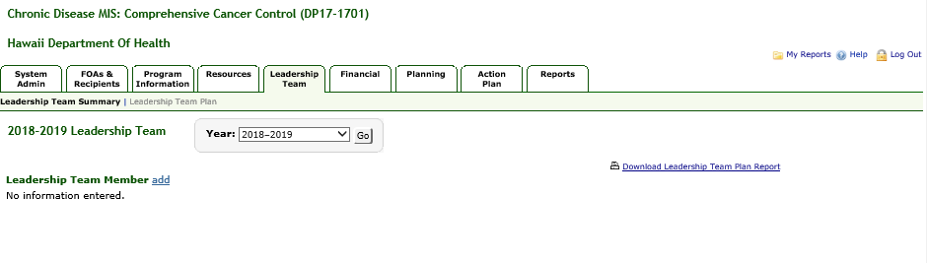

# Add Leadership Team Member

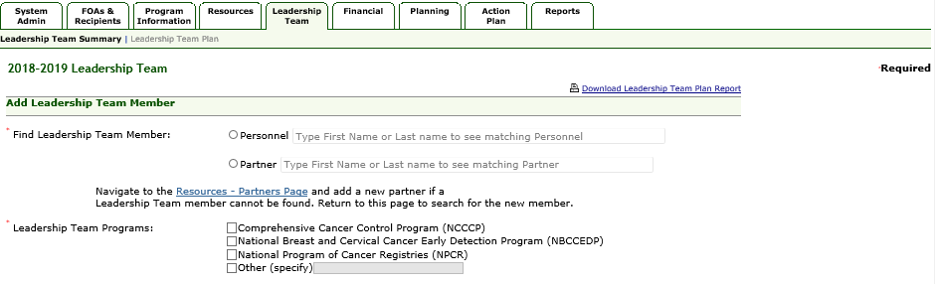

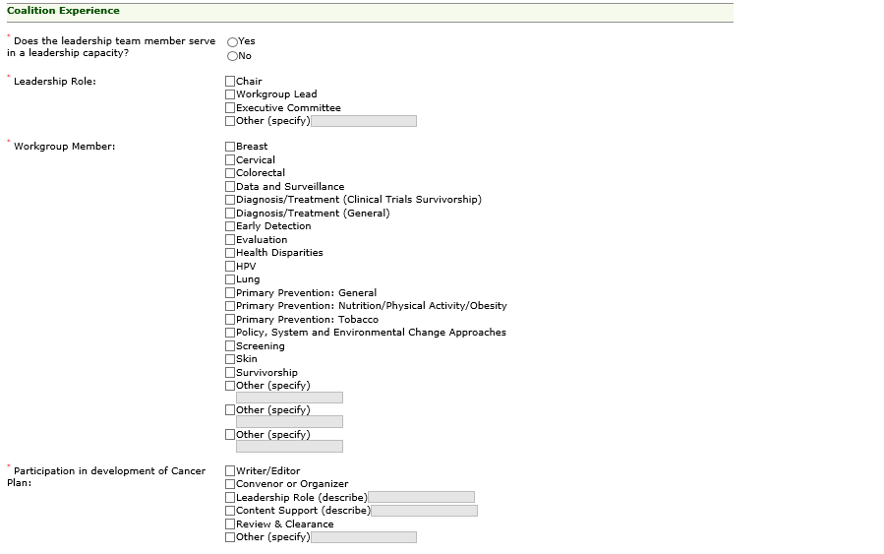

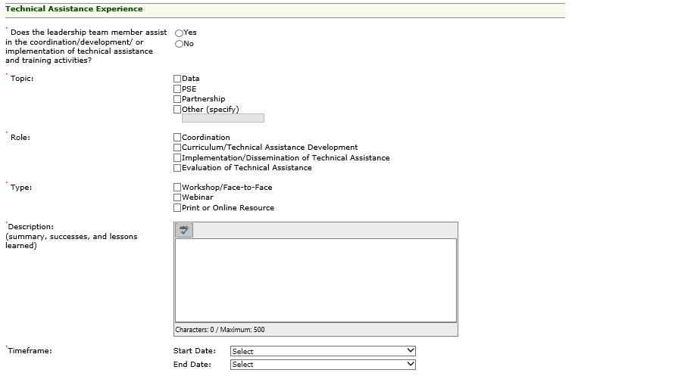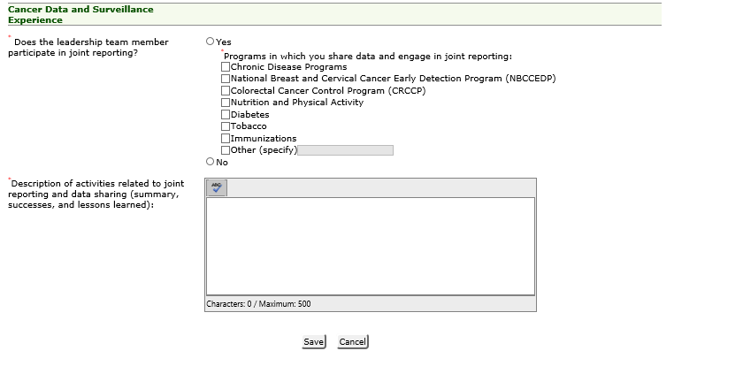

# Leadership Team Member Table

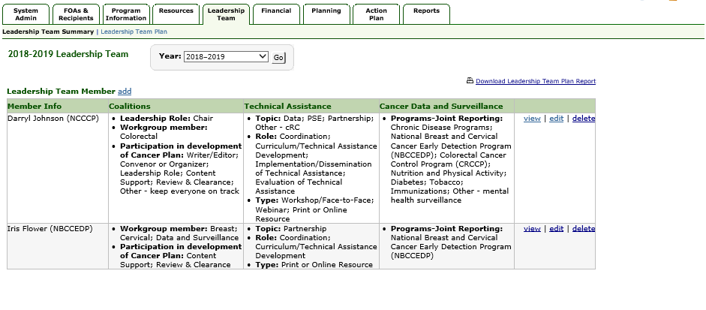

# View Leadership Team Member

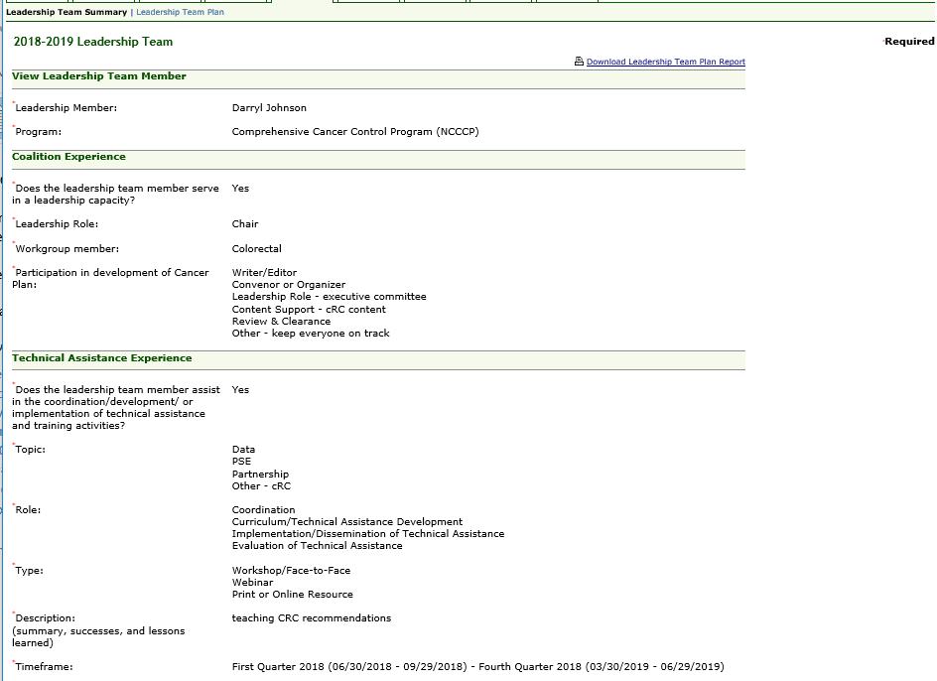

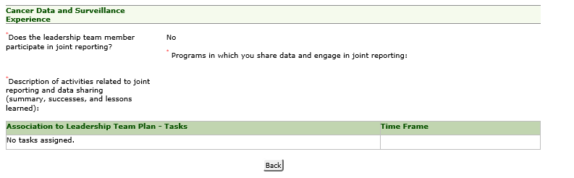

# Delete Leadership Team Member

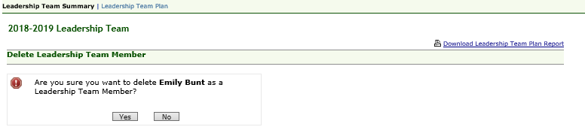

# Leadership Team Plan

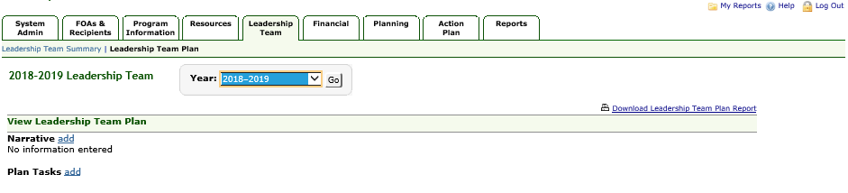

# Add Leadership Team Plan Narrative

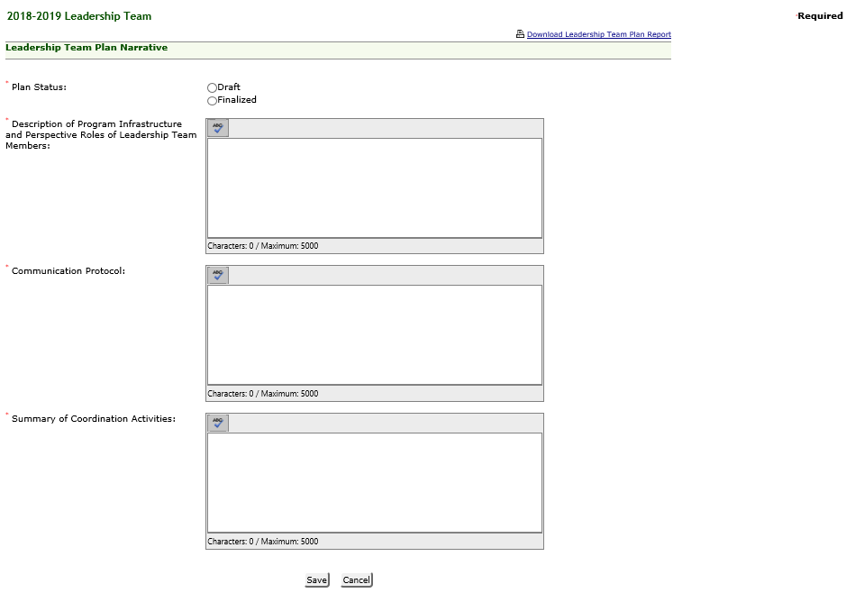

# Add Leadership Team Plan Task

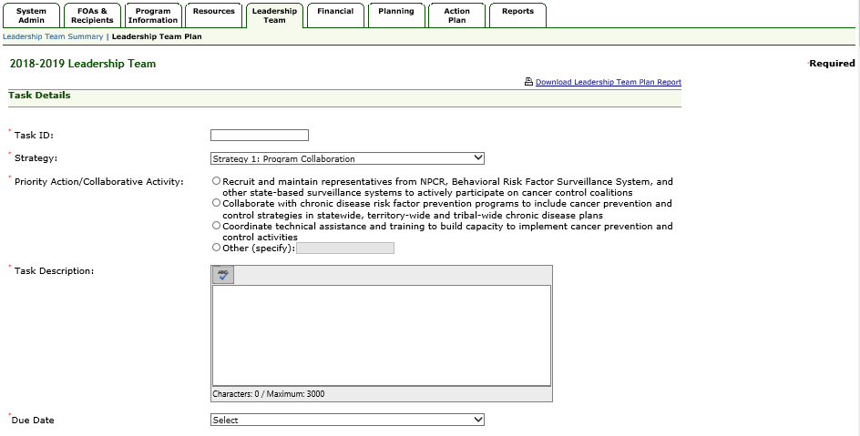

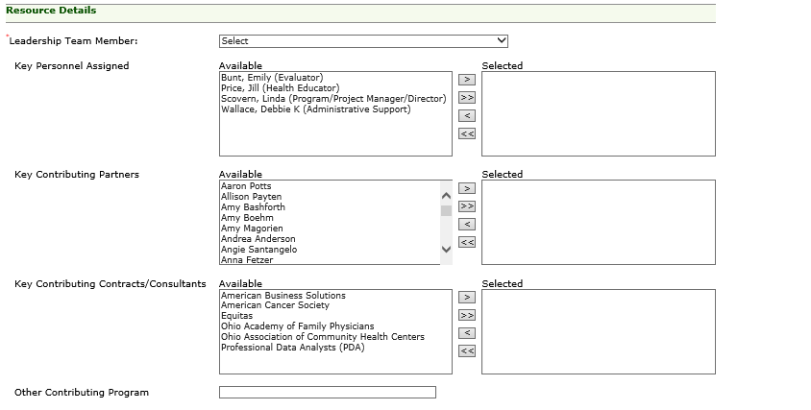

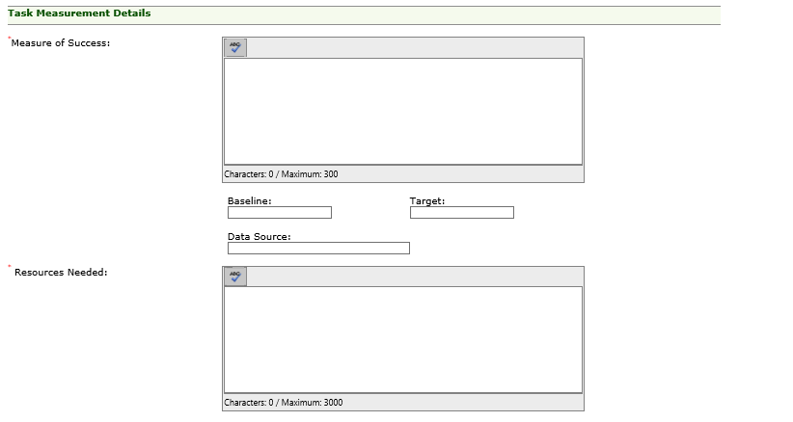

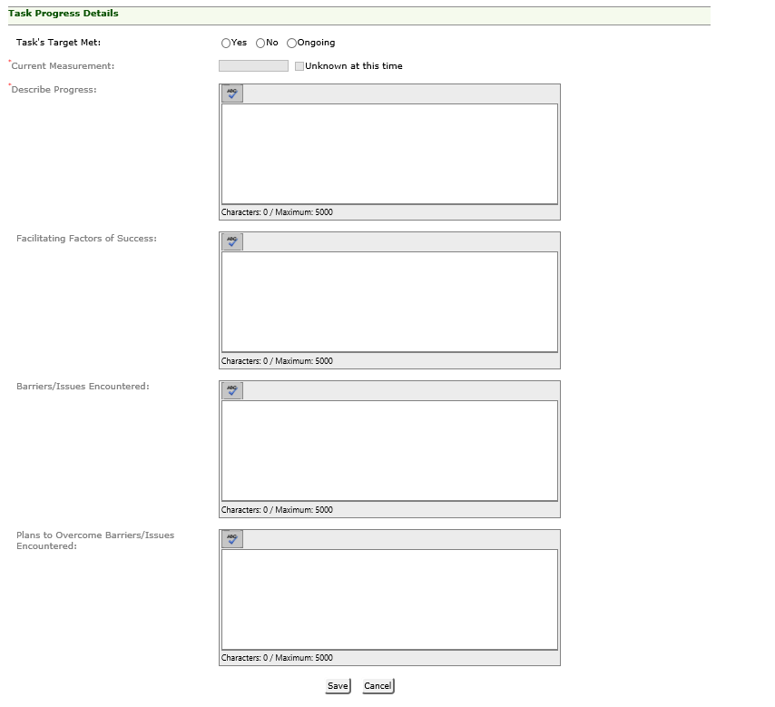

# View Leadership Team Plan

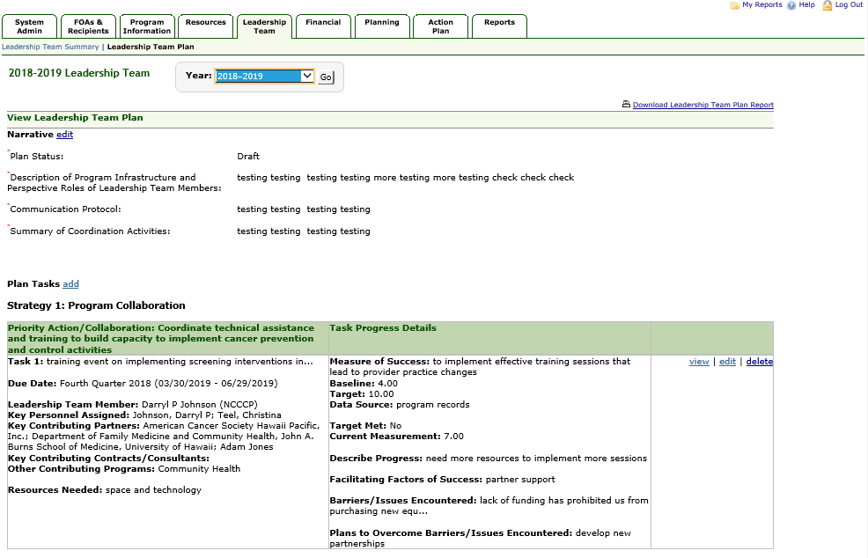

# View Leadership Team Plan Task

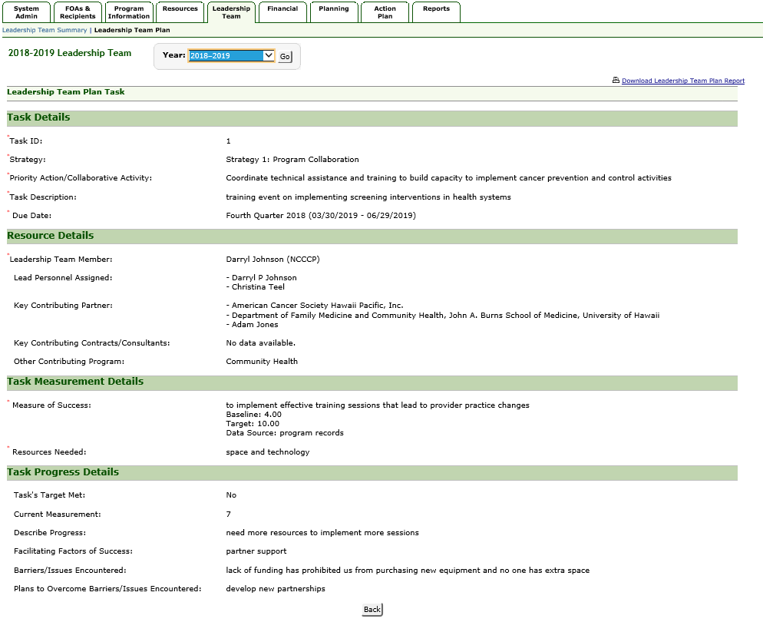

# Delete Leadership Team Plan Task

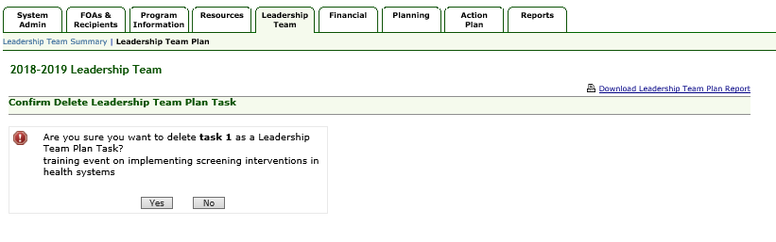

# Assign Leadership Team Plan- Tasks

Under **Edit** Leadership Team Member- Leadership Team Summary Link

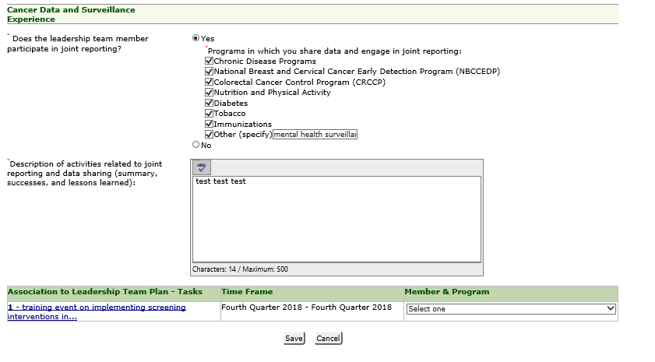

# Download Leadership Team Plan Report

