Sample EHLR Registration Forms (using conference platforms to sign up for “EHLR Immersion Training” session)
We are presenting this attachment to show alternate registration methods for the “EHLR Immersion Training.” We assume that conference registration will take an estimated 10 minutes, and a 3-minute subset of that time is estimated be used to register for the “EHLR Immersion Training” conference session.
Participants who have successfully completed Module 1, 2, and/or 3 of the EHLR Basic training are eligible to apply for the corresponding EHLR Immersion course.
A compilation of environmental and public health conference registration forms is shown below.
Target Conference Registration Form Examples:
Google searchhttps://www.google.com/search?sxsrf=APq-WBslUV8AGSdECFHFpyUlxPwEyoOVZA:1645196721810&source=univ&tbm=isch&q=environmental+conference+registration+forms&fir=4jHe4msF7o64WM%252CPft1uZvum8FJbM%252C_%253BmmNBBed3bvFT4M%252Cet_Id87OXRcgcM%252C_%253BHiiM4WLCQtOz2M%252CPft1uZvum8FJbM%252C_%253BsZhceZekGkRhAM%252CJfE8jLxtE2u3eM%252C_%253BqRNpHbn5z5y3aM%252CS0Od0LZuAPBhDM%252C_%253BBzcVeK6yxIp5dM%252CPft1uZvum8FJbM%252C_%253BqFUw1Ek7uj5qhM%252CfiVpjeQVbCOenM%252C_%253BO1YilcA5iOdQHM%252CPft1uZvum8FJbM%252C_%253BOJKQEoLroD-LVM%252CPbWrAVN9RvOCOM%252C_%253BiDDaxixs_vmBYM%252CWSQTNVg9SepaxM%252C_&usg=AI4_-kQcklNrj0QPndd4yGMeSF3Gxa85ww&sa=X&ved=2ahUKEwj_g8Gxw4n2AhVNgnIEHQ7XArAQjJkEegQIKxAC&biw=1536&bih=714&dpr=1.25

EHLR Registration Forms

Form Approved
OMB No. 0923-0060
Expiration Date: XX/XX/XX

Thank you for completing the registration form for the Environmental Health Land Reuse (EHLR) Training.
ATSDR estimates the average public reporting burden of this collection of information as 3 minutes per response, including the time for reviewing instructions, searching existing data/information sources, gathering, and maintaining the data/information needed, and completing and reviewing the collection of information. An agency may not conduct or sponsor, and a person is not required to respond to a collection of information unless it displays a currently valid OMB control number. Send comments regarding this burden estimate or any other aspect of this collection of information including suggestions for reducing this burden to CDC/ATSDR Information Collection Review Office; 1600 Clifton Road NE, MS H21-8 Atlanta, Georgia 30333; ATTN: PRA (0923-0060)

Brownfields 2021 (fillable form, estimated 10 mins):
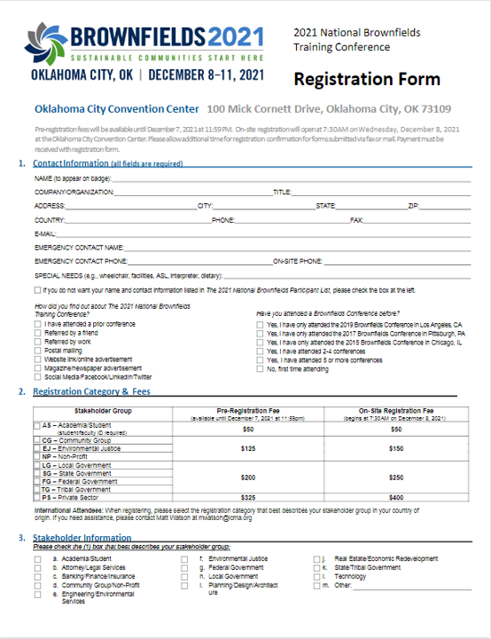

2018 Youth Environmental Leadership Conference
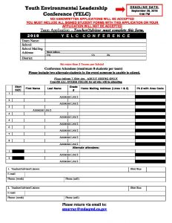

Association of WV Solid Waste. Fillable PDF Registration
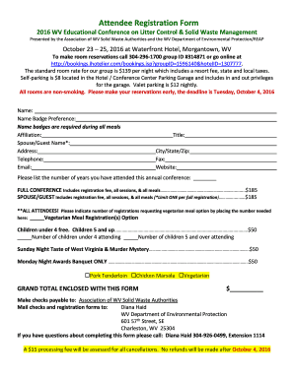
APHA 2020
https://www.google.com/search?q=APHA+conference+registration+forms&tbm=isch&ved=2ahUKEwjTgqXyxYn2AhVMgnIEHdeYD34Q2-cCegQIABAA&oq=APHA+conference+registration+forms&gs_lcp=CgNpbWcQAzoHCCMQ7wMQJ1DMDFicEmC4KWgAcAB4AIABSIgB1AKSAQE1mAEAoAEBqgELZ3dzLXdpei1pbWfAAQE&sclient=img&ei=UrgPYtORIMyEytMP17G-8Ac&bih=714&biw=1536#imgrc=eTNLjAvAoM2YsM

