OMB#: 0925-0648 Exp. date: 6/30/2024

NIDA Website User Feedback Survey

Survey Burden Statement
Public reporting burden for this collection of information is estimated to be 3 minutes per response, including the time for reviewing instructions, searching existing data sources, gathering and maintaining the data needed, and completing and reviewing the collection of information. An agency may not conduct or sponsor, and a person is not required to respond to, a collection of information unless it displays a currently valid OMB control number. Send comments regarding this burden estimate or any other aspect of this collection of information, including suggestions for reducing this burden, to: NIH, Project Clearance Branch, 6705 Rockledge Drive, MSC 7974, Bethesda, MD 20892-7974, ATTN: PRA (0925-0648). Do not return the completed form to this address.

Question 1: Was this page helpful?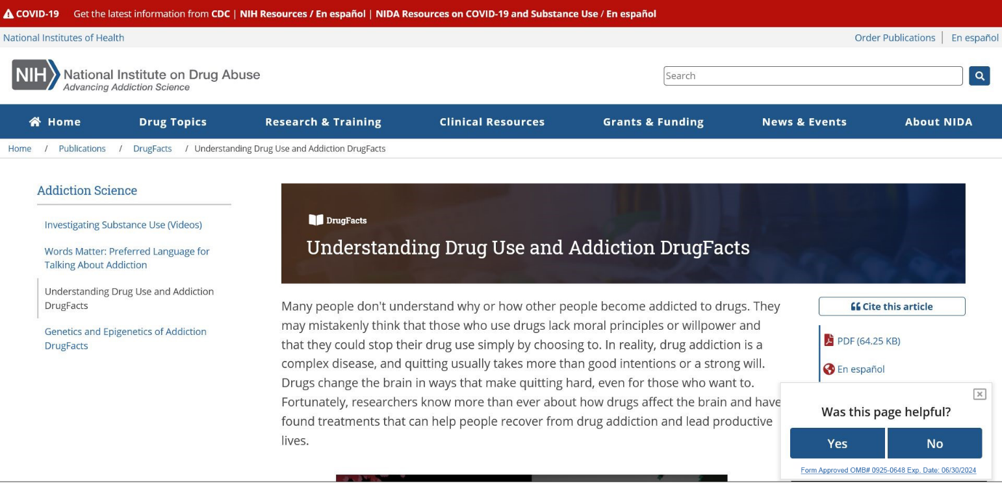
From here, a user can choose to answer the first survey question. If the user answers the first question, subsequent questions will appear on the same page in the same place (no more than 4 questions). A user can also click the “x” to make the survey go away.

Question 2: Did you find what you were looking for?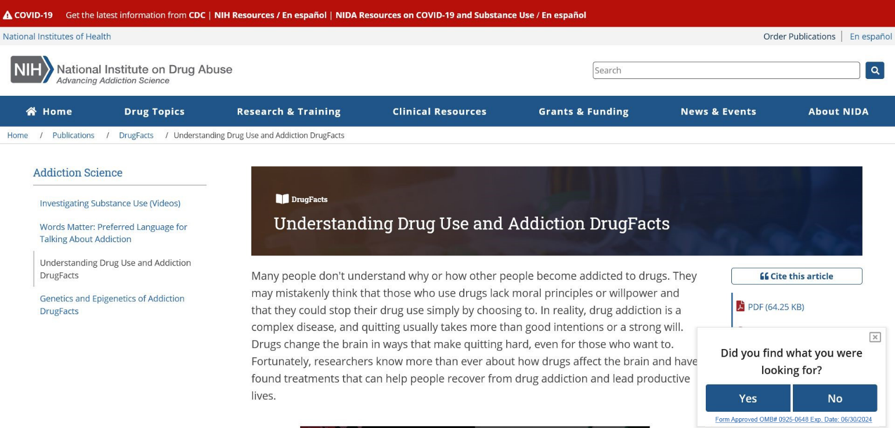

Question 3: To help us write better content for others like you, can you tell us what best describes you?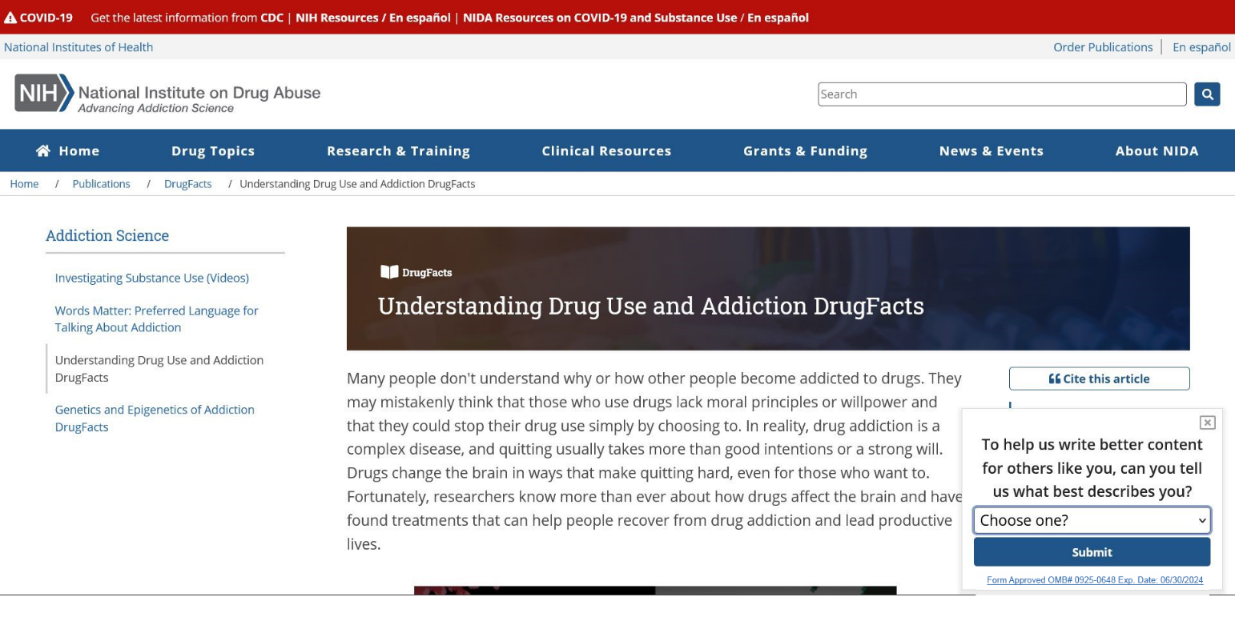

Question 3: Options
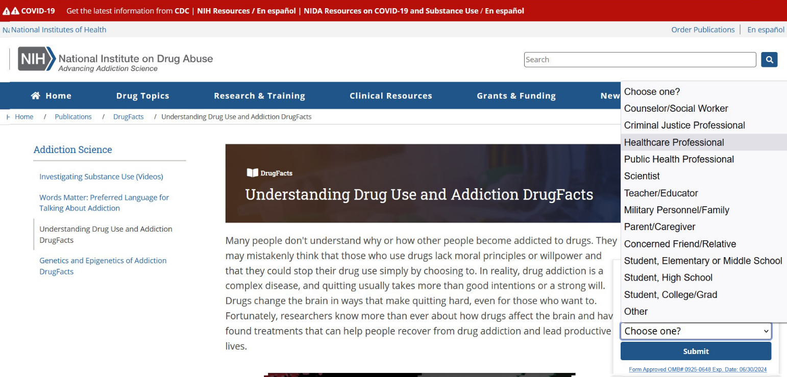

Final Thank You Screen
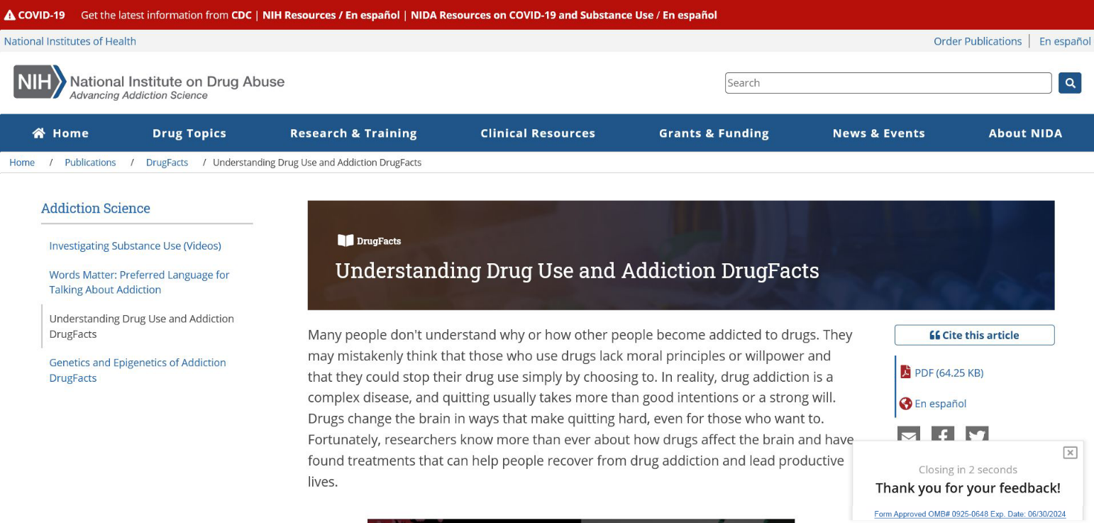

Updated Versions of Current Questions
The possible responses on Question 3 have been updated to better capture different types of roles that might describe visitors to the NIDA website.
- Was this page helpful?
  - Yes [move onto next question]
  - No [probe for open ended response] How could we improve it?
- Did you find what you were looking for?
  - Yes [move onto next question]
  - No [probe for open ended response] What were you looking for?
- Which of the following best describes your primary role in coming to the site? Knowing your background will help us develop resources that meet your interests and needs.
  - Person seeking information on their own health condition(s), such as a substance use disorder and/or chronic pain
  - Person interested in drugs and substance use
  - A loved one or caregiver seeking health information for someone else
  - Counselor/social worker
  - Healthcare professional
  - Student
  - Researcher
  - Teacher/educator
  - Public health professional/prevention specialist
  - Other
If Other is selected, follow up will be: Please specify [open ended]

Question Bank
The following questions could be swapped in and out for the current questions, to capture different feedback to support NIDA’s communicate feedback needs:
1. What specific information were you looking for? [open ended]

2. What is your main reason for visiting our site today? [choose one or more]:
- To learn about substances and substance use
- To learn about the health effects of a substance
- To learn about the signs of substance use and/or addiction
- To find out about effective treatment options for substance use disorders (addiction)
- To learn about opportunities in addiction research
- To complete an assignment for school
- To understand the number of people impacted by substance use, addiction and/or overdose
- Other
If Other is selected, follow up will be: Please specify [open ended]

3. How easy was it to find what you were looking for on this site? [choose one]
- Very easy
- Somewhat easy
- Neither easy nor difficult
- Somewhat difficult (please specify)
- Very difficult (please specify)
If d. or e. is selected, follow up will be: Please tell us more. [open ended]
4. How easy is it to understand the information on this page? [choose one]
- Very easy
- Somewhat easy
- Neither easy nor difficult
- Somewhat difficult (please specify)
- Very difficult (please specify)
If d. or e. is selected, follow up will be: Please tell us more. [open ended]

5. When you are looking for health information online, which of these formats is helpful to you? [choose one or more]
- Frequently asked questions
- Fact sheets
- Articles that summarize recent research
- A collection of links and resources about a drug topic
- Lesson plans or activities for students
- Community education resources
- Resources for patients/clients
- Blog posts about drug topics
- Illustrations
- Photographs
- Graphs, charts, and infographics (pictures that included text and data)
- Videos
- Resources for social media use
- Chat bots
- Other
If Other is selected, follow up will be: Please specify [open ended]

6. Which topics most interest you? [choose one or more]
- Substance use disorders (addiction)
- Brain science (neuroscience)
- Substance use prevention
- Drugs (substances), in general
- Information on a specific drug
- Harm reduction
- Overdose and overdose prevention
- Recovery
- Substance use disorder (addiction) treatment
- The relationship between substance use and other health topics (e.g., HIV, chronic pain)
- Trends and statistics about substance use
- Substance use and children and teens
- Mental health and mental illness
- Trauma and stress
- Other
If Other is selected, follow up will be: Please specify [open ended]

7. How can we improve [this website / these search results / this page]? [open ended]
8. How likely are you to return to this site? [rating scale]
- Very likely
- Somewhat likely
- Neither likely or unlikely
- Somewhat unlikely
- Very unlikely

9. Why would you return to this website in the future? [choose one or more]
- I trust NIDA’s information
- I can find and view the information easily
- I can understand the information
- The information is free
- The website is not linked to another company or business
- I do not need to share my personal information
- Other
If Other is selected, follow up will be: Please specify [open ended]

10. Which of these best describes your ethnicity? [choose one]
- Hispanic or Latino
- Not Hispanic or Non-Latino
11. Which of these best describes your race? [choose one or more]¹⁰
- American Indian or Alaska Native
- Asian
- Black or African American
- Native Hawaiian or Other Pacific Islander
- White

12. How likely is it that you would recommend our site to a friend, family member, or colleague?
- Very likely
- Somewhat likely
- Neither likely nor unlikely
- Somewhat unlikely
- Very unlikely

13. For whom are you seeking information today? [choose one]¹⁰
- Myself
- A family member or friend
- A patient or client
- Educational setting (e.g., classroom)
- Community setting (public health resources)
- No one in particular; I'm just curious
- Other
If Other is selected, follow up will be: Please specify [open ended]

14. Are you an educator or other school professional?
  - Yes
  - No
15. Which grade bands do you support? [choose one or more]
a. 9th-12th grades
b. 6th-8th grades
c. 3rd-5th grades
d. Kindergarten-2nd grade

16. Which subject might you use this lesson plan for?
- Biology
- Chemistry
- English/ Language Arts
- Forensic Science
- Health
- Life Skills
- Math
- Physical education
- Science
- Social studies
- Other
If Other is selected, follow up will be: Please specify [open ended]

17. Approximately what is your average class size? Please enter a whole number.

18. In which state or territory is your school located? Please enter the two letter state abbreviation. You can enter N/A if you are outside of the United States.

19. On which other drugs and addiction topics would you like lesson plan content?

20. In which type of setting do you work with youth?
- Public school
- Private school
- Charter school
- Magnet school
- Religious school
- Home school
- Community organization
- Afterschool club/activity
- Health care organization
- College or university
- Other
If Other is selected, follow up will be: Please specify [open ended]

From the National Institute on Alcohol Abuse and Alcoholism (NIAAA) Survey https://www.reginfo.gov/public/do/PRAViewIC?ref_nbr=202104-0925-001&icID=235681.
Adapted from NIAAA Survey https://www.reginfo.gov/public/do/PRAViewIC?ref_nbr=202104-0925-001&icID=235681.
From NIAAA Survey https://www.reginfo.gov/public/do/PRAViewIC?ref_nbr=202104-0925-001&icID=235681.
From NIAAA Survey https://www.reginfo.gov/public/do/PRAViewIC?ref_nbr=202104-0925-001&icID=235681.
From NIAAA Survey https://www.reginfo.gov/public/do/PRAViewIC?ref_nbr=202104-0925-001&icID=235681.
From NIAAA Survey https://www.reginfo.gov/public/do/PRAViewIC?ref_nbr=202104-0925-001&icID=235681.
From NIAAA Survey https://www.reginfo.gov/public/do/PRAViewIC?ref_nbr=202104-0925-001&icID=235681.
Q13 from the National Library of Medicine Survey https://www.reginfo.gov/public/do/PRAViewIC?ref_nbr=202103-0925-003&icID=248245.
From Federal COVID Response Survey https://www.reginfo.gov/public/do/PRAViewIC?ref_nbr=202103-0925-003&icID=247232.
From NIAAA Survey https://www.reginfo.gov/public/do/PRAViewIC?ref_nbr=202104-0925-001&icID=235681.

