Banner at top of page requesting feedback – Desktop and Mobile Versions

OMB # and Exp. Date
Button to launch survey
`

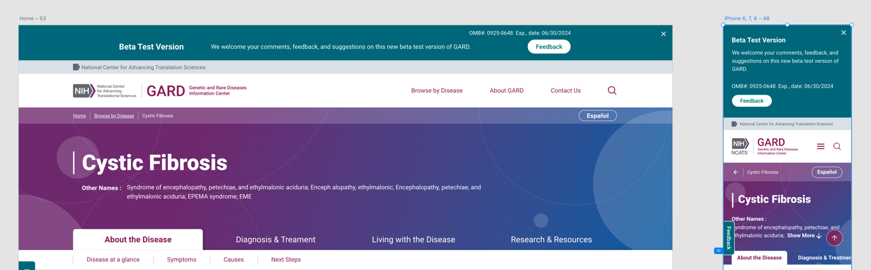

Recruitment: Participants will self-select themselves. Survey respondents will be visitors to NCATS GARD website pages who choose to view the preview of the draft new version of the page and wish to respond to the survey by selecting the “Feedback Form” button.

