NIH HEAL Email Survey
The language below will appear in the email outreach to ask readers to take our survey:
Our readers are important to us, and it’s been a while since we heard from you. Please take a moment to complete this reader survey about your interests and background. We are looking for your suggestions on topics that you want to know more about.
Please note, this survey is voluntary and all responses will remain anonymous. The estimated time to complete the survey is on average 3 minutes, and you can choose to answer as many or as few questions as you like.

Qualtrics survey preview
The screenshots below show the survey as the user would see it on the Qualtrics platform.
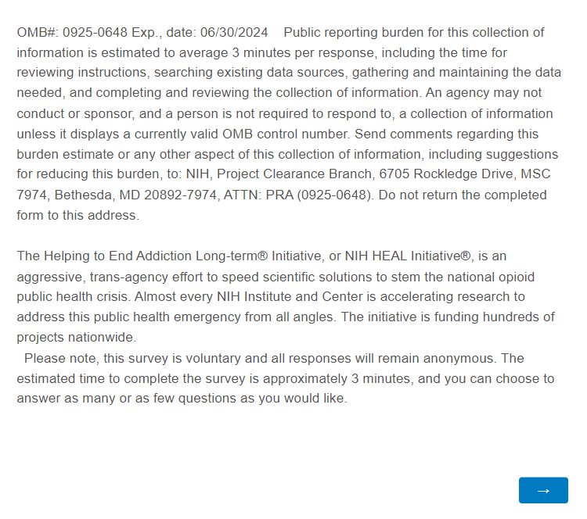

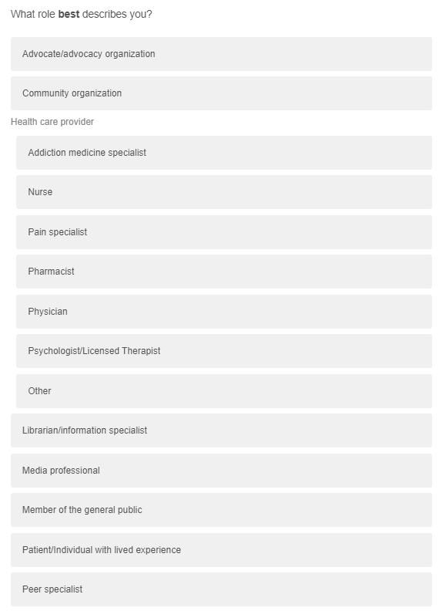
1.

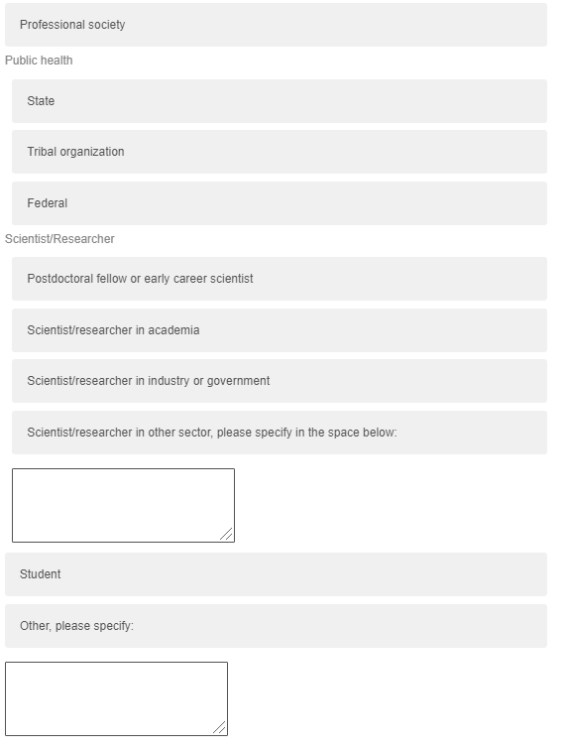

From the previous question, ‘what role best describes you?’, users who select either ‘Postdoctoral fellow or early career scientist’, ‘scientist/researcher in academia’, ‘scientist/researcher in industry or government’, or ‘scientist researcher in other sector’ will be guided to the question 1a. All other users will skip this question and move onto question 2.
1a.
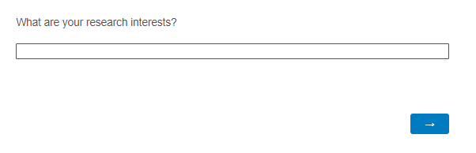

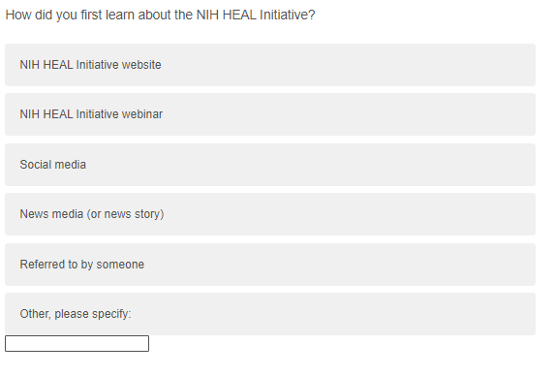
2.

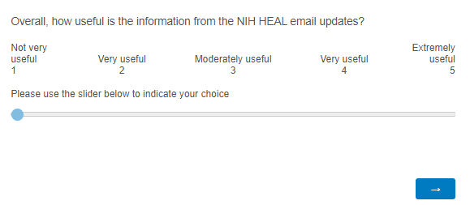
3.

All users who select a number 3 or below on question 3 will be guided to question 3a. All other users will skip this question and move on to question 4.
3a.
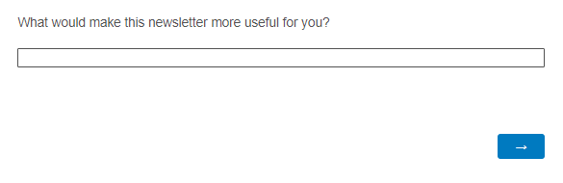

4.
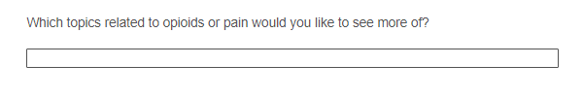

5.
