**Attachment 2: Screenshots of NIAMS Website User Feedback Survey**

**Question 1:**

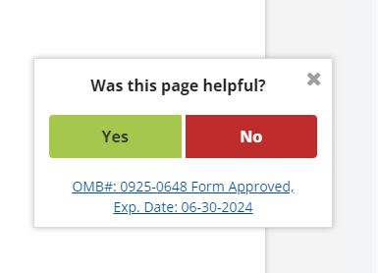

From here, a user can choose to answer the first survey question. If the user answers the first question, subsequent questions will appear on the same page in the same place (no more than 4 questions). A user can also click the “x” to make the survey go away.

**Question 1b:**

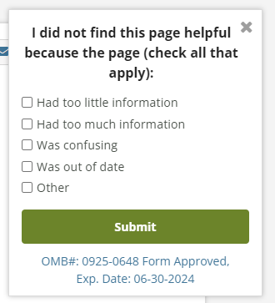

**Question 2:**

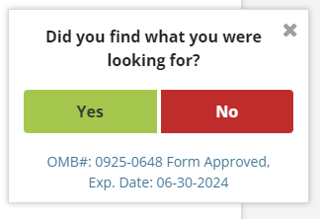

**Questions 3:**

