Email Invitations to Participate in Patient Feedback Surveys
Adult
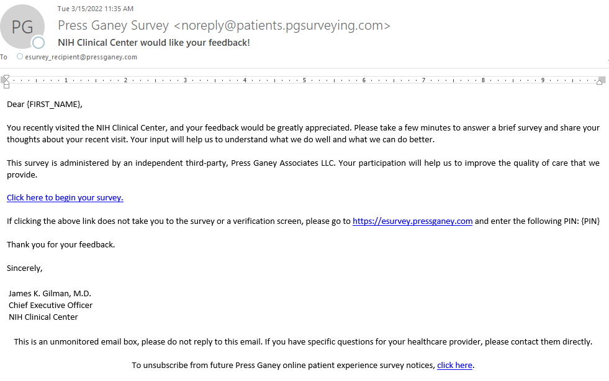
Pediatric