NIEHS PEPH Metrics Manual Training Post-Workshop Participant Survey Screenshot
OMB#: 0925-0648
Expiration Date: 06/2024
Public reporting burden for this collection of information is estimated to average 1 minute per response, including the time for reviewing instructions, searching existing data sources, gathering, and maintaining the data needed, and completing and reviewing the collection of information. An agency may not conduct or sponsor, and a person is not required to respond to, a collection of information unless it displays a currently valid OMB control number. Send comments regarding this burden estimate or any other aspect of this collection of information, including suggestions for reducing this burden to: NIH, Project Clearance Branch; 6705 Rockledge Drive, MSC 7974, Bethesda, MD 20892-7974, ATTN: PRA (0925-0648). Do not return the completed form to this address.
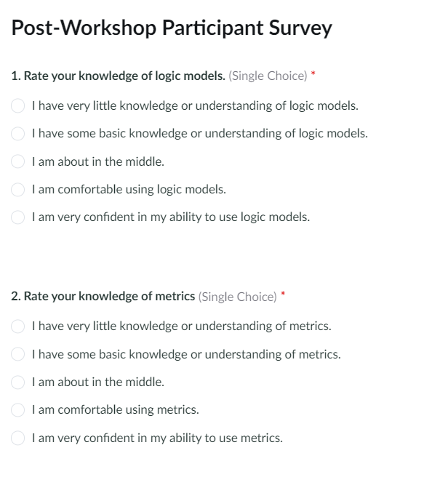
Participants will be asked to respond to the following questions using the chat feature:
What are two things you learned today that you’ll be able to apply to a current or upcoming project?

What are two things you wished we had covered during the workshop that we didn’t cover?

