NIH CIT Digital Web Strategy

External Survey

*CIT public-facing website users*

**Presentation of Survey:**

1. Banner will pop up on the [CIT website home screen](https://www.cit.nih.gov/):

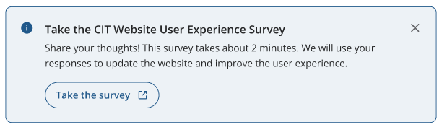

1. The button will redirect users to take the survey in MS Forms:

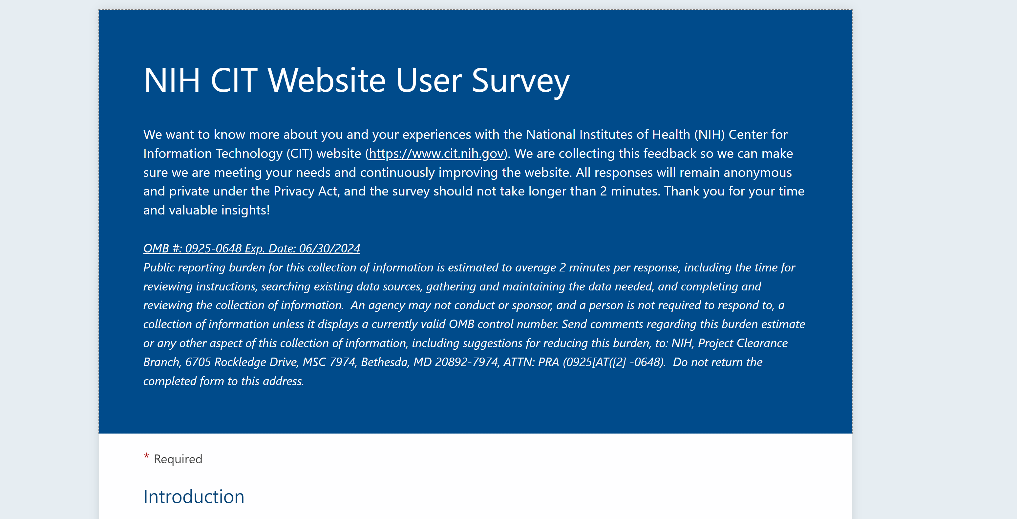

**Survey Introduction**

We want to know more about you and your experiences with the National Institutes of Health (NIH) Center for Information Technology (CIT) website (<https://www.cit.nih.gov>). We are collecting this feedback so we can make sure we are meeting your needs and continuously improving the website. All responses will remain anonymous and private under the Privacy Act, and the survey should not take longer than 2 minutes. Thank you for your time and valuable insights!

**OMB #:** **0925-0648 Exp. Date: 06/30/2024**

Public reporting burden for this collection of information is estimated to average 2 minutes per response, including the time for reviewing instructions, searching existing data sources, gathering and maintaining the data needed, and completing and reviewing the collection of information. **An agency may not conduct or sponsor, and a person is not required to respond to, a collection of information unless it displays a currently valid OMB control number.** Send comments regarding this burden estimate or any other aspect of this collection of information, including suggestions for reducing this burden, to: NIH, Project Clearance Branch, 6705 Rockledge Drive, MSC 7974, Bethesda, MD 20892-7974, ATTN: PRA (0925-0648). Do not return the completed form to this address.

**Introduction**

[**\*\*** = required questions]

**\*\* Where do you work?**

* + I am an NIH employee/contractor
  + I am an NIH extramural researcher or grantee
  + I am a non-NIH government employee/contractor
  + I do not work for the government

*If participant chooses “NIH”:*

**\*\* Which NIH Institute or Center (IC) do you work for?**

[open text]

**\*\* How would you categorize your role?**

* + Executive staff
  + IT community
  + Scientific community
  + Administrative community

**\*\* What are the top three CIT services most applicable to you in your job? (select top three, if applicable)**

* + Accounts & Access (account access, identity, and authorization)
  + Applications & Systems (systems and services to support scientific research and operational and business activities)
  + Business Operations (business intelligence, cloud resources, technology training)
  + Collaboration Services (livestreaming, video conferencing, virtual meetings, file-sharing tools)
  + Hardware & Software (e.g., software licensing, IT support & monitoring)
  + Hosting & Storage (e.g., data storage and backup, hosting and databases, cloud resources, STRIDES)
  + Networks (digital and virtual networks and environments)
  + Research Computing & Systems (services and tools for researchers)
  + None of these apply to me

*If participant chooses “extramural”:*

**\*\* What are the top three CIT services most applicable to you in your job? (select top three, if applicable)**

* + Accounts & Access (account access, identity, and authorization)
  + Applications & Systems (systems and services to support scientific research and operational and business activities)
  + Business Operations (business intelligence, cloud resources, technology training)
  + Collaboration Services (livestreaming, video conferencing, virtual meetings, file-sharing tools)
  + Hardware & Software (e.g., software licensing, IT support & monitoring)
  + Hosting & Storage (e.g., data storage and backup, hosting and databases, cloud resources, STRIDES)
  + Networks (digital and virtual networks and environments)
  + Research Computing & Systems (services and tools for researchers)
  + None of these apply to me

*If participant chooses “non-NIH government”:*

**\*\* Which government industry best describes where you work?**

* + Health and Human Services (e.g., CDC, FDA, HHS)
  + Legislative, Executive, or Judicial Branches
  + Defense, Security, and Justice (e.g., FBI, CIA, DOD, DOJ, DHS)
  + Infrastructure, Transport, and Regional Government (e.g., State of Georgia, University of California)
  + None of these describe where I work

*If participant chooses “do not work for the government”:*

**\*\* Which industry do you work in?**

* + Technology
  + Media and communications
  + Healthcare
  + Education and Research
  + Finance
  + Oil and gas
  + Industrial
  + Consumer goods
  + Consumer services
  + Other [add area for open text response]

**CIT Website User Experience**

**\*\* What brings you to the CIT website today? (select all that apply)**

* + Access the Service Desk to request IT support
  + Contact CIT
  + Browse information about CIT's IT services
  + Request IT service(s)
  + Learn about CIT leadership and/or org chart
  + Learn about CIT mission and vision
  + Catch up on CIT news
  + Other [add area for open text response]

**\*\* Likert Matrix**

|  |  |  |  |  |  |
| --- | --- | --- | --- | --- | --- |
|  | Strongly disagree | Somewhat disagree | Neither agree nor disagree | Somewhat agree | Strongly agree |
| The CIT website has useful information |  |  |  |  |  |
| The CIT website is easy to navigate |  |  |  |  |  |
| The CIT website is visually appealing |  |  |  |  |  |
| The CIT website connects me to resources I need to help me do my job |  |  |  |  |  |

**What information do you wish you could find on the CIT website?**

______ [open text response]

**How could we make the CIT website better?**

______ [open text response]

**Wrap Up**

**\*\* Would you be willing to participate in a short discussion in early 2023 to further elaborate on your experiences with the CIT website?**

Participants will be randomly selected, and your response to this question does not guarantee your participation. If interested, we will follow up with you in early 2023 to verify your involvement and next steps.

* + Yes
  + No
  + Maybe

*If yes or maybe:*

**First and Last Name**

We will only use your name and contact information to contact you for follow-up; your responses to this survey will still be anonymous and aggregated.

[open text response]

**Email address**[open text response]