NHLBI Website Usability Tests
Content Feedback, Design Feedback and A/B Comparison
OMB#: 0925-0648 Exp. Date: 06/2024

Introduction, Questions & Screenshots
The following pages include the usability test questions and some example screenshots from the Helio.app and Wynter web-based tools that will be used to conduct the unmoderated usability tests.
Please note: NHLBI will conduct just one of the following usability tests at a time.

Introduction
For each usability test, participants will see an introduction screen with instructions, OMB Fast Track number, expiration date, and burden statement, along with a “Let’s Begin” button to start.
Figure 1. Introduction Screen
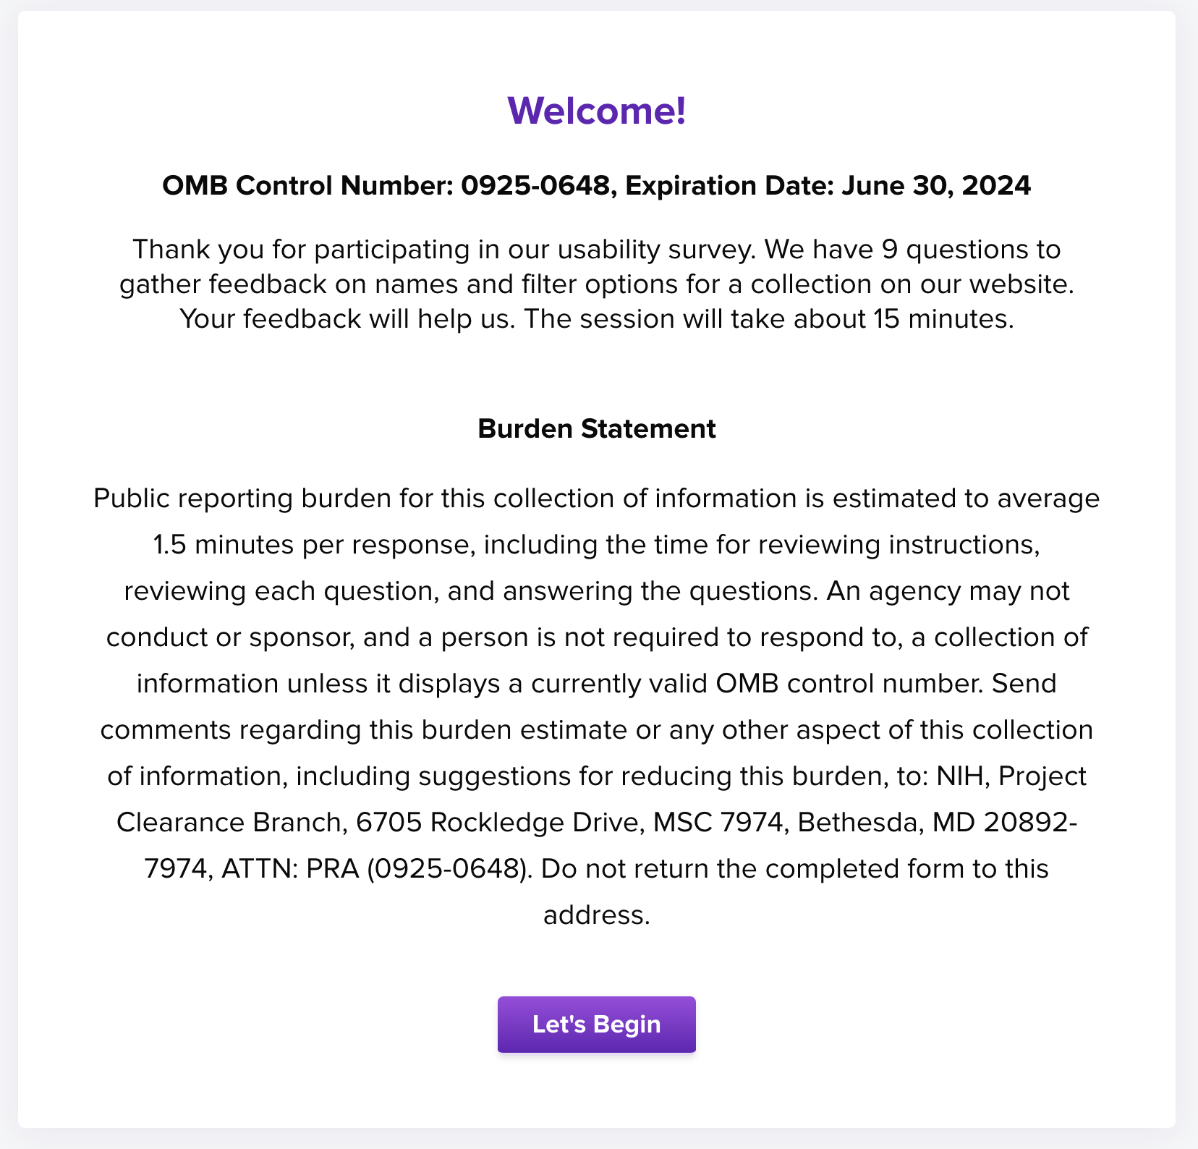
Up to 10 questions would be asked in each usability test.

Content Feedback Usability Test
- What would you read (or try) first?
Screenshot from tool
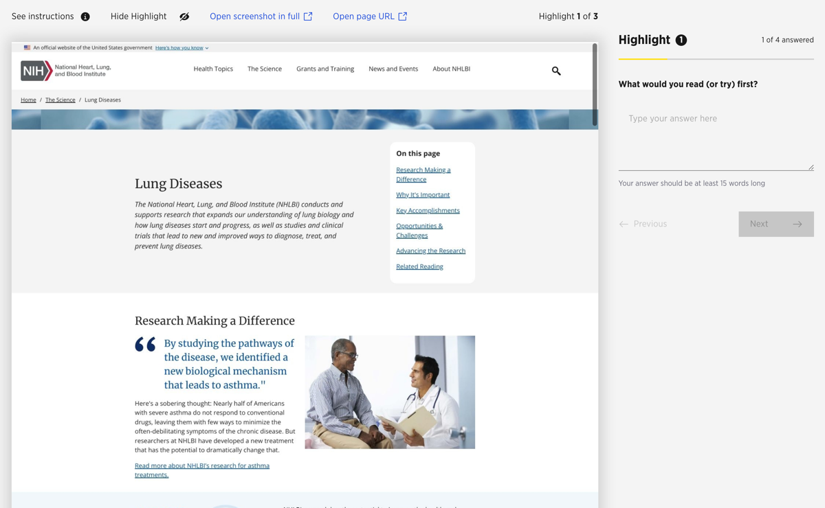
- What information on [topic, condition] is most important to you? Why?
Screenshot from tool
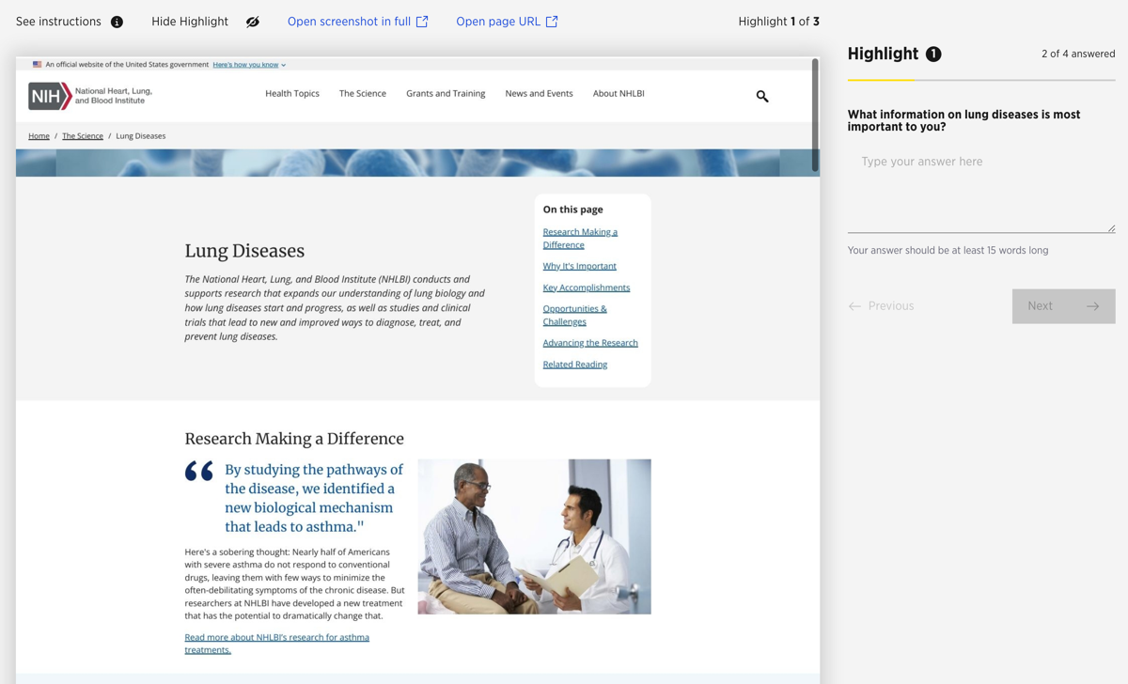
- Please rate how easy it is to read the content.
Screenshot from tool
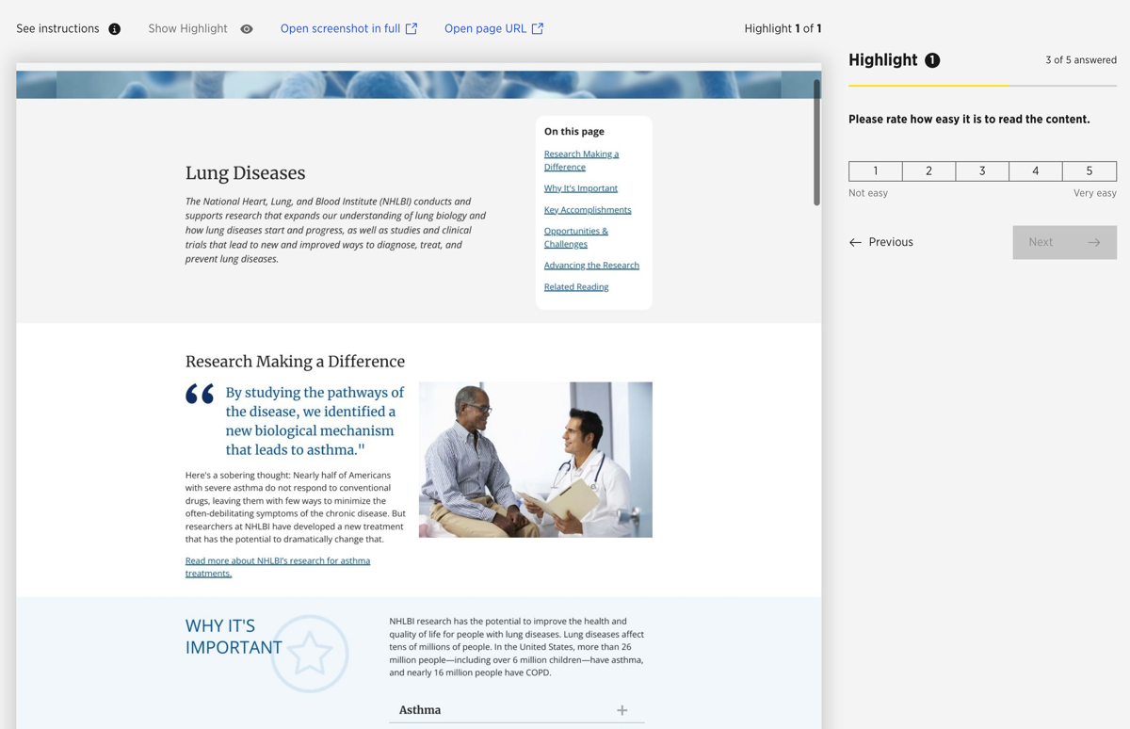

PLEASE NOTE: The remaining questions will use the same structure as those above – screenshot on left / question on right for easy participant reference.
- How useful would this be for you? 1 – not useful to 5 – very useful
- I want to read the next paragraph. 1 – not at all to 5 – very much
- Please rate the overall clarity of this content. 1 – unclear to 5 – very clear
- What are your reactions to how this page is laid out or organized?
- How could we improve this [webpage, menu, content, etc.]?
- After reading everything, what questions do you still have?

Design Feedback Usability Test
- Please click on the first thing that catches your eye on this page.
Screenshot from tool
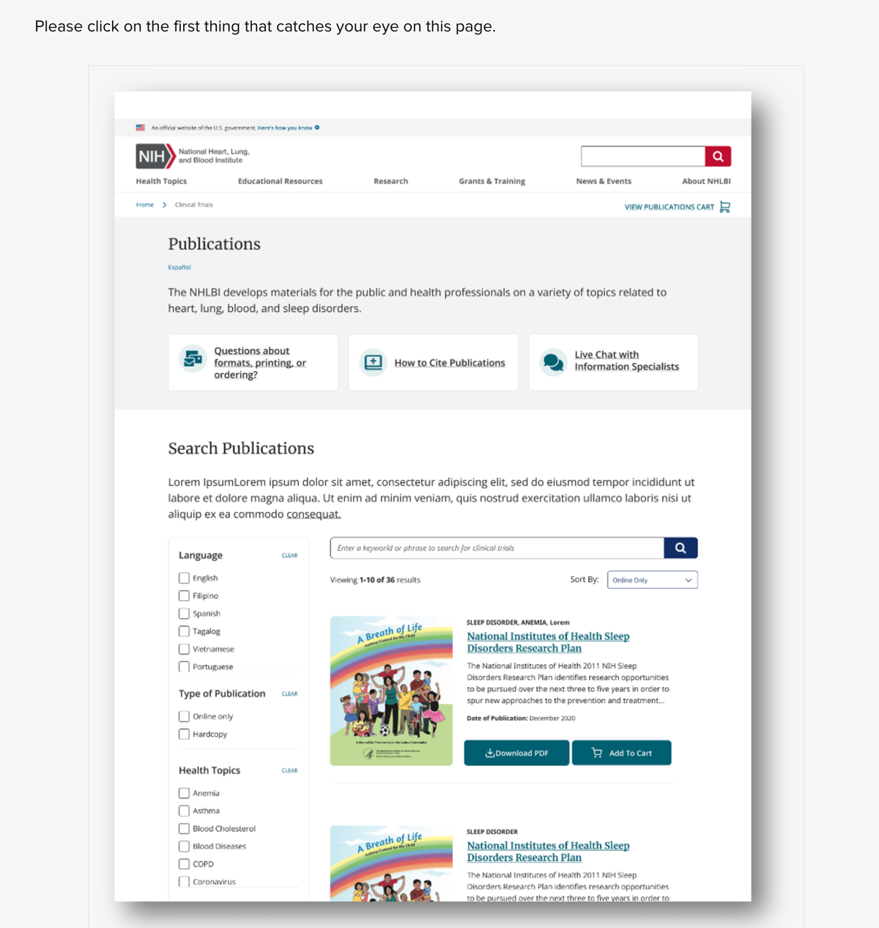

- You arrived on this page from a Google search. How would you find […]? [Please click on the image below to indicate where you would click.]
Screenshot from tool
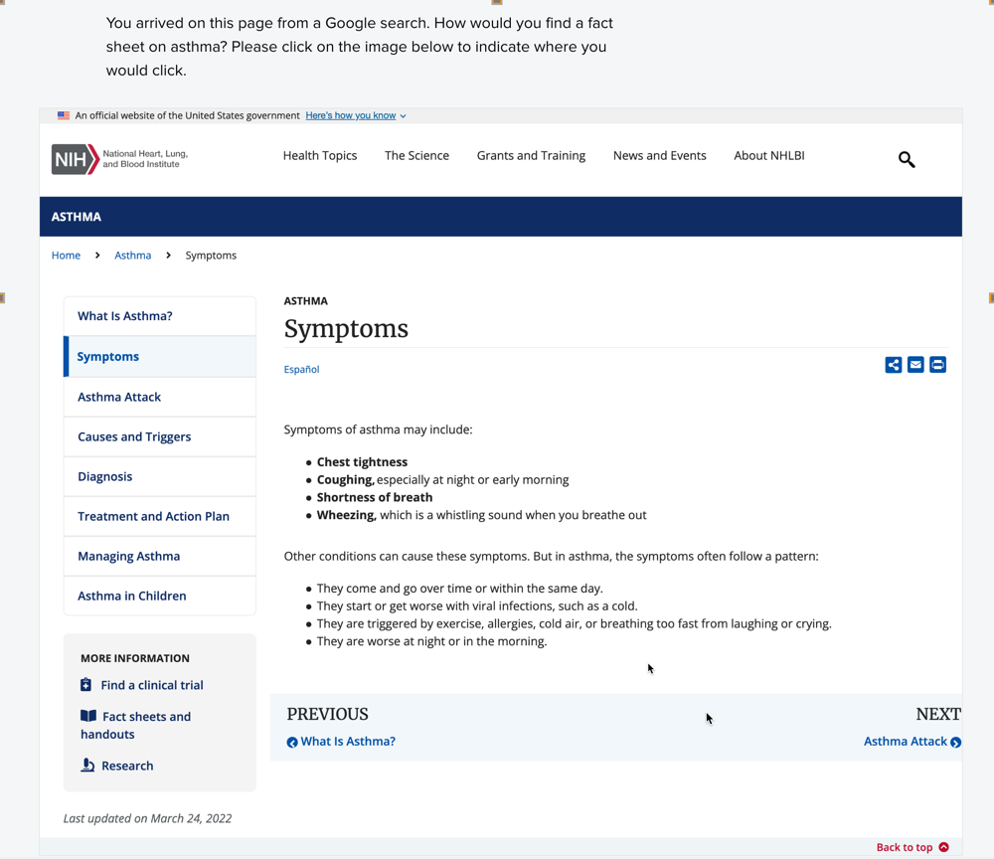
PLEASE NOTE: The remaining questions will use a similar structure to screenshots above and include the relevant screenshots as needed for easy participant reference.
- If you wanted to find […], what would you do first? [Please click on the image below to indicate where you would start.]
- Why did you choose that [option, label, grouping]?
- What did you think about the design of this [component – e.g., webpage, menu, image, headings, etc.]?
- What do you like best about this [component]? [Please click on the item/area you like best.]
- What are your reactions to how this page is laid out or organized?
- How could we improve this [webpage, menu, content, etc.]?
- Is there anything you think is missing from this [component]?
- Please rate the ‘look and feel’ (i.e., colors, images, fonts, etc.) of this webpage [or design element or content item, etc.].

A/B Comparison Usability Test
- Please take a look at these two [webpages, design elements, content items, etc.]. [The main difference between these two items is …] Which do you prefer?
Screenshot from tool
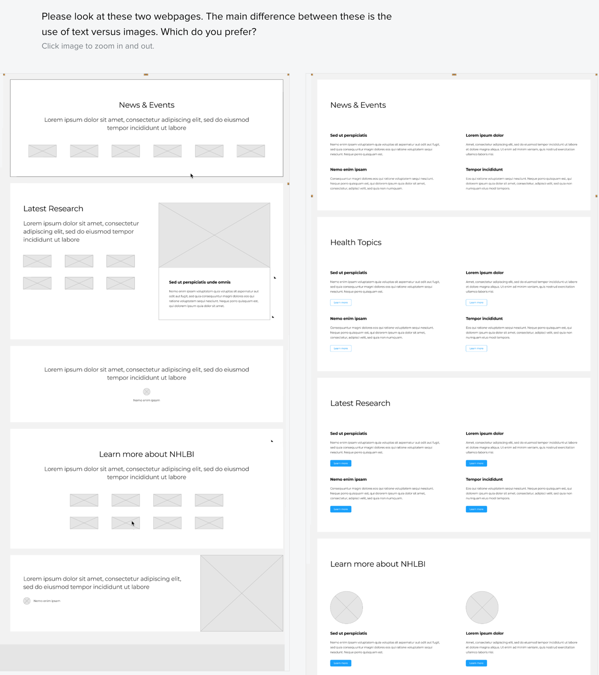
- Why did you select the [webpage, design element, etc.] option that you chose?
Screenshot from tool
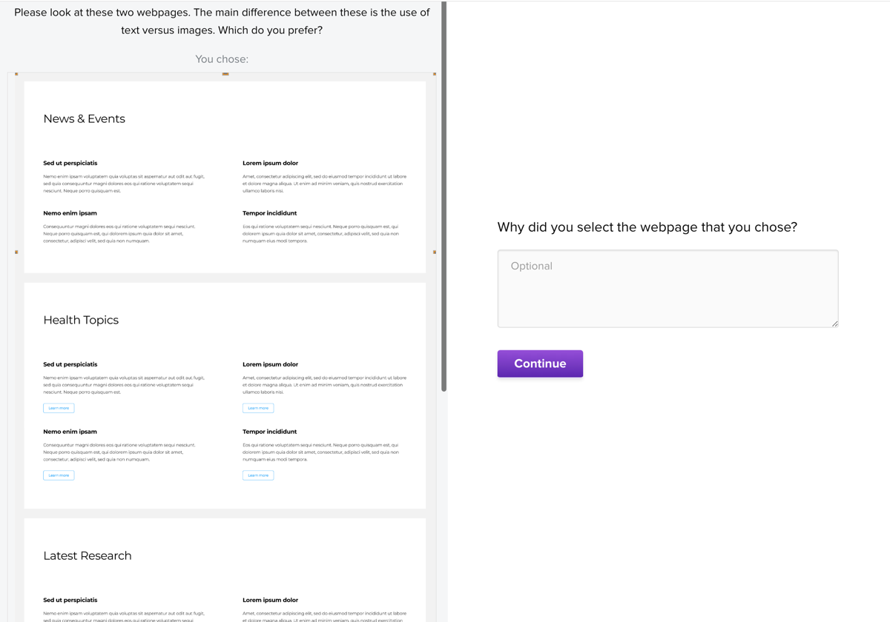
- If you saw the following list of [items, topics]: […bulleted list of items…] … which label would you choose to describe them? [list possible options and an “Other (please specify):” option]
Screenshot from tool
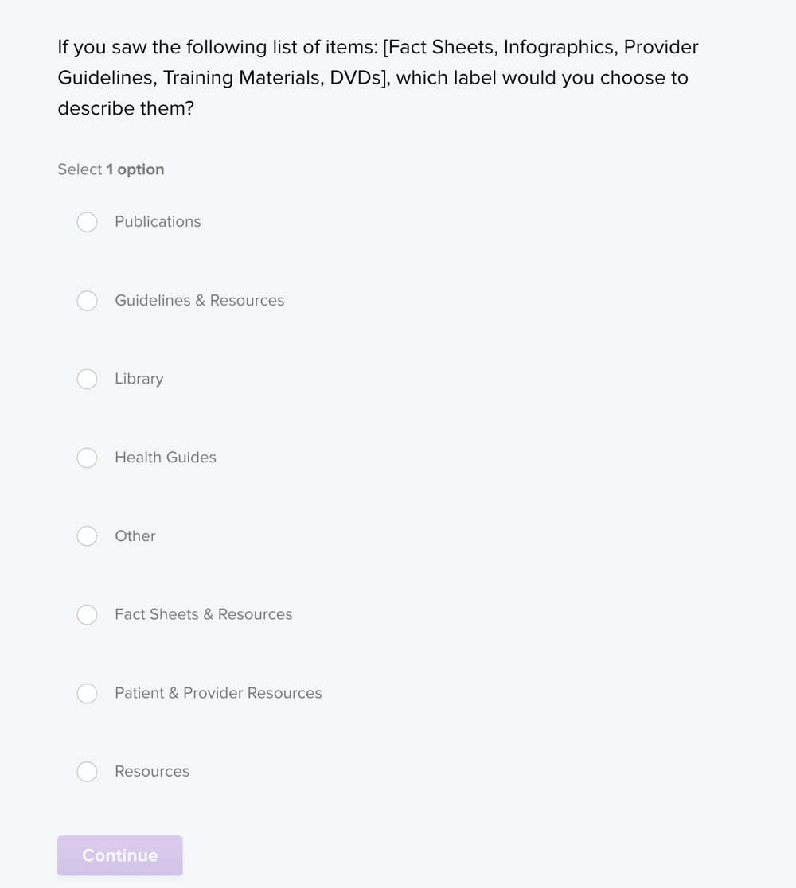
PLEASE NOTE: The remaining questions will use a similar structure to screenshots above and include the relevant screenshots as needed for easy participant reference.
- Why did you choose that [option, label, grouping]?
- Please rate the appeal of this webpage [or design element or content item, etc.]. (show Option A)
- What could be done to improve your satisfaction with this [webpage, design element, etc.]? (show Option A)
- Please rate the appeal of this webpage [or design element or content item, etc.]. (show Option B)
- What could be done to improve your satisfaction with this [webpage, design element, etc.]? (show Option B)
- What is your overall reaction to the pages you saw today?
- Is there anything you think is missing from this [component]?

