# NHLBI Website Usability Tests Content Feedback, Design Feedback and A/B Comparison OMB#: 0925-0648 Exp. Date: 06/2024

## Recruitment

This document describes how participants will be recruited for usability tests. **Please note:** NHLBI will conduct just one of the following usability tests at a time.

### For Design and A/B Comparison Usability Tests: Helio.app Participant Panels

For design and A/B comparison usability tests, NHLBI will recruit participants by requesting them from participant panels via our Helio.app usability test tool subscription. Helio.app has created participant panels of people who opt in to participate in future tests. Using their self-reported interests and traits (e.g., profession, online news use, etc.), Helio.app assigns the users to panels.

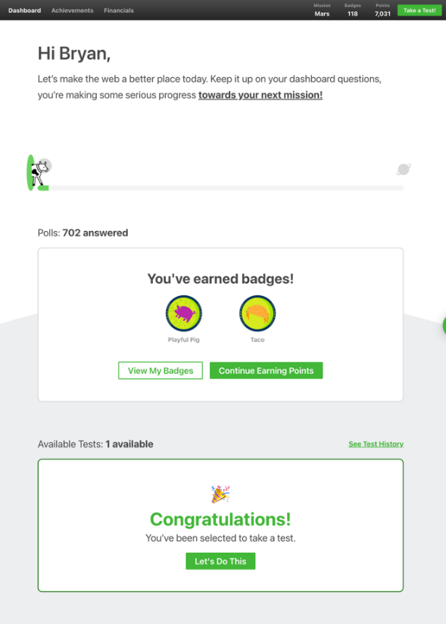

With this subscription, NHLBI sets up the test in Helio.app:

1. We then request participants from the appropriate panel (e.g., Online Content Readers)
2. Helio.app randomly selects participants from that panel and displays a Dashboard message to those users
3. These potential participants see a “Congratulations, You’ve been selected to take a test” and “Let’s Do This” button they can click to participate (see Figure 1)
4. Once the desired number of participants complete the test, the test stops and our NHLBI team gets results.

**Figure 1. Helio.app Participant Dashboard**

### For Content Feedback Usability Tests: NHLBI Subscriber Lists

For content feedback usability tests, existing NHLBI subscriber lists will be used. NHLBI will email the following invitation with a link to take the test to these participants. The test will close after the desired number of participants completes it. ***Sample email:***

**Subject:** NHLBI Wants Your Feedback

**NHLBI is Updating Resources and Needs Your Help**

We are looking for participants to provide feedback on NHLBI resources being updated. Your feedback will be used to help further improve the site so that it’s easier to use.

**How do I participate?**

You can participate by answering the questions you’ll find at <https://app.wynter.io/test/id-of-test>

**It takes less than 15 minutes**. All you need is your computer and an internet connection.

**Questions?**

If you have any questions, please contact [Contact Name] at [[contacts-email-address@nih.gov](mailto:contacts-email-address@nih.gov)].